INVESTOR BRIEFING
Surgical Foundations VR
Practise the first steps of keyhole surgery before you ever touch a patient.
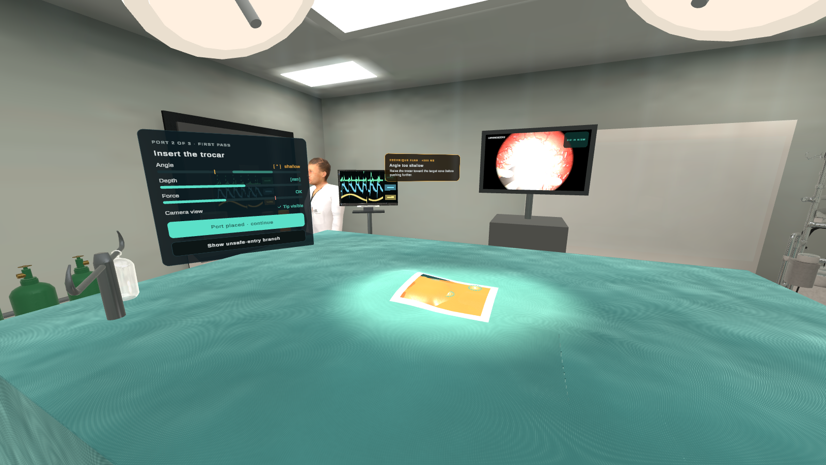
A learner’s view during port placement: live guidance on angle, depth and force, the laparoscope feed on the tower monitor, and the draped patient.
Surgeons should make their first mistakes in a headset, not on a patient. We give every trainee a safe, repeatable, objectively scored place to do exactly that.

1. The problem is real
Keyhole (laparoscopic) surgery is one of the hardest skills a young surgeon learns, and the way we teach it has a structural flaw: the learning happens where the stakes are highest.
- The skill is counter-intuitive. The surgeon watches a flat screen instead of the body, works through long instruments that pivot at the skin so the tip moves the opposite way to the hand, and feels far less tissue than in open surgery. It takes many hours of deliberate practice to build.
- Practice happens on real patients. Much of that practice still takes place in the live operating theatre, where time is scarce, pressure is high and every mistake matters to a patient.
- The costliest lessons are not about instruments. A glove brushing a non-sterile edge, a forgotten swab, a port placed at the wrong angle. These are easy to make, and today they are learned the hard way.
- Access to practice is gated. Simulator labs, theatre time and supervising mentors are limited, expensive to book and unevenly available. Assessment depends on who happened to be supervising.

What this costs
Who bears the cost | How
Patients | Avoidable sterility breaches, retained-item risks and port-placement injuries carry real harm.
Hospitals and training programmes | Scarce theatre and mentor time spent on basics; inconsistent assessment; hard to show a trainee is ready.
Trainees | Anxiety, uneven exposure, and no way to rehearse at 11pm the night before a list.
Educators | No standard scenario, so no fair comparison between learners or cohorts.

2. Our solution
Surgical Foundations VR is a virtual-reality operating theatre for Meta Quest 3. In about fifteen minutes a learner scrubs in, prepares a sterile field, places ports and operates through a laparoscope, with a guide at their shoulder and honest feedback on every step.
Pain point today | What the headset provides
Practice is limited by theatre and mentor availability | Repeat a full procedure at any hour, with no booking, no mentor and no simulator lab.
Sterility and counting errors are learned on the job | Habits are built in simulation; a mistake is shown the moment it happens, with the reason.
Hand-eye skills of keyhole surgery are hard to acquire | Instruments pivot about the port like the real thing; the learner watches a laparoscope view on a monitor.
Assessment varies with the supervisor | Every learner meets the same scenario and the same criteria, scored by the system.
Training hardware is expensive and fixed | Standalone headset: no PC, designed to work offline.
It does not replace supervised training in the real theatre. It helps learners arrive there better prepared, more confident and safer.

3. The product, inside the headset
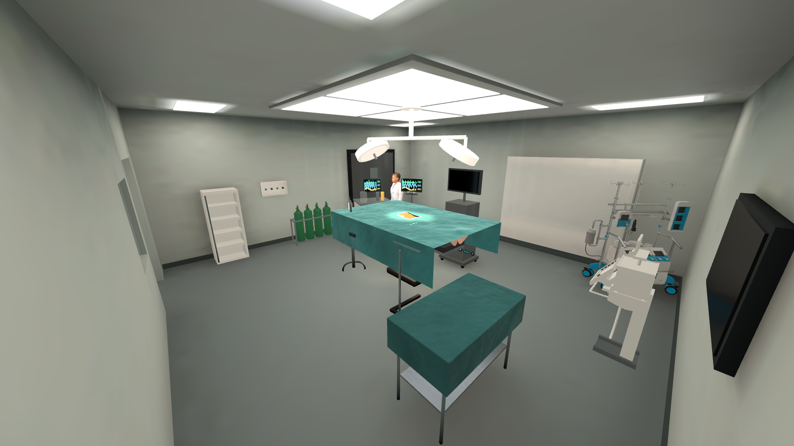
The operating theatre: table, surgical lights, laparoscopic tower, anaesthesia area and equipment.
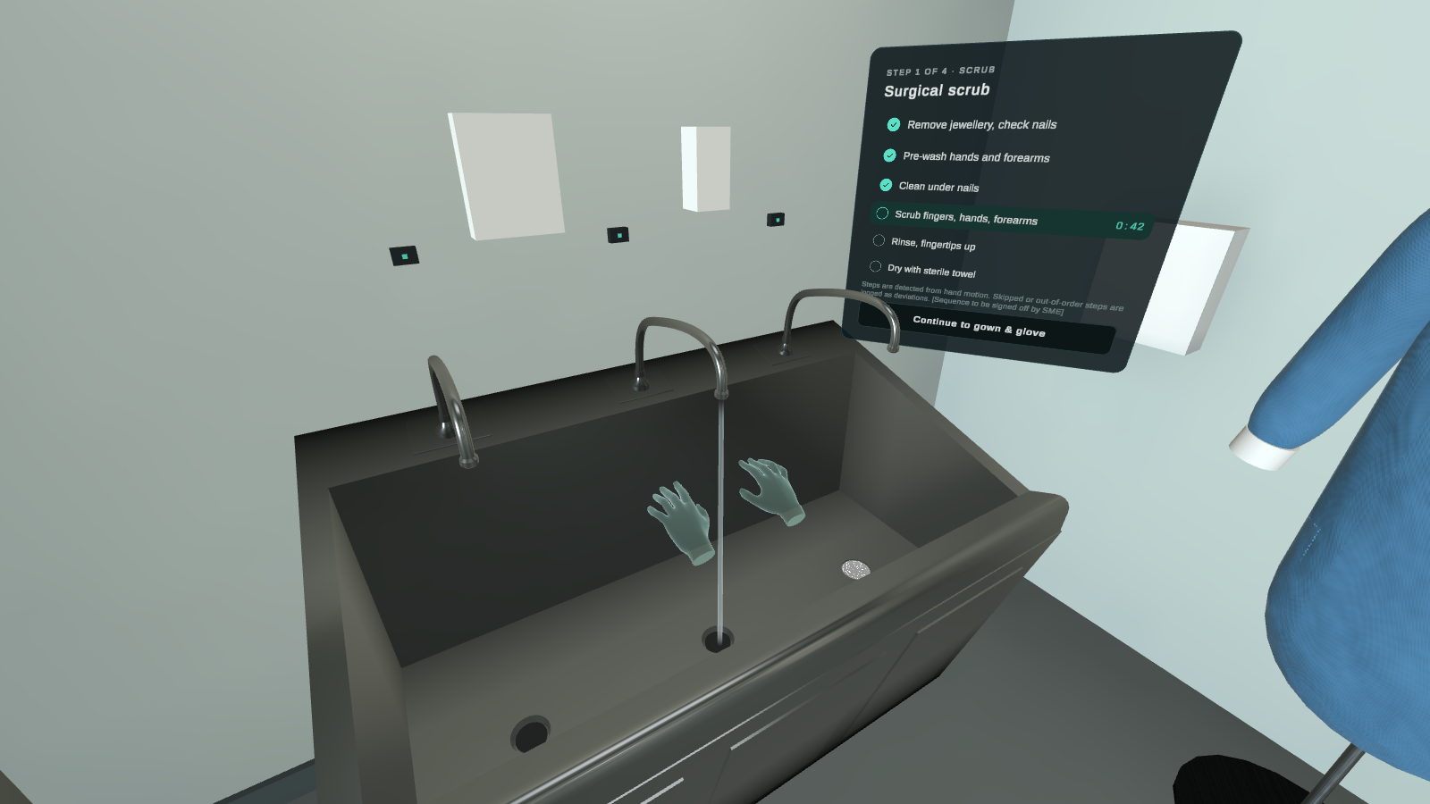  Scrubbing in, with the correct technique demonstrated. | 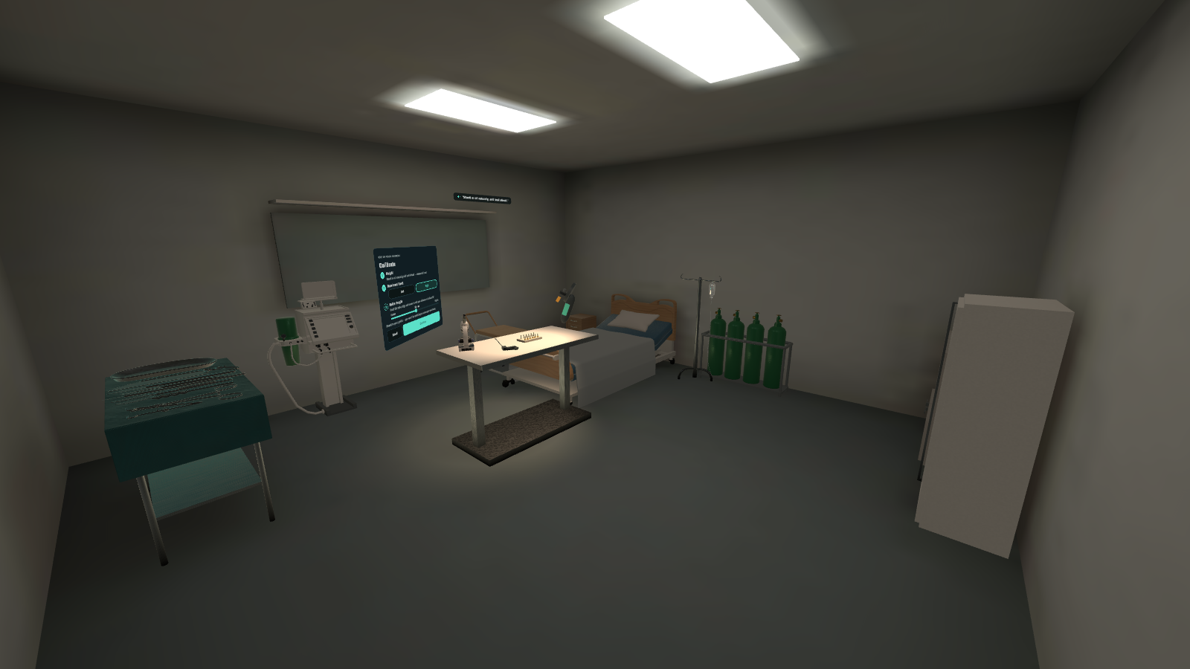  The skills lab: adjustable training table and a ward bay.
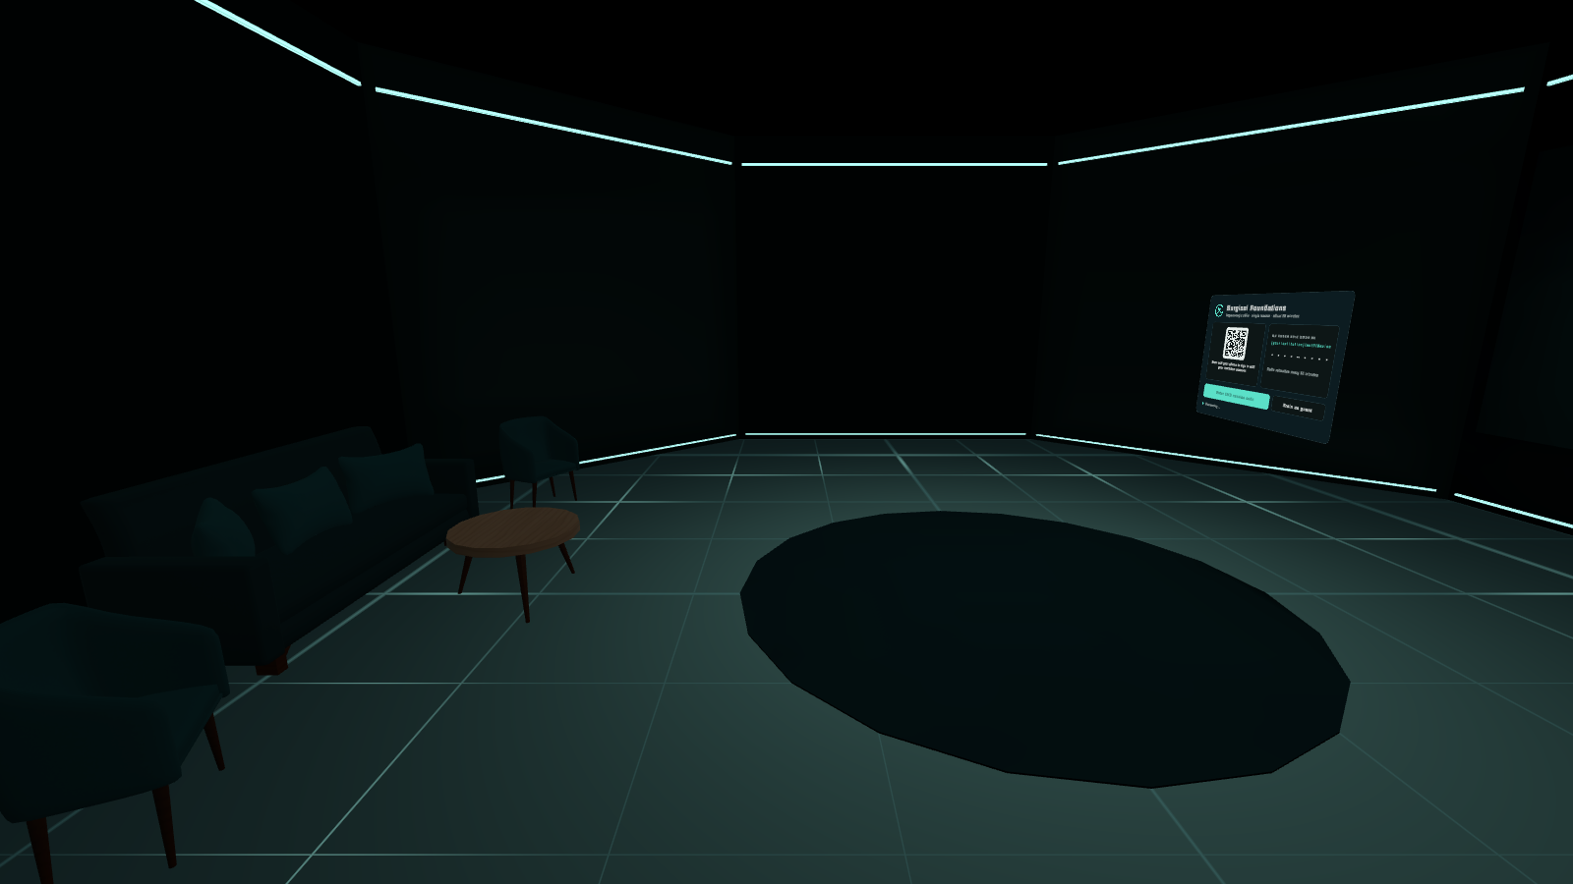  The calm lobby where every session starts. | Port placement with live guidance on angle, depth and force.
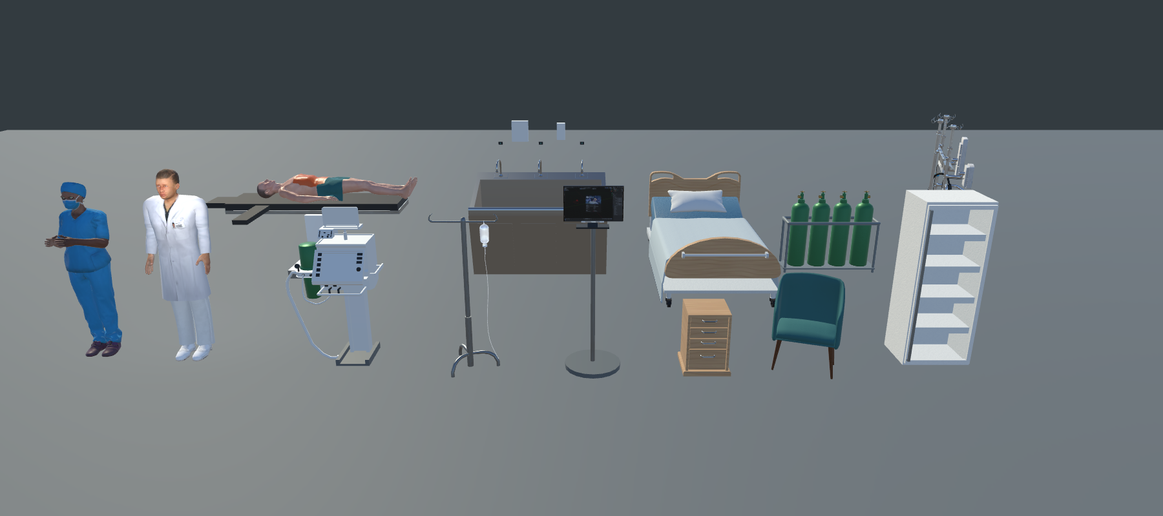
The people and equipment of the simulation: scrub nurse, anaesthetist, patient, scrub sink, hospital bed, IV stand, anaesthesia cart, monitors and furniture.

The learner journey
Stage | What the learner does
Sign in & lobby | Signs in by QR code, learning-platform code or as guest. Chooses Guided (hints and live feedback) or Assessment (no help, just a result).
Skills lab | Sets own height and table height, practises controls on a peg board.
1 · Prep | Scrubs with a hand-movement demo, gowns and gloves, checks the sterile back table, counts instruments, drapes the patient.
2 · Access | Marks port sites and inserts each trocar, watched for entry angle, depth and force.
3 · Operate | Works through a real laparoscope view on the monitor: moves objects, dissects, clips and divides a duct.
4 · Close | Counts every instrument and swab (one is hidden on purpose) and removes ports safely, camera port last.
Results | Overall score, score per stage, and the three things to work on next.

Feedback that teaches
- On protocol: done correctly.
- Delayed: right action, too late.
- Deviation: something that would put a patient at risk. The view edges flash, a sound plays, and the learner is told what went wrong and why.
Guided mode coaches in the moment. Assessment mode stays silent until the results, so the score reflects what the learner can do alone. Both use the same rules, so the score means the same thing.

4. Why it is different
- A complete procedure, not a single drill. From scrub sink to closing, in real-life order, so habits connect into a routine.
- Real instrument mechanics. Pivot-about-the-port behaviour reproduces the reversed, levered movement that is the core difficulty of keyhole surgery.
- Patient safety as a first-class skill. Sterility, counting and safe port placement are scored as seriously as surgical technique. The patient cannot be closed until every swab is counted.
- Complications are part of the scenario. Too-deep trocar entry branches into a port-site bleed; time to control it is recorded.
- Objective, consistent scoring. Each run is measured from what the learner actually did (time, instrument path length, errors) and recorded for replay from any angle.
- Built for institutions. Standalone headset, offline-tolerant, results uploaded when Wi-Fi returns and designed to flow to existing learning platforms via xAPI and SCORM.
- Comfort and accessibility. Standing or seated, height-adjustable, subtitles on every prompt, and no camera movement that causes motion sickness.

5. Who we serve
Customer | Value
Medical students | A first, low-stress encounter with the theatre: scrubbing, sterility, and what a laparoscopic operation looks like from the surgeon’s position.
Junior surgical trainees | Repeatable practice of port placement, instrument handling through the scope, and the counting and closing routine.
Educators | One standard scenario with identical criteria; fair comparison and visible group-level gaps.
Training programmes | Standalone headset practice that reports into the learning platform they already use.

6. Where we are today
A playable prototype of the whole experience, built in Unity for Meta Quest 3.
- Built: full sign-in to results flow in a lit, furnished theatre; all sixteen interface screens; voice prompts and sound; recognition of scrub steps, sterility breaches, port placement quality and instrument drift; instrument pivot mechanics; playable peg-board, dissect and clip-and-divide tasks; counts and the bleed complication; a camera assistant; Guided and Assessment modes.
- Connected: a working server with QR/code/guest sign-in, offline result storage with later upload, and a path to xAPI and SCORM.
- Next: a web dashboard for institutions and learners (server side already built); soft tissue that deforms under instruments; later, tearing tissue, spoken camera commands and haptics.

What we are being honest about
- Scoring limits are placeholders until a surgical educator signs them off.
- Behaviour has been tested in the editor, not yet on a headset.
- Third-party 3D model licences must be confirmed before any public release.
- This is an educational tool, not a medical device, and is not for clinical use.

7. Proposed path to proof
These milestones turn a convincing prototype into evidence. Timelines and funding amounts are to be set with you.
# | Milestone | Why it matters
1 | Educator sign-off of scoring criteria | Makes the score clinically credible.
2 | On-headset validation on Quest 3 | Confirms comfort and performance on the real target device.
3 | Pilot with one medical school or training programme | Real learners, real feedback, first usage data.
4 | Measured outcomes (e.g. trainee confidence, error rates, time to proficiency vs. a control group) | The evidence buyers need to commit budget.
5 | Institution dashboard and learning-platform integration live | Turns a demo into something a programme can deploy.

To complete before the meeting
Add the figures only you can source: target market size, pricing and licence model, the cost of current simulator training at a named institution, and any pilot letters of intent. We have deliberately not invented numbers here.
The ask: back the team that is making safer surgeons possible, one rehearsal at a time.
Surgical Foundations VR is an educational tool. It is not a medical device and is not intended for clinical use or clinical decision-making.

