

Vidyavardhini’s College of Engineering & Technology

Department of Computer Engineering

Experiment No.1
Design and Development of a Multi-Section Webpage Using
HTML5 and CSS3
Date of Performance: 08/01/2026
Date of Submission: 08/01/2026

MDC401: Introduction to Web Technologies



Vidyavardhini’s College of Engineering & Technology

Department of Computer Engineering

Aim: To design and develop a structured multi-section webpage using HTML5 and CSS3.

Objective: To create a webpage with multiple sections using semantic HTML5 elements and apply CSS3 styling techniques for layout, design, and improved visual presentation.
Theory:
HTML5 and CSS3 are essential technologies used to design structured and visually appealing web pages. HTML5 provides semantic elements such as <header>, <section>, <nav>, and
<footer> that help in organizing content clearly and improving readability and accessibility. These elements also make the webpage more meaningful for browsers and search engines, enhancing overall usability.
CSS3 is used to style and layout the webpage by applying properties like colors, fonts, spacing, borders, and backgrounds. It also includes advanced features such as flexbox, grid, and media queries, which help in creating responsive designs that adapt to different screen sizes. By combining HTML5 and CSS3, developers can build multi-section web pages that are well-structured, visually attractive, and user-friendly
Implementation: HTML CODE
<!DOCTYPE html>
<html lang="en">
<head>
<meta charset="UTF-8">
<title>Multi-Section Webpage</title>
<link rel="stylesheet" href="style.css">
</head>
<body>

<header>
<h1>My Website</h1>
<nav>
<a href="#home">Home</a>
<a href="#about">About</a>
<a href="#services">Services</a>
<a href="#contact">Contact</a>
</nav>
</header>

<section id="home">
<h2>Home</h2>
<p>Welcome to our website.</p>
</section>

<section id="about">
<h2>About</h2>
<p>This section describes the website.</p>
</section>

<section id="services">
<h2>Services</h2>
<p>We provide web development services.</p>
</section>

<section id="contact">
<h2>Contact</h2>
<p>Email: example@email.com</p>
</section>

<footer>
<p>&copy; 2026 My Website</p>
</footer>

</body>
</html>

CSS:
body {
margin: 0;
font-family: Arial, sans-serif;
}

header {
background: #333;
color: white;
padding: 15px;
text-align: center;
}

nav a {
color: white;
margin: 10px;
text-decoration: none;
}

nav a:hover {
text-decoration: underline;
}

section {
padding: 40px;
border-bottom: 1px solid #ccc;
}

#home {
background: #f4f4f4;
}

#about {
background: #e2e2e2;
}

#services {
background: #d1d1d1;
}

#contact {
background: #c0c0c0;
}

footer {
background: #333;
color: white;
text-align: center;
padding: 10px;
}

Output:
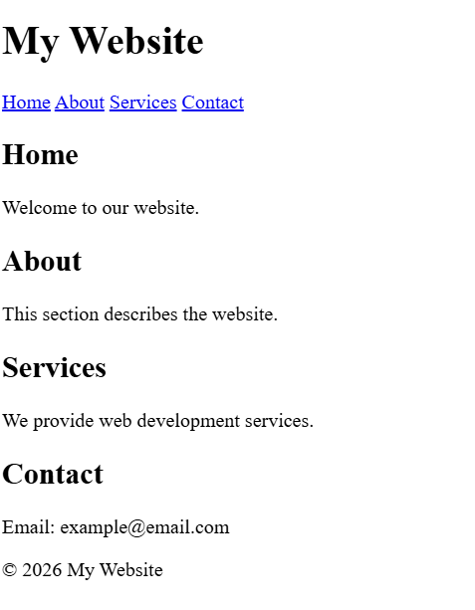

Conclusion:-
Creating a multi-section webpage involves organizing content using semantic HTML5 elements and styling it with CSS3. HTML5 elements like <header>, <nav>, <section>, and <footer> help structure the webpage clearly, making it more readable and accessible.
CSS3 is used to improve the design by applying colors, fonts, spacing, and layouts. Techniques like Flexbox, Grid, and media queries help create responsive and visually appealing pages that work on different devices.
In short, HTML5 provides structure, while CSS3 enhances appearance, resulting in a well-designed, user-friendly webpage.

MDC401: Introduction to Web Technologies

