

Vidyavardhini’s College of Engineering & Technology

Department of Computer Engineering

Experiment No.2
Deployment and Hosting of a Static Website Using GitHub Pages
Date of Performance: 21/01/2026
Date of Submission: 21/01/2026

MDC401: Introduction to Web Technologies



Vidyavardhini’s College of Engineering & Technology

Department of Computer Engineering

Aim: To deploy and host a static website using GitHub Pages.
Objective: To upload website files to a GitHub repository, configure GitHub Pages, and make the website accessible online through a public URL.
Theory:
GitHub Pages is a web hosting service that allows users to deploy and host static websites directly from a GitHub repository. It provides an easy and efficient way to make web projects accessible online without the need for complex server setup. By uploading website files such as HTML, CSS, and JavaScript to a repository, users can manage their code using version control while preparing it for deployment.
The process involves configuring GitHub Pages settings to select a specific branch or folder from which the website will be served. Once configured, GitHub automatically generates a public URL where the website can be accessed. This approach not only simplifies deployment but also supports continuous updates, allowing developers to make changes and instantly reflect them online.

Implementation:
<!DOCTYPE html>
<html lang="en">
<head>
<meta charset="UTF-8">
<meta name="viewport" content="width=device-width, initial-scale=1.0">
<title>VCET - Vidyavardhini College of Engineering and Technology</title>

</head>
<body style="font-family: Arial, sans-serif; background-image: url('VCET.jpg'); background-size: cover; background-position: center; color: #333; margin: 0; padding: 0; height: fit-content; width: 250;">
<header style="background-color: rgba(0, 123, 255, 0.8); color: white; text-align: center; padding: 20px;">
<h1>Vidyavardhini College of Engineering and Technology (VCET)</h1>
<p>Excellence in Education</p>
</header>
<nav style="background-color: rgba(0, 0, 0, 0.7); text-align: center; padding: 10px;">
<a href="#about" style="color: white; margin: 0 15px; text-decoration: none;">About</a>
<a href="#courses" style="color: white; margin: 0 15px; text-decoration: none;">Courses</a>
<a href="#admissions" style="color: white; margin: 0 15px; text-decoration: none;">Admissions</a>
<a href="#contact" style="color: white; margin: 0 15px; text-decoration: none;">Contact</a>
</nav>
<section id="about" style="padding: 50px; text-align: center;">
<h2>About VCET</h2>
<p>VCET is a premier institution dedicated to providing quality education in engineering and technology.</p>
</section>
<section id="courses" style="padding: 50px; text-align: center;">
<h2>Our Courses</h2>
<p>We offer a variety of undergraduate and postgraduate programs in engineering disciplines.</p>
</section>
<section id="admissions" style="padding: 50px; text-align: center;">
<h2>Admissions</h2>
<p>Apply now for the upcoming academic year. Check eligibility and deadlines.</p>
</section>
<section id="contact" style="padding: 50px; text-align: center;">
<h2>Contact Us</h2>
<p>Email: info@vcet.edu | Phone: +91-123-456-7890</p>
</section>
<footer style="background-color: rgba(0, 123, 255, 0.8); color: white; text-align: center; padding: 10px; position: fixed; width: 100%; bottom: 0;">
<p>&copy; 2023 VCET. All rights reserved.</p>
</footer>
</body>
</html>

Outpu:
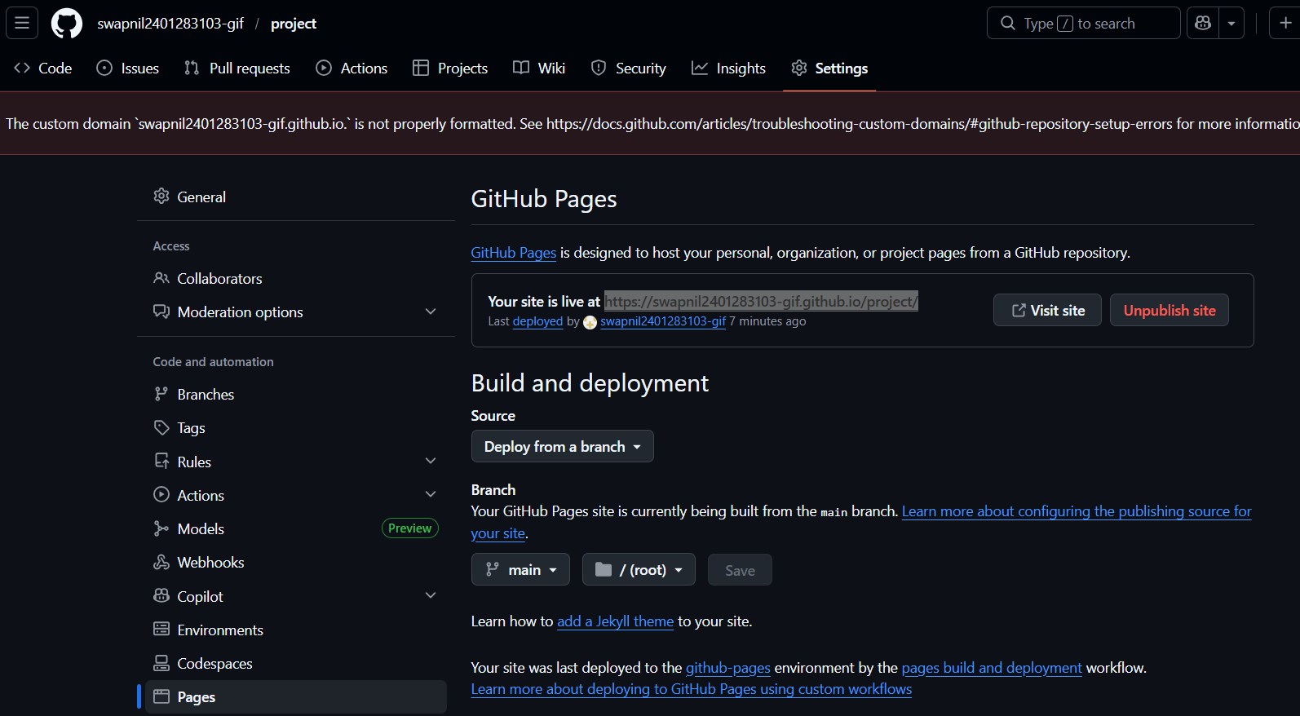
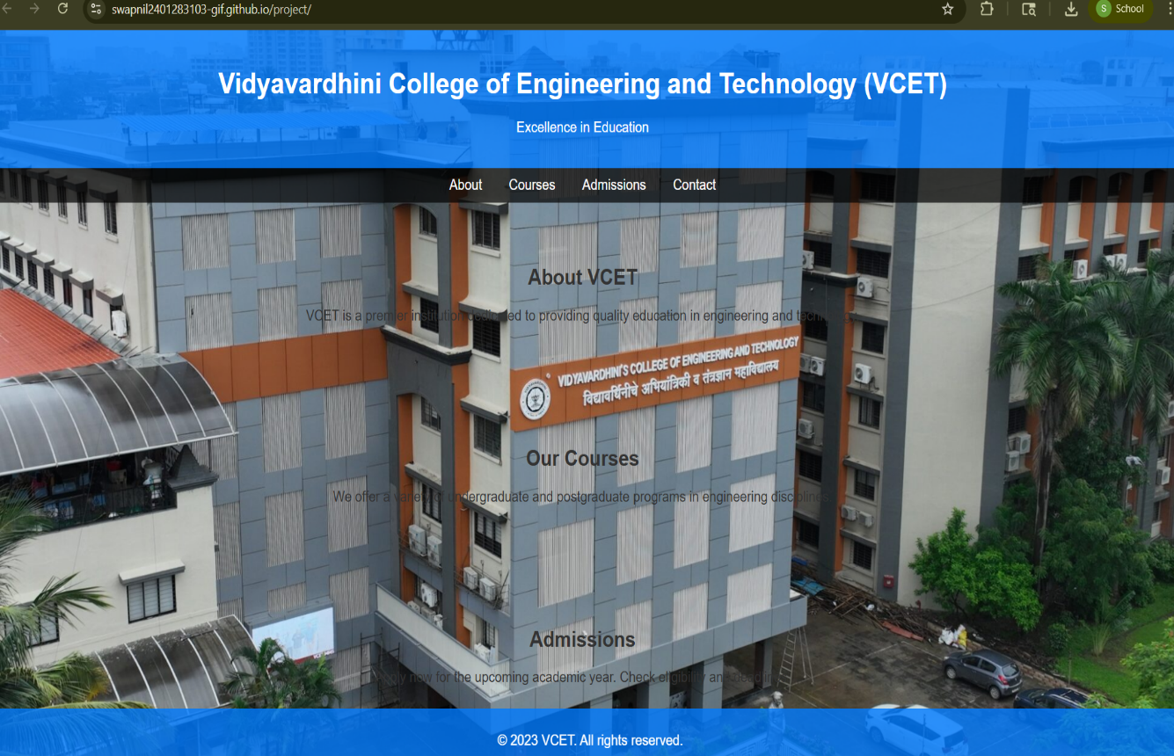

Conclusion:
In this experiment, website files were successfully uploaded to a repository on GitHub. GitHub Pages was then configured by selecting the appropriate branch for deployment. As a result, the website was hosted online and made accessible through a public URL.
This method provides a simple and efficient way to deploy static websites, and any updates made to the repository are automatically reflected on the live site.

MDC401: Introduction to Web Technologies

