

Vidyavardhini’s College of Engineering & Technology

Department of Computer Engineering

Experiment No.3
Design of a Responsive Landing Page Using CSS3 and
Bootstrap Framework
Date of Performance: 28/01/2026
Date of Submission: 28/01/2026

MDC401: Introduction to Web Technologies



Vidyavardhini’s College of Engineering & Technology

Department of Computer Engineering

Aim: To design and develop a responsive landing page using CSS3 and the Bootstrap framework.
Objective: To create a visually appealing and mobile-friendly landing page using CSS3 styling techniques and Bootstrap components such as grid system, navigation bar, and responsive layouts.
Theory:
A landing page is a crucial part of web design that focuses on presenting information in a clear, attractive, and engaging manner. CSS3 plays a key role in enhancing the visual appeal of the landing page by allowing developers to apply styles such as colors, fonts, spacing, backgrounds, and animations. These styling techniques help in creating a clean and modern interface that captures user attention and improves readability.
Bootstrap is a popular front-end framework that simplifies the process of creating responsive and mobile-friendly web pages. It provides a grid system for structured layout design, prebuilt components like navigation bars, buttons, and cards, and responsive utilities that ensure the page adapts to different screen sizes. By combining CSS3 with Bootstrap, developers can efficiently design landing pages that are both visually appealing and functionally responsive.
Implementation:
<!DOCTYPE html>
<html lang="en">
<head>
<meta charset="UTF-8">
<meta name="viewport" content="width=device-width, initial-scale=1.0">
<title>Responsive Landing Page</title>

<!-- Bootstrap CSS -->
<link href="https://cdn.jsdelivr.net/npm/bootstrap@5.3.0/dist/css/bootstrap.min.css" rel="stylesheet">

<style>
/* Hero Section */
.hero {
height: 100vh;
background: linear-gradient(to right, #007bff, #00c6ff);
display: flex;
align-items: center;
color: white;
}

.hero h1 {
font-size: 3rem;
font-weight: bold;
}

.hero p {
font-size: 1.2rem;
}

.btn-custom {
padding: 10px 20px;
font-size: 18px;
}

/* Features Section */
.feature-box {
padding: 20px;
transition: transform 0.3s;
}

.feature-box:hover {
transform: scale(1.05);
}

/* Footer */
footer {
background-color: #222;
color: white;
}

/* Responsive */
@media (max-width: 768px) {
.hero h1 {
font-size: 2rem;
}
}
</style>
</head>

<body>

<!-- Navbar -->
<nav class="navbar navbar-expand-lg navbar-dark bg-dark">
<div class="container">
<a class="navbar-brand" href="#">MyWebsite</a>
<button class="navbar-toggler" data-bs-toggle="collapse" data-bs-target="#navMenu">
<span class="navbar-toggler-icon"></span>
</button>

<div class="collapse navbar-collapse" id="navMenu">
<ul class="navbar-nav ms-auto">
<li class="nav-item"><a class="nav-link" href="#">Home</a></li>
<li class="nav-item"><a class="nav-link" href="#">Features</a></li>
<li class="nav-item"><a class="nav-link" href="#">Contact</a></li>
</ul>
</div>
</div>
</nav>

<!-- Hero Section -->
<section class="hero text-center">
<div class="container">
<h1>Welcome to My Website</h1>
<p>Your solution for modern web design</p>
<a href="#" class="btn btn-primary btn-custom">Get Started</a>
</div>
</section>

<!-- Features Section -->
<section class="py-5">
<div class="container">
<div class="row text-center">

<div class="col-md-4 feature-box">
<h3>Fast</h3>
<p>Optimized performance for better experience.</p>
</div>

<div class="col-md-4 feature-box">
<h3>Responsive</h3>
<p>Works on all devices and screen sizes.</p>
</div>

<div class="col-md-4 feature-box">
<h3>Easy</h3>
<p>Simple and clean design structure.</p>
</div>

</div>
</div>
</section>

<!-- Contact Section -->
<section class="bg-light py-5">
<div class="container text-center">
<h2>Contact Us</h2>
<p>Email: example@email.com</p>
</div>
</section>

<!-- Footer -->
<footer class="text-center py-3">
<p>© 2026 MyWebsite | All Rights Reserved</p>
</footer>

<!-- Bootstrap JS -->
<script src="https://cdn.jsdelivr.net/npm/bootstrap@5.3.0/dist/js/bootstrap.bundle.min.js"></script>

</body>
</html>
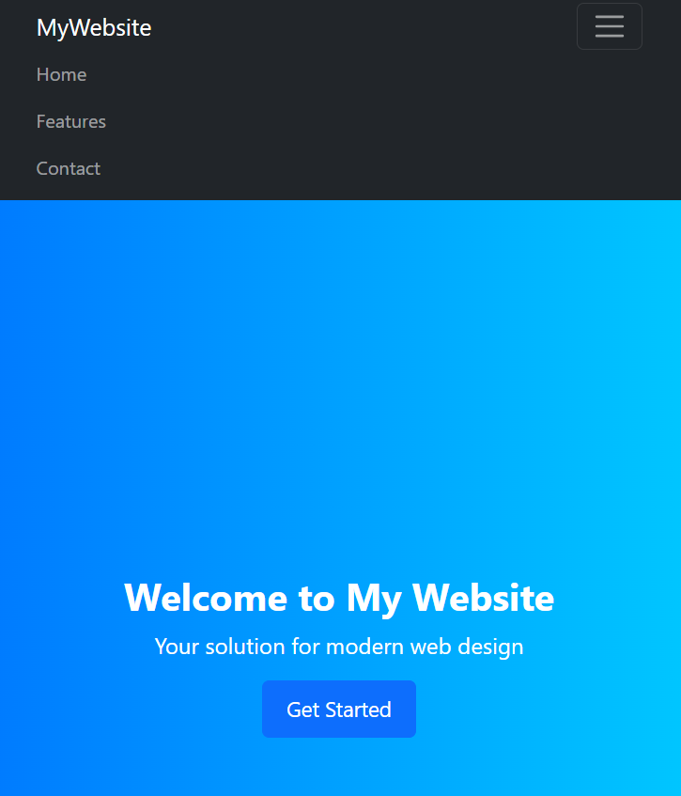
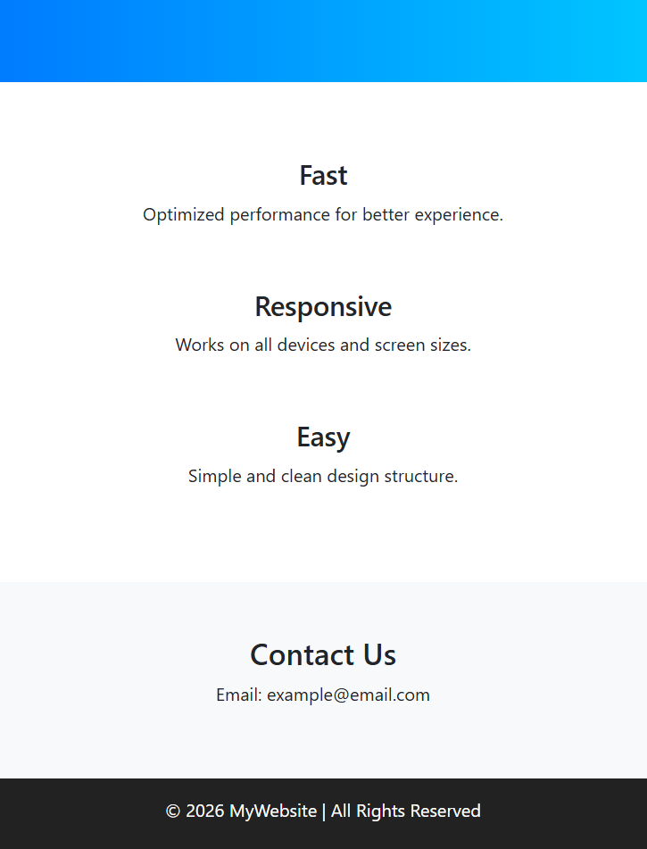

Conclusion:
A visually appealing and mobile-friendly landing page can be created using CSS3 and Bootstrap. CSS3 is used to enhance the design with colors, fonts, spacing, and animations, making the page attractive and engaging. Bootstrap provides a responsive grid system to organize content into rows and columns, ensuring proper layout on all screen sizes.
The navigation bar helps users easily move between sections and becomes collapsible on smaller devices for better usability. Responsive layouts are achieved using Bootstrap classes and CSS media queries, allowing the page to automatically adjust for mobiles, tablets, and desktops.
Thus, by combining CSS3 styling with Bootstrap components, a clean, responsive, and user-friendly landing page can be developed.

MDC401: Introduction to Web Technologies

