

Vidyavardhini’s College of Engineering & Technology

Department of Computer Engineering

Experiment No.4
Develop a Responsive Photo Gallery Using CSS Grid, Hover Effects, and JavaScript
Date of Performance: 04/02/2026
Date of Submission: 04/20/2026

MDC401: Introduction to Web Technologies



Vidyavardhini’s College of Engineering & Technology

Department of Computer Engineering

Aim:- To develop a responsive photo gallery using CSS Grid, hover effects, and JavaScript.
Objective: To design a responsive gallery layout using CSS Grid, implement hover effects for enhanced user interaction, and use JavaScript to add dynamic features such as image preview, filtering, or navigation.
Theory:
A responsive photo gallery is an important component of modern web design that allows images to be displayed in an organized and visually appealing manner across different devices. CSS Grid is a powerful layout system that enables developers to create flexible and structured gallery layouts with rows and columns. It automatically adjusts the placement and size of images based on screen size, ensuring responsiveness and consistency.
Hover effects using CSS enhance user interaction by providing visual feedback when users interact with images, such as zooming, fading, or highlighting. JavaScript is used to add dynamic functionalities like image preview in a modal, filtering images based on categories, and navigation through images. By combining CSS Grid, hover effects, and JavaScript, developers can create interactive and responsive photo galleries that improve user experience.
Implementation:
<!DOCTYPE html>
<html lang="en">
<head>
<meta charset="UTF-8">
<title>jawhar turist places</title>
<meta name="viewport" content="width=device-width, initial-scale=1.0">

<!-- Bootstrap CSS -->
<link href="https://cdn.jsdelivr.net/npm/bootstrap@5.3.2/dist/css/bootstrap.min.css" rel="stylesheet">
<link href="https://cdn.jsdelivr.net/npm/bootstrap-icons@1.11.1/font/bootstrap-icons.css" rel="stylesheet">

<!-- Custom CSS -->
<link rel="stylesheet" href="style.css">
</head>
<body>

<!-- Navbar -->
<nav class="navbar navbar-expand-lg navbar-dark bg-transparent fixed-top">
<div class="container">
<a class="navbar-brand fw-bold" href="#">EXPLORE_JAWHAR</a>

<button class="navbar-toggler" data-bs-toggle="collapse" data-bs-target="#navMenu">
<span class="navbar-toggler-icon"></span>
</button>

<div class="collapse navbar-collapse" id="navMenu">
<ul class="navbar-nav ms-auto align-items-lg-center">
<li class="nav-item"><a class="nav-link" href="#">Home</a></li>
<li class="nav-item"><a class="nav-link" href="#">Gallery</a></li>
<li class="nav-item"><a class="nav-link" href="#">Contact</a></li>
<li class="nav-item ms-lg-3">
<button id="modeToggle" class="btn btn-outline-light btn-sm">
<i class="bi bi-moon"></i>
</button>
</li>
</ul>
</div>
</div>
</nav>

<div style="height:90px;">jawhar turist places</div>

<!-- Filter Buttons -->
<section class="container text-center mb-4">
<h2 class="fw-bold mb-4 fade-in">JAWHAR_TOURIST_PLACES</h2>
<div class="btn-group">
<button class="btn btn-primary filter-btn" data-filter="all">All</button>
<button class="btn btn-outline-primary filter-btn" data-filter="forts">Forts</button>
</div>
</section>

<!-- Gallery -->
<section class="container">
<div class="row g-4 gallery">
<div class="col-md-6 col-sm-6 fade-in" data-category="forts">
<img src="./7.jpg" alt="Ranthambore Fort, Rajasthan" class="img-fluid rounded">
</div>

<div class="col-md-6 col-sm-6 fade-in" data-category="forts">
<img src="./8.jpg" alt="Nahargarh Fort, Rajasthan" class="img-fluid rounded">
</div>

<div class="col-md-6 col-sm-6 fade-in" data-category="forts">
<img src="./9.jpg" alt="Jaigarh Fort, Rajasthan" class="img-fluid rounded">
</div>

<div class="col-md-6 col-sm-6 fade-in" data-category="forts">
<img src="./10.jpg" alt="Lohagarh Fort, Uttar Pradesh" class="img-fluid rounded">
</div>

<div class="col-md-6 col-sm-6 fade-in" data-category="forts">
<img src="./11.jpg" alt="Bhangarh Fort, Rajasthan" class="img-fluid rounded">
</div>

<div class="col-md-6 col-sm-6 fade-in" data-category="forts">
<img src="./12.jpg" alt="Taragarh Fort, Madhya Pradesh" class="img-fluid rounded">
</div>

<div class="col-md-6 col-sm-6 fade-in" data-category="forts">
<img src="./13.jpg" alt="Sisodia Rani Palace, Rajasthan" class="img-fluid rounded">
</div>

<div class="col-md-6 col-sm-6 fade-in" data-category="forts">
<img src="./14.jpg" alt="Vijay Stambh, Gujarat" class="img-fluid rounded">
</div>

<div class="col-md-6 col-sm-6 fade-in" data-category="forts">
<img src="./15.jpg" alt="Sonar Qila, Uttar Pradesh" class="img-fluid rounded">
</div>

<div class="col-md-6 col-sm-6 fade-in" data-category="forts">
<img src="./images.jpg" alt="Jodhpur Fort, Rajasthan" class="img-fluid rounded">
</div>
</div>
</section>

<!-- Footer -->
<footer class="text-center mt-5">
<div class="container">
<h5>Explore Indian Forts</h5>
<div class="mb-3 social-icons">
<a href="#"><i class="bi bi-facebook"></i></a>
<a href="#"><i class="bi bi-instagram"></i></a>
<a href="#"><i class="bi bi-twitter"></i></a>
<a href="#"><i class="bi bi-youtube"></i></a>
</div>
<p>&copy; 2026 FortGallery | All Rights Reserved</p>
</div>
</footer>

<!-- Modal -->
<div class="modal fade" id="fortModal" tabindex="-1" aria-labelledby="fortModalLabel" aria-hidden="true">
<div class="modal-dialog modal-lg">
<div class="modal-content">
<div class="modal-header">
<h5 class="modal-title" id="fortModalLabel">Fort Information</h5>
<button type="button" class="btn-close" data-bs-dismiss="modal" aria-label="Close"></button>
</div>
<div class="modal-body">
<img id="modalImage" src="" alt="" class="img-fluid mb-3">
<h4 id="modalTitle"></h4>
<p id="modalDescription"></p>
</div>
</div>
</div>
</div>

<!-- Bootstrap JS -->
<script src="https://cdn.jsdelivr.net/npm/bootstrap@5.3.2/dist/js/bootstrap.bundle.min.js"></script>

<!-- Custom JS -->
<script src="script.js"></script>

</body>
</html>
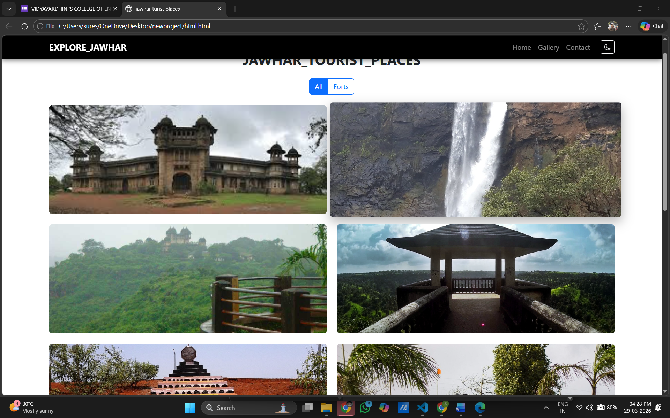

Conclusion:
Designing a responsive gallery using CSS Grid ensures a flexible and well-structured layout that adapts to different screen sizes. Hover effects enhance user interaction by making the gallery more engaging and visually appealing. With the help of JavaScript, dynamic features like image preview, filtering, and navigation improve functionality and user experience. Overall, this approach results in a modern, interactive, and mobile-friendly photo gallery

MDC401: Introduction to Web Technologies

