

Vidyavardhini’s College of Engineering & Technology

Department of Computer Engineering

Experiment No.5
Design and Development of a Web-Based Quiz System Using JavaScript
Date of Performance: 11/02/2026
Date of Submission: 11/20/2026

MDC401: Introduction to Web Technologies



Vidyavardhini’s College of Engineering & Technology

Department of Computer Engineering

Aim:- To design and develop a web-based quiz system using JavaScript.
Objective: To create an interactive quiz application using JavaScript that includes question display, user input handling, score calculation, and dynamic result generation.
Theory:
A web-based quiz application is an interactive platform that allows users to answer questions and receive instant feedback. JavaScript plays a key role in building such applications by dynamically displaying questions, capturing user input, and controlling the flow of the quiz. It enables real-time interaction without requiring page reloads, making the experience smooth and engaging.
The application includes features such as presenting questions one by one, validating user answers, calculating scores, and generating results dynamically. JavaScript functions and event handling are used to manage user responses and update the interface accordingly. This helps in creating an efficient and user-friendly quiz system that provides immediate results and enhances learning or assessment experiences.
Implementation:
<!DOCTYPE html>
<html lang="en">
<head>
<meta charset="UTF-8">
<meta name="viewport" content="width=device-width, initial-scale=1.0">
<title>Quiz System</title>

<style>
body {
font-family: Arial;
background: linear-gradient(to right, #4facfe, #00f2fe);
text-align: center;
margin: 0;
}

.quiz-container {
background: white;
width: 90%;
max-width: 500px;
margin: 50px auto;
padding: 20px;
border-radius: 10px;
}

h2 {
margin-bottom: 20px;
}

.option {
display: block;
margin: 10px 0;
padding: 10px;
background: #eee;
border-radius: 5px;
cursor: pointer;
}

.option:hover {
background: #ddd;
}

button {
margin-top: 15px;
padding: 10px 20px;
border: none;
background: #007bff;
color: white;
cursor: pointer;
border-radius: 5px;
}

button:hover {
background: #0056b3;
}

#result {
font-size: 20px;
font-weight: bold;
}
</style>
</head>

<body>

<div class="quiz-container">
<h2 id="question">Question here</h2>
<div id="options"></div>
<button onclick="nextQuestion()">Next</button>
<p id="result"></p>
</div>

<script>
const quiz = [
{
question: "What is HTML?",
options: ["Programming Language", "Markup Language", "Database", "Operating System"],
answer: "Markup Language"
},
{
question: "What is CSS used for?",
options: ["Structure", "Styling", "Logic", "Database"],
answer: "Styling"
},
{
question: "Which is a JavaScript framework?",
options: ["React", "HTML", "CSS", "MySQL"],
answer: "React"
}
];

let index = 0;
let score = 0;

function loadQuestion() {
const q = quiz[index];
document.getElementById("question").innerText = q.question;

const optionsDiv = document.getElementById("options");
optionsDiv.innerHTML = "";

q.options.forEach(option => {
const btn = document.createElement("div");
btn.innerText = option;
btn.classList.add("option");
btn.onclick = () => checkAnswer(option);
optionsDiv.appendChild(btn);
});
}

function checkAnswer(selected) {
if (selected === quiz[index].answer) {
score++;
}
}

function nextQuestion() {
index++;
if (index < quiz.length) {
loadQuestion();
} else {
document.querySelector(".quiz-container").innerHTML =
"<h2>Quiz Completed</h2><p>Your Score: " + score + "/" + quiz.length + "</p>";
}
}

loadQuestion();
</script>

</body>
</html>
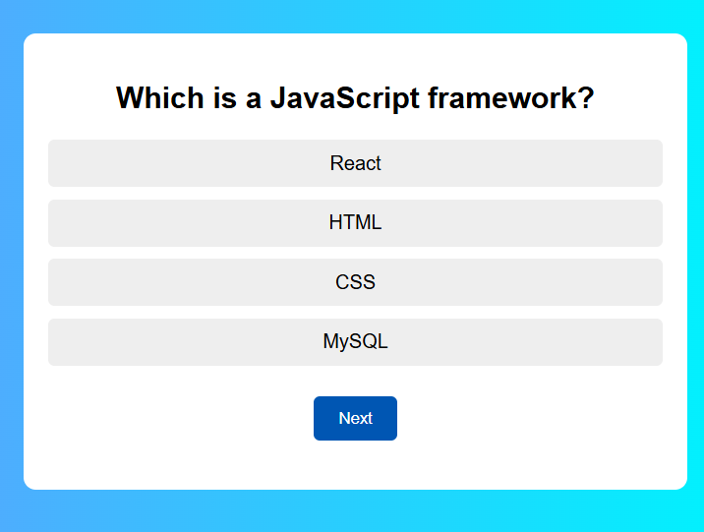
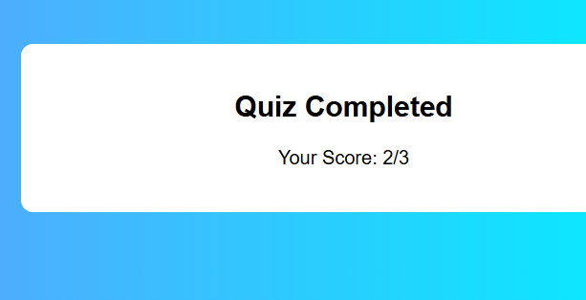

Conclusion:
An interactive quiz application using JavaScript displays questions and options dynamically on the webpage. It handles user input by recording selected answers and compares them with correct ones to calculate the score. JavaScript also manages navigation between questions and generates the final result dynamically, making the quiz responsive and user-friendly.

MDC401: Introduction to Web Technologies

