

Vidyavardhini’s College of Engineering & Technology

Department of Computer Engineering

Experiment No.6
Development of a Dynamic Weather Dashboard with Real-
Time Search Using JavaScript DOM Manipulation and AJAX
Date of Performance: 18/02/2026
Date of Submission: 18/02/2026

MDC401: Introduction to Web Technologies



Vidyavardhini’s College of Engineering & Technology

Department of Computer Engineering

Aim: To develop a dynamic weather dashboard with real-time search using JavaScript, DOM manipulation, and AJAX.

Objective: To create an interactive weather application that fetches real-time data using AJAX, updates the webpage dynamically using DOM manipulation, and allows users to search for weather information of different cities.

Theory:
A weather application is a dynamic web application that provides real-time weather information for different locations. AJAX (Asynchronous JavaScript and XML) is used to fetch data from external weather APIs without reloading the webpage, making the application faster and more efficient. This allows users to get updated weather details such as temperature, humidity, and conditions instantly.
JavaScript DOM manipulation is used to dynamically update the content of the webpage based on the fetched data. Users can search for different cities, and the application processes the request, retrieves relevant data, and displays it in a structured format. This combination of AJAX and DOM manipulation helps in creating an interactive, user-friendly, and responsive weather dashboard.

Implementation:
<!DOCTYPE html>
<html lang="en">
<head>
<meta charset="UTF-8">
<meta name="viewport" content="width=device-width, initial-scale=1.0">
<title>Weather Demo</title>

<style>
body {
font-family: Arial;
background: linear-gradient(to right, #2193b0, #6dd5ed);
text-align: center;
}

.container {
background: white;
padding: 20px;
margin: 40px auto;
width: 90%;
max-width: 400px;
border-radius: 10px;
}

input {
padding: 10px;
width: 65%;
}

button {
padding: 10px;
margin: 5px;
background: #007bff;
color: white;
border: none;
cursor: pointer;
}

.weather img {
width: 80px;
}

.forecast {
display: flex;
justify-content: space-between;
margin-top: 20px;
}

.forecast div {
background: #f1f1f1;
padding: 10px;
border-radius: 5px;
width: 18%;
}
</style>
</head>

<body>

<div class="container">
<h2>Weather Dashboard (Demo)</h2>

<input type="text" id="city" placeholder="Enter city">
<button onclick="getWeather()">Search</button>

<div class="weather" id="weatherResult"></div>
<div class="forecast" id="forecast"></div>
</div>

<script>
// Mock Weather Data
const weatherData = {
Mumbai: {
temp: 30,
condition: "Clouds",
icon: "https://openweathermap.org/img/wn/03d@2x.png"
},
Delhi: {
temp: 35,
condition: "Sunny",
icon: "https://openweathermap.org/img/wn/01d@2x.png"
},
Pune: {
temp: 28,
condition: "Rain",
icon: "https://openweathermap.org/img/wn/10d@2x.png"
}
};

function getWeather() {
const city = document.getElementById("city").value;

if (!weatherData[city]) {
document.getElementById("weatherResult").innerHTML = "❌ City not found (Demo)";
document.getElementById("forecast").innerHTML = "";
return;
}

const data = weatherData[city];

document.getElementById("weatherResult").innerHTML = `
<h3>${city}</h3>
<img src="${data.icon}">
<p>${data.condition}</p>
<p>${data.temp} °C</p>
`;

// Fake 5-day forecast
let forecastHTML = "";
for (let i = 1; i <= 5; i++) {
forecastHTML += `
<div>
<p>Day ${i}</p>
<img src="${data.icon}">
<p>${data.temp + i} °C</p>
</div>
`;
}

document.getElementById("forecast").innerHTML = forecastHTML;
}

// Auto load Mumbai
window.onload = () => getWeatherByDefault();

function getWeatherByDefault() {
document.getElementById("city").value = "Mumbai";
getWeather();
}
</script>

</body>
</html>

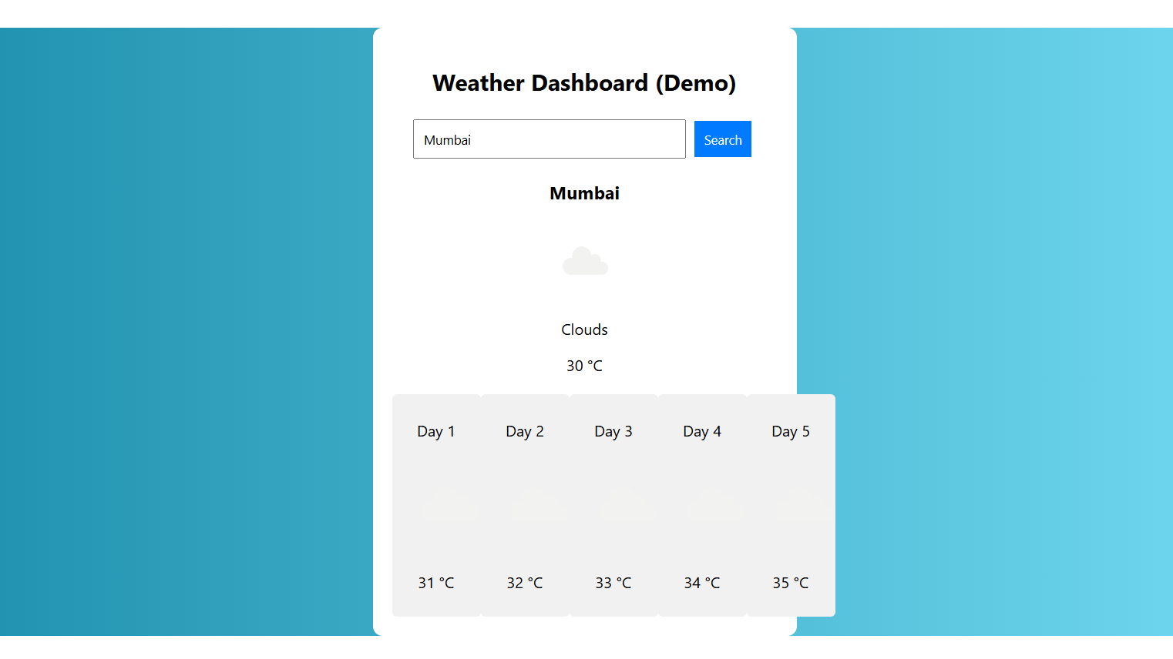

Conclusion:
Creating an interactive weather application using JavaScript demonstrates how real-time data can be fetched using AJAX and displayed dynamically on a webpage through DOM manipulation. The application allows users to search for different cities and instantly view updated weather information, making it user-friendly and responsive. Overall, it highlights the effective use of modern web technologies to build dynamic and interactive web applications.

MDC401: Introduction to Web Technologies

