

Vidyavardhini’s College of Engineering & Technology

Department of Computer Engineering

Experiment No.7
Implementation of User Registration and Session-Based Login Using PHP and MySQL
Date of Performance: 25/02/2026
Date of Submission: 25/02/2026

MDC401: Introduction to Web Technologies



Vidyavardhini’s College of Engineering & Technology

Department of Computer Engineering

Aim: To implement user registration and session-based login using PHP and MySQL.
Objective: To design a user registration system, store user data securely in a MySQL database, and implement session-based authentication to manage user login and access control.
Theory:
A user registration system is an essential part of web applications that allows users to create accounts and securely store their information. Using PHP, developers can design forms to collect user details such as name, email, and password, and process this data on the server side. MySQL is used as the database to store and manage user information efficiently, ensuring data is organized and easily retrievable.
To ensure security, user input is validated and sensitive information like passwords is stored in an encrypted format. Session-based authentication is implemented using PHP sessions, which allows the server to maintain user login state across multiple pages. This helps in controlling access to protected areas of the application and ensures that only authorized users can access certain features.

Implementation:
<?php
session_start();

// DB Connection
$conn = new mysqli("localhost", "root", "", "user_auth");

// Register
if (isset($_POST['register'])) {
$username = $_POST['username'];
$email = $_POST['email'];
$password = password_hash($_POST['password'], PASSWORD_DEFAULT);

$conn->query("INSERT INTO users (username, email, password)
VALUES ('$username', '$email', '$password')");
$msg = "Registration Successful!";
}

// Login
if (isset($_POST['login'])) {
$email = $_POST['email'];
$password = $_POST['password'];

$result = $conn->query("SELECT * FROM users WHERE email='$email'");
if ($result->num_rows > 0) {
$user = $result->fetch_assoc();

if (password_verify($password, $user['password'])) {
$_SESSION['user'] = $user['username'];
} else {
$msg = "Invalid Password";
}
} else {
$msg = "User not found";
}
}

// Logout
if (isset($_GET['logout'])) {
session_destroy();
header("Location: index.php");
}
?>

<!DOCTYPE html>
<html>
<head>
<title>Login System</title>

<!-- Bootstrap -->
<link href="https://cdn.jsdelivr.net/npm/bootstrap@5.3.0/dist/css/bootstrap.min.css" rel="stylesheet">

</head>
<body class="bg-light">

<div class="container mt-5">

<?php if (isset($_SESSION['user'])): ?>

<!-- Dashboard -->
<div class="card p-4 text-center shadow">
<h2>Welcome, <?php echo $_SESSION['user']; ?> 👋</h2>
<a href="?logout=true" class="btn btn-danger mt-3">Logout</a>
</div>

<?php else: ?>

<div class="row justify-content-center">
<div class="col-md-4">

<?php if (isset($msg)) echo "<div class='alert alert-info'>$msg</div>"; ?>

<!-- Tabs -->
<ul class="nav nav-tabs">
<li class="nav-item">
<button class="nav-link active" data-bs-toggle="tab" data-bs-target="#login">Login</button>
</li>
<li class="nav-item">
<button class="nav-link" data-bs-toggle="tab" data-bs-target="#register">Register</button>
</li>
</ul>

<div class="tab-content bg-white p-4 shadow">

<!-- Login -->
<div class="tab-pane fade show active" id="login">
<form method="POST">
<input type="email" name="email" class="form-control mb-2" placeholder="Email" required>
<input type="password" name="password" class="form-control mb-2" placeholder="Password" required>
<button name="login" class="btn btn-success w-100">Login</button>
</form>
</div>

<!-- Register -->
<div class="tab-pane fade" id="register">
<form method="POST">
<input type="text" name="username" class="form-control mb-2" placeholder="Username" required>
<input type="email" name="email" class="form-control mb-2" placeholder="Email" required>
<input type="password" name="password" class="form-control mb-2" placeholder="Password" required>
<button name="register" class="btn btn-primary w-100">Register</button>
</form>
</div>

</div>

</div>
</div>

<?php endif; ?>

</div>

<!-- Bootstrap JS -->
<script src="https://cdn.jsdelivr.net/npm/bootstrap@5.3.0/dist/js/bootstrap.bundle.min.js"></script>

</body>
</html>
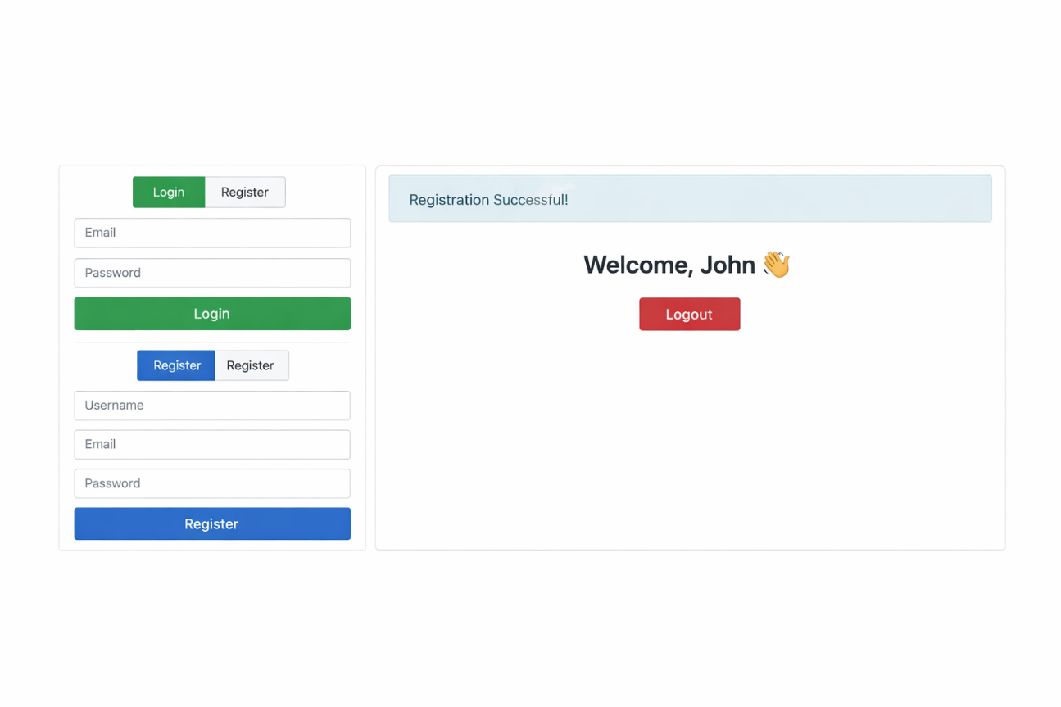

Conclusion:
Designing a user registration system using PHP and MySQL ensures that user information is collected and stored securely in a database. By applying techniques like password hashing, sensitive data is protected from unauthorized access. The implementation of session-based authentication allows users to log in securely and maintains their session across different pages. It also helps in controlling access to protected areas of the application. Overall, this system provides a secure, efficient, and user-friendly way to manage user registration, login, and access control in web applications.

MDC401: Introduction to Web Technologies

