

Vidyavardhini’s College of Engineering & Technology

Department of Computer Engineering

Experiment No.8
Design and Transformation of XML Data Using DTD and
XSLT
Date of Performance: 11/03/2026
Date of Submission: 11/03/2026

MDC401: Introduction to Web Technologies



Vidyavardhini’s College of Engineering & Technology

Department of Computer Engineering

Aim: To design and transform XML data using DTD and XSLT.
Objective: To define the structure of XML documents using DTD and apply XSLT to transform and display XML data in different formats such as HTML.
Theory:
XML (Extensible Markup Language) is used to store and transport data in a structured and flexible format. A Document Type Definition (DTD) is used to define the structure and rules of an XML document, specifying the elements, attributes, and their relationships. This ensures that the XML data follows a valid format and maintains consistency across applications.
XSLT (Extensible Stylesheet Language Transformations) is used to transform XML data into different formats such as HTML for display in web browsers. It allows developers to extract, rearrange, and format XML content according to specific requirements. By using DTD and XSLT together, XML data can be both validated and presented effectively in a readable and user-friendly format.

Implementation:
<?xml version="1.0"?>

<!DOCTYPE students [
<!ELEMENT students (student+)>
<!ELEMENT student (name, age, course)>
<!ELEMENT name (#PCDATA)>
<!ELEMENT age (#PCDATA)>
<!ELEMENT course (#PCDATA)>
]>

<?xml-stylesheet type="text/xsl"?>

<xsl:stylesheet version="1.0"
xmlns:xsl="http://www.w3.org/1999/XSL/Transform">

<xsl:template match="/">
<html>
<body>

<h2>Student List</h2>

<table border="1">
<tr>
<th>Name</th>
<th>Age</th>
<th>Course</th>
</tr>

<xsl:for-each select="students/student">
<tr>
<td><xsl:value-of select="name"/></td>
<td><xsl:value-of select="age"/></td>
<td><xsl:value-of select="course"/></td>
</tr>
</xsl:for-each>

</table>

</body>
</html>
</xsl:template>

</xsl:stylesheet>

<students>
<student>
<name>John</name>
<age>20</age>
<course>Computer Science</course>
</student>
<student>
<name>Alice</name>
<age>22</age>
<course>Information Technology</course>
</student>
</students>

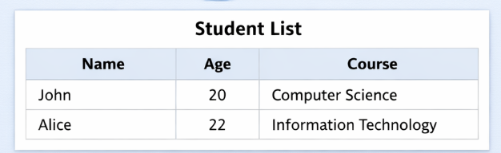

Conclusion:
Defining the structure of XML documents using DTD ensures that the data follows a valid and consistent format. By applying XSLT, the XML data can be transformed into different formats such as HTML for better visualization and presentation. This approach improves data organization, validation, and display, making XML more useful and user-friendly in web applications.

MDC401: Introduction to Web Technologies

