Portofolio 3

Gustav Helms, Sigrid Agersnap, Anders Hjulmand, Morten Street

2/19/2020

#Setup  
library(pacman)  
pacman::p_load("tidyverse", "lme4", "reshape2", "pracma")  
  
#load data  
  
fmri<-as.matrix(read.csv("portfolio_assignment3_aud_fmri_data37.csv", header=FALSE))  
##making it a time-series  
fmri2<-ts(fmri)  
##design  
  
  
fmrides<-as.matrix(read.csv("portfolio_assignment3_aud_fmri_design.csv", header=FALSE))  
##making it a time-series  
fmrides2<-ts(fmrides)

## 1. Make three figures:

### 1.a. A figure with lineplots of the data from all participants as a function of time in one figure.

# Restructuring the df  
melt <- melt(fmri2)  
  
ggplot(melt, aes(melt$Var1, melt$value, colour = melt$Var2))+  
 geom_line()+  
 labs(x = "Time", y = "Value")

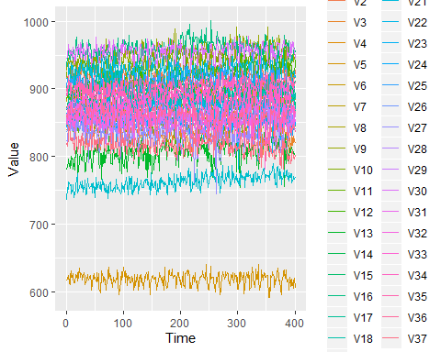

### 1.b. A boxplot with the signal intensity for each participant. Note how much the baseline signal can vary between participants.

ggplot(melt, aes(Var2, value, colour = Var2))+  
 geom_boxplot()

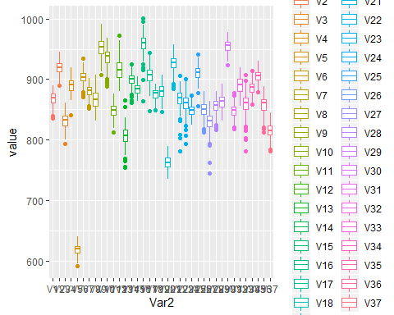

### 1.c. A lineplots figure with the model covariates.

melt2 <- melt(fmrides2)  
  
ggplot(melt2, aes(Var1, value, colour = Var2))+  
 geom_line()+  
 facet_wrap(melt2$Var2, ncol = 1)

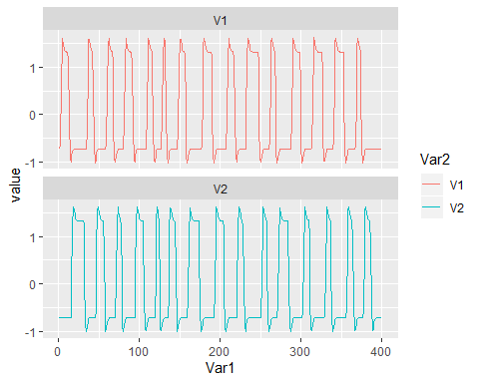

## 2. Based on the shape of the model: How many stories did the participants listen to in each condition (you can also automatise this, e.g. using “findpeaks” in library(pracma))?

#Finding peaks in condition 1  
nrow(findpeaks(fmrides[,1]))

## [1] 15

# There are 15 peaks  
  
#Finding peaks in condition 2  
nrow(findpeaks(fmrides[,2]))

## [1] 15

# There are 15 peaks

There was 15 stories in each condition. In total that’s 15+15=30 stories.

### 3.a. Are the two model covariates correlated?

#Checking visually for normality in the data  
hist(fmrides2[,1])

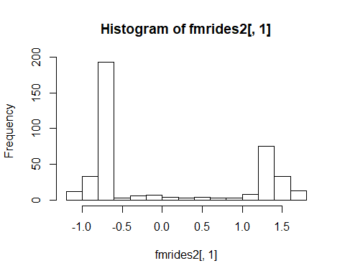

#By visual inspection the data are not normally distributed  
  
#Checking visually for normality in the data  
hist(fmrides2[,2])

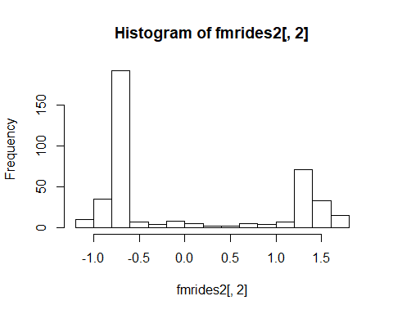

#By visual inspection the data are not normally distributed

Since the data are not normally distributed a non-parametric correlation test is used.

# Running correlationtest  
cor <- cor.test(fmrides2[,1],fmrides[,2], method = "spearman")

## Warning in cor.test.default(fmrides2[, 1], fmrides[, 2], method =  
## "spearman"): Cannot compute exact p-value with ties

cor

##   
## Spearman's rank correlation rho  
##   
## data: fmrides2[, 1] and fmrides[, 2]  
## S = 16863964, p-value < 2.2e-16  
## alternative hypothesis: true rho is not equal to 0  
## sample estimates:  
## rho   
## -0.5810065

There is a significant negative correlation of rho=-0.58, p< 0.001, between the two conditions which reflects a middle effect. This correlation might reflect that the two conditions have a similar trend which is skewed from each other (see figure in 1.c).

### 3.b. Have the covariates been mean-centered?

# Sum of covariate 1  
sum(fmrides2[,1])

## [1] -0.0005395

# Sum of covariate 2  
sum(fmrides2[,2])

## [1] 0.000818

Both sums of the covariates approximates 0, meaning they are mean-centered.

## 4. Please report the percentage of shared variance in the two covariates.

# The r^2 of the correlation test exlains how much of the variance the covariates explains.   
cor$estimate^2

## rho   
## 0.3375686

The two covariates share 33.8 % of the variance in the data.

## 5. Pick one participant’s data set.

# Subsetting participant 23.   
p1 <- fmri2[,23]

Conduct 6 analyses using lm(): ### 5.a. Fit the model as it is, including intercept.

# Doing lm  
summary(lm(p1 ~ fmrides2))

##   
## Call:  
## lm(formula = p1 ~ fmrides2)  
##   
## Residuals:  
## Min 1Q Median 3Q Max   
## -69.406 -9.152 0.349 8.344 37.720   
##   
## Coefficients:  
## Estimate Std. Error t value Pr(>|t|)   
## (Intercept) 860.5850 0.6878 1251.304 < 2e-16 ***  
## fmrides2V1 5.8274 0.8199 7.107 5.53e-12 ***  
## fmrides2V2 5.1652 0.8199 6.300 7.92e-10 ***  
## ---  
## Signif. codes: 0 '***' 0.001 '**' 0.01 '*' 0.05 '.' 0.1 ' ' 1  
##   
## Residual standard error: 13.76 on 397 degrees of freedom  
## Multiple R-squared: 0.1293, Adjusted R-squared: 0.1249   
## F-statistic: 29.48 on 2 and 397 DF, p-value: 1.152e-12

Both covariates significantly explains the data with p-values<0.001.

### 5.b. Fit the model as it is, excluding intercept.

#Mean centering the data to remove the intercept  
p1_mean <- p1-mean(p1)  
  
# making the new model, excluding the intercept  
summary(lm(p1_mean ~ fmrides2))

##   
## Call:  
## lm(formula = p1_mean ~ fmrides2)  
##   
## Residuals:  
## Min 1Q Median 3Q Max   
## -69.406 -9.152 0.349 8.344 37.720   
##   
## Coefficients:  
## Estimate Std. Error t value Pr(>|t|)   
## (Intercept) -2.703e-06 6.878e-01 0.000 1   
## fmrides2V1 5.827e+00 8.199e-01 7.107 5.53e-12 ***  
## fmrides2V2 5.165e+00 8.199e-01 6.300 7.92e-10 ***  
## ---  
## Signif. codes: 0 '***' 0.001 '**' 0.01 '*' 0.05 '.' 0.1 ' ' 1  
##   
## Residual standard error: 13.76 on 397 degrees of freedom  
## Multiple R-squared: 0.1293, Adjusted R-squared: 0.1249   
## F-statistic: 29.48 on 2 and 397 DF, p-value: 1.152e-12

The slopes stay the same but the intercept approximates 0 in the new model with mean centered data.

### 5.c. Fit only the 1st covariate as a model.

#Fitting only the first covariate  
m1 <- summary(lm(p1 ~ fmrides2[,1]))  
m1

##   
## Call:  
## lm(formula = p1 ~ fmrides2[, 1])  
##   
## Residuals:  
## Min 1Q Median 3Q Max   
## -64.389 -8.383 -0.127 9.599 42.611   
##   
## Coefficients:  
## Estimate Std. Error t value Pr(>|t|)   
## (Intercept) 860.5850 0.7204 1194.592 < 2e-16 ***  
## fmrides2[, 1] 3.0237 0.7213 4.192 3.41e-05 ***  
## ---  
## Signif. codes: 0 '***' 0.001 '**' 0.01 '*' 0.05 '.' 0.1 ' ' 1  
##   
## Residual standard error: 14.41 on 398 degrees of freedom  
## Multiple R-squared: 0.04228, Adjusted R-squared: 0.03988   
## F-statistic: 17.57 on 1 and 398 DF, p-value: 3.411e-05

Using the 1st covariate as a model significantly explains the data.

### 5.d. Fit only the 2nd covariate as a model.

#Fitting only the second covariate  
m2 <- summary(lm(p1 ~ fmrides2[,2]))  
m2

##   
## Call:  
## lm(formula = p1 ~ fmrides2[, 2])  
##   
## Residuals:  
## Min 1Q Median 3Q Max   
## -69.319 -8.598 0.779 8.854 41.854   
##   
## Coefficients:  
## Estimate Std. Error t value Pr(>|t|)   
## (Intercept) 860.5850 0.7293 1180.052 < 2e-16 ***  
## fmrides2[, 2] 2.0021 0.7302 2.742 0.00639 **   
## ---  
## Signif. codes: 0 '***' 0.001 '**' 0.01 '*' 0.05 '.' 0.1 ' ' 1  
##   
## Residual standard error: 14.59 on 398 degrees of freedom  
## Multiple R-squared: 0.01854, Adjusted R-squared: 0.01607   
## F-statistic: 7.518 on 1 and 398 DF, p-value: 0.006385

Using the 2nd covariate as a model significantly explains the data. However, the slope gradient are different in the two models.

#### The residuals represent the variance left when fitting a model. They are thus data that have been “cleaned” from the variance explained by the model. We can use those “cleaned” data to fit another model on. This is similar to using a type III sum of squares approach to your statistics.

### 5.e. Fit the 2nd covariate to the residuals from analysis 5.c., the 1st covariate only analysis

#Fitting the 2nd covariate to the residuals of the first covariate  
summary(lm(m1$residuals~fmrides2[,2]))

##   
## Call:  
## lm(formula = m1$residuals ~ fmrides2[, 2])  
##   
## Residuals:  
## Min 1Q Median 3Q Max   
## -69.365 -9.141 0.929 8.907 38.854   
##   
## Coefficients:  
## Estimate Std. Error t value Pr(>|t|)   
## (Intercept) -7.451e-06 6.969e-01 0.000 1   
## fmrides2[, 2] 3.643e+00 6.978e-01 5.221 2.87e-07 ***  
## ---  
## Signif. codes: 0 '***' 0.001 '**' 0.01 '*' 0.05 '.' 0.1 ' ' 1  
##   
## Residual standard error: 13.94 on 398 degrees of freedom  
## Multiple R-squared: 0.0641, Adjusted R-squared: 0.06175   
## F-statistic: 27.26 on 1 and 398 DF, p-value: 2.871e-07

### 5.f. Fit the 1st covariate to the resistuals from 5.d., the 2nd covariate only analysis

#Fitting the 1st covariate to the residuals of the second covariate  
summary(lm(m2$residuals~fmrides2[,1]))

##   
## Call:  
## lm(formula = m2$residuals ~ fmrides2[, 1])  
##   
## Residuals:  
## Min 1Q Median 3Q Max   
## -66.333 -8.397 0.292 9.304 40.716   
##   
## Coefficients:  
## Estimate Std. Error t value Pr(>|t|)   
## (Intercept) 5.544e-06 6.996e-01 0.000 1   
## fmrides2[, 1] 4.110e+00 7.005e-01 5.868 9.31e-09 ***  
## ---  
## Signif. codes: 0 '***' 0.001 '**' 0.01 '*' 0.05 '.' 0.1 ' ' 1  
##   
## Residual standard error: 13.99 on 398 degrees of freedom  
## Multiple R-squared: 0.07962, Adjusted R-squared: 0.07731   
## F-statistic: 34.43 on 1 and 398 DF, p-value: 9.312e-09

### 5.g. Does the order in which the predictor variables are fitted to the data matter for the estimates? If it does, what can explain this?

The order in which the predicter variables are fitted to the data matters for the estimate. Fitting the residuals from the first model to the second covariate had an estimate of beta=3.643, and vice versa the other model had an estimate of beta=4.11. The difference of 0.5 in the gradients of the two covariates could be explained by the skewness of the two conditions in the design matrix (see figure in 1.c).

## 6. Fit the full model to each of the 37 participants’ data and extract the coefficients for each participant. (hint: the full participant data frame can be set as outcome. Alternatively, you can change the data structure and use lmList from assignement 1 (remember pool=FALSE)).

#Making the full model  
m <- lm(fmri2~fmrides2)  
  
#Organizing the data into a data frame  
df <- data.frame("Intercept" = m$coefficients[1,],  
 "V1" = m$coefficients[2,],  
 "V2" = m$coefficients[3,])  
df

## Intercept V1 V2  
## V1 867.3275 9.582330 8.926516  
## V2 919.4350 5.773264 6.104578  
## V3 831.2300 7.340939 8.233871  
## V4 890.1325 2.682228 3.133700  
## V5 618.7725 5.872990 6.041478  
## V6 903.3950 3.209499 3.230518  
## V7 880.8425 2.606846 2.499852  
## V8 868.2550 3.828594 3.530697  
## V9 952.3775 2.422324 0.992906  
## V10 936.6850 6.400593 7.207420  
## V11 847.8800 6.989003 6.538979  
## V12 916.2025 3.464375 3.385156  
## V13 806.2725 4.626842 3.595325  
## V14 900.0700 3.304558 3.914555  
## V15 884.1000 3.566603 3.495208  
## V16 959.1700 5.566010 5.802205  
## V17 907.0200 3.756718 3.873774  
## V18 875.3125 5.436519 5.276158  
## V19 879.4675 2.814987 2.626577  
## V20 762.8750 2.829585 2.658036  
## V21 926.4350 7.351865 6.394320  
## V22 868.1425 5.963731 5.905760  
## V23 860.5850 5.827429 5.165241  
## V24 848.9875 3.880726 4.050404  
## V25 910.4025 6.534162 6.399795  
## V26 850.3925 4.849484 4.703407  
## V27 829.9300 4.997005 3.951056  
## V28 855.8500 7.818241 7.767283  
## V29 863.1775 5.474936 5.903824  
## V30 954.6175 6.648170 6.628171  
## V31 847.9225 5.056695 5.756162  
## V32 889.6675 4.891110 4.607988  
## V33 859.4825 4.526764 6.001619  
## V34 885.8825 4.904306 3.930084  
## V35 905.4525 4.095500 4.176857  
## V36 857.7000 10.521195 10.631068  
## V37 815.1875 4.760363 4.646695

### 6.a. Test the two individual hypotheses that the set of coefficient from each covariate is different from zero across the whole group (similar to assignment 1).

# doing one sample t-test for covariate 1.   
t.test(df$V1)

##   
## One Sample t-test  
##   
## data: df$V1  
## t = 16.607, df = 36, p-value < 2.2e-16  
## alternative hypothesis: true mean is not equal to 0  
## 95 percent confidence interval:  
## 4.512224 5.767586  
## sample estimates:  
## mean of x   
## 5.139905

Covariate 1 is significantly different from 0, t(36)=16.61, p<0.001.

# doing one sample t-test for covariate 2.   
t.test(df$V2)

##   
## One Sample t-test  
##   
## data: df$V2  
## t = 15.603, df = 36, p-value < 2.2e-16  
## alternative hypothesis: true mean is not equal to 0  
## 95 percent confidence interval:  
## 4.413274 5.731982  
## sample estimates:  
## mean of x   
## 5.072628

Covariate 2 is significantly different from 0, t(36)=15.6, p<0.001.

### 6.aa. Make a contrast that investigates the difference between the two covariates, i.e. the two types of stories (hint: subtraction).

df$Contrast <- df$V1-df$V2  
df

## Intercept V1 V2 Contrast  
## V1 867.3275 9.582330 8.926516 0.65581370  
## V2 919.4350 5.773264 6.104578 -0.33131441  
## V3 831.2300 7.340939 8.233871 -0.89293270  
## V4 890.1325 2.682228 3.133700 -0.45147183  
## V5 618.7725 5.872990 6.041478 -0.16848855  
## V6 903.3950 3.209499 3.230518 -0.02101973  
## V7 880.8425 2.606846 2.499852 0.10699381  
## V8 868.2550 3.828594 3.530697 0.29789701  
## V9 952.3775 2.422324 0.992906 1.42941758  
## V10 936.6850 6.400593 7.207420 -0.80682690  
## V11 847.8800 6.989003 6.538979 0.45002325  
## V12 916.2025 3.464375 3.385156 0.07921988  
## V13 806.2725 4.626842 3.595325 1.03151654  
## V14 900.0700 3.304558 3.914555 -0.60999652  
## V15 884.1000 3.566603 3.495208 0.07139554  
## V16 959.1700 5.566010 5.802205 -0.23619571  
## V17 907.0200 3.756718 3.873774 -0.11705603  
## V18 875.3125 5.436519 5.276158 0.16036159  
## V19 879.4675 2.814987 2.626577 0.18841019  
## V20 762.8750 2.829585 2.658036 0.17154882  
## V21 926.4350 7.351865 6.394320 0.95754501  
## V22 868.1425 5.963731 5.905760 0.05797112  
## V23 860.5850 5.827429 5.165241 0.66218773  
## V24 848.9875 3.880726 4.050404 -0.16967800  
## V25 910.4025 6.534162 6.399795 0.13436743  
## V26 850.3925 4.849484 4.703407 0.14607779  
## V27 829.9300 4.997005 3.951056 1.04594858  
## V28 855.8500 7.818241 7.767283 0.05095722  
## V29 863.1775 5.474936 5.903824 -0.42888830  
## V30 954.6175 6.648170 6.628171 0.01999890  
## V31 847.9225 5.056695 5.756162 -0.69946688  
## V32 889.6675 4.891110 4.607988 0.28312193  
## V33 859.4825 4.526764 6.001619 -1.47485532  
## V34 885.8825 4.904306 3.930084 0.97422218  
## V35 905.4525 4.095500 4.176857 -0.08135714  
## V36 857.7000 10.521195 10.631068 -0.10987261  
## V37 815.1875 4.760363 4.646695 0.11366801

### 6.b. Test the hypothesis that the contrast is different from zero across participants.

t.test(df$Contrast)

##   
## One Sample t-test  
##   
## data: df$Contrast  
## t = 0.69615, df = 36, p-value = 0.4908  
## alternative hypothesis: true mean is not equal to 0  
## 95 percent confidence interval:  
## -0.1287197 0.2632734  
## sample estimates:  
## mean of x   
## 0.06727684

The contrast between covariate 1 and 2 is not significantly different from 0, t(36)=0.25, p=0.80. This entails that the slopes of the covarients across participants are not significantly different.

### 6.c. Make a bar diagram including the mean effect of the two coefficents and the contrast, including error bars (indicating standard error of mean).

#Rearranging the df  
melt_df <- melt(df)

## No id variables; using all as measure variables

#making the bar-plot, excluding intercept  
ggplot(melt_df %>% filter(variable != "Intercept"), aes(variable,value, fill = variable))+  
 stat_summary(fun.y = mean, geom = "Bar")+  
 stat_summary(fun.data = mean_se, geom = "errorbar", width = 0.3)

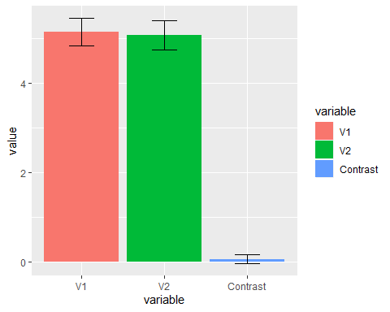 We do not see a significant difference in the mean effect of the two covariants, i.e. there is no difference between the two conditions (factual or fiction). This is seen by the two error-bars overlapping, and further underpinned by the t-test in 6.b.

### 7.a. For each partipant, add a covariate that models the effect of time (hint: 1:400).

#Making a new column in our design matrix that models the effect of time from 1 to 400.   
fmrides2 <- cbind(fmrides2, "Time" =c(1:400))

### 7.b. Does that improve the group results in term of higher t-values?

#Making the whole analysis againg  
  
#Making the full model  
m <- lm(fmri2~fmrides2)  
  
#Organizing the data into a data frame  
df1 <- data.frame("Intercept" = m$coefficients[1,],  
 "V1" = m$coefficients[2,],  
 "V2" = m$coefficients[3,],  
 "Time" = m$coefficients[4,]  
 )  
df1

## Intercept V1 V2 Time  
## V1 868.0578 9.550016 8.884649 -0.0036422065  
## V2 917.2425 5.870281 6.230279 0.0109351864  
## V3 837.5525 7.061170 7.871389 -0.0315337457  
## V4 876.7980 3.272271 3.898191 0.0665059681  
## V5 618.5361 5.883448 6.055029 0.0011788024  
## V6 900.4885 3.338111 3.397156 0.0144963991  
## V7 880.7089 2.612759 2.507513 0.0006664460  
## V8 848.4977 4.702847 4.663425 0.0985402495  
## V9 941.9349 2.884405 1.591603 0.0520828978  
## V10 927.6008 6.802563 7.728234 0.0453075849  
## V11 847.9025 6.988008 6.537690 -0.0001121534  
## V12 892.7402 4.502570 4.730295 0.1170187452  
## V13 795.6141 5.098470 4.206392 0.0531589673  
## V14 899.2625 3.340289 3.960850 0.0040273769  
## V15 880.0330 3.746568 3.728380 0.0202845108  
## V16 954.4670 5.774115 6.071837 0.0234562781  
## V17 912.1634 3.529123 3.578890 -0.0256530483  
## V18 874.1432 5.488261 5.343197 0.0058319930  
## V19 868.4097 3.304290 3.260543 0.0551511340  
## V20 751.2437 3.344263 3.324880 0.0580112666  
## V21 925.7719 7.381207 6.432338 0.0033073449  
## V22 871.8300 5.800563 5.694350 -0.0183913104  
## V23 860.1728 5.845666 5.188871 0.0020556440  
## V24 850.5987 3.809432 3.958032 -0.0080357482  
## V25 903.3099 6.848006 6.806427 0.0353744407  
## V26 838.8855 5.358663 5.363126 0.0573914391  
## V27 835.1618 4.765501 3.651108 -0.0260936683  
## V28 859.9679 7.636024 7.531194 -0.0205382764  
## V29 863.3169 5.468770 5.895835 -0.0006950470  
## V30 952.5385 6.740166 6.747366 0.0103691595  
## V31 846.4594 5.121437 5.840045 0.0072972862  
## V32 873.1977 5.619891 5.552235 0.0821435352  
## V33 861.8084 4.423846 5.868273 -0.0116002920  
## V34 892.3598 4.617687 3.558725 -0.0323059488  
## V35 900.5387 4.312931 4.458572 0.0245074791  
## V36 864.3029 10.229020 10.252511 -0.0329321231  
## V37 821.6538 4.474234 4.275971 -0.0322506678

#Making t-test on the covariates  
  
t.test(df1$Time)

##   
## One Sample t-test  
##   
## data: df1$Time  
## t = 2.6232, df = 36, p-value = 0.01269  
## alternative hypothesis: true mean is not equal to 0  
## 95 percent confidence interval:  
## 0.003711374 0.029008405  
## sample estimates:  
## mean of x   
## 0.01635989

The t-test shows that there is a significant difference between the sum of the slopes for the added covariate time and 0. Thus, time as a covariate is a significant predictor of changes in voxel values across participants, t(36)=2.62, p<0.05. One possible explanation could be that some of the participants fell asleep during the experiment, which changed the values of the voxels over time.

### 8. Make a bar diagram like in 6.c., but display effects as percent signal change (hint: percent signal change is slope divided by intercept).

#making new colloumn in df1  
df2 <- data.frame("pv1" = df1$V1/df1$Intercept,  
 "pv2" = df1$V2/df1$Intercept,  
 "pTime" = df1$Time/df1$Intercept)  
  
  
  
melt_df2 <- melt(df2)

## No id variables; using all as measure variables

ggplot(melt_df2, aes(variable,value, fill = variable))+  
 stat_summary(fun.y = mean, geom = "Bar") +  
 stat_summary(fun.data = mean_se, geom = "errorbar", width = 0.3)

