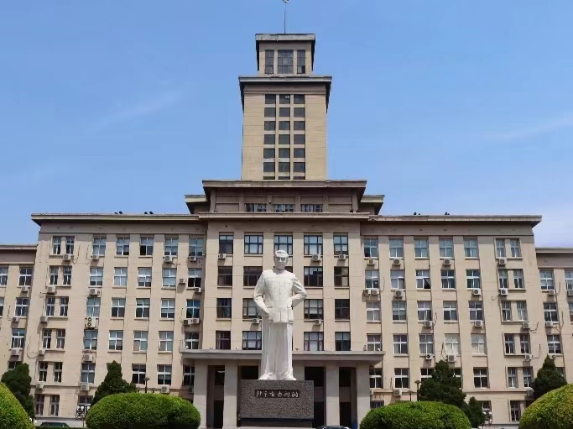

After the May Fourth Movement broke out in 1919, Zhou Enlai, who had just returned to China from Japan, actively participated in the movement.He edited the Tianjin Student Federation newspaper, founded the student patriotic organization "Awakening Society", and gradually became the leading backbone of the student movement.
On January 23, 1920, members of the Tianjin Student Association investigating Japanese goods found the store hidden Japanese goods didn’t report to the leadership , covered up the cooperation with Japanese, beat students, all of which aroused indignation. People from all walks of life petitioned the provincial government, but the reactionary authorities brutally suppressed them. In order to oppose the the Northern Warlord government's suppression of the students' patriotic movement, Zhou Enlai led more than 5,000 students from various schools in Tianjin petition the Government office , but they were arrested by the military police. The reactionary authorities arrested over 20 representatives ,closed down student federation and associations ,causing a sensational political event.
Since his arrest on January 29, 1920, Zhou Enlai unswervingly believed that there was nothing wrong with students protesting against the government's inaction for the sake of national development and national awakening.
In prison, arrested students went on hunger strikes against the government to declare themselves.In response to the students' struggle, the prosecution allowed their family and friends to visit them, and they can read books and relax in the yard regularly.
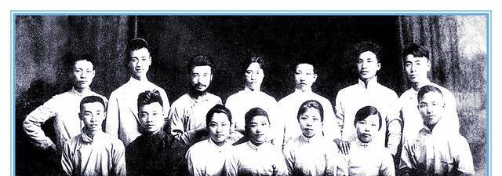
“Cease to struggle and you cease to live.”Here, Zhou Enlai organized reading groups and regularly gave lectures to those arrested students.On July 17, the Tianjin District Court held a court session, acquitted those representatives who had been arrested for six months in the prison was released on the spot.
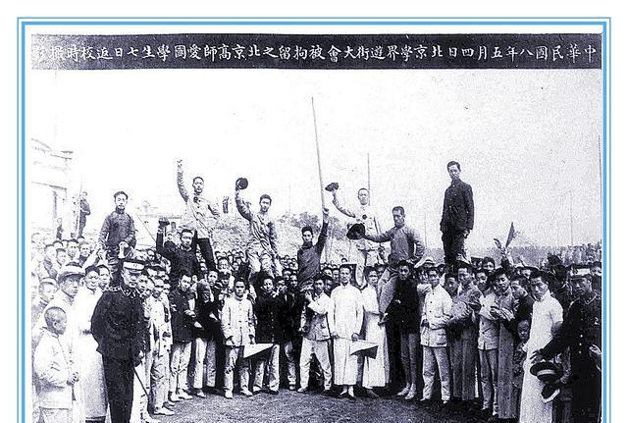
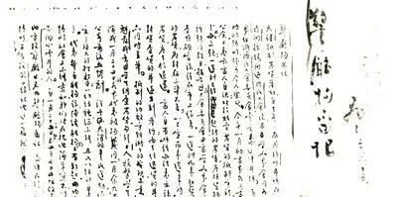
The experience of being in the prison made Zhou Enlai more firm in his ideal of reading for the rise of China.In November of the same year, with the support of Yan Xiu and Liu Chongyou, the founders of Nankai University, Zhou Enlai sailed to France and embarked on a new revolutionary course.
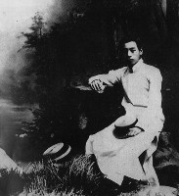

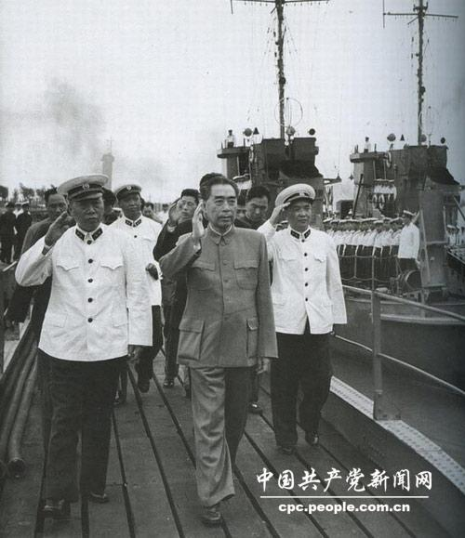
Later, he united and led a large number of progressive in the US and Europe to join the Communist Party of China. The major decisions made and events experienced by the Communist Party of China are closely related to him. After the founding of the People's Republic of China, he also assisted Mao Zedong in leading the all-round construction of the People's Republic of China, and made great efforts in running the Party, state and army, as well as in the fields of internal affairs, national defense and foreign affairs.

