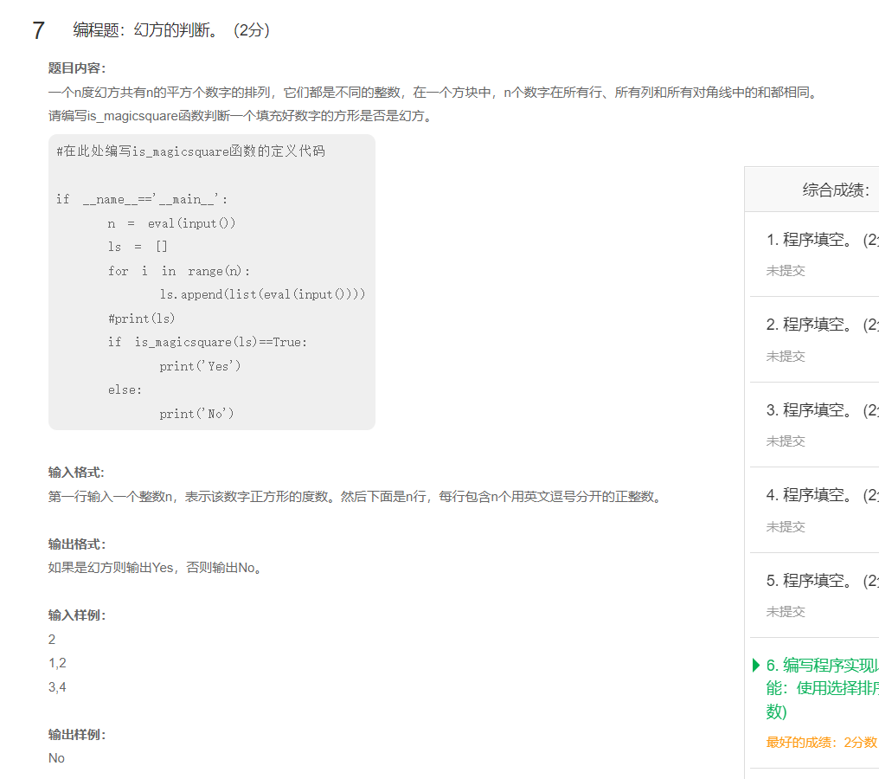
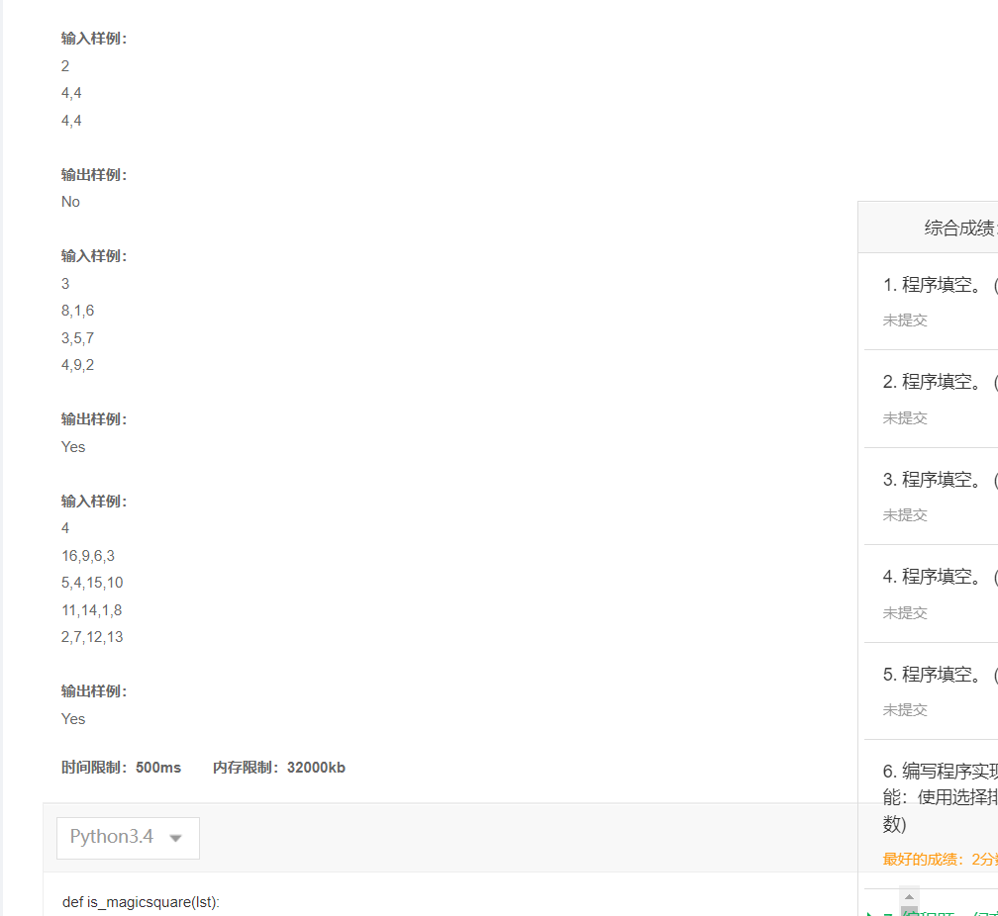
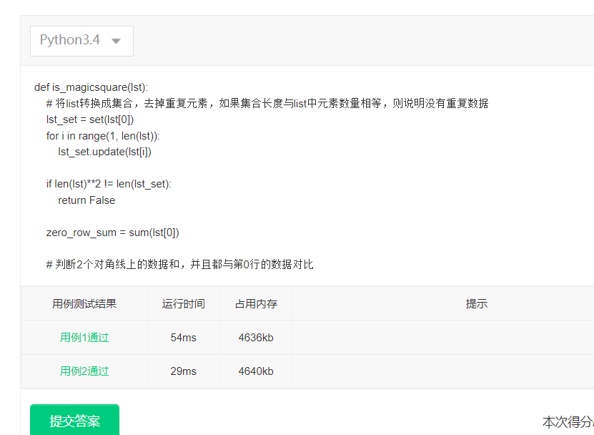
def is_magicsquare(lst):
lst_set = set(lst[0])
for i in range(1, len(lst)):
lst_set.update(lst[i])

if len(lst)**2 != len(lst_set):
return False

zero_row_sum = sum(lst[0])

sum1 = sum([lst[i][i] for i in range(len(lst))])
sum2 = sum([lst[i][len(lst) - 1 - i] for i in range(len(lst))])
if sum1 != sum2 or sum1 != zero_row_sum or sum2 != zero_row_sum:
return False

for i in range(len(lst)):
if sum(lst[i]) != zero_row_sum or sum(lst[:][i]) != zero_row_sum or sum(lst[i]) != sum(lst[:][i]):
return False
return True

if __name__=='__main__':
n = eval(input())
ls = []
for i in range(n):
ls.append(list(eval(input())))
#print(ls)
if is_magicsquare(ls)==True:
print('Yes')
else:
print('No')

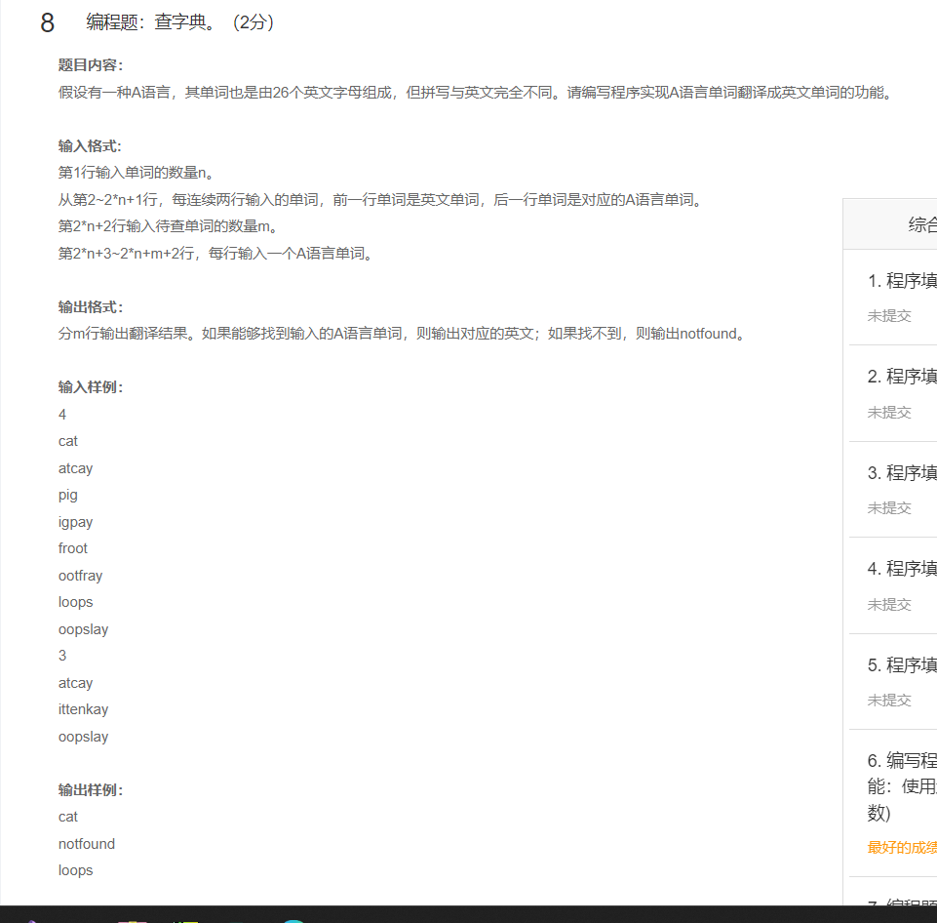
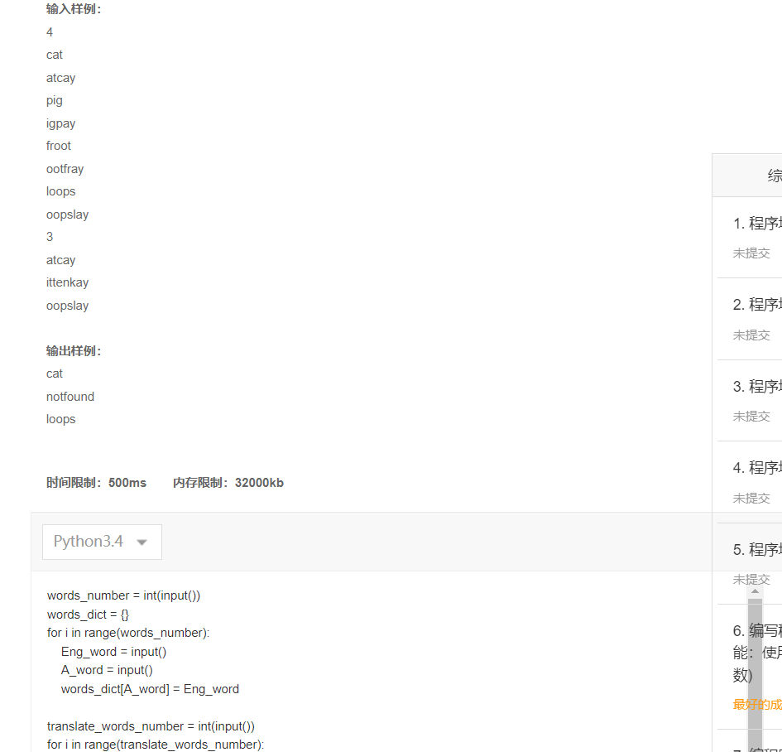

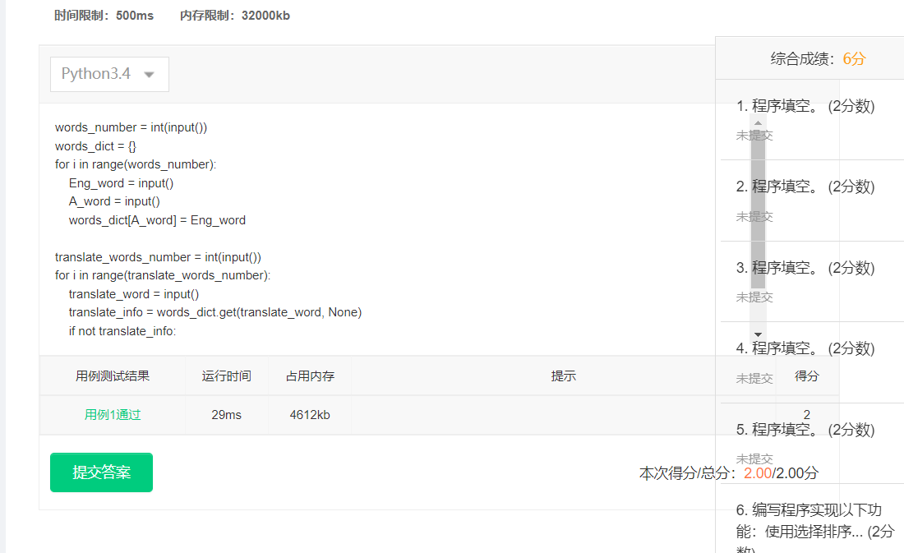
words_number = int(input())
words_dict = {}
for i in range(words_number):
Eng_word = input()
A_word = input()
words_dict[A_word] = Eng_word

translate_words_number = int(input())
for i in range(translate_words_number):
translate_word = input()
translate_info = words_dict.get(translate_word, None)
if not translate_info:
print('notfound')
else:
print(translate_info)

