Report: Analyzing the Impact of Tariffs and GDP East Asia & Pacific Exports (1988-2022)

**Data Source :** [**https://wits.worldbank.org/**](https://wits.worldbank.org/)

**Region : East Asia & Pacific**

**1. Executive Summary**

* **Objective**: The goal of this study is to analyse how **MFN (Most Favored Nation) tariffs** and **GDP** influence **exports** in the East Asia & Pacific region over the period **1988-2022**.
* **Key Findings**:
  + **97.8% of the variation** in exports is explained by tariffs and GDP.
  + **Negative relationship** between **tariffs and exports** (higher tariffs reduce exports).
  + **Positive relationship** between **GDP and exports** (higher GDP increases exports).
  + **Regression assumptions are satisfied**, meaning the model is statistically valid.
* **Business Implications**:
  + Lowering tariffs could enhance exports.
  + A growing GDP supports trade expansion.
  + Policymakers and businesses should use GDP trends to forecast trade flows.

**2. Data & Methodology**

* **Data** : Historical export data (in USD), MFN tariff rates, and GDP from 1988-2022.
* **Variables**:
  + **Dependent Variable**: **Exports (US$ Thousand)**
  + **Independent Variables**:
    - **MFN Tariff (as a %)** – Expected negative impact on exports.
    - **GDP (current US$)** – Expected positive impact on exports.
* **Methodology**:
  + Performed **exploratory data analysis (EDA)** to clean and visualize trends.
  + Used **multiple linear regression** to quantify the relationships.
  + Verified regression **assumptions (linearity, normality, homoscedasticity, independence, and multicollinearity)**.

**3. Regression Analysis & Interpretation**

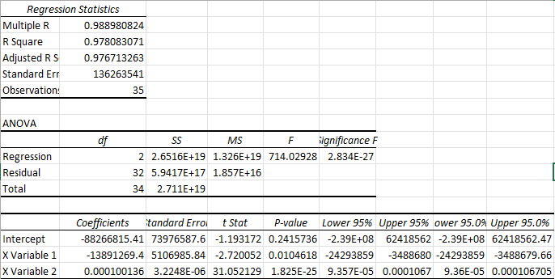

* **Model Summary**:
  + R² = **0.978** (model explains 97.8% of variance in exports).
  + Adjusted R² = **0.976** (high explanatory power, minimal overfitting).
  + **Intercept**: -8.8e+07 (not meaningful for interpretation).
  + **MFN Tariff Coefficient**: -1.41e+07
    - **Interpretation**: A **1% increase in MFN tariffs** leads to a **$14.1 million reduction in exports**, holding GDP constant.
  + **GDP Coefficient**: 9.84e-05
    - **Interpretation**: A **$1 billion increase in GDP** leads to a **$98.4 million increase in exports**, holding tariffs constant.
* **ANOVA (Statistical Significance)**:
  + **F-Statistic = 714.02, p-value = 2.83e-27** (model is highly significant).
  + **P-values**:
    - MFN Tariff: **0.026** (statistically significant at 5% level).
    - GDP: **<0.001** (highly significant).

**4. Descriptive Analysis**

* Variables Description:

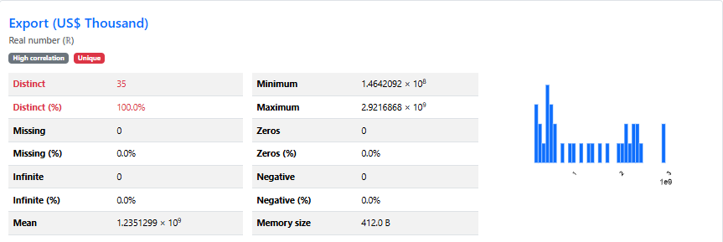

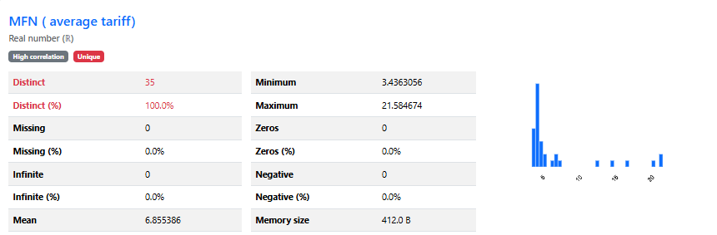

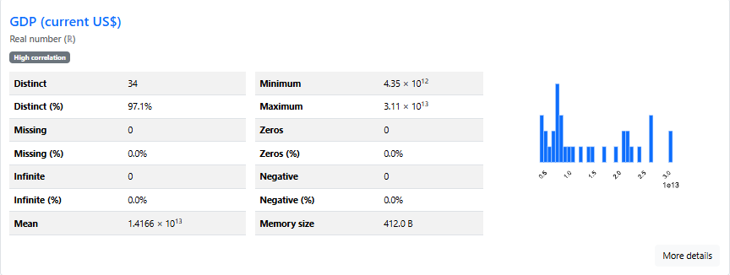

* Relation Between independent variables with **dependent variable( Export )**

1. **GDP Vs Export** – There is positive relationship between variables

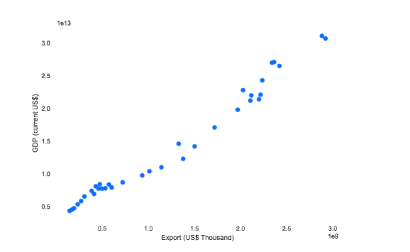

1. **MFN Vs Export** – There is a negative relationship between variables

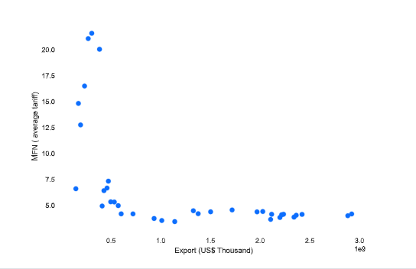

* Correlation Matrix

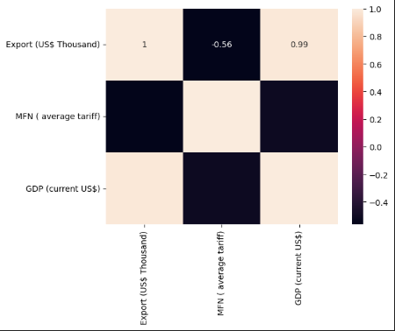

* There is only Positive correlation with GDP , not with MFN Tariff.

**4. Business Implications & Recommendations**

* **For Policymakers**:
  + Reducing **MFN tariffs** could significantly **boost exports**.
  + Growth policies focused on increasing **GDP** will naturally **drive exports**.
  + Trade agreements should aim to lower tariffs on high-value goods.
* **For Businesses & Exporters**:
  + Invest in markets where GDP is **growing rapidly**.
  + Consider tariff rates when choosing **export destinations**.
  + Monitor economic policies affecting **MFN tariff structures**.
* **For Investors**:
  + Trade-focused sectors should be evaluated based on **tariff policies**.
  + High-GDP regions will likely experience continued **export growth**.
  + Predicting GDP growth can inform long-term **investment strategies**.

**5. Model Validation & Limitations**

* **Validation**:
  + Assumptions of **linearity, independence, homoscedasticity, and normality** are satisfied.

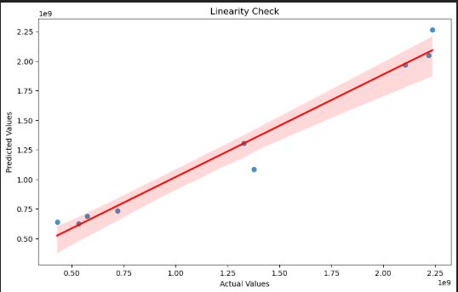

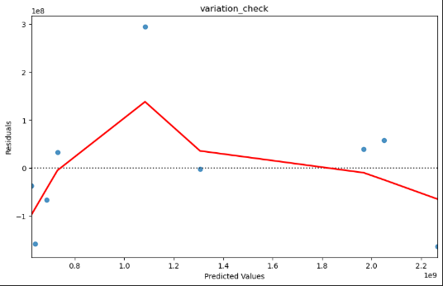

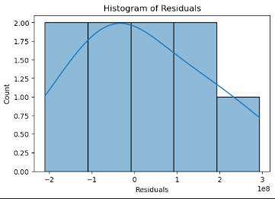

* + **Durbin-Watson Test**: **2.06** (no autocorrelation).
  + **Multicollinearity Test**: No significant correlation issues.
* **Limitations**:
  + Model does not include **exchange rates, political stability, or trade policies**.

**6. Conclusion**

* **Main Insight**: **GDP growth is the strongest driver of export expansion, while higher tariffs significantly reduce exports**.
* **Strategic Use**: Businesses and policymakers can use these insights to **optimize trade strategies, tariff policies, and investment decisions**.
* **Future Work**: Expanding the model to include **exchange rates, inflation, and industry-specific data** could enhance predictive power.