Report – Homework 1
Student: Riccardo Stucovitz

1. Create the description of your robot and visualize it in Rviz

(a) Download the arm_description package from the repo https://github.com/RoboticsLab2023/
arm_description.git into your catkin_ws using git commands

Used commands
$ cd catkin_ws/src
$ git clone https://github.com/RoboticsLab2023/arm_description.git

(b) Within the package create a launch folder containing a launch file named display.launch that
loads the URDF as a robot_description ROS param and starts the robot_state_publisher
node, the joint_state_publisher node, and the rviz node. Launch the file using roslaunch.
Note: To visualize your robot in rviz you have to change the Fixed Frame in the lateral bar
and add the RobotModel plugin interface. Optional: save a .rviz configuration file, thad auto-
matically loads the RobotModel plugin by default, and give it as an argument to your node in the
display.launch file
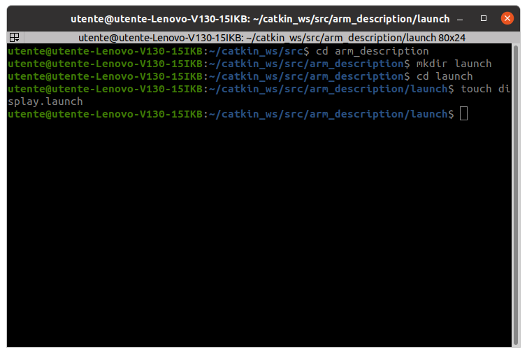

Used commands
$ cd arm_description
$ mkdir launch
$ cd launch
$ touch display.launch

Taking inspiration from:
~/catkin_ws/src/ros_tools/launch/rviz.launch ~/catkin_ws/src/iiwa_stack/iiwa_description/launch/iiwa7_upload.launch.

I filled “~/catkin_ws/src/arm_description/launch/display.launch”:
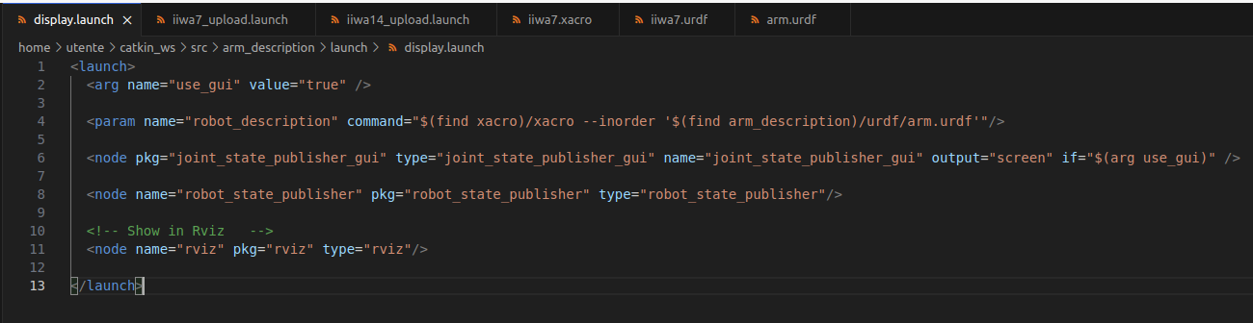

N.b I could have even write: <param name="robot_description" command="cat '$(find arm_description)/urdf/arm.urdf'”/>
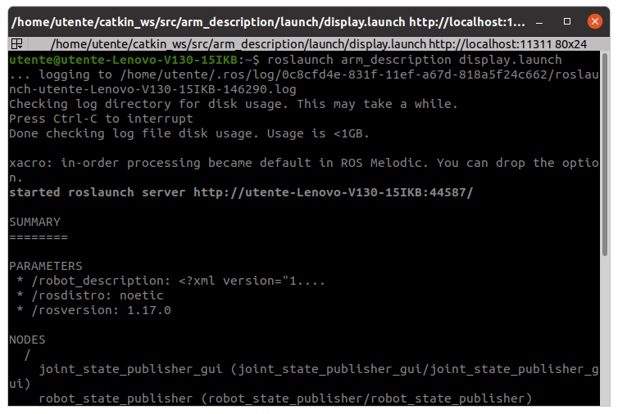
Then I launch it:
$ roslaunch arm_description display.launch

In RVIZ GUI, I added in the lateral bar:
Fixed Frame → base_link
Add → RobotModel → ✓
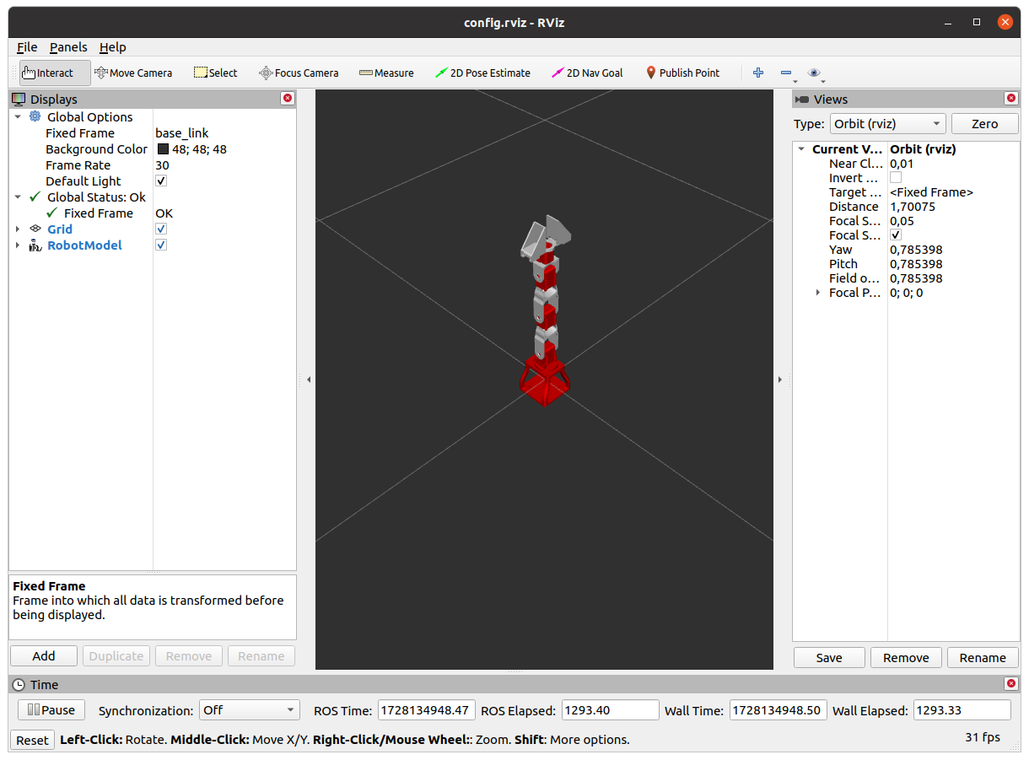

Ctrl + S (Save) → I saved this configuration “config.rviz”, creating a new folder “/config”: ~/catkin_ws/src/arm_description/config/config.rviz.

Then I further modified “display.launch”, such that it would launch automatically the new RVIZ configuration:
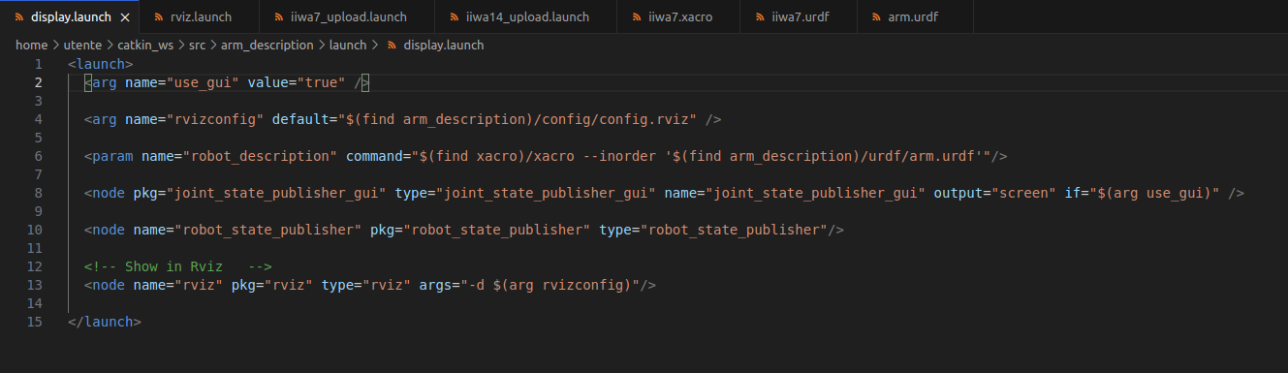

(c) Substitute the collision meshes of your URDF with primitive shapes. Use <box> geometries of
reasonable size approximating the links. Hint: Enable collision visualization in rviz (go to the
lateral bar > Robot model > Collision Enabled) to adjust the collision meshes size

I modified “~/catkin_ws/src/arm_description/urdf/arm.urdf”.
I’ll take as example just one of the links: for all the other ones, I should have done the same.
It yelds to:
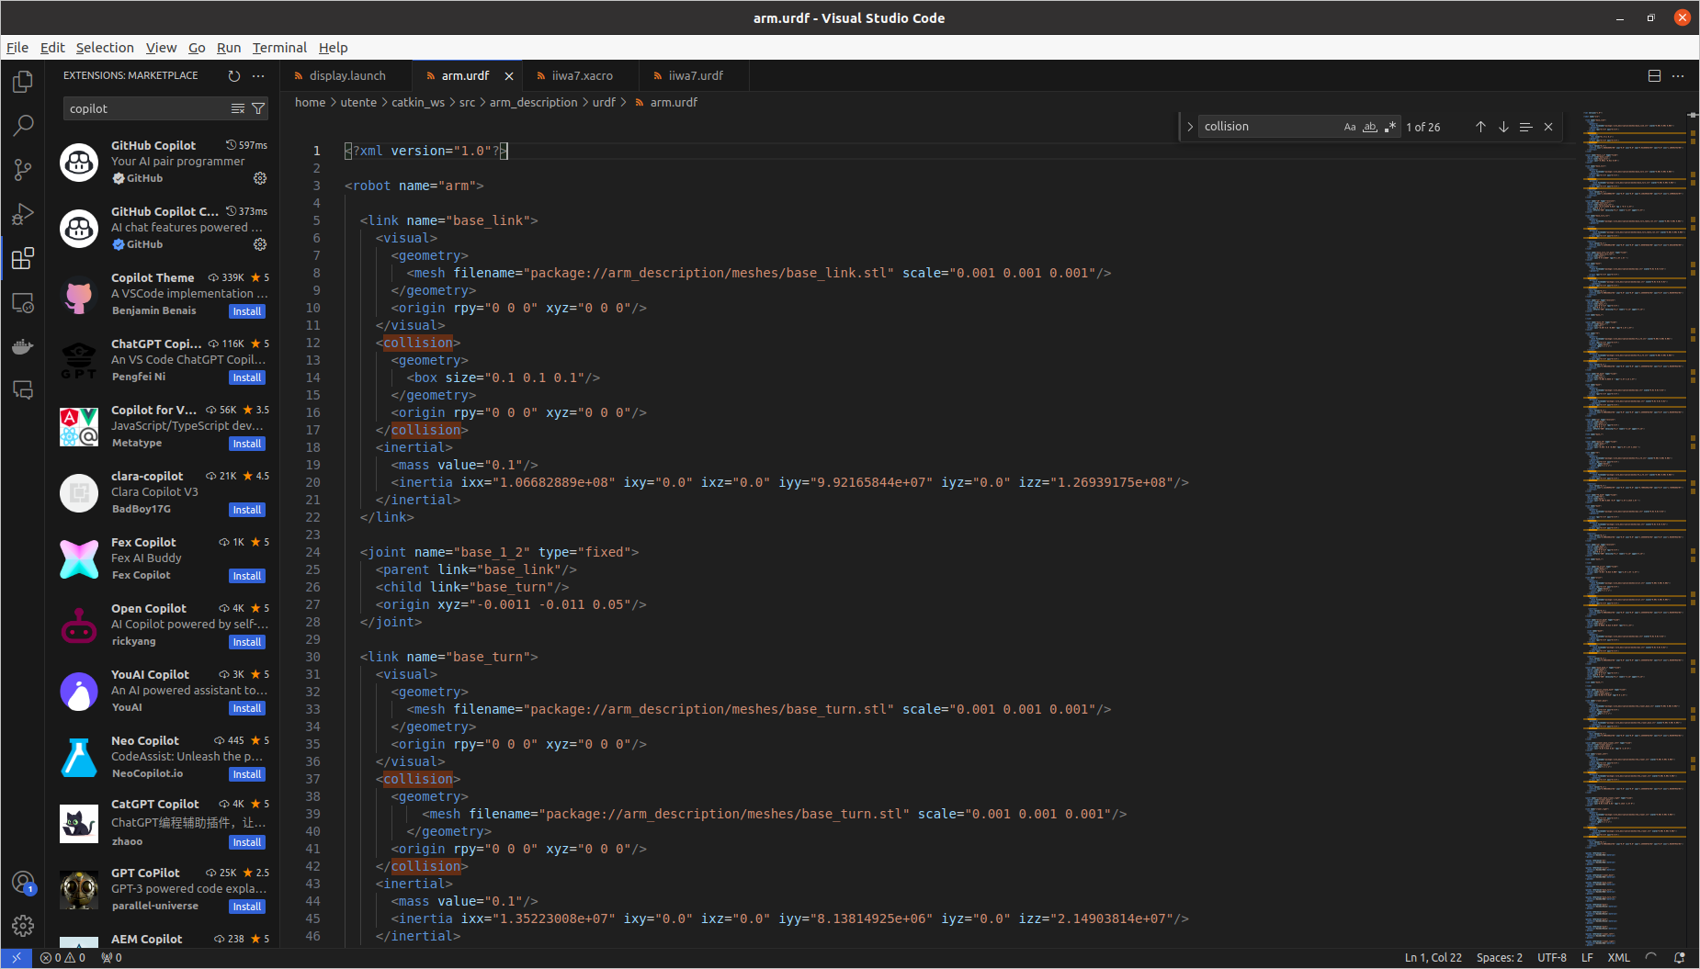

In the RVIZ GUI: RobotModel → Collision Enabled → ✓
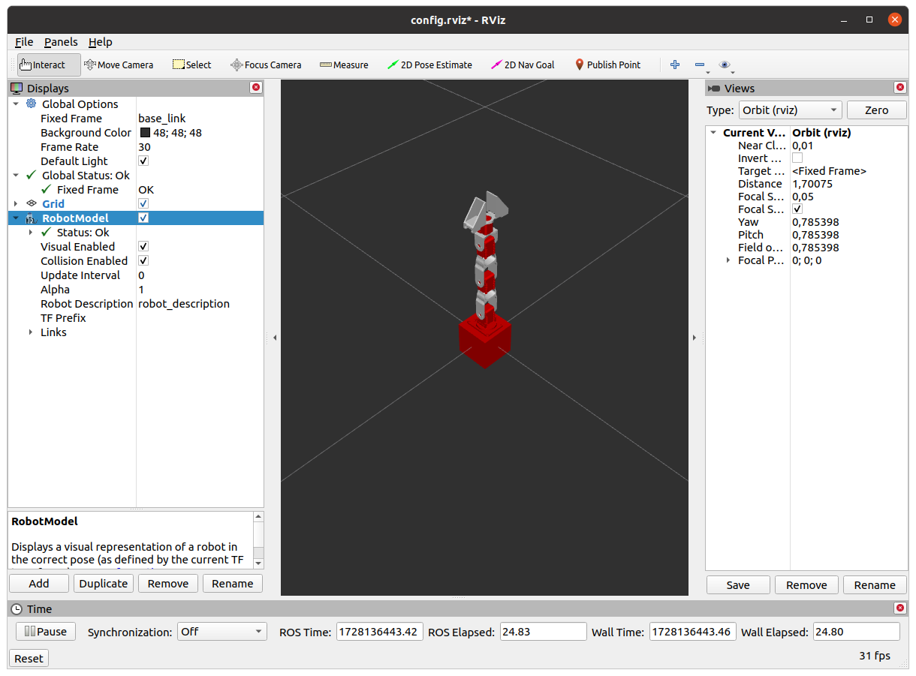

(d) Create a file named arm.gazebo.xacro within your package, define a xacro:macro inside your
file containing all the <gazebo> tags you find within your arm.urdf and import it in your URDF
using xacro:include. Remember to rename your URDF file to arm.urdf.xacro, add the string
xmlns:xacro="http://www.ros.org/wiki/xacro" within the <robot> tag, and load the URDF
in your launch file using the xacro routine

I created ~/catkin_ws/src/arm_description/urdf/arm.gazebo.xacro
$ cd ~/catkin_ws/src/arm_description/urdf
$ touch arm.gazebo.xacro

Taking inspiration from:
~/catkin_ws/src/iiwa_stack/iiwa_description/urdf/iiwa.gazebo.xacro
~/catkin_ws/src/iiwa_stack/iiwa_description/urdf/iia7.xacro
~/catkin_ws/src/iiwa_stack/iiwa_description/urdf/iiwa7.urdf.xacro

I filled ~/catkin_ws/src/arm_description/urdf/arm.gazebo.xacro:
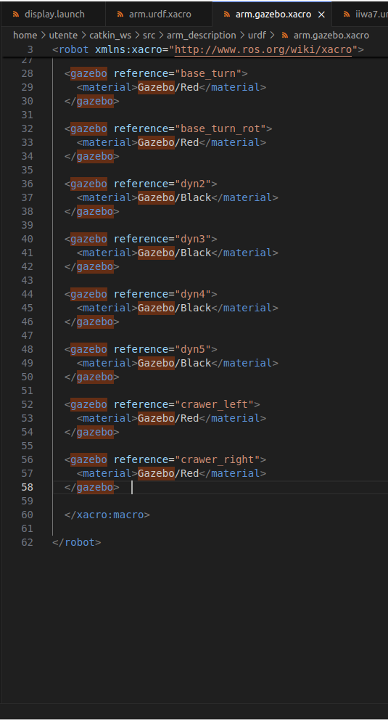
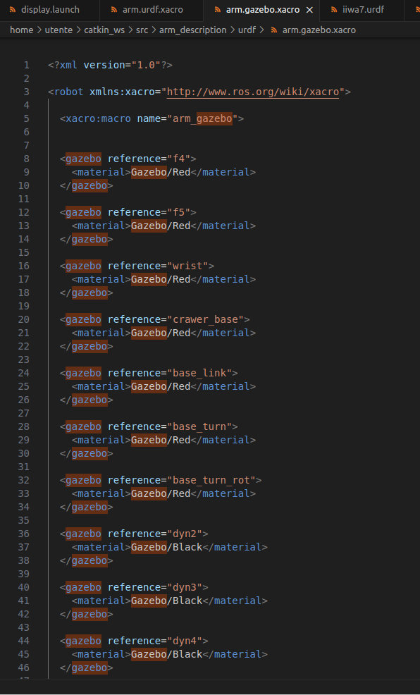

and renamed and modified ~/catkin_ws/src/arm_description/urdf/arm.urdf.xacro (ex “arm.urdf”) (raws 5,6; raw 407):

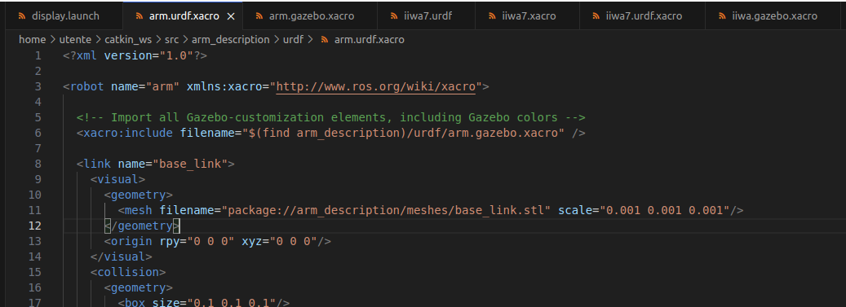
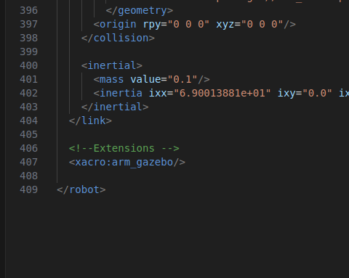

It’s important to notice that, when you include a “.xacro” file inside another “.xacro” file, in addition to include it, you must invoke the relative macro, to generate the desired matter in the model.

2. Add transmission and controllers to your robot and spawn it in Gazebo
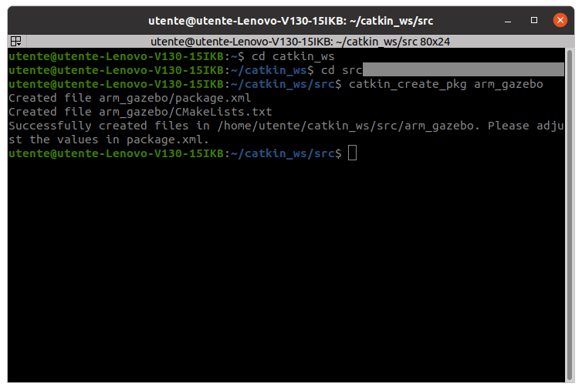
(a) Create a package named arm_gazebo

$ catkin_ws/src
$ catkin_create_pkg arm_gazebo

(b) Within this package create a launch folder containing a arm_world.launch file

$ cd launch
$ mkdir launch
$ cd launch
$ touch arm_world.launch

(c) Fill this launch file with commands that load the URDF into the ROS Parameter Server and spawn
your robot using the spawn_model node. Hint: follow the iiwa_world.launch example from the
package iiwa_stack: https://github.com/IFL-CAMP/iiwa_stack/tree/master. Launch the
arm_world.launch file to visualize the robot in Gazebo

Taking inspiration from:
~/catkin_ws/src/iiwa_stack/iiwa_gazebo/iiwa_world.launch

I filled “~catkin_ws/src/arm_gazebo/launch/arm_world.launch”:

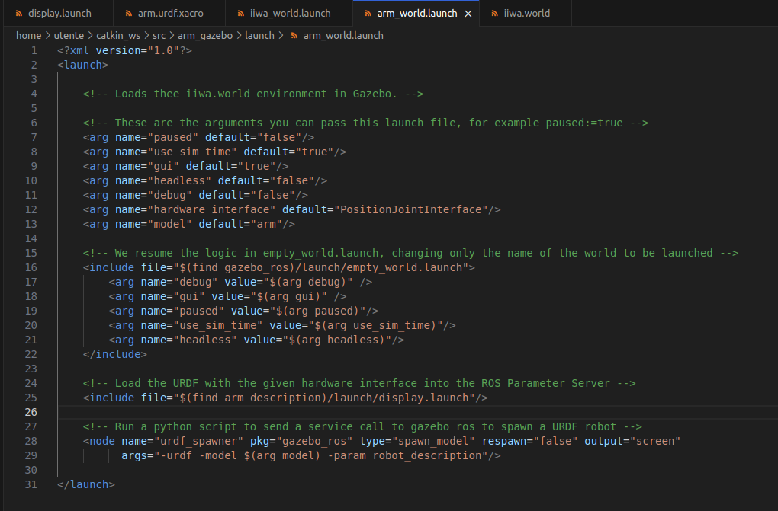

Then I launch it:
$ roslaunch arm_gazebo arm_world.launch

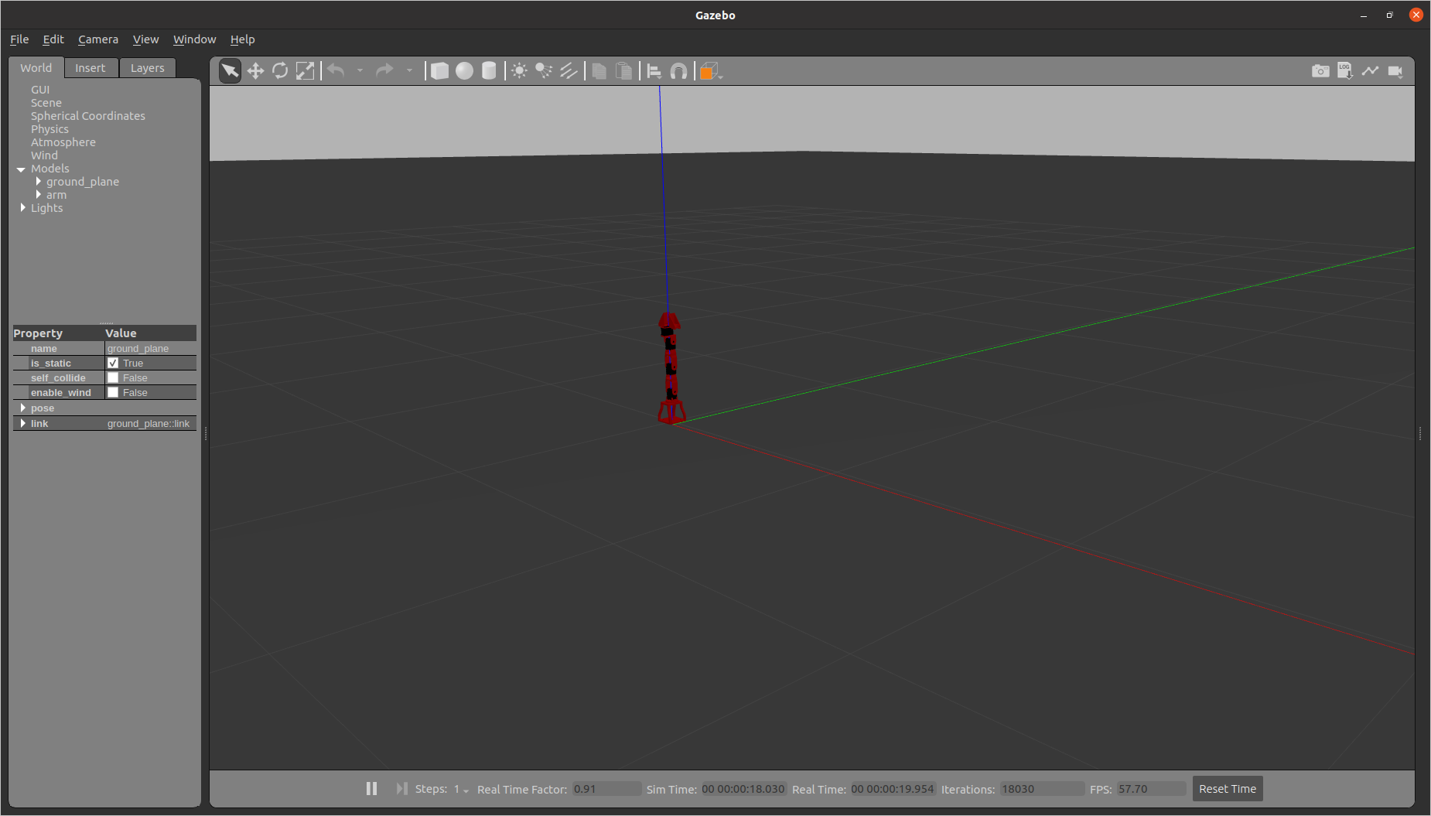

(d) Now add a PositionJointInterface as hardware interface to your robot: create a
arm.transmission.xacro file into your arm_description/urdf folder containing a xacro:macro
with the hardware interface and load it into your arm.urdf.xacro file using xacro:include.
Launch the file

$ cd ~/catkin_ws/src/arm_description/urdf
$ touch arm.transmission.xacro

Taking inspiration from:
~/catkin_ws/src/iiwa_stack/iiwa_description/urdf/iiwa.transmission.xacro

I filled “~/catkin_ws/src/arm_description/urdf/arm.transmission.xacro”:

“PositionJointInterface” is an interface that allows to control joint position, that means to use “position_controllers”: controllers that send as output position commands to robot joints.
Of course, I defined transmissions just for the non-fixed joints (j0, j1, j2, j3).

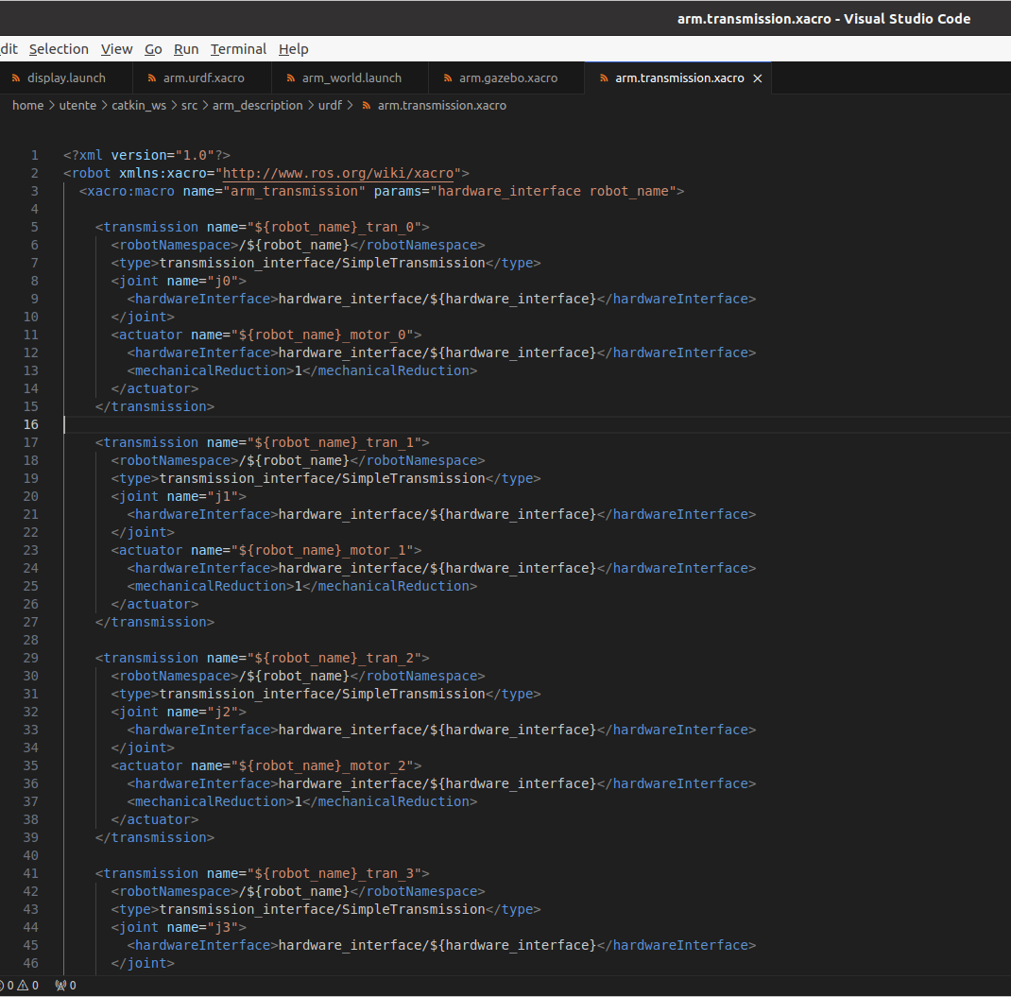

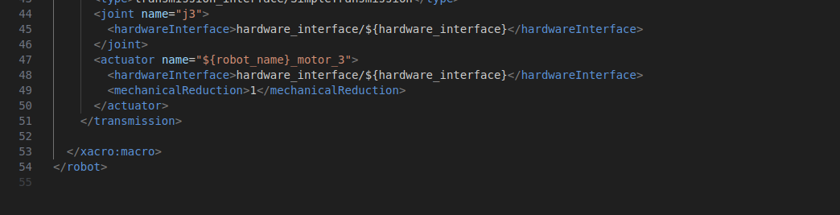

Then I modified “~/catkin_ws/src/arm_description/urdf/arm.urdf.xacro” (raws 8,9):

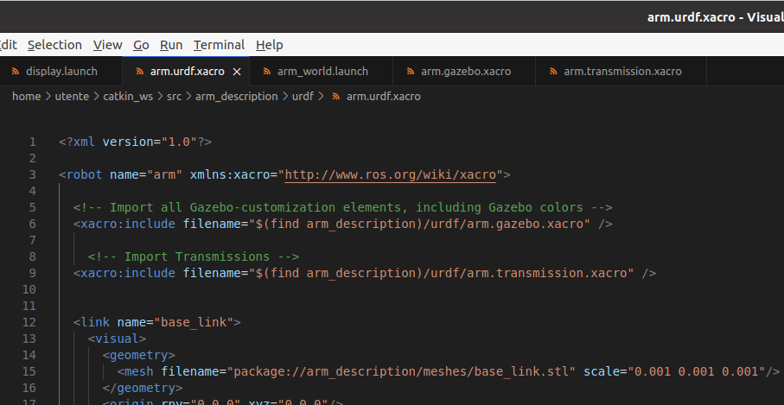

Remember to invoke even its macro (raw 412):

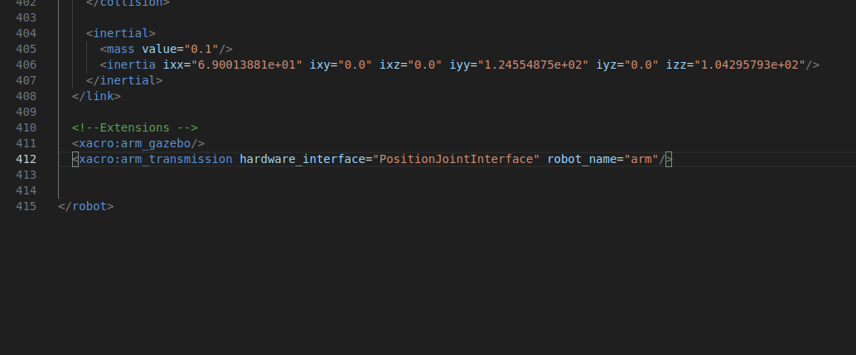

(e) Add joint position controllers to your robot: create a arm_control package with a
arm_control.launch file inside its launch folder and a arm_control.yaml file within its config
folder
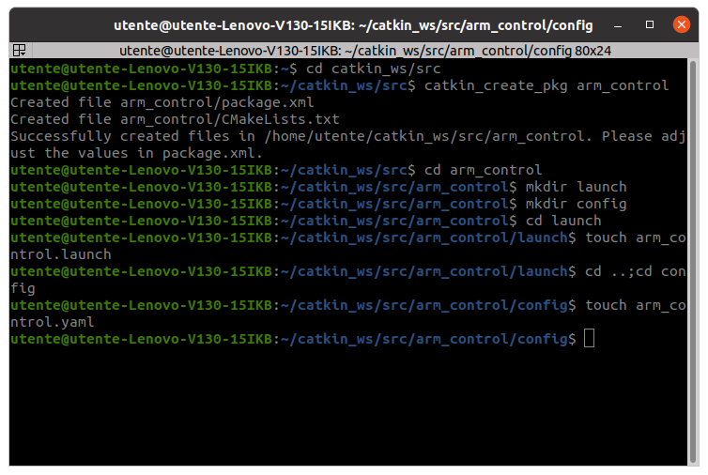

(f) Fill the arm_control.launch file with commands that load the joint controller configurations from
the .yaml file to the parameter server and spawn the controllers using the controller_manager
package. Hint: follow the iiwa_control.launch example from corresponding package

(g) Fill the arm arm_control.yaml adding a joint_state_controller and a
JointPositionController to all the joints

(h) Create an arm_gazebo.launch file into the launch folder of the arm_gazebo package loading the
Gazebo world with arm_world.launch and spawning the controllers within arm_control.launch.
Go to the arm_description package and add the gazebo_ros_control plugin to your main
URDF into the arm.gazebo.xacro file. Launch the simulation and check if your controllers are
correctly loaded

It was such a mess! I had to do all these three points together!

Taking inspiration from:
~/catkin_ws/src/iiwa_stack/iiwa_control/iiwa_control.launch
~/catkin_ws/src/iiwa_stack/iiwa_control/config/iiwa_control.yaml
~/catkin_ws/src/iiwa_stack/iiwa_gazebo/launch/iiwa_gazebo.launch

I filled the “~/catkin_ws/src/arm_control/config/arm_control.yaml” (just non-fixed joints):

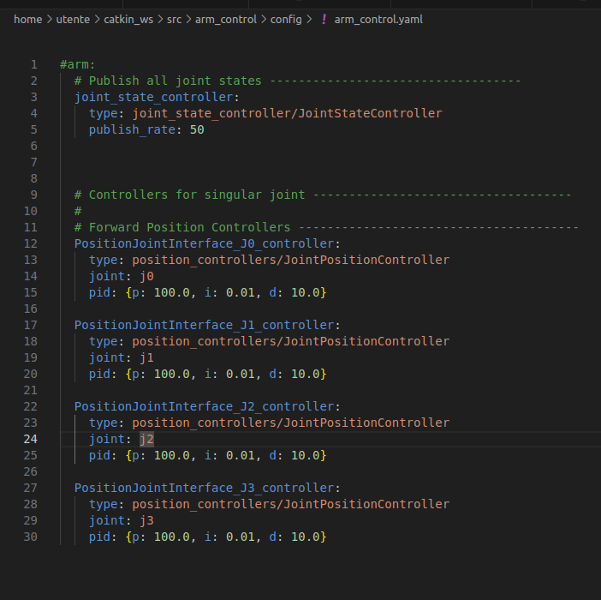

Then the “~/catkin_ws/src/arm_control/config/arm_control.launch”:
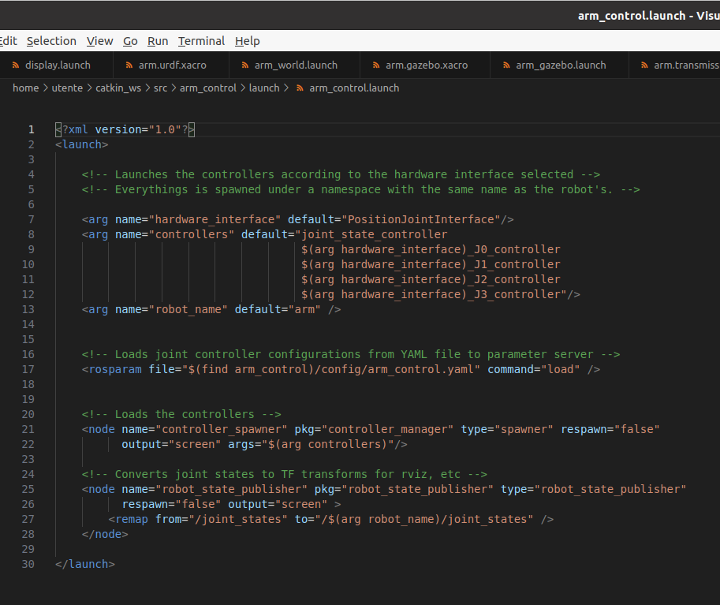

And then I created a “~/catkin_ws/src/arm_gazebo/launch/arm_gazebo.launch:

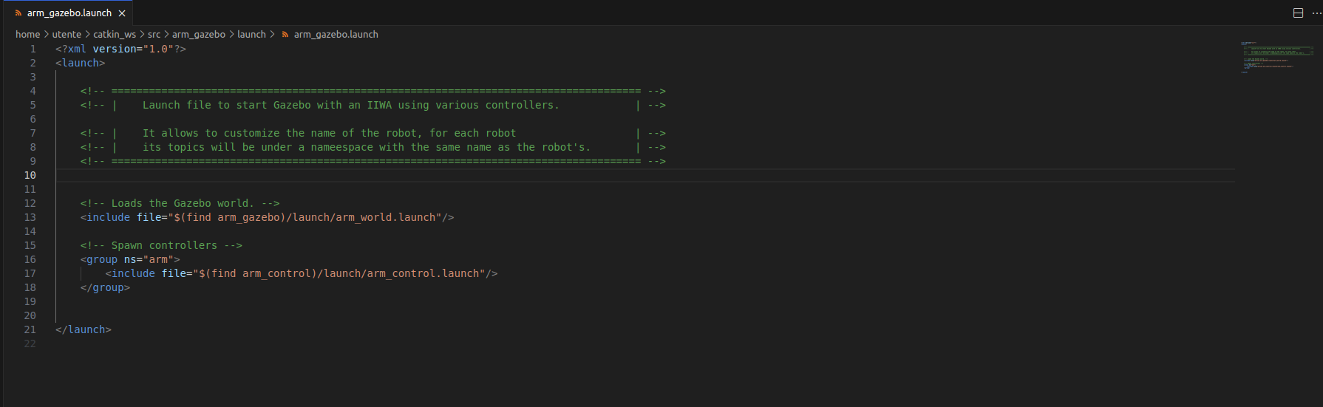

In particular, in this last file, I had to create an “arm” namespace for the “arm_control.launch” file, such that all the names conflict’s problems could be avoided (see “robot_state_publisher” node). The use of “ns=arm" means that all topics, parameters, and other elements launched within that group will be prefixed with “arm/”.

Finally, I added the gazebo_ros_control plugin in “arm.gazebo.xacro”:

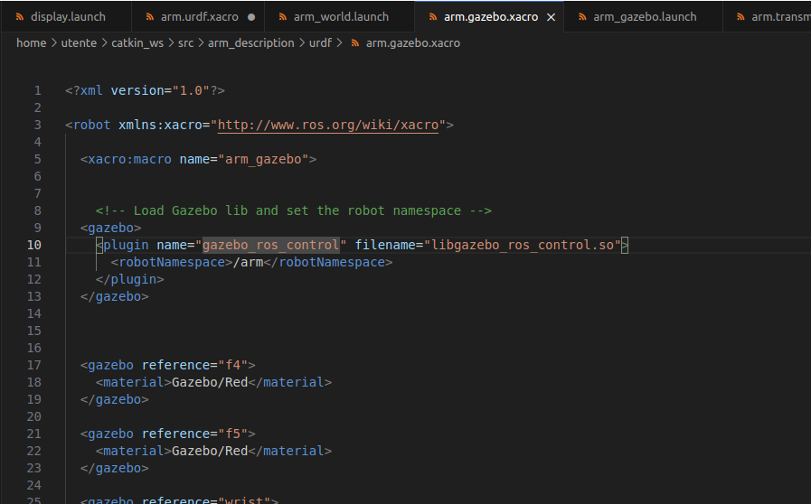

Simulation:
$ roslaunch arm_gazebo arm_gazebo.launch
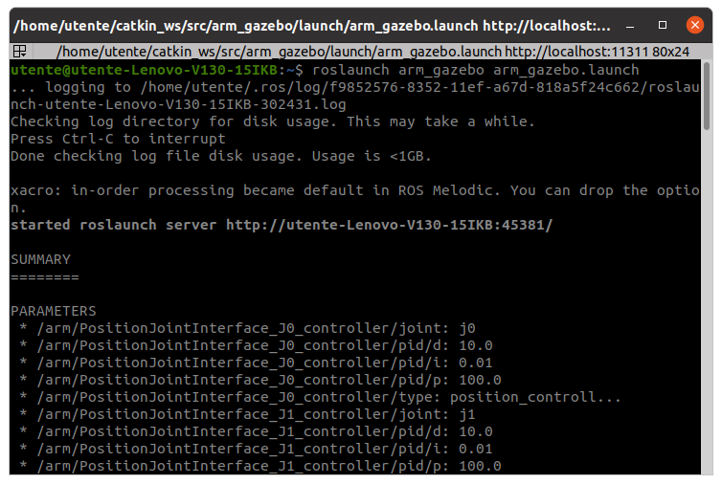

And thanks to the screen below, we can say that controllers have been correctly loaded:
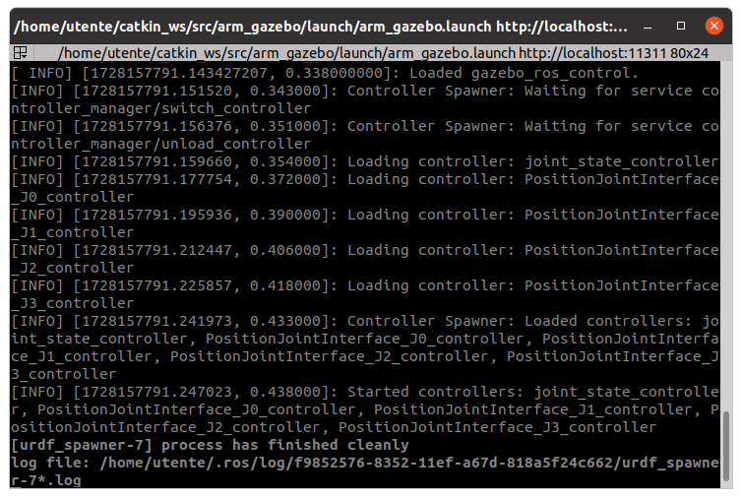

3. Add a camera sensor to your robot

(a) Go into your arm.urdf.xacro file and add a camera_link and a fixed camera_joint with
base_link as a parent link. Size and position the camera link opportunely

Taking inspiration from:
~/catkin_ws/src/iiwa_stack/iiwa_description/urdf/iiwa14.urdf
~/catkin_ws/src/iiwa_stack/iiwa_description/urdf/iiwa14.urdf.xacro
~/catkin_ws/src/iiwa_stack/iiwa_description/urdf/iiwa14.xacro
~/catkin_ws/src/iiwa_stack/iiwa_description/urdf/iiwa.gazebo.xacro

I modified “~/catkin_ws/src/arm_description/urdf/arm.urdf.xacro”:
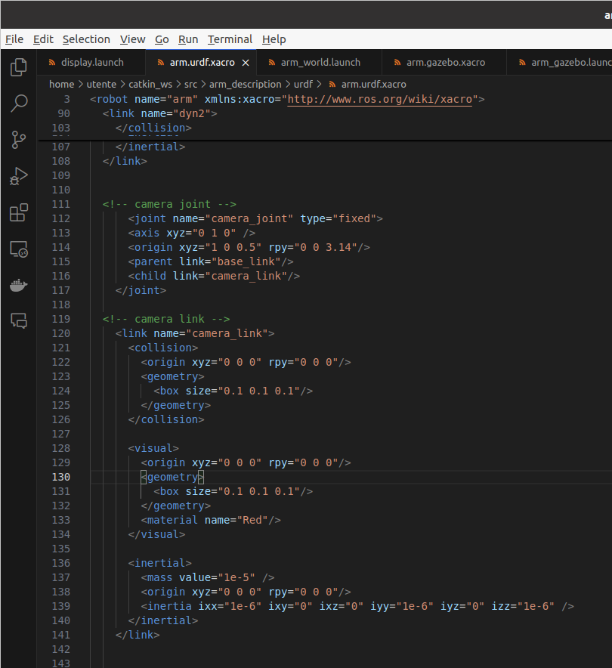

In particular, I put the camera about 1 m away on the x axis, 0 m away on the y axis and 0.5 m away on the z axis from the base_link positioned in the origin of the spatial frame, and since the camera originally is oriented on the same direction and verse of the x axis, I rotated it of 180° (3.14 = pi rads), so that the camera can see the robot itself.

And “~/catkin_ws/src/arm_description/urdf/arm.gazebo.xacro”:
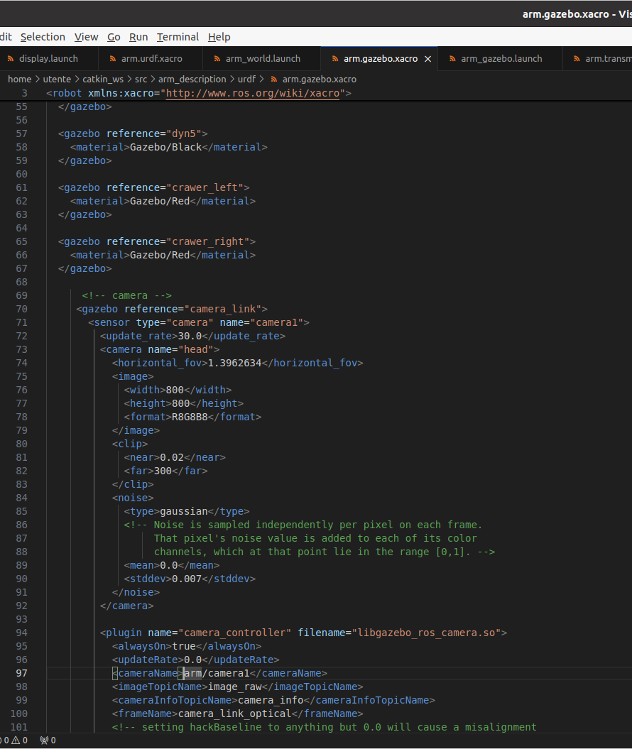
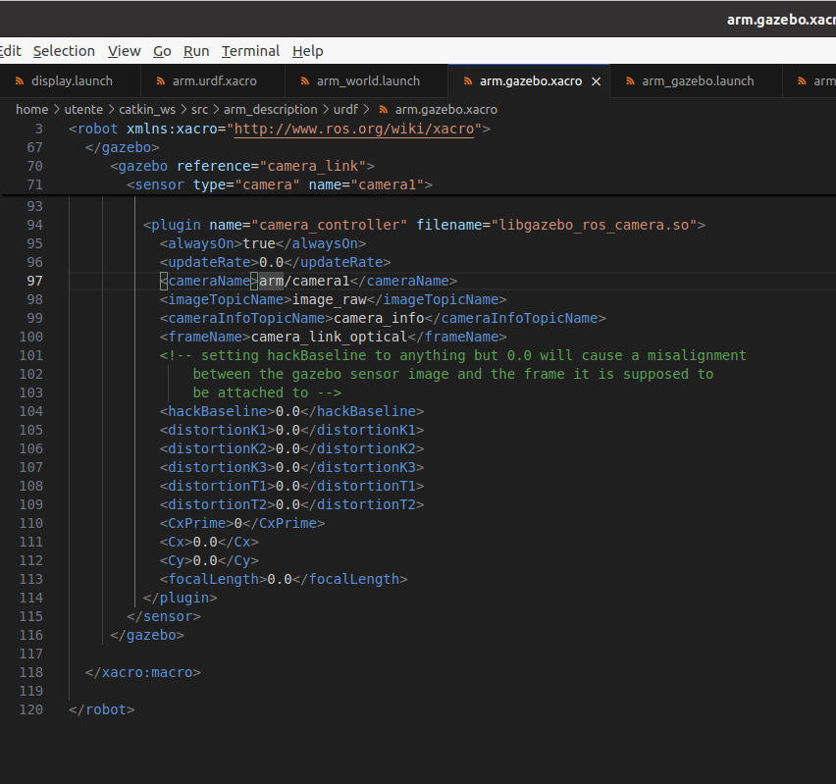

2 topics will spawn: arm/camera1/image_raw and arm/camera1/camera_info

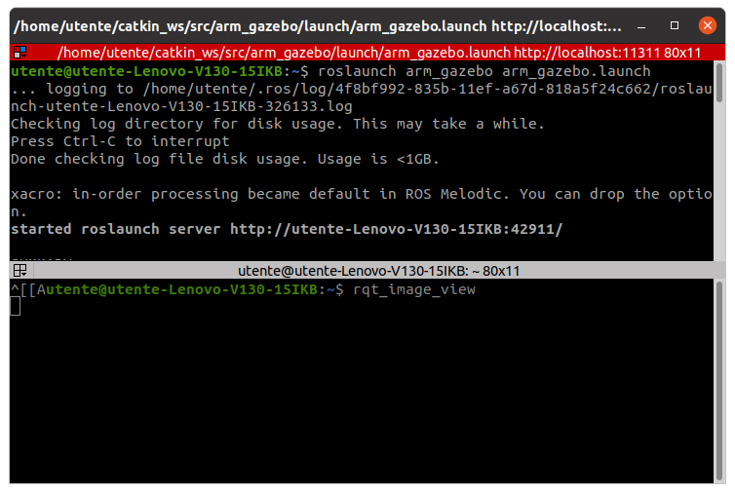
Simulation :

$ roslaunch arm_gazebo arm_gazebo.launch (terminal 1)
$ rqt_image_view (terminal 2)

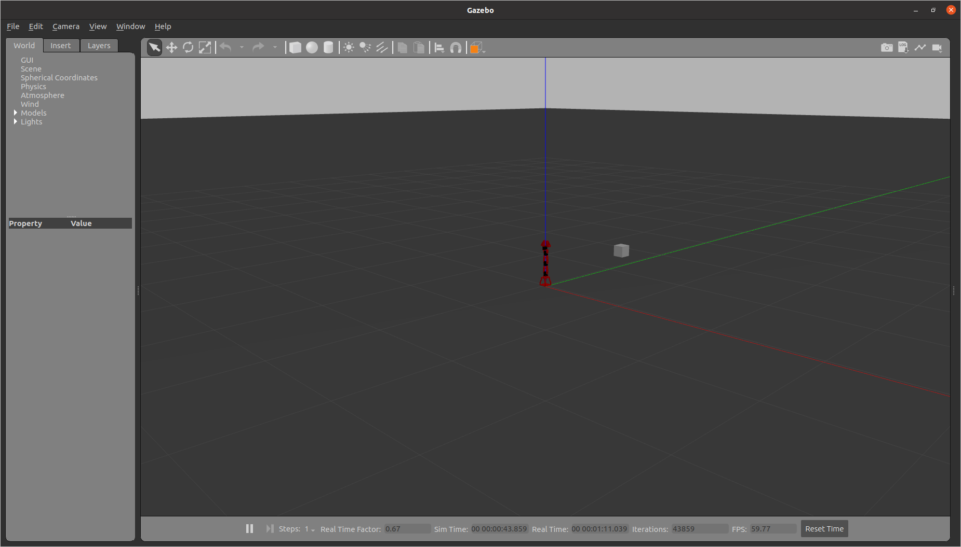

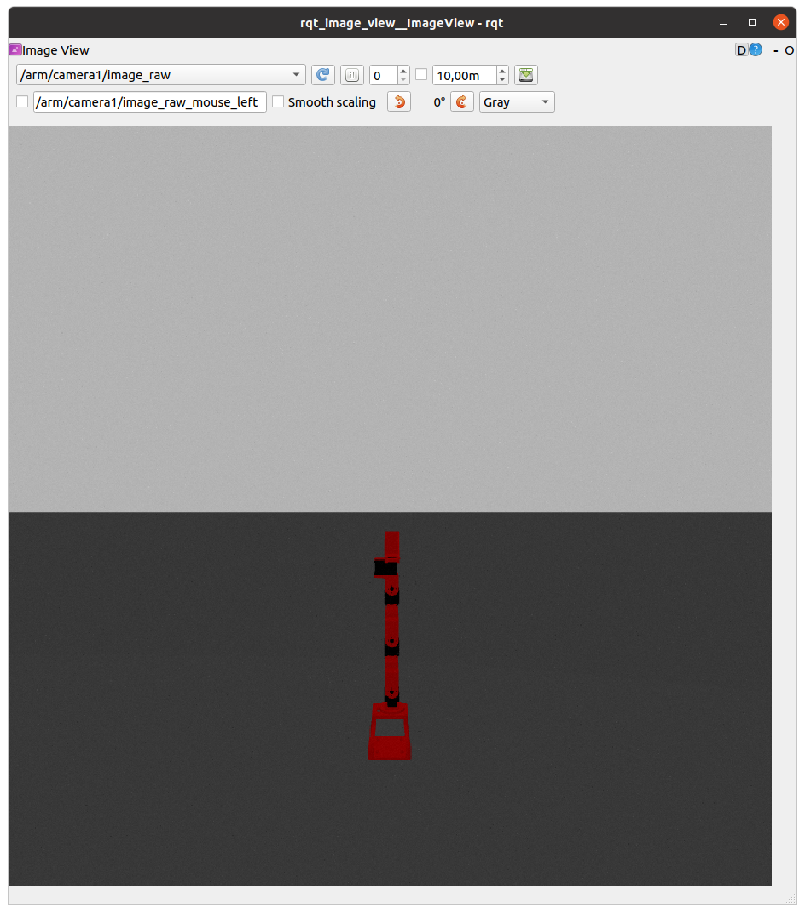

rqt_image_view GUI → arm/camera1/image_raw → ✓

4. Create a ROS publisher node that reads the joint state and sends joint position commands to your
robot

(a) Create an arm_controller package with a ROS C++ node named arm_controller_node. The
dependencies are roscpp, sensor_msgs and std_msgs. Modify opportunely the CMakeLists.txt
file to compile your node. Hint: uncomment add_executable and target_link_libraries lines

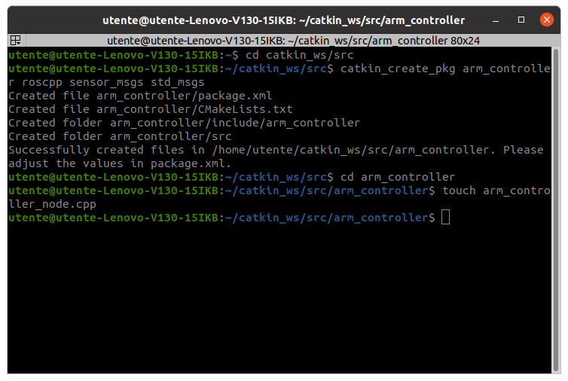
$ cd catkin_ws/src
$ catkin_create_pkg arm_controller roscpp sensor_msgs std_msgs
$ cd arm_controller
$ touch arm_controller_node.cpp

(nodes are executable, and we will generate one from a C++ source file)

Then I modified the “~/catkin_ws/src/arm_controller/CMakeLists.txt” to compile our node:

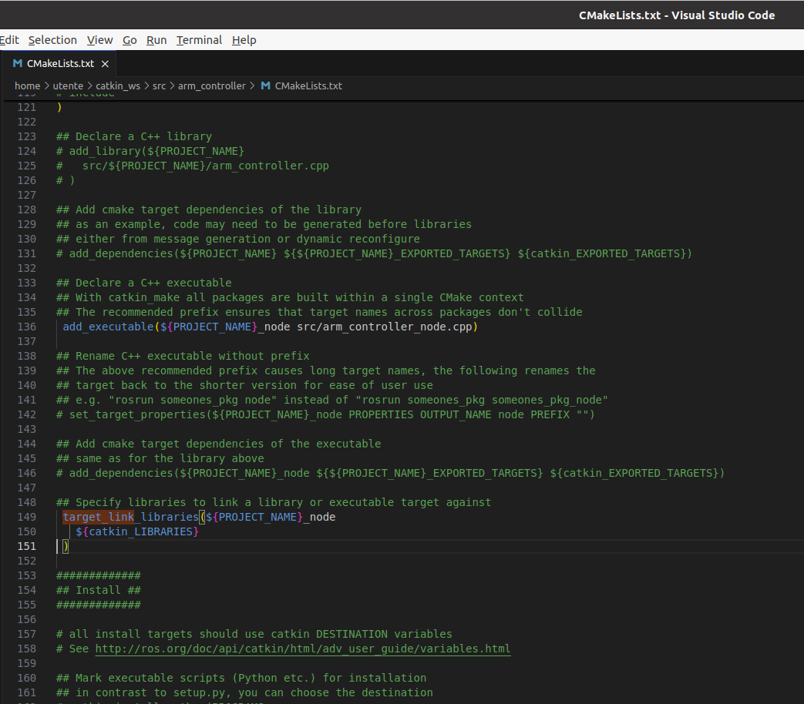

(b) Create a subscriber to the topic joint_states and a callback function that prints the current
joint positions (see Slide 45). Note: the topic contains a sensor_msgs/JointState

(c) Create publishers that write commands onto the controllers’ /command topics (see Slide 46). Note:
the command is a std_msgs/Float64

Finally I filled “~/catkin_ws/src/arm_controller/arm_controller_node.cpp”:

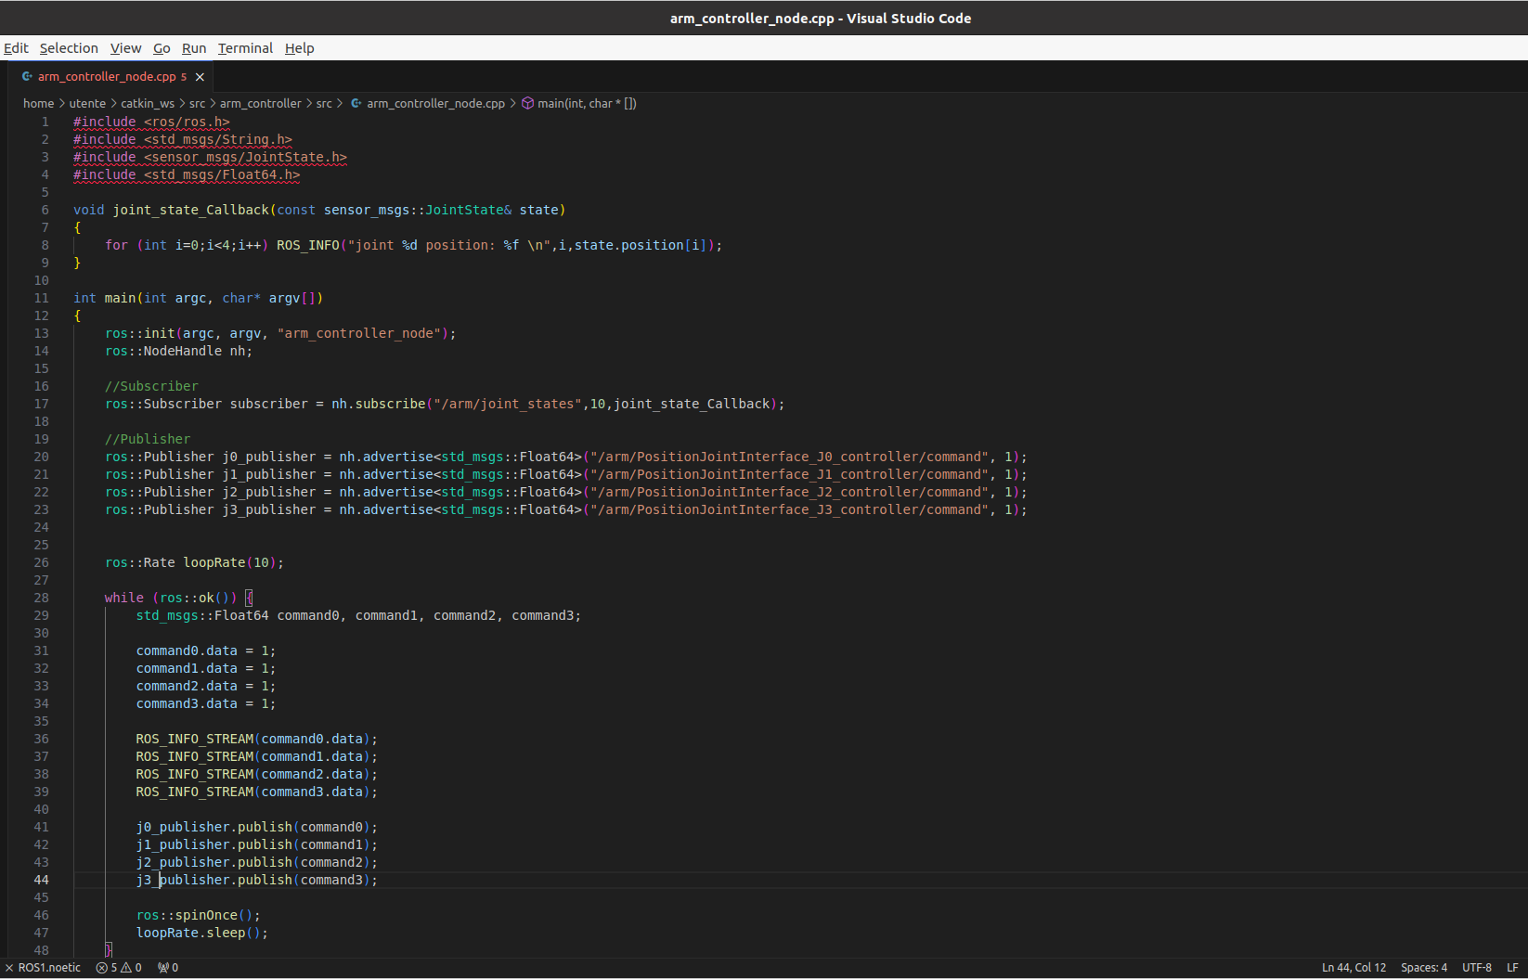
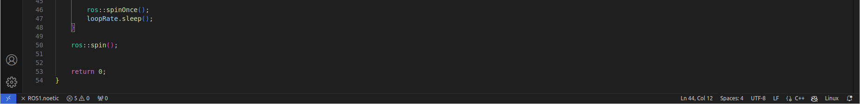

In this way, it prints both joints commands and joints positions.

Simulation:

$ roslaunch arm_gazebo arm_gazebo.launch (terminal 1)

$ cd catkin_ws (terminal 2)
$ catkin build arm_controller
$ source devel/setup.bash
$ rosrun arm_controller arm_controller_node

$ rqt_image_view (terminal 3)

rqt_image_view GUI → “arm/camera1/image_raw”



