Report – Homework 2
Student: Riccardo Stucovitz

1. Substitute the current trepezoidal velocity profile with a cubic polinomial linear trajectory

(a) Modify appropriately the KDLPlanner class (files kdl_planner.h and kdl_planner.cpp) that pro-
vides a basic interface for trajectory creation. First, define a new KDLPlanner::trapezoidal_vel
function that takes the current time t and the acceleration time tc as double arguments and re-
turns three double variables s, ṡ and s̈ that represent the curvilinear abscissa of your trajectory 1 .
Remember: a trapezoidal velocity profile for a curvilinear abscissa s ∈ [0, 1] is defined as follows
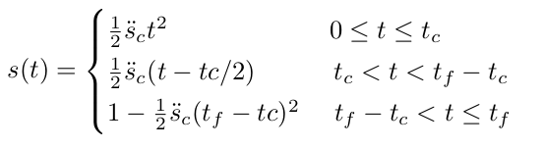

where tc is the acceleration duration variable while ṡ(t) and s̈(t) can be easily retrieved calculating
time derivative of (1).

On the base of "Robotics" di Siciliano → chapter 4 → eq (4.5), I modified “~/catkin_ws/src/kdl_robot/include/kdl_ros_control/kdl_planner.h”:
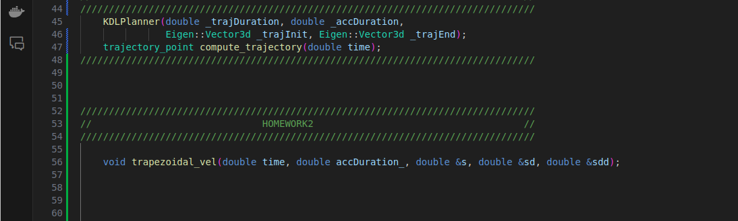

And “~/catkin_ws/src/kdl_robot/src/kdl_planner.cpp”:
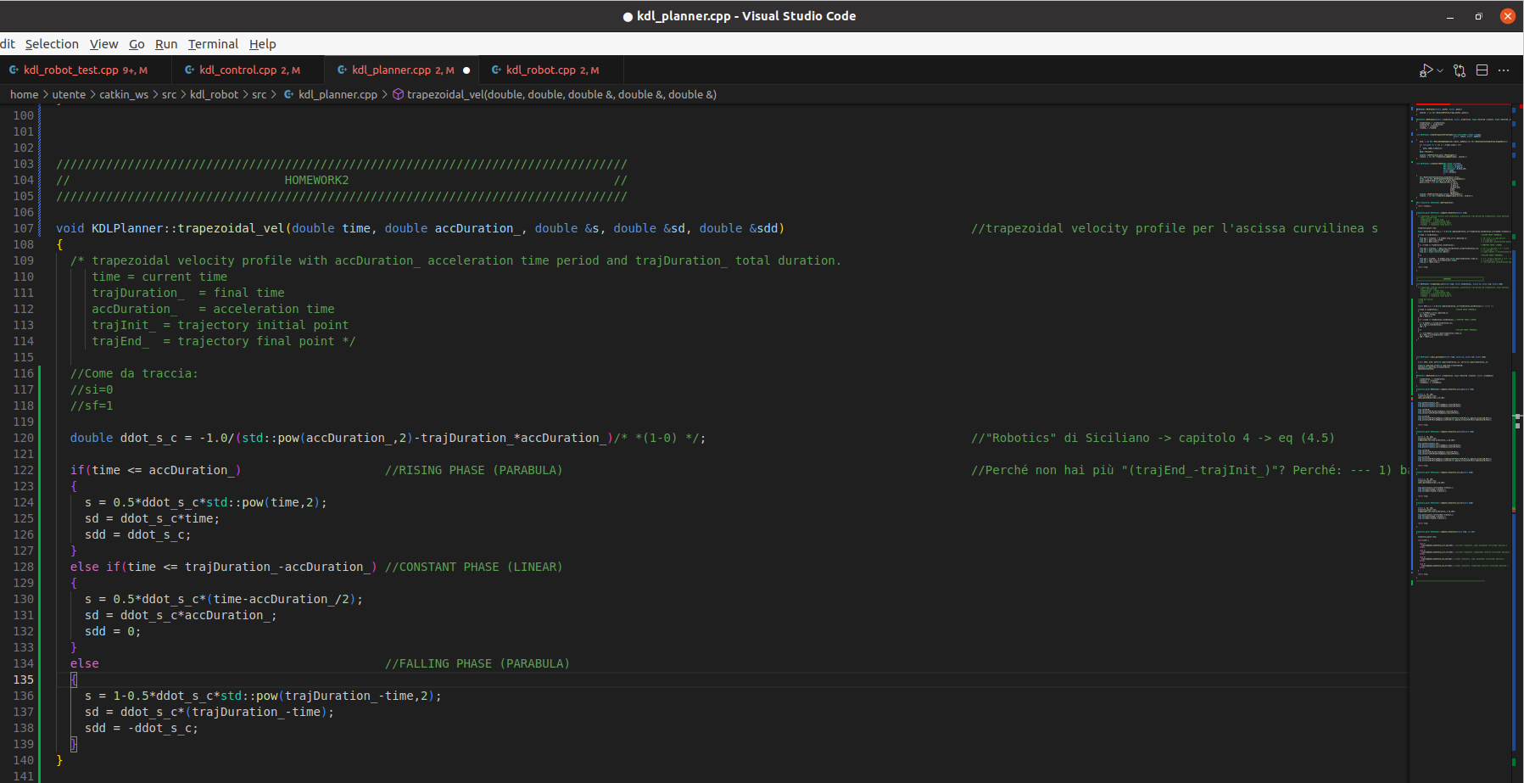

(b) Create a function named KDLPlanner::cubic_polinomial that creates the cubic polynomial
curvilinear abscissa for your trajectory. The function takes as argument a double t representing
time and returns three double s, ṡ and s̈ that represent the curvilinear abscissa of your trajectory.
Remember, a cubic polinomial is defined as follows
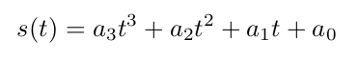
(2)
where coefficients a 3 , a 2 , a 1 , a 0 must be calculated offline imposing boundary conditions, while
ṡ(t) and s̈(t) can be easily retrieved calculating time derivative of (2).

On the base of "Robotics" di Siciliano → chapter 4 → eq (4.1), I modified “~/catkin_ws/src/kdl_robot/include/kdl_ros_control/kdl_planner.h”:
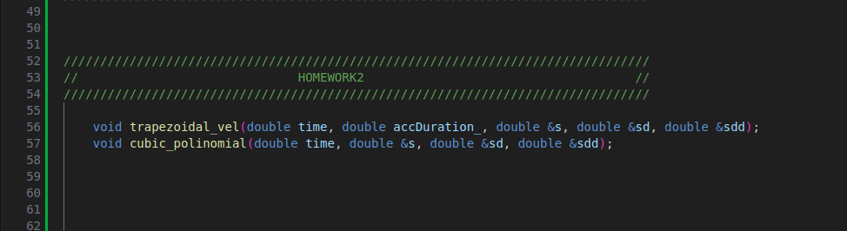

And “~/catkin_ws/src/kdl_robot/src/kdl_planner.cpp”:

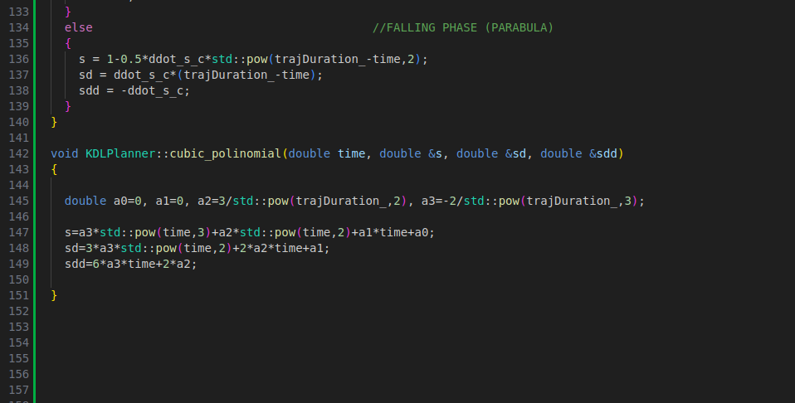

2. Create circular trajectories for your robot

(a) Define a new constructor KDLPlanner::KDLPlanner that takes as arguments the time duration
_trajDuration, the starting point Eigen::Vector3d _trajInit and the radius _trajRadius
of your trajectory and store them in the corresponding class variables (to be created in the
kdl_planner.h).

I modified “~/catkin_ws/src/kdl_robot/include/kdl_ros_control/kdl_planner.h”:
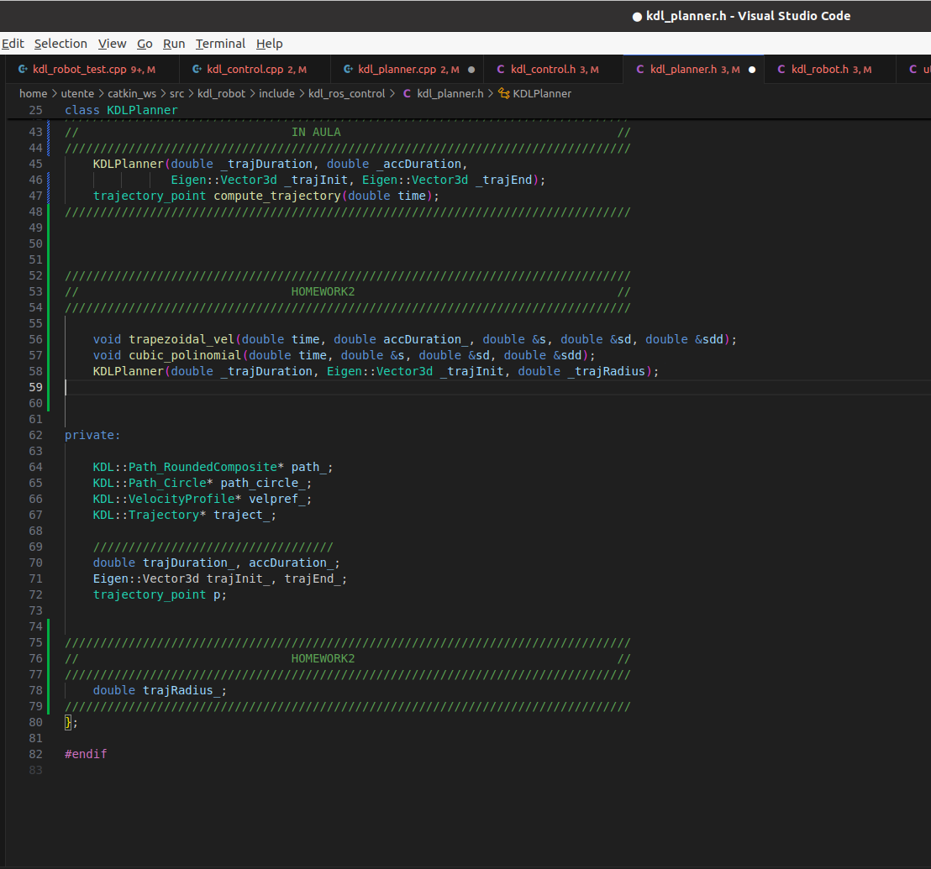

And “~/catkin_ws/src/kdl_robot/src/kdl_planner.cpp”:
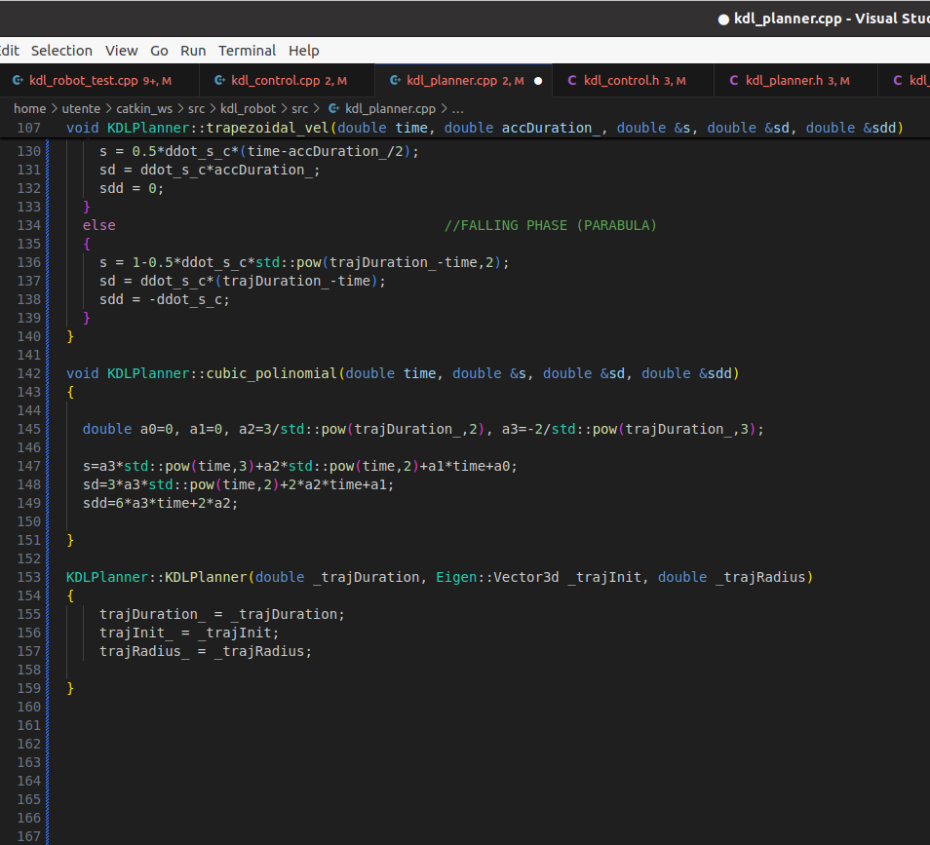

(b) The center of the trajectory must be in the vertical plane containing the end-effector. Create the
positional path as function of s(t) directly in the function KDLPlanner::compute_trajectory:
first, call the cubic_polinomial function to retrieve s and its derivatives from t; then fill in the
trajectory_point fields traj.pos, traj.vel, and traj.acc. Remember that a circular path in
the y − z plane can be easily defined as follows
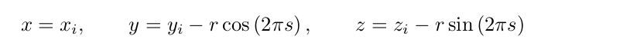

(c) Do the same for the linear trajectory.

3. Test the four trajectories

(a) At this point, you can create both linear and circular trajectories, each with trapezoidal velocity
of cubic polinomial curvilinear abscissa. Modify your main file kdl_robot_test.cpp and test the
four trajectories with the provided joint space inverse dynamics controller.

Unifying these three questions, I modified “~/catkin_ws/src/kdl_robot/include/kdl_ros_control/kdl_planner.h”:
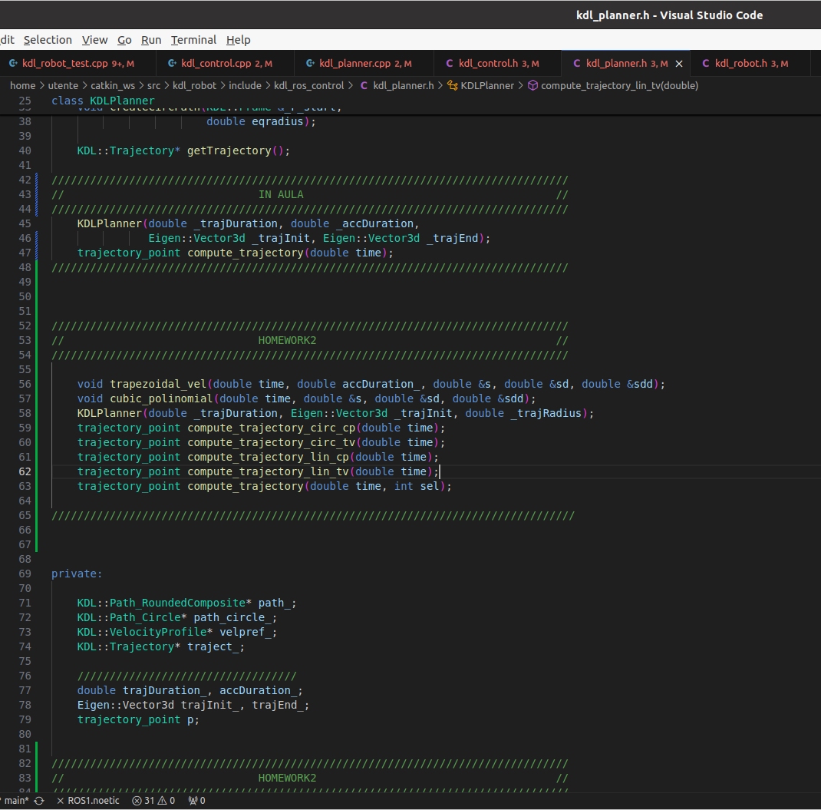

And “~/catkin_ws/src/kdl_robot/src/kdl_planner.cpp”:

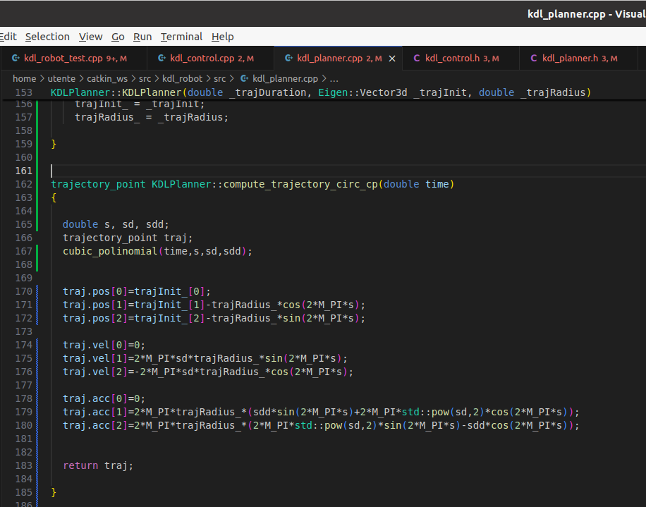

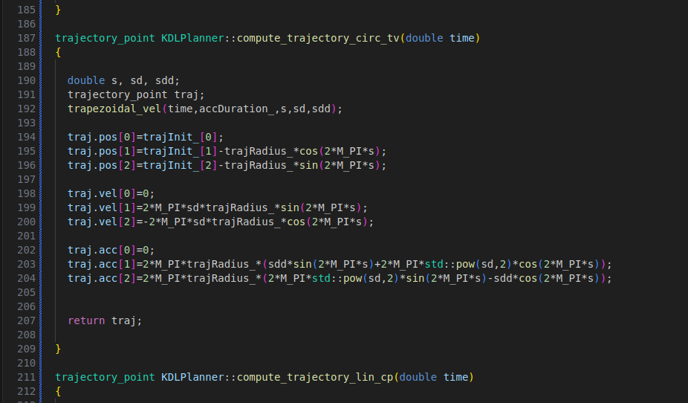

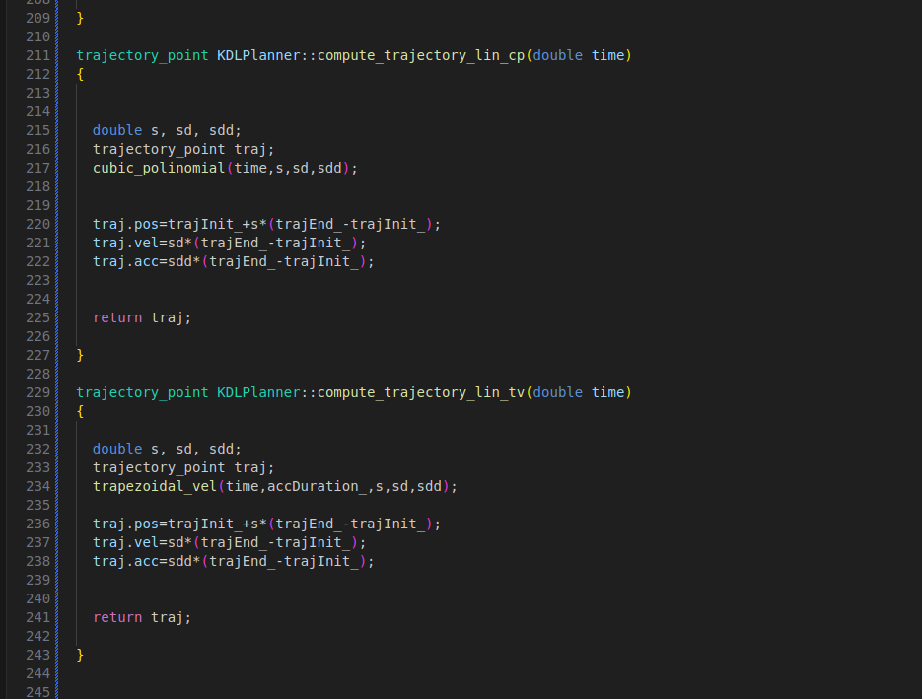

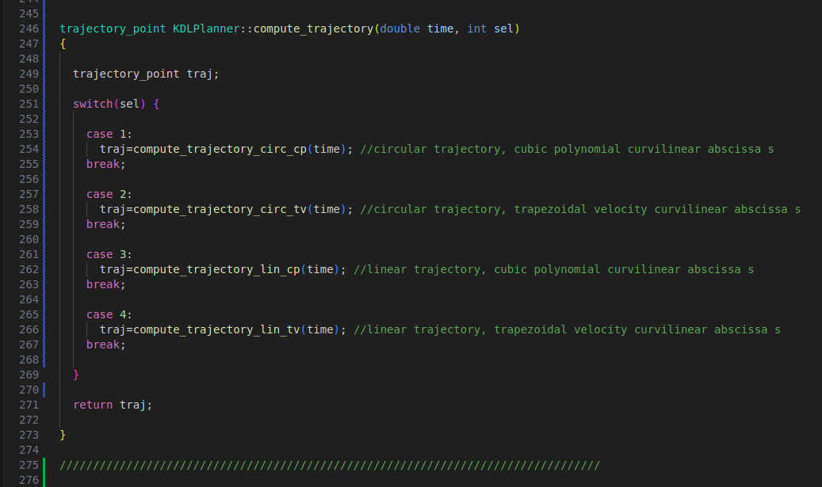

(b) Plot the torques sent to the manipulator and tune appropriately the control gains Kp and Kd until
you reach a satisfactorily smooth behavior. You can use rqt_plot to visualize your torques at
each run, save the screenshot.

//Inverse Dynamics Controller in joint space
//Circular trajectory
//Cubic polynomial curvilinear abscissa s

In “~/catkin_ws/src/kdl_robot/src/kdl_robot_test.cpp” I modified:

19 → int selection=1;
155 → KDLPlanner planner(traj_duration, init_position, radius);
159 → trajectory_point p = planner.compute_trajectory(t,selection);
162 → double Kp = 50, Kd = sqrt(Kp);
190 → p = planner.compute_trajectory(0.0,selection);
195 → p = planner.compute_trajectory(t-init_time_slot,selection);
224 → tau = controller_.idCntr(qd, dqd, ddqd, Kp, Kd);

Simulation:

$ roslaunch iiwa_gazebo iiwa_gazebo_effort.launch (terminal 1)

$ cd ~/catkin_ws (terminal 2)
$ catkin build kdl_ros_control
$ source devel/setup.bash
$ rosrun kdl_ros_control kdl_robot_test ./src/iiwa_stack/iiwa_description/urdf/iiwa14.urdf

$ rqt_plot (terminal 3)

Our kuka iiwa lwr 14 will start in the initial configuration:
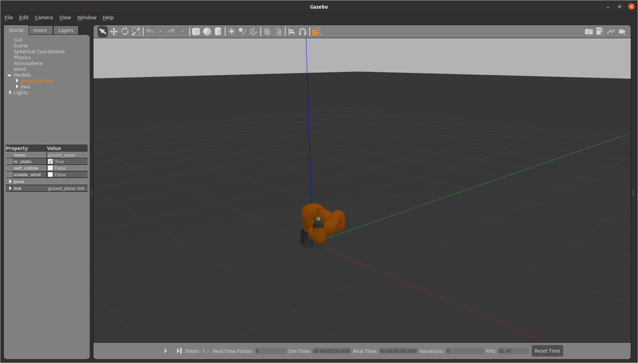

Gazebo GUI → “Play” (bottom left)
Rqt_plot GUI → select “iiwa/iiwa_joint_i_effort_controller/command” for all the 7 controllers

Kp = 50, Kd = sqrt(Kp)
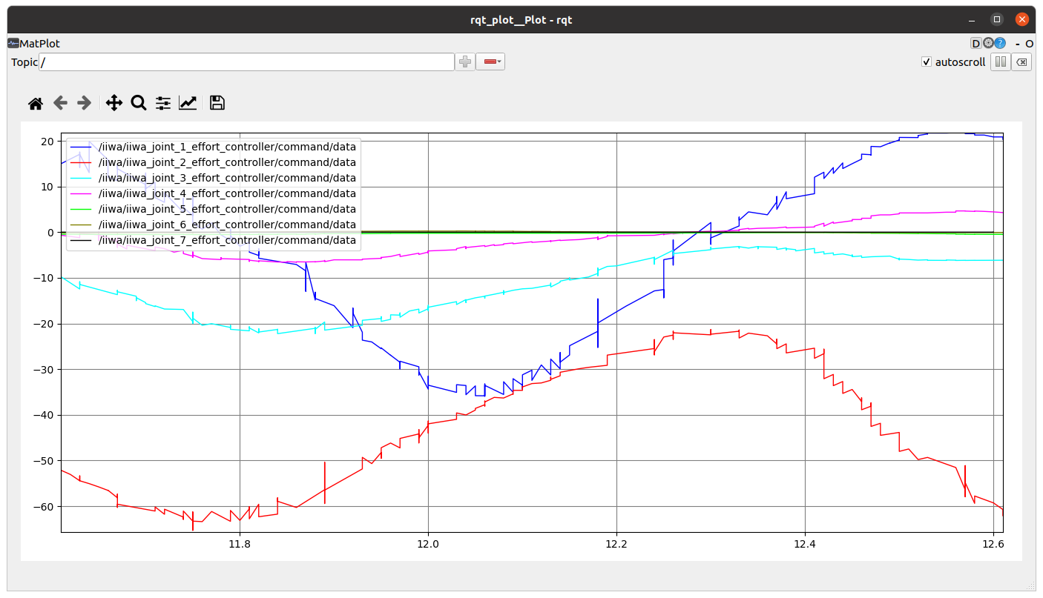

- Smooth plots
- Good trajectory tracking
- Robot terminates its trajectory

Kp = 20, Kd = sqrt(Kp)

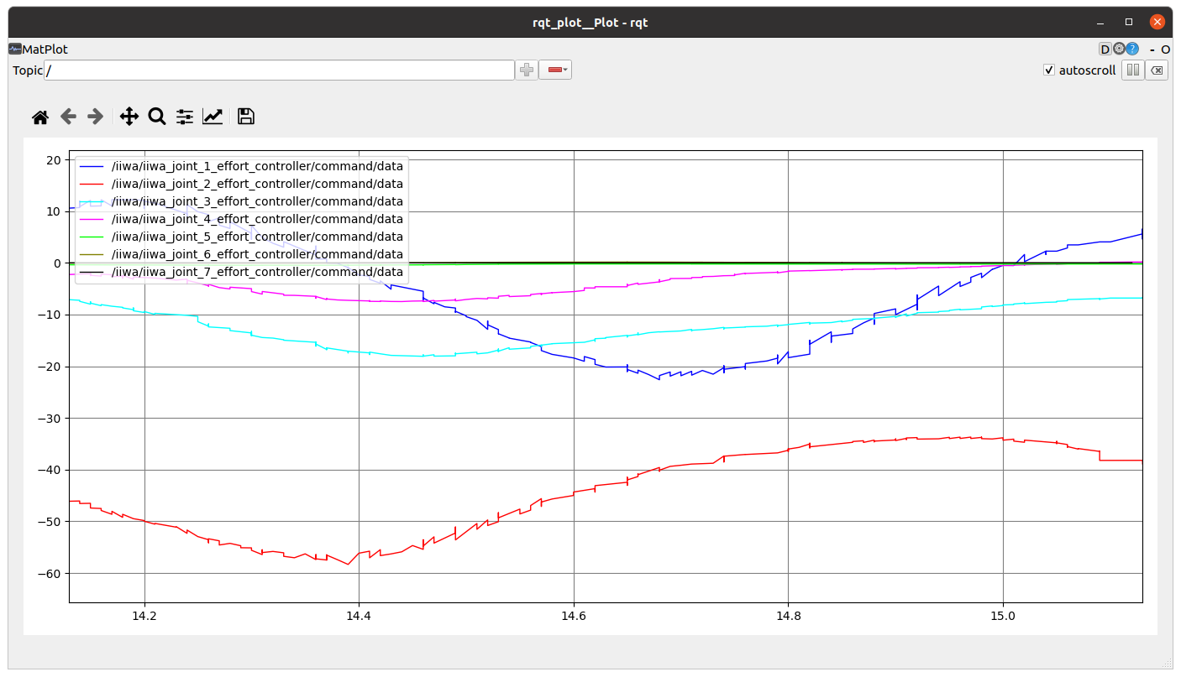

- Smoothness increases
- Worse trajectory tracking
- Robot doesn’t terminate its trajectory

Kp = 150, Kd = sqrt(Kp)

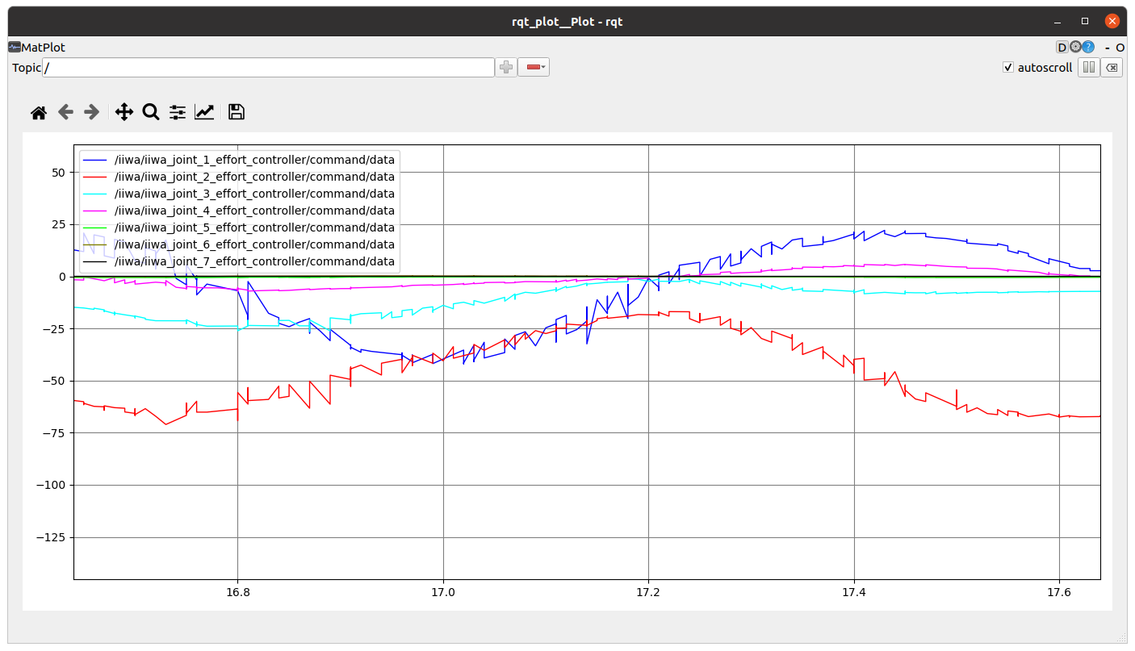

- Smoothness decreases
- Better trajectory tracking
- Robot terminate its trajectory in less time than the first case

In all the other simulation, I had similar results.

//Inverse Dynamics Controller in joint space
//Circular trajectory
//Trapezoidal velocity curvilinear abscissa s

In “~/catkin_ws/src/kdl_robot/src/kdl_robot_test.cpp” I modified:

19 → int selection=2;
155 → KDLPlanner planner(traj_duration, init_position, radius);
159 → trajectory_point p = planner.compute_trajectory(t,selection);
162 → double Kp = 50, Kd = sqrt(Kp);
190 → p = planner.compute_trajectory(0.0,selection);
195 → p = planner.compute_trajectory(t-init_time_slot,selection);
224 → tau = controller_.idCntr(qd, dqd, ddqd, Kp, Kd);

//Inverse Dynamics Controller in joint space
//Linear trajectory
//Cubic polynomial curvilinear abscissa s

In “~/catkin_ws/src/kdl_robot/src/kdl_robot_test.cpp” I modified:

19 → int selection=3;
155 → KDLPlanner planner(traj_duration, acc_duration, init_position, end_position);
159 → trajectory_point p = planner.compute_trajectory(t,selection);
162 → double Kp = 50, Kd = sqrt(Kp);
190 → p = planner.compute_trajectory(0.0,selection);
195 → p = planner.compute_trajectory(t-init_time_slot,selection);
224 →tau = controller_.idCntr(qd, dqd, ddqd, Kp, Kd);

//Inverse Dynamics Controller in joint space
//Linear trajectory
//Trapezoidal velocity curvilinear abscissa s

In “~/catkin_ws/src/kdl_robot/src/kdl_robot_test.cpp” I modified:

19 → int selection=4;
155 → KDLPlanner planner(traj_duration, acc_duration, init_position, end_position);
159 → trajectory_point p = planner.compute_trajectory(t,selection);
162 → double Kp = 50, Kd = sqrt(Kp);
190 → p = planner.compute_trajectory(0.0,selection);
195 → p = planner.compute_trajectory(t-init_time_slot,selection);
224 →tau = controller_.idCntr(qd, dqd, ddqd, Kp, Kd);

4. Develop an inverse dynamics operational space controller

(a) Into the kdl_contorl.cpp file, fill the empty overlayed KDLController::idCntr function to
implement your inverse dynamics operational space controller. Differently from joint space inverse
dynamics controller, the operational space controller computes the errors in Cartesian space.
Thus the function takes as arguments the desired KDL::Frame pose, the KDL::Twist velocity and,
the KDL::Twist acceleration. Moreover, it takes four gains as arguments: _Kpp position error
proportional gain, _Kdp position error derivative gain and so on for the orientation.

(b) The logic behind the implementation of your controller is sketched within the function: you must
calculate the gain matrices, read the current Cartesian state of your manipulator in terms of end-
effector parametrized pose x, velocity ẋ, and acceleration ẍ, retrieve the current joint space inertia
matrix M and the Jacobian (compute the analytic Jacobian) and its time derivative, compute the
linear e p and the angular e o errors (some functions are provided into the include/utils.h file),
finally compute your inverse dynamics control law following the equation
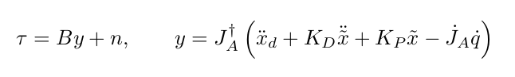

(4)

(c) Test the controller along the planned trajectories and plot the corresponding joint torque com-
mands.

On the base of "Robotics" di Siciliano → chapters 2 – 3, I modified “~/catkin_ws/src/kdl_robot/include/kdl_ros_control/utils.h”:

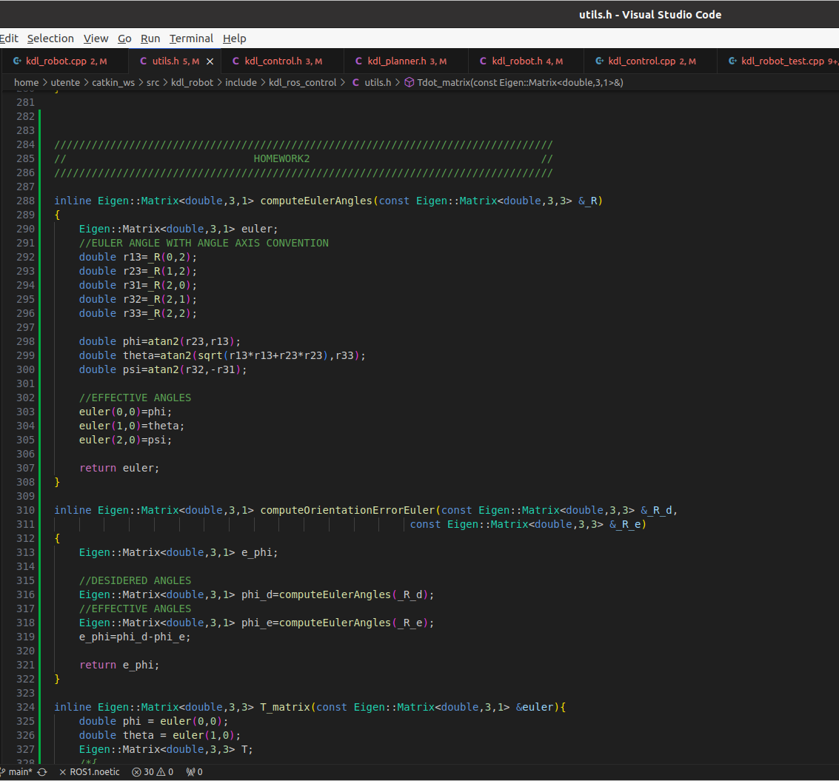

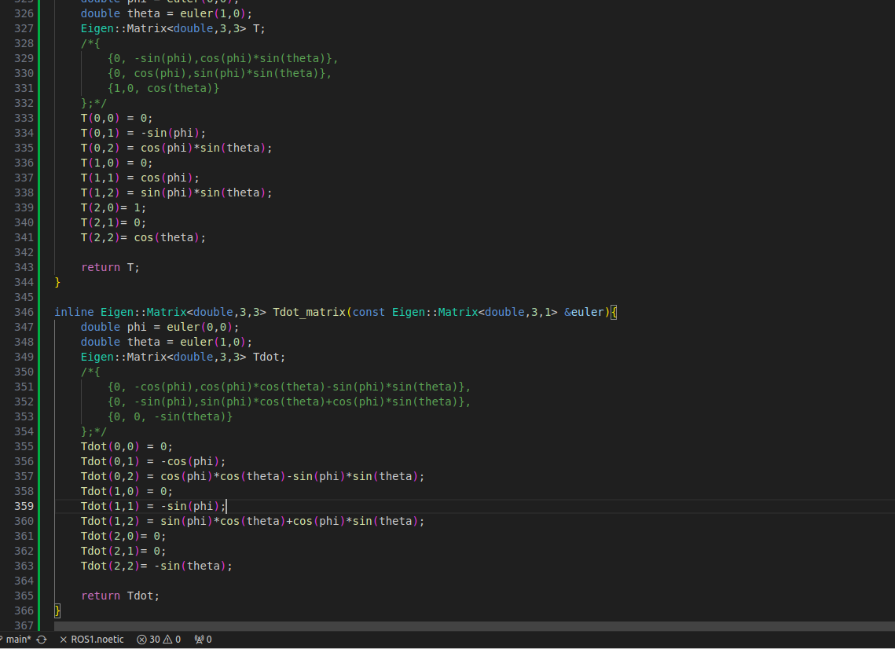

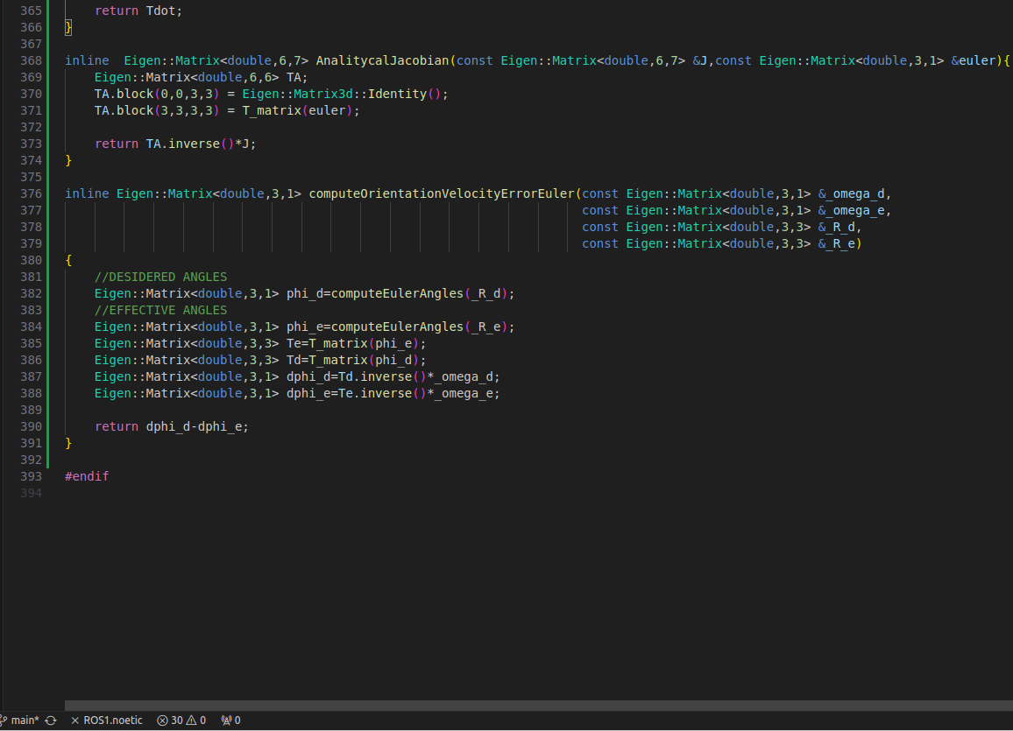

I modified “~/catkin_ws/src/kdl_robot/include/kdl_ros_control/kdl_control.h”:
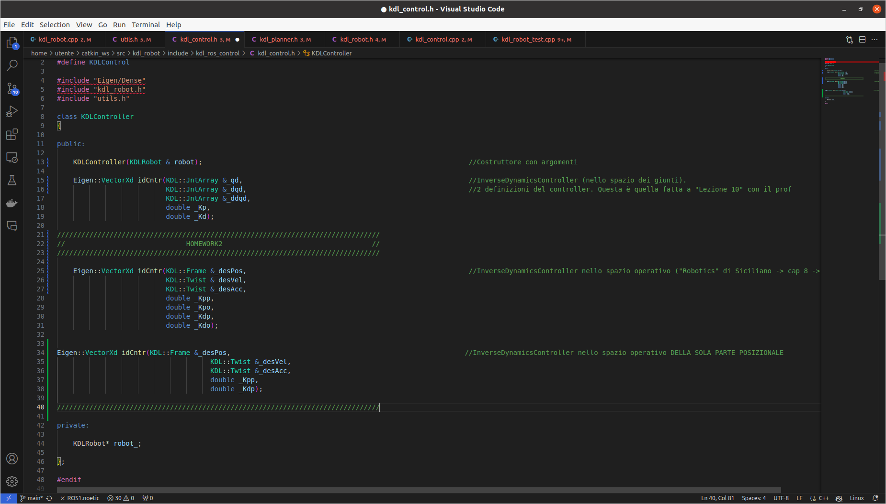

And “~/catkin_ws/src/kdl_robot/src/kdl_control.cpp”:

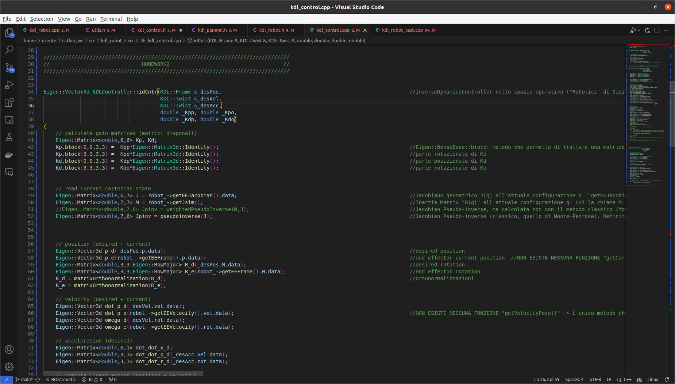

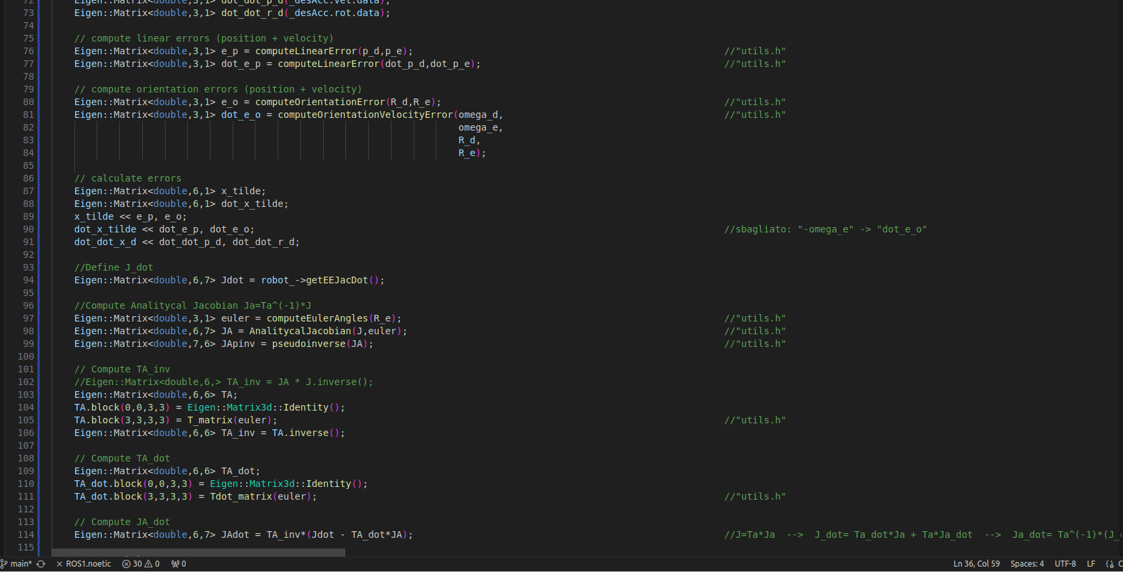

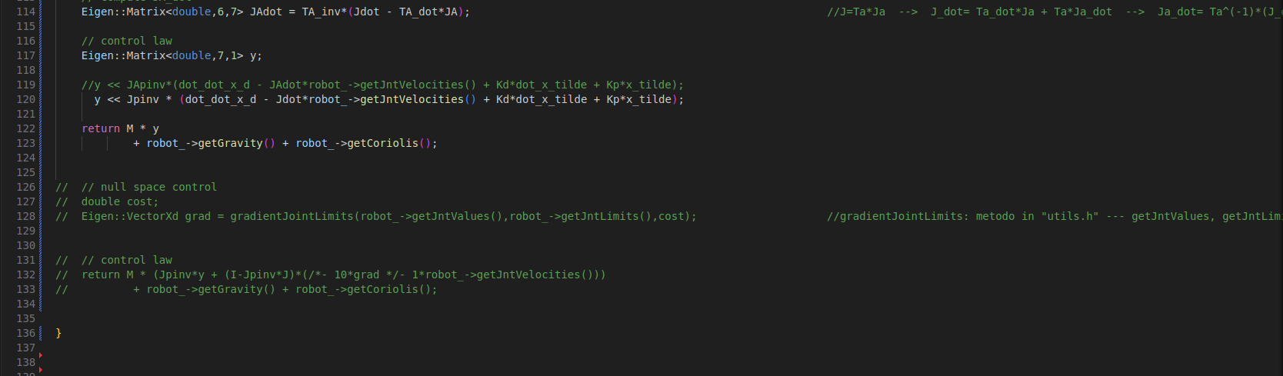

//Inverse Dynamics Controller in operational space
//Linear trajectory
//Cubic polynomial curvilinear abscissa s

In “~/catkin_ws/src/kdl_robot/src/kdl_robot_test.cpp” I modified:

19 → int selection=3;
155 → KDLPlanner planner(traj_duration, acc_duration, init_position, end_position);
159 → trajectory_point p = planner.compute_trajectory(t,selection);
163 → Kp = 50, Ko = 50;
190 → p = planner.compute_trajectory(0.0,selection);
195 → p = planner.compute_trajectory(t-init_time_slot,selection);
228 → tau = controller_.idCntr(des_pose, des_cart_vel, des_cart_acc,Kp, Ko, 2*sqrt(Kp), 2*sqrt(Ko));

Simulation:

$ roslaunch iiwa_gazebo iiwa_gazebo_effort.launch (terminal 1)

$ cd ~/catkin_ws (terminal 2)
$ catkin build kdl_ros_control
$ source devel/setup.bash
$ rosrun kdl_ros_control kdl_robot_test ./src/iiwa_stack/iiwa_description/urdf/iiwa14.urdf

$ rqt_plot (terminal 3)



