Report – Homework 3
Student: Riccardo Stucovitz

1. Construct a gazebo world inserting a circular object and detect it via the opencv_ros package

(a) Go into the iiwa_gazebo package of the iiwa_stack. There you will find a folder models contain-
ing the aruco marker model for gazebo. Taking inspiration from this, create a new model named
circular_object that represents a 15 cm radius colored circular object and import it into a new
Gazebo world as a static object at x=1, y=-0.5, z = 0.6 (orient it suitably to accomplish the next
point). Save the new world into the /iiwa_gazebo/worlds/ folder.

Colored circle model:

Taking inspiration from “~/catkin_ws/src/iiwa_stack/iiwa_gazebo/models/aruco_marker/model.sdf” and “~/catkin_ws/src/iiwa_stack/iiwa_gazebo/models/aruco_marker/model.config”, I created the equivalent ones in “~/catkin_ws/src/iiwa_stack/iiwa_gazebo/models/circular_object/” folder:

“model.sdf”:

WARNING: “sdf” and “urdf” are DIFFERENT file formats used for robots and environments, and so are their specifications!
Check → http://sdformat.org/spec

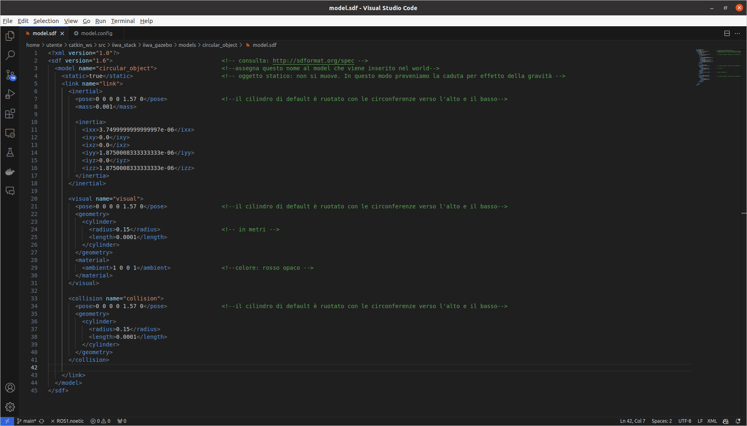

“model.config”:
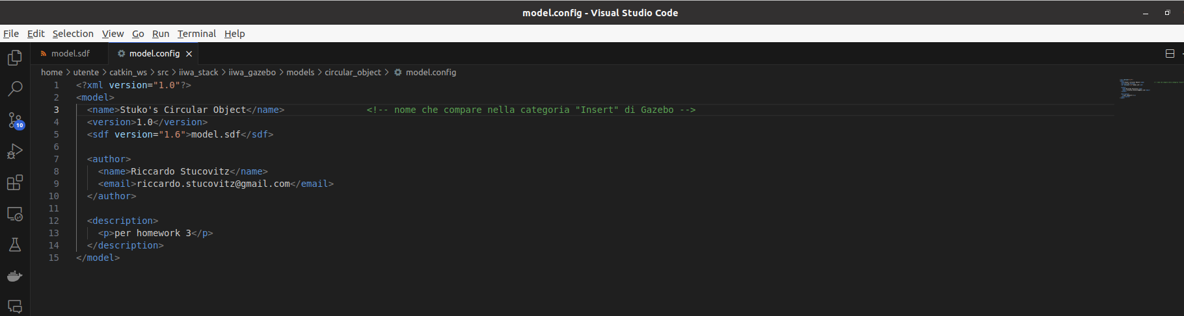

Since this “/models” folder is in an already added path on Gazebo (see “Add Path” in the next simulation), once I started the simulation:

$ roslaunch iiwa_gazebo iiwa_gazebo_aruco.launch

...I could already find there the new available model (Stuko’s Circular Object).

So I:
- Added this object in the simulation in a randomic position
- Deleted both the aruco_marker and the kuka lwr iiwa robot.
- Gazebo GUI → “File → Save World As → “~/catkin_ws/src/iiwa_stack/iiwa_gazebo/worlds/circular_object_world”
- Renamed “circular_object_world.world” (otherwise Gazebo crashes idk why)

To position with accuracy the object in the desired pose, I modified “~/catkin_ws/src/iiwa_stack/iiwa_gazebo/worlds/circular_object_world.world” (raws 117, 120):

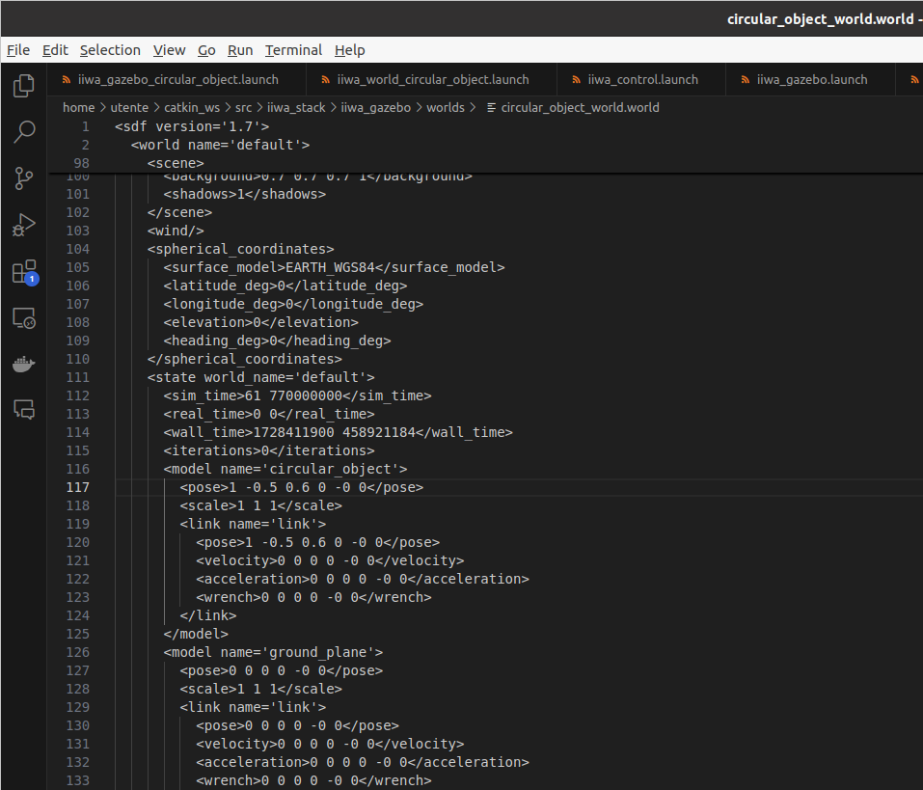

(b) Create a new launch file named launch/iiwa_gazebo_circular_object.launch that loads the
iiwa robot with PositionJointInterface equipped with the camera into the new world via a
launch/iiwa_world_circular_object.launch file. Make sure the robot sees the imported ob-
ject with the camera, otherwise modify its configuration (Hint: check it with rqt_image_view).

Taking inspiration from
“~/catkin_ws/src/iiwa_stack/iiwa_gazebo/launch/iiwa_world.launch”
“~/catkin_ws/src/iiwa_stack/iiwa_gazebo/launch/iiwa_gazebo.launch”

I created:

“~/catkin_ws/src/iiwa_stack/iiwa_gazebo/launch/iiwa_world_circular_object.launch “(that includes our world and the “~/catkin_ws/src/iiwa_stack/iiwa_description/launch/iiwa14_upload.launch”):

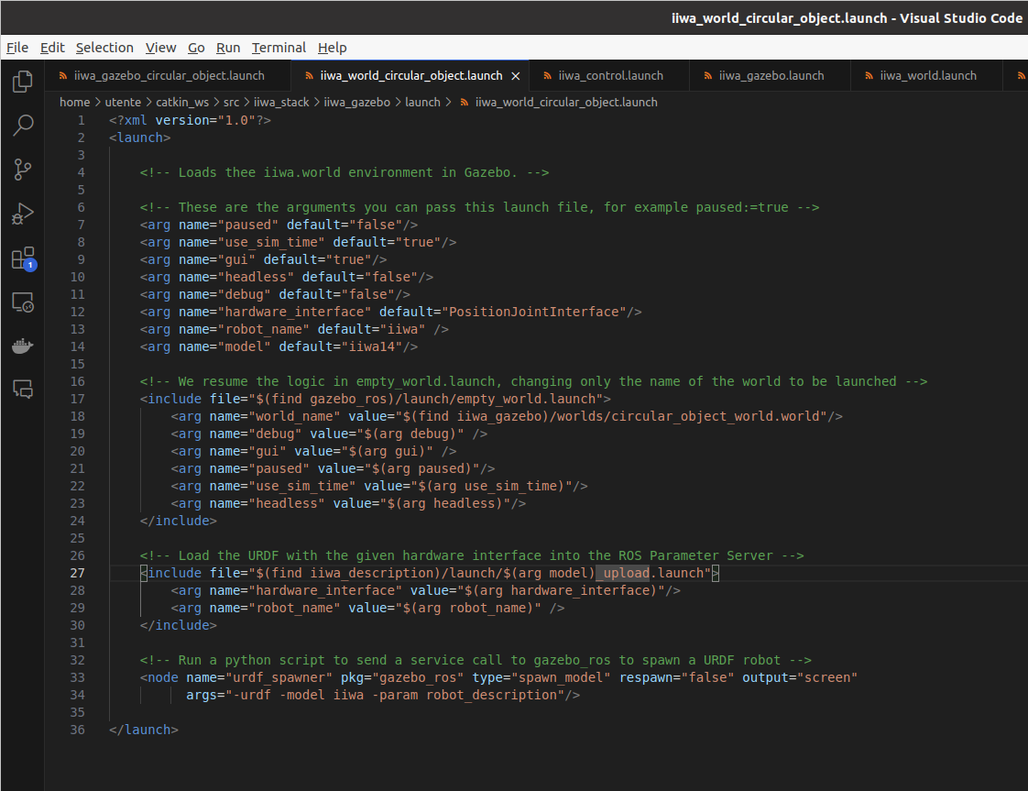

“~/catkin_ws/src/iiwa_stack/iiwa_gazebo/launch/iiwa_gazebo_circular_object.launch” (that includes “~/catkin_ws/src/iiwa_stack/iiwa_gazebo/launch/iiwa_world_circular_object.launch”(the file above)):

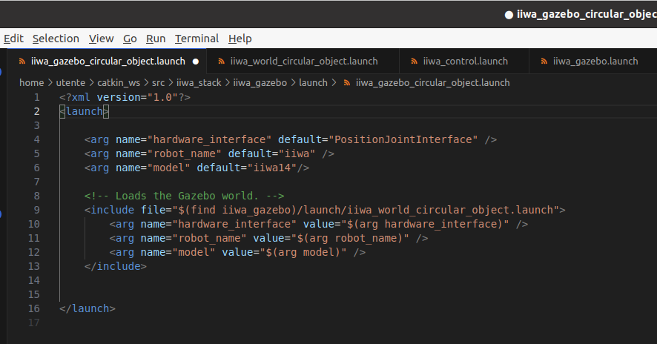

Simulation:

$ roslaunch iiwa_gazebo iiwa_gazebo_circular_object.launch (terminal 1)

$ rqt_image_view → /iiwa/camera1/image_raw (terminal 2)

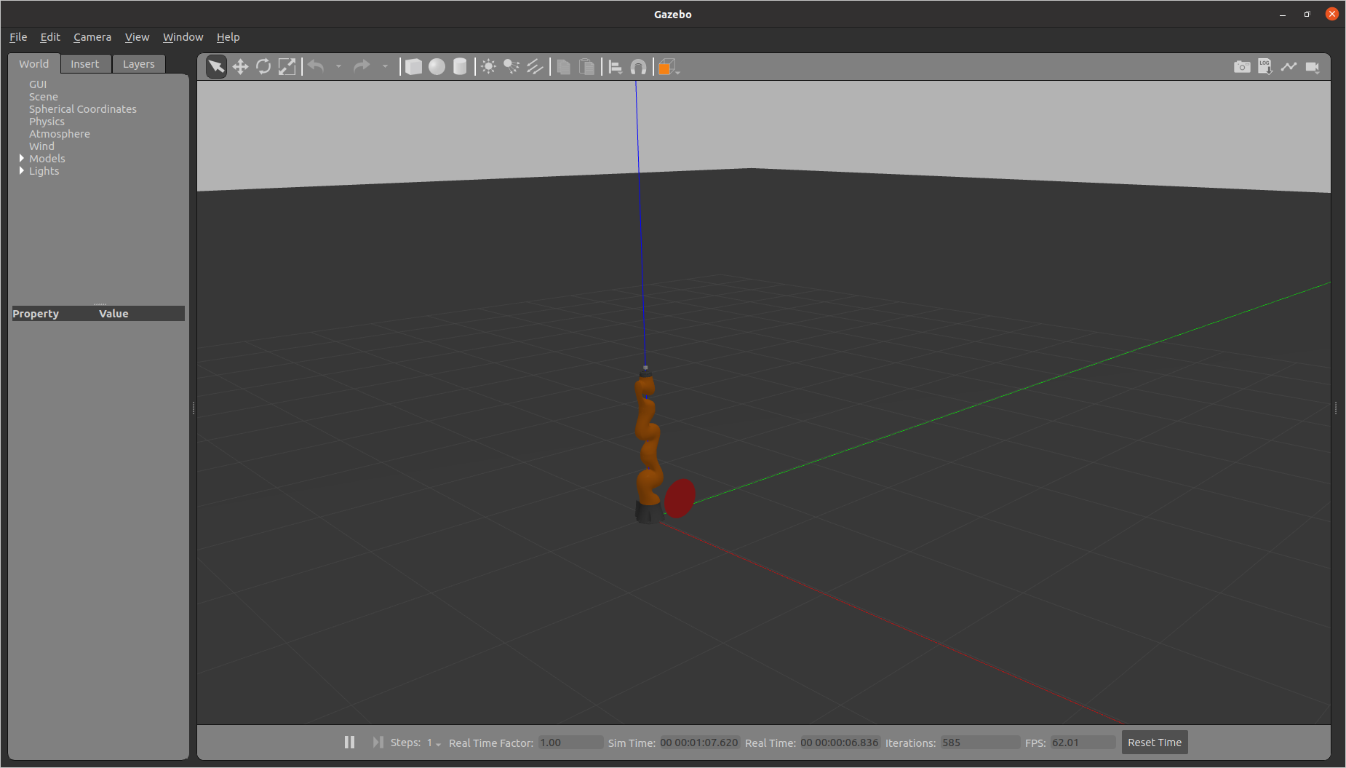
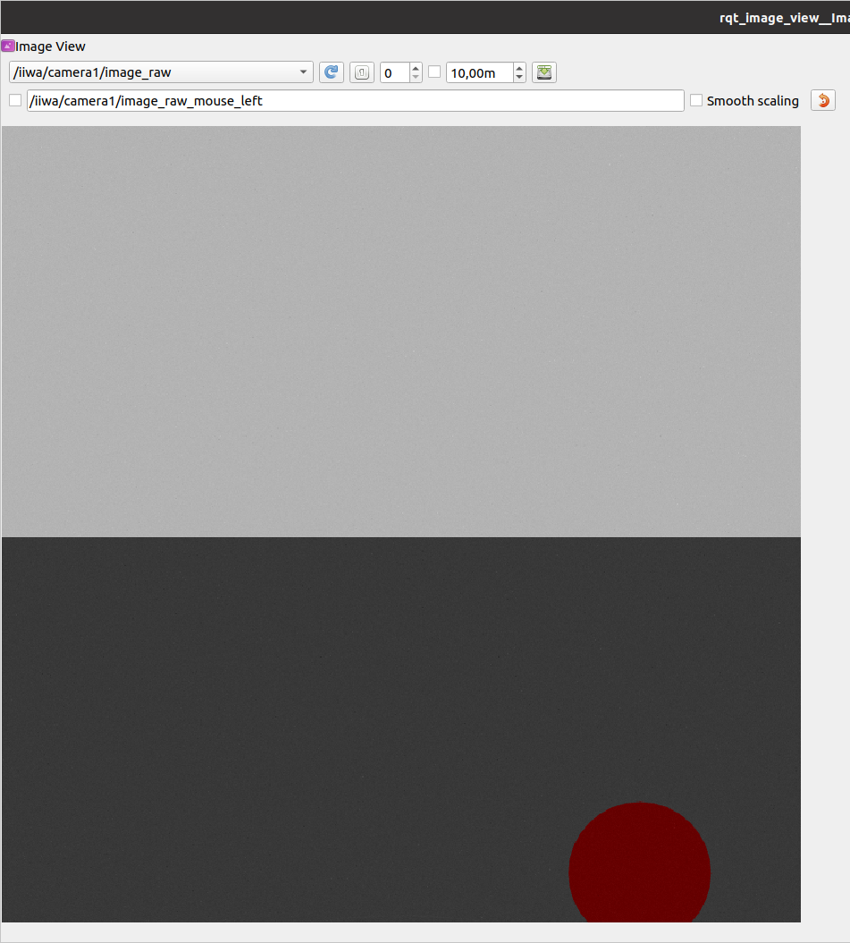

The object is not fully set inside the camera → I modified further through “circular_object_world.world” (raws 117, 120):

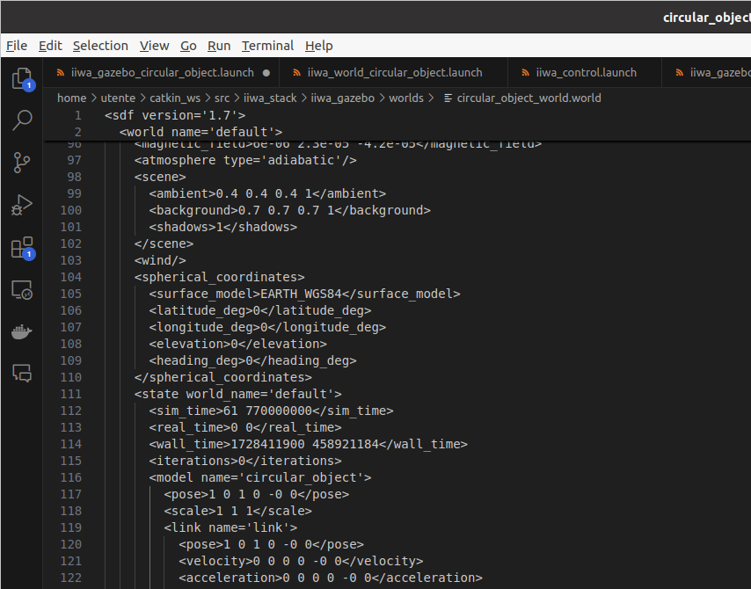

Now:
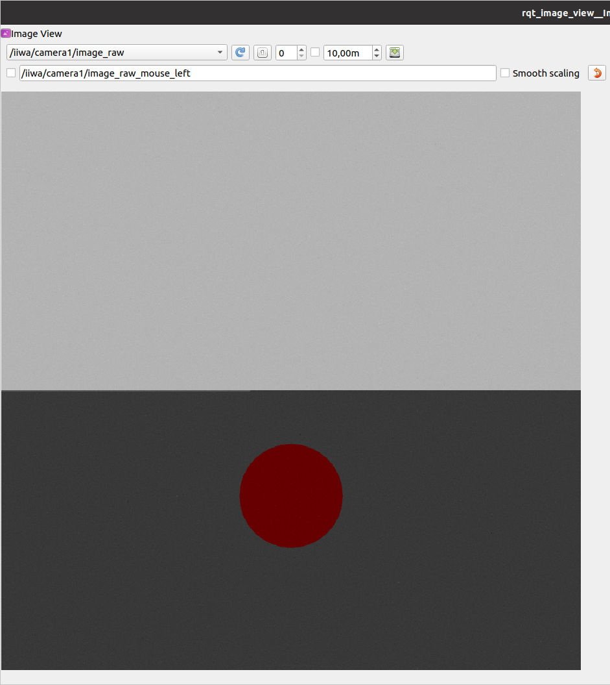

(c) Once the object is visible in the camera image, use the opencv_ros/ package to detect the circular
object using open CV functions. Modify the opencv_ros_node.cpp to subscribe to the simulated
image, detect the object via openCV functions 1 , and republish the processed image.

Taking inspiration from the suggested code, I modified “~/catkin_ws/src/opencv_ros/opencv_ros_node.cpp”:

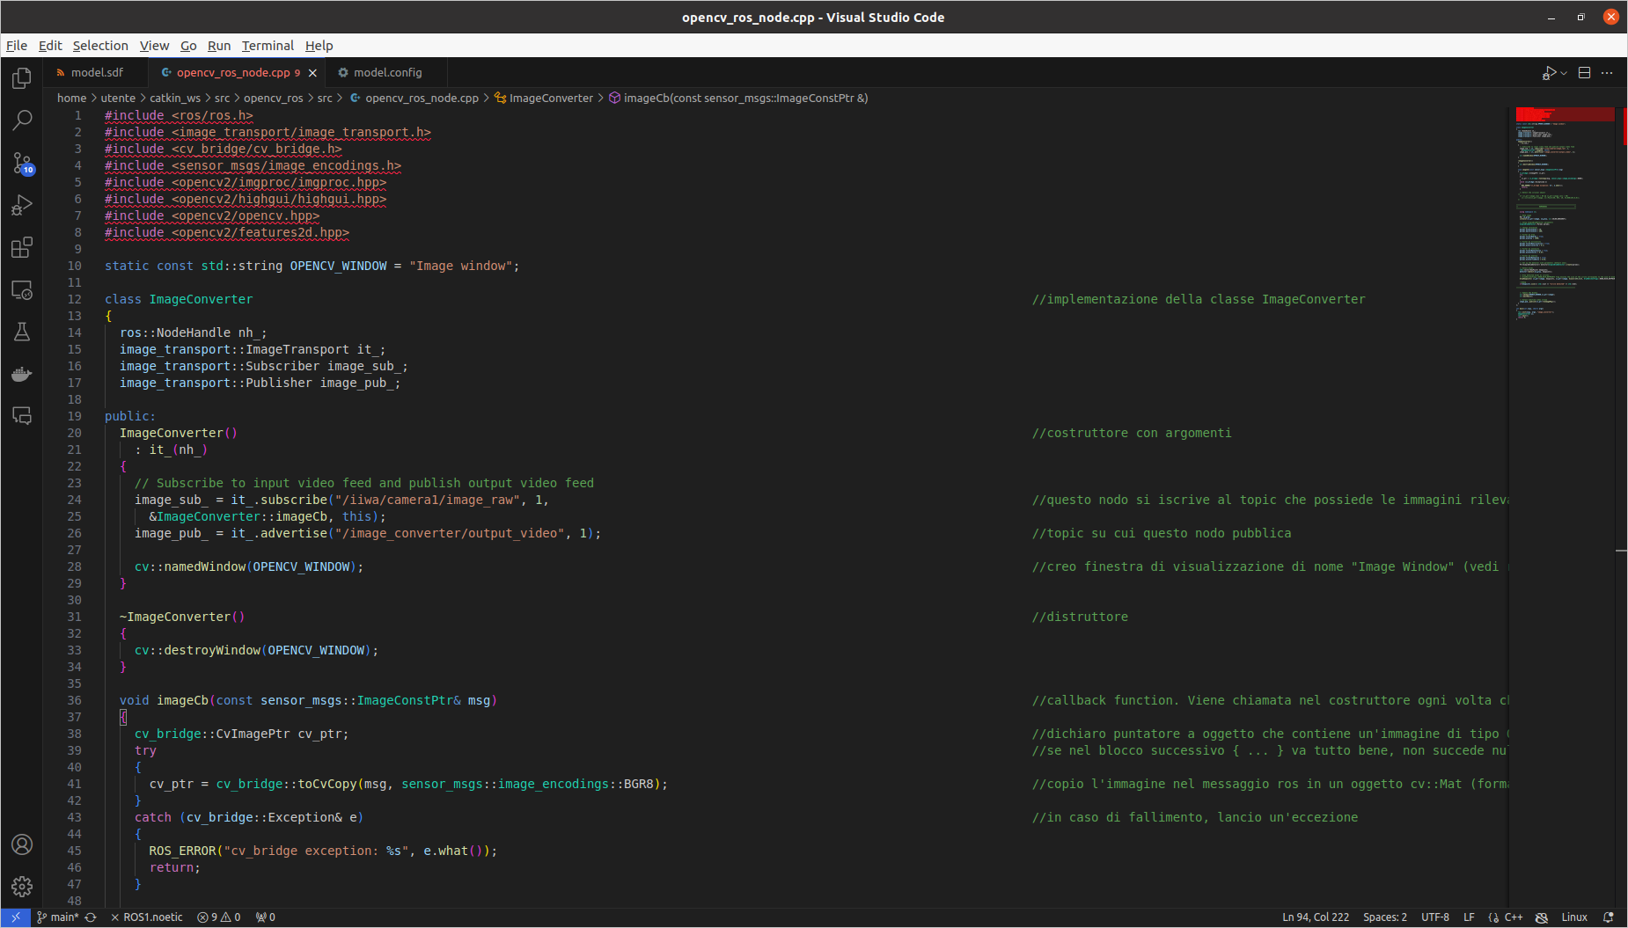
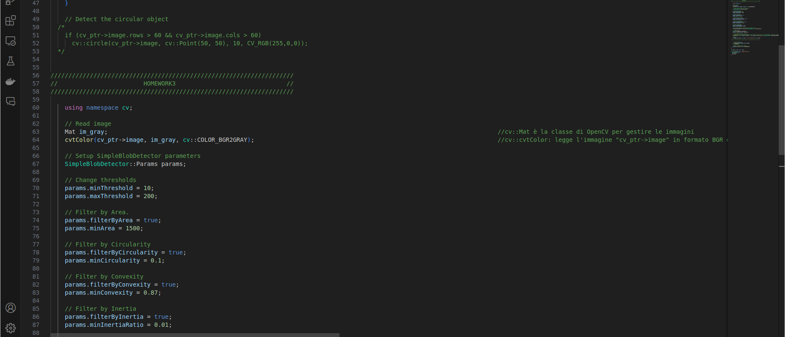

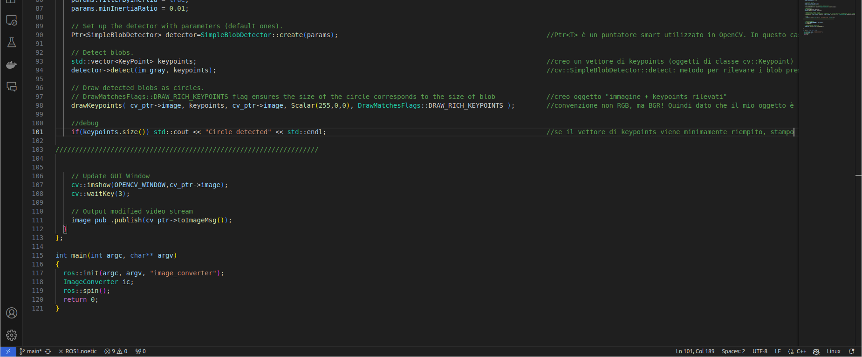

Simulation:

$ roslaunch iiwa_gazebo iiwa_gazebo_circular_object.launch (terminal 1)

$ rqt_image_view→ /iiwa/camera1/image_raw (terminal 2)

$ cd catkin_ws (terminal 3)
$ catkin build opencv_ros
$ source devel/setup.bash
$ rosrun opencv_ros opencv_ros_node

After many tries → problem: circle too close to the camera → push away at (x , y , z) = ( 3 , 1.5 , 0)

So, in “~/catkin_ws/src/iiwa_stack/iiwa_gazebo/worlds/circular_object_world.world”
(raws 117, 120):

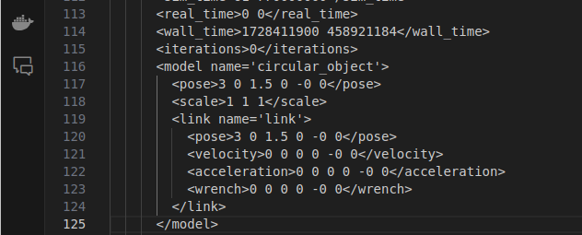

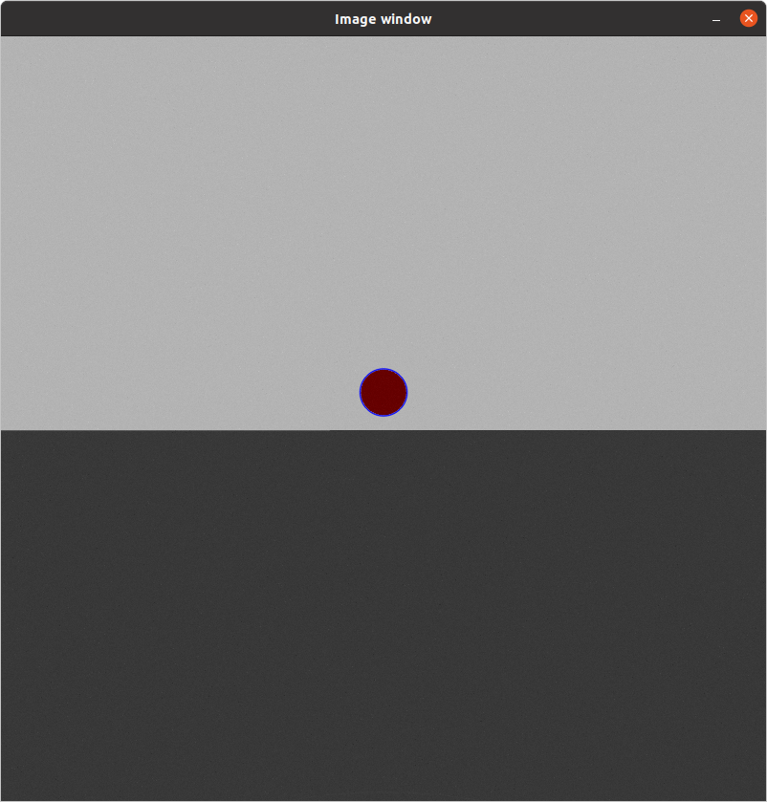

Result:

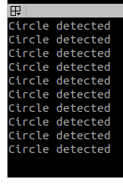

2. Modify the look-at-point vision-based control example

(a) The kdl_robot package provides a kdl_robot_vision_control node that implements a vision-
based look-at-point control task with the simulated iiwa robot. It uses the VelocityJointInterface
enabled by the iiwa_gazebo_aruco.launch and the usb_cam_aruco.launch launch files. Modify
the kdl_robot_vision_control node to implement a vision-based task that aligns the camera to
the aruco marker with an appropiately chosen position and orientation offsets. Show the tracking
capability by moving the aruco marker via the interface and plotting the velocity commands sent
to the robot.

I modified “~/catkin_ws/src/kdl_robot/src/kdl_robot_vision_control.cpp”:

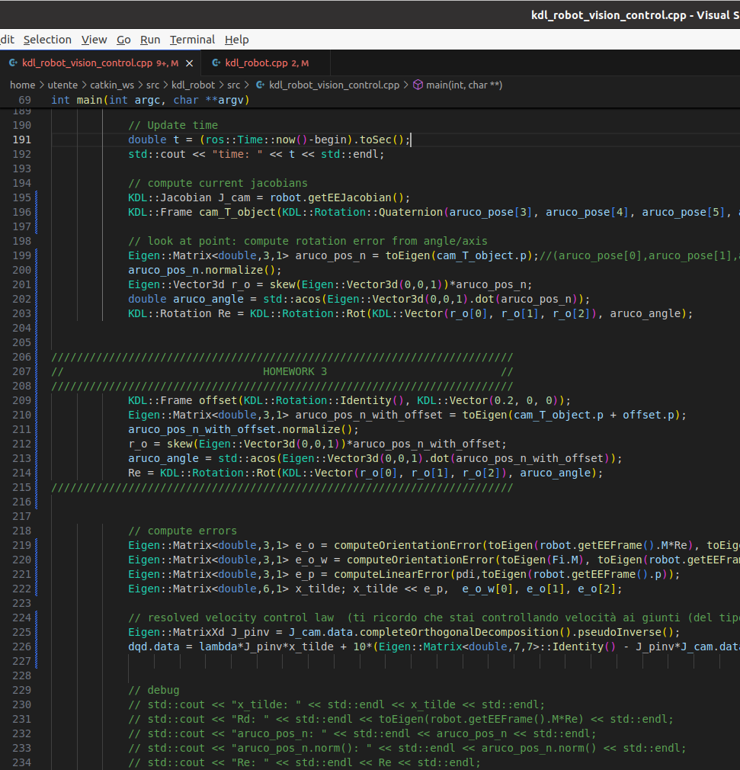
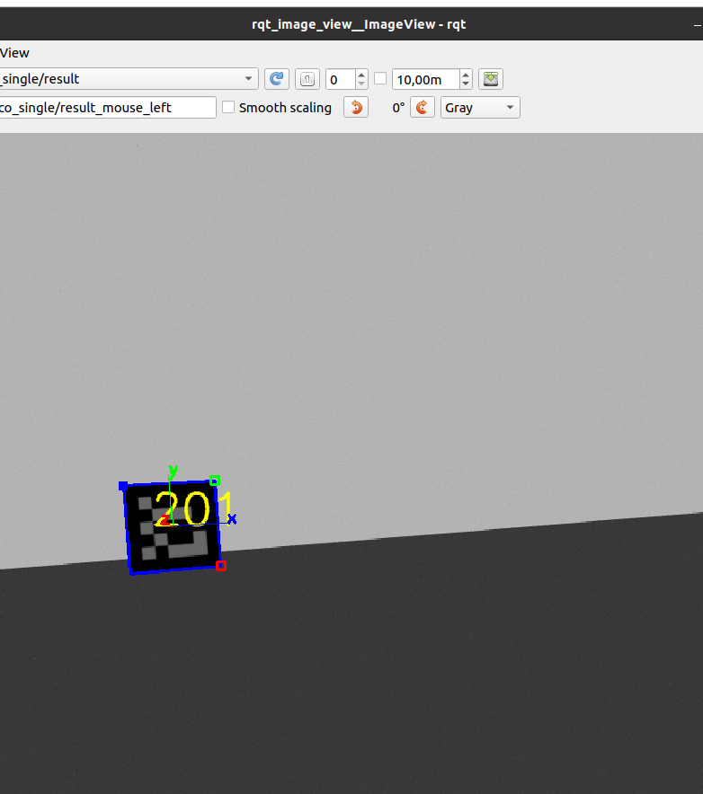

Simulation:

$ cd catkin_ws (terminal 1)
$ source devel/setup.bash
$ roslaunch iiwa_gazebo iiwa_gazebo_aruco.launch

$ cd catkin_ws (terminal 2)
$ source devel/setup.bash
$ roslaunch aruco_ros usb_cam_aruco.launch camera:=/iiwa/camera1

$ rqt_image_view (terminal 3)

$ cd catkin_ws (terminal 4)
$ catkin build kdl_ros_control
$ source devel/setup.bash
$ rosrun kdl_ros_control kdl_robot_vision_control ./src/iiwa_stack/iiwa_description/urdf/iiwa14.urdf

As you can see, aruco marker is not perfectly centralized within the camera lens.

(b) An improved look-at-point algorithm can be devised by noticing that the task is belonging to S 2 .
Indeed, if we consider
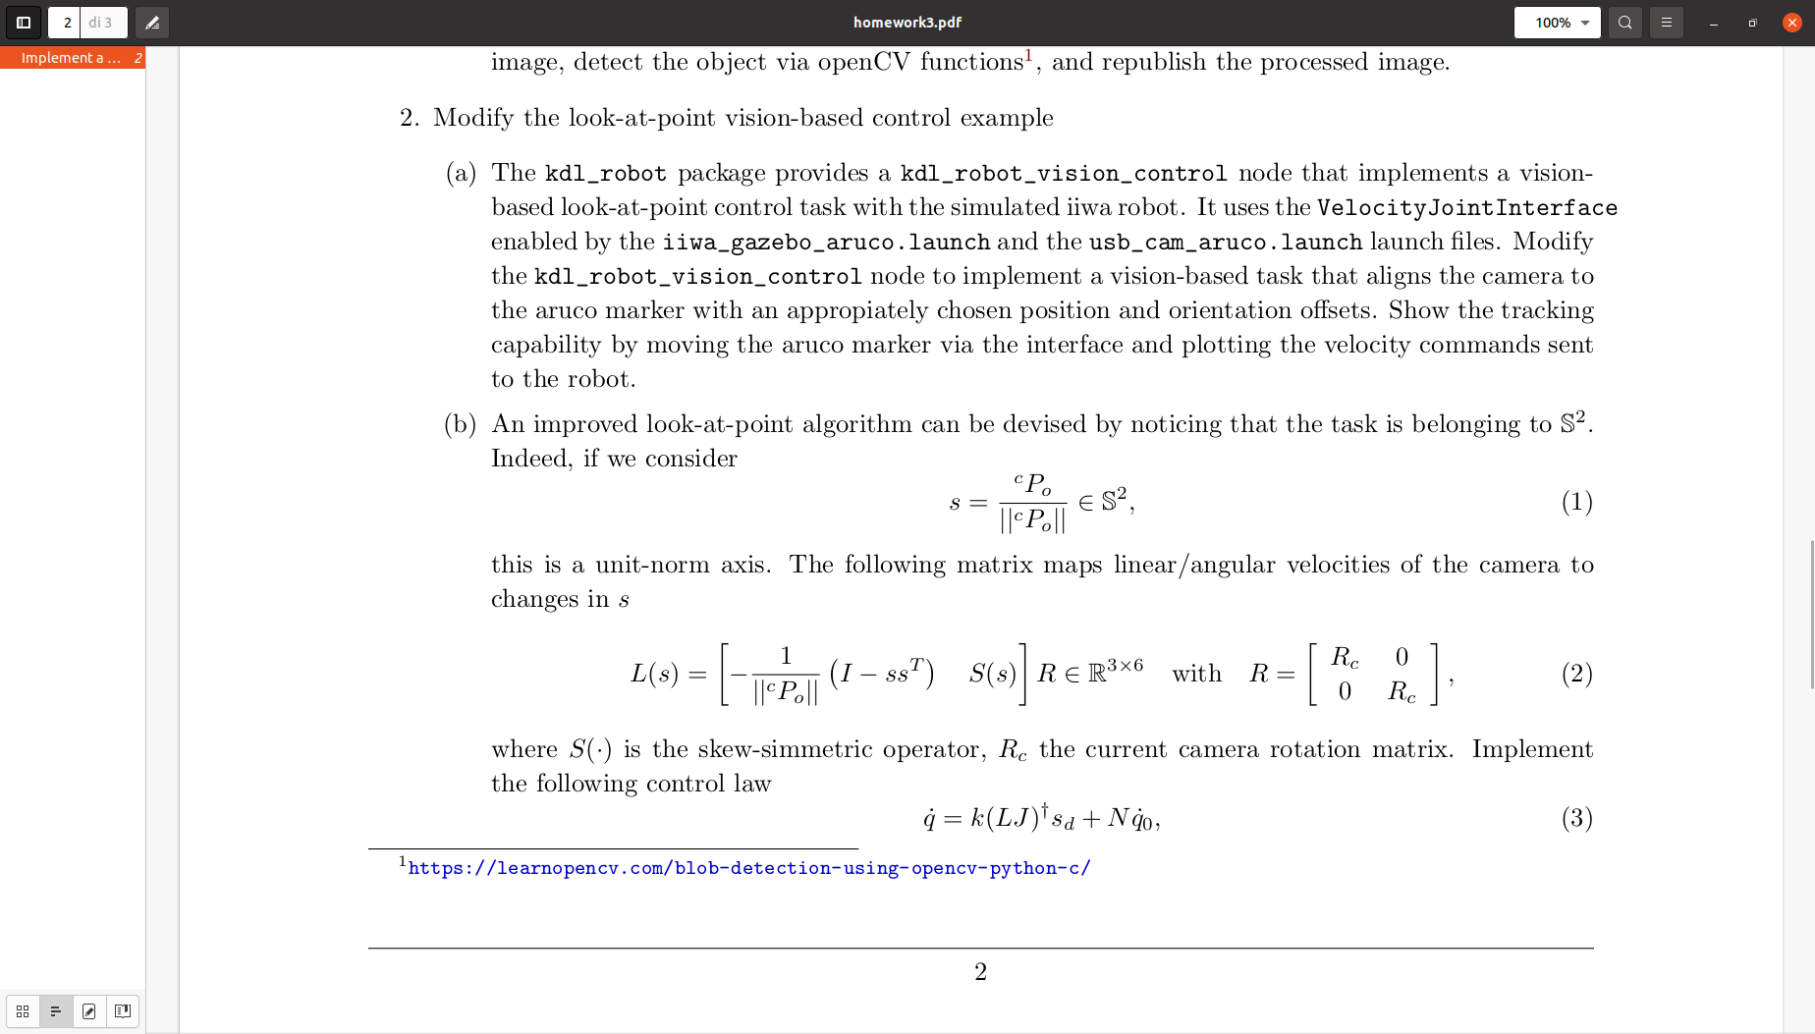

this is a unit-norm axis. The following matrix maps linear/angular velocities of the camera to
changes in s

where S(·) is the skew-simmetric operator, R c the current camera rotation matrix. Implement
the following control law
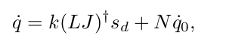

where s d is a desired value for s, e.g. s d = [0, 0, 1], and N = I − (LJ) † LJ being the matrix
spanning the null space of the LJ matrix. Verify that the for a chosen q̇ 0 the s measure does not
change by plotting joint velocities and the s components.

I modified “~/catkin_ws/src/kdl_robot/src/kdl_robot_vision_control.cpp”:
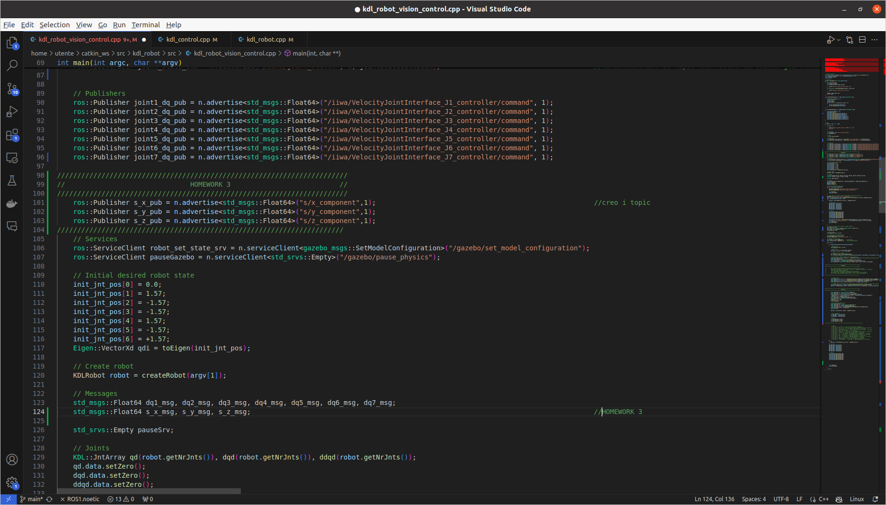

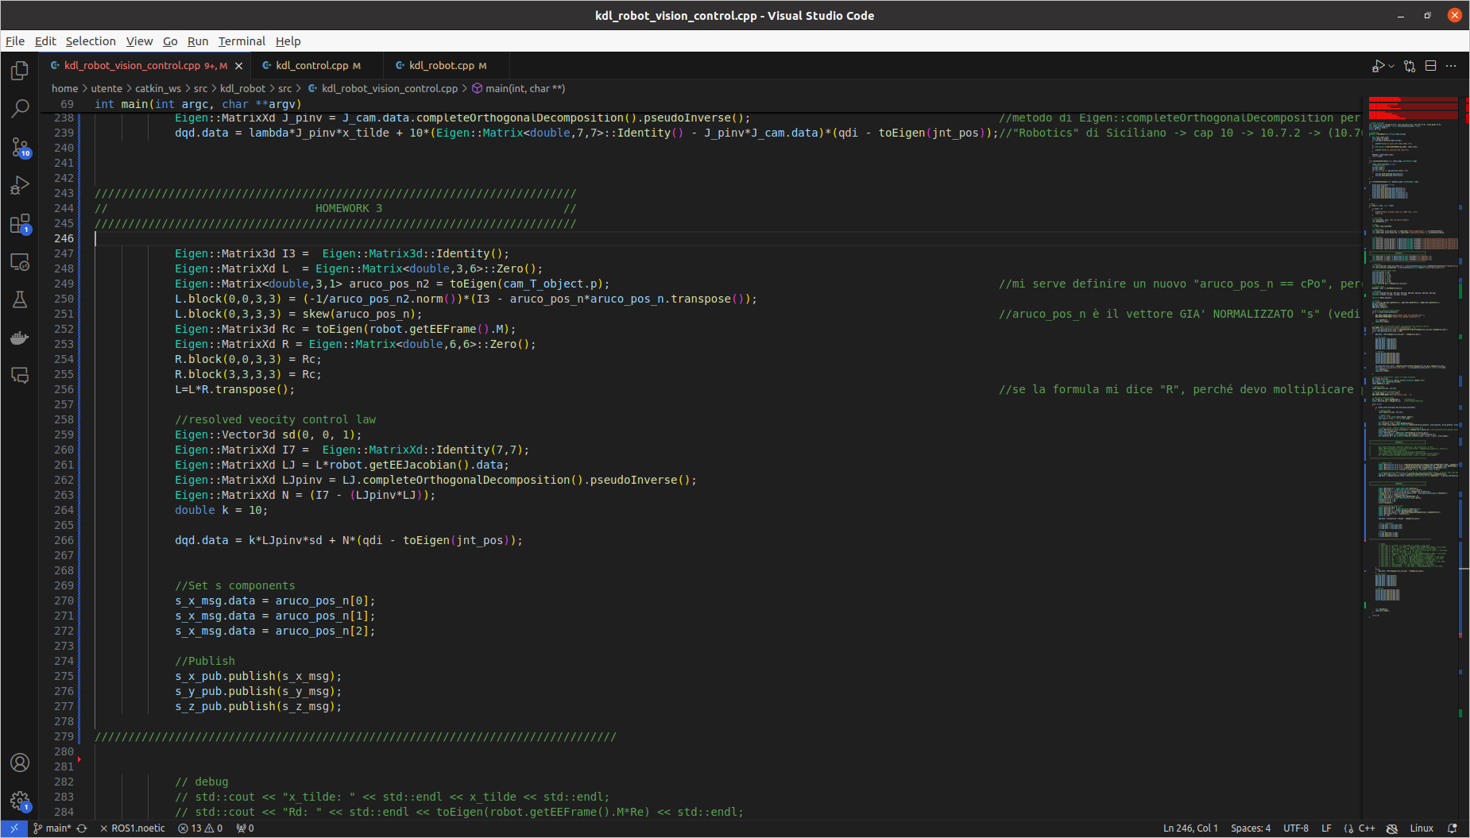

q0_dot ( == qdi) has been chosen equal to the assigned one for simplicity. I verified that for this value of this vector, the s measure (in my case s = (1, 0, 0) ) does not change:

Simulation:

$ cd catkin_ws (terminal 1)
$ source devel/setup.bash
$ roslaunch iiwa_gazebo iiwa_gazebo_aruco.launch

$ cd catkin_ws (terminal 2)
$ source devel/setup.bash
$ roslaunch aruco_ros usb_cam_aruco.launch camera:=/iiwa/camera1

$ rqt_image_view (terminal 3)

$ cd catkin_ws (terminal 4)
$ catkin build kdl_ros_control
$ source devel/setup.bash
$ rosrun kdl_ros_control kdl_robot_vision_control ./src/iiwa_stack/iiwa_description/urdf/iiwa14.urdf

$ rqt_plot (terminal 5)

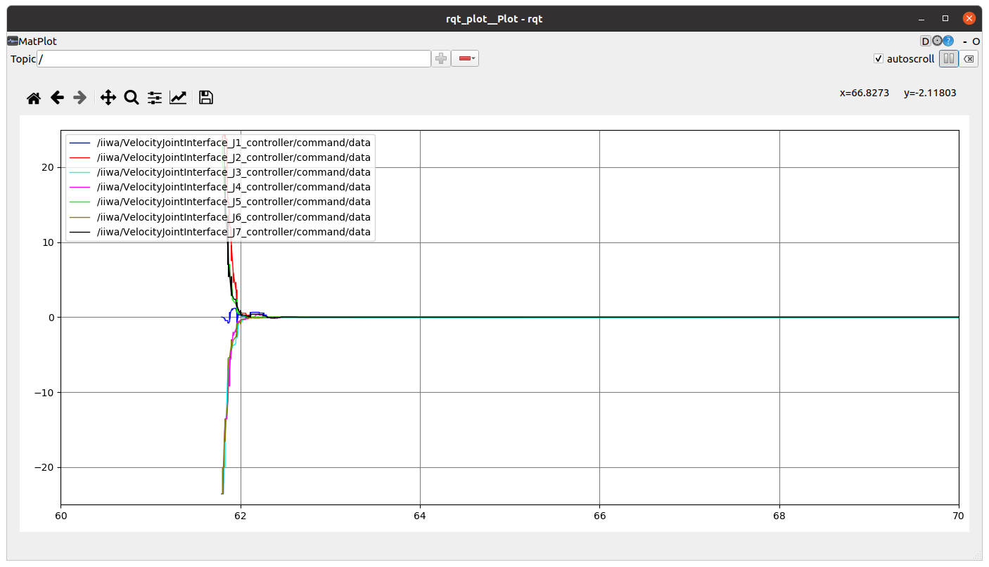
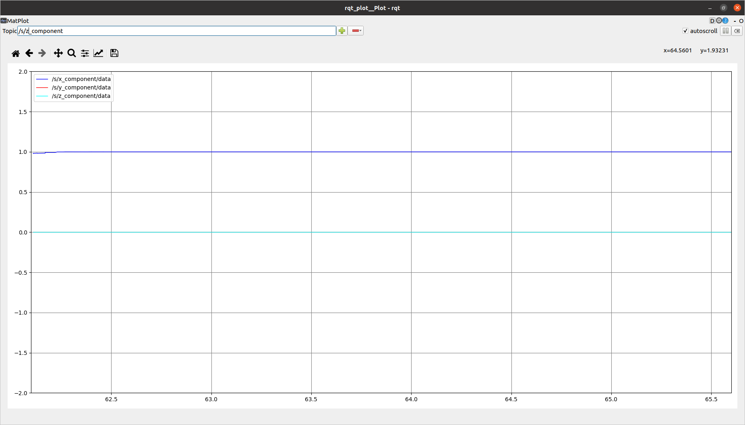

As I moved the aruco_maker… ( I moved it twice and got closer with the focus in the rqt_plot):

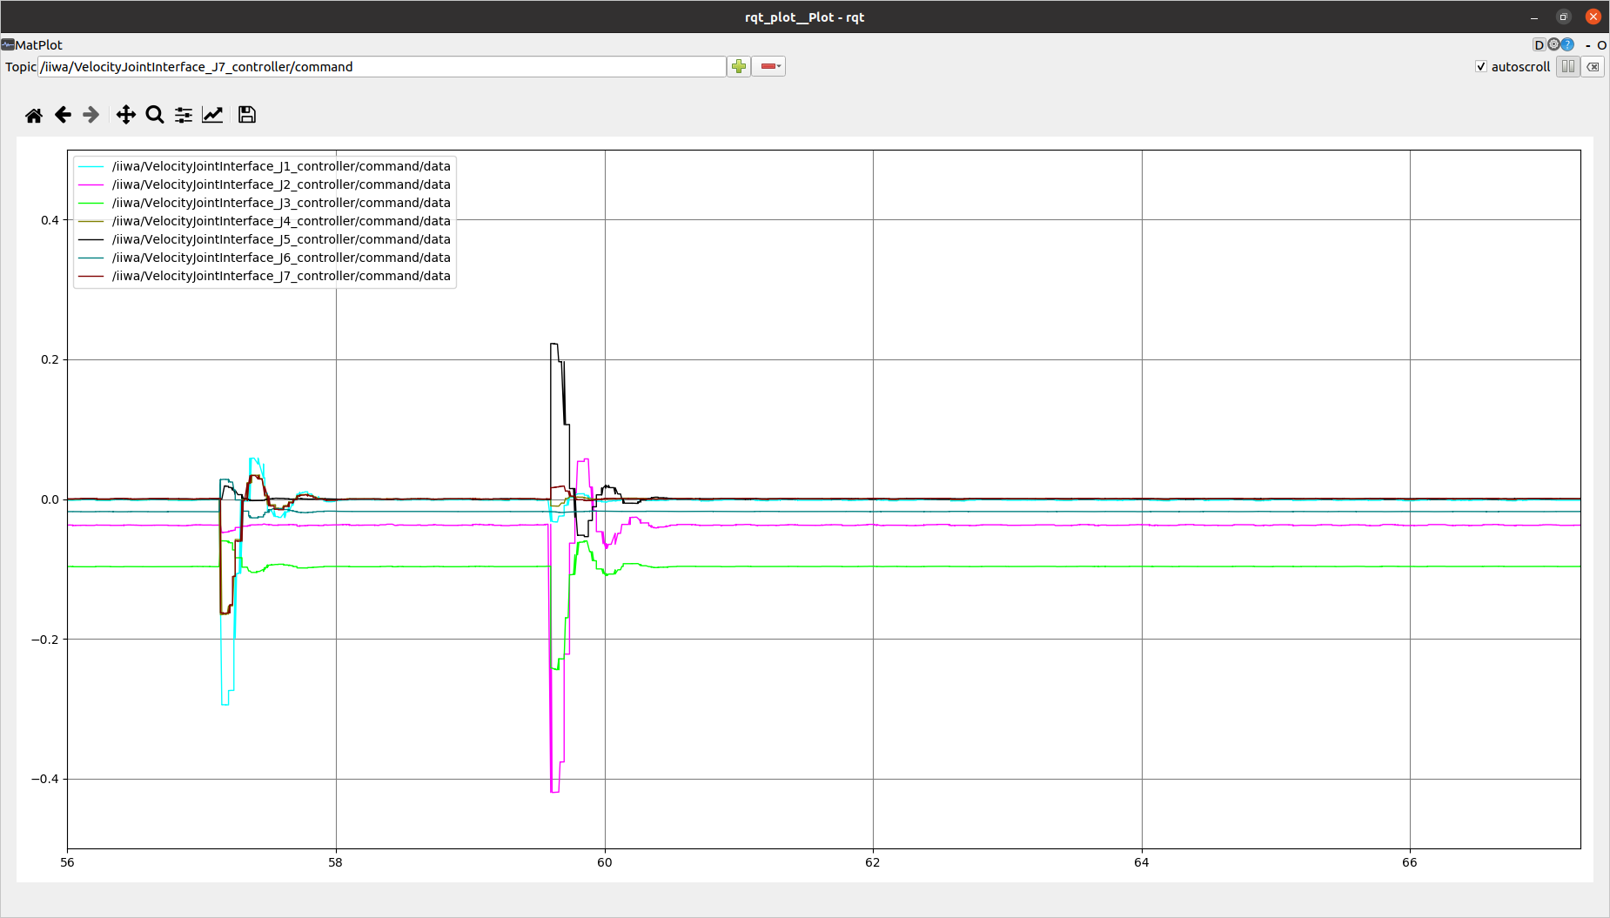

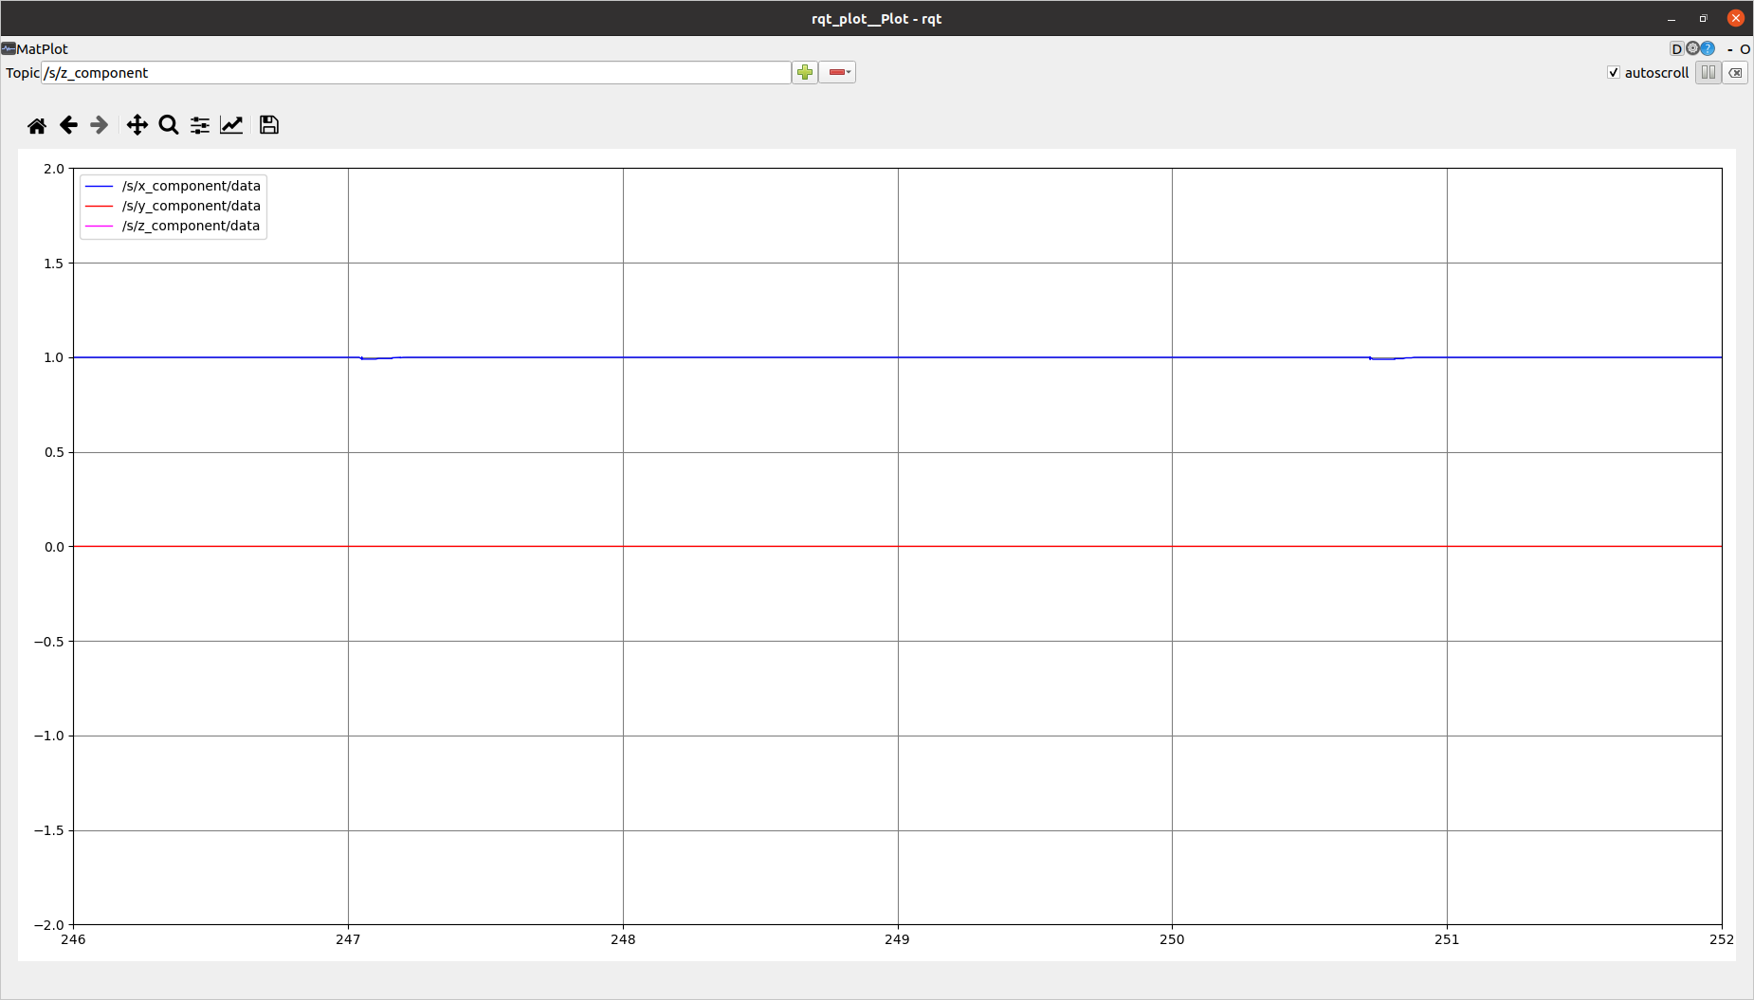

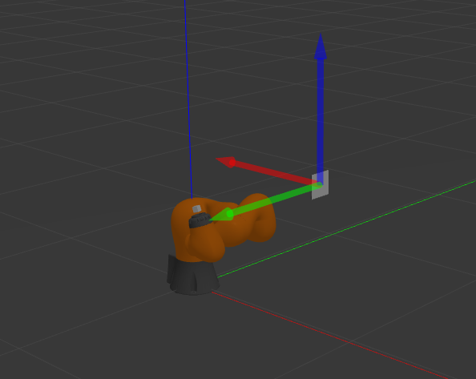
The s variations are really imperceptible!

In fact the orientation of the camera with respect to the aruco_marker is always the same!

(c) Develop a dynamic version of the vision-based controller. Track the reference velocities generated
by the look-at-point vision-based control law with the joint space and the Cartesian space inverse
dynamics controllers developed in the previous homework. To this end, you have to merge the two
controllers and enable the joint tracking of a linear position trajectory and the vision-based task.
Hint: Replace the orientation error e o with respect to a fixed reference (used in the previous
homework), with the one generated by the vision-based controller. Plot the results in terms of
commanded joint torques and Cartesian error norm along the performed trajectory.

Reading “commanded joint torques” and “vision based”, I can infer that I need a world with an aruco marker and a torques-commanded robot.

Taking inspiration from:
“~catkin_ws/src/iiwa_stack/iiwa_gazebo/launch/iiwa_gazebo_aruco.launch” (Homework 3)
“~catkin_ws/src/iiwa_stack/iiwa_gazebo/launch/iiwa_gazebo_effort.launch” (Homework 2)

I created:
“~catkin_ws/src/iiwa_stack/iiwa_gazebo/launch/iiwa_gazebo_aruco_effort.launch” :

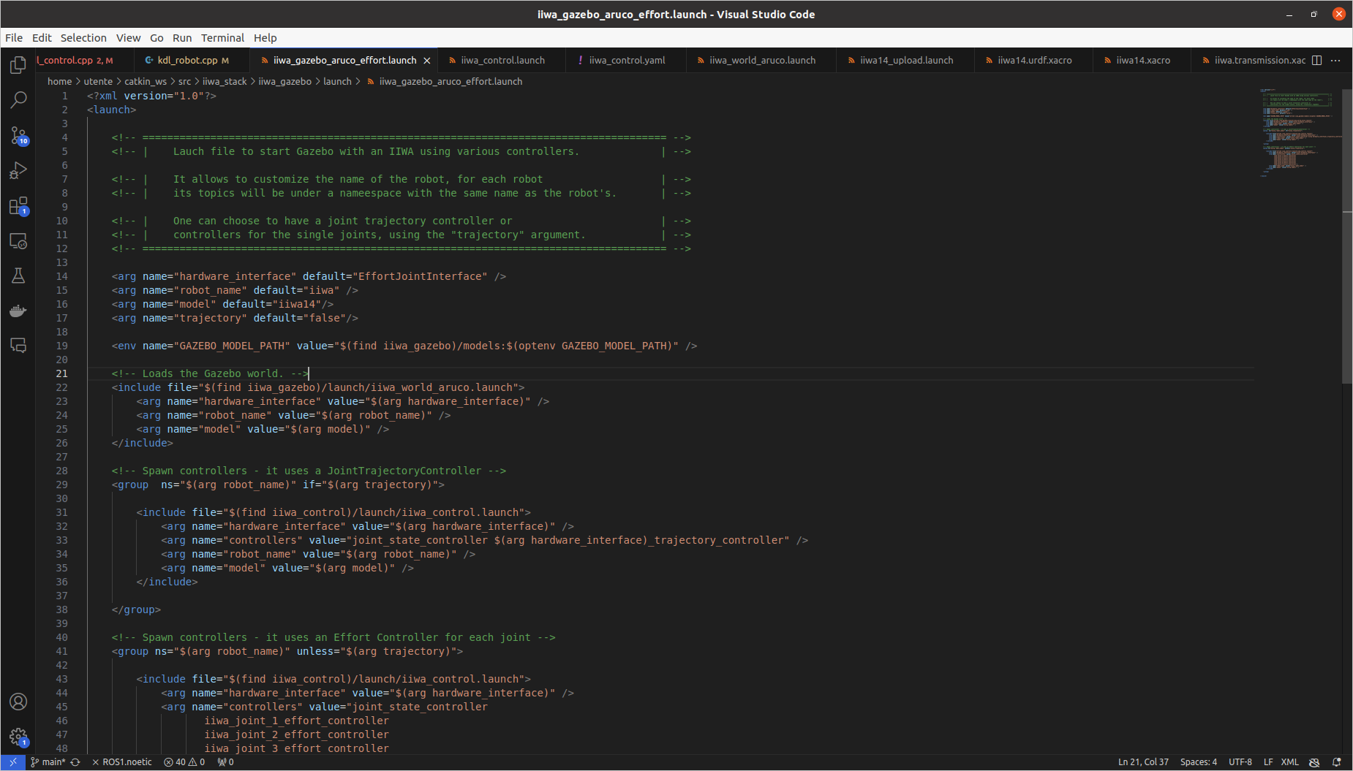
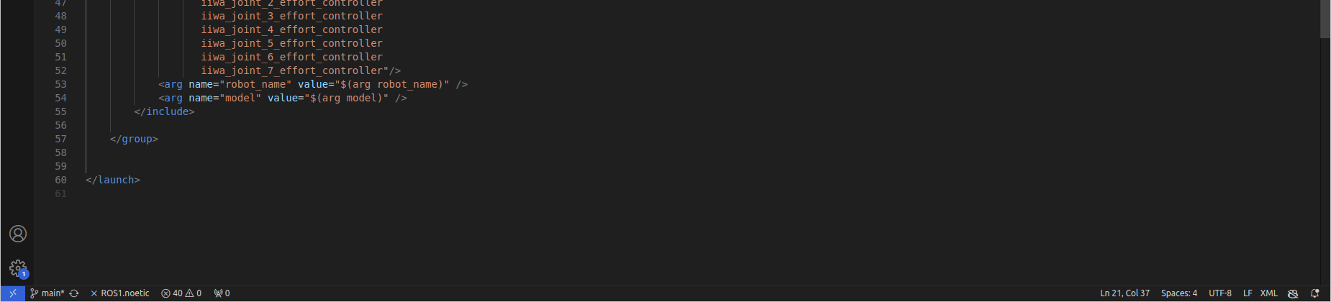

As I could see in a few moves, since our robot camera in the initial configuration (see “~/catkin_ws/src/kdl_robot/src/kdl_robot_test.cpp”: its initial configuration is different from the kdl_robot_vision_control.cpp one) doesn’t focus on the aruco marker in its initial position, I created a new world “iiwa_aruco_effort_hw3.world” with a position for the marker for which this situation happens.
N.b. I could have even modified the camera frame orientation

So:
I launch “~catkin_ws/src/iiwa_stack/iiwa_gazebo/launch/iiwa_gazebo_aruco_effort.launch”;
that launchs a new “~catkin_ws/src/iiwa_stack/iiwa_gazebo/launch/iiwa_world_aruco_effort.launch” (taking inspiration from “~catkin_ws/src/iiwa_stack/iiwa_gazebo/launch/iiwa_world_aruco.launch” :
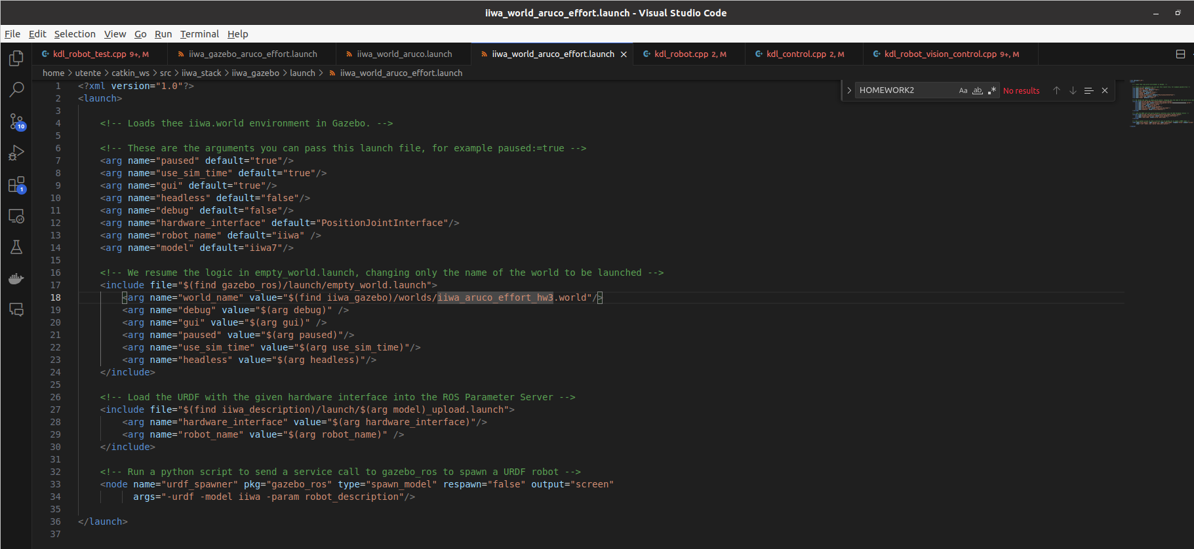

that launchs “~catkin_ws/src/iiwa_stack/iiwa_gazebo/worlds//iiwa_aruco_effort_hw3.world” (no image).

Since the hint suggests to “replace the orientation error e_o with respect to a fixed reference (used in the previous homework)…”, I can infer that using and modifying “kdl_robot_test.cpp” and/or “kdl_control.cpp” is the right decision to take.

So, I modified only “~/catkin_ws/src/kdl_robot/src/kdl_robot_test.cpp”, such that the new desired orientation “des_pose.M” is the one looking the aruco marker:
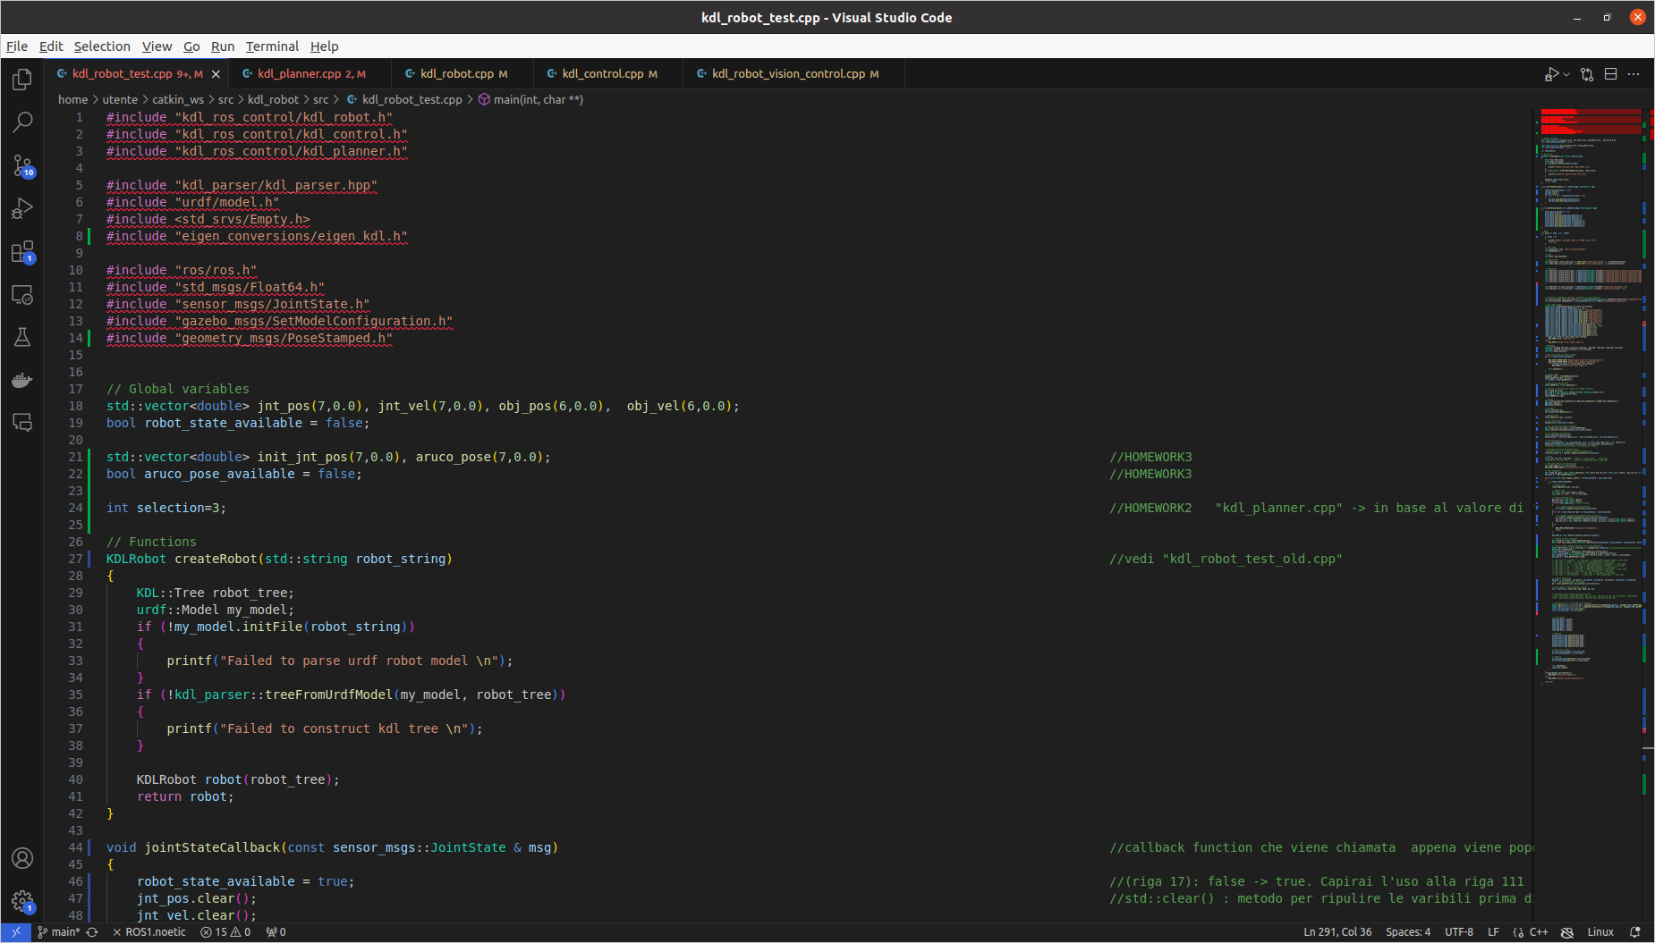

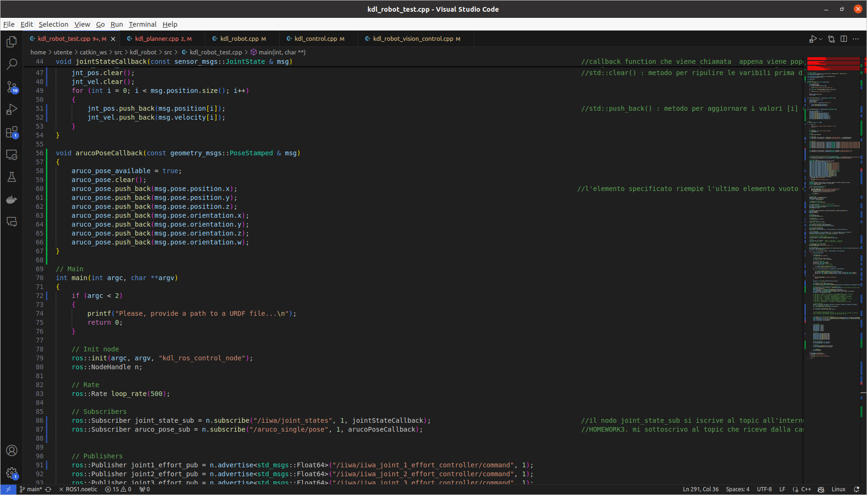

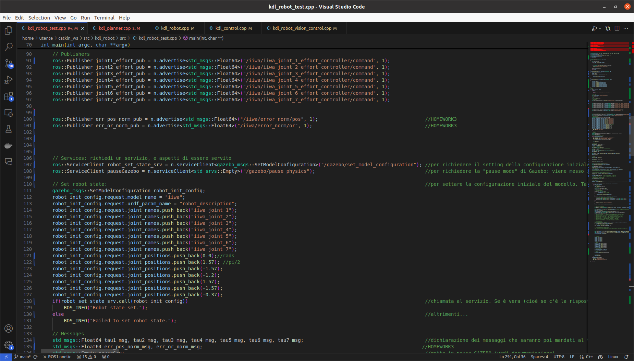

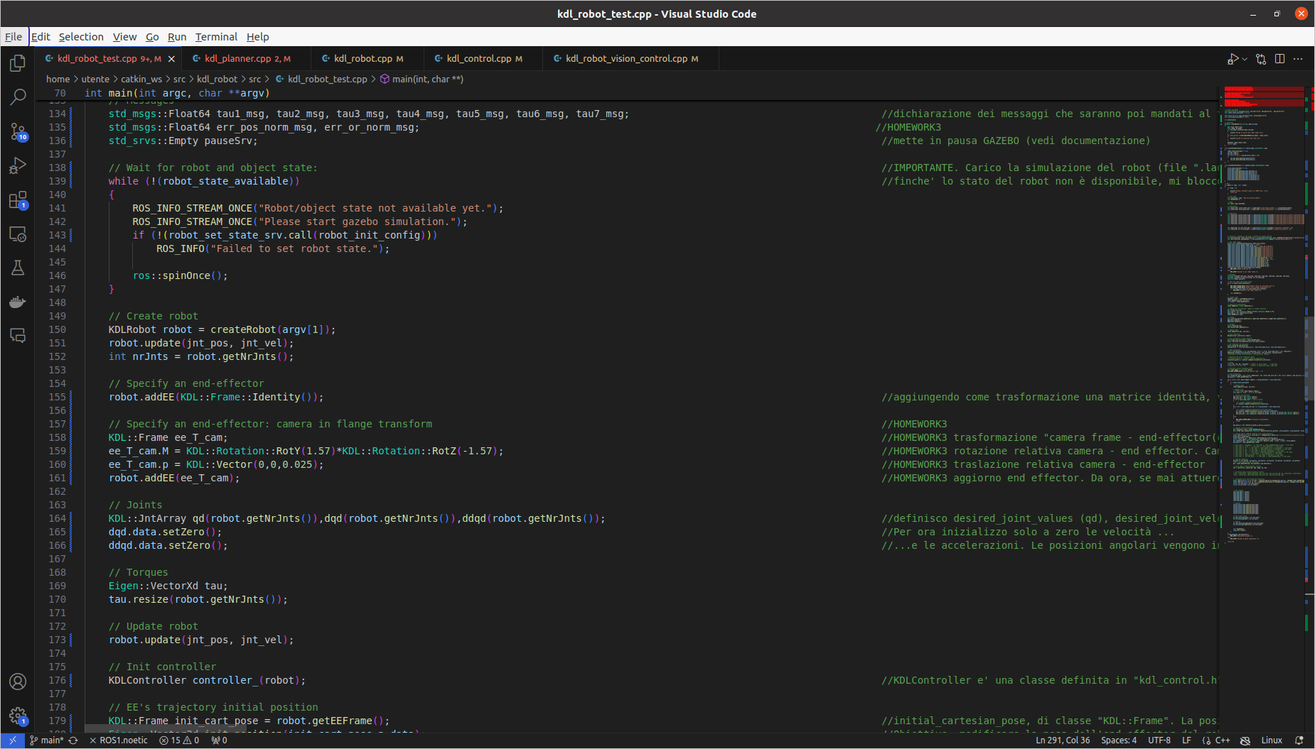
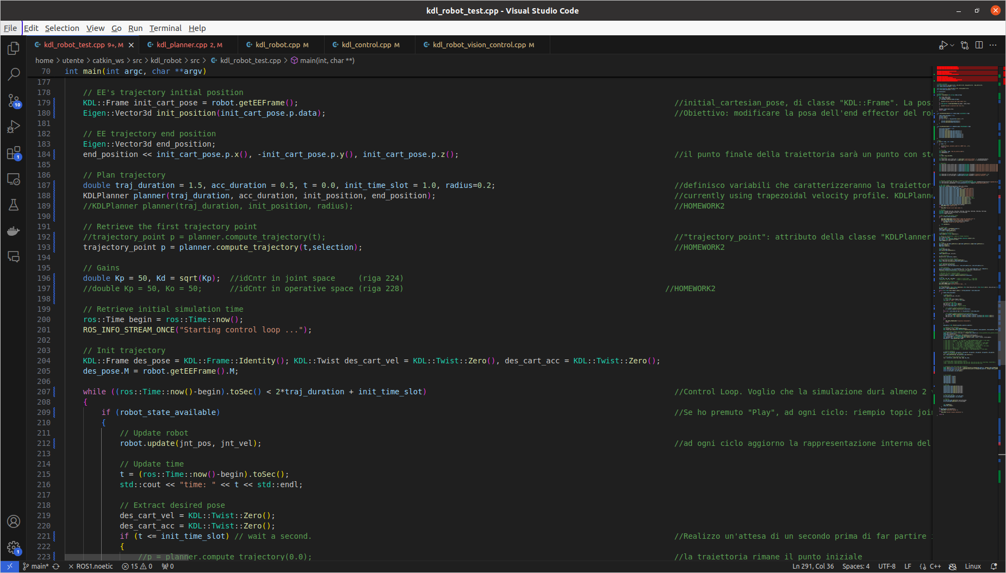

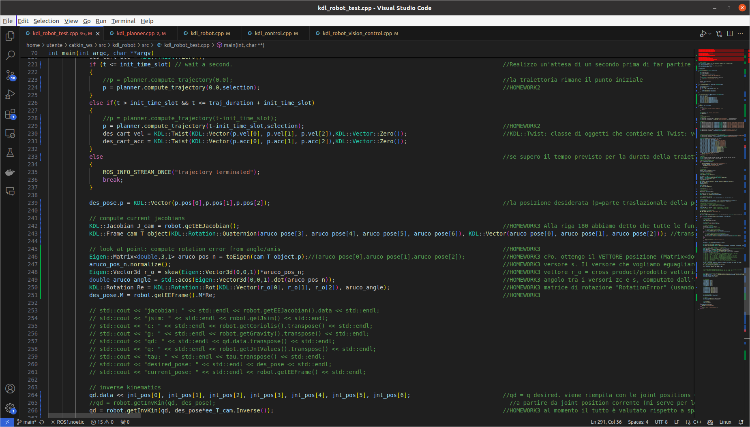

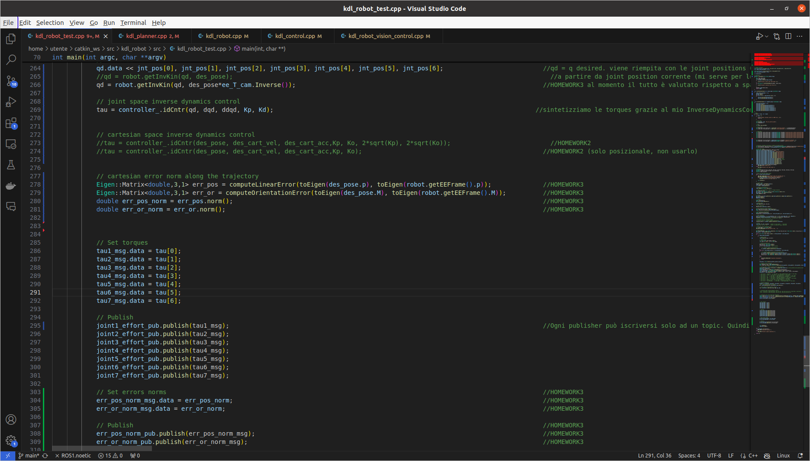

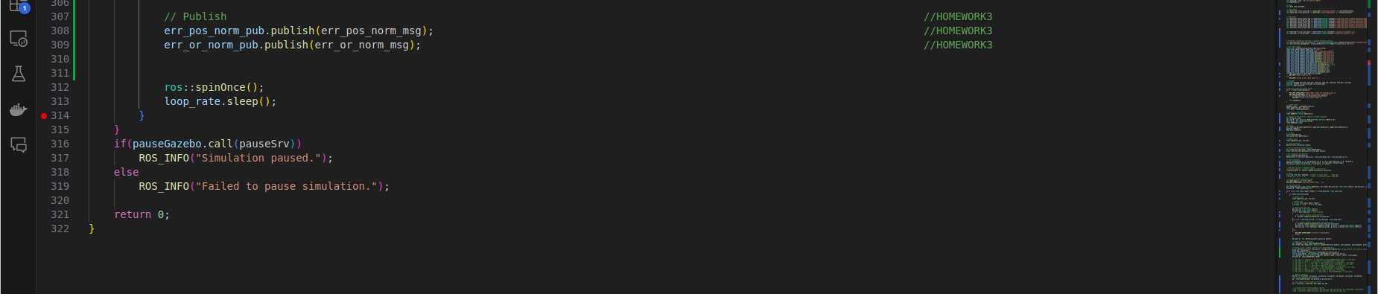

//Inverse Dynamics Controller in joint space
//Linear trajectory
//Cubic polynomial curvilinear abscissa s

In “~/catkin_ws/src/kdl_robot/src/kdl_robot_test.cpp” I modified:

155 → KDLPlanner planner(traj_duration, acc_duration, init_position, end_position);
159 → trajectory_point p = planner.compute_trajectory(t,selection);
163 → double Kp = 50, Kd = sqrt(Kp);
190 → p = planner.compute_trajectory(0.0,selection);
195 → p = planner.compute_trajectory(t-init_time_slot,selection);
228 → tau = controller_.idCntr(qd, dqd, ddqd, Kp, Kd);

Simulation:

$ cd catkin_ws (terminal 1)
$ source devel/setup.bash
$ roslaunch iiwa_gazebo iiwa_gazebo_aruco_effort.launch

$ cd catkin_ws (terminal 2)
$ source devel/setup.bash
$ roslaunch aruco_ros usb_cam_aruco.launch camera:=/iiwa/camera1

$ rqt_image_view (terminal 3)

$ cd catkin_ws (terminal 4)
$ catkin build kdl_ros_control
$ source devel/setup.bash
$ rosrun kdl_ros_control kdl_robot_test ./src/iiwa_stack/iiwa_description/urdf/iiwa14.urdf

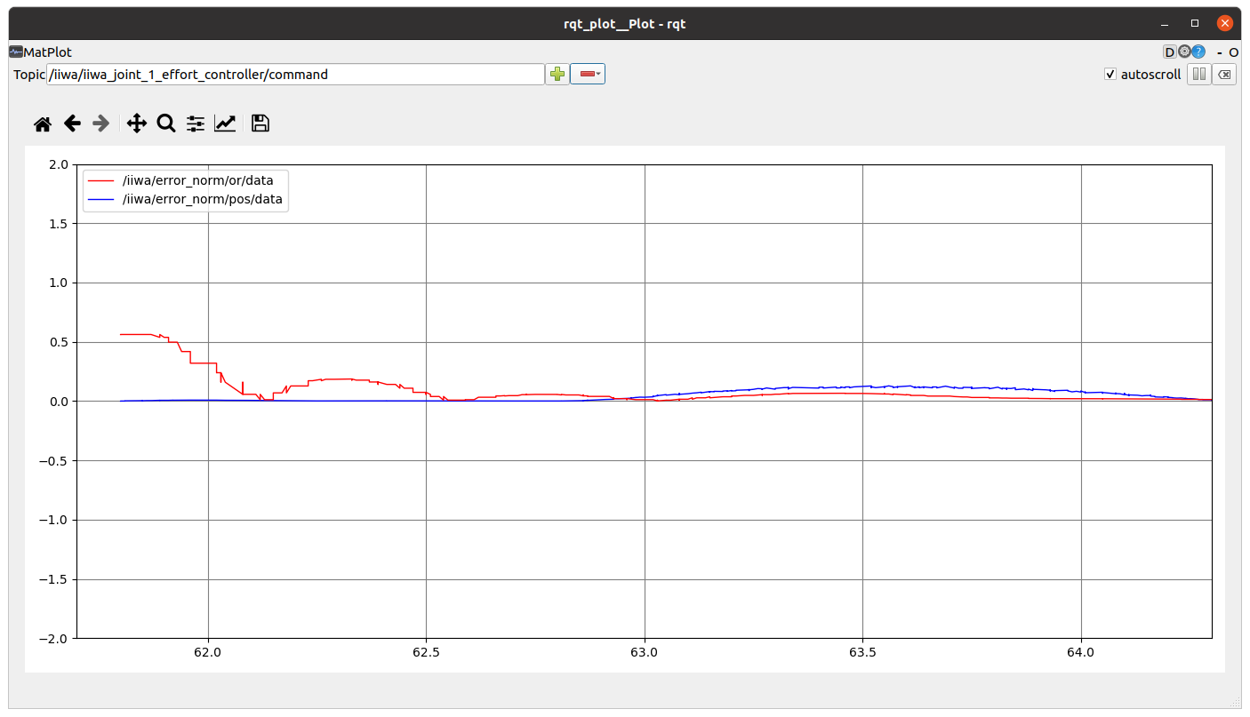
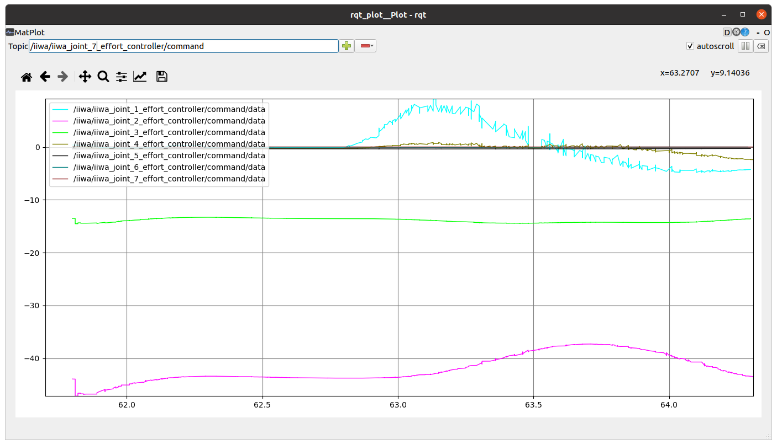

//Inverse Dynamics Controller in operational space
//Linear trajectory
//Cubic polynomial curvilinear abscissa s

In “~/catkin_ws/src/kdl_robot/src/kdl_robot_test.cpp” I modified:

19 → int selection=3;
155 → KDLPlanner planner(traj_duration, acc_duration, init_position, end_position);
159 → trajectory_point p = planner.compute_trajectory(t,selection);
163 → Kp = 50, Ko = 50;
190 → p = planner.compute_trajectory(0.0,selection);
195 → p = planner.compute_trajectory(t-init_time_slot,selection);
228 → tau = controller_.idCntr(des_pose, des_cart_vel, des_cart_acc,Kp, Ko, 2*sqrt(Kp), 2*sqrt(Ko));

Simulation : same



