Report – Homework 4
Student: Riccardo Stucovitz

1. Construct a gazebo world and spawn the mobile robot in a given pose

(a) Launch the Gazebo simulation and spawn the mobile robot in the world rl_racefield in the
pose
x = −3 y = 5 yaw = −90 deg
with respect to the map frame. The argument for the yaw in the call of spawn_model is Y.

I modified “~/catkin_ws/src/rl_fra2mo_description/launch/spawn_fra2mo_gazebo.launch”:

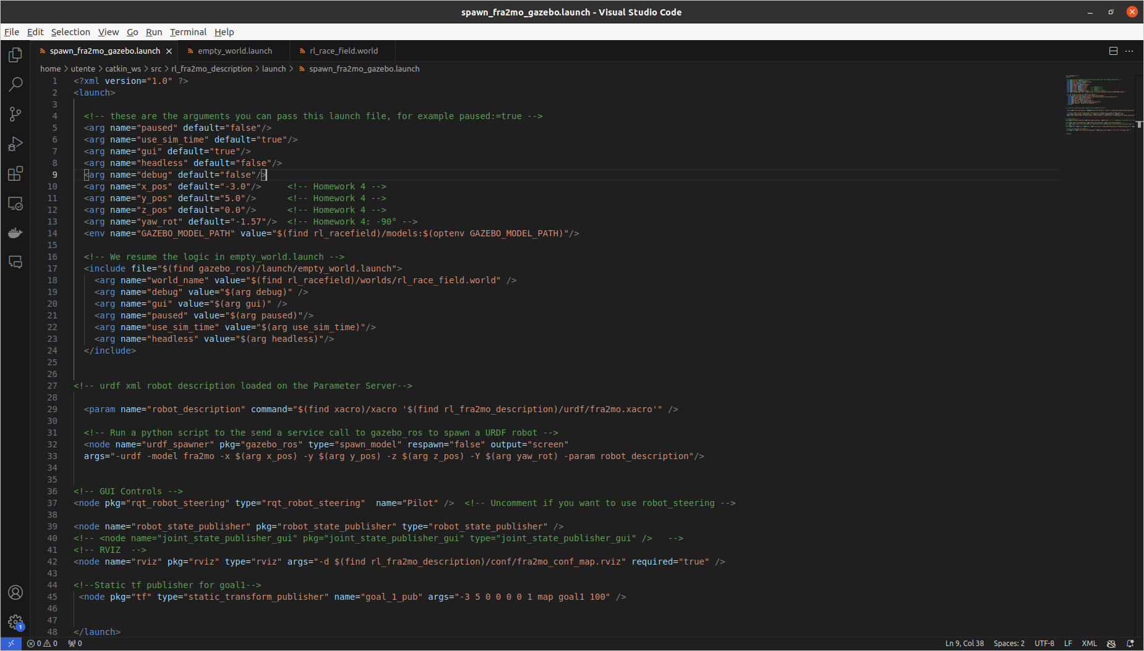

Check:

$ roslaunch rl_fra2mo_description spawn_fra2mo_gazebo.launch
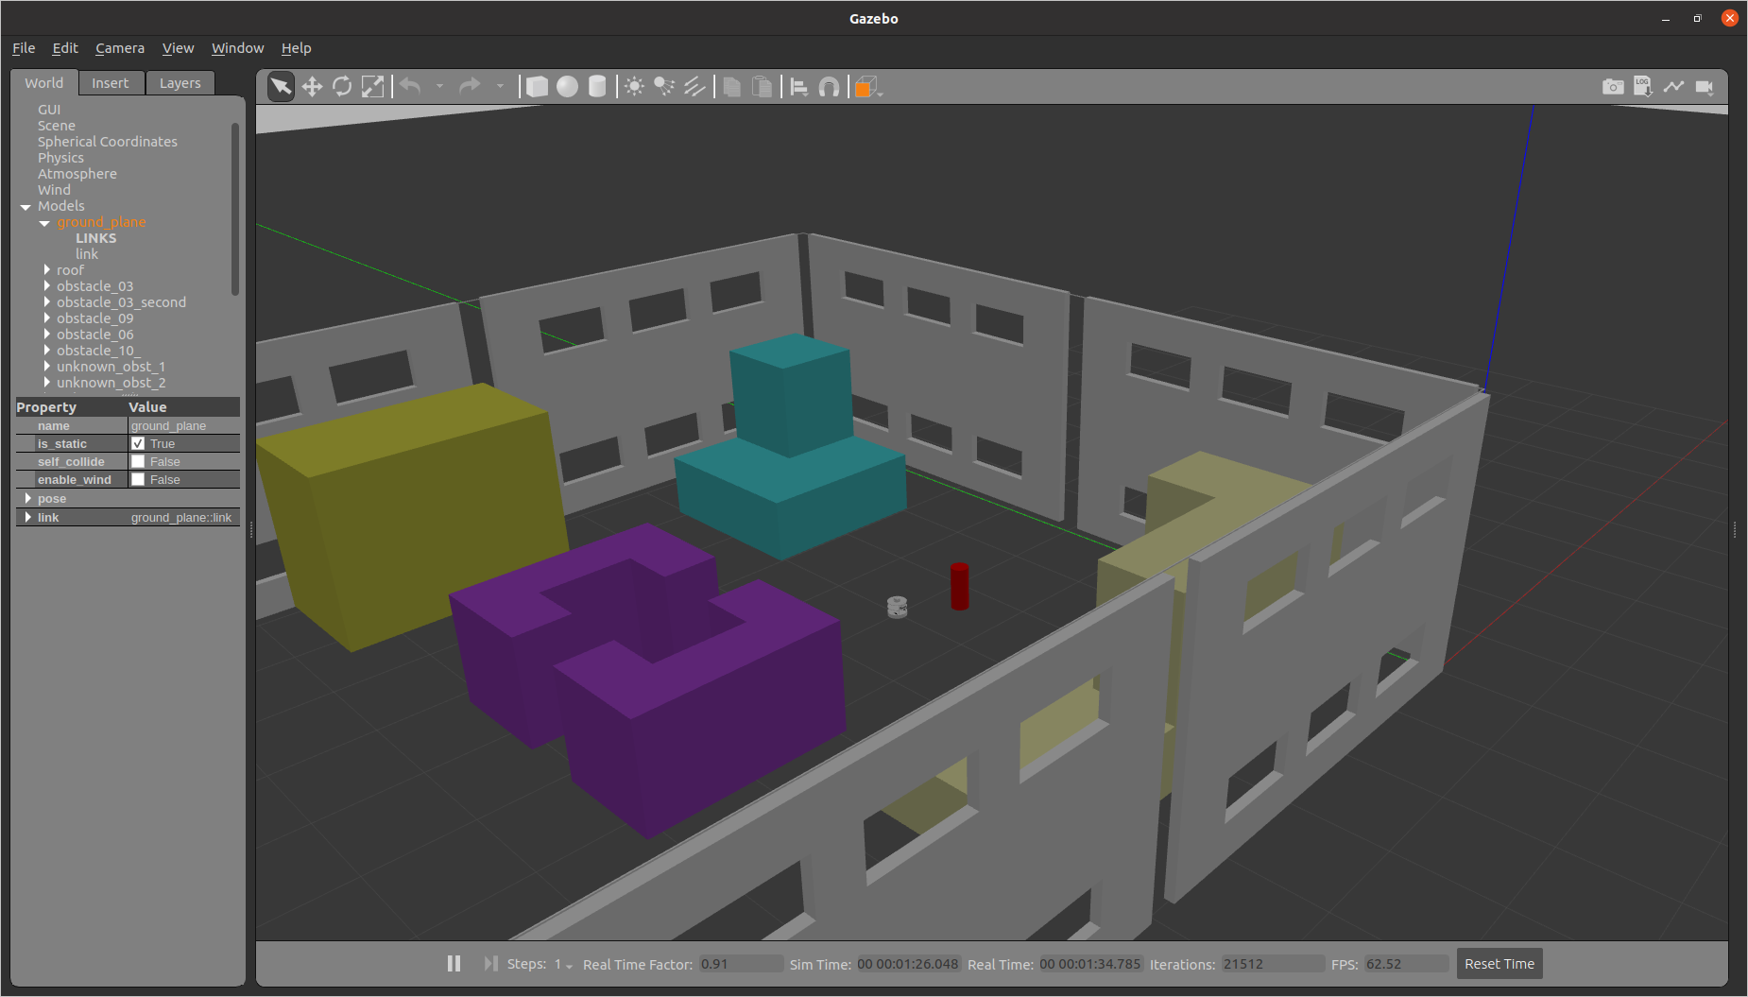

(b) Modify the world file of rl_racefield moving the obstacle 9 in position:
x = −17 y = 9 z = 0.1 yaw = 3.14

I modified “~/catkin_ws/src/rl_racefield/worlds/rl_race_field.world”:
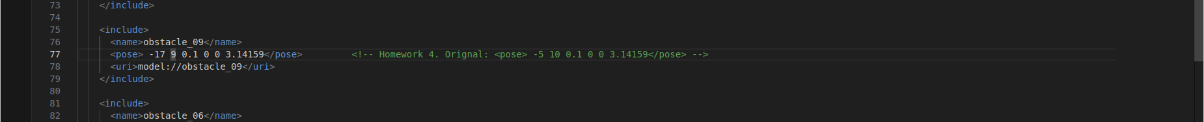
Check (the yellow obstacle):

$ roslaunch rl_fra2mo_description spawn_fra2mo_gazebo.launch

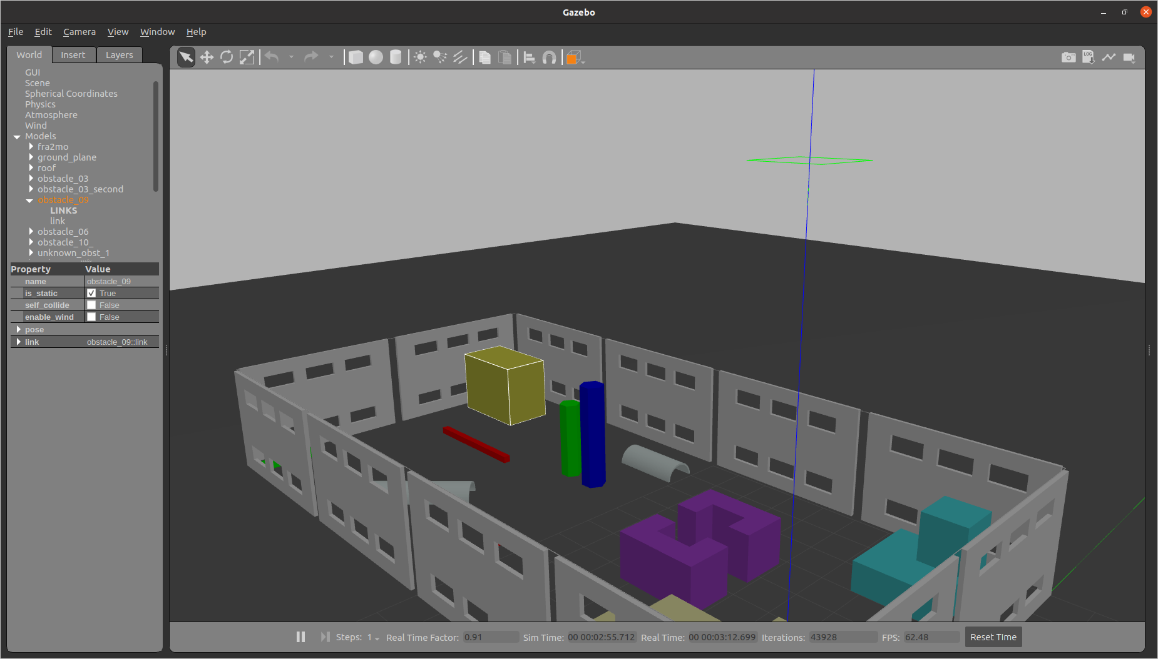

(c) Place the ArUco marker number 115 1 on obstacle 9 in an appropriate position, such that it is
visible by the mobile robot’s camera when it comes in the proximity of the object.

I created the ArUco marker 115:
https://chev.me/arucogen/ →Dictionary: Original ArUco; Marker ID: 115; Marker size, in mm: 100 → Save

~/Scaricati → “aruco-115.svg” → “Apri con Inkscape” → “Esporta come …” /home/utente/Scaricati/aruco-115.png → Esporta → Rimpiazza
~/Scaricati → aruco—115.png

I made it a model to insert in our world:

$ cd ~/catkin_ws/src/rl_racefield/models
$ mkdir marker_115

Taking inspiration from the other models already existing in this folder:

marker_115.sdf (“name” → marker name as a model in Gazebo GUI → Lateral bar → “World”):

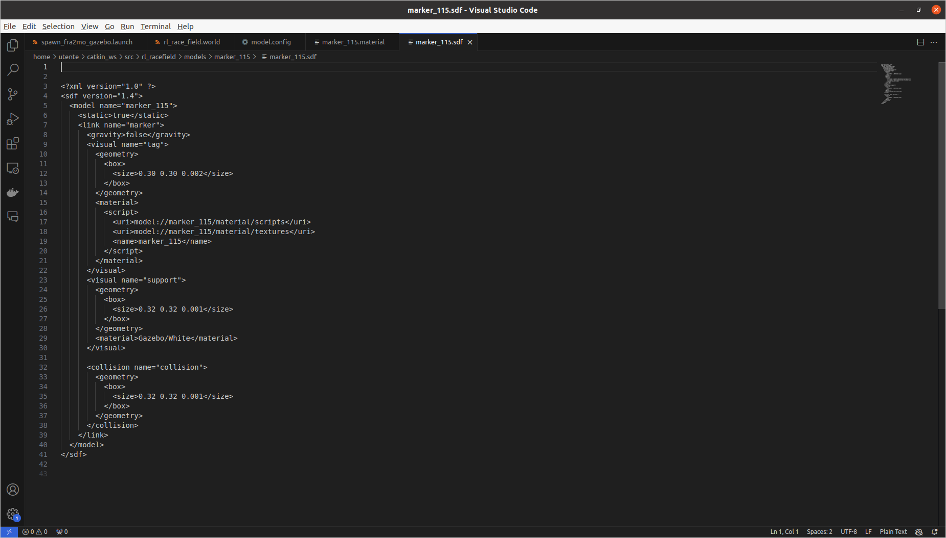

model.config (“name” → marker name in Gazebo GUI → Lateral bar → “Insert”):

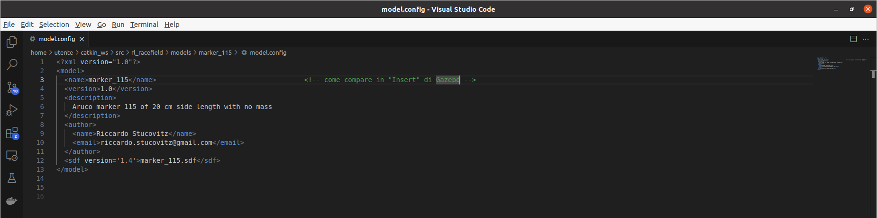

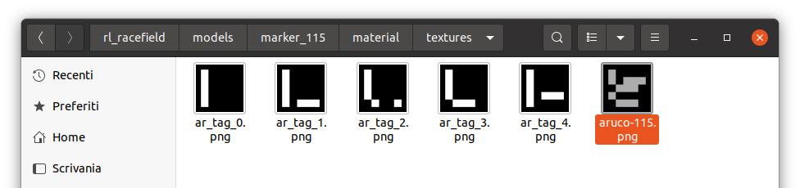
material/textures:

material/scripts/marker_115.material:

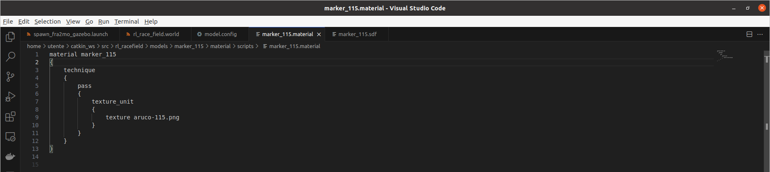

I placed it inside our world:

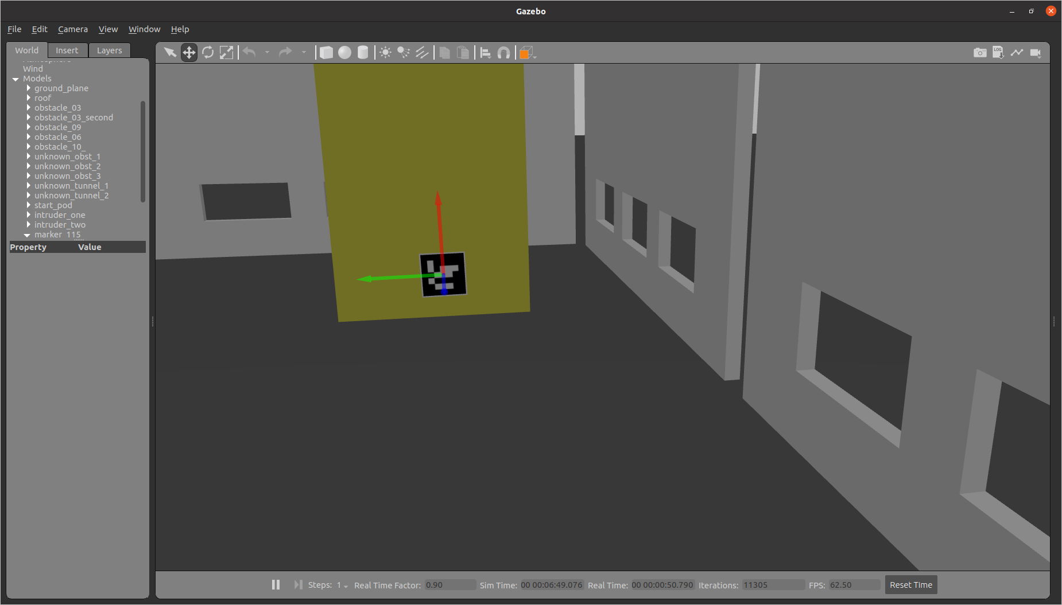

Then I saved this world as a new one:

Gazebo GUI:
- Lateral bar → World → Models → “fra2mo” → delete
- Save World As: ~/catkin_ws/src/rl_racefield/worlds/rl_race_field_homework4
- Rename: rl_race_field_homework4.world (otherwise Gazebo crashes)

Then I made “spawn_fra2mo_gazebo.launch” launch it directly:
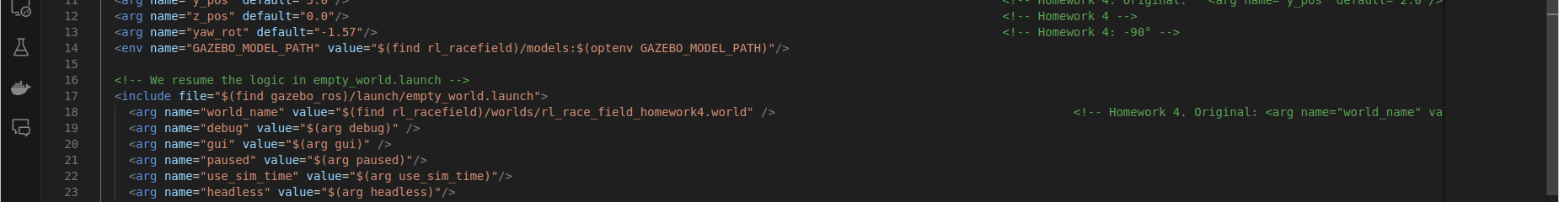

2. Place static tf acting as goals and get their pose to enable an autonomous navigation task

(a) Insert 4 static tf acting as goals in the following poses with respect to the map frame:

• Goal 1: x = −10 y = 3 yaw = 0 deg
• Goal 2: x = −15 y = 7 yaw = 30 deg
• Goal 3: x = −6 y = 8 yaw = 180 deg
• Goal 4: x = −17.5 y = 3 yaw = 75 deg

Follow the example provided in the launch file rl_fra2mo_description/launch/spawn_fra2mo_gazebo.launch of the simulation.

I modified “~/catkin_ws/src/rl_fra2mo_description/launch/spawn_fra2mo_gazebo.launch”:

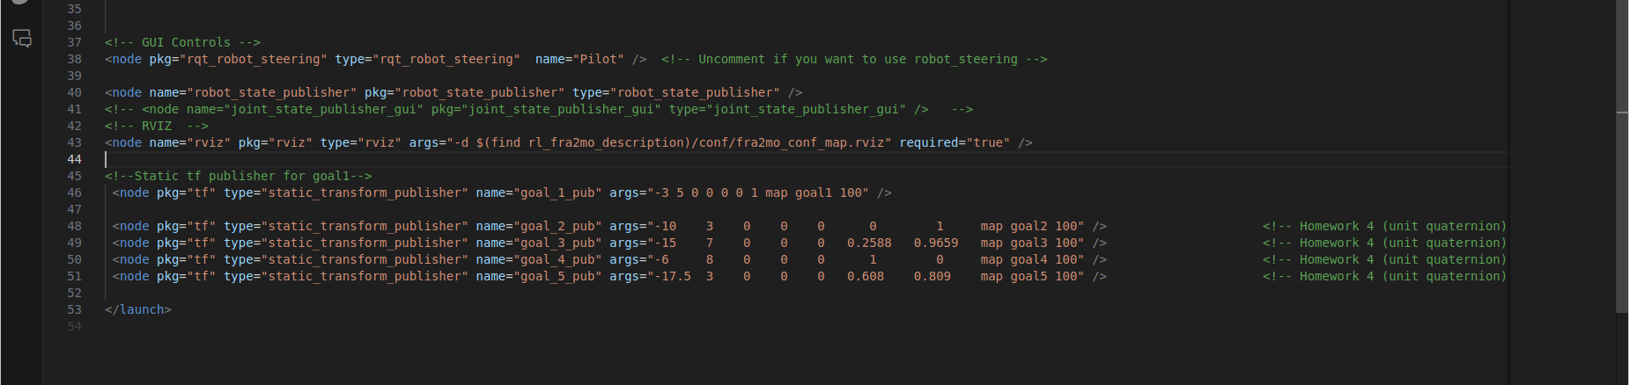
“static_transform_publisher” is a node publishing a static transformation among two reference frames

(b) Following the example code in fra2mo_2dnav/src/tf_nav.cpp, implement tf listeners to get
target poses and print them to the terminal as debug.

I modified “~/catkin_ws/src/fra2mo_2dnav/src/tf_nav.cpp”, but for simplicity I implemented a debug just for Goal_1 (in my code it’s “goal2”) :
N.b. it’s the commented code
N.b. in (c) I debugged all of the goals
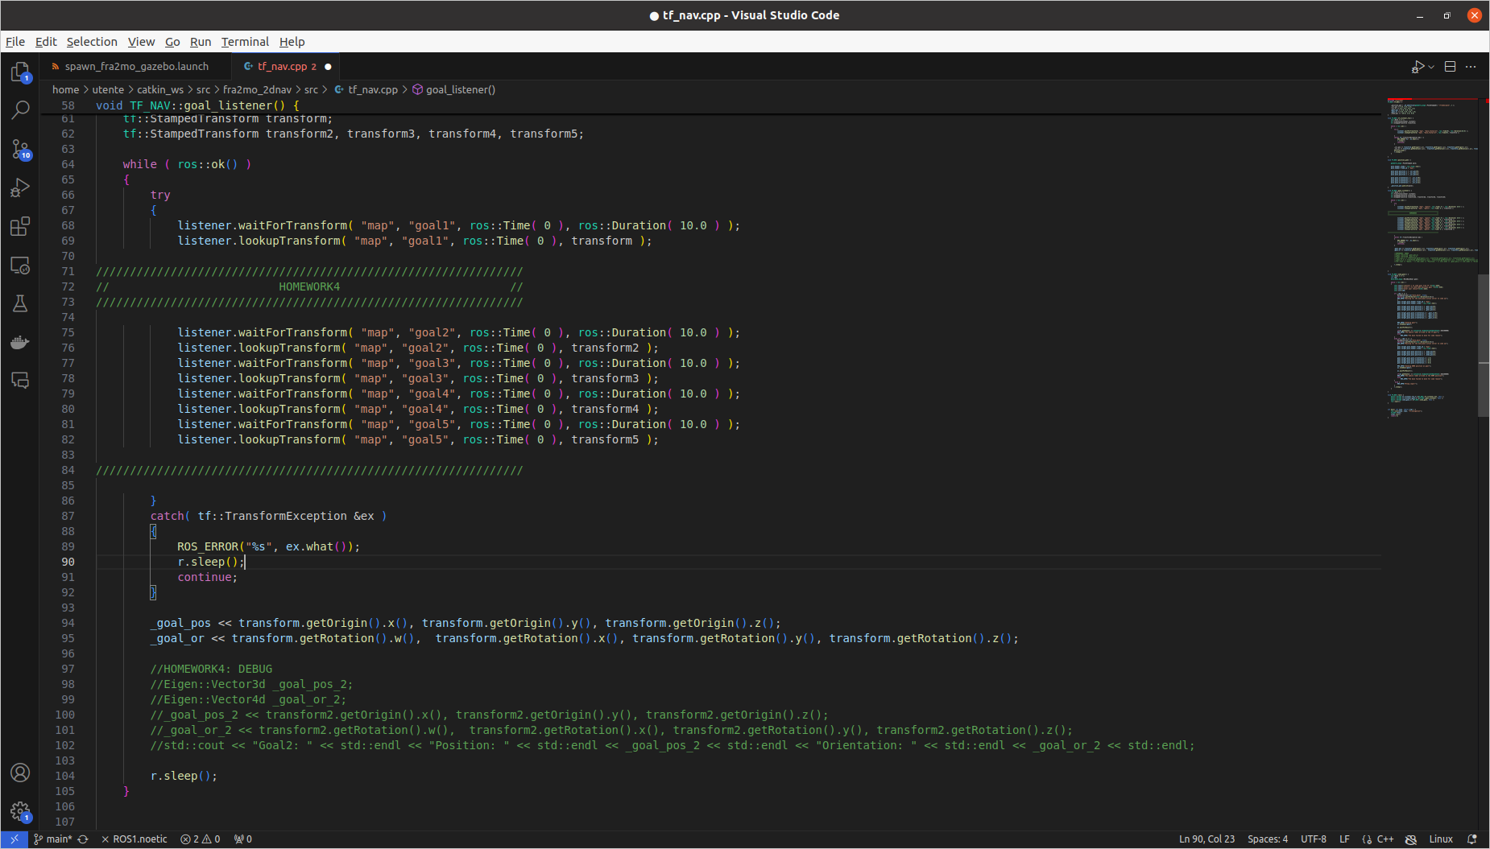
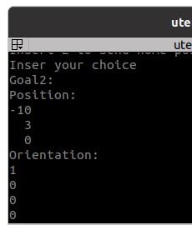
Simulation:

$ roslaunch fra2mo_2dnav fra2mo_nav_bringup.launch (terminal 1)

$ cd catkin_ws (terminal 2)
$ cd catkin build fra2mo_2dnav
$ source devel/setup.bash
$ rosrun fra2mo_2dnav tf_nav

(c) Using move_base, send goals to the mobile platform in a given order. Go to the next one once
the robot has arrived at the current goal. The order of the explored goals must be Goal 3 →
Goal 4 → Goal 2 → Goal 1. Use the Action Client communication protocol to get the feedback
from move_base. Record a bagfile of the executed robot trajectory and plot it as a result.

I modified:

~/catkin_ws/src/fra2mo_2dnav/include/tf_nav.h
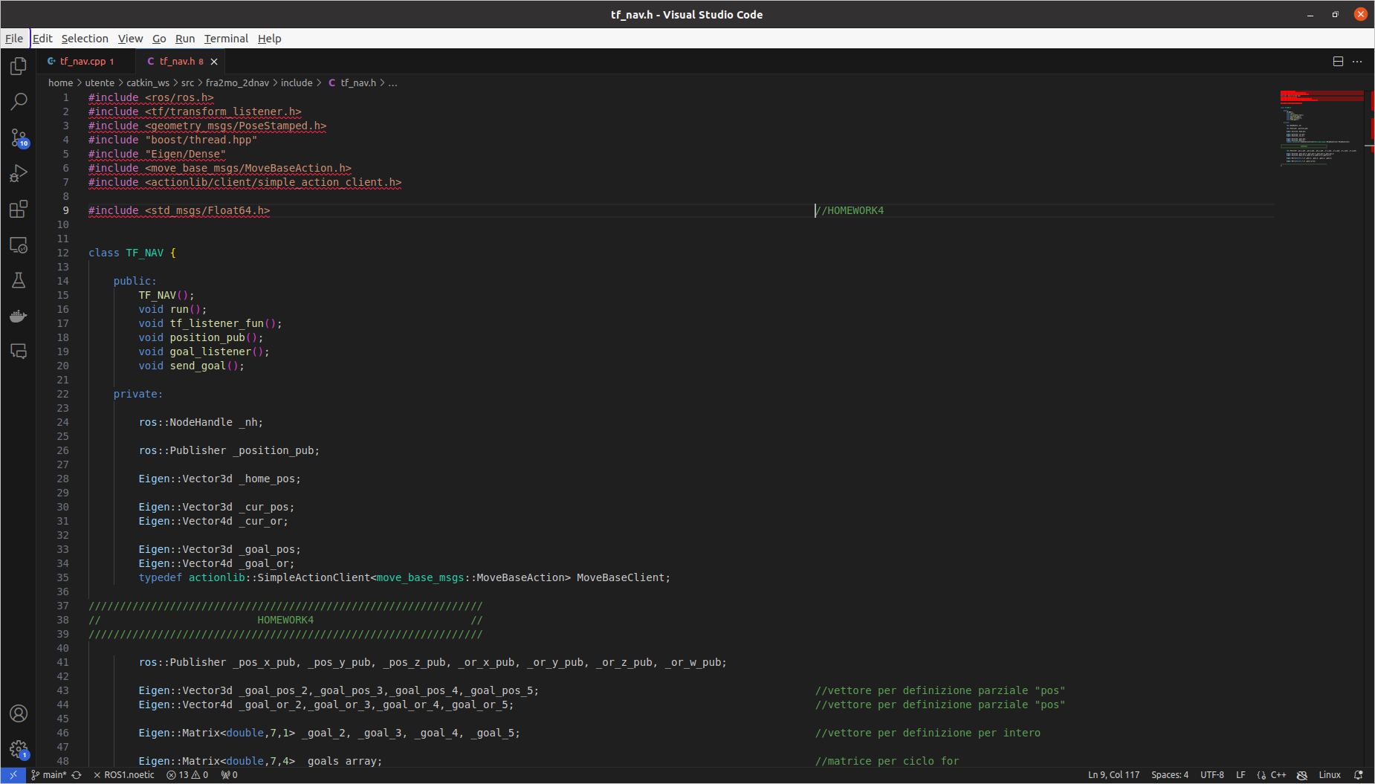
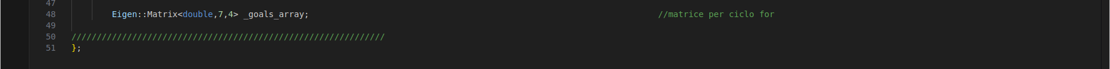
~/catkin_ws/src/fra2mo_2dnav/src/tf_nav.cpp

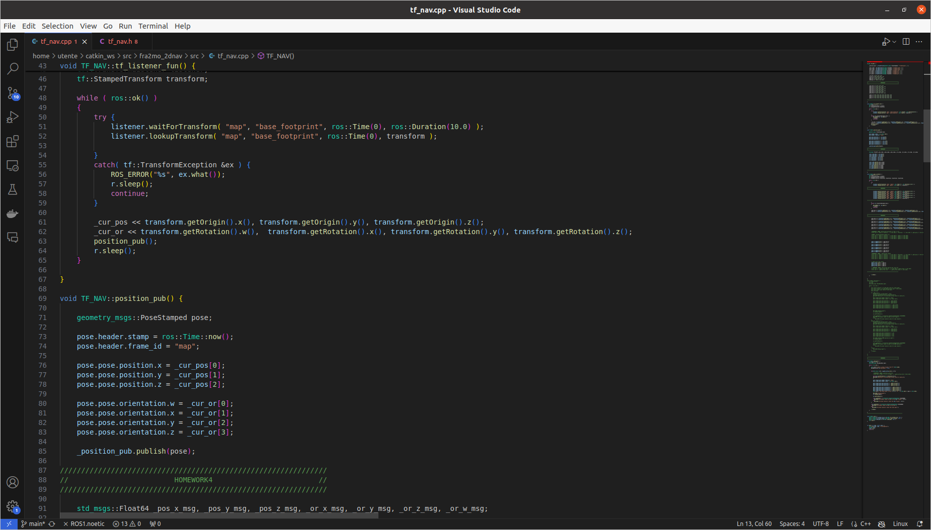
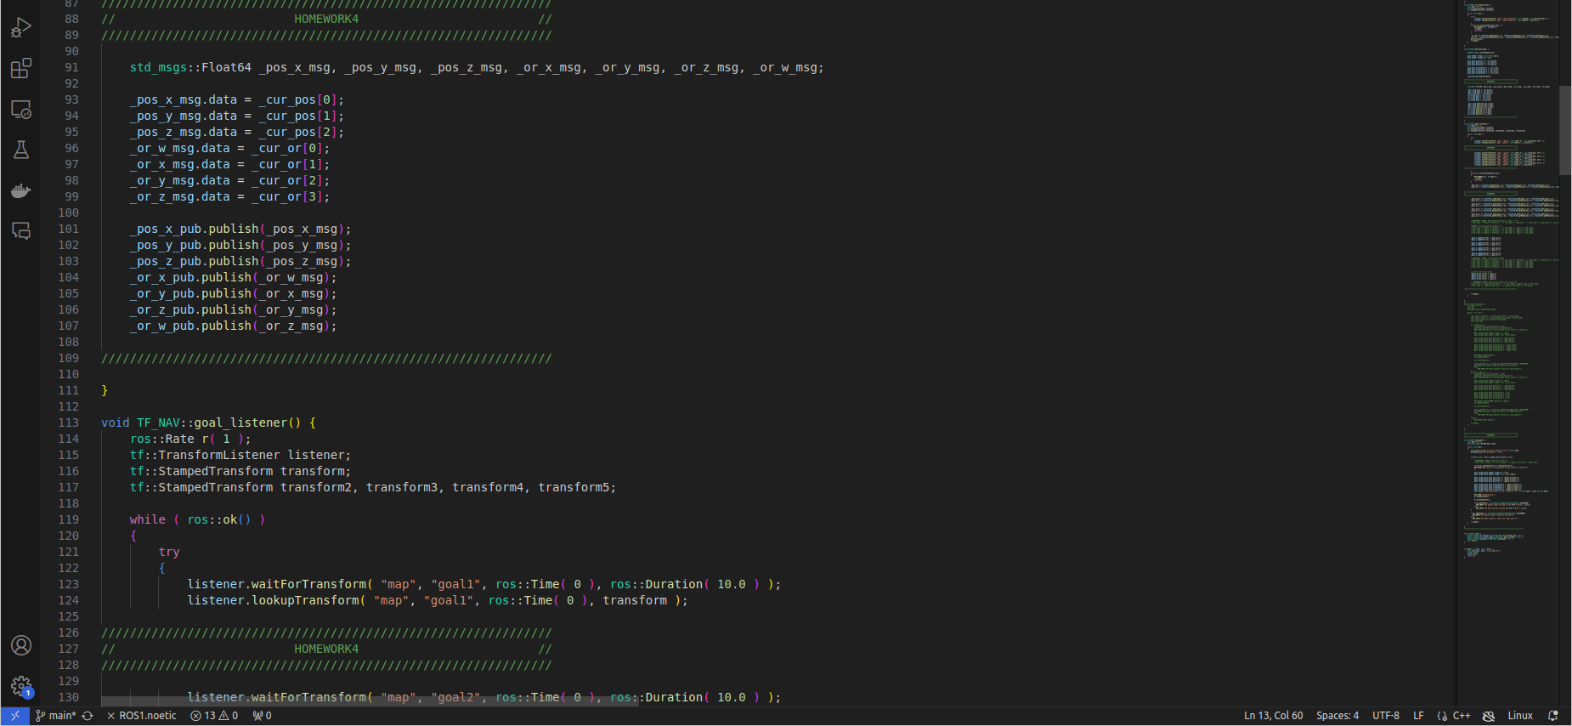
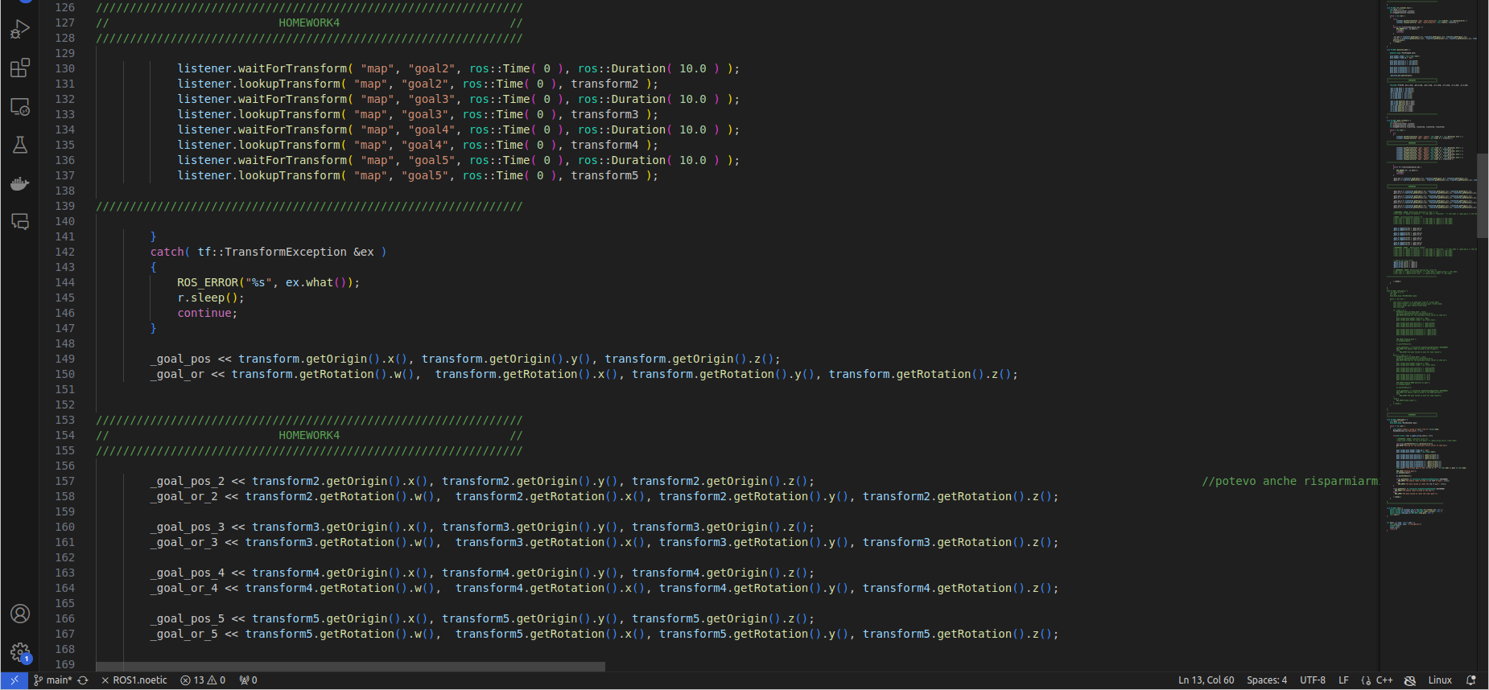

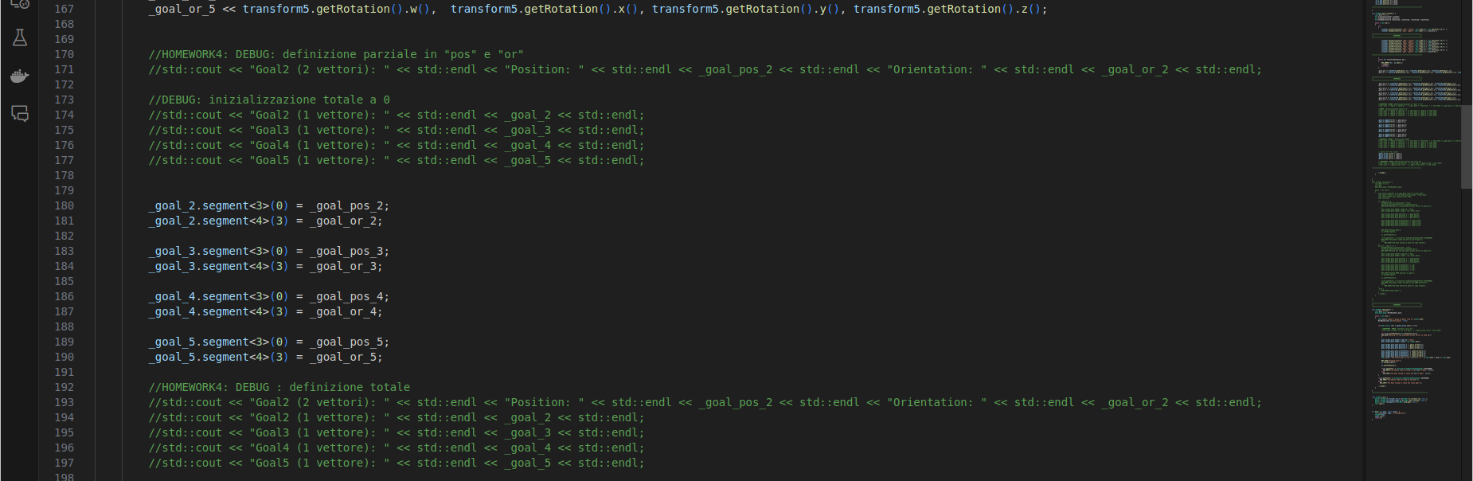
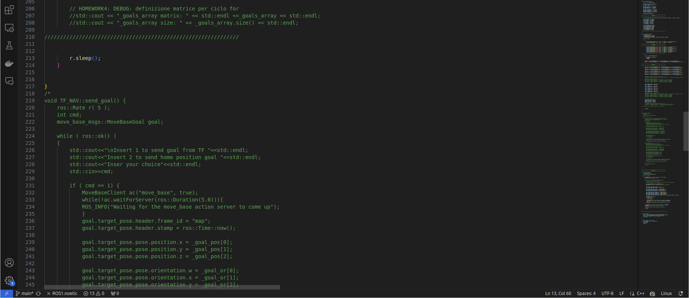
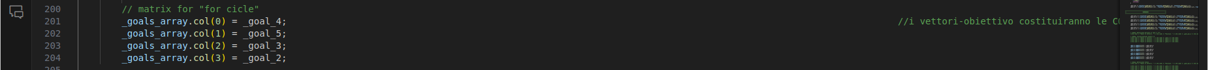

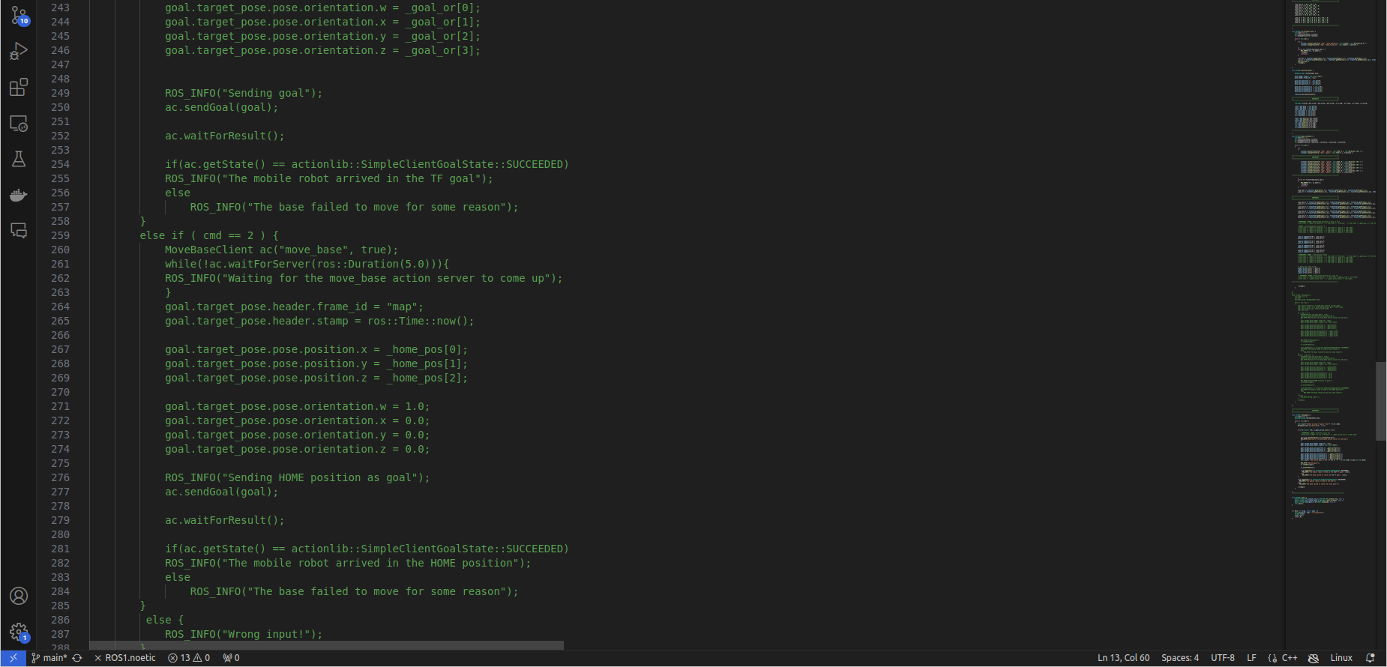

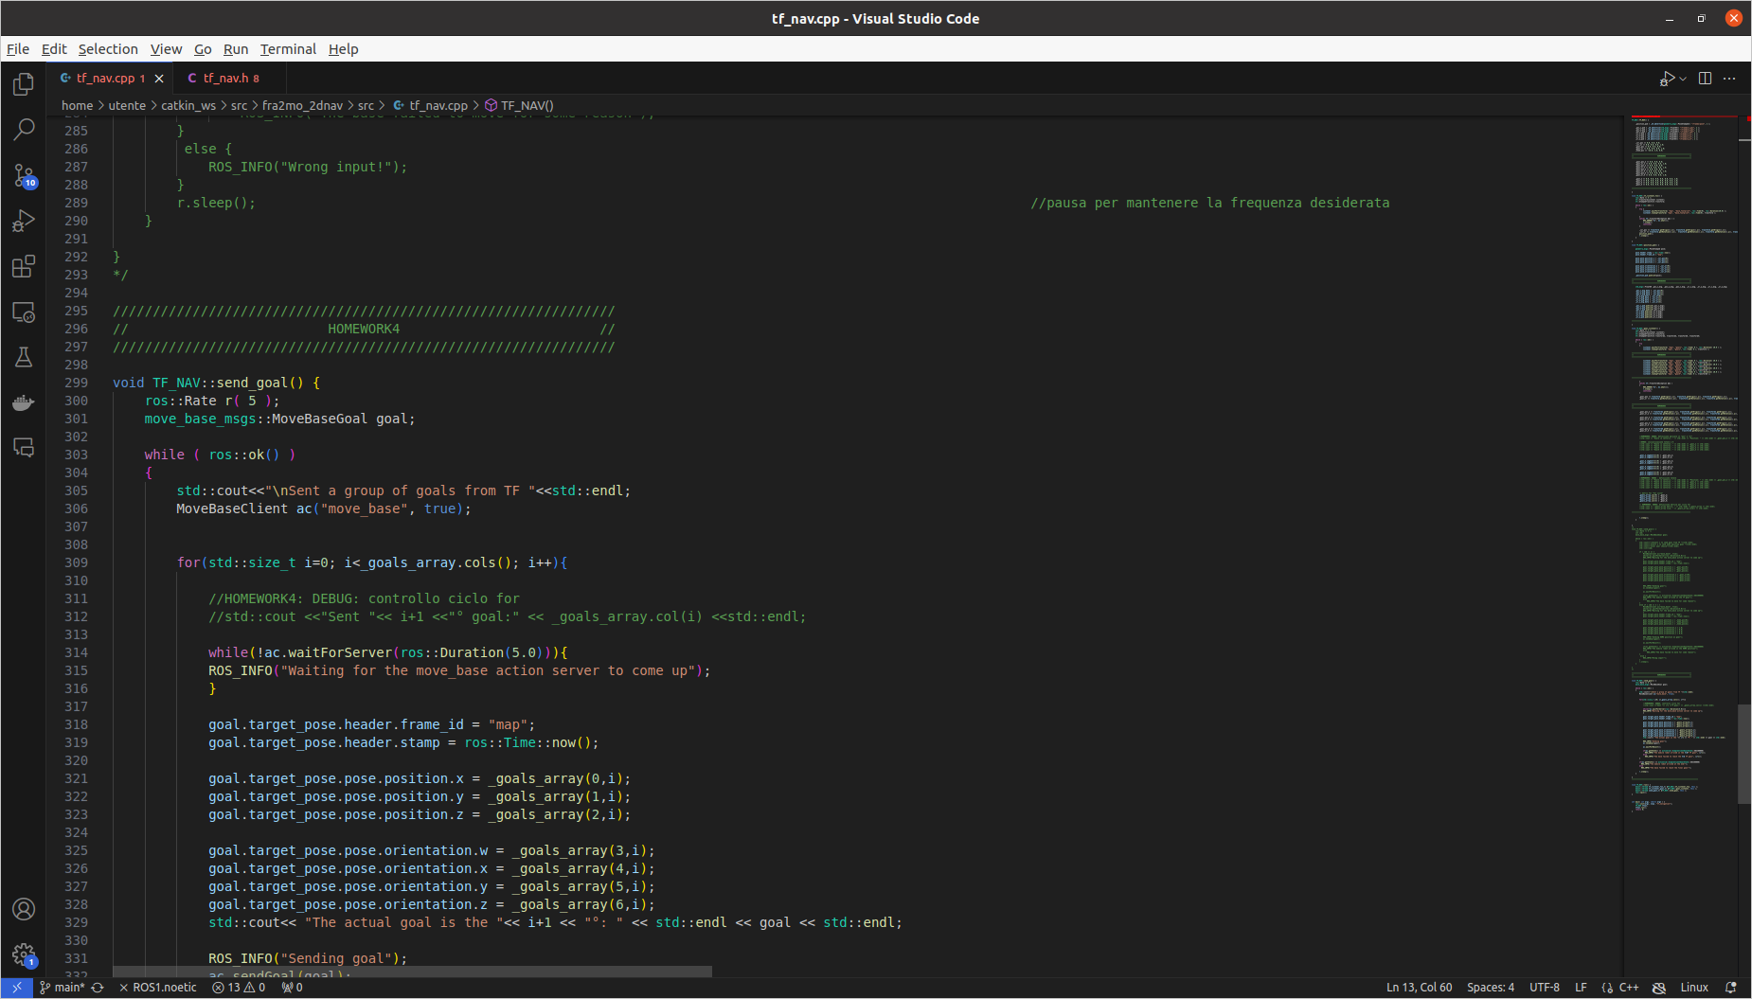

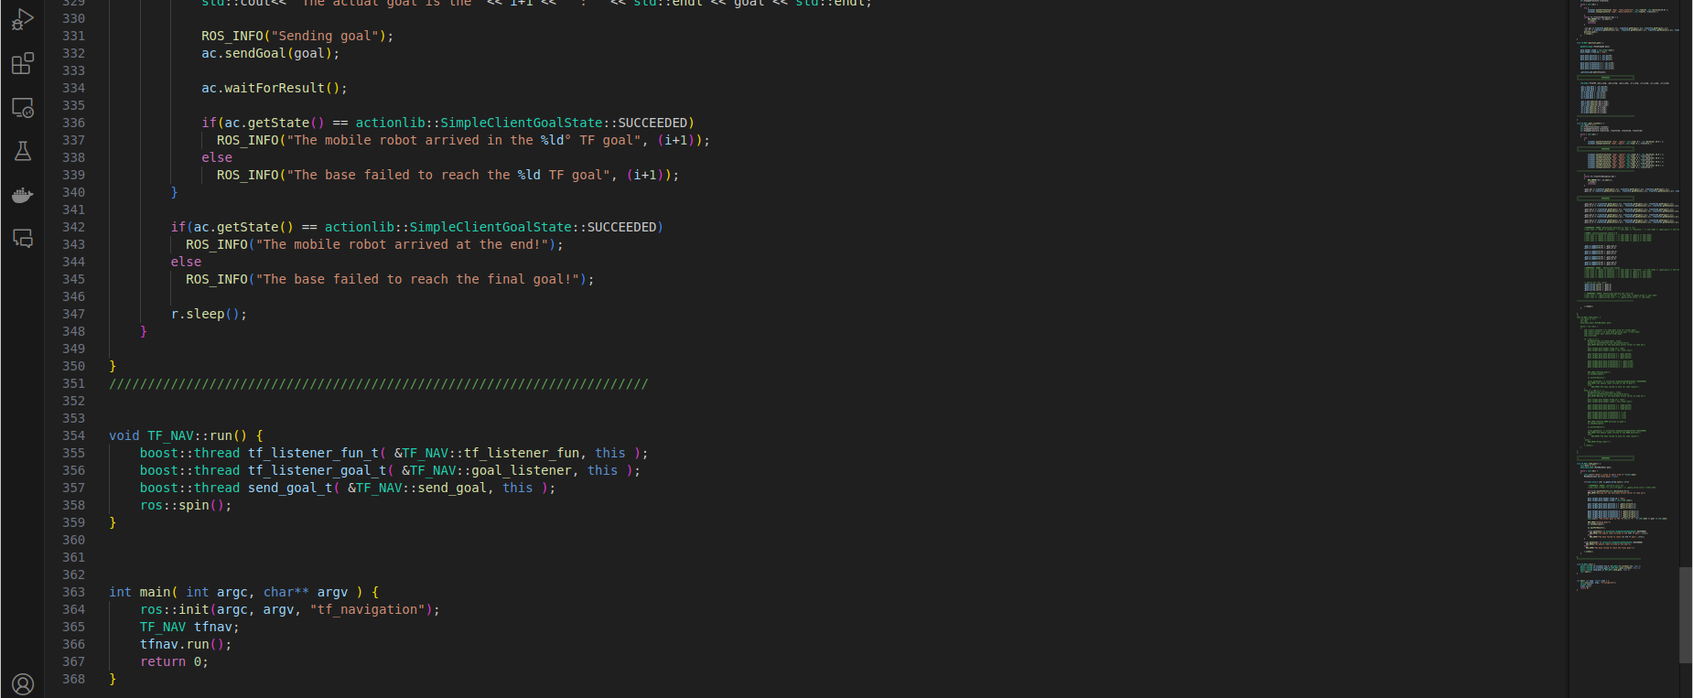

In particular, I collected all the goals’ poses vectors in a matrix “goals_array”, and used the latter to implement a for-cycle (we slide from column to column, so that at the end of every single goal’s trajectory, the robot starts immediately the next one).
The send_goal() function has been completely rebuilt from scratch.

Simulation:

$ roslaunch fra2mo_2dnav fra2mo_nav_bringup.launch (terminal 1)

$ cd ~/catkin_ws (terminal 2)
$ catkin build fra2mo_2dnav
$ source devel/setup.bash
$ rosrun fra2mo_2dnav tf_nav

$ rqt_plot (terminal 3)

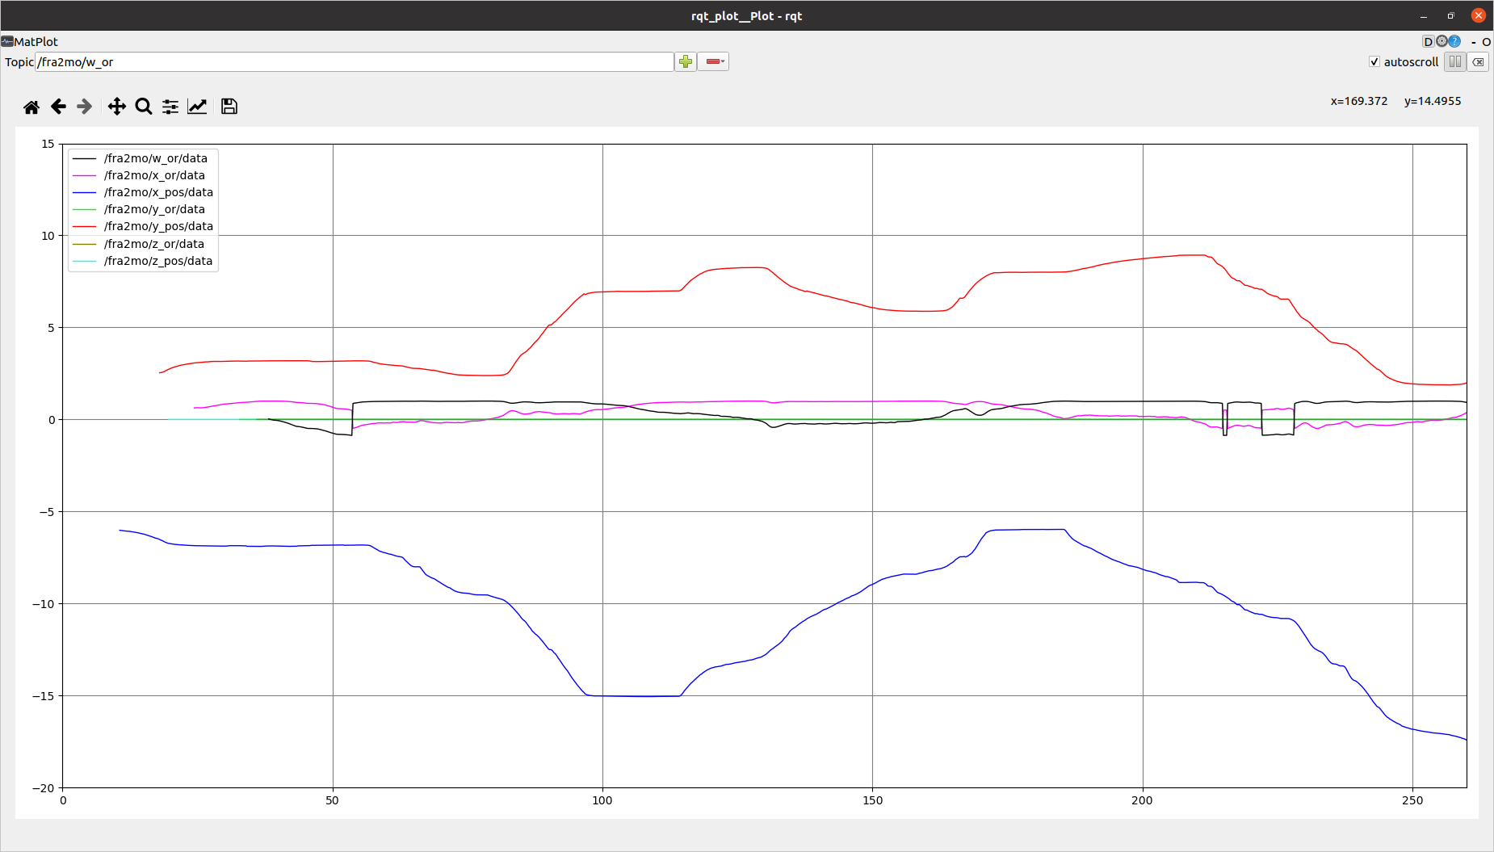
To save information of this kind in a rosbag file in “~/catkin_ws”:

$ roslaunch fra2mo_2dnav fra2mo_nav_bringup.launch (terminal 1)

$ cd ~/catkin_ws (terminal 2)
$ catkin build fra2mo_2dnav
$ source devel/setup.bash
$ rosrun fra2mo_2dnav tf_nav

$ rqt_plot (terminal 3)

$ cd ~/catkin_ws/fra2mo_2dnav (terminal 4)
$ rosbag record /fra2mo/x_pos /fra2mo/y_pos fra2mo/z_pos fra2mo/x_or fra2mo/y_or fra2mo/z_or fra2mo/w_or

To stop and save the recording, I killed the process (CTRL + C) in terminal 4. Then I renamed this file.
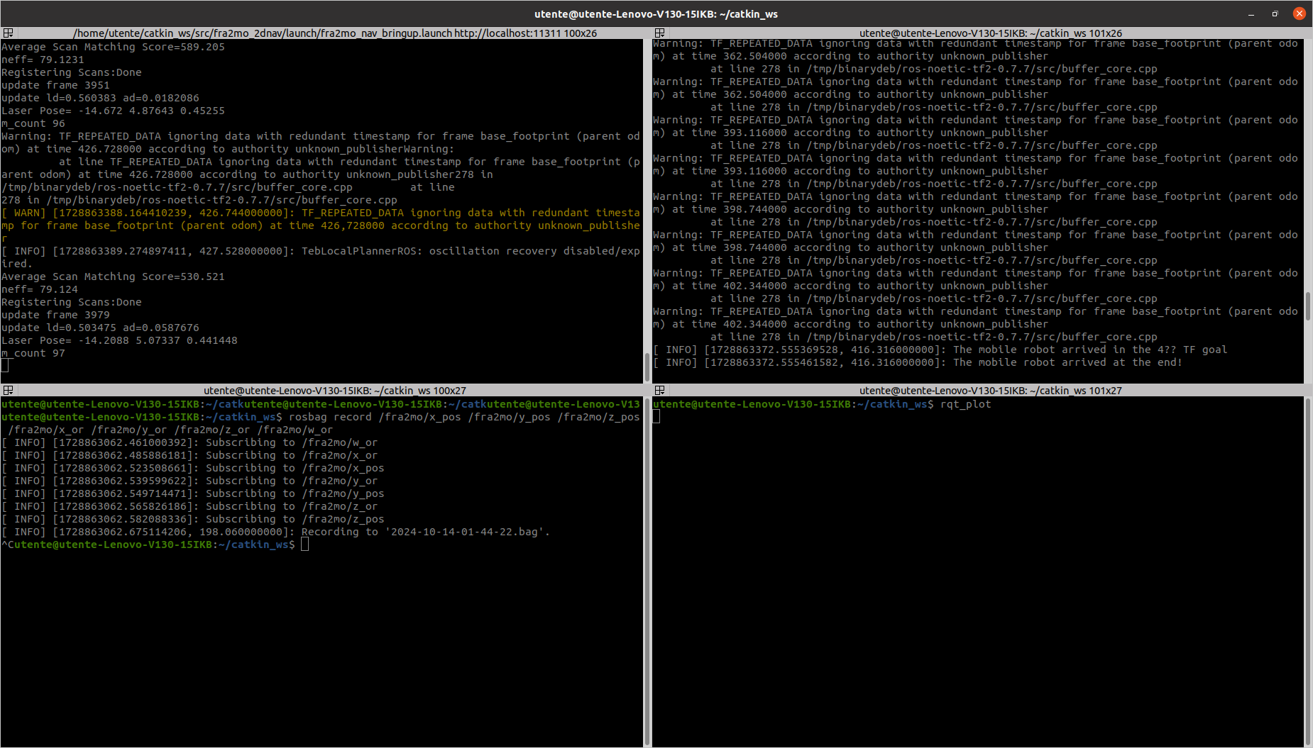
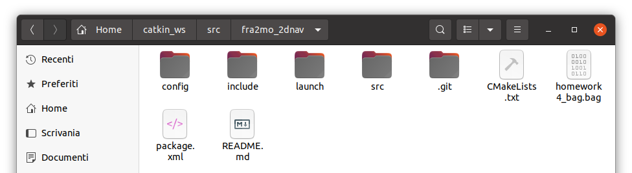

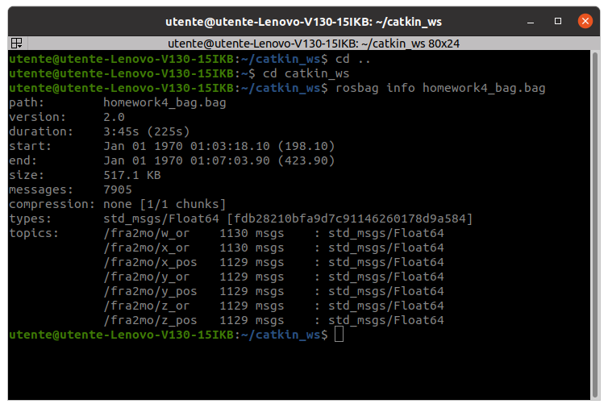

To check if everything went ok:

$ cd catkin_ws/src/fra2mo_2dnav
$ rosbag info homework4_bag.bag

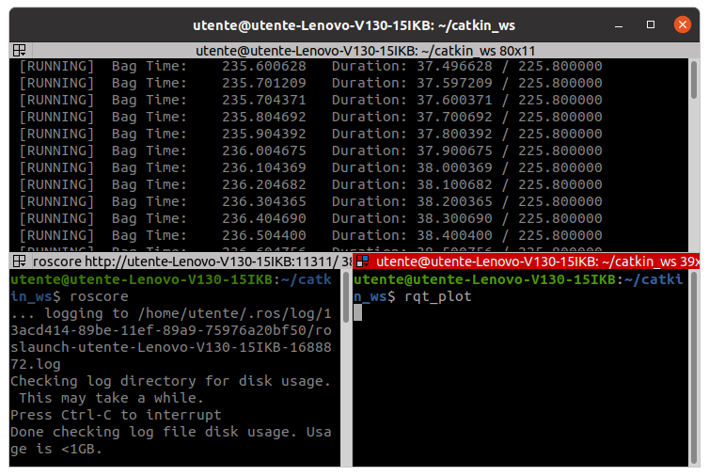
To play it:

$ roscore (terminal 1)

$ cd ~/catkin_ws/fra2mo_2dnav (terminal 2)
$ rosbag play homework4_bag.bag

$ rqt_plot (terminal 3)

It plots in the rqt_plot (no image)

3. Map the environment tuning the navigation stack’s parameters

(a) Modify, add, remove, or change pose, the previous goals to get a complete map of the environment.

With the trajectory points assigned, the robot failed in completing the map of the environment. So I completely modified them: it has been a long “trial and error” process, where I found out that both robot and planner don’t like narrow spaces. This is the map of the new TF goals (modified with Inkscape):
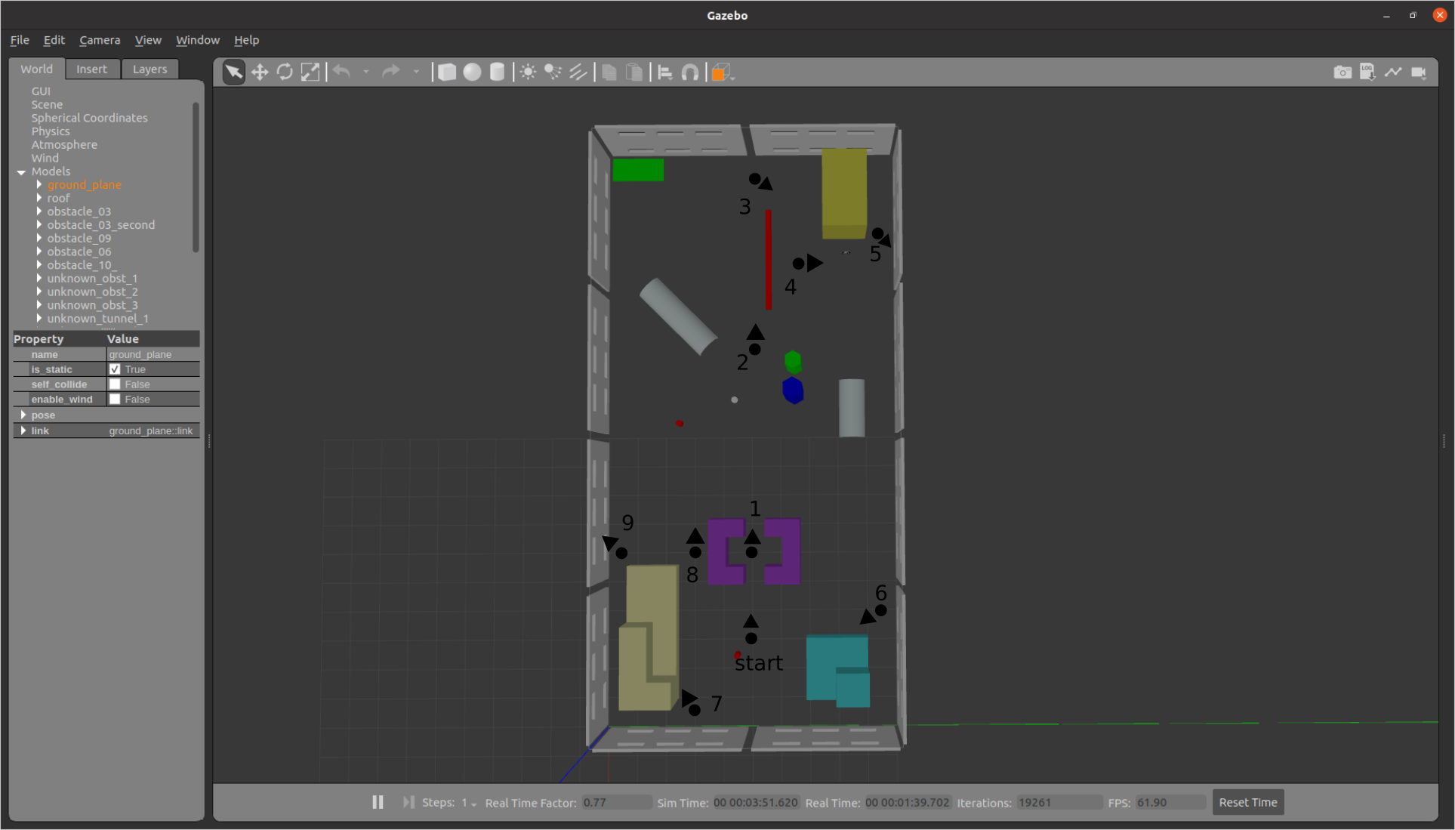

So I modified:
“~/catkin_ws/src/rl_fra2mo_description/launch/spawn_fra2mo_gazebo.launch”:

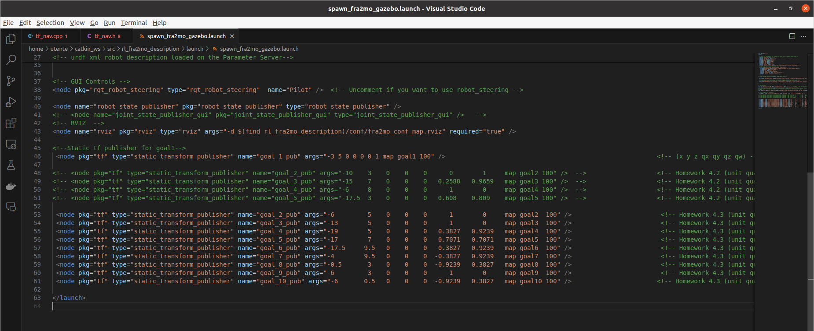

“~/catkin_ws/src/fra2mo_2dnav/src/tf_nav.h”:
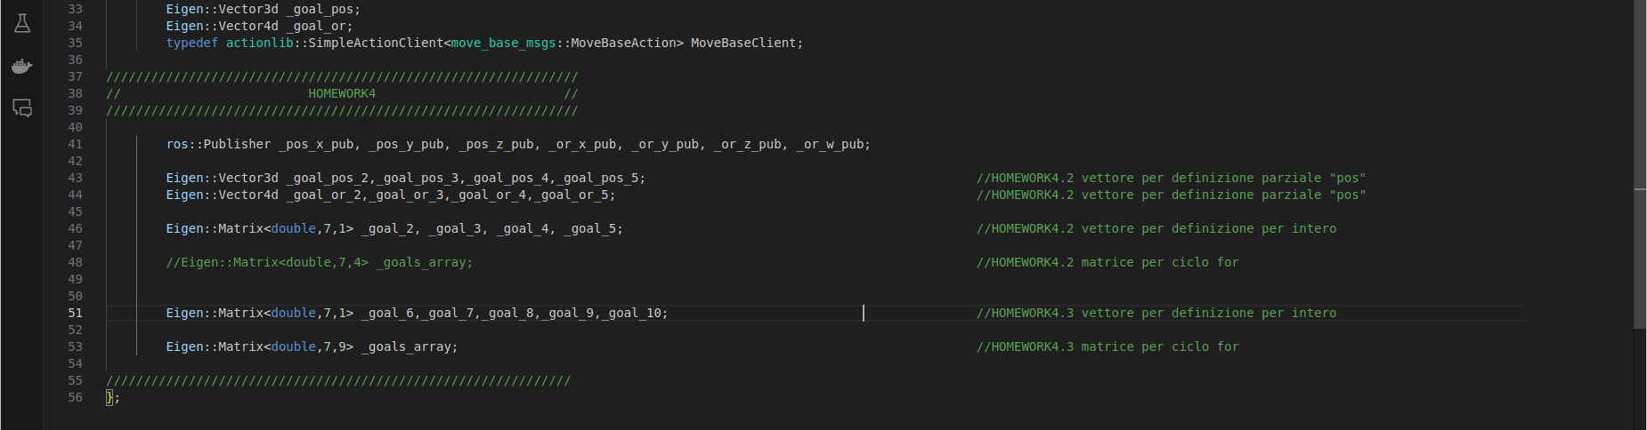

“~/catkin_ws/src/fra2mo_2dnav/src/tf_nav.cpp”:

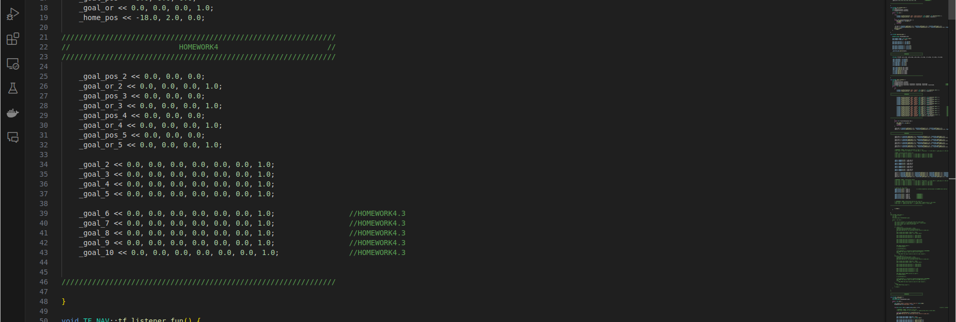
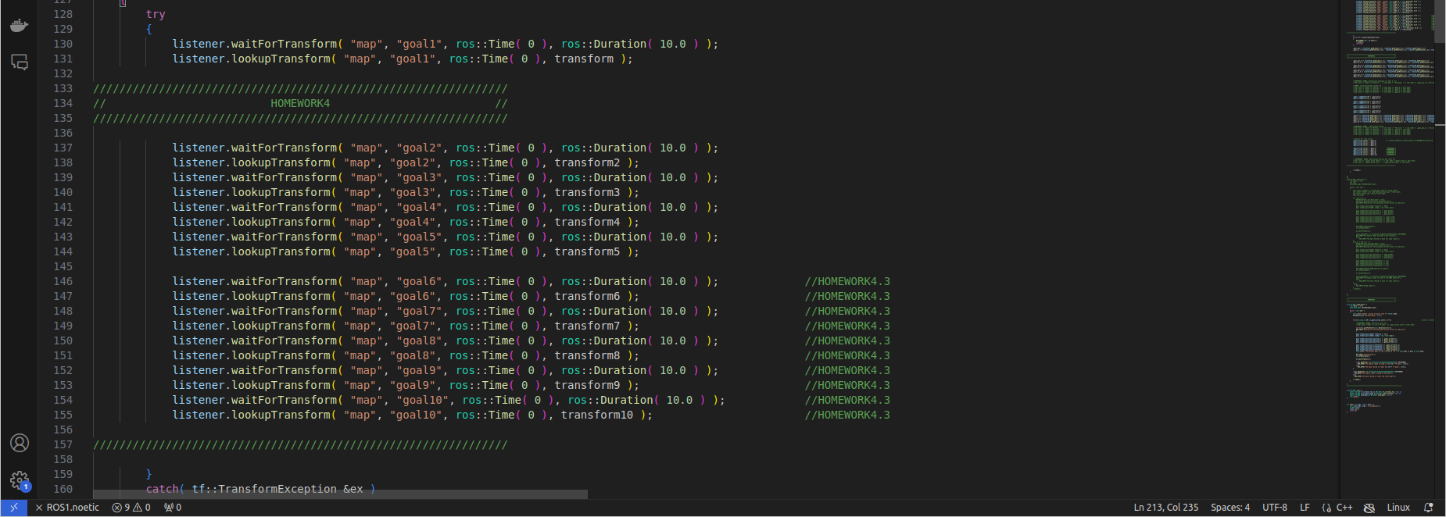

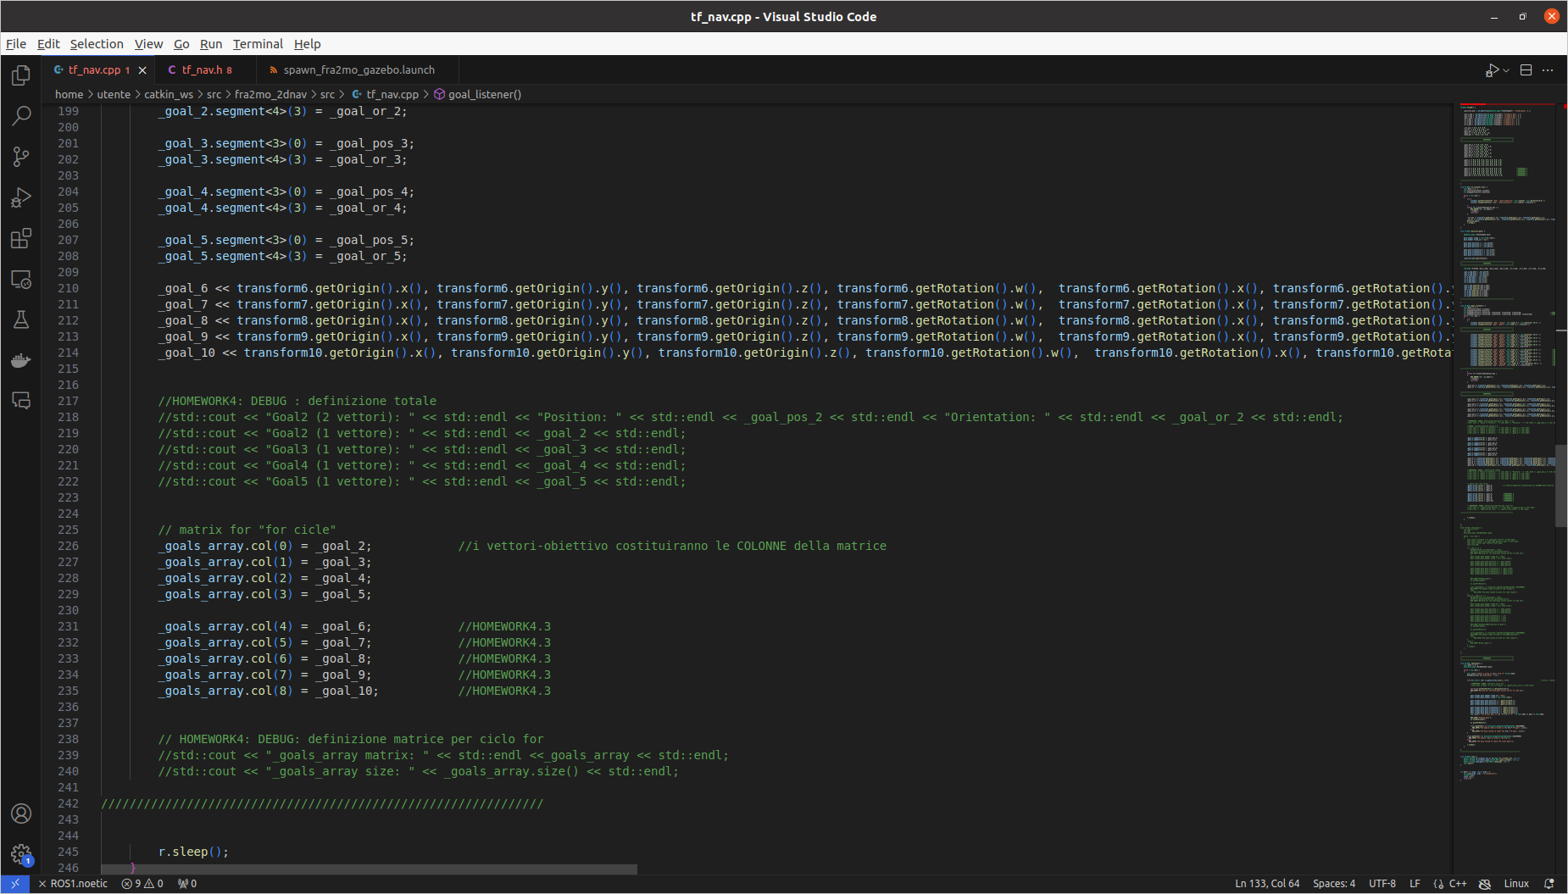

And this is the completed map seen in RVIZ, tracked through the new trajectory:
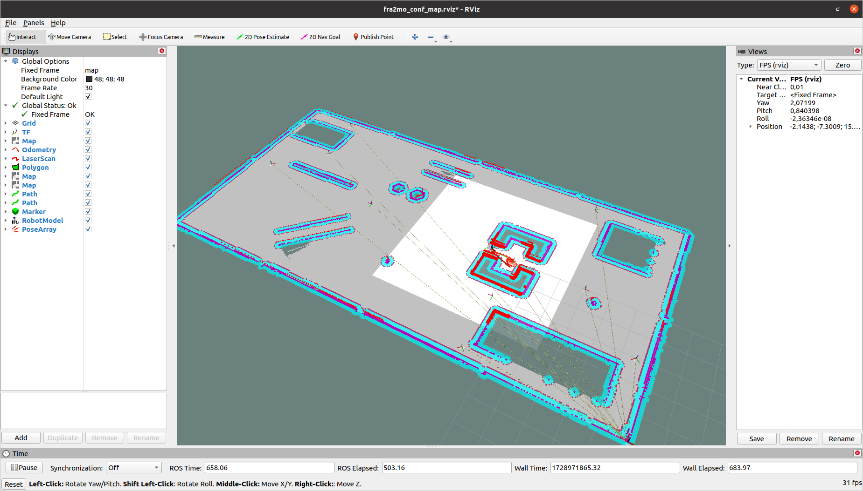

(b) Change the parameters of the planner and move_base (try at least 4 different configurations) and
comment on the results you get in terms of robot trajectories. The parameters that need to be
changed are:
• In file teb_locl_planner_params.yaml: tune parameters related to the section about tra-
jectory, robot, and obstacles.
• In file local_costmap_params.yaml and global_costmap_params.yaml: change dimensions’
values and update costmaps’ frequency.
• In file costmap_common_params.yaml: tune parameters related to the obstacle and raytrace
ranges and footprint coherently as done in planner parameters

I modified:

1) ~/catkin_s/src/fra2mo_2dnav/config/teb_local_planner_params.yaml

raw 9 → dt_ref: 1 (was 0.5) → defines the reference time interval (in seconds) between two consecutive poses along the trajectory planned by the TEB Local Planner. As it gets higher, the trajectory becomes less detailed and less computationally demanding, and viceversa

raw 19 → max_vel_x: 0.8 (was 0.6) → maximum velocity on the robot x axis (forward)

raw 42 → min_obstacle_dist: 0.20 (was 0.10)→minimum distance from obstacle that must be hold

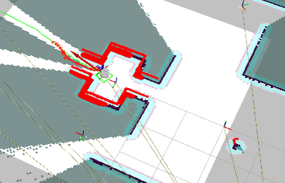
With these values, we cannot appreciate their variation, since the robot, due to min_obstacle_dist: 0.20, is able to enter with difficulty inside the purple obstacle, but not to get out of it (image).

raw 9 → dt_ref: 1

raw 19 → max_vel_x: 0.8

raw 42 → min_obstacle_dist: 0.15
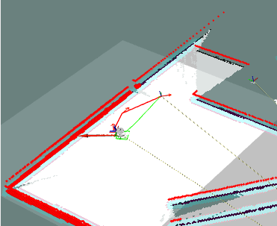
With these values, our robot becomes much faster when it doesn’t track any obstacles and on the straight paths, but stays further away from the obstacles (a lot of difficulties trying to get out of the purple obstacle) and it finds with difficulty an optimal paths to reach every goal (image), indeed it skips some of them

2) Local Costmap and Global Costmap are essential components in robot navigation systems. They provide spatial representations of the environment that enable robots to perceive their surroundings and plan their movements effectively.
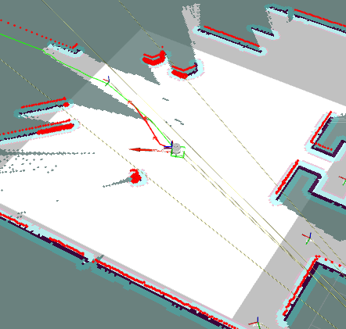
The local costmap represents a small area surrounding the robot (lighter square 7m x 7m around the robot in the image), typically focused on immediate obstacles and terrain features that the robot needs to navigate around in real-time. It is used for local path planning, helping the robot make real-time decisions about how to navigate around obstacles in its immediate vicinity.

The global costmap provides a broader view of the environment, representing the overall layout of obstacles and free space across a larger area, typically the entire map that the robot operates within. It’s used for global path planning, allowing the robot to determine the best route to reach a goal based on a comprehensive view of its environment.

~/catkin_s/src/fra2mo_2dnav/config/local_costmap_params.yaml

raw 4 → update_frequency: 10.0 (was 5.0) → local costmap’s update frequency. As it gets higher, the costmap receives updates with an higher frequency. So, the robot becomes more reactive to possible environment changes. However, this improvement demands an increased computational load. The reverse is also true.

raw 8 → width: 15.0 (was 7.0) → local costmap’s width around the robot (a 15m x 15m square around the robot). As it gets higher,the robot can foresee obstacles and plan the paths in a better way. However, this improvement demands an increased computational load. The reverse is also true.

raw 9 → height: 15.0 (was 7.0) → local costmap’s vertical dimension around the robot. Same considerations as “width”

~/catkin_s/src/fra2mo_2dnav/config/global_costmap_params.yaml

raw 4 → update_frequency: 10.0 (was 5.0) → as local costmap’one

raw 9 → width: 60.0 (was 30.0) → global costmap’s width around the robot. As it gets higher,the robot can see a wider portion of the environment, useful for taking into consideration alternative paths. However, this improvement demands an increased computational load. The reverse is also true.

raw 10 → height: 60.0 (was 30.0) → global costmap’s vertical dimension around the robot. Same considerations as “width”

With these changes, just as I started the simulation, I could notice a way higher computational burden (my PC was way hotter and its fan was getting crazy).

Since the local costmap has an higher width (15m x 15m in the image) and update frequency (the same goes for the global one), I noticed that the planner computed smoother and more precise trajectories, and in every instant it chose them in a faster way than before.
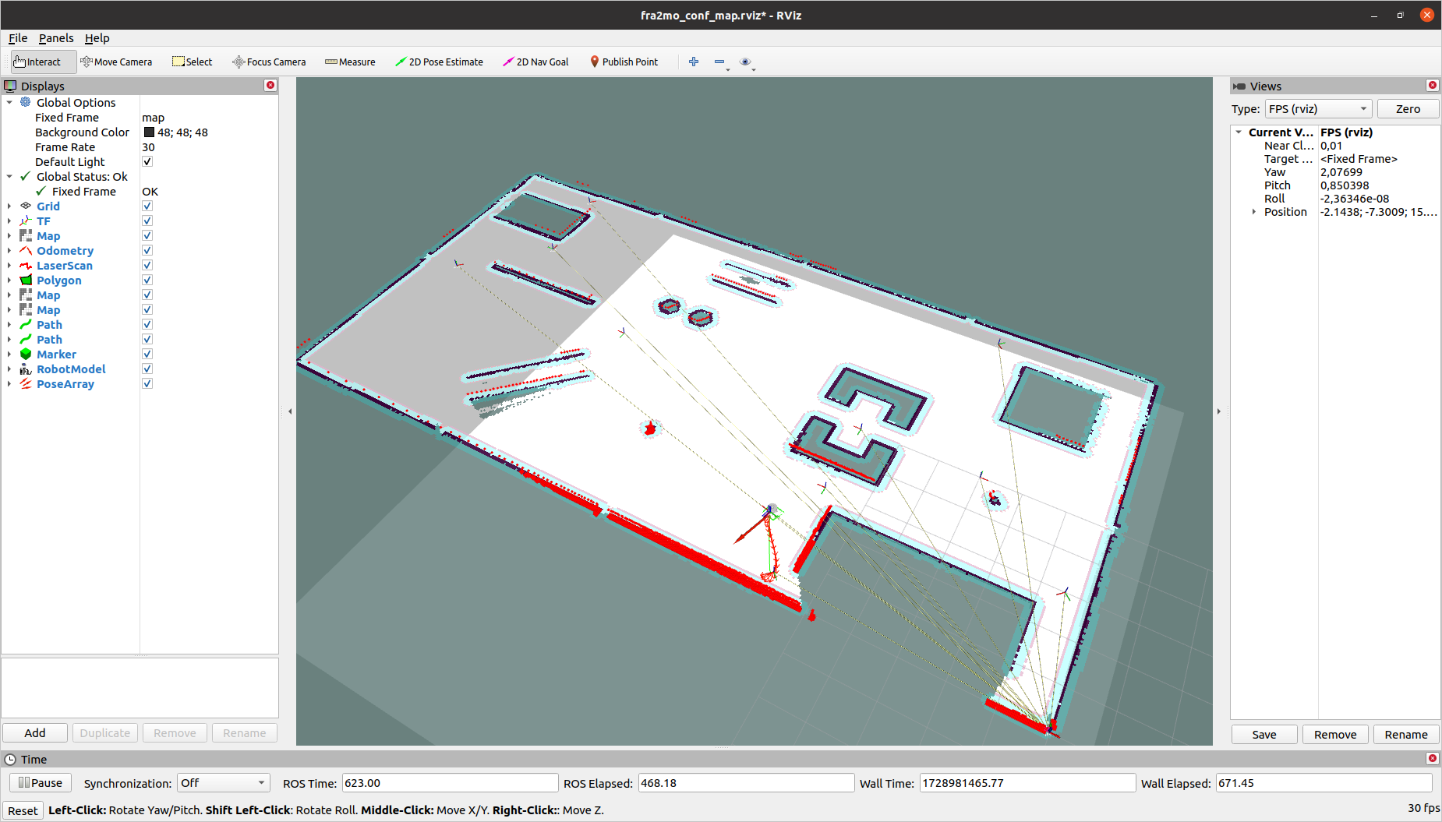

3) “costmap_common_params.yaml” is a configuration file that defines parameters for the costmap.

Raw 4 → obstacle_range: 1.0 (was 7.0) → maximum distance (in meters) that the sensor can read to consider a point as an obstacle. Any sensor reading beyond this distance will not be recorded as an obstacle in the costmap.

raw 5 → raytrace_range: 1.0 (was 8.0)→ maximum distance (in meters) up to which the costmap will perform ray tracing to identify free areas based on sensor readings. This parameter helps calculate free space and avoid obstacles.

raw 6 → footprint: [[0.30, -0.30],[-0.30, 0.30], [0.30, 0.30]] (were all 0.15) → Defines the shape of the robot in the costmap, represented as a polygon. The specified points are the (x, y) coordinates that define the perimeter of the robot. This helps calculate collisions and determine if the robot can move in a specific area without hitting obstacles.
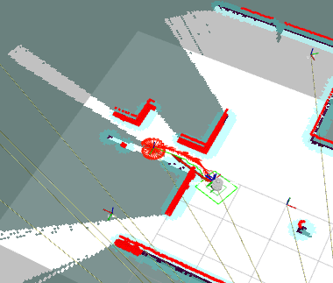
With this configuration, our robot couldn’t find a way to arrive in the first goal, since our costmap identified it as too big (see “footprint”).

Raw 4 → obstacle_range: 1.0 (was 7.0) → maximum distance (in meters) that the sensor can read to consider a point as an obstacle. Any sensor reading beyond this distance will not be recorded as an obstacle in the costmap.

raw 5 → raytrace_range: 1.0 (was 8.0)→ maximum distance (in meters) up to which the costmap will perform ray tracing to identify free areas based on sensor readings. This parameter helps calculate free space and avoid obstacles.

raw 6 → footprint: [[0.15, -0.15],[-0.15, 0.15],[-0.15, 0.2], [0.15, 0.15]] (the original) → Defines the shape of the robot in the costmap, represented as a polygon. The specified points are the (x, y) coordinates that define the perimeter of the robot. This helps calculate collisions and determine if the robot can move in a specific area without hitting obstacles.
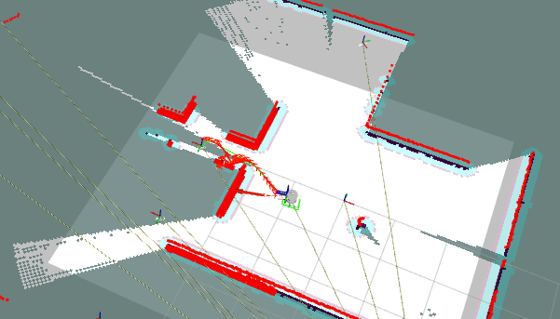
Our robot is less sensible to the external environment: walks more randomly, and avoids the obstacles at the last moment (images).
The only space were its behavior doesn’t change with respect to the simulation preceding these changes, is the one inside the purple obstacle, that in fact is a very narrow space (3m x 1m).

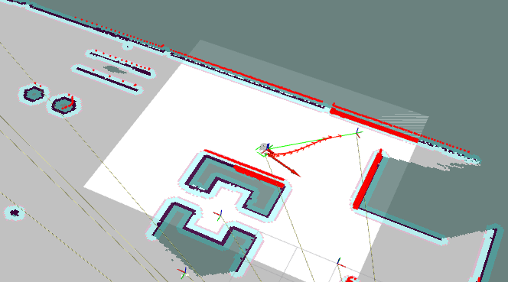
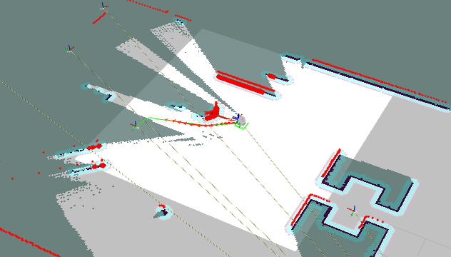

(a) Run ArUco ROS node using the robot camera: bring up the camera model and uncomment it in
that fra2mo.xacro file of the mobile robot description rl_fra2mo_description. Remember to
install the camera description pkg: sudo apt-get install ros-<DISTRO>-realsense2-description

First of all I installed the necessary package (already done in the past):
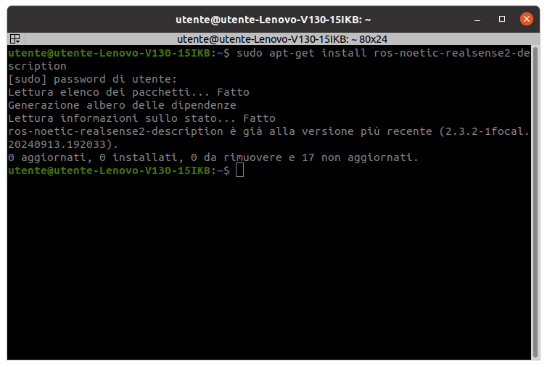
$ sudo apt-get install ros-noetic-realsense2-description

Since I found out that there are 17 packages not updated, I did it at that moment:

$ sudo apt update
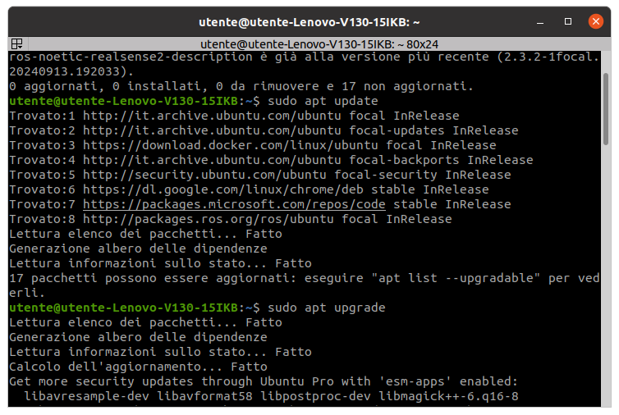
$ sudo apt upgrade
Then, I pressed “s” (“yes”) when Operative System asked me

After that, I modified “~/catkin_ws/src/rl_fra2mo_description/fra2mo.xacro”:

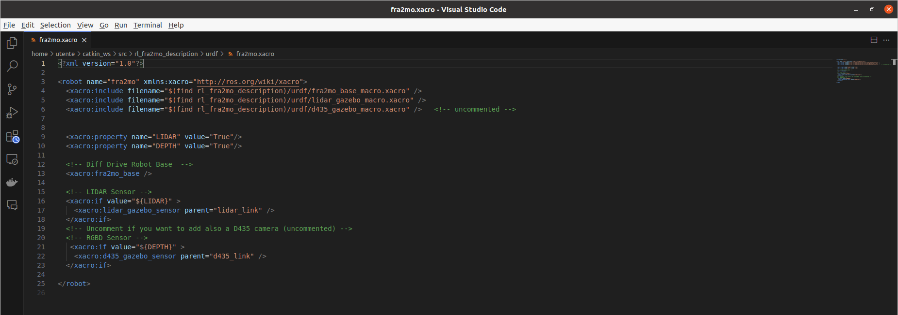
(b) Implement a 2D navigation task following this logic
• Send the robot in the proximity of obstacle 9.
• Make the robot look for the ArUco marker. Once detected, retrieve its pose with respect to
the map frame.
• Set the following pose (relative to the ArUco marker pose) as next goal for the robot

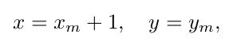

where x m , y m are the marker coordinates.

I created a new path through the frames:
“start” → goal_aruco_mid → goal_aruco_approach

Once the robot arrives to the last frame, and if the camera focuses on, and recognizes the aruco marker:
- The robot computes the estimate of the aruco pose with respect to the camera (transformation “camera→object”). This estimate is hold in the topic “/aruco_single/pose”. To achieve this objective, I launched even a “usb_cam_aruco_hw4.launch” file.
- Transformation “map→camera” is retrieved through the use of “tf” library.
- I merged both, in order to calculate the estimate of the transformation “map→object”, that consists in the estimate of the pose of the aruco marker with respect of the base frame.

Taking inspiration from “~/catkin_ws/src/aruco_ros/aruco_ros/launch/usb_cam_aruco.launch”, I created “~/catkin_ws/src/aruco_ros/aruco_ros/launch/usb_cam_aruco_hw4.launch”:
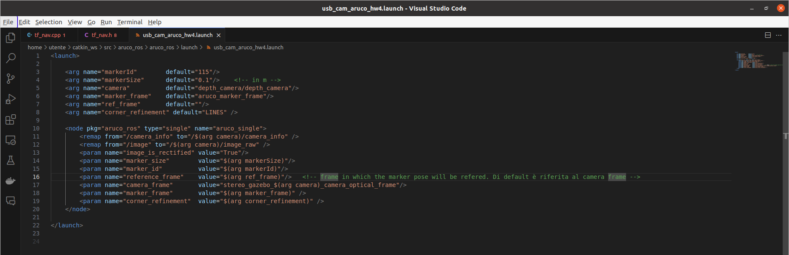
I had the robot to recognize the aruco marker 115, with the d435i camera (check with $ rostopic list → “/depth_camera/depth_camera/camera_info”)

I modified:

“~/catkin_ws/src/rl_fra2mo_description/launch/spawn_fra2mo_gazebo.launch”

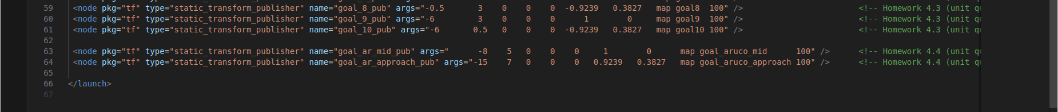

“~/catkin_ws/src/fra2mo_2dnav/include/tf_nav.h”:
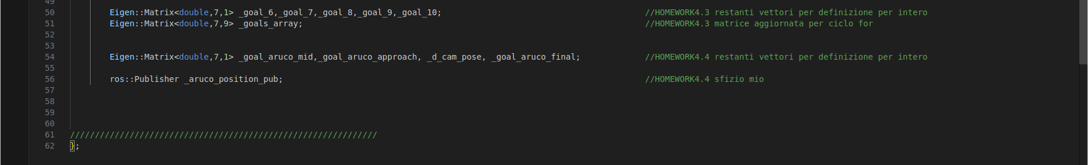

“~/catkin_ws/src/fra2mo_2dnav/include/tf_nav.cpp” (taking inspiration from “~/catkin_ws/src/kdl_robot/src/kdl_robot_vision_control.cpp”):

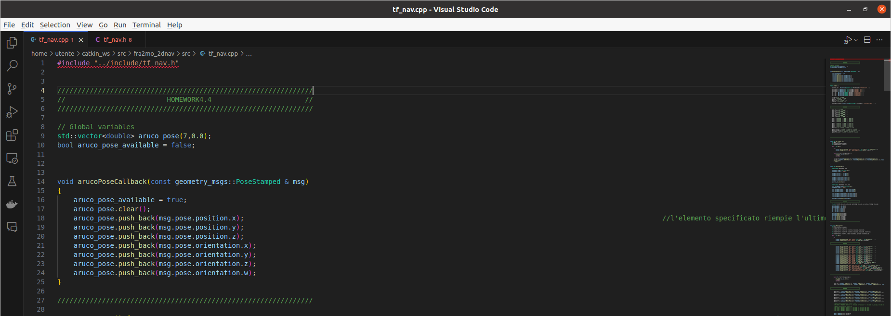
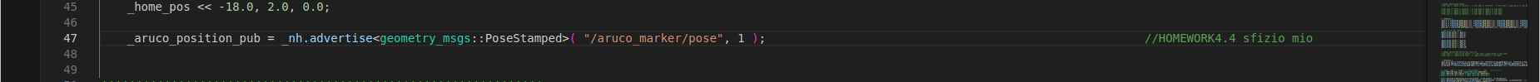
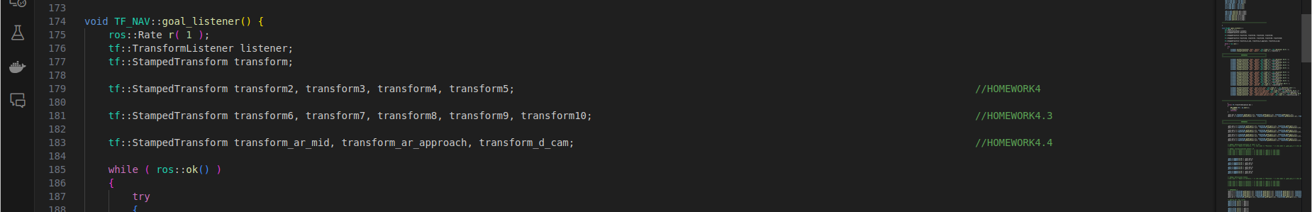

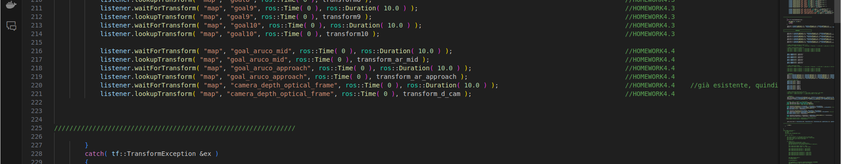
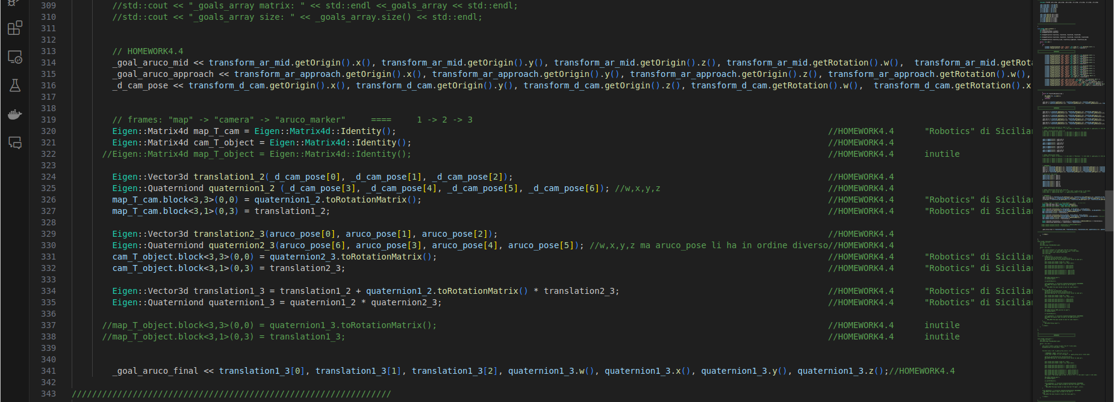
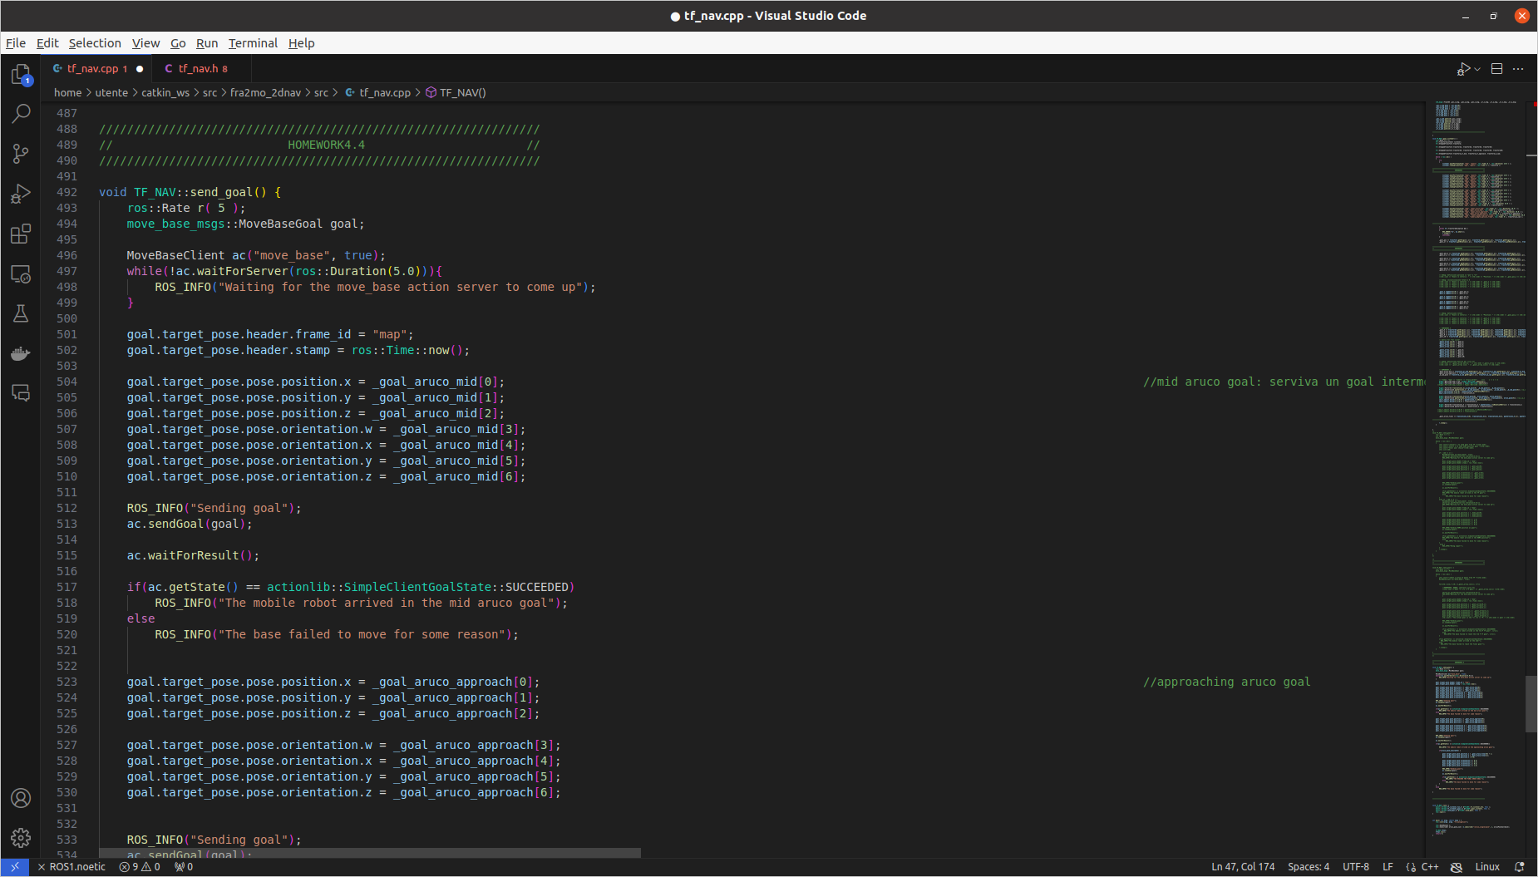

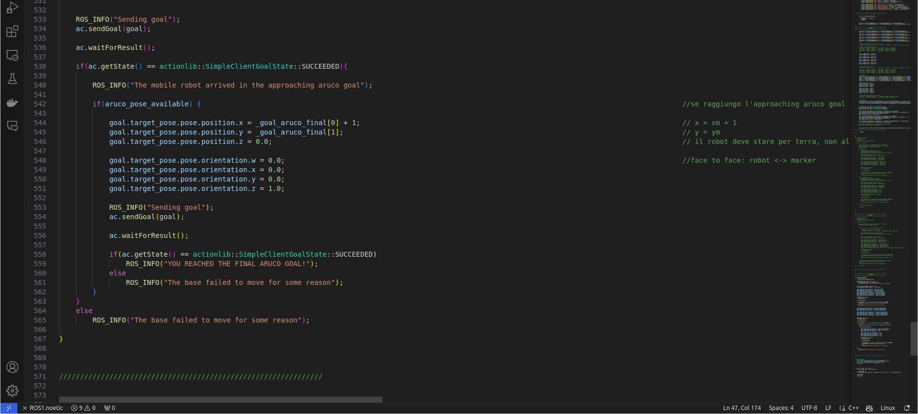
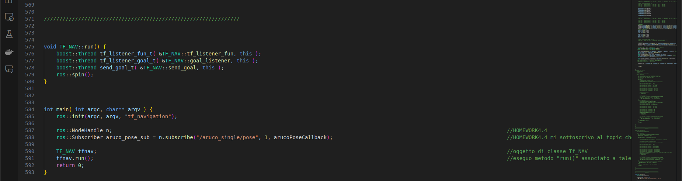

Simulation:

$ cd ~/catkin_ws (terminal 1)
$ roslaunch fra2mo_2dnav fra2mo_nav_bringup.launch

$ cd ~/catkin_ws (terminal 2)
$ source devel/setup.bash
$ roslaunch aruco_ros usb_cam_aruco_hw4.launch

$ cd ~/catkin_ws (terminal 3)
$ catkin build fra2mo_2dnav
$ source devel/setup.bash
$ rosrun fra2mo_2dnav tf_nav

$ rqt_image_view (terminal 4)

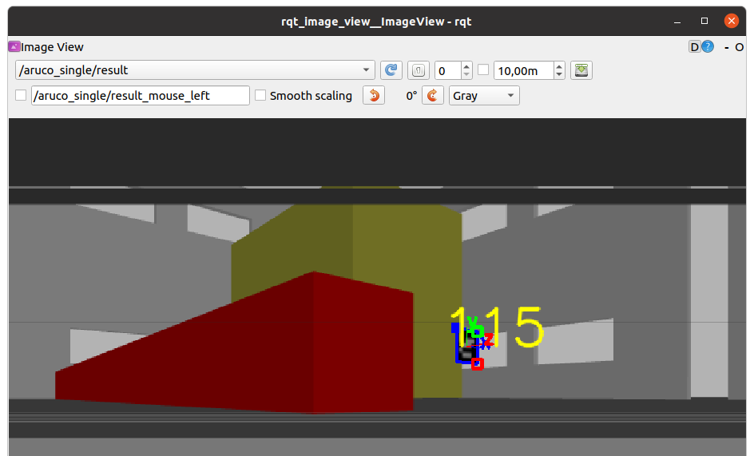
During the path, robot start recognizing the aruco marker.

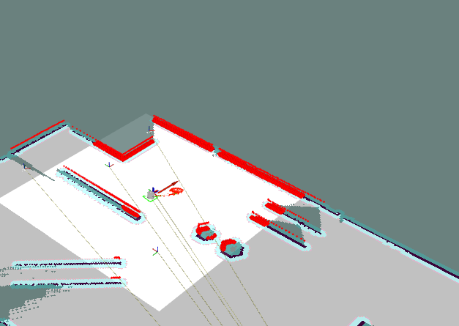
After reaching the aruco approaching goal it computes the aruco pose in the map frame and reaches its new goal: a pose for which it stands right before the marker!

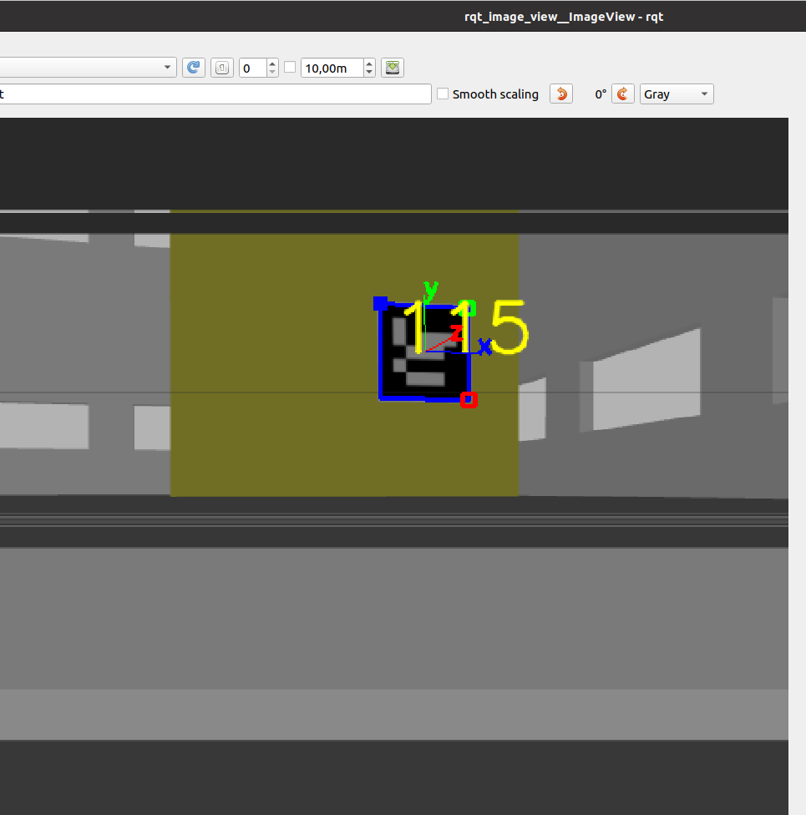
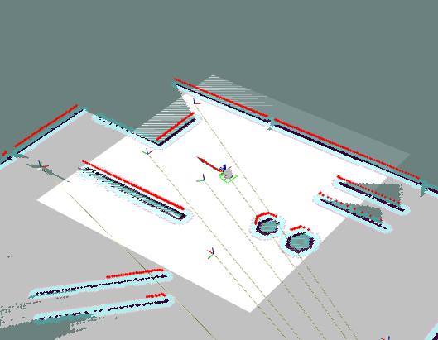
It reaches the final goal!
As you can see, the robot doesn’t stand as we desired in front of the marker, because its pose estimate, (that changes every instant based on robot movement) is not so accurate.
This behavior will be better analyzed in the successive point (c).

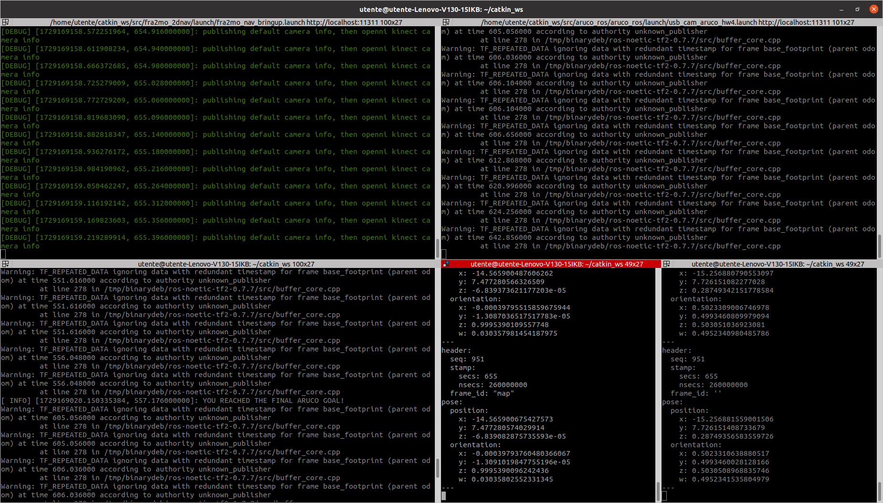

(c) Publish the ArUco pose as TF following the example at this link.

Taking inspiration from this example:
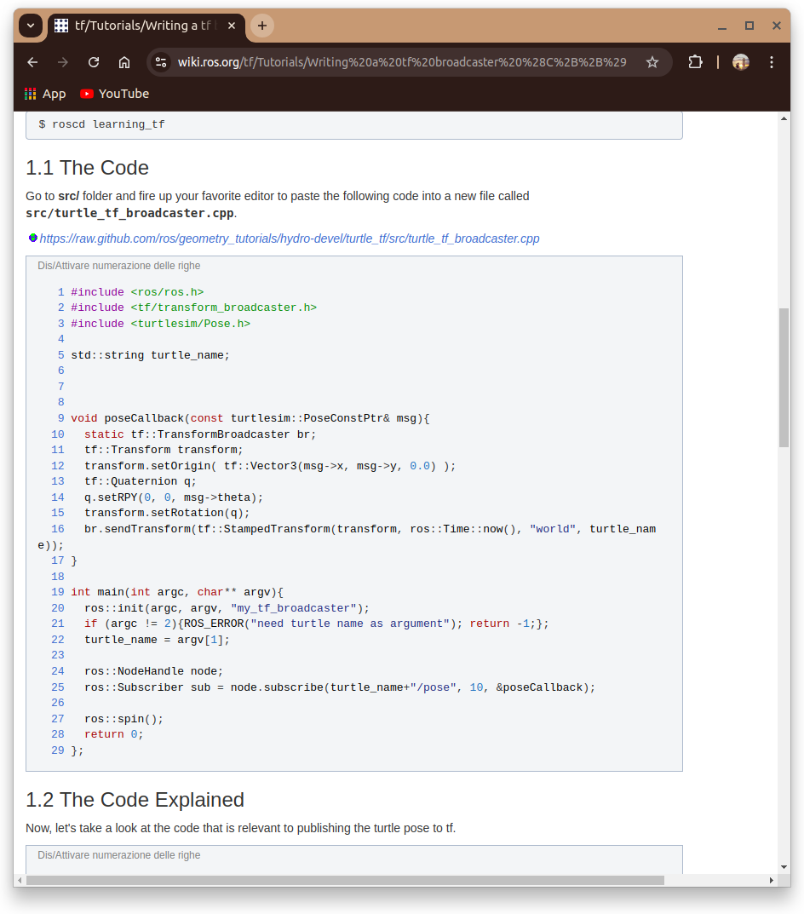

I modified
“~/catkin_ws/src/fra2mo_2dnav/include/tf_nav.h” :
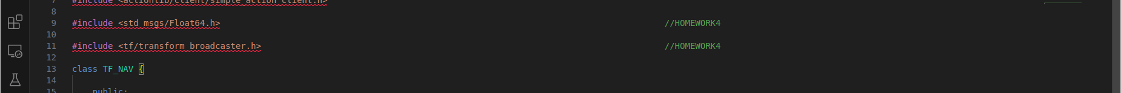
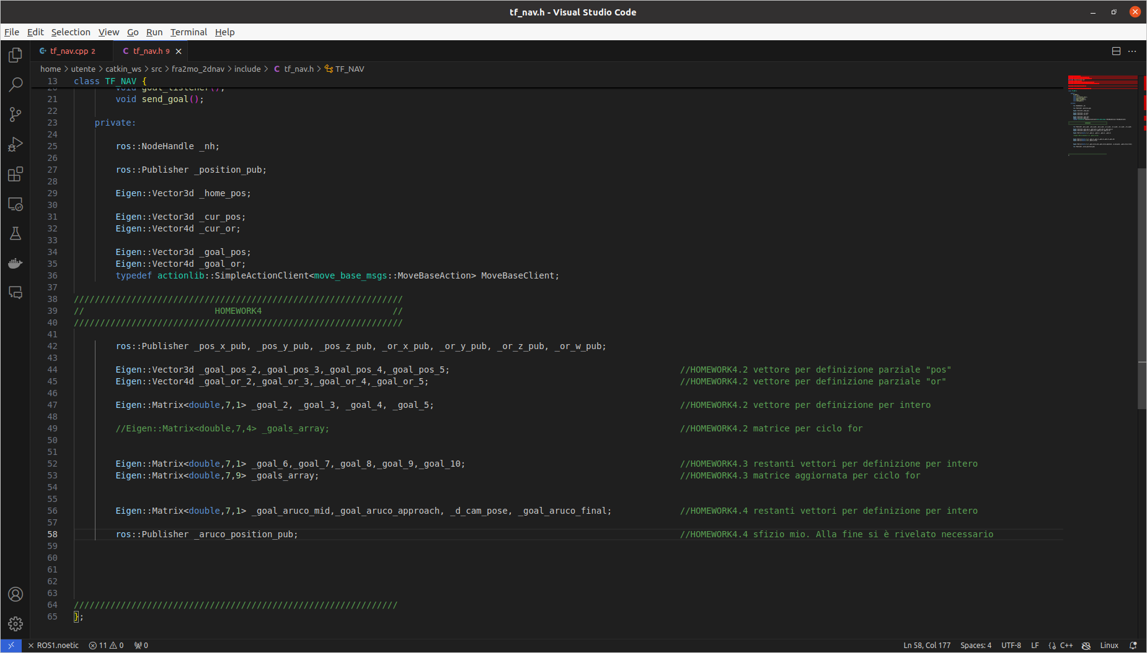

“~/catkin_ws/src/fra2mo_2dnav/include/tf_nav.cpp” :

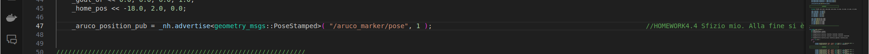

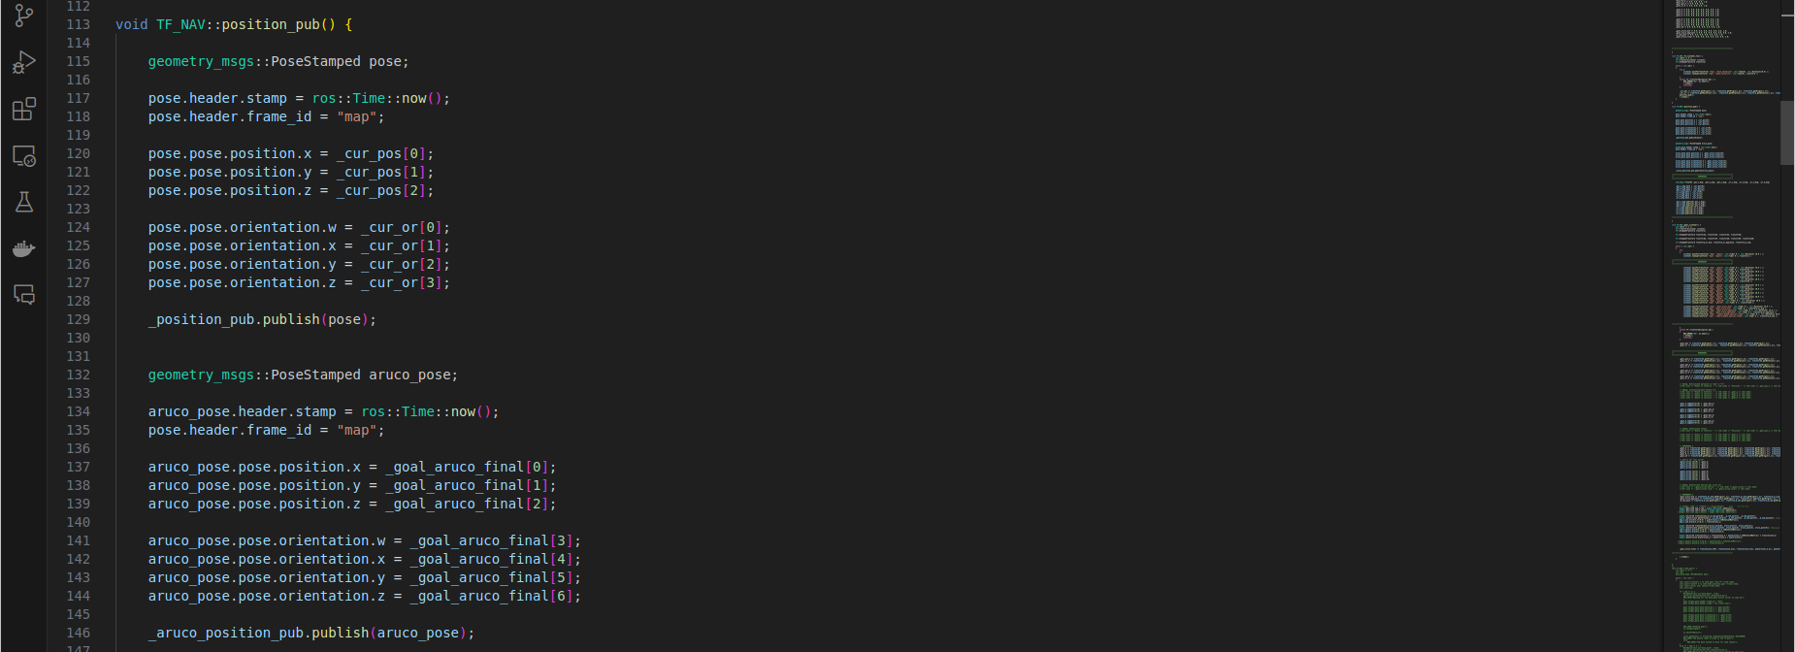
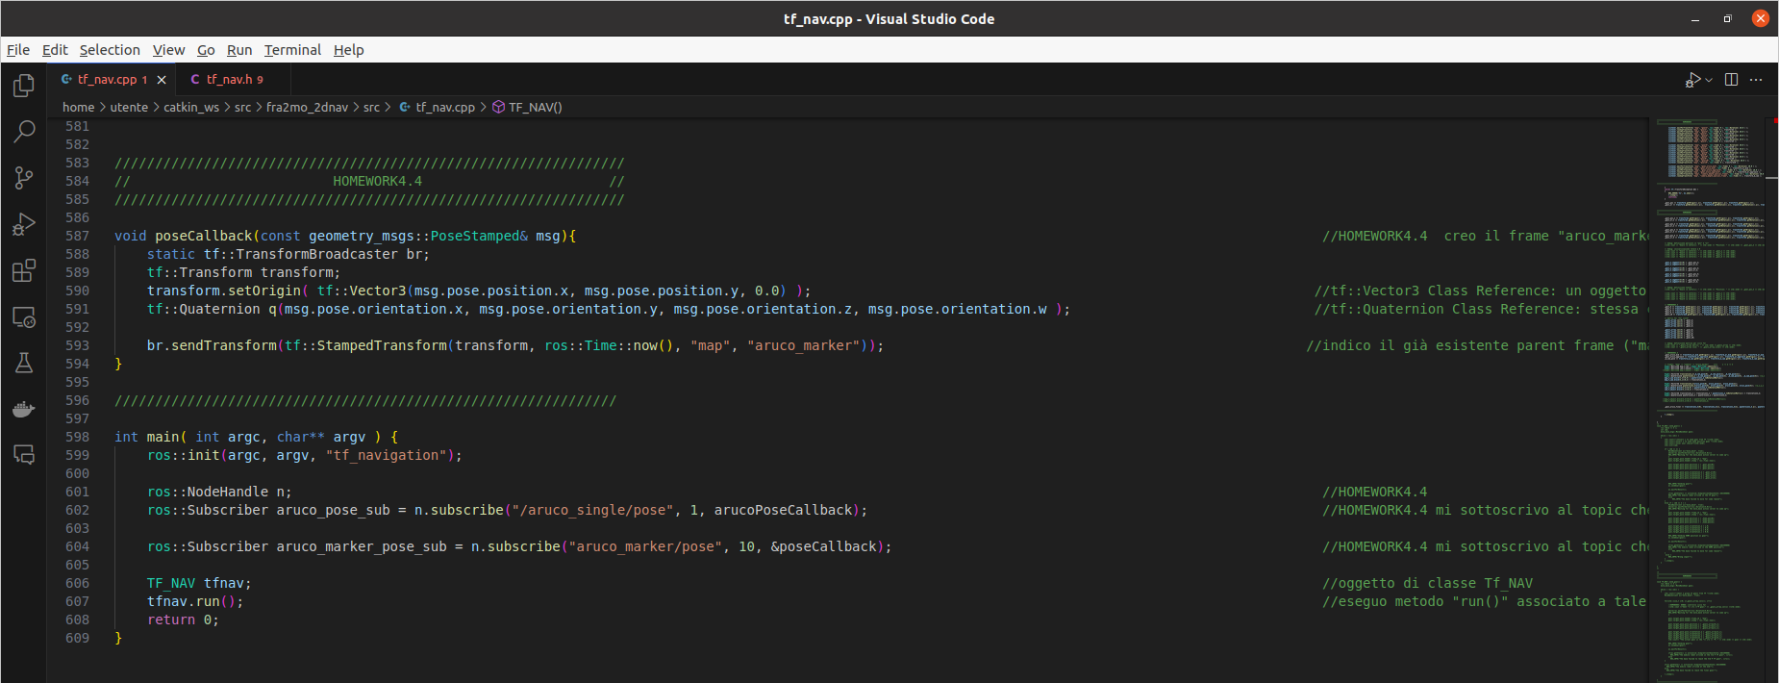

Simulation:

$ cd ~/catkin_ws (terminal 1)
$ roslaunch fra2mo_2dnav fra2mo_nav_bringup.launch

$ cd ~/catkin_ws (terminal 2)
$ source devel/setup.bash
$ roslaunch aruco_ros usb_cam_aruco_hw4.launch

$ cd ~/catkin_ws (terminal 3)
$ catkin build fra2mo_2dnav
$ source devel/setup.bash
$ rosrun fra2mo_2dnav tf_nav

$ rqt_image_view (terminal 4)

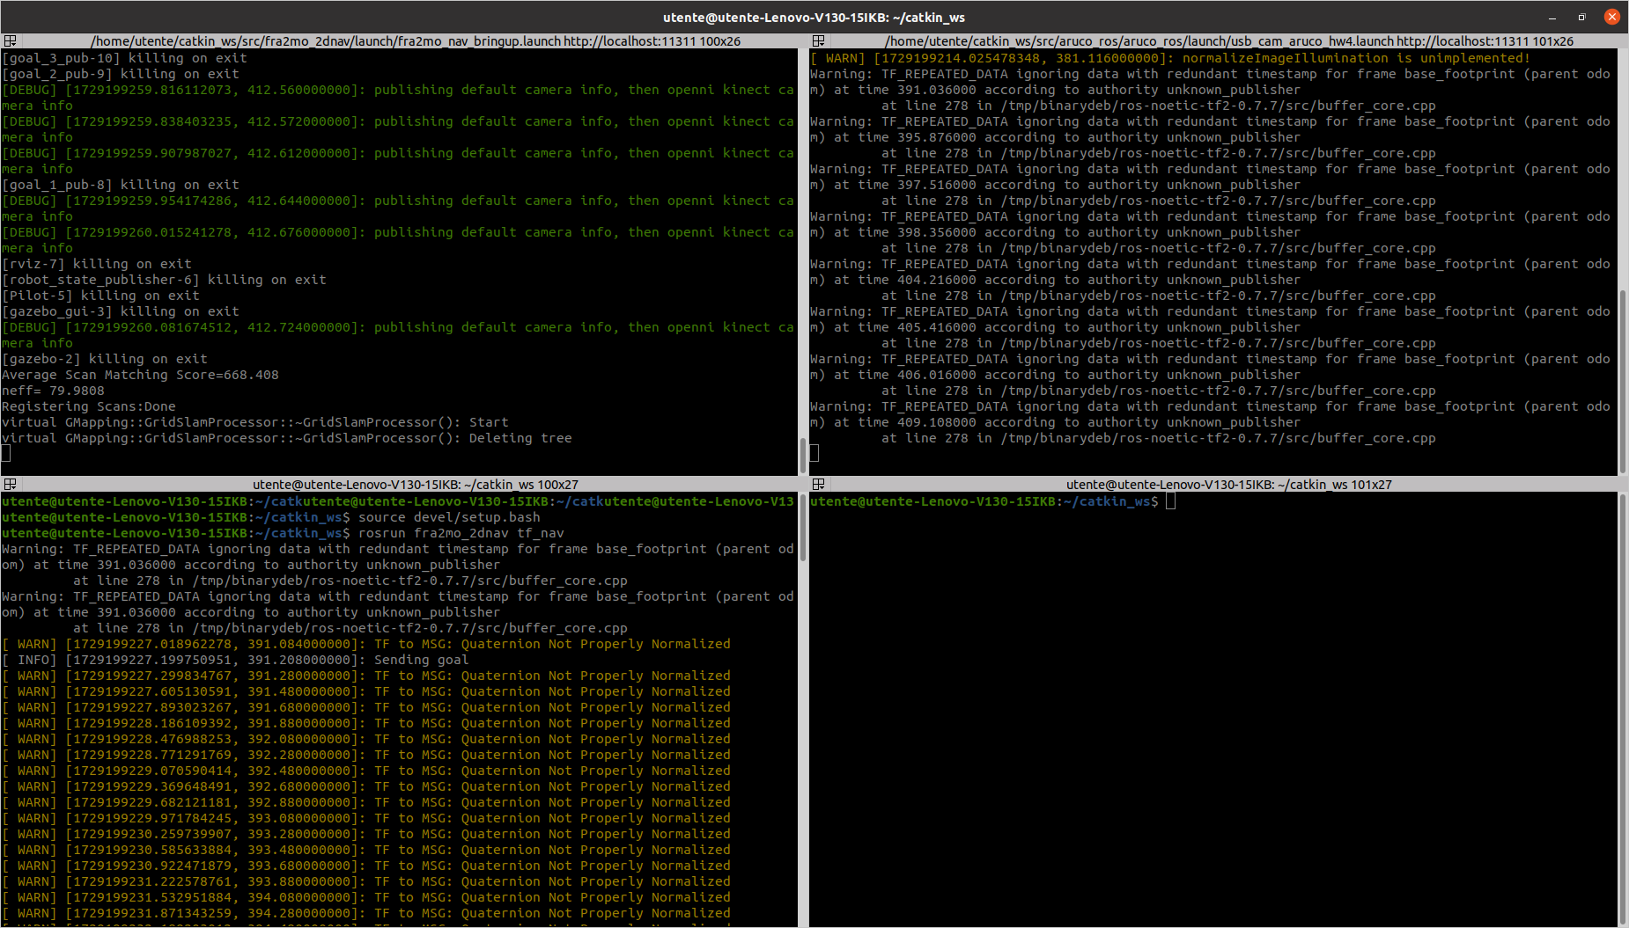

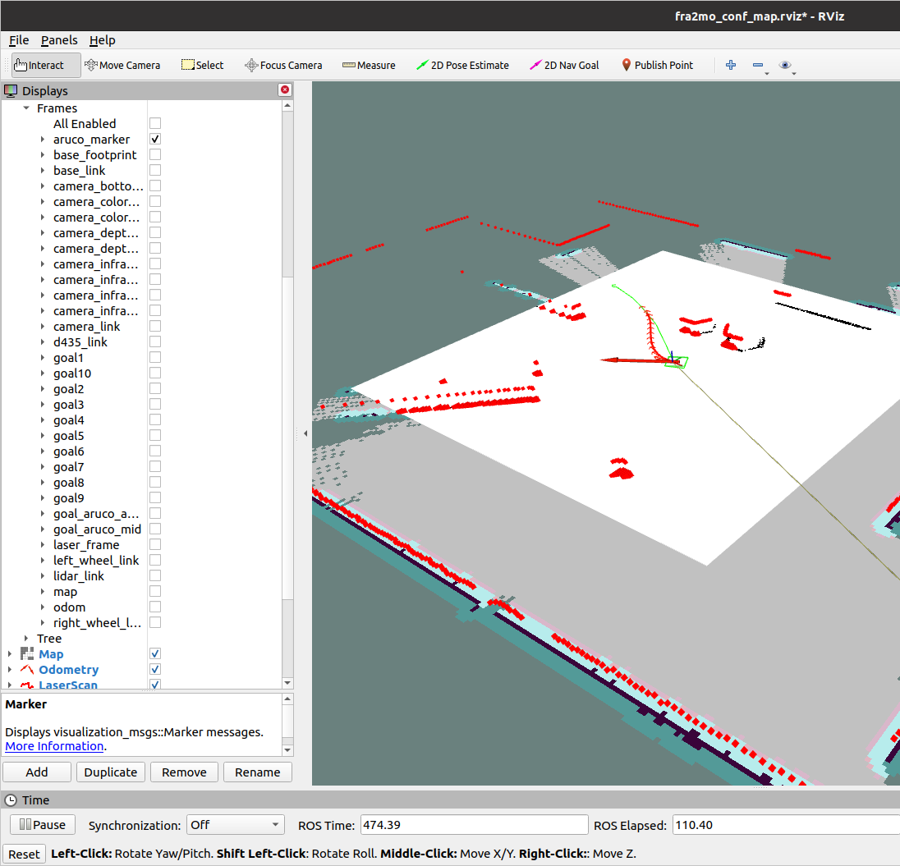

Rviz GUI → “TF” → “Frames” → select just “aruco_marker”

As you can see, until our robot doesn’t recognize through the “d435i” camera the aruco marker, “aruco_marker” frame
coincides with the “camera_depth_optical_frame” frame (that’s fixed on the robot).

As soon as our robot recognizes the marker, the “aruco_marker” frame pose changes and separates from the robot. Since its pose is estimated in every instant, and this estimate is not so accurate, it changes continuously: it’s obvious to notice that even “aruco_marker” frame moves in the same way.



