Advice Financial
SharePoint Modernisation, Governance & Information Architecture Assessment
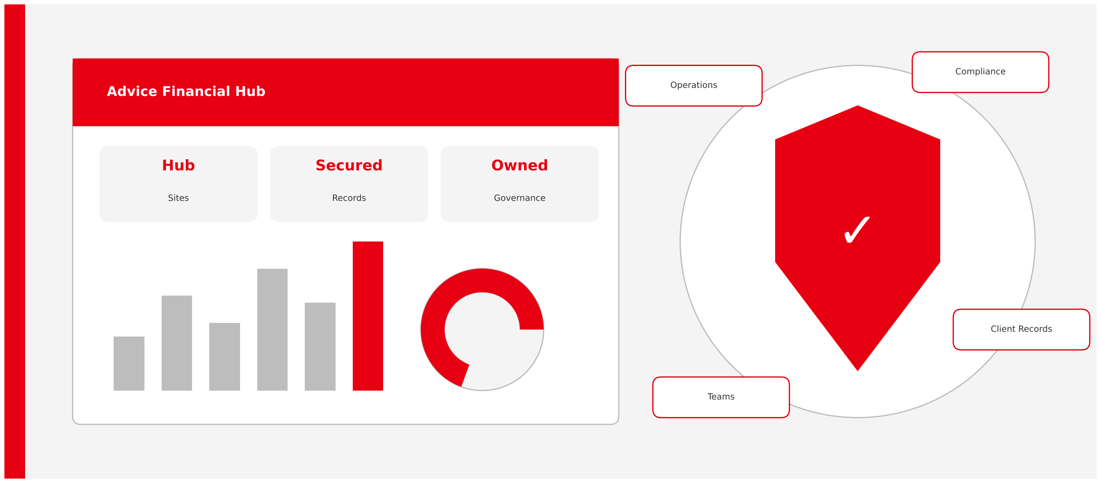
Hero image: rendered illustration. For final artwork, use this AI prompt: "Modern New Zealand financial services workplace, clean Microsoft 365 digital workplace, SharePoint intranet dashboards, governance visualisation, Ricoh red branding accents, professional executive consulting style, white background, corporate infographic aesthetic."
Prepared by Ricoh New Zealand
October 2026

Executive Summary

Key Findings
Area | Assessment
SharePoint Adoption | Strong
Client Data Management | High Risk
Information Architecture | Limited
Governance Controls | Requires Improvement
Permissions Model | Significant Exposure
Future Readiness | Moderate

236,539  files in AF Client Portal | 104.58 GB  AF Client Portal storage | 179,236  file interactions

Supporting evidence includes
- AF Client Portal contains approximately 236,539 files
- AF Client Portal stores approximately 104.58 GB
- AF Client Portal recorded approximately 179,236 file interactions
- Numerous client records are accessible via "Everyone Except External Users" permissions
- Archived OneDrive repositories remain present within the tenant
- The "Everyone except external users" report lists 280 shared items, 263 of them in AF Client Portal and 270 with Edit rights
- Eleven OneDrive accounts hold 331,318 files and 489 "Anyone" links; the admin OneDrive alone holds 235,208 files and 152 links
- Seven of the eight SharePoint sites have no primary admin, none has a sensitivity label and none is joined to a hub
Advice Financial has strongly adopted SharePoint, but client records, operational content and governance documentation share one broadly permissioned ecosystem. The priority is to segregate client data and move to role-based access.

Section 1: Current Environment Overview

Current State Architecture
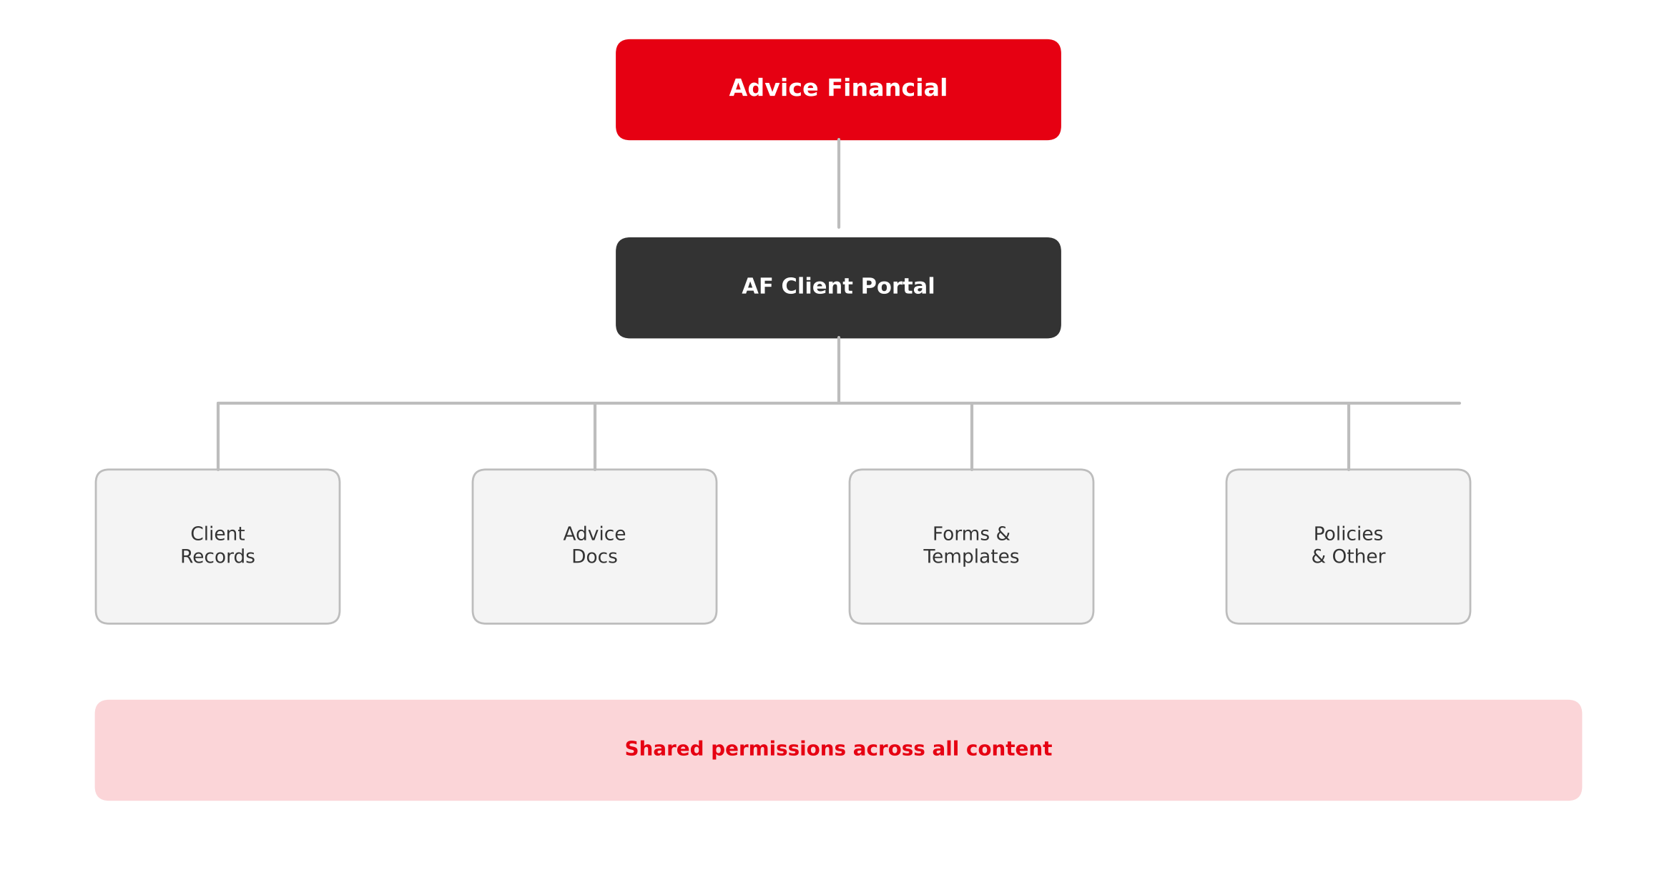
Figure 1: Current state architecture
Based on the assessment, client records, operational content and governance documentation coexist within the same ecosystem.

Current Environment Statistics
236,539  Files | 104.58 GB  Storage | 179,236  File interactions

Metric | Value
SharePoint Sites | Multiple
Largest Site | AF Client Portal
Files in AF Client Portal | 236,539
Storage Consumption | 104.58 GB
File Interactions | 179,236
Page Views | 115
Page Visits | 9

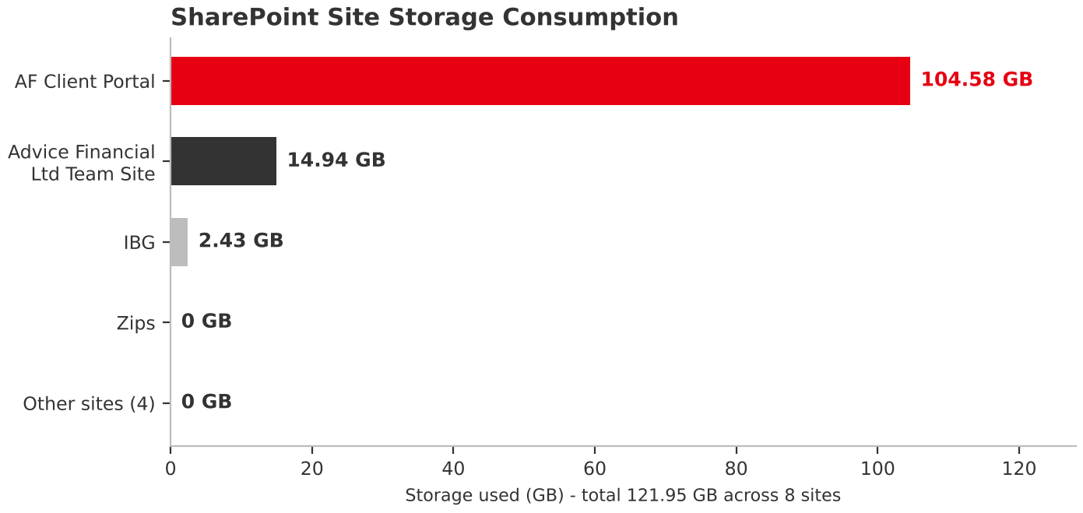
Figure 2: SharePoint site storage consumption (source: AllSitesActiveFinance.xlsx). The four sites grouped as "Other sites" each use 0 GB.

SharePoint Site Inventory
Site | Template | GB | Files | Last activity | Primary admin
AF Client Portal | Team site | 104.58 | 236,539 | 8 Sep 2026 | None
Advice Financial Ltd Team Site | Team site (classic) | 14.94 | 18,163 | 8 Sep 2026 | System Account
IBG | Document Center | 2.43 | 712 | 23 Oct 2024 | None
Georges Mortgages | Team site | 0 | 2 | 13 Jul 2026 | None
testCLIENT PORTAL | Team site | 0 | 8 | 2 Sep 2026 | None
All Company | Team site | 0 | 4 | 10 Dec 2025 | None
AFFINITY GROUP CALCULATORS | Team site | 0 | 2 | 20 May 2024 | None
Zips | Communication site | 0 | 3 | 20 May 2024 | None

Governance observations from the site inventory
- Total storage is 121.95 GB across 255,433 files; AF Client Portal holds 86% of the storage and 93% of the files
- Seven of eight sites have no primary admin recorded
- No site carries a sensitivity label and no site is associated with a hub
- External sharing is on for six of the eight sites; only IBG and Zips have it off
- Four sites show no activity for a year or more or hold almost no content (AFFINITY GROUP CALCULATORS, Zips and IBG last active in 2024; All Company in December 2025)
- Storage use is under 1.5% of quota on every site, so capacity is not a constraint

OneDrive Footprint
OneDrive owner | Files | Users with access | Unique-permission items | "Anyone" links
Advice Financial (admin) | 235,208 | 13 | 170 | 152
Jamie Coltman | 51,989 | 7 | 41 | 27
Hamish Coltman | 12,931 | 10 | 98 | 79
Paul Bartlett | 11,071 | 2 | 14 | 12
Jessica Coltman | 11,536 | 8 | 32 | 27
Tom Coltman | 4,845 | 6 | 47 | 42
Marcus Brown | 3,246 | 6 | 23 | 19
George Orton | 321 | 2 | 3 | 0
Irene Mendoza | 157 | 8 | 130 | 127
Sharrah Tracy | 13 | 3 | 7 | 4
John Bell | 1 | 1 | 0 | 0
Total (11 accounts) | 331,318 | 66 | 565 | 489

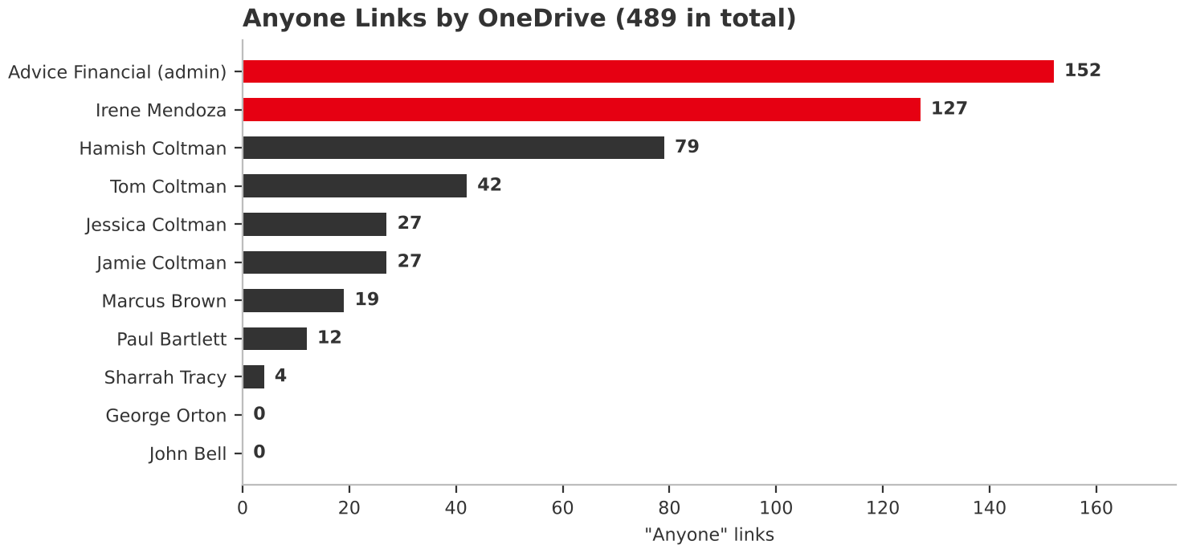
Figure 3: "Anyone" links per OneDrive (source: Permissioned Users Count OneDrive report, 14 Oct 2026)

Section 2: Risk Assessment

Information Risk Overview
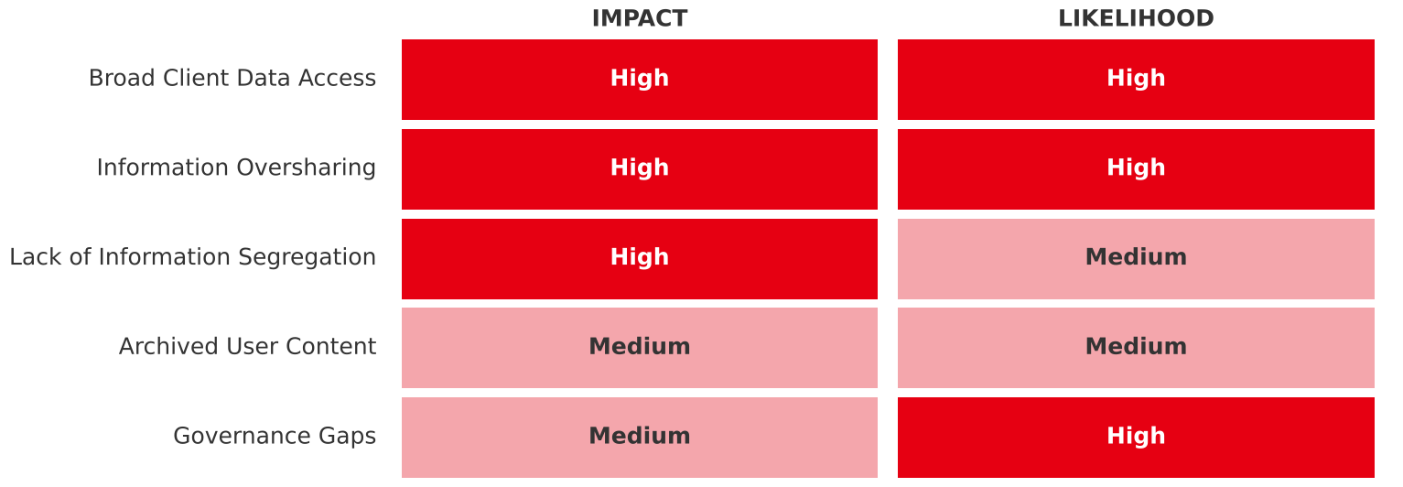
Figure 4: Executive heat map
Risk | Impact | Likelihood
Broad Client Data Access | High | High
Information Oversharing | High | High
Lack of Information Segregation | High | Medium
Archived User Content | Medium | Medium
Governance Gaps | Medium | High

Based on
- Client files appearing with Everyone Except External Users permissions
- Broad SharePoint group access
- Mixed operational and client content structures

Permissions Exposure
280  items shared with Everyone except external users | 263  in AF Client Portal | 270  granted Edit rights

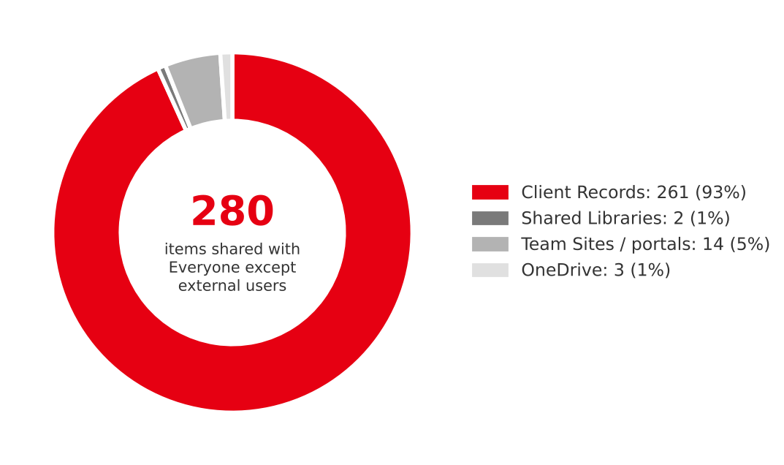
Figure 5: Items shared with Everyone except external users, by location (source: EEEU report, 14 Oct 2026)
Multiple client documents and folders were identified with "Everyone Except External Users" permissions, increasing exposure of sensitive client information across the organisation.

What the sharing reports show
Location of shared item | Items
Client Records: Personal Clients folders (190 client folders) | 203
Client Records: Out Of Force - Inactive (40 former clients) | 40
Client Records: Standalone Company and other business client folders | 18
Shared libraries (AF Client Portal library and site level) | 2
Team sites and portals (Team Site, All Company, search and portal webs) | 14
OneDrive (two "Shared with Everyone" folders and one feed list) | 3
Total | 280

- The 280 entries are 256 files, 12 folders, 9 webs and 3 lists; 238 of the files are PDFs, and fact-find documents appear throughout the client folders
- All 263 AF Client Portal entries are granted through the "AF Client Portal Members" SharePoint group, which resolves to 8 users
- Edit is the role on 270 of the 280 entries, so broad access includes modification, not just reading
- The separate "Everyone" report returned a single entry: Read access at the root of the My Site Host web
- Across the 11 OneDrives, 489 "Anyone" links and 10 organisation-wide links exist, along with 565 items with unique permissions and 42 guest permissions; the admin OneDrive carries 152 of the "Anyone" links
"Anyone" links need review alongside the "Everyone except external users" findings. They allow access without sign-in and are the highest-priority clean-up item in the OneDrive data.

Section 3: Future State Vision

Transformation Vision
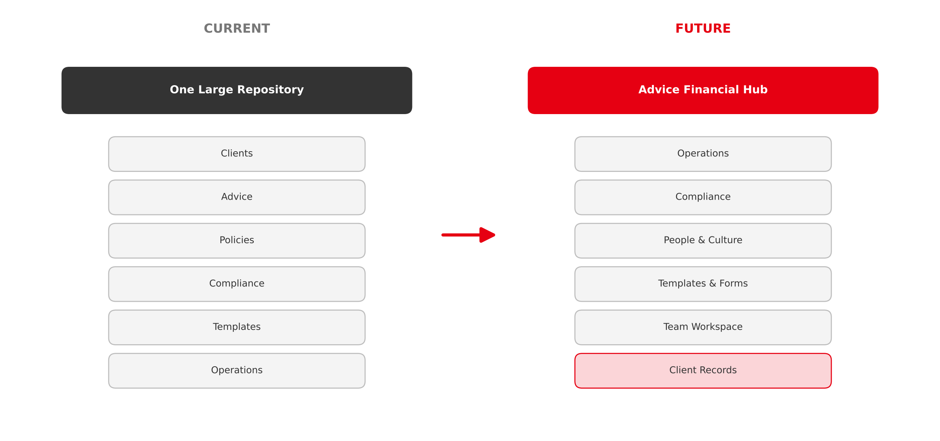
Figure 6: Current versus future structure

Modern Intranet Vision
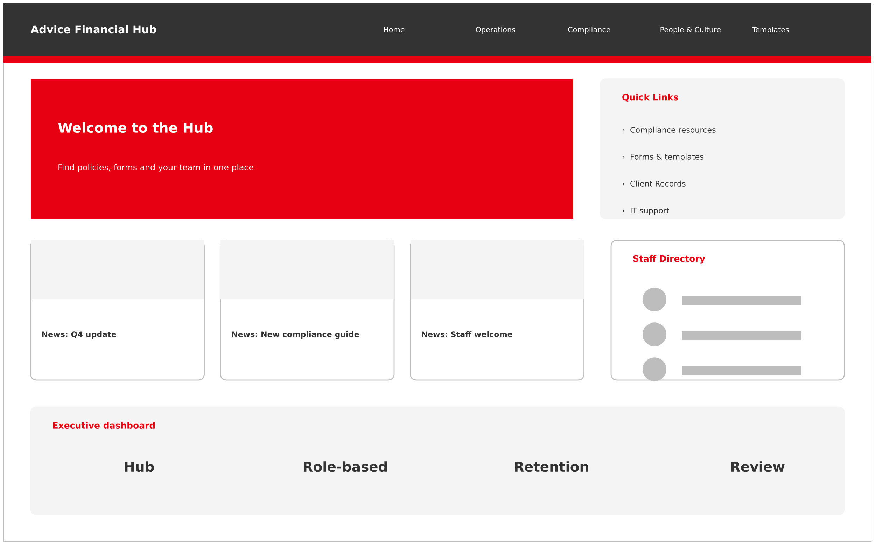
Figure 7: Advice Financial Hub concept mockup
Mockup AI prompt: "Modern SharePoint intranet homepage for financial advisory firm, Ricoh corporate styling, red accents, clean white interface, Microsoft 365 modern webparts, news cards, quick links, compliance resources, staff directory, executive dashboard layout." Based on the Advice Financial Hub concept.

Section 4: Recommended Information Architecture

Future Hub Architecture
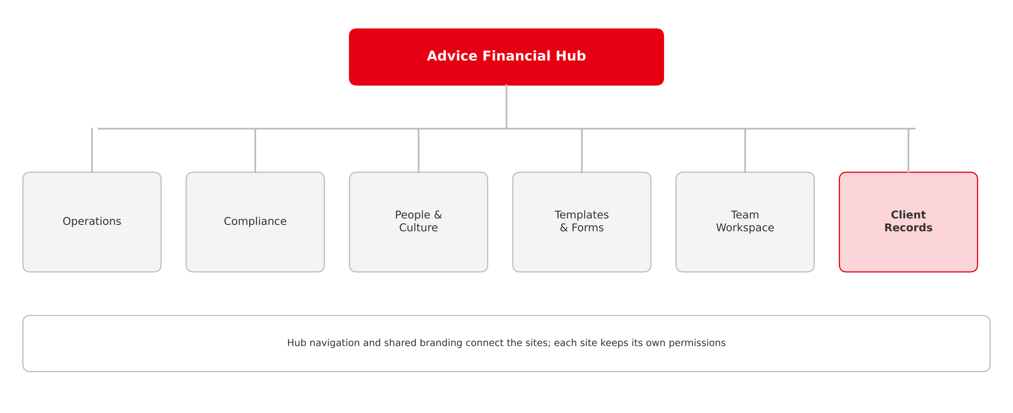
Figure 8: Advice Financial Hub architecture

Client Records Model
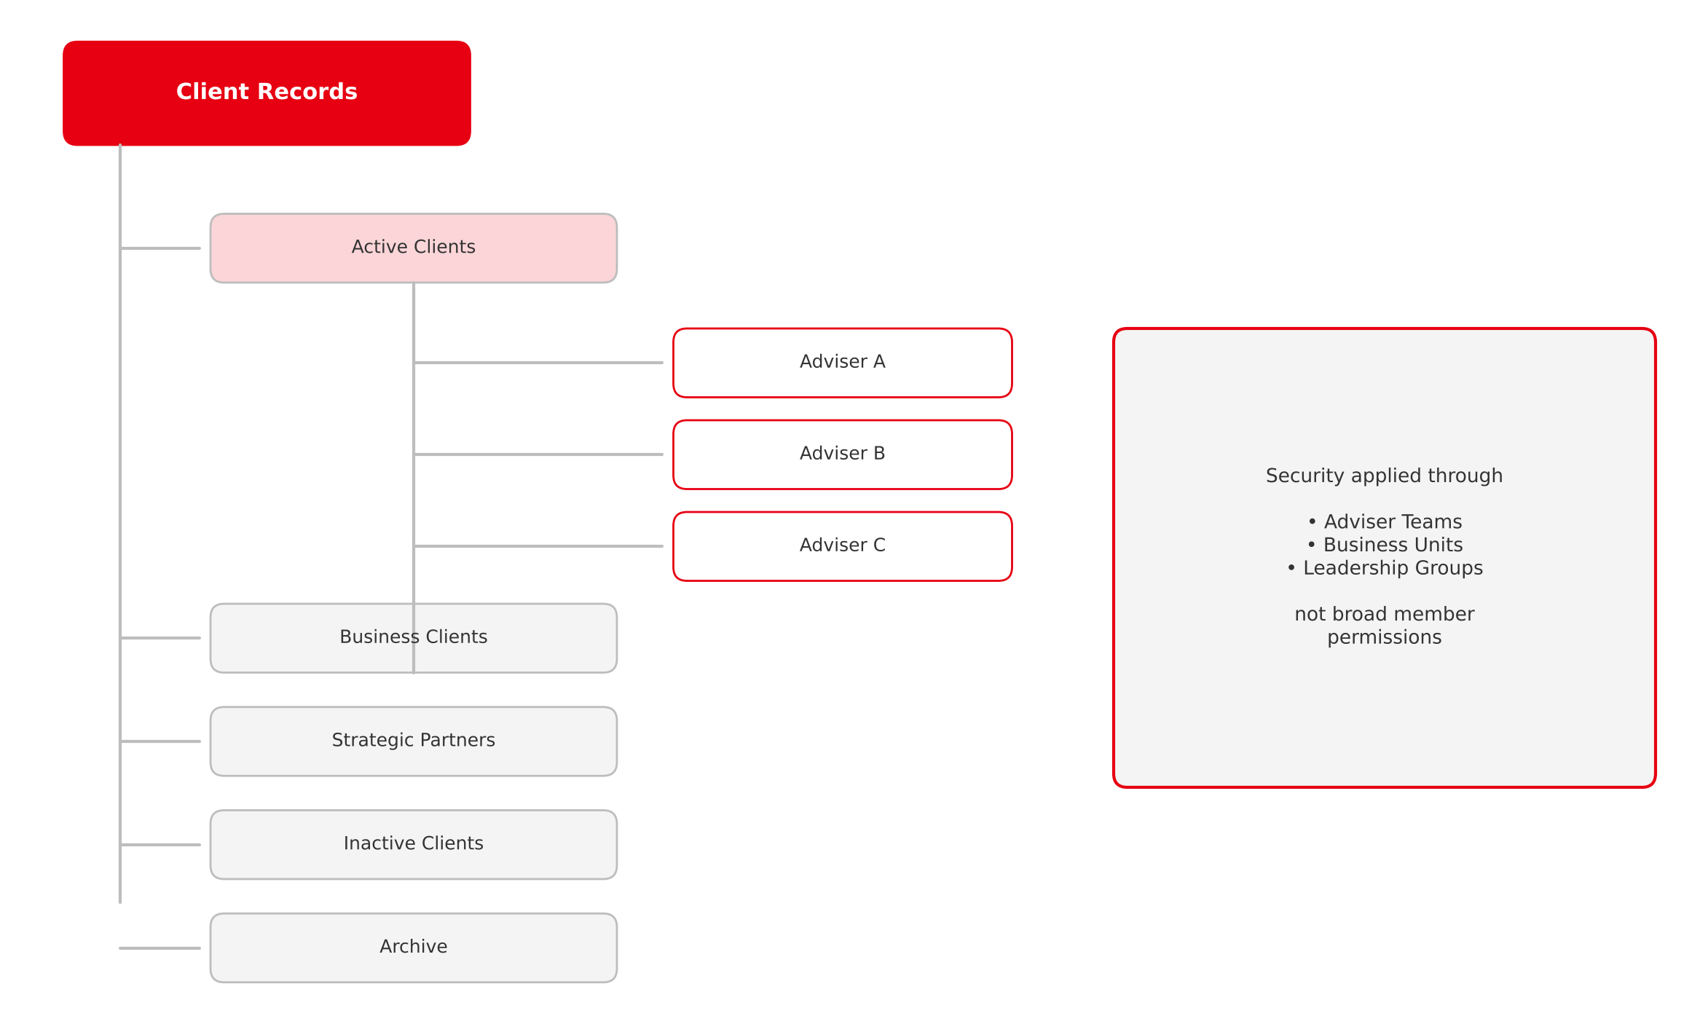
Figure 9: Client Records structure and security model
Security is applied through Adviser Teams, Business Units and Leadership Groups, rather than broad member permissions.

Section 5: Governance Framework

Governance Model
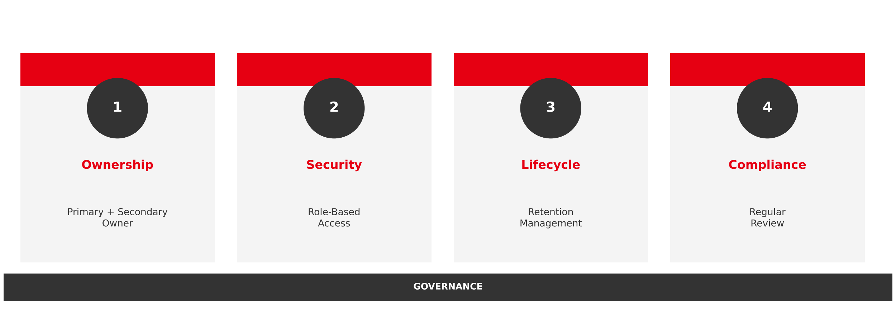
Figure 10: Four-pillar governance model
Pillar | Practice
Ownership | Primary + Secondary Owner
Security | Role-Based Access
Lifecycle | Retention Management
Compliance | Regular Review

Recommended Permission Model
Replace | With
Everyone | Advisers
Everyone Except External Users | Operations
 | Compliance
 | Leadership
 | Role-Based Security Groups

Section 6: Implementation Roadmap
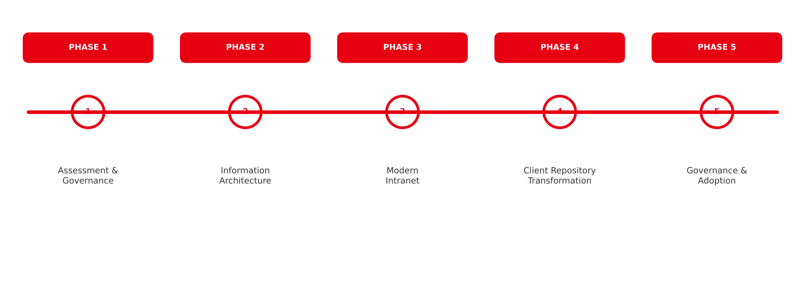
Figure 11: Implementation roadmap
Phase | Focus
Phase 1 | Assessment & Governance
Phase 2 | Information Architecture
Phase 3 | Modern Intranet
Phase 4 | Client Repository Transformation
Phase 5 | Governance & Adoption

Section 7: Expected Business Outcomes
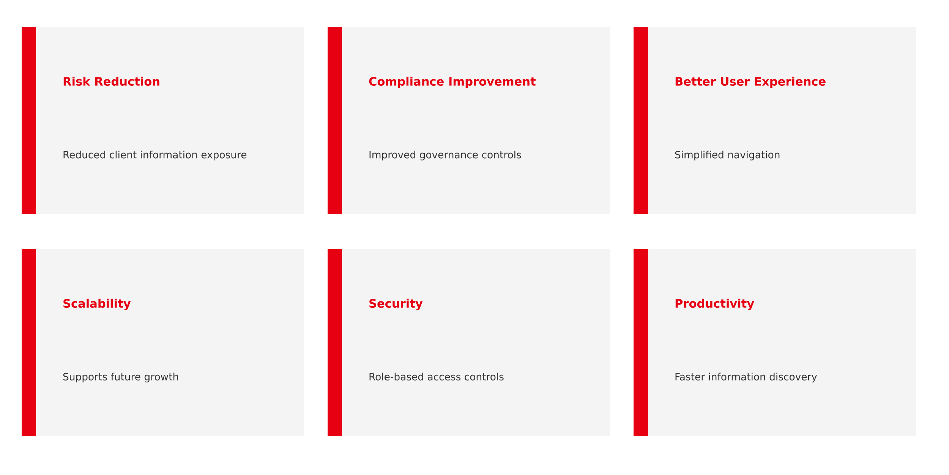
Figure 12: Executive benefits
Based on the future-state recommendations outlined in the solution brief.

Ricoh Branding Recommendations

Colour Palette
 | Primary Ricoh Red | #E60012
 | Dark Charcoal | #333333
 | Light Grey | #F4F4F4
 | White | #FFFFFF

Fonts
Use | Font
Headings | Aptos Display / Segoe UI Semibold
Body | Aptos / Segoe UI
Data Visualisation | Segoe UI

Design Style
- White background
- Strong use of Ricoh Red as accent
- Minimalist executive consulting style
- Full-width section dividers
- Modern Microsoft-style icons
- Large metrics and callout boxes
- Dashboard-style visualisations

Data Notes
- Figures come from the five Excel reports supplied; the Sites_20261014225729869.xlsx report was not available for this revision
- Reporting windows differ: the site list shows 236,539 files and 115 page views / 9 visits for AF Client Portal, while the 180-day usage report (refreshed 12 Oct 2026) shows 239,797 files, 352 page views and 15 visits
- Client names and file paths from the sharing reports are deliberately excluded from this document; only counts are reported
- The source reports do not flag which OneDrives are archived, so the "archived OneDrive" finding is carried over from the solution brief

Sources Used
- AdviceFinancialSolutionBrief.docx
- AllSitesActiveFinance.xlsx
- ActiveFinanceSharePointSiteUsageDetail10_13_2026 9_36_37 PM.xlsx
- Content_Shared_With_Everyone except external users_group_2026-10-14.xlsx
- Permissioned_Users_Count_OneDrive_report_2026-10-14.xlsx
- Sites_20261014225729869.xlsx
- Content_Shared_With_Everyone_group_2026-10-14.xlsx

