**SPT CUIT Guide**

This document shows how to configure the SPT CUIT project to run SPT benchmarks, which including below three topics:

- Setup project to run

- Check output reports and compared results

- Handle exception

Reference previous file:



# 1. Setup SPT CUIT project

## 1.1 Update Screen Resolution as 1366*768.

(but I really think this resolution suit for almost laptop)

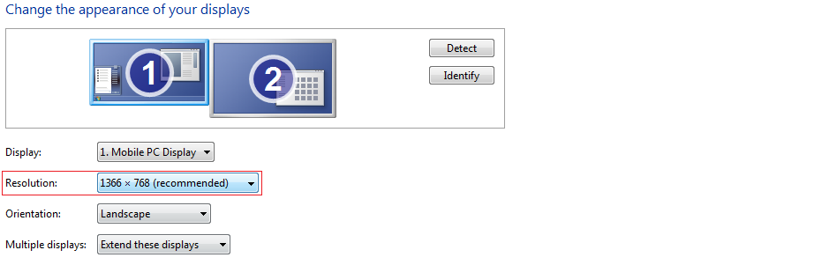

## 1.2 Get the SPT Benchmark Project code and project from network

Always gets the latest copy using date time stamp and paste and unzip into anywhere in local pc.

Project Code : \\mercer.com\US_Data\Shared\Dfl\Data1\RSS\SQA\RETIRE_STUDIO_BENCHMARK_CLIENTS_2\QTP_MasterExecution\QDrive\CUIT\Special_Payment_Tool

Benchmark Files : <http://rtgtfs.mercer.com/sites/Evolve/Special%20Payment%20Tool%20SPT/Forms/AllItems.aspx?RootFolder=%2Fsites%2FEvolve%2FSpecial%20Payment%20Tool%20SPT%2FSPT%20Benchmark%20Documents%2FSPT%20Benchmark%20Script&FolderCTID=0x0120004116D372E9A5CE438609DEEEA34CF6D8&View=%7B71A55FA5%2D7DD9%2D47EB%2DA22B%2DA3F76800975E%7D>

## 1.3 Configure the project to run test

### Step 1: visual studio config

Open the “**SPT_CUIT.sln**” from local pc, then import test setting file:

Goto Menu >> TEST >> Test Settings >> Select Test Settings File, then select “TestSettings1.testsettings” and click open.

(This setting file makes sure script run server hours. Otherwise, Visual Studio default run time just half an hour.)

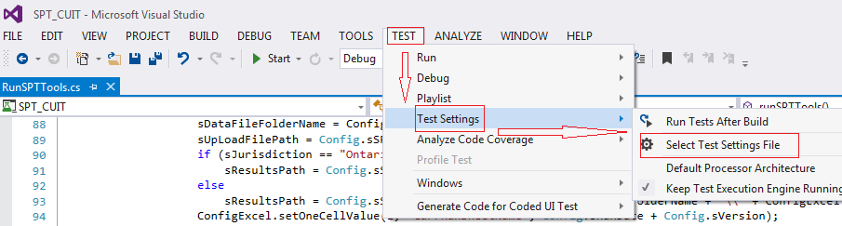

### Step 2: visual studio update file path and parameter

1, Open file “RunSPTTools.cs” in right Solution Explorer, looks next snapshot.

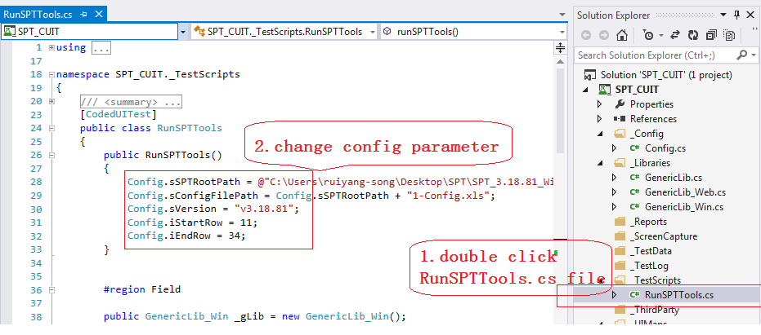

2, Set **sSPTRootPath** as SPT Benchmark file root path where you unzipped to local pc, it should be include 4 directors and one excel file, looks snapshot.

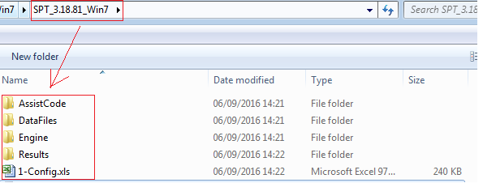

3, Set the **sVersion** as current version.

### Step 3: update start row and end row

1, Set **iRowStart** and **iRowEnd** as which we would like to run.

**Note:** We have 938 cases in the ‘1-Config.xls’ from row 2 to row 939. It will take a very long time to run if you want to run all the cases at one time. So I suggest you to run them separately group by ‘DataFileFolder’.

**For example:**

From row **2** to **10**, it will process all the data files in ‘**\DataFiles\Federal Benchmarks from Evolve\**’ folder.

From row **11** to **139**, it will process all the data files in **‘\DataFiles\QC2014\**’ folder.

From row **140** to **185**, it will process all the data files in **‘\DataFiles\Federal\**’ folder.

From row **186** to **313**, it will process all the data files in ‘\**DataFiles\QC30_QC2012\**’ folder.

From row **314** to **845**, it will process all the data files in **‘\DataFiles\Ontario\’** folder.

From row **846** to **867**, it will process all the data files in **‘\DataFiles\BC_Pre\’** folder.

From row **868** to **901**, it will process all the data files in **‘\DataFiles\BC_Post\**’ folder.

From row **902** to **939**, it will process all the data files in **‘\DataFiles\Alberta\’** folder.

(We can make the code automatically do this, but the side-effective is, if script stops somewhere, the browser will be closed by code as well, which gives us troubles to locate the issue point. So we just manually open testing site to make it still visible even error occurs.)

### Step 4: execute code view

Like next snapshot(RunSPTTools.cs) means main execute method,

You can comment or uncomment single line to decide which method should be run.

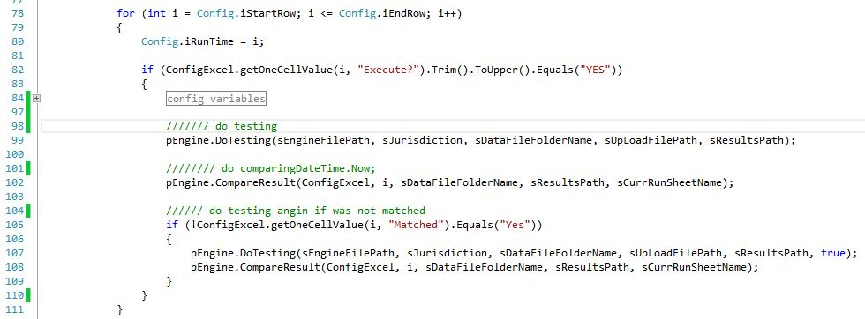

# 2. Check output reports and comparison results

You can check 1-config.xls file when test finished or test process was broken up.

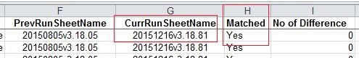

There is no referential meaning if the value of **CurrRunSheetName** was filled. Only the value of **Matched** or **No of Difference** were filled means this case run completed.

# 3. Handle exception

1. If next message box popup when run testing, it means you do not select test setting file, please do last **step 1.**

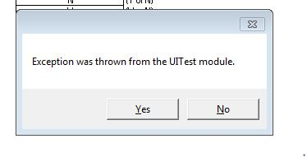

1. There is a **KillExcelProcess.bat** file under CUIT project directory, which using to kill excel process. You can copy it to your desktop or somewhere you can convert to using it.

If you come across any question when you running, please let me know when you free, I will be happy to resolve it.

Aug-31-2016

Lori song