Github Link -- <https://github.com/StupidME2000/Sem-4-DSA-ICA-Week-12-SSSA.git>

1)

|  |  |  |  |  |  |  |
| --- | --- | --- | --- | --- | --- | --- |
|  | 0 | 1 | 2 | 3 | 4 | 5 |
| 0 | 0 | 10 | 0 | 0 | 15 | 5 |
| 1 | 10 | 0 | 10 | 30 | 0 | 0 |
| 2 | 0 | 10 | 0 | 12 | 5 | 0 |
| 3 | 0 | 30 | 12 | 0 | 0 | 20 |
| 4 | 15 | 0 | 5 | 0 | 0 | 0 |
| 5 | 5 | 0 | 0 | 20 | 0 | 0 |

3)

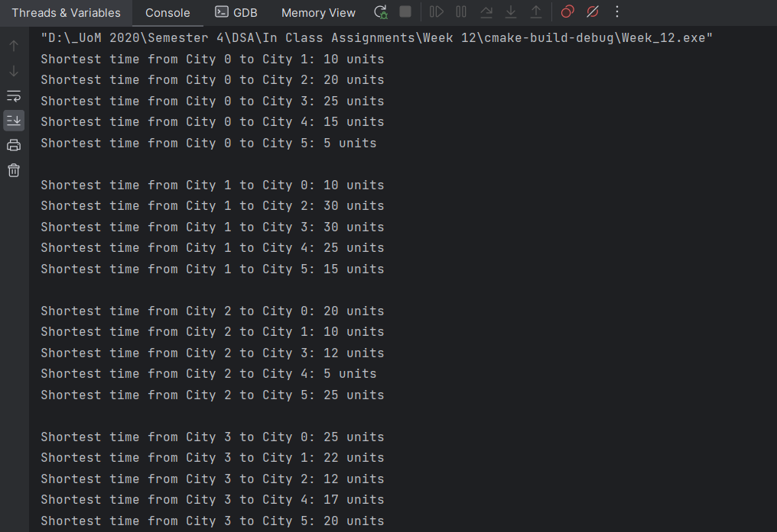

4)

