Weather Conditions Across the
2025 Formula 1 Season
Temirkhan Adilet and Bertayev Azat | Professor Koishiyeva
KBTU · Data collection and preparation · SIS №1 · 7 October 2026
This project compares weather at the circuits on all 24 local race dates in the 2025 Formula 1 season. The final dataset contains 576 hourly records. Mean daily air temperature ranged from 13.7°C in Japan to 32.1°C in Saudi Arabia, while 11 race days had some modelled precipitation. These comparisons describe entire calendar days, including hours before and after each race.

Data and collection
The two data sources were static Wikipedia pages and the Open-Meteo Historical Weather API. Python requests retrieved the season calendar and 24 linked circuit pages, and BeautifulSoup extracted round numbers, race names, dates and circuit coordinates [1]. The collection process checked Wikipedia’s robots.txt and cached the HTML. The Las Vegas Grand Prix was correctly assigned to 22 November, its local race date.
One API request per circuit used its coordinates, automatic local timezone selection and the explicit ERA5 model. The selected fields were air temperature at 2 m (°C), relative humidity at 2 m (%), precipitation (mm) and wind speed at 10 m (km/h) [2]. Responses were collected on 7 October 2026. Saved HTML and JSON, request parameters, timestamps and SHA-256 hashes preserve the source evidence for an offline rerun.

Preparation and analysis
Column names were standardized, dates and numeric fields were typed, and coordinate, unit and physical-range checks were applied. Each weather row was linked to the unique race metadata using its round. UTC timestamps were converted to each circuit’s timezone before filtering to the local race date. Coverage checks found 24 hours per race, no duplicate race-hour keys and no missing weather values. No values were imputed.
Precipitation requires a boundary correction: each API value covers the preceding hour [2]. The next-midnight value was therefore mapped to the final interval of the race day; temperature, humidity and wind timestamps stayed unchanged. The API returned two dates to obtain that boundary, but only the 24 race-day intervals entered the analysis. Daily means, temperature ranges and precipitation totals produced 24 comparison rows. Correlations were calculated across these race days rather than treating all 576 related hours as independent observations.
Five notebook figures compare daily temperature ranges, precipitation totals, humidity and wind, race-day correlations, and hourly temperature patterns. The daily summaries used in these comparisons are described in Table 1.
Table 1 Descriptive statistics across the 24 race days
Race day measure | Mean | Minimum | Maximum
Mean air temperature (°C) | 20.5 | 13.7 | 32.1
Mean relative humidity (%) | 68.3 | 36.1 | 89.7
Total precipitation (mm) | 3.9 | 0.0 | 24.2
Mean wind speed (km/h) | 12.5 | 5.0 | 34.3
Each row summarizes 24 daily measures. Precipitation is a daily total; the other measures are daily means.

Results
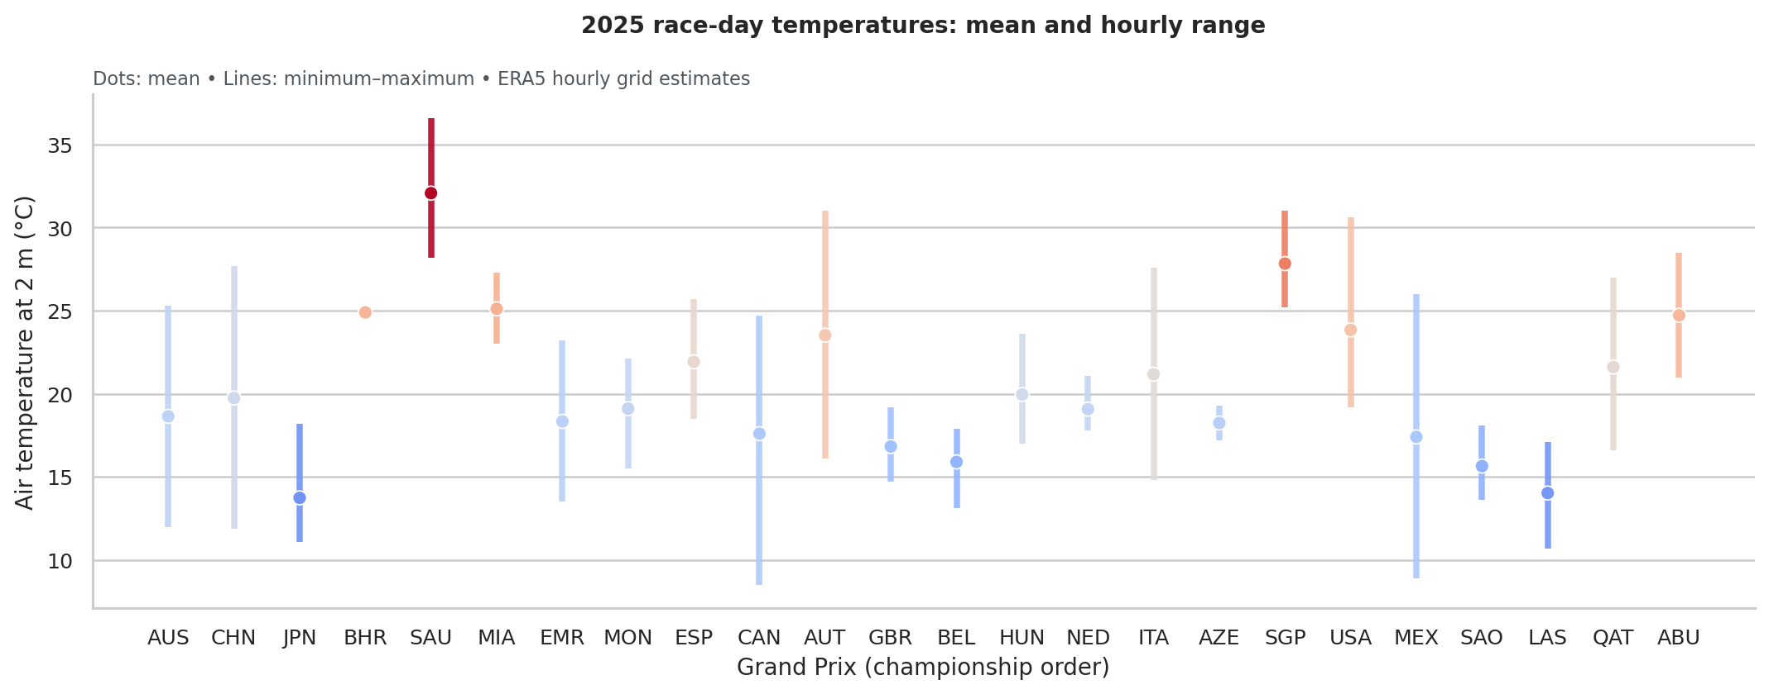
Figure 1 Daily mean temperature and hourly minimum–maximum range in championship order. Source: calculations from Open-Meteo ERA5 data [2].
The average of the 24 daily mean temperatures was 20.5°C, with a sample standard deviation of 4.4°C. Saudi Arabia’s 32.1°C mean exceeded Japan’s 13.7°C mean by more than 18°C. Across individual hours, air temperature ranged from 8.5°C to 36.6°C. The season therefore covered quite different thermal conditions, even before considering temperatures at the actual race start.
Miami had the highest daily precipitation total, 24.2 mm, followed by Belgium at 20.2 mm and Japan at 18.6 mm. Although 11 of 24 dates had positive precipitation, only seven reached 1 mm, showing that the definition of a wet day changes the count. Azerbaijan had the highest mean wind speed, 34.3 km/h, and Belgium the highest mean relative humidity, 89.7%.
Daily mean humidity and precipitation were positively associated (Pearson r = 0.51; Spearman rank correlation = 0.76; n = 24). Both measures indicate that wetter days tended to be more humid in this sample. Temperature and humidity had a weaker negative association (r = −0.35), while temperature and wind had almost no linear association (r = 0.005). These exploratory correlations do not establish causation.

Limits and conclusion
ERA5 is gridded reanalysis at approximately 25 km resolution, so these values are estimates near each circuit rather than measurements at a track weather station [2]. Local showers and terrain can be poorly represented. Whole-day averages also mix daytime and night-time conditions and cannot identify whether the race itself was wet. Geography and season vary together across only 24 events, limiting generalization. The results establish a reproducible comparison of race-day weather; linking weather to lap times or race outcomes would require separate session-time and performance data.

Sources
[1] Wikipedia contributors. 2025 Formula One World Championship and its 24 linked circuit articles. Retrieved 7 October 2026.
[2] Open-Meteo. Historical Weather API documentation and ERA5 hourly archive responses. Retrieved 7 October 2026. Data: CC BY 4.0; aggregated for this analysis.
The notebook and cached source manifest retain each circuit URL, API request and raw response.

