**INTRODUCTION:**

As we know clean environment plays a vital role in our daily routine. We can think about this, let you wake up and get a glass of dirty water for drinking or suppose went out for office and encounter with a foul smell that is coming from waste material that keep thrown continuously near your house or smoke that is unbidden enter your house and make you suffocating. Therefore, this is necessity to keep our surrounding clean.

So, this time we choose Kalyani of West Bengal whose characteristics is given by underground sewage system, paved roads forming rectangular grids, tree-lined avenues and community parks. But still need a lot to make it environment friendly place.

**ISSUES:**

Let’s start with waste management and recycling. Now a time, it is hard to believe that there are proper-plans of recycling and harmless waste management project. It is because neither any proper areas dustbins are there nor any member of workers found regularly to take garbage from their home. If the condition of the city is like this then citizens are also not interested to make effort in cleaning their surrounding and thrown it nearby houses. And then some one day of week workers of municipal community arrived get rid of all and throw it on unpopulated lands in open and this is just like making one place dirty to clean the other. This affects the nearby water-bodies and make it unfit. And the whole recycling process which is most important is depend on two-three people who collect some non-biodegradable waste for small amount of money and they didn’t know how much huge contribution they are given too our society. So, this is crystal clear that there is a need of great efforts to make change.

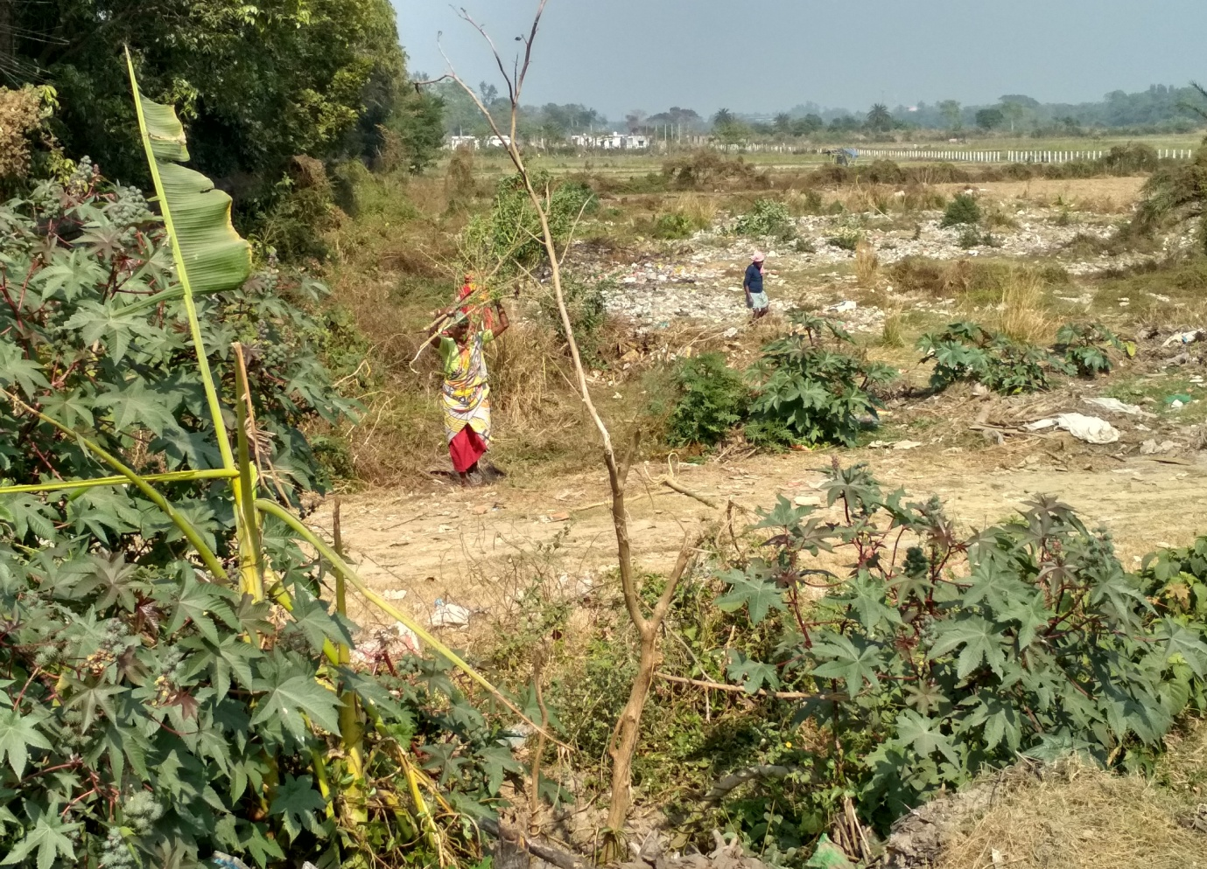

Fig. (1)

This is also known to us that there is direct relationship between industries and pollution. If there increase in industries then there must be increase in pollution and Kalyani has a dedicated industrial zone including Andrew Yule and Company, Kalyani Breweries (UB Group), Black Label beer and Dabur, though some of the industry have closed or stopped production but still many of them are remaining. And this industry is huge source of water and air pollution as it produces pollutants that are extremely harmful like Asbestos, Lead, Mercury, Nitrates, Phosphates, etc. Thus, in this aspect there is also need to make changes for beneficiary environment.

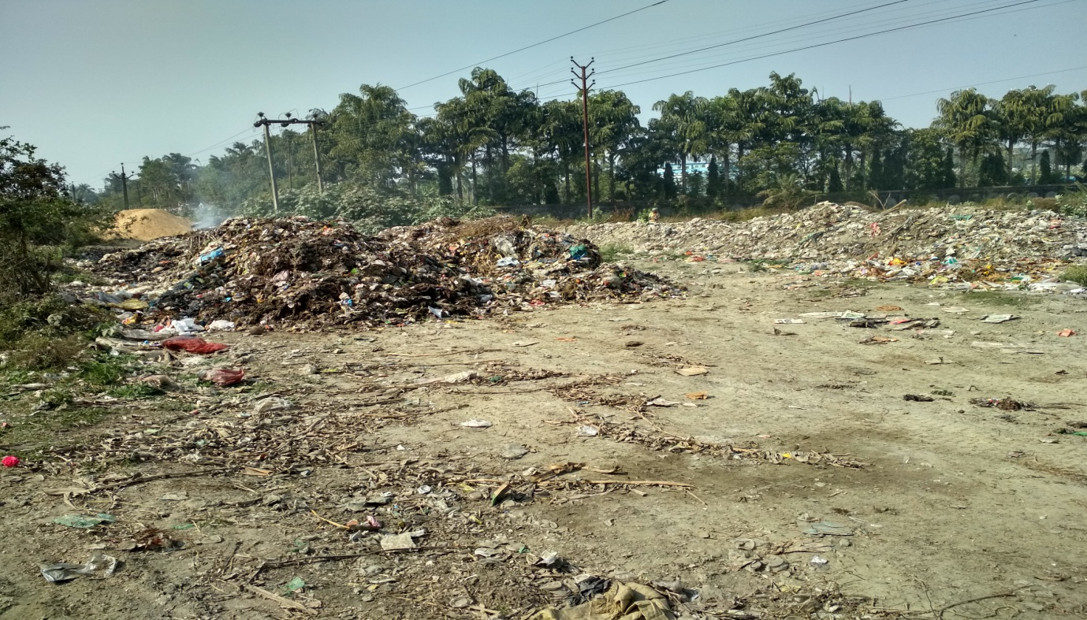

Fig. (2)

**ECONOMIC AND SOCIAL FACTORS:**

Any place to become environment friendly then it must pass through bridge of economic and social factors. And their basic criteria are Growth, Development, Accessibility, Sharing and many others. It actually means to Address ‘wellness needs’ of the population, Value family/community over individuals, Rely on information, not machinery, Establish deliberative decision process, Reduce family size and resource use, Subsidize food, health care, and education, Launch program to reduce automobile use, Expand green zones to safeguard open space, Enlarge the amount of per capita green space, Encourage residents to separate their garbage, Set up programs to recycle recyclables Produce civic theater to promote recycling, Develop a low emissions industrial zone, Nurture civic enthusiasm, brightness and zest.

**CONCLUSION:**

After tackling through different deals, issues and various factors the first thing to be done is making separate organization like Ramky group which focused in the areas of civil, environmental and waste management infrastructure. Government comes forward with a commitment to make this planet greener and healthier. There must be some awareness campaign regarding pollution free environment. The literacy rate of Kalyani is 88.75%, so the educated citizens try to play some role for human welfare environment and live cleaner, greener and healthier lives.