**Time Series Analysis Journal**

Daily low and high temperatures in Houston, Texas from 1989 - 2019

Predictions for temperatures in 2020

STAT 4307

12/9/2021

Alison Bradburn

**Introduction**

​​

Houston’s subtropical climate has always led to extreme weather in our city. Heat waves are the norm, but we also get heavy rains due to a preponderance of tropical systems in the Gulf of Mexico. The year 2021 brought an extreme freeze unlike any many residents have seen here, with sustained temperatures dropping well below freezing. Due to this vast difference in weather, we want to know if there is a trend in average daily temperature. This project will be focused on determining if temperatures have remained constant from 1989 through 2019 or if there has been an increase in average daily temperature over time.

The dataset was collected by the National Weather Service at Houston Hobby Airport. It contains the daily low and high temperature, along with the average daily temperature and precipitation. I am expecting heavy seasonality within specific time frames and expect seasonal trends with minimal drastic yearly changes as time progresses. Using time series analysis, I plan to forecast monthly temperatures from January to December of 2020.

**Selecting the Model:**

A plot of Houston’s monthly average temperature was made, showing the seasonal nature of temperature (Figure 1). The model holds a mean of 70.9 degrees (F) with a standard deviation of about 11 degrees. The model does indicate an overall slight increasing trend. From 2010 through 2020, the summer temperatures consistently approached 90; the previous 20 years saw that temperature around 85. Due to seasonality and trend, our data set is not stationary. 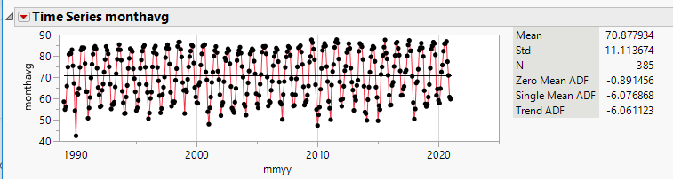

Figure

Outliers were present, but were not removed since weather extremes are a valid indication of a change in weather patterns. In fact, the number of outliers appears to be increasing, thus affirming that they are becoming part of the pattern.

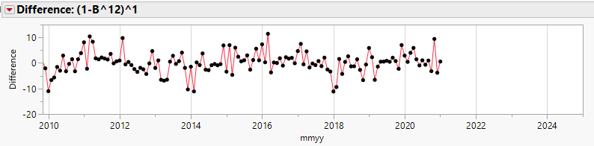Temperature data is strongly seasonal, demonstrated by the sinusoidal shape of the beginning ACF, which repeats every 12 lags. We can also see a PACF that slowly reduces over the first 12 lags. The first step was to differentiate the data set to remove that seasonality. With the resulting (0,0,0)(0,1,0)12 model, we have removed the seasonality but still do not have a stationary model (Figure 2). We take the first difference.

Figure 2

In Figure 3, we have a (0,1,0)(0,1,0)12 model. It has constant mean around 0 and constant variance. It is now stationary. 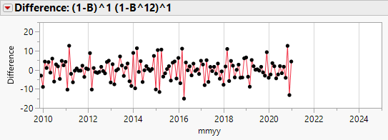

Figure

The original data was divided into two sets, with 30 years of monthly data (360 data points) in the training set and one year (12 data points) in the remaining set. An analysis of the ACF and PACF shows expected spikes around lags 12, 24 and 36, verifying annual seasonality (Figure 4).

The ACF shows a sharp spike at lag 1, then reducing to within the standard deviation, while the PACF shows exponential decay, so a moving average model of order 1 will fit the data. This will give us a SARIMA(0,1,0)(0,1,1) 12.

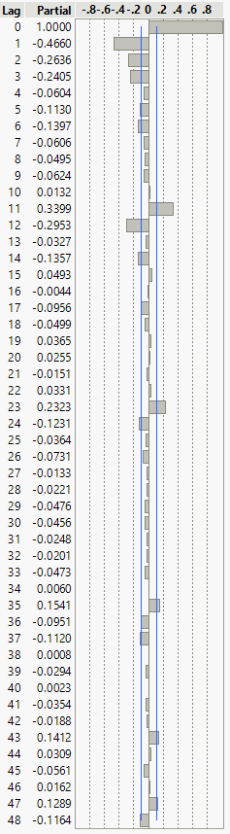 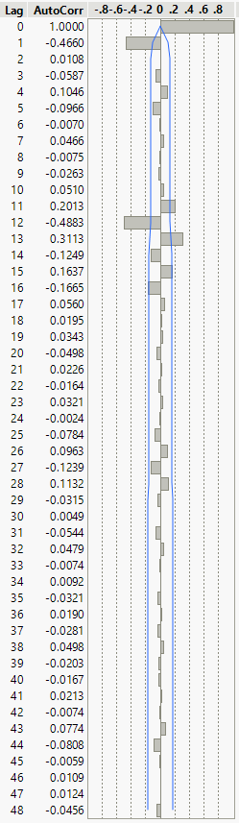

Figure

Next, I used the Arima Model Group function, run with the above determined orders. This JMP function determined the best potential fit using AIC (Figure 5) was (1,1,2)(0,1,1) 12. The best fit measured using SBC (Figure 6) was (0,1,1)(0,1,1) 12. 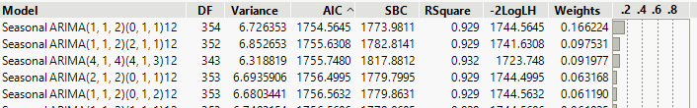

Figure

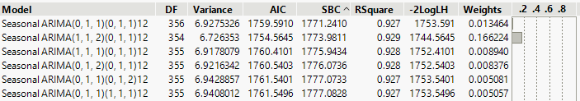

Figure

For the first model, ARIMA(0,1,1)(0,1,1) 12  was chosen, the best fit SBC model with a value of 1771.2410. It failed the test on residuals with a p-value of 0.0447 on the first lag.

For the second model, SARIMA(1,1,2)(0,1,1) 12 was chosen. Its AIC value is 1754.5645. Further analysis of this model shows residuals within 2 standard deviations and a mean of 0. P-values for the Ljung-box test show no significant correlation (Figures 7 & 8).

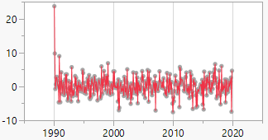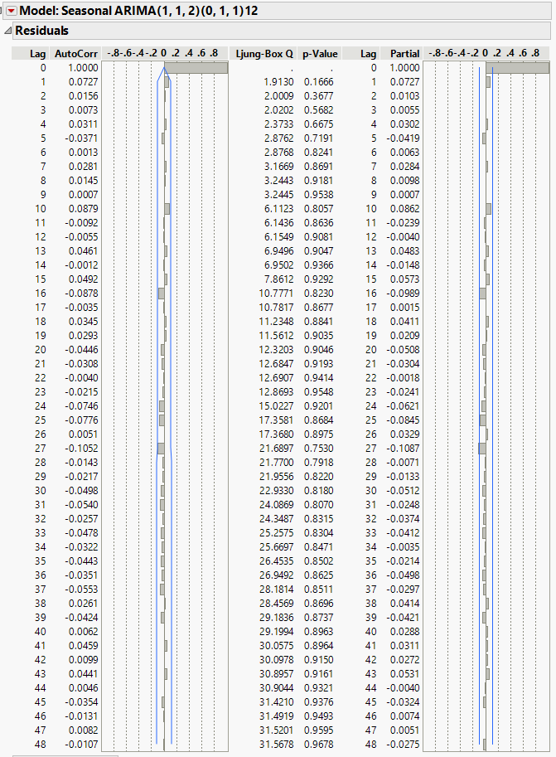

Figure 8

Figure

Figure 7

Because the first model failed the Ljung-box test, a third model was chosen. The third model is SARIMA(1,1,2)(2,1,1) 12. Its SBC value is 1773.9811. This model also fits the guidelines as valid and parsimonious (Figures 9 & 10).

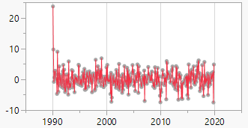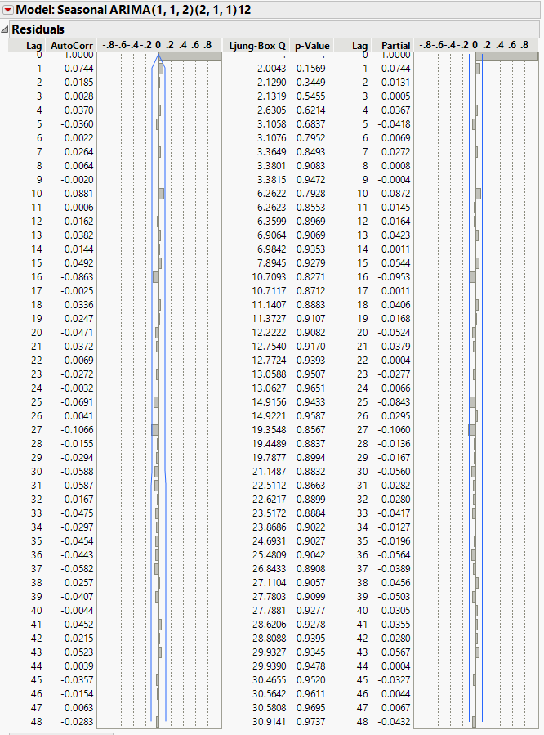

Figure 10

Figure 9

**Trend:**

There is a barely discernible trend in the data that becomes more apparent when the average temperature for each year is plotted (Figure 11). 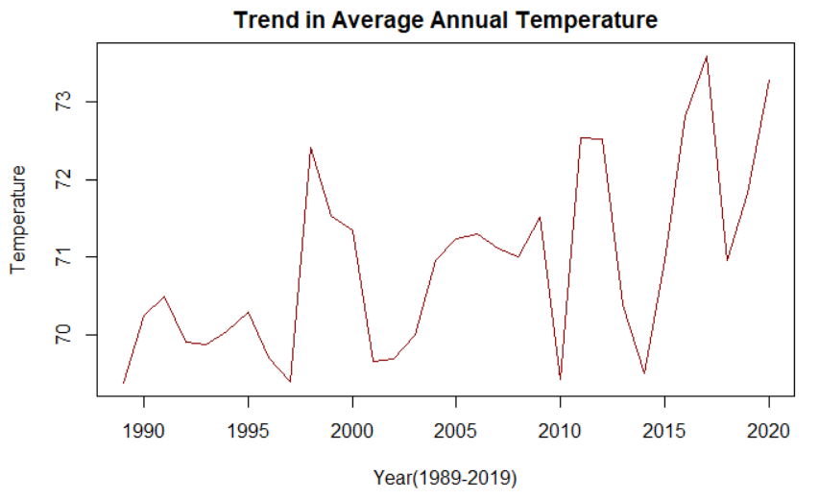

Figure

**Figure 11** Trend in Average Annual Temperature

In Figure 12, average temperatures are broken down by month. Eight of twelve months show an upward trend over time. Overall, there is an increasing trend in the average temperatures recorded, especially in the second part of the year beginning in June. All trends are transformed with a first order difference.

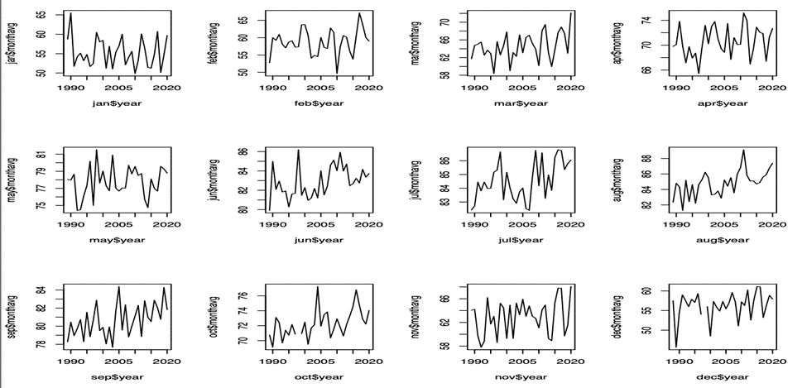

**Figure 12** Average Temperatures by Month

**Forecast:**

As seen in figures 13 and 14, both models have a similar forecast. The expected temperature follows the same pattern. It is interesting that the curves demonstrating the 95% confidence interval nearly reach the many outliers in the colder months but far exceed the highest temperatures in the warmer months.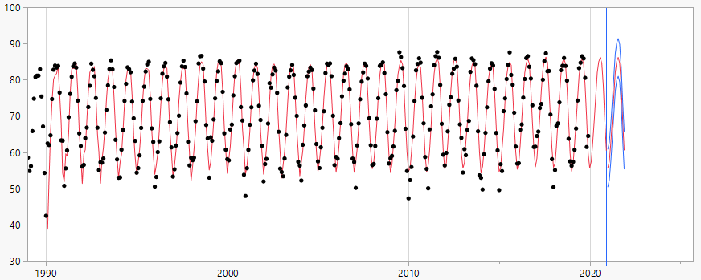

**Figure 13** SARIMA(1,1,2)(0,1,1,12)

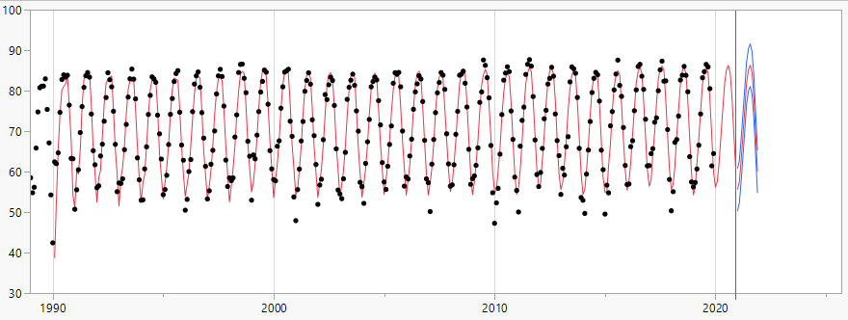

Figure 14 SARIMA(1,1,2)(2,1,1,12)

Figure 15 shows the temperature forecasts of the SARIMA models against the average actual temperature recorded in Houston. The forecast graphs show a uniform increase in temperature over the first 4 months with them flattening out by June. The forecast models show the average temperature peak around 85 degrees around June and July. The plot line of actual temperature shows the same peak, but it does show the forecast calling for a slower decline in temperature until the colder weather settles in in November.

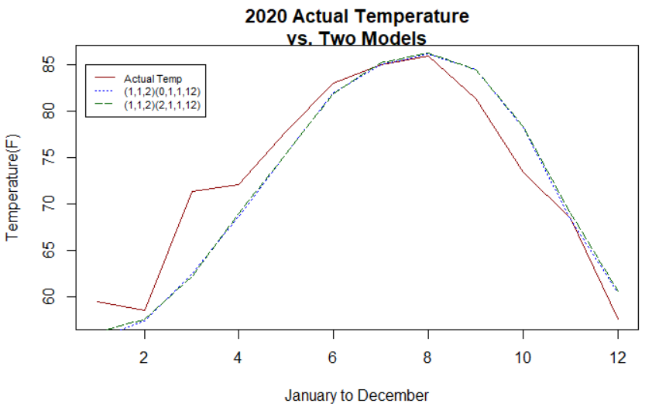

Figure

Figure

Figure

Figure

Figure

Figure

Figure

As you can see from the graph above, there is effectively very little difference between the models. The sum of the errors (forecast error) in SARIMA(1,1,2)(0,1,1) 12 is 14.750, with a percent error of 1.78%. The forecast error for SARIMA(1,1,2)(2,1,1) 12 is 13.192 with a percent error of 1.59% (Table 1). The SARIMA(1,1,2)(2,1,1) 12 just edges out the other model, so this is the one chosen to model temperature data for the Houston area. Locations in other climates, either with more extreme or less extreme weather, may require a different model.

Table

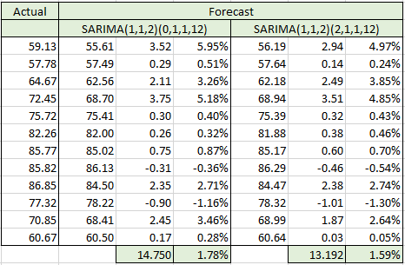

**Limitations**

The proposal above stated that I would be modeling and predicting daily temperatures. I had a very difficult time modeling daily temperatures, especially selecting a period for repeating. A period of 365 gave bad results across the board. Instead, I averaged the high, low and average temperatures for each month.

Additionally, if local weather continues to produce extreme heat and freezing events, the model may need to be changed. More outliers make forecasting more difficult.

**Conclusion**

Temperature time series are a study in contrasts. The range of temperatures one can expect in a given month are predictable by just about anybody, even a child. However, as has been seen this year, with a record number of exceedingly hot days in the Pacific Northwest and the protracted freezing temperatures we experienced in Texas in February, temperatures outside the norm are frequent enough to give us pause. Additionally, as the outliers on our time series shows, they are getting more frequent. Add to that an upward trend in temperature and we have cause for concern for the future.

**Citations**

NOAA National Centers for Environmental Information

<https://www.ncdc.noaa.gov/cdo-web/>