A photographic negative imaging inspired method for low
illumination night-time image enhancement

Student : Rogoz Bogdan
Group : 30433

Table of Contents
1. Introduction 3
2. Basic principles 3
3. Algorithm 4
3.1. Input 4
3.2. Output 5
3.3. Steps 5
4. Application 5
5. Future improvements 5
6. Bibliography 5

1. Introduction
Low illumination night-time image enhancement is critical for a wide range of image-related outdoor applications, such as surveillance systems, intelligent vehicles, satellite imaging, and outdoor object recognition systems. Images captured in night-time under low illumination conditions are usually seriously degraded due to insufficient light, such as low contrast, distorted colors and unclear details etc., and seriously affect the performance of image - related outdoor systems.

2. Basic principles
Based on the observation of the photographic developing, we find that the contrast of images can be enlarged and their saturation can also be increased when their negative images (or reverse images) are rectified.
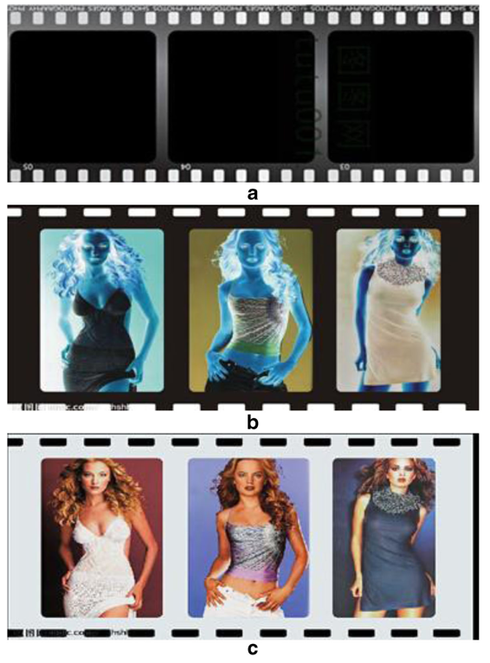

As seen in the picture above, the steps for developing photographs are:
- Take the photograph and expose the film; the result is a film containing latent, invisible images
- By developing the photograph, it will become visible; the more dense a place on the image is, the blacker it will be
- Since the developed image is the negative one, we just have to invert it in order to generate the final image
Based on the technique applied on film rolls, the following steps have been derived for an illuminating algorithm:
- The input night-time image is reversed to obtain its corresponding negative image
- A rectification on the negative image is done by using Dark channel prior based image enhancement technique (this operation comes from such an observation that the negative image looks like a hazed image)
- The enhanced negative image is reversed to obtain the final enhanced night-time image

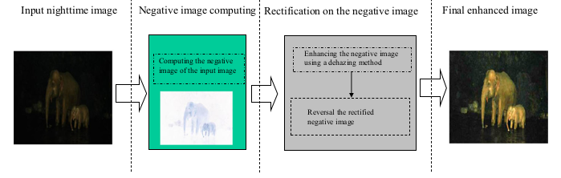

3. Algorithm

3.1. Input
- Low illumination night – time input ( I_{input} )
- The patch size ( Ω )
- The initial transmission coefficient ( t₀ )
- The threshold value T of the histogram of the night-time negative image

3.2. Output
- The enhanced night – time illumination image ( I_{output} )

3.3. Steps
- Compute the negative of the input image
- Rectify the negative image
  - Compute the dark channel of the negative image
  - Compute the gray histogram of the dark channel and count the percent of pixels whose intensity value is smaller than the threshold value T
  - Estimate the value of A (the global atmospheric for the negative image)
  - Compute parameter t(x) (the transmission coefficient)
  - Compute the rectified negative image
- Compute the final night – time enhanced image

4. Application
The above algorithm will be implemented in a C++ project, aiming to provide an application capable of taking an image specified by the user and improve it for night time vision.

5. Future improvements
Some of the possible improvements to the aforementioned project are:
- Android port
- Comparison to results given by other low illumination image enhancent on a certain image

6. Bibliography
https://link.springer.com/article/10.1007/s11042-017-4453-z

