Student: Rogoz Bogdan
Group: 30433

Table of Contents

1. Requirements Analysis 3
1.1 Assignment Specification 3
1.2 Functional Requirements 3
1.3 Non-functional Requirements 3
2. Use-Case Model 3
3. System Architectural Design 4
4. UML Sequence Diagrams 6
5. Class Design 7
6. Data Model 7
7. System Testing 8
8. Bibliography 8

1. Requirements Analysis

Assignment Specification
Design and implement a client-server application for a news agency.

Functional Requirements
- The readers can view a list of articles, read an article and do not need to login in order to use the application
- The writers need to authenticate in order to create, update or delete articles
- The admin is the only one who can create writer accounts, but cannot create new admin accounts
- When reading an article the user should be able to see the title and and the abstract of the related articles
- The application must support multiple concurrent users

Non-functional Requirements
- The application must be client-server
- Use the Observer design pattern for updating the list of articles in real time
- For sending data from the client to the server use JSON serialization
- When writing an article, show a list that supports multi-select for choosing the related articles

2. Use-Case Model
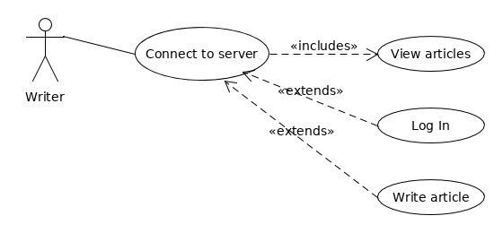

Use case : Write article
Level : user goal
Primary actor : writer
Main success scenario :
- The user fills the IP and Port fields
- The user clicks the “Connect” button
- The user fills the email and password fields
- The user clicks the “Log In” button
- The user clicks the write article button
Extensions :
- The user fills the IP and Port fields
- The user clicks the “Connect” button
- An error message is displayed

- The user fills the IP and Port fields
- The user clicks the “Connect” button
- The user fills the email and password fields
- The user clicks the “Log In” button
- An error message is displayed

3. System Architectural Design

3.1 Architectural Pattern Description
- Model – View – Controller : it is made of 3 main components:
  - Model : observable objects that hold the data represented by the View component. If the model changes, the View is updated, an vice-versa.
  - View : the visual part of the application. It contains stages, scenes, text fields etc.
  - Controller : handles user input and sets the properties of the visual components.
- Client – Server : a centralized architecture, consisting of:
  - Server : the central core, listens for incoming client connections and performs communication through messages
  - Client : a connection to the server, can connect and disconnect at any time

3.2 Diagrams
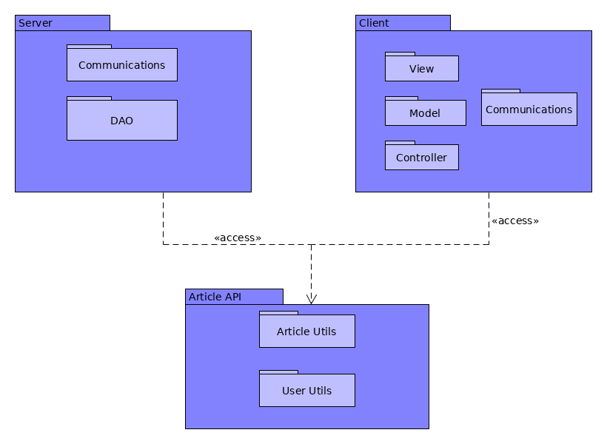

Package diagram

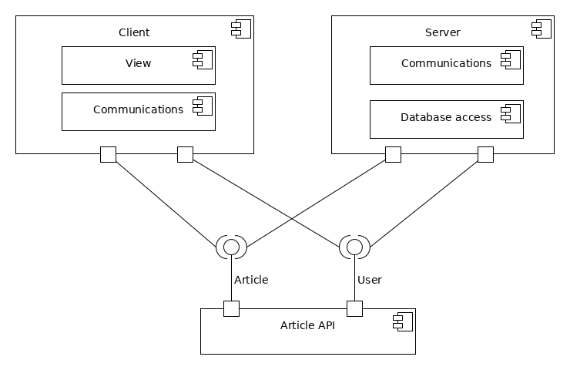

Component diagram

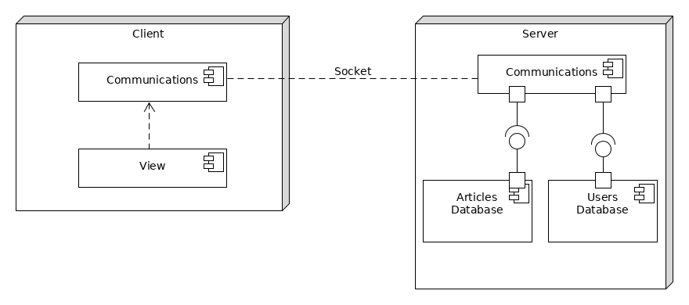

Deployment diagram

4. UML Sequence Diagrams
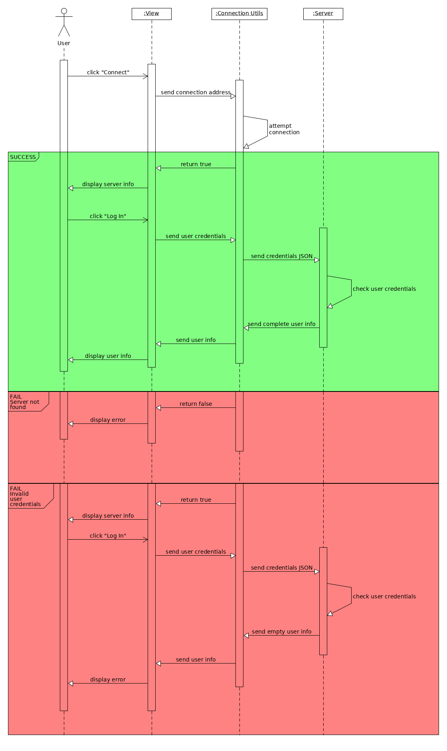

5. Class Design

5.1 Design Patterns Description
- Singleton – Used for ensuring correct functionality of the JDBC Driver
- Observer – Used for real time update of the articles list

5.2 UML Class Diagram
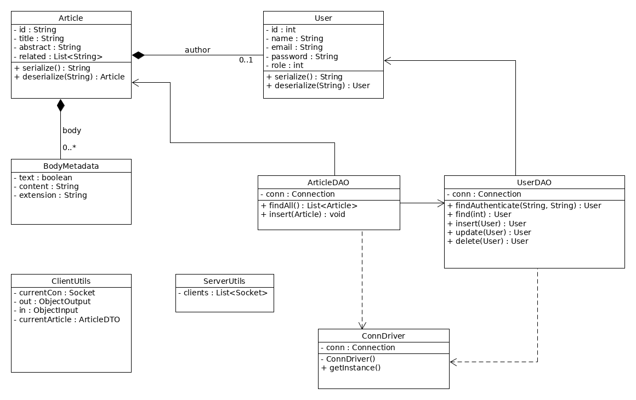

6. Data Model
- User / UserDTO – contains the information about user accounts
- Article / ArticleDTO – contains the content and information about articles
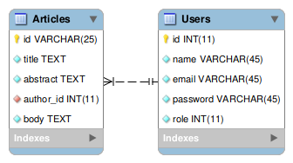

7. System Testing
Unit testing should be employed for this software:
- check email regex
- check connection status
- check log in credentials
- check conflicts when performing database operations

8. Bibliography
https://docs.oracle.com/javase/tutorial/networking/sockets/index.html
https://www.tutorialspoint.com/jackson/jackson_first_application.htm
https://www.tutorialspoint.com/design_pattern/observer_pattern.htm
https://www.journaldev.com/1535/composite-design-pattern-in-java

