Analysis and Design Document

Student: Bogdan Rogoz
Group: 30433

Revision History

Date | Version | Description | Author
01/04/2018 | 1.0 | Initial documentation | Bogdan Rogoz

Table of Contents
I. Project Specification 4
II. Elaboration – Iteration 1.1 4
1. Domain Model 4
2. Architectural Design 4
2.1 Conceptual Architecture 4
2.2 Package Design 5
2.3 Component and Deployment Diagrams 6
III. Elaboration – Iteration 1.2 7
1. Design Model 7
1.1 Dynamic Behavior 7
1.2 Class Design 7
2. Data Model 7
3. Unit Testing 7
IV. Elaboration – Iteration 2 7
1. Architectural Design Refinement 7
2. Design Model Refinement 7
[Refine the UML class diagram by applying class design principles and GRASP; motivate your choices. Deliver the updated class diagrams.] 7
V. Construction and Transition 8
1. System Testing 8
2. Future improvements 8
VI. Bibliography 8

Project Specification
The purpose of the Watch2Gether project is to provide its users a friendly environment where they could listen to a wide variety of music, in a synchronized manner, while being situated in totally different spaces.

Elaboration – Iteration 1.1

Domain Model
The Client will contain 2 models:
- User – represents a user, either the active one or other users present in the room
- Media – holds the information about media files : title, URL address, cover image, duration etc.
The Server consists of the following models:
- User – same as above
- Media – same as above
Although the Client will have a more declarative implementation, the server will have a more object – orietned design, as in the diagram below:
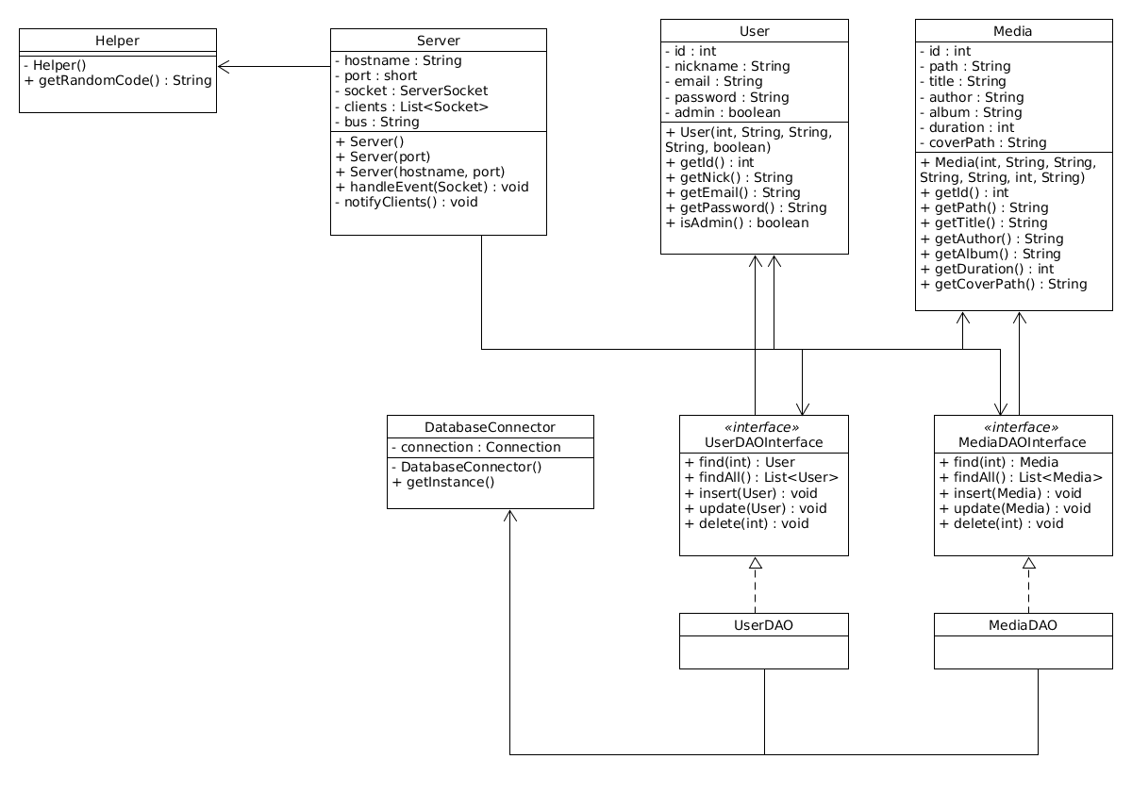

Architectural Design

Conceptual Architecture
The system consists of two endpoints : the users and the server. The used architectural patterns are:
- Client – Server : The server sends request / response messages to each client at a given point in time and vice-versa. While communicating with all its clients, the server also listens for new connections.
- Event Bus : The server acts as a virtual bus. Every client listens for events while performing playback. When a client wants to perform an action (eg. pause, stop), it sends a message to the server telling it to place the message on the bus, and all the other clients are then notified.
The described approach has been selected due to its simplicity and performance.

Package Design
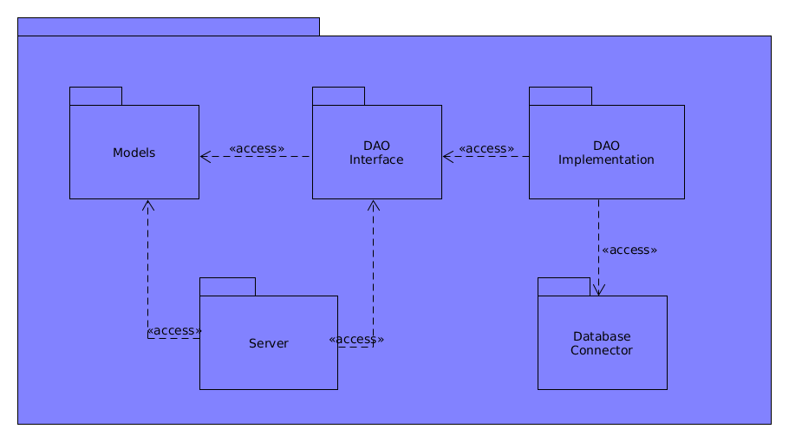

Component and Deployment Diagrams
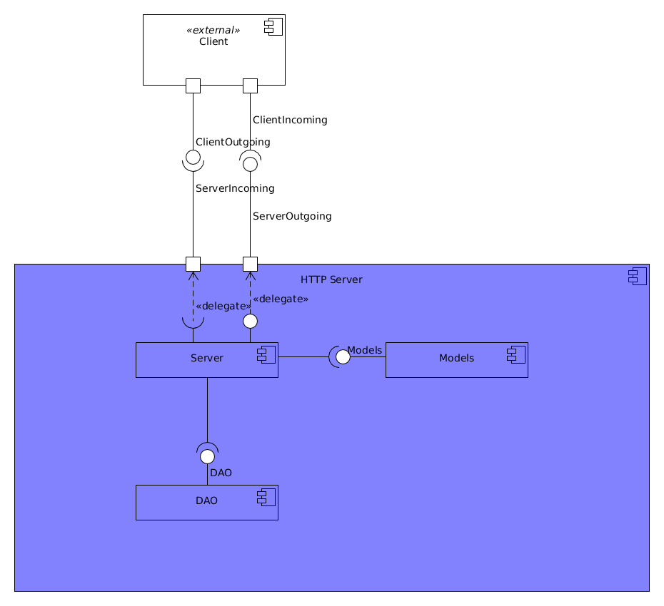

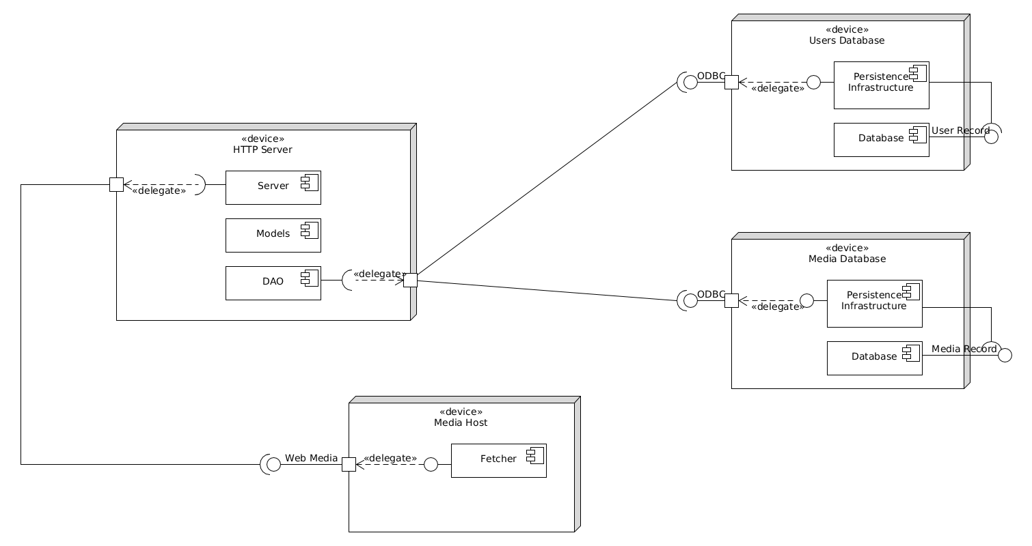

Elaboration – Iteration 1.2

Design Model

Dynamic Behavior
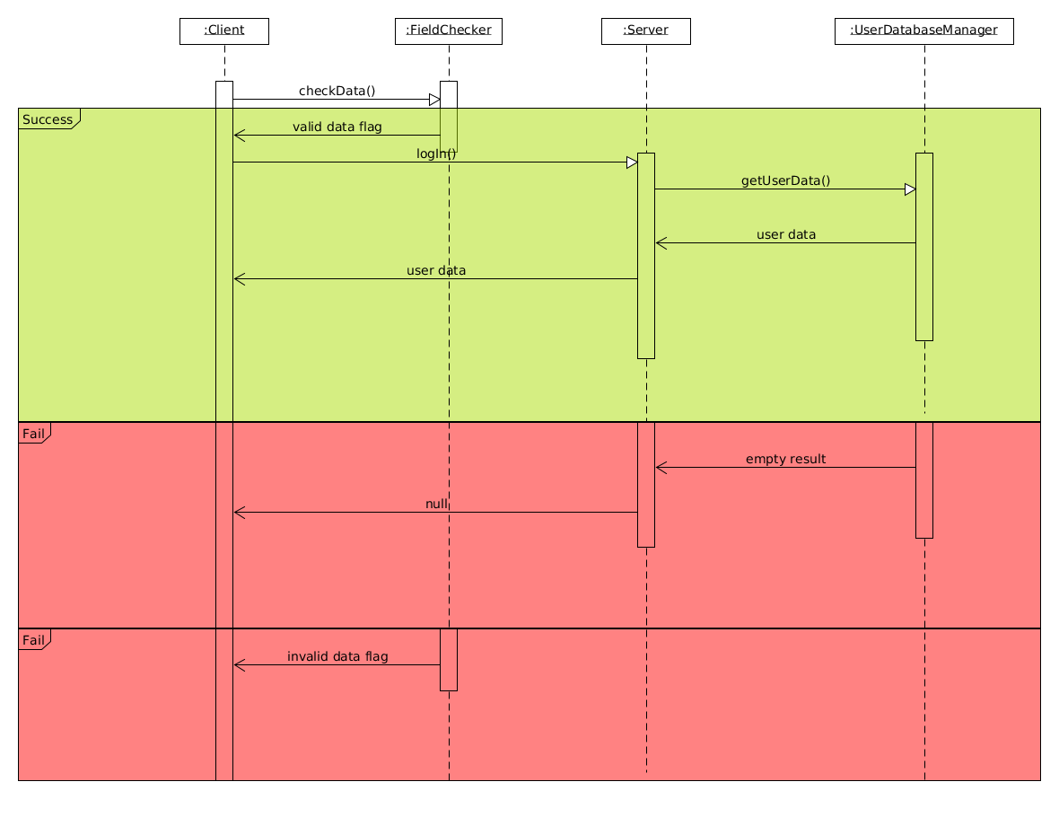
Log In Sequence Diagram

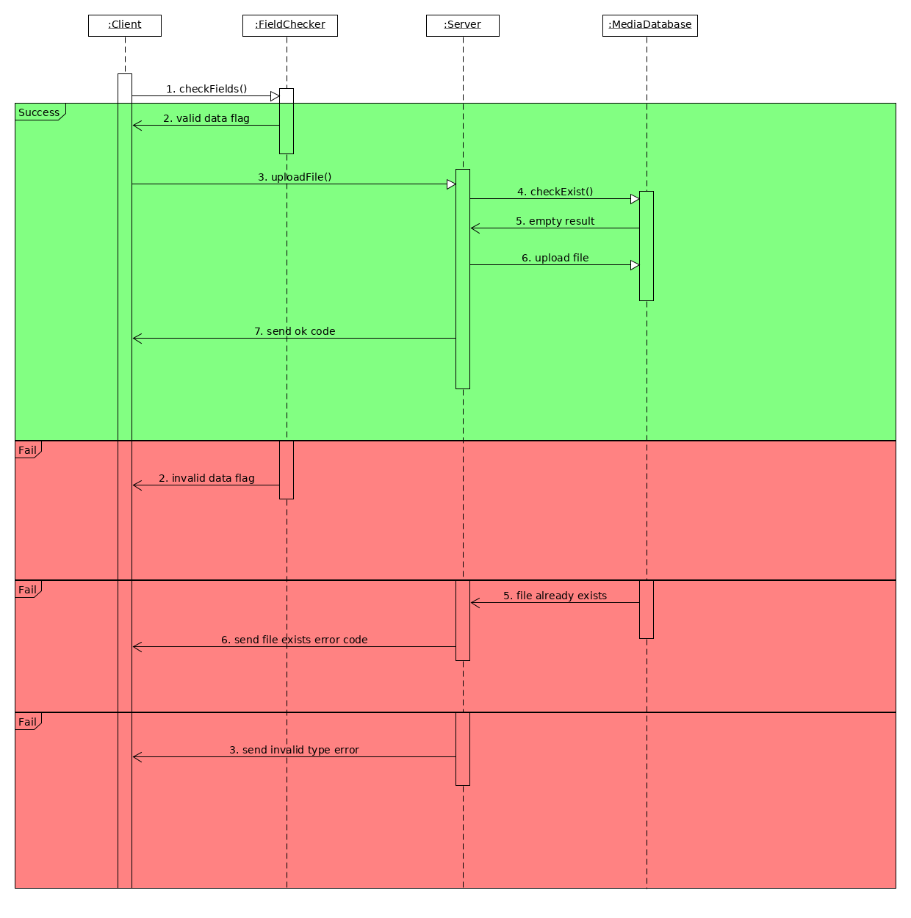
Upload Media communications diagram

Class Design
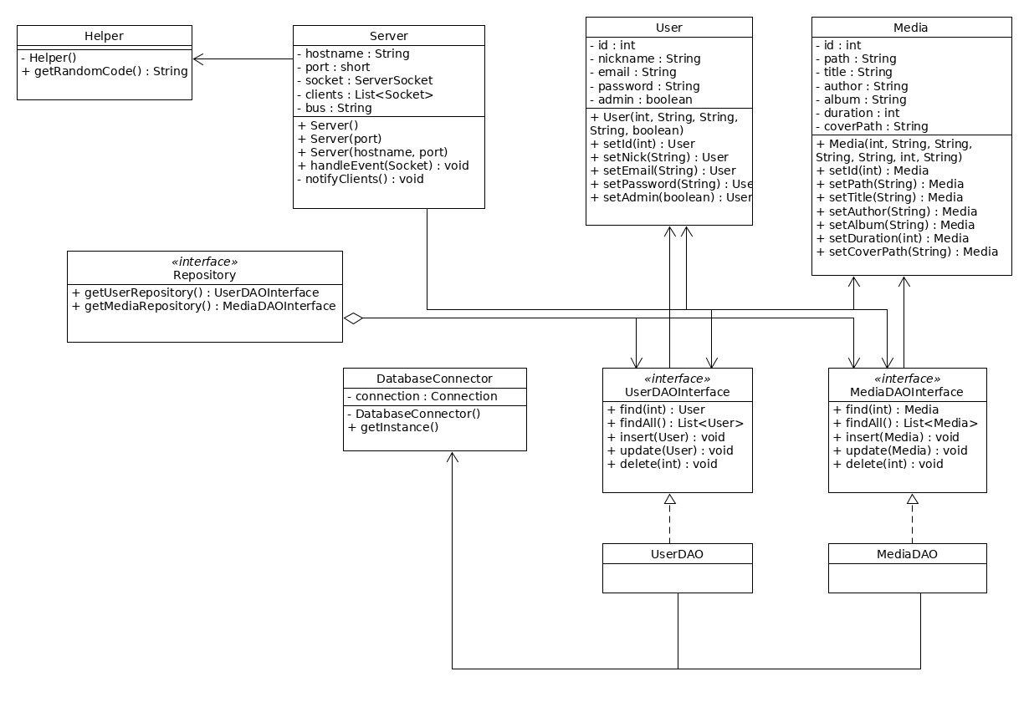

Data Model
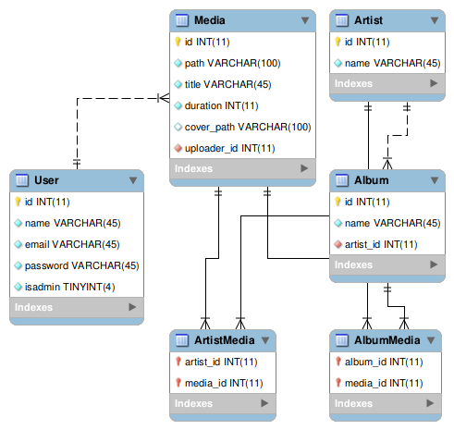

Unit Testing
In order to ensure the good functionality of the application, we could perform multiple tests:
- provide invalid login data and see how the system reacts
- provide valid login data and see how the system reacts
- attempt to upload a non-media file (eg. text)
Although some features that require validation can be tested, there are some things that cannot be validated in any way, due to the high difficulty of the user to calculate the results ahead (eg. room code generation).

Elaboration – Iteration 2

Architectural Design Refinement
The application will be implemented using the Model – View – Controller architectural pattern. This way, it becomes easier to differentiate tasks performed by various components of the server, and also the views on the client side and their representation on the server.

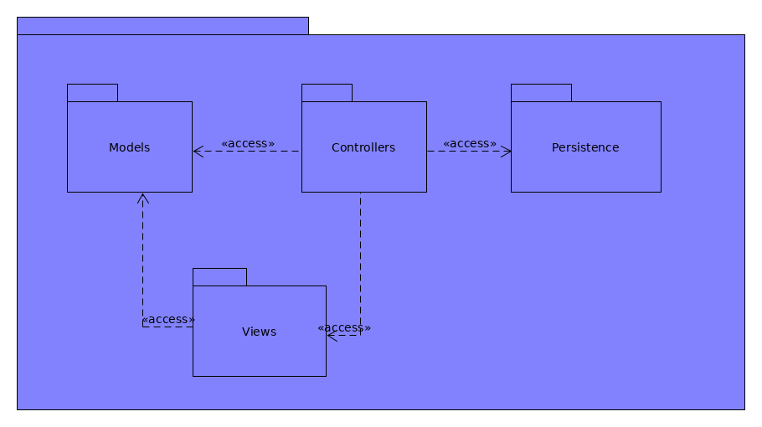
Package diagram

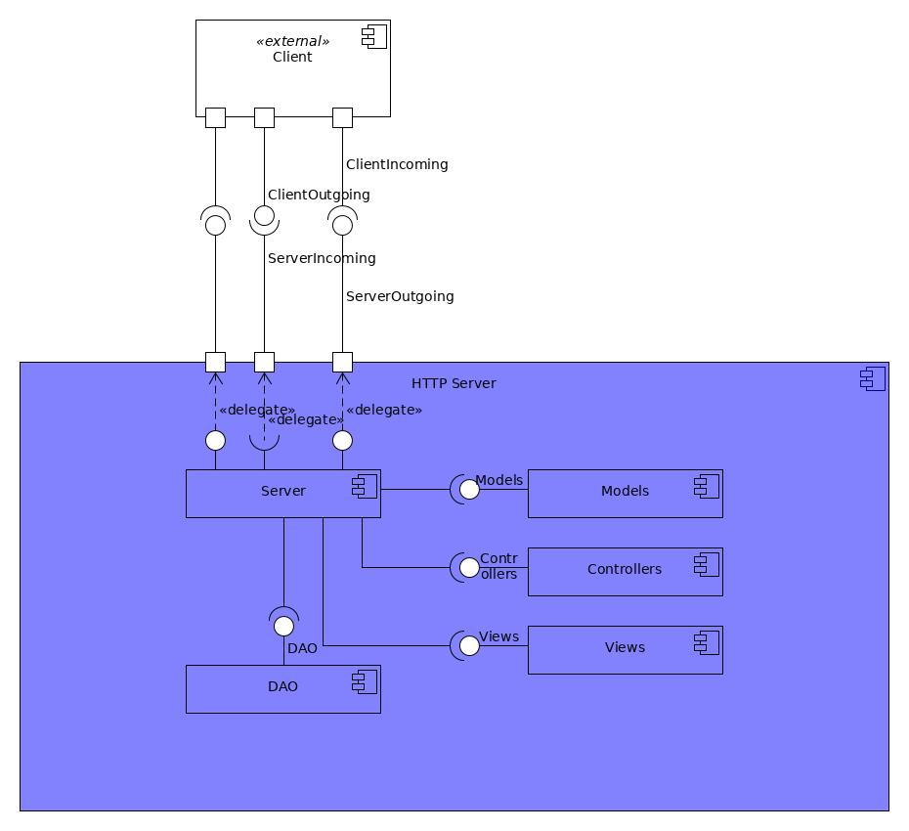
Component diagram

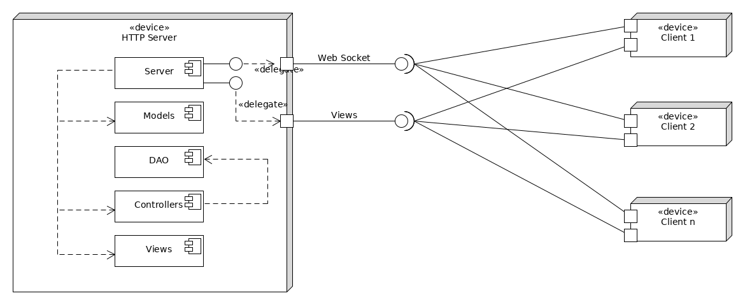
Deployment diagram

Design Model Refinement
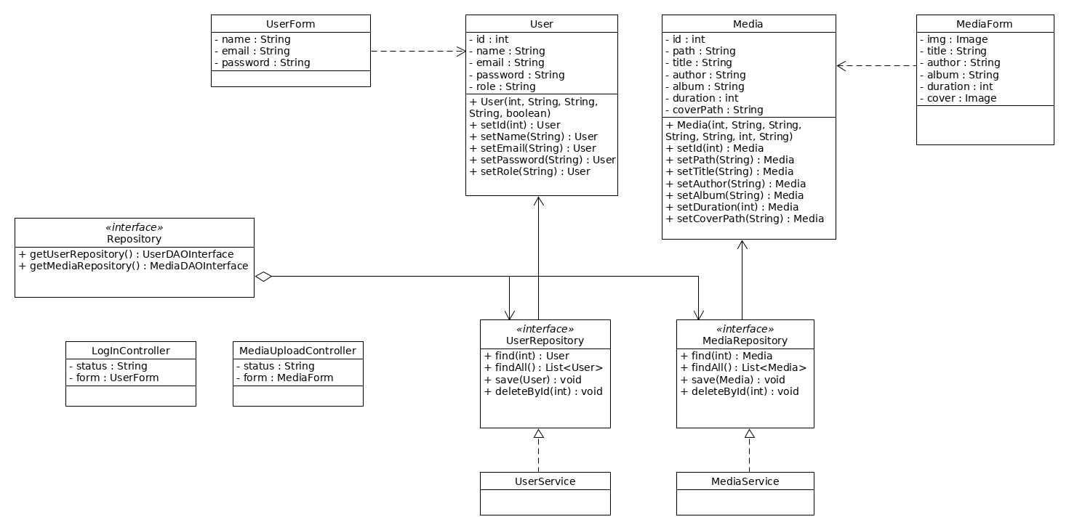

Construction and Transition

System Testing
Each feature has been tested using a web browser. Some of the cases include:
- Invalid login credentials
  - Access the main server
  - Enter wrong login credentials (eg. password with less than 8 characters)
  - Get redirected to the login page
- Invalid room id
  - Access the create chat feature
  - Enter an invalid room id
  - Get redirected to the previous page

Future improvements
Some possible improvements include:
- View the number of people inside a room
- Room chat
- 3rd party service support (eg. YouTube, DailyMotion etc.)
- Better UI

Bibliography
https://sourcemaking.com/
https://spring.io/guides/
http://mkyong.com/tutorials/spring-boot-tutorials/

