CHAROTAR UNIVERSITY OF SCIENCE & TECHNOLOGY
Faculty of Technology & Engineering
Devang Patel Institute of Advance Technology and Research (DEPSTAR)
Advanced Web Development and Frameworks (ITUE301)
Practical File – ODD Semester 2025–26
Student ID: 24DIT020
Student Name: Gondha Stuti

PRACTICAL 2: State Management and Routing in React
Problem Definition:
• Extend the portfolio application from Practical 1 by adding React
Router.
• Implement a navigation bar with at least 3 routes: Home, Projects, and
Contact.
• Each route must render a distinct component without a full page reload.
• Add at least 2 useState variables used meaningfully one for toggling UI
visibility and one for managing a form input on the Contact page.
• The Contact page must include a controlled input that captures and
displays user input in real time.
Solution:
Home.jsx:
function Home() {
return (
<section className="page-card hero-section">
<p className="eyebrow">Welcome</p>
<h1>Student Portfolio</h1>
<p className="intro">
I am building thoughtful and responsive web experiences with a strong focus on clarity,
design, and clean user interfaces.
</p>
<div className="pill-row">
<span className="pill">HTML</span>
<span className="pill">CSS</span>
<span className="pill">JavaScript</span>
<span className="pill">React</span>
</div>
</section>
);
}

export default Home;
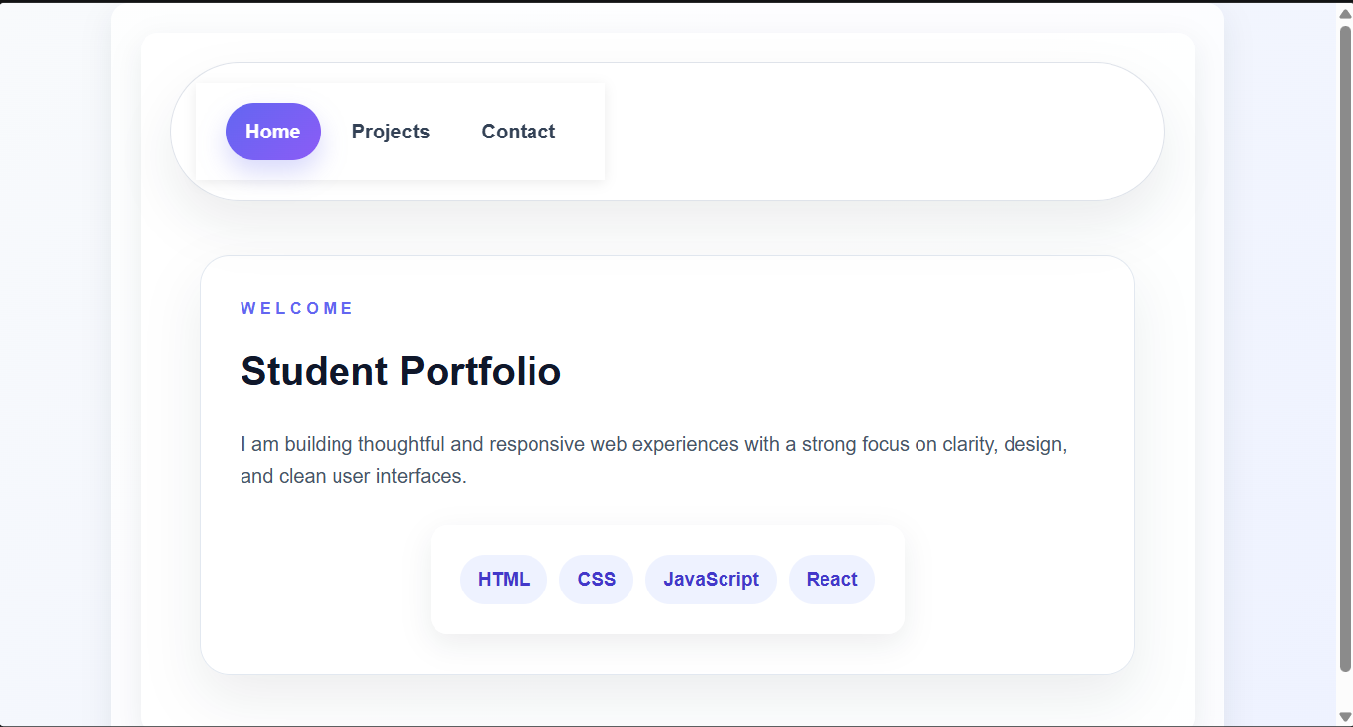

Projects.jsx:
function Projects() {
return (
<section className="page-card">
<p className="eyebrow">Projects</p>
<h2>Featured work</h2>
<div className="project-grid">
<article className="project-card">
<h3>Portfolio Website</h3>
<p>A clean personal site designed to present projects and contact information clearly.</p>
</article>

</div>
</section>
);
}

export default Projects;
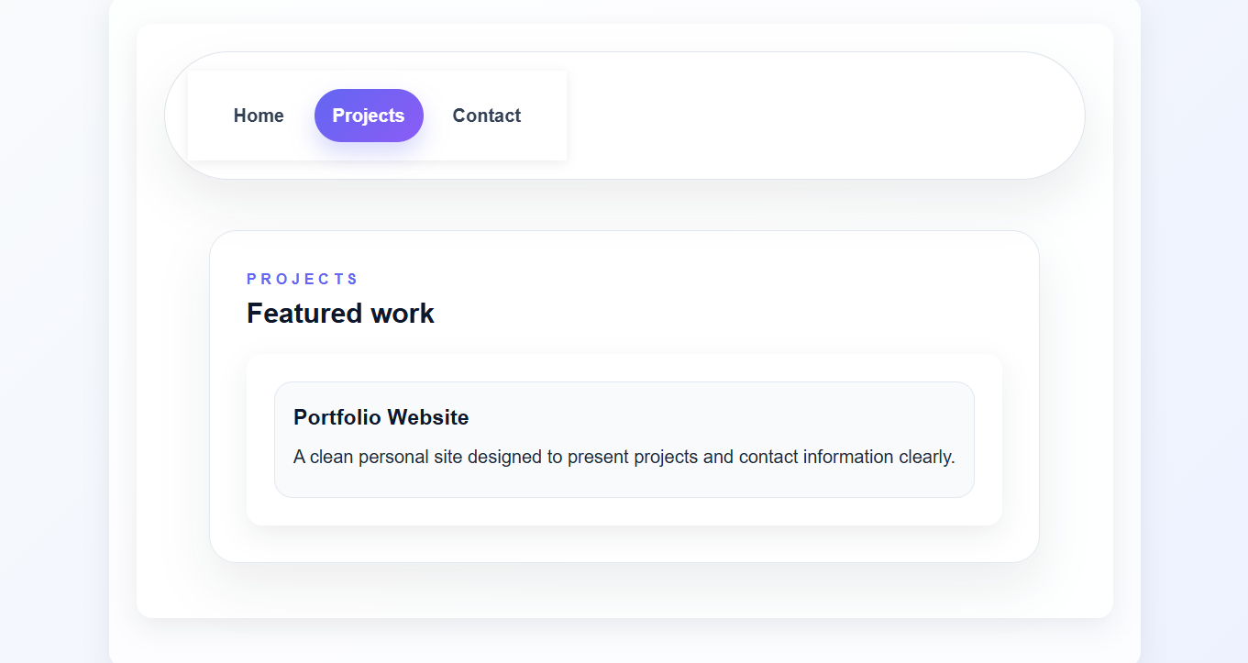

Contact.jsx:-
import { useState } from 'react';

function Contact() {
const [message, setMessage] = useState('');

return (
<div>
<h2>Contact Me</h2>
<input
id="message"
type="text"
value={message}
onChange={(e) => setMessage(e.target.value)}
placeholder="Type your message..."
/>
<p>{message}</p>
<p>character Count={message.length}</p>
</div>
);
}

export default Contact;
