CHAROTAR UNIVERSITY OF SCIENCE & TECHNOLOGY
Faculty of Technology & Engineering
Devang Patel Institute of Advance Technology and Research (DEPSTAR)
Advanced Web Development and Frameworks (ITUE301)
Practical File – ODD Semester 2025–26
Student ID: 24DIT020
Student Name: Gondha Stuti

Practical 4: Building a RESTful API with Node.js and Express
Project Definition:
Build a Node/Express backend for a Task Management system.
Implement REST endpoints for creating, reading, updating, and
deleting tasks (in-memory array, no database yet).
Apply a request logging middleware that logs method, URL, and
timestamp for every incoming request.
Apply a global error handling middleware as the last middleware in the
pipeline.
Use correct HTTP status codes (200, 201, 404, 500) for each response.

Code:
const express = require("express");

const app = express();
const PORT = 3000;

app.use(express.json());

let tasks = [];

app.use((req, res, next) => {
console.log(
`${new Date().toLocaleString()} | ${req.method} | ${req.url}`
);
next();
});

app.get("/tasks", (req, res) => {
res.status(200).json(tasks);
});

app.post("/tasks", (req, res) => {

const task = {
id: Date.now(),
title: req.body.title,
completed: false
};

tasks.push(task);

res.status(201).json(task);

});

app.put("/tasks/:id", (req, res, next) => {

const id = Number(req.params.id);

const task = tasks.find(t => t.id === id);

if (!task) {

const err = new Error("Task Not Found");
err.status = 404;
return next(err);

}

task.title = req.body.title || task.title;

if (req.body.completed !== undefined)

task.completed = req.body.completed;

res.status(200).json(task);

});

app.delete("/tasks/:id", (req, res, next) => {

const id = Number(req.params.id);

const index = tasks.findIndex(t => t.id === id);

if (index === -1) {

const err = new Error("Task Not Found");
err.status = 404;
return next(err);

}

tasks.splice(index, 1);

res.status(200).json({
message: "Task Deleted"
});

});

app.use((err, req, res, next) => {

res.status(err.status || 500).json({

error: err.message || "Internal Server Error"

});
});

app.listen(PORT, () => {

console.log(`Server running at http://localhost:${PORT}`);

});

GET:
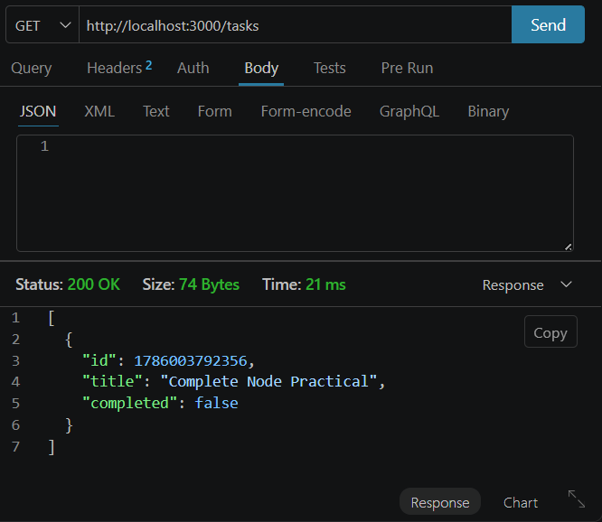
POST:

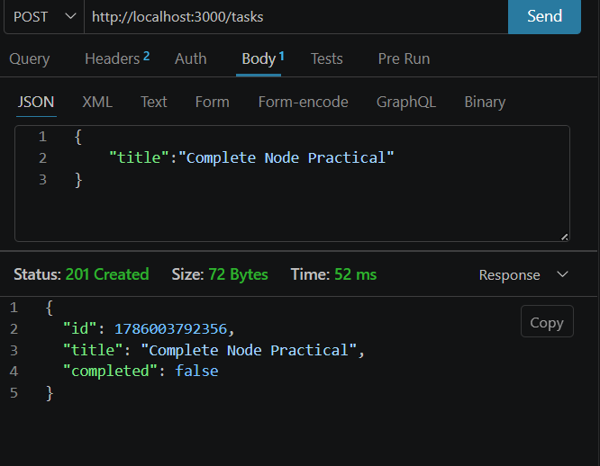

PUT:
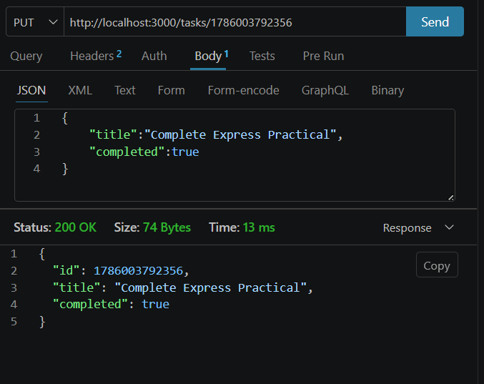
DELETE:

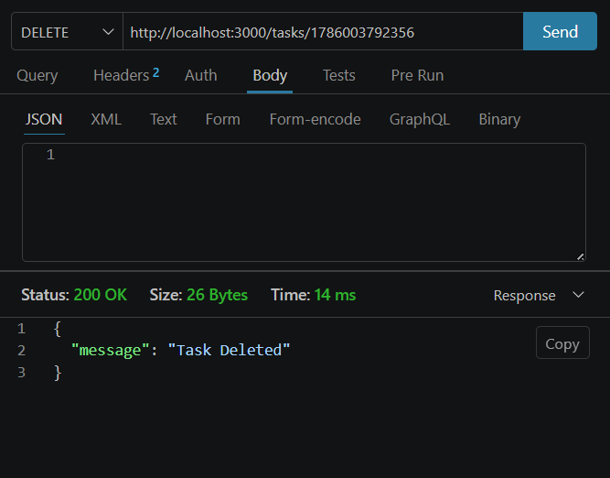

Supplementary Problem:
Add a 404 handler for undefined routes that returns a structured JSON
response.
