IOT for Smart Cities

By
Stuti B Prajapati
Exam No:
A
Report
Submitted in partial fulfillment of the requirement for
US06CBCA26-Current Trends in IT LAB
Subject
of
BCA Semester- VI
Sardar Patel University
March, 2023

VP & RPTP SCINCE COLLEGE
Sardar Patel University

CERTIFICATE

This is to certify that the content in this report titled “IOT for Smart Cities” was complied by Stuti B Prajapati [Seat no] at VP & RPTP SCINCE COLLEGE for partial fulfillment of the subject US06CBCA26-Current Trends IT Lab of BCA Semester VI of Sardar Patel University.

This report is prepared as per the guidelines.

Date:
Place:

Signature of Student Signature of Subject Teacher

Signature of Head of Institute

Seal of Institute

Acknowledgement
This project work has been the most practical and exciting part of what we learning experience, which would be an asset for our future career.

This project is complete after hardworking of Stuti B Prajapati .So I also thankful each other for better co-ordination and hardworking. The project was started during the month of December 2022 and completed in the March 2023.

I would like to thank VP & RPTP Science College for providing computer Lab and proper environment to develop the application.

Our sincere thanks to our principal Piyush A Lashakari for mounding our thoughts and vision and vision thoughts towards all the subjects, we were studying in all these three years.

I also thankful to…………………………….. (Head of the BCA Department VP & RPTP Science College) for providing me facilities and knowledge. I also thankful for inspiration given by them.

I would like to thankful to …………………………. who provided us expert guidance and inspiration during all phase of this project as my project guide. His guidance and suggestion have been a source of inspiration and helpful in refining my thinking and approaches during the project time.

I also greatly thankful to the entire B.C.A department who has helped us in completion of this project directly or indirectly.

Stuti B Prajapati

Abstract
The new Internet of Things (IOT) applications are enabling smart city initiative worldwide. It provides the ability to remotely monitor, manage and control devices, and to create new insights and actionable information from massive streams of real-time data. Internet of things (IOT) is a system that integrates different devices and technologies, removing the necessity of human intervention. This enables the capacity of having smart cities around the world. The explosive growth of smart city and internet of things applications creates many scientific and engineering challenges that call for ingenious research efforts from both academia and industry, especially for the development of efficient, scalable and reliable smart city based on IOT.

Index
Sr.no | Content | Page. no
1. | Introduction. | 1
2. | What is an Internet Of Things (IOT)? | 2
3. | What is Smart Cities? | 3
4. | Why Do We Need Them? | 4
5. | Components Of Smart Cities. | 5
6. | Smart City Development Framework | 6
7. | How Smart Cities Work? | 7
8. | Why Smart Cities are Important? | 8
9. | Smart City Features. | 9
10. | Table of Contents. | 10
10.1 | Smart Parking Management System. | 10
10.2 | Smart Traffic Management System. | 16
10.3 | Smart Street Lights Management System. | 22
11. | Advantages & Disadvantages of Smart city. | 28
12. | Smart City Challenges. | 30
13. | Conclusion. | 31
14. | Reference. | 32

1. Introduction
The Internet of things (IOT) is changing the way we do business, with a tremendous impact on the world around us. The growth of IOT technologies and business models is transforming cities in various ways, from improving public safety to creating smarter cities.
Smart cities use a variety of software, user interfaces and communication networks alongside the Internet of Things (IOT) to deliver connected solutions for the public. Of these, the IOT is the most important. Smart cities use IOT devices such as connected sensors, lights, and meters to collect and analyze data. The cities then use this data to improve infrastructure, public utilities and services, and more. Smart city devices work to make everyday tasks easier and more efficient, while relieving pain points related to public safety, traffic, and environmental issues.

1
2. What is an Internet of Things (IOT)?
The Internet of Things (IOT) describes the network of physical objects—“things”—that are embedded with sensors, software, and other technologies for the purpose of connecting and exchanging data with other devices and systems over the internet.
The Internet of Things is a network of physical objects that are connected to the Internet so that they can exchange data and information in order to improve productivity, efficiency, services, and more.
IOT technology can be found in a growing number of places, including industry, enabling the concept of a smart home to become a reality, and even to assist the infrastructure of an entire smart city.
IOT stands for Internet of Things. It refers to the interconnectedness of physical devices, such as appliances and vehicles that are embedded with software, sensors, and connectivity which enables these objects to connect and exchange data.
This technology allows for the collection and sharing of data from a vast network of devices, creating opportunities for more efficient and automated systems.

2
3. What is Smart Cities?
There is no only one definition of smart city broadly it is desire to provide good infrastructure services to the citizens of the city.
A technology-intensive city, with sensors everywhere & highly efficient public services by gathering information in real time by all interconnected devices.
Ex: Smart Dustbins, Smart Traffic Signal.
Smart city provides a good relation between citizens & government using available technologes.The relations between them is maintained by a good feedback system of to create mechanism to gather the information improve services delivery.
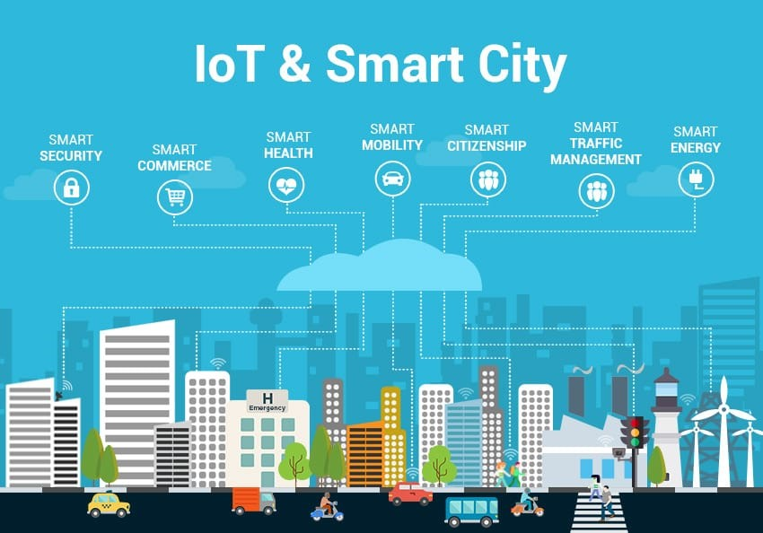
Figure 3.1: IOT & Smart City

3
4. Why do we need them?
A smart city should provide an urban environment that delivers a high quality of life to residents while also generating economic growth. This means delivering a suite of joined-up services to citizens with reduced infrastructure costs.
This becomes increasingly important in the light of the future population growth in urban areas, where more efficient use of infrastructure and assets will be required. Smart city services and applications will allow for these improvements which will lead to a higher quality of life for citizens.
Smart city improvements also provide new value from existing infrastructure while creating new revenue streams and operational efficiencies to help save money for governments and citizens alike.

4

5. Components of Smart Cities

- Smart Parking.
- Smart Traffic.
- Smart Street Lights.
- Smart Waste Management.
- Smart Meters & Billing.
- Public Transport.
- Environment.
- Public Safety.
- Smart Agriculture.
- Smart Homes.
- Smart Industry.
- Smart Infrastructure.
- Smart Road.

5

6. Smart City Development Framework
- Smart Government Road Map: Understanding the existing infrastructure. Setting a path towards a smart cities model for the next five or ten years.
- Identification Of City Priorities: Interactive session with main stakeholders.
- CO-Creating Solutions: Based on the problem statements identified before, cities should conduct hackathon & app challenges.
- Urban Innovation lab: Space to facilitate ongoing interaction between all stockholders where new ideas & solution can be tested.
- Networked cities: cities should make a network to share application & practices.

6

7. How Smart Cities Work?
Smart cities follow four steps to improve the quality of life and enable economic growth through a network of connected IOT devices and other technologies. These steps are as follows:
1. Collection – Smart sensors gather real-time data.
2. Analysis – The data is analyzed to gain insights into the operation of city services and operations.
3. Communication – The results of the data analysis are communicated to decision makers.
4. Action – Action is taken to improve operations, manage assets and improve the quality of city life for the residents.
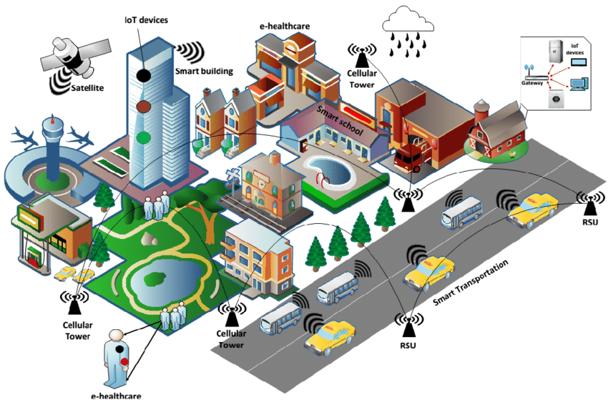
The ICT (Information and communication technology) framework brings together real time data from connected assets, objects and machines to improve decision making. However, in addition, citizens are able to engage and interact with smart city ecosystems through mobile devices and connected vehicles and buildings. By pairing devices with data and the infrastructure of the city, it is possible to cut costs, improve sustainability and streamline factors such as energy distribution and refuse collection, as well as offering reduced traffic congestion, and improve air quality.
Figure 7.1: Smart Cities Work

7
8. Why Smart Cities Are Important?
54% of the world’s populations live in cities and this is expected to rise to 66% by 2050, adding a further 2.5 billion people to the urban population over the next three decades. With this expected population growth there come needs to manage environmental, social and economic sustainability of resources.
Smart cities allow citizens and local government authorities to work together to launch initiatives and use smart technologies to manage assets and resources in the growing urban environment.

8
9. Smart City Features
Combining automation, machine learning and the IOT is allowing for the adoption of smart city technologies for a variety of applications. For example, smart parking can help drivers find a parking space and also allow for digital payment.
Another example would be smart traffic management to monitor traffic flows and optimize traffic lights to reduce congestion, while ride-sharing services can also be managed by a smart city infrastructure.
Smart city features can also include energy conservation and environmental efficiencies, such as streetlights that dim when the roads are empty. Such smart grid technologies can improve everything from operations to maintenance and planning to power supplies.
Smart city initiatives can also be used to combat climate change and air pollution as well as waste management and sanitation via internet-enabled rubbish collection, bins and fleet management systems.
Aside from services, smart cities allow for the provision of safety measures such as monitoring areas of high crime or using sensors to enable an early warning for incidents like floods, landslides, hurricanes or droughts.
Smart buildings can also offer real-time space management or structural health monitoring and feedback to determine when repairs are necessary. Citizens can also access this system to notify officials of any problems, such as potholes, while sensors can also monitor infrastructure problems such as leaks in water pipes.

In addition, smart city technology can improve the efficiency of manufacturing, urban farming, energy use, and more.

9

10. Table of contents

  - Smart Parking
  - Smart Traffic
  - Smart Street Lights

10.1 Smart Parking Management System

- What is Smart Parking management System?

Smart Parking is based on IOT (Internet of Things) and AI (Artificial Intelligence) technologies. It gives access to real-time parking occupancy and parking availability, predicts peak and non-peak times, makes dynamic pricing according to congestion and provides parking operators with big real-time data and reporting. Smart parking system using IOT has smart phones and other sensors added into an interconnected system to determine parking space or level and provide real-time feedback. It is accomplished by using cameras, counters on the doors or gates of parking lots, sensors embedded in the paved area of ​​individual parking lots, among other locations, depending on the deployment.

Smart parking systems are starting to offer solutions for urban mobility. This is a system which, thanks to the Internet of Things and sensor technology, allows real-time data to be obtained about parking availability, both outside and inside, and regarding traffic and road conditions.

The system’s hardware features sensors that detect available parking slots and communicate this information to all drivers in the area. This data is updated in real-time, which means drivers never have to worry about not finding an available space.
In addition to helping drivers find a spot, the system also sends alerts about peak times and peak prices. The goal of these alerts is to help save drivers money while also reducing congestion.

10
- Why IOT Based Smart Parking System Is Needed?
The demand for parking is ever-growing, and with cars becoming more fuel-efficient, the number of vehicles will continue to increase. As a result, there are fewer available parking spaces.
Smart parking systems solve the problem of finding an available spot by providing drivers with information about available spots near them. Drivers can also use the system remotely via their smart phone to find a space before arriving at the parking lot.
These systems help drivers to find an available spot faster and more easily than traditional methods like circling around or waiting for someone to leave. By leveraging this technology, drivers can avoid wasting time looking for a space.

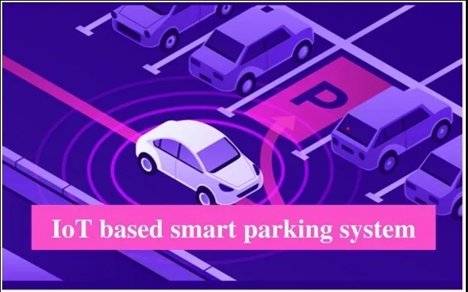Figure 10.1.1: IOT based Smart Parking System

11
- Architecture of Smart Parking System
- Parking Sensors: The role of the parking sensors is tracking space in the parking IOT. Ultrasonic sensors are used to detect the presence of vehicles.
- Processing Unit: The processor-on-a-chip acts as a central point between the sensors and the cloud platforms, relaying data to and from.
- Mobile Application: It is a visual interface for end-users to interact with the smart parking system.
- The cloud: The cloud serves as a repository for all records related to parking spaces and end-user that have access to the system.
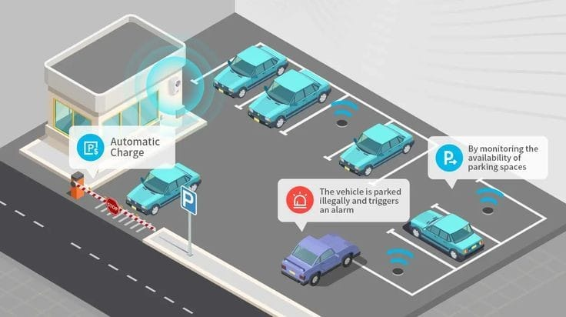
Figure 10.1.2: Architecture of Smart Parking
12
- Smart Parking Technology
Various devices and processes form the structure of smart parking, acting as parking space detectors. On the one hand, the deployment of sensors and/or cameras, which record and process data and images to provide real-time traffic occupancy data for the area we are heading to.
An IOT cloud-based system, on the other hand, allows these devices to be connected and the data to be centralized. The data are then analyzed using big data in order to calculate the availability of on-street parking spaces or spaces in public and private parking facilities.

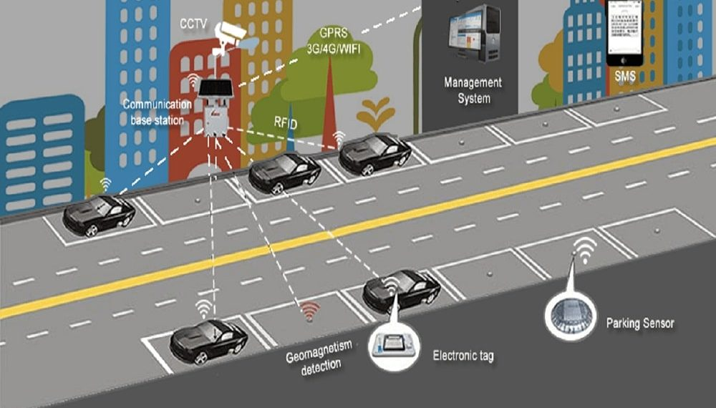
Figure 10.1.3: Smart Parking Technology

Smart parking maps

If we want even more accurate information about how likely we are to find an on-street parking space, we don't always have to use an app. Functionalities already available on our devices such as Google Maps provide us with real-time traffic data and the likelihood of parking in these areas. These service and other maps update the information the closer we get to our selected destination.

13

Smart signage

Smart technologies are also being used in road-sign systems with the aim of increasing safety and helping to coordinate pedestrian and vehicle traffic more efficiently. Examples include traffic lights and pedestrian crossings that change color or light up depending on real-time or estimated traffic volumes, such as peak hours.

Smart detectors for vehicles

Knowing exactly how many vehicles are located in a parking lot at any given time is the basis of smart parking. This car parking monitoring system is made up of sensor systems including dual channel loop detectors, ultrasonic vehicle presence sensors or LiDAR vehicle sensors. They detect whether the parking space is free/occupied, they identify if a parking garage is full and provide an accurate location of vehicles, respectively.

Sensors to detect parking spot occupancy
In this case, these sensors detect available parking spaces, facilitating the task for drivers looking for vacant parking spots in closed spaces. Thanks to the incorporation of LED indicators, drivers can see how many parking spaces are available, with red or green light signs indicating whether the parking space is currently used or is free for parking.
- Advantages of Smart Parking System
- Saves fuel.
- Saves time.
- Less traffic on road.
- Easy payment option.
- Disadvantages of Smart Parking System
- Limited privacy.
- Social control.
- Excess network trust.
14
- Future of smart parking System
The parking industry is in the midst of a transformation. Rapid technological advances are enabling a new breed of parking solutions that are more efficient, convenient, and sustainable. Cities and parking managers from across the globe are well aware of how vital smart parking is. Much other technological advancement will be crucial for this upcoming generation of parking facilities.

15
10.2 Smart Traffic Management System
- What is Smart Traffic management system?
A smart traffic management system utilizing sensor data, communication and automated algorithms is to be developed to keep traffic flowing more smoothly. The aim is to optimally control the duration of green or red light for a specific traffic light at an intersection. The traffic signals should not flash the same stretch of green or red all the time, but should depend on the number of cars present. When traffic is heavy in one direction, the green lights should stay on longer; less traffic should mean the red lights should be on for longer time interval. This solution is expected to eliminate inefficiencies at intersections and minimize the cost of commuting and pollution.
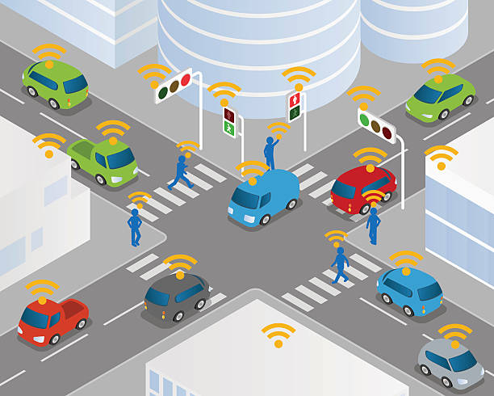
Traffic management is one of the biggest infrastructure hurdles faced by developing countries today. Developed countries and smart cities are already using IOT and to their advantage to minimize issues related to traffic. The culture of the car has been cultivated speedily among people in all types of nations. In most cities, it is common for people to prefer riding their own vehicles no matter how good or bad the public transportation is or considering how much time and money is it going to take for them to reach their destination.
Figure 10.2.1: Smart Traffic Management System
16
- Components of Smart Traffic
- LEDS: LEDS are used for the purpose of signaling according to the traffic condition.
- IR Sensor: IR Sensor is used to count the vehicles on the road.
- Jumper Wires: It is used to connect the components to each other.
- Intelligent traffic management with the help of IOT technology
IOT traffic management systems are automated systems that incorporate the latest advances in IOT technology. Each IOT platform has its own set of unique features and mechanisms. Specifically, for Smart traffic management system, it offers:
- Data warehouse and data access.
- Communication, coordination, and device control capabilities.
- Deploy cloud and software for connected devices.
- And all the necessary infrastructure for all of the above.
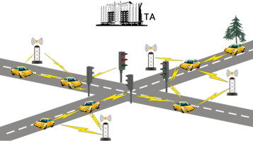

Figure 10.2.2: Smart Traffic Signals

17
- How Smart Traffic System work?
Intelligent Transportation Systems can help solve the traffic problem by integrating IOT technology with existing infrastructure. Take, for example, an IOT-based smart traffic signal monitoring system.
It relies on a priori information provided by the IOT sensors and adjusts the traffic signals so that the time interval depends on the number of vehicles on that particular part of the road. The main advantage of this system is that it can reduce downtime and traffic density in various areas. Some of the key functionalities that cities acquire through these systems include the following:
- Traffic jam detection: With cameras and sensors constantly monitoring intersections, technicians can monitor all streets in a town from the city’s traffic control center.
- Adaptive control: Congestion detection leads to dynamic systems adjustments, including traffic lights, entry alarms, and express bus lanes.
- Interaction with connected cars: Smart Traffic Management can connect roadside devices to them to enable intelligent vehicles to communicate directly with intersections.
- Emergency routing: A critical application of a smart traffic system using IOT is providing priority access to police, fire, and ambulance services.
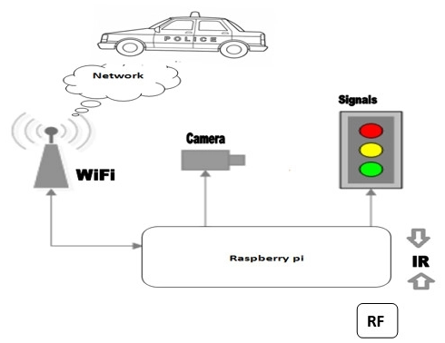
Figure 10.2.3: Work Process of Smart Traffic Signals

18

Advantages of Smart Traffic System

Safe travel

The ability to track metrics such as train speed, carriageway temperature, or the number of vehicles at an intersection using IOT technology can help improve the safety of transportation systems around the world.

Efficient processes
Municipalities and organizations adopting IOT technologies are reaping significant productivity benefits. They can better monitor critical infrastructures and design efficient processes to minimize operating costs and increase system throughput.

Improving the environment
IOT-enabled systems can quickly respond to changing traffic patterns and return real-time data to help drivers plan their journeys better with better congestion monitoring. Reducing congestion and energy consumption has a positive impact on the environment.

- Disadvantages of Smart Traffic System
- Expensive.
- Not practical for all roads.
- Perceived by some as a way of raising funds.
- Less or no effect beyond the camera.
- Need regular maintenance.

19
- Challenges of integrating IOT in the traffic management system

Additional security requirements
As the number of IOT devices connecting to the central network grows, its vulnerability increases the likelihood of hacker attacks to take over confidential data. Therefore, any traffic management solution must have a basic and an additional level of security. Typically, that data transmission encryption, user access control, and device authentication.

The need for high-tech network infrastructure

All high-tech solutions require high-speed data transfer methods. Since IOT solutions involve working with large amounts of data and many IP addresses, network facilities must maintain constant communication and collect data from sensors and other IOT devices. Thus, to operate efficiently, you need strong networks that can meet the needs of the Internet of Things as they evolve.

Time spent on adaptation
The IOT-based intelligent traffic management system includes thousands of sensors and devices, and it is impossible to manage all of these endpoints manually. A digital traffic solutions provider must provide an intuitive IOT traffic control system with an automatic connection and a centralized control panel.

Additional investment
As mentioned above, the implementation of IOT technology in the long term reduces costs and optimizes the operations of any organization. But the initial integration requires investment.
These are the costs associated with the network infrastructure, the modernization of vehicles directly connected to the IOT solution, and the planning, implementation, management, and security of IOT systems. Therefore, many customers immediately submit IOT development on outsourcingtoUkraine, known for its pool of talented programmers and quality solutions at a fair price.

20
- Future of smart Traffic
For future directions, different priority levels for multiple incidents and scenarios can be considered. The main issue with IOT is that the security of the entire system have to be concentrated on and not a particular IOT layer, device or software. Hence, integrating the entire traffic management system with multiple layer security for various data generated from various sources can be another subject of future scope. Along with that an emergency signal for an emergency vehicle (such as an Ambulance) can also be included in order to serve them better.

21

10.3 Smart Street Lights
- What is Smart Street Light?
A smart streetlight is a public lighting fixture that incorporates technology, such as cameras, light-sensing photocells and other sensors, to introduce real-time monitoring functionalities. Also referred to as adaptive lighting or intelligent street lighting, this type of lighting system is recognized as a significant step in the development of smart cities.
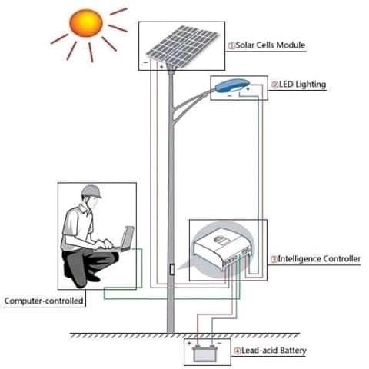
In addition to enabling cities to provide the proper amount of street light for local conditions, installing intelligent lighting will help improve citizen satisfaction regarding security and safety, while bringing municipalities’ significant savings in power consumption and lighting system maintenance. Plus, outdoor lighting infrastructure will serve as a backbone for a number of internets of everything (IOE) applications, such as monitoring weather, pollution and traffic.

Figure 10.3.1 Smart Street Lighting
22

How Smart Street lights work?
The technology behind smart streetlights can vary depending on its features and requirements, but typically, it involves a combination of cameras and sensors. When implemented on standard streetlights, these devices can detect movement that enables dynamic lighting and dimming.

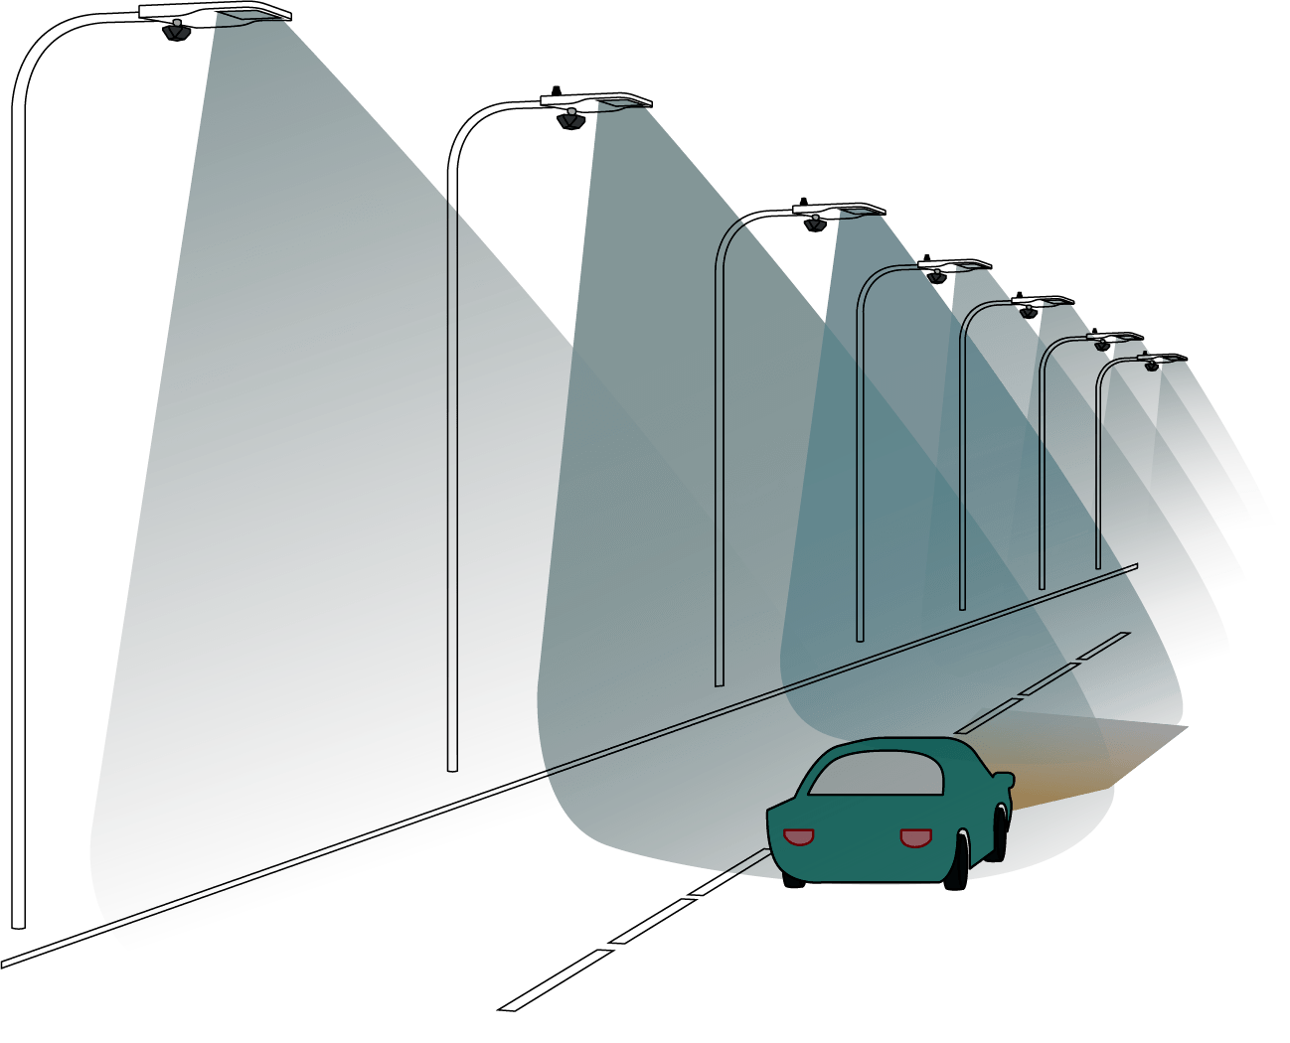

Figure 10.3.2 Work Process of Smart Street Lighting

23
- Challenges of Smart Street Light
Faulty lights: Often, there is no standard idea about how many faulty lights are in the area. The next problem is that there is no data to know which lights work or which not. There is a good possibility that a particular manufacturer is not suitable as a specific brand could be inexpensive to get but they have a high failure rate. Hence, the lack of standard data and analytics causes inconvenience.
Electricity theft: Electricity theft is a massive obstacle in many countries. There is no data on how much electricity each light consumes, or in a broader stage, also how much a phase consumes; there is no way of identifying if there is a leak somewhere in the line. However, this can address analytics and IOT based remote monitoring solutions, which will provide the government to see how much electricity is being siphoned off by illegal practices.
Unnecessary usage: For many countries, it is quite common to view street lights working even during the day. This leads to the wastage of electricity. Yet again, to know how much energy is wasted and how it can be stopped, analytics is required.

- Solution of Smart Street Lights: An IOT-based solution like Smart Street Lights involves a combination of connectivity and sensors. When installed on standard streetlights, these devices can detect movement that facilitates dynamic lighting and dimming. The integration of controls, sensors, and connectivity enables smart street lights to make a self-adaptive distributed system that adjusts street lighting to the road’s changing conditions. The light controller can be instructed to manage the street light in varying forms as per traffic, time, and environmental circumstances. It also provides nearby fixtures to communicate with each other. If a pedestrian or car is discovered, all surrounding lights will shine till any movement is captured.

24
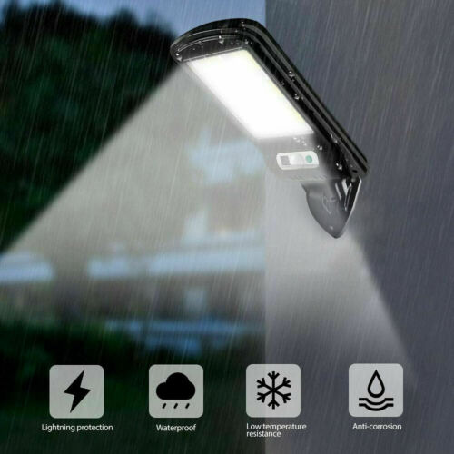
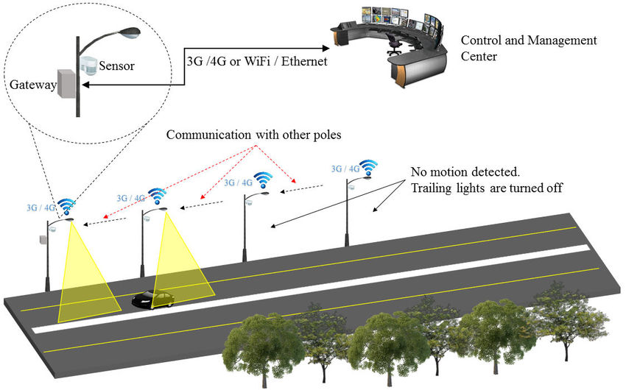
Figure 10.3.3 Solution of Smart Street Lights

Figure 10.3.4 Solution of Smart Street Lights

25

Features of smart streetlights
While the features of smart streetlights depend on the specific technology used by city planners, examples of common functionality include the following:
- Dynamic lighting controls based on movement detection.
- Environmental and weather monitoring.
- Digital signage that can update as needed, such as parking regulations or accident alerts.
- Parking management, such as alerting officials of illegally parked vehicles or drivers of open spaces.
- Extended cellular and wireless communications.
- Traffic management through real-time data feeds that track congestion and speed.
- Automatic emergency response in the event of a car crash or crime.
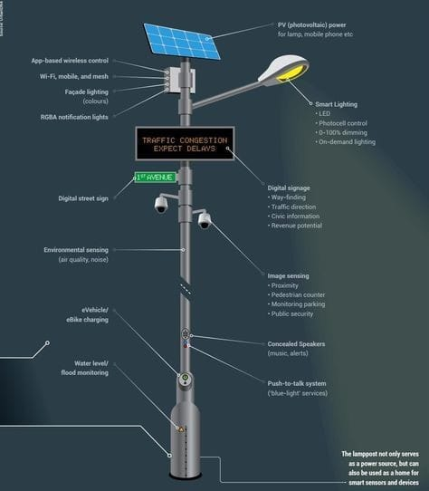

Figure 10.3.2 Work Process of Smart Street Lighting
26

Advantages of smart streetlights
- Reduced energy cost and usage with flexible dimming controls.
- Increased pedestrian satisfaction through improved safety measures.
- Lowered repair and maintenance costs with the monitoring software.
- Reduced carbon emissions and light pollution.
- Increased lamp life and shorter response times to outages.
- Improved architectural planning based on real traffic patterns and insights.
- Increased revenue opportunities, such as leasing poles for digital signage or other services.

Disadvantages of smart streetlights
- Despite the long-term value in upgrading lighting networks, there are a few challenges. Although smart streetlights save money over time, the initial investment is a large one. Street lighting costs can account for more than 40% of a city's energy costs -- although converting from halogen to basic LED luminaries yields up to 80% in instant savings.

- Future of Smart Street Light

- These smart lights will help cities reduce electricity costs, lower CO2 emissions, and improve maintenance.

With auto-dimming, scheduling, and a host of other capabilities, cities could see a 50-

75% reduction in energy costs via smart street lighting.

27

11. Advantages & Disadvantages of Smart City

- Advantages of Smart City
- Better transportation services: A smart city has the potential to drastically improve the current level of transportation throughout a city. It will have better traffic management, the ability to track public transportations and serve its citizens better with constant information and low prices.
- Safer Communication: A smart city will have the most technological advances and partnerships with the private sector will benefit society since there will be lesser criminal activity. The example of such technology is license plate recognition, connected crime centers, shooting detectors, better emergency services, and body cameras.
- Efficient public services: Since there are a limited number of natural resources left to meet the demand of the people, smart cities will have technologies and the necessary tools to cut down on our usage of natural resources and decrease waste of water, electricity, etc. without having to cut down on any factors.
- Reduced environmental footprint: A smart city has thousands of energy-efficient buildings that can improve the air quality, use renewable energy sources, and decrease the dependence on non-renewable energy sources. These will help to decrease the ecological impact we have on the environment.
- More digital equity: People must have access to high-speed internet services at affordable prices and devices. If they have access to public Wi-FI in local areas in the city, all residents will have equal opportunities.
- Economic development opportunities: Investing in smart cities will lead to improving their regional and global competitiveness and attract new residents and improve business. Since the entire city will have access to an open data platform, information, etc. companies will flourish. They can make informed decisions with the available technologies and lead to economic development.
- Improvement of infrastructure: Old roads, buildings, highways, bridges require massive investments to maintain their state and increase their useful life. But, with the help of smart technologies, cities will have the ability to analytically predict and identify the areas that can cause infrastructure failures before it occurs.
- Job opportunities: A smart city will have many businesses and job opportunities since the people will get equal access to basic resources such as transportation, internet connection, and job offers.
- Decrease of crime: Since the authorities can monitor the dealings of people closely with the help of technologies, there will be a reduced amount of crime. Besides, crime increases when there are fewer jobs and more unemployed people.

28
- Disadvantages of Smart City
Though Smart City has many advantages, there are some disadvantages. Knowing these can help one to understand the flip side of the coin. The disadvantages are as follows.
- Limited privacy: Since the authorities or the government will have access to security cameras and intelligent systems connected through many different spaces, the citizens will have difficulty in maintaining their anonymity. Facial recognition and such things will drastically change the concept of privacy or personal space.
- Social control: The people who can track and centralize the data they gather with security cameras will have greater power. It can be a government, a private agency, or other authorities. They will have the power to control a citizen’s data and can easily manipulate public opinions.
- Excess network trust: Since the citizen of these smart cities will rely almost entirely on electronics and networks, they will lose autonomy in their decision-making and could become incompetent. They would not be able to react appropriately in a scenario where these tools are not usable.
- Difficulty in the pre-commerce stage: Though money will be available, the smart technologies will be still in their pre-commercial stages. These cities will lack the technology-related skills and capacity.
- Pre-training is required: If the people of the city don’t know about technology, then they will not be able to use it. Without training, they will find it irrelevant to their daily lives and will find it difficult to utilize it.

29
12. Smart City Challenges
For all of the benefits offered by smart cities, there are also challenges to overcome. These include government officials allowing widespread participation from citizens. There is also a need for the private and public sectors to align with residents so that everyone can positively contribute to the community.
Smart city projects need to be transparent and available to citizens via an open data portal or mobile app. This allows residents to engage with the data and complete personal tasks like paying bills, finding efficient transportation options and assessing energy consumption in the home.
This all requires a solid and secure system of data collection and storage to prevent hacking or misuse. Smart city data also needs to be anonymized to prevent privacy issues from arising.
The largest challenge is quite probably that of connectivity, with thousands or even millions of IOT devices needing to connect and work in unison. This will allow services to be joined up and ongoing improvements to be made as demand increases.
Technology aside, smart cities also need to account for social factors that provide a cultural fabric that is attractive to residents and offer a sense of place. This is particularly important for those cities that are being created from the ground up and need to attract residents.

30
13. Conclusion
The “smartness” of a city describes its ability to bring together all its resources, to effectively operate with maximum possible efficiency to fulfill the purposes it has set itself. The smart city is a concept and a variety of definitions exist among academia and practitioners. A smart city can have one or more smart components, including smart transportation, smart grid, smart health care, and smart governance. The Internet of Things (IOT), cyber physical systems (CPS), and Big Data are key technologies in the context of information and communication technology (ICT) critical for the implementation of smart cities. The need for smart cities is increasing day by day with the increase of population as earthly resources are limited.

31
14. Reference
1. https://simplycoding.in/internet-of-things/
2. https://www.twi-global.com/technical-knowledge/faqs/what-is-a-smart- city#SmartCityDefinition
3. https://www.finextra.com/blogposting/17931/what-is-the-role-of-iot-in-smart-cities
4. https://www.scnsoft.com/blog/iot-for-smart-city-use-cases-approaches-outcomes
5. https://www.insiderintelligence.com/insights/iot-smart-city-technology/#:~:text=Smart%20cities%20use%20IoT%20devices,utilities%20and%20services%2C%20and%20more
6. https://www.airtel.in/blog/business/iot-based-smart-parking-system-a-step-towards-building-smart-city/
7. https://chintglobal.com/blog/iot-based-smart-parking-system/
8. https://nobelsystemsblog.com/smart-city-with-iot/

32

