**IML-CSL2010**

**PROJECT REPORT**

**Project Title: Stable Grasping**

Stuti Yadav - B23CH1044

**Introduction:**

This project focuses on building a Machine Learning model to predict the stability of a grasping robotic arm using sensor data from its joints. It explores the use of machine learning to predict the robustness of a shadow robot arm. Robustness refers to the robot's ability to maintain performance and stability under varying conditions.

**Motivation:**

The stability of robotic arm grasping is critical in various applications, including industrial automation, healthcare, and service robotics.

Ensuring that a robotic arm can securely grasp and manipulate objects without slippage or failure is essential for operational efficiency and safety. As robots are increasingly integrated into complex environments, the ability to predict and enhance grasp stability through machine learning (ML) becomes paramount.

This project focuses on developing an ML model that leverages sensor data from the joints of a robotic arm to predict the stability of its grasp. By analyzing data such as joint angles, torque, and position, the model can identify patterns that contribute to successful or unsuccessful grasps.

The choice of this project stems from the growing need for intelligent robotic systems that can adapt to varying object shapes, weights, and environmental conditions. 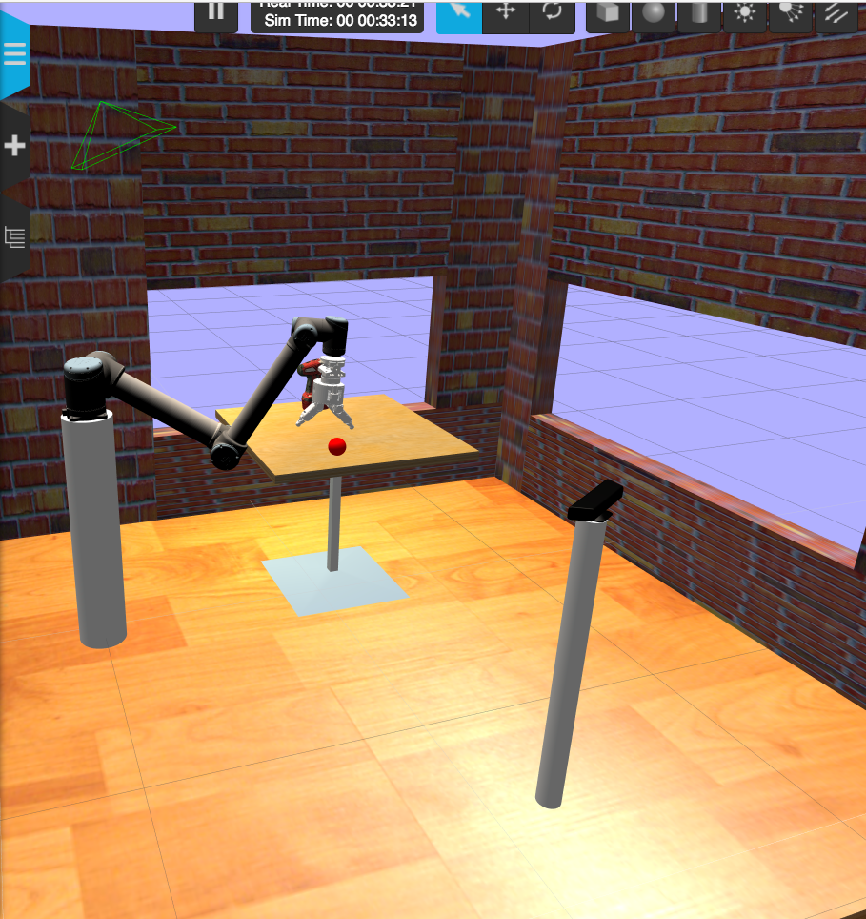

**Problem Statement :**

This project focuses on building a Machine Learning model to predict the robustness value of a robotic arm and classifying the grasp as stable/unstable using sensor data from its joints.

**Background Study:**

We gained insights for the project from the GitHub Simulator link shared with us of the Smart Grasping Sandbox.

The Smart Grasping Sandbox is a ROS-based simulation that lets researchers and developers experiment with robotic grasping and manipulation tasks. It’s specifically geared toward autonomous pick-and-place challenges, making it a useful tool for testing grasping strategies, optimizing robot movements, and training grasping algorithms. The sandbox simulates Shadow Robot's advanced robotic hand, known for its human-like dexterity, within a controlled environment.

Data collection in the Shadow Robot Smart Grasping Sandbox can be accomplished by logging various aspects of the robot's interactions with objects, sensor readings, and simulation parameters.

The sandbox uses ROS (Robot Operating System), which relies on *topics* to publish and subscribe to different data streams. Important data points such as joint positions, forces, sensor readings, and object poses are published to specific ROS topics.

#### 1. Data Preprocessing

* Handling Missing Values: Incomplete sensor readings can occur due to various reasons, such as sensor malfunctions or communication errors. Techniques such as imputation (mean, median, mode) or removal of incomplete records help ensure that the dataset is robust for modeling .
* Normalization : Normalizing features in sensor data is crucial for optimal performance of machine learning algorithms, as it standardizes the range of input features. This technique involves transforming the data to a common scale, typically between 0 and 1 or with a mean of 0 and a standard deviation of 1.
* Outliers Handling :Outlier handling is essential in stable grasping prediction, as outliers can skew the data and compromise the accuracy and robustness of predictive models. Techniques such as identifying and removing outliers using statistical methods help mitigate their impact.Implementing effective outlier handling strategies not only improves model performance but also enhances the reliability of grasping predictions in dynamic environments.
* Feature Selection :Feature selection is vital for stable grasping prediction, as it identifies key attributes that define grasp stability. A correlation matrix reveals relationships between features, allowing for the removal of redundancies. Principal Component Analysis (PCA) reduces dimensionality by transforming features into uncorrelated components, preserving essential variance.

#### 2. Exploratory Data Analysis (EDA)

EDA involves analyzing the dataset to summarize its main characteristics, often using visual methods. Key aspects include:

* Visualizing Distributions: Understanding the distribution of each feature helps identify patterns and potential anomalies in the data.
* Correlation Analysis: Identifying relationships between different sensor readings and grasp stability can inform feature selection and engineering, guiding the choice of input variables for the ML models.

#### 3. Classification and Regression Models

Depending on how stability is defined (e.g., stable vs. unstable grasp), different ML approaches can be applied:

* Classification:

Logistic Regression : Logistic regression is a statistical method used for binary classification problems. It predicts the probability that an input belongs to a particular class by applying the logistic (sigmoid) function, which maps any input to a value between 0 and 1. This probability is then used to classify the input into one of two classes, typically using a threshold like 0.5.

Naive Bayes Classifier : Naive Bayes is a probabilistic classifier based on Bayes' theorem, which assumes that the features in a dataset are conditionally independent given the class label. Despite this "naive" independence assumption, it often performs well in practice, especially with text classification tasks. It calculates the probability of each class for a given input and predicts the class with the highest probability.

Random Forest Classifier : The Random Forest classifier is an ensemble learning method that builds multiple decision trees and merges them to improve classification accuracy and control overfitting. Each tree is trained on a random subset of data and features, and the final prediction is made by taking a majority vote among all the trees. This approach enhances robustness and reduces variance compared to a single decision tree.

Support Vector Machines : Support Vector Machine (SVM) is a powerful classification algorithm that finds the optimal hyperplane to separate data points from different classes with the maximum margin. It works by identifying support vectors—data points closest to the hyperplane—which define this margin. SVMs can handle both linear and non-linear classification through the use of kernel functions that map data to higher-dimensional spaces.

* Regression:

Linear Regression : Linear regression is a simple statistical model used to predict a continuous target variable based on one or more input features. It assumes a linear relationship between the input variables and the target, represented by a straight line. The model minimizes the difference between predicted and actual values by adjusting coefficients to best fit the data, often using least squares.

Decision Tree Regressor : Decision Tree Regression is a predictive model that splits data into smaller subsets based on feature values, forming a tree-like structure. At each split, the model aims to reduce the variance in the target variable within the resulting subsets. The prediction is made by averaging the values in the final leaf nodes, allowing it to capture non-linear relationships in the data.

* Deep Learning:

Artificial Neural Networks : Artificial Neural Networks (ANNs) are computational models inspired by the human brain, used to recognize patterns and make predictions. They consist of layers of interconnected nodes, or "neurons," where each neuron applies a weighted sum and activation function to its inputs. By adjusting these weights through training, ANNs can learn complex, non-linear relationships within data, making them effective for tasks like image and speech recognition.

4. Evaluation Techniques : R² Score: Measures how well the model explains the variance in the target variable, with 1 indicating perfect fit.

MSE (Mean Squared Error): Calculates the average of squared differences between actual and predicted values, showing model error in regression.

Confusion Matrix: A table that shows true vs. predicted classifications, used to assess classification model performance.

Classification Report: Provides precision, recall, F1-score, and support for each class in a classification model.

Accuracy: The ratio of correctly predicted instances to total instances, indicating overall model correctness.

**Related Work:**

Research on robotic arms often emphasizes performance metrics like force and position accuracy, but there is limited focus on predicting robustness in grasping. Our project specifically targets this gap by employing a comprehensive multi-model approach that combines regression and classification techniques.

Existing studies have primarily utilized single-method models, while our approach integrates dimensionality reduction and outlier management to enhance robustness predictions. By using sensor data from the robotic arm's joints, we provide a direct assessment of grasp stability, setting our work apart from previous research focused mainly on visual inputs.

This project not only builds upon existing methodologies but also aims to create a more nuanced analysis applicable to various robotic systems facing robustness challenges.

**Dataset Overview:**

The grasping dataset availed from Kaggle has 30 columns. An experiment consists of grasping the ball, shaking it for a while, while computing a grasp robustness (which is the variation of the distance between the palm and the ball during the shake). Multiple measurements are taken during a given experiment. Only one robustness value is associated though.

A quick note about the names used in the columns:

* H1 stands for Hand one (there's only one hand but…)
* F1 for finger one (three fingers per hand)
* J1 for joint one (three joints per finger)
* pos / vel / effort are the position, velocity and effort measurements of the joints.

‘X’ (input features) is defined as all the columns in the dataset except Robustness, measurement number and ‘y’ (target variables) is the Robustness column.

The higher the value of robustness, the less stable the grasp and vice-versa.

**System Architecture:**

The system architecture follows a supervised learning pipeline:

* *Data Preprocessing:*

Scaling: Standard Scalar is applied .

Outliers handling : Two approaches were explored for our model : filtering and replacing outliers with mean. The impact of both techniques on model performance was evaluated.

* *Feature Selection:* For our model Feature selection by correlation matrix and dimension reduction by Principal Component Analysis both were explored.
* *Exploratory Data Analysis :* For Data visualization , Histograms , Boxplots as well as correlation matrix is shown .
* *Model Selection and Training*: Several machine learning models were explored.

For Regression :

*Linear Regression*

*Decision Tree Regressor*

For Deep Learning:

*Artificial Neural Network (ANN)*

For Classification :

*Logistic Regression*

*Decision Tree Classifier*

*Random Forest*

*Support Vector Machine (SVM)*

The models were trained using the preprocessed data. Hyperparameter tuning was employed to optimize model performance.

* *Model Evaluation:* Model performance is assessed using metrics like Mean Squared Error (MSE) ,R-squared (R²), Confusion matrix , classification report .

**Objectives:**

* Develop a machine learning model (classification and regression models) for predicting robot arm robustness and classifying the grasp as stable/unstable.
* Compare different approaches for data preprocessing as well as comparing different models for better performance of the overall model .

**Experiment and Results:**

* *Data Exploration:* Data visualizations were used to understand feature distributions and identify potential outliers.

EDA:

1. Histograms:

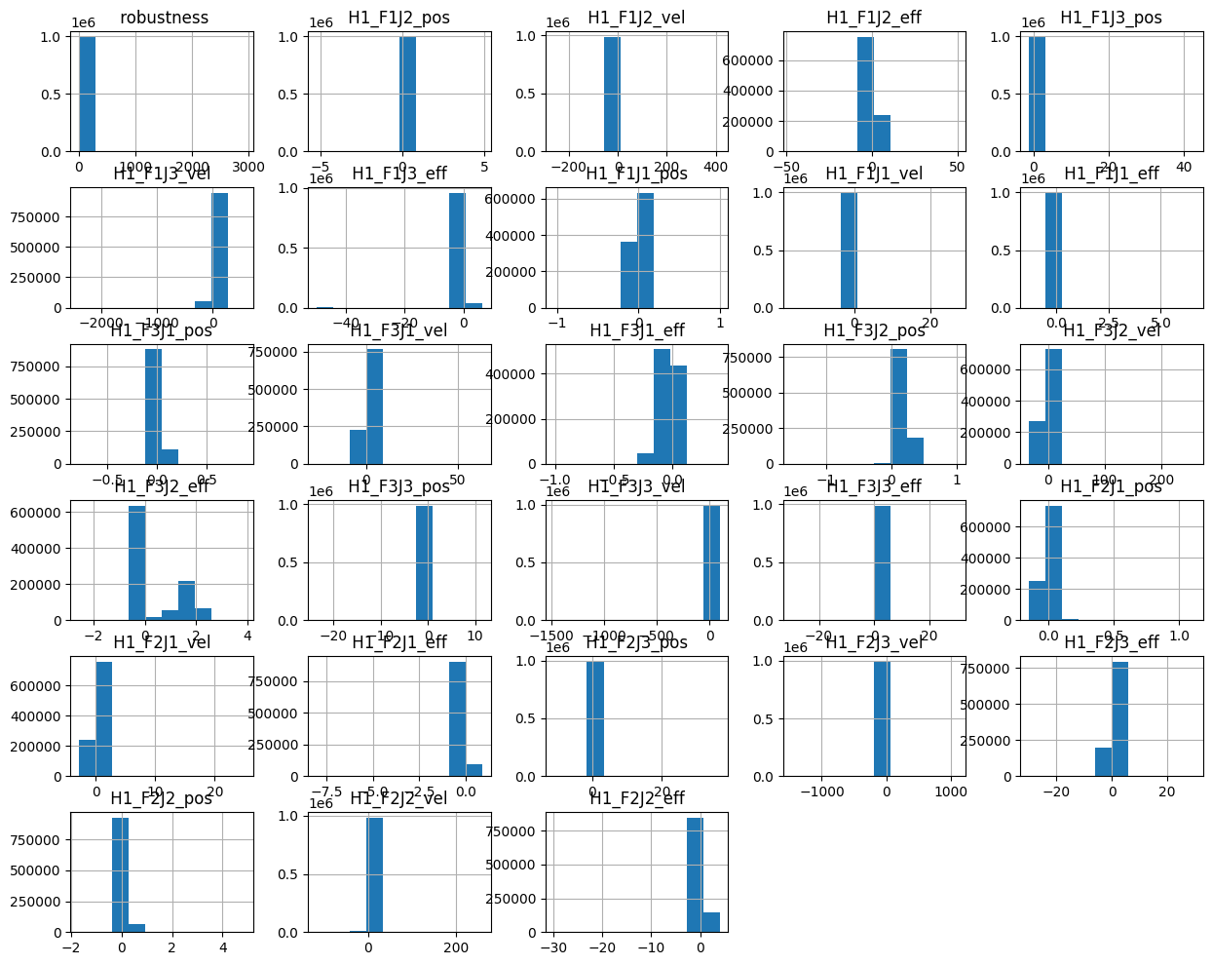

These histograms show skewed distributions, potential outliers, and varying feature ranges.

1. Correlation matrix:

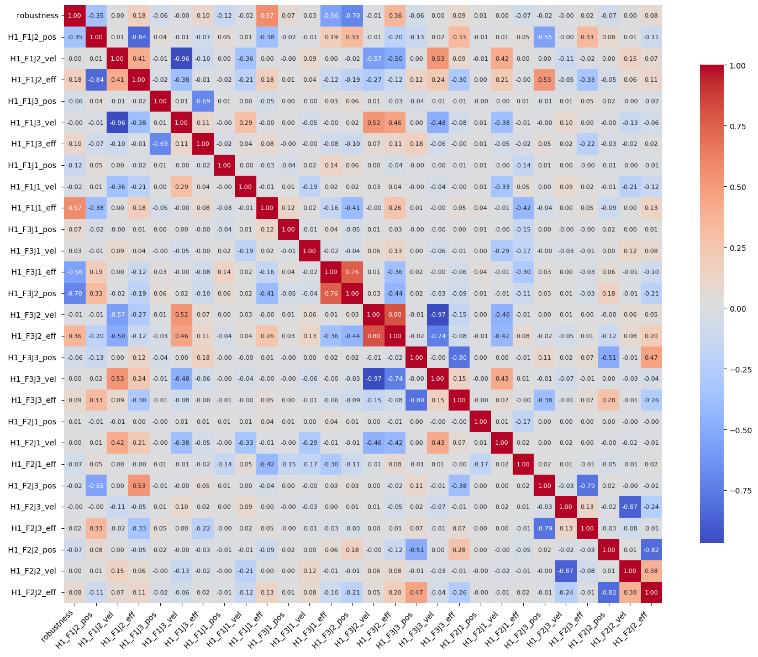

Correlation Matrix showed that ' H1_F1J3_vel ': [' H1_F1J2_vel '],

' H1_F3J2_eff ': [' H1_F3J2_vel'],

' H1_F3J3_vel ': [' H1_F3J2_vel ', ' H1_F3J2_eff '],

' H1_F3J3_eff ': [' H1_F3J3_pos '],

' H1_F2J2_vel ': ['H1_F2J3_vel '],

' H1_F2J2_eff ': [' H1_F2J2_pos '] these features are highly correlated with each other .

For feature selection features among above which are highly correlated with target variable are taken .

1. Box Pots

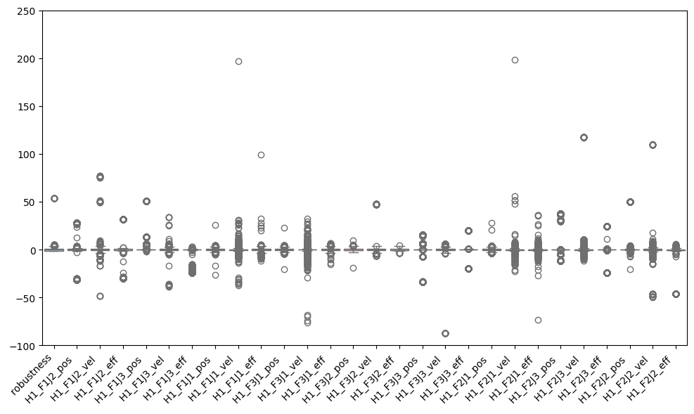

The plot shows the distribution of robustness across various conditions, with most values centered around zero but varying widely in spread and density. Some categories display significant outliers, suggesting occasional extreme deviations. This indicates variability in robustness depending on the condition.

* *Feature Selection***:** Performance of both i.e, Feature selection from correlation matrix and Dimension Reduction from Principal Component Analysis were evaluated by decision tree model and Feature selection from correlation matrix showed better accuracy .

Accuracy

From correlation matrix : **0.8708**

From PCA : **0.8148**

Hence the final model used data after feature selection from correlation matrix .

* *Outliers Handling :* Removing outliers provided less accuracy while evaluation rather than replacing them with mean.

Accuracy by Removing : **0.8260**

Accuracy by Replacing : **0.8372**

* Regression models:

*Decision Tree Regressor:* Achieved a R² score of **0.87** which

indicates best performance .

*Linear Regression:* R² score was **0.67**, indicating performance with less accuracy.

* Deep Learning:

*ANN Regressor:* The ANN emerged as the moderate-performing model, achieving the lowest MSE of 0.18 and highest R² value of **0.84**.

* Classification models:

A threshold of 17.29 which is the lowest 30% of values that the robustness column holds was applied to the predicted robustness scores to classify the robot arm as "stable" or "unstable."

Classification models like Logistic Regression, Random Forest, SVM were evaluated for their accuracy in predicting stability.

*Logistic Regression:* Achieved an accuracy of **0.9751**, demonstrating strong generalization on unseen data.

*Naive Bayes Classifier:*  Achieved an accuracy of **0.7256**.Which was least among all other models .

*Random Forest Classifier:* Provided the best accuracy at **0.9885**, with excellent classification performance.

*SVM:* Achieved an accuracy of **0.9757**, effectively separating classes.

**Key Observations:**

* **Regression**: **Decision Tree Regressor** performed best with R² = 0.87.
* **ANN**: Achieved the lowest MSE (0.18) and highest R² (0.84), showing good performance but not the best for regression.
* **Feature Selection**: **Correlation Matrix** outperformed **PCA** for feature selection.
* **Outlier Handling**: Replacing outliers with mean resulted in better accuracy than removal.
* **Classification**: **Random Forest** achieved the highest accuracy (0.9885), outperforming other classifiers like Logistic Regression and SVM.

**Conclusion and Future Scope:**

The project successfully developed machine learning models to predict robot arm robustness as well as classify them as stable/unstable grasp . Outlier handling and feature selection techniques were found to influence model performance.

Models like Logistic Regression, Random Forest Classifier, Support Vector Machine showed promising results with an accuracy of 0.97.

*Future Scope:*

* Explore the use of additional sensor data or different data sources.
* Implement online learning for the model to adapt to changing operational conditions.
* Integrate the model into a real-time robot control system for proactive adjustments and error prevention.

**References:**

1. <https://github.com/shadow-robot/smart_grasping_sandbox>
2. Scikit-learn documentation on preprocessing, PCA, and model selection.