Detailed Model Research for Cyber Threat Detection

Introduction
This research presents a comparative study of machine learning models used for cyber threat detection. The goal is to evaluate standard performance metrics - Accuracy, Precision, Recall, and F1-Score to identify the most robust approach for identifying malicious network activities.

Model Analysis
- Logistic Regression: A linear model used as a baseline for binary classification. It estimates the probability of a network event being malicious. While highly interpretable and fast, it struggles with complex non-linear patterns found in modern threat data.

- Decision Tree Classifier: A non-parametric method that splits data based on feature values. It is useful for visualizing decision rules and capturing non-linear relationships. It offers balanced performance but is prone to overfitting on high-dimensional or noisy threat data.

- Random Forest Classifier: An ensemble technique that combines multiple decision trees to improve accuracy and generalization. Achieved the highest F1-Score among direct models and exceptionally high recall.

- Support Vector Machine (SVM): Finds the optimal hyperplane to separate classes with maximum margin. Achieved perfect Recall, minimizing false negatives.

- XG Boost Classifier: Optimized gradient boosting algorithm designed for scalability. It is best for overall accuracy for large-scale datasets.

- Neural Network (MLP): Learns complex non-linear relationships. Requires careful tuning and computational resources.

Hybrid and Ensemble Approaches
- Stacking Classifier: Meta-learning approach combining base models.
- Voting Classifier: It aggregates predictions from multiple models for robustness.
- Bagging Classifier: It helps in reducing variance by training models on random subsets.

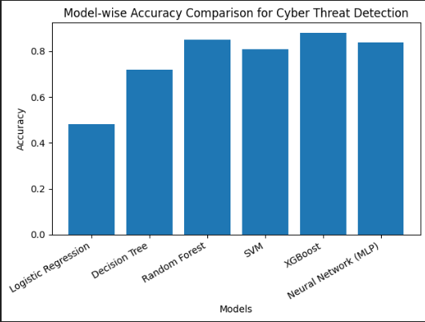
The graph presents a comparative analysis of different machine learning models based on their accuracy for cyber threat detection. It clearly shows that XG Boost achieves the highest accuracy, indicating its strong capability to handle large-scale and complex cybersecurity datasets by capturing intricate feature interactions and managing class imbalance effectively. Random Forest and Neural Network (MLP) also demonstrate high accuracy, highlighting their ability to learn non-linear patterns and generalize well across diverse threat scenarios. Support Vector Machine (SVM) performs competitively, making it a reliable choice when accurate classification and strong threat separation are required. Decision Tree shows moderate accuracy, which reflects its simplicity and interpretability but also its susceptibility to overfitting in high-dimensional or noisy data. Logistic Regression, used as a baseline model, records the lowest accuracy due to its linear nature, making it less effective for identifying complex and evolving cyber-attack patterns. Overall, the graph emphasizes that ensemble and advanced learning models outperform simpler algorithms in cyber threat detection tasks.

Conclusion
XG Boost achieved the highest overall accuracy, while Random Forest, SVM, and Stacking Classifier are preferred for high-recall security-critical systems.

