**Lesson #1: History of Backscatter Communication, Communication System Overview**

**Lesson #1 Learning Objectives:** Upon successfully completing this lesson and the associated homework, students will be able to:

1. Describe the basic operating principle of a backscatter communication system
2. Give examples of historical backscatter communication systems
3. Recall the basic functions of a wireless communication system
4. Create a block diagram describing a wireless communication system
   1. 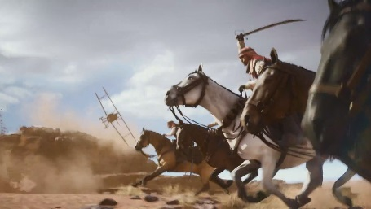**History**

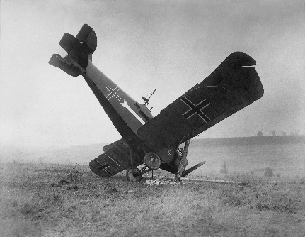Though planes existed on the battlefields of WW1, they didn’t start resembling the metallic flying beasts that we know today until the WWII era. According to the book[1], British pilots noticed German aircraft spontaneously all performing a roll at the same time. They put it up to German engineering. However, when they looked a little closer, they noticed the German aircraft would execute the roll right around the same time that a radar would be pointed there way.

Why?

This is an early example of friend-or-foe identification. If the people on the ground waited until they could see the planes before they started taking defensive measures … it would be too late. But at the same time, when they used their recently developed radar technology, they could see farther into the distance and notice that a plane was approaching. Was it a friendly plane brining supplies? Or was it an enemy?

The Germans pilots learned that if they executed a roll as soon as they noticed that they were being hit with a radar, the radar operator would see a blip on the screen and know that friendly planes were approaching[2].

Can you think of any problems with this scenario?

First, as a means of identifying a friend vs. a foe, well … any old airplane can do a barrel roll. Second, there’s really no identifying information being sent. So right away, there are problems with **security** and **ID space**. In fact, we’re only sending 1-bit of data (plane does barrel roll, or plane does not do a barrel roll).

Nonetheless, this still highlights several interesting things. By observing the radar changes on their screen, a radar operator can detect if a plane attempts to be identified as a friendly. The plane does this without knowing anything about the radar, other than it’s turned on. This is a very early example of a **passive backscatter modulation system**. *Passive* meaning there is no radio transmitter on the object being identified, *backscatter* referring to the radio waves being reflected and *modulation* referring to an extra message being placed “on top of” the radio signal[3].

But … this is not the first example.

* + 1. **Alexander Graham Bell**

Back before the radio, Bell demonstrated the **photophone**. Get ready. In 1880, pre-dating the invention of the radio, Bell showed that he could transmit speech wirelessly over a distance of 214 meters (700 feet) completely passively without a battery! For reference, Marconi first showed a public demonstration of the radio in 1896.

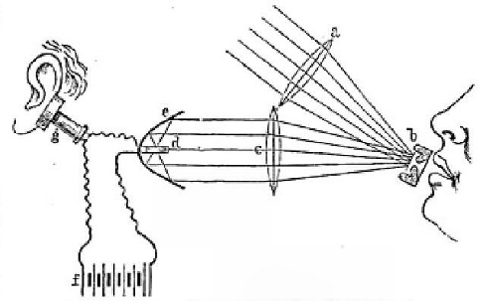

Here is a video of a modern photophone: <https://www.youtube.com/watch?v=17jED0zmR48>

Bell demonstrated wireless transmission of analog signals (human speech) without need for a battery for the transmitting node. All power for the wireless link came from either ambient light, or (as mentioned in his paper, which is in the public domain, because it was published way back in the 80’s[4]) from something as simple as a candle. The receiver only needed a battery which was used to bias a solar cell and amplify the received fluctuations of light.

* + 1. **So wait … What is “Backscatter?”**

Though its been mentioned several times, we should probably define what “backscatter” is. When ever an *electromagnetic* (EM) wave hits something, a portion of that wave will be absorbed and a portion will be reflected. These reflected waves are referred to as the *scattered* signal, or simply *scattering*.

The portion of the scattered signals that are directed *back* in the direction that the incident wave came from is called the **backscattered signal**. There is also *forward scattering* which is how the photophone operates, but we will be mainly concerned with the backscattered fields – the energy/portion of the EM wave that is reflected back to the source. Why is this important to us? As we will see, by not operating a radio, we can significantly reduce our power requirements.

* + 1. 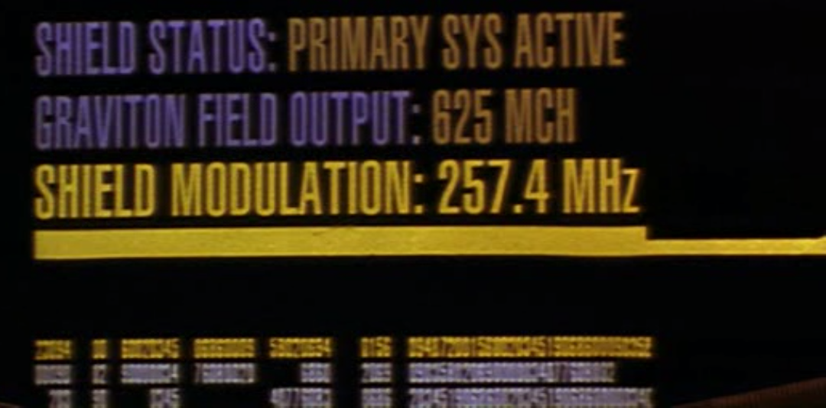**Modulation**

You’ve already modulated data. Put simply, when we modulate something, we are putting a message on top of it. Put more scientific, we are varying some properties of a periodic signal, known as the **carrier signal**, such that a message is conveyed or transmitted.

Where have you seen it? On the first day of class we modulated light. The group with the flight turned the light on and off to send set of Morse code data. This modulated the amplitude of the light. The group with the mirror would either reflect back the light, or reflect the light away. This also modulates the amplitude of the light reflected back.

* + 1. **Other examples of backscatter communication**

We’ve seen examples from WWII, and an example from 1880. There a couple more that are important. In 1948, Stockman presented results from a series of experiments. This is really the first example of something that reflects modern backscatter systems.

Stockman used fairly high frequencies[5] for his carrier, but was also able to achieve 10 km separation. Stockman used positional modulation where a microphone was used to modulate the position of an antenna.

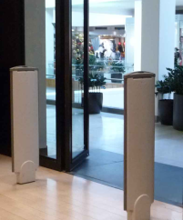Worth noting is that although Stockman’s work is the first study in RF backscatter, a few years before his story hit the press, Lev Theremin (yep, the inventor of the theremin instrument) created and deployed a passive-backscatter device used for spying on the American embassy. It’s exactly as awesome as it sounds. Look up the “Great Seal Bug” if you are interested.

Continuing development in backscatter led to investigation of inductively coupled systems (coupled transformers). This led to development of the 1-bit transponder in the 1960’s. It was able to detect if a magnetic material had been magnetized or de-magnetized. This has found its way into the modern retail store in the form of the big strange white things you walk by/through at the doors and is used for anti-theft.

All this is great[6], but we want to add logic and some processing to these systems. The big problem is we need MORE POWER. Enter Sandia National Lab. These folks did some pretty fun stuff in the 1970s. They device they developed was for tracking animals. Specifically cows.

To do that, they built a device worn in a backpack that servers as the **interrogator** or **reader**. The reader generates a 1 GHz, 4 W signal and transmits this through an antenna.

The tag worn by the cows converts a portion of the signal to dc power for powering the device logic. Communication back to the reader is performed by load modulation to modulate the backscattered signal. The data modulating the backscatter is supplied from a temperature dependent subcarrier oscillator that itself is on-off keyed (amplitude modulation) from an ID code generator.

To summarize: 1) Koelle et al., 1975, Sandia National lab, 2) tag is fully powered by RF, 3) backscatter modulation by load modulation, 4) “subcarrier modulation” is a technique robust to noise and very similar to what modern devices implement. The key for “subcarrier modulation” is that the frequency (20 kHz) is much smaller than the carrier (1 GHz), 5) the received (RX) and transmitted (TX) signal are compared directly, 6) the subcarrier frequency … is temperature dependent. And this was intentional because now, we can get a read of the cow’s temperature as well as ID all from a few meters away.

* + 1. **From the 70’s till now**

From here, things started developing fairly rapidly. The rail industry adopted similar devices to identify rail cars as they are on the tracks. The Fastpass was widely deployed for automated toll collection. ISO developed an air protocol which standardized how readers and tags communicated, cementing the RFID industry. Which has led us to modern RFID.

* 1. **Elements of a wireless communication system**

Functional diagram of a communication system:

So a communication system is really just a data transfer system. Information goes into a transmitter, its passed through a channel and enters the receiver where it is examined. The transmitter is responsible for selecting the frequency which will be used to “carry” the data and the type of modulation (how the data is represented as it is modifying parameters of the carrier signal). The channel is the physical medium through which the data travels. This is typically freespace --- a fancy name for well, what you’re breathing: air --- or a wire such as a coaxial cable. The receiver is responsible for demodulation, or converting the varying parameters of the carrier signal into useful data symbols.

Let’s take a slightly different look and see how we would actually draw a transmitter/receiver combination in a block diagram form. When a transmitter and receiver are combined together, this is called a **transceiver**.

The digital-to-analog converter (DAC) converts a stream of bits into an analog signal[7]. This would typically be filtered and then mixed, or multiplied, with the high frequency carrier signal generated by a frequency synthesizer. The mixed signal is now modulated with the data, passed through a power amplifier to boost the signal strength, and radiated out into the air through an antenna. A similar set of actions takes place for the received signal. The signal absorbed by the antenna is passed through a low noise amplifier (LNA) to increase the signal strength and mixed with a local copy of the carrier signal generated by the frequency synthesizer. This signal is known as the local oscillator (lo). This mixing operation removes the carrier signal, leaving[8] the original set of symbols that were put onto the carrier.

If you’re confused, don’t worry. If you haven’t studied frequency translation and modulation before, don’t panic. The idea is: if you have a signal, or rather, a time-varying data stream, when we multiply it with a high-frequency sine wave, we are shifting the frequency content of the signal to a higher value while still leaving all the data intact. Doing the same mixing operation again[9] will give you back the original signal you started with.

The main things to observe are:

1. Such a communication link is symmetric. Both sides (nodes A and B) operate their own transceiver that is doing the same thing at each end.
2. Each node runs a frequency synthesizer to generate the lo. This is a key idea: **Even if you want to lower the power of the radio, the power draw of the synthesizer will be the lower bound of the power consumption.** Because it’s always gonna be on!
   * 1. **So what about RFID?**

The innovation of backscatter communication and what has enabled RFID to exist is a breaking of this symmetry. We divide the world up into a Reader and some Tags.

What are some advantages of a traditional communication system?

What are some disadvantages of a traditional communication system?

What are some advantages of an RFID/backscatter communication system?

What are some disadvantages of an RFID/backscatter communication system?

**1.4 Key Take-Aways**

1. Electromagnetic waves will hit an object and scatter. The scattering directed back towards the source is known as **backscatter**. When the backscattered signals can be controlled, this is known as **backscatter modulation**.
2. There are several examples of early backscatter communication systems. This included Bell’s photophone, WWII planes, Stockman’s experiments, and Sandia’s cow tracking system.
3. A wireless communication system is capable of both receiving and transmitting data. For data transmission: the data is converted to an analog signal and mixed with a high-frequency carrier which is amplified and sent into the air through an antenna. For data reception: the signal absorbed by the antenna is amplified and mixed with a copy of the local oscillator (lo). This result is then used for data demodulation and determining what the received bits or data are.
4. While traditional wireless communication systems are symmetric, RFID and backscatter devices breaks this symmetry meaning less power is required for the tag to wirelessly send data.

1. This is an unconfirmed story aside from those rapscallions on the Internet. But it’s probably on Wikipedia [CITATION NEEDED] so it’s more than likely, possibly, could be, the truth.
2. So break out the fattened sausage and spätzle for celebration.
3. Also, if we assume a plane is a few kilometers away from the radar, since the speed of light is limited, taking about 3µs to travel 1 km, simply by timing the delay for the signal to return we can estimate distance to a plane as well!
4. 1880’s that is. Think top hats and big beards, not hammer pants and big hair.
5. 10 GHz
6. It really is!
7. Typically it would be a set of analog signals as most systems modulate both the real part and the imaginary part of the carrier.
8. “Hopefully” leaving, that is.*

   * You’d be surprised how much of advanced communications systems relies in this idea of hopefully. It’s really all just a toss of the dice and hoping against the odds you’re right.
9. Technically, you’d need to include a low-pass filter here as well.