**Lesson #2: Why do reflections matter?**

**Lesson #2 Learning Objectives:** Upon successfully completing this lesson and the associated homework, students will be able to:

1. Describe the effects reflections can have on circuits
2. Develop multiple strategies to mitigate reflections
3. Measure the speed of light.
   1. **Let’s take a measurement**

Let’s take a measurement of the following circuit.

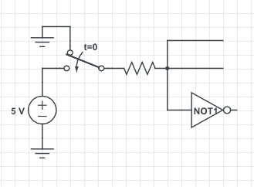

…

…

…

You are given the circuit shown above. There’s a DC supply, and a switch that’s thrown at time t=0. You are asked to find the voltage at the node circled in red.

Go!

What questions do you have?

I can think of two good ones:

1. What is connected on those lines with the dots?
2. What is the not gate going to?
3. What is the resistor value?

And you’d be right in asking those. So, let me tell you: the wire that is left open is just that --- an open circuit. No worries. The NOT gate is a circuit element with a high-impedance input[1].

So, a wire that’s an open circuit, a high-impedance gate of a transistor … what’s your guess?

Based on my circuit knowledge, I’d guess 5V. The switch is thrown at time t=0, there’s nothing pulling the node down to a lower voltage.

* 1. **What’s the result?**

Here are my results from implementing this circuit:

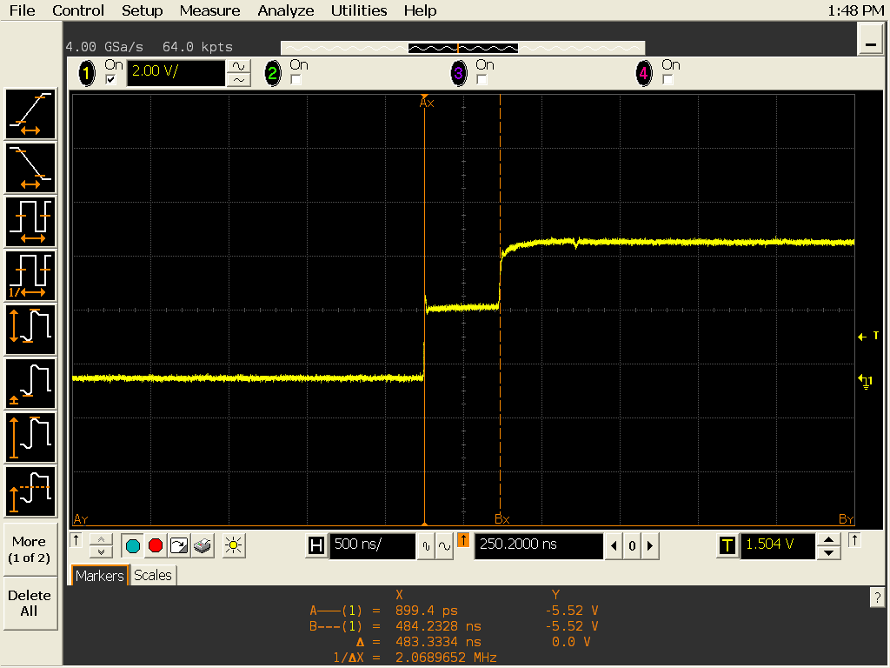

Ok. That’s horrible. It’s like it rose up a few volts, then got bored halfway through before figuring out what to do. Either way, this makes NO sense!

Why is it doing this?!?

I really did take this data, here’s the proof:

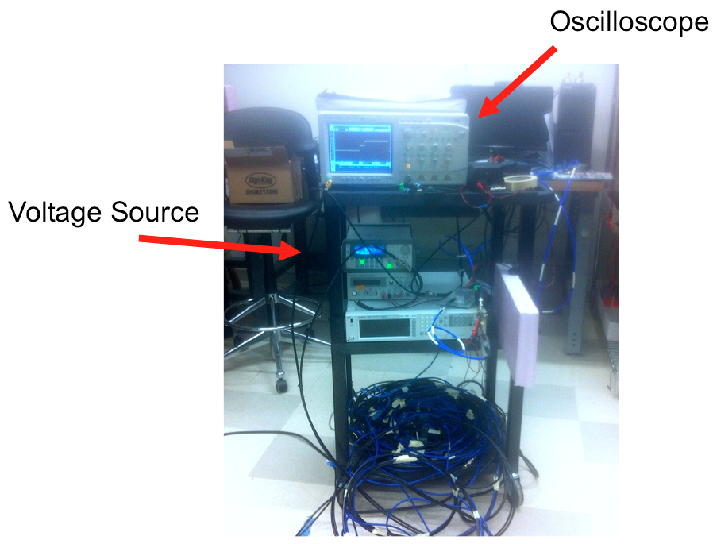

There is a function generator acting as our voltage source. It is set in the 50-ohm output impedance. It’s output is a coaxial cable tee with one line going into the oscilloscope, and the other line going off to an open circuit.

Any other thoughts?

It DOES have something to do with the cable.

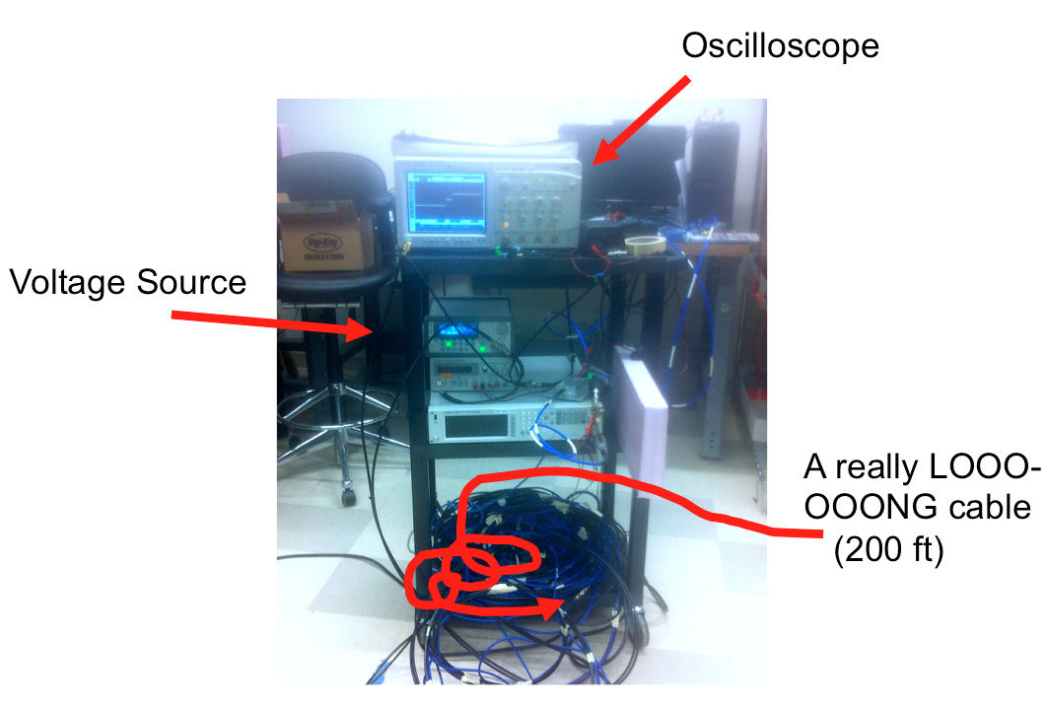

Or maybe in schematic form, maybe we could write

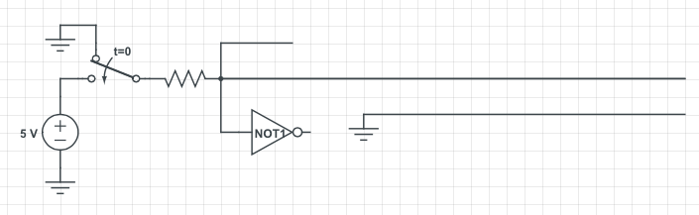

And the picture once again:



* 1. **Impedances and reflections**

The source generator has an output impedance of 50 ohms. The coaxial cable has a characteristic impedance of 50 ohms. That means the cable itself acts like a resistor. So if we have a 5 V, 50 ohm source, and a 50 ohm cable, what do we expect?

Let’s redraw the circuit to see what’s going on.

So, we would expect to see 2.5 V at the circled node.

If we look closely, it appears that that is what the circuit is trying to stabilize at. It just then sneaks up again. Strange.

So what is going on? Any ideas?

There is a reflection. The wavefront is traveling down the cable, hits the end, and is reflected back. Our cable is so long, that we can see the effect!

What is a way we can fix this?

 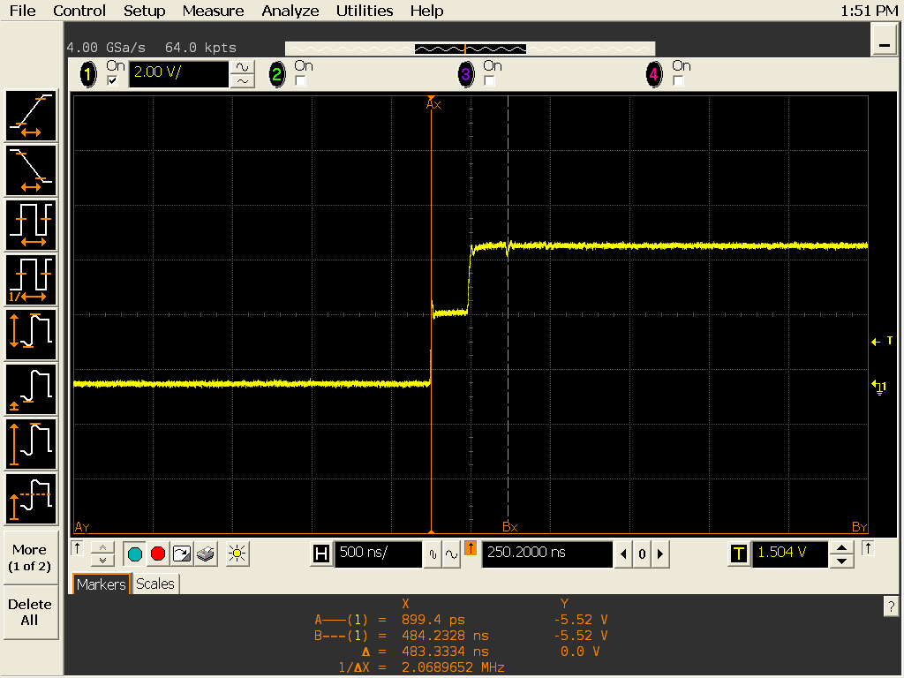

Though hard to see, the image on the right was taken using a shorter cable. The result is still there! So using a shorter cable won’t make this completely go away.

Instead, let’s look at the other end of the cable. For now, we have an open circuit. This will actually cause the signal to completely reflect its energy back. We finally see the result of this after everything settles. This is what we would expect to see if we had no cable there at all[2].

Let’s change the open to s ahort.

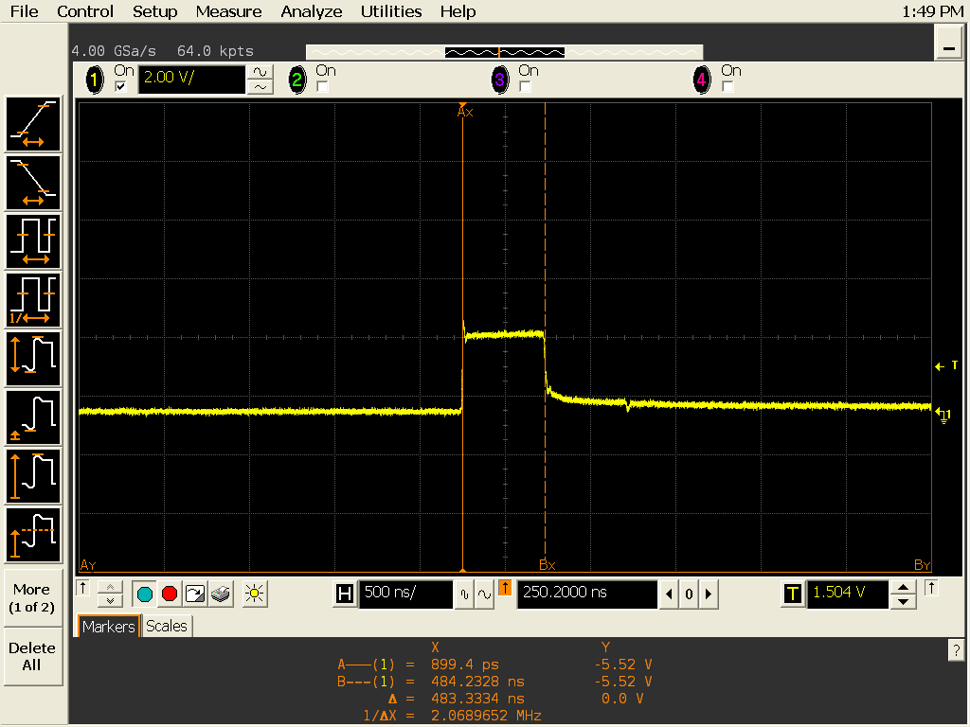

Once again we are reflecting energy. The voltage rises up to the proper point, and then crashes back down when the wavefront returns.

What impedance should we put on the end of the cable?

* 1. **The match**

If we put a 50 ohm resistor on the end, then the source impedance will match the impedance of the coaxial cable and match the load impedance. All nicely synced up at 50 ohms. Let’s try it!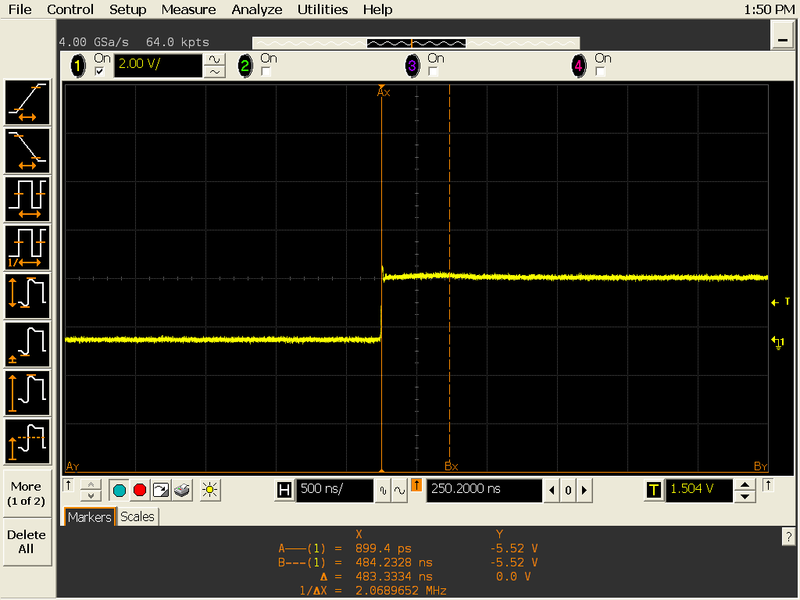

And Voila! There it is. The reflections are cancelled. The drawback is that we are at half of the potential voltage from before though.

* 1. **One more thing**

Let’s measure the speed of light!

No seriously, let’s do it.

This data is taken with a 200 foot cable. The wave travels down the cable to the end and then bounces back. So we can measure the total return trip.

If we know the time (seconds) and the distance (meters), we can estimate the speed of light in this material. Go!

**1.4 Key Take-Aways**

1. Circuit theory does not completely hold up for high-frequency signals or short traces. We need to consider the speed of light.
2. Impedance matters! Reflections can be cancelled with a load impedance that matches our source impedance. Open circuit and short circuit will cause full reflections of energy.
3. We can cancel reflections with a match may get by with reducing the length of our trace.
4. Knowing the return time, the speed of light for our material can be calculated.

1. The gate of a FET is a high-impedance input.
2. And would match what we expect from traditional circuit analysis