**Lesson #4: Let’s make a Smith chart**

**Lesson #4 Learning Objectives:** Upon successfully completing this lesson and the associated homework, students will be able to:

1. Explain the premise behind a Smith chart
2. Create a Smith chart.
3. Use a Smith chart to show reflection coefficients
   1. **The Smith chart**

The Smith chart is perhaps the most recognized microwave design tool there is. It is the *de facto* calling card for rf (radio frequency) engineers. I have many times heard of this referred to as a “black magic chart” that only the greybeards understand. There are also rumors using one involves sacrificial coffee grinds being laid out in cryptic sygil patterns by the light of a CRT. I’m actually only slightly joking, and I don’t know why the Smith chart has such a strange reputation.

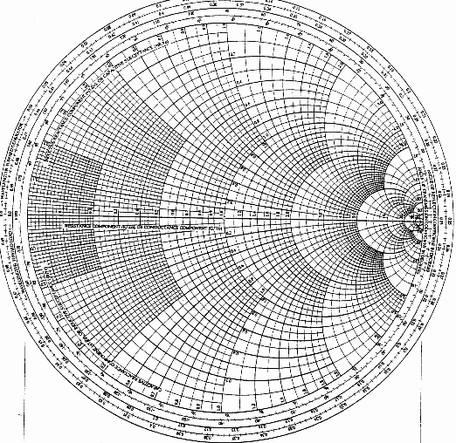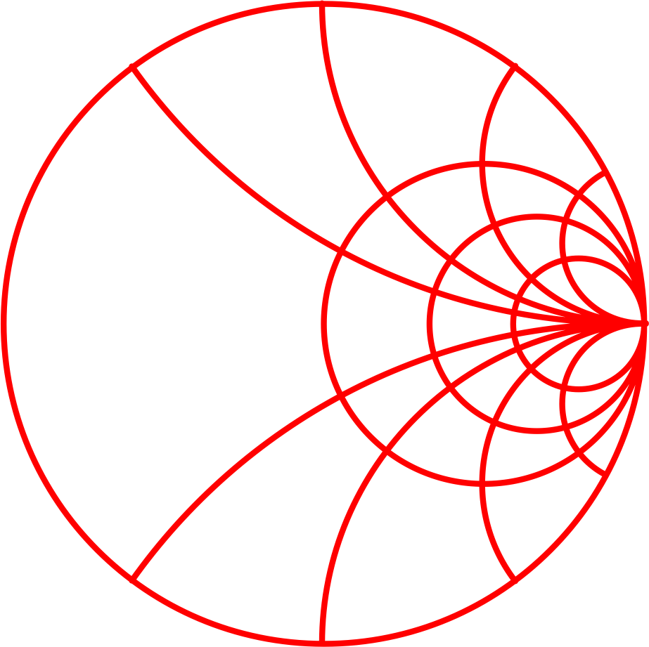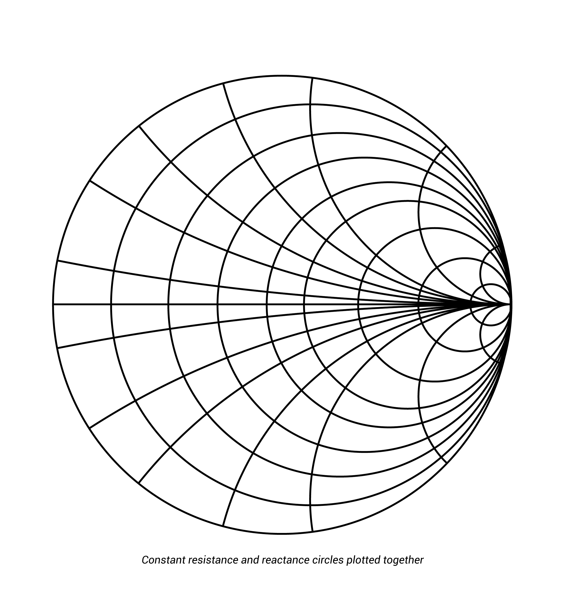The Smith chart (with capital ‘S’ because Smith was a guy who invented this back in the 40s) maps the entire right (real) half of the complex impedance plane — which is infinite! — into a finite area. Not an easy task. All values of reactance and all positive values of resistance from 0 to infinity fall within the outer circle of a Smith chart[1].

The Smith chart can vary from the simple (left) to the complicated (right). There’s a lot of available information, but when you’re just getting started, you’ll only need to focus on a couple of things.

The most important things to know for now are:

1. The Smith chart resembles a polar plot and its predominant feature is a circle of radius 1 centered at the origin (0,0).
2. The leftmost point (-1, 0) of the circle represents a short circuit load.
3. The rightmost point (+1,0) of the circle represents an open circuit (infinite impedance) load.
4. The middle point (0,0) represents a matched state when the load impedance equals the characteristic impedance.

Recall the reflection coefficients from yesterday. We see that these points match exactly to the results from calculating the reflection coefficient for the open-circuit, short-circuit and matched loads.

Here’s the key **— We plot the reflection coefficient directly onto the Smith chart.** And in fact, the Smith chart itself is just made up of a bunch of already-plotted reflection coefficients.

There’s a whole lot more information shown on the Smith chart, but for now, you see the basics. If we have a load, we want it to be as close to the center as we can make it.[2]

* 1. **Let’s make one!**

Our goal is to produce a MATLAB function named **smithchart.m** that will plot a Smith chart. We will later use this function to plot circuit reflection coefficients.

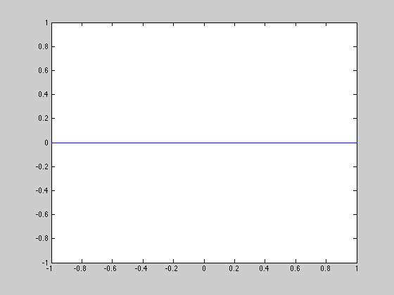For now, let’s start easy. Plot what is known as the ‘real line’ which extends from (-1, 0) through the origin (1, 0). This line represents any load that has no reactance and is purely resistive.

Your result should appear as on the right. Not so bad so far.

**\*\*Print a copy of this plot for the assignment\*\***

Let’s keep going.

**Plotting Constant Resistance**

One feature of the Smith chart are the curves of constant resistance or reactance. This allows an in-the-know engineer to quickly trace and see what would happen if more capacitance or inductance were to be added to the system. These next traces that we will draw represent reflection coefficients where the resistance is held constant and the reactance is swept over all possible values.

Plot two curves of constant resistance

1. You will need to hold ‘R’ constant and sweep the load reactance. I suggest using 500 points and sweeping X (reactance) from -100 to +100. Remember to plot the reflection coefficient! Plot your first circle for R = 500 and assume a 50-Ohm characteristic impedance. **Remember that Z = R + jX and you are plotting the resulting Gamma!**
2. Now plot the circle corresponding to zero ohms.

At this point, you should see 2 semi-circles and your original real line. If you do not, then there are a few other commands we need to include.

After you plot the real line and before you start the circles, add the following commands:

axis equal; % Makes circles look like circles  
axis off; % turns off regular axis and background  
hold on; % Lets us plot more than 1 curve

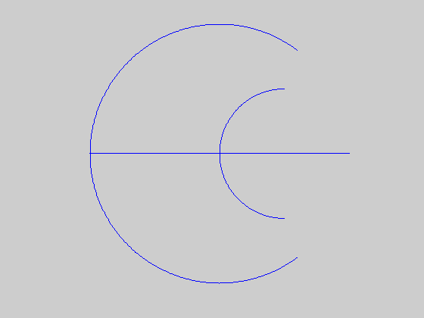These will make things look better. Re-run your code. You should now see 2 circles and 1 line on your plot.

**\*\*Print out this step for the assignment\*\*** (and yeah, it totally looks like a weird death star coming around into view of Yavin IV.)

You may notice that these don’t quite look like circles. Try increasing the range of the reactance and see if you can complete the circle.

By plotting several trials, we see that this will *eventually* be a circle. We know the rightmost edge of the circle should touch the point (1,0). The leftmost point of the circle should cross the real line at the value of the reflection coefficient when the load is purely real. You need to use a little algebra at this point to solve for the radius and circle center. After that, it's a straightforward method to plot the set of circles.

**Normalized Impedances**

Before going any further, it is time to discuss the normalized Smith chart. All reflection coefficients should fall within the unit circle. This is true for any combination of passive loads and any characteristic impedance. To aid us in plotting and discussing values, we often normalize our impedances before plotting. This is equivalent to dividing our reflection coefficient by the characteristic impedance $Z_{0}$. The result is $Γ = \frac{(Z – 1) }{(Z+1)}$ where Z is the load impedance divided by the characteristic impedance $Z= {Z_{L}}/{Z_{0}}$. For example — If $Z_{L}= 150$ and $Z_{0}= 50$, then the normalized Z would be 3.

To really start making your Smith chart, write your function to plot the real line and circles of constant resistance for values of R = [0, 10, 25, 50, 100, 200] Ohms. These are not normalized! The normalized resistances are R = [0, 0.2, 0.5, 1, 2, 4].

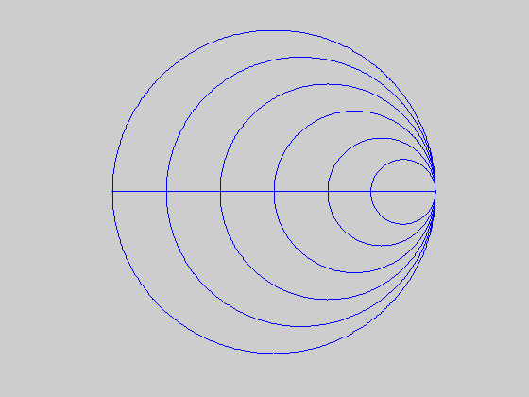

**\*\* Print out your Chart for the assignment\*\***

**Adding the Curves of Constant Reactance**

Now repeat the process for the curves of constant reactance.

Hold reactance constant at X=50 (or normalized to X=1) and sweep the resistance from 0 ohms to 100 ohms in 500 steps.

For now, include

1. A curve for X=150 with R varying from 0 to 100.
2. A curve for X=50 with R varying from 0 to 100.
3. A curve for X=10 with R varying from 0 to 1000.

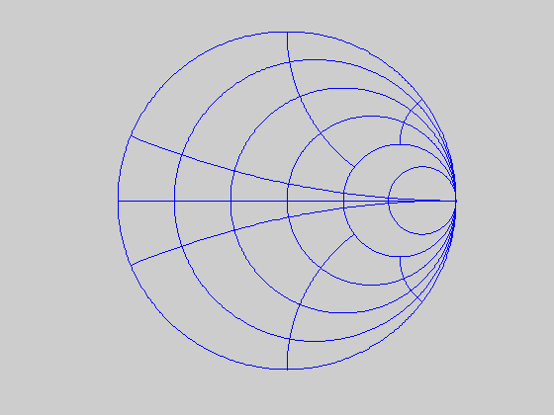Hmm, something’s not right here. There’s nothing below the real line! Have your plot show the curves below the real line.

**\*\* Print out your plot for the assignment\*\***

These are actually circles too! In fact, it’s not too hard to derive the equations for these circles. Remember that the reflection coefficient is an impedance that consists of a real and imaginary component. We normalize this to the characteristic impedance, and find an expression for Gamma. However, Gamma (the reflection coefficient) itself is complex and has a real part A and an imaginary part B, or $Γ=A+jB.$



From here, we separate out the real and imaginary and find values for A and B. If we solve for R and plug back in the 2nd equation, we find



which is an expression for the circles of constant resistance we have already plotted. Nice work on your algebra from a few minutes ago! Your radius and center should match this expression.

If instead, we first solve for X above and then plug it back into an equation, we find that



which gives the expression for a circle of constant reactance. Note that although the constant reactance arcs are complete circles, Smith charts only show (or care about) a small arc of the circle that fits within the unit circle.

For plotting these arcs, it is easier to use these equations. There is an extra credit opportunity if you can derive these equations on your own!

Knowing the circle radius, **r**, and center in the y direction, **cy**,



where VEC is a vector that extends from 0 to 1. Examples include: linspace(0, 1, 500) or [0 : 0.1 : 1]. X is the normalized reactance.

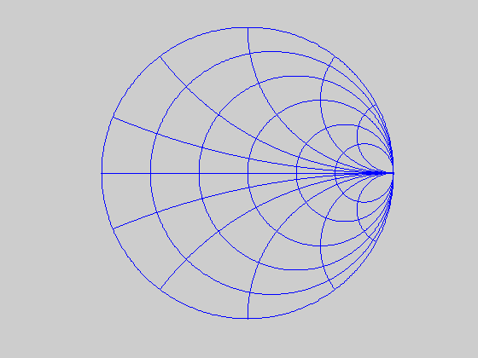Plot arcs of constant reactance for X = 10, 25, 50, 100, 200. These values should be normalized to a system impedance of 50 Ohms. Also, remember to include the curves below the real line!

**\*\* Print out your chart for the assignment \*\***

Now two more requests.

1. Have all of the lines you print be a slightly less dark color such as **[.125, .125, .125].**

and 2) add meaningful labels to your Smith chart such as those shown below. Choose an appropriate fontsize and make sure that the text is readable. I have shown normalized labels, but you may also put the non-normalized labels. (i.e., the center of the chart would read ‘50’ instead of ‘1’.)



**\*\* And one last printout, of this step\*\***

**\*\* Print out your code for the function smithchart.m \*\***

1. A quote from Agilent’s “Understanding the Fundamental Principles of Vector Network Analysis”
2. This is not always the case! Many antennas are not exactly 50 Ohms, and in that case we need to have a load that presents the corresponding impedance for maximum power transfer. Our textbook covers this quite a bit in one of the later chapters.