**Lesson #5: Transforming Impedances**

**Lesson #5 Learning Objectives:** Upon successfully completing this lesson and the associated homework, students will be able to:

1. Explain a Vector Network Analyzer’s (VNA) function.
2. Demonstrate the transformation of a load impedance.
3. 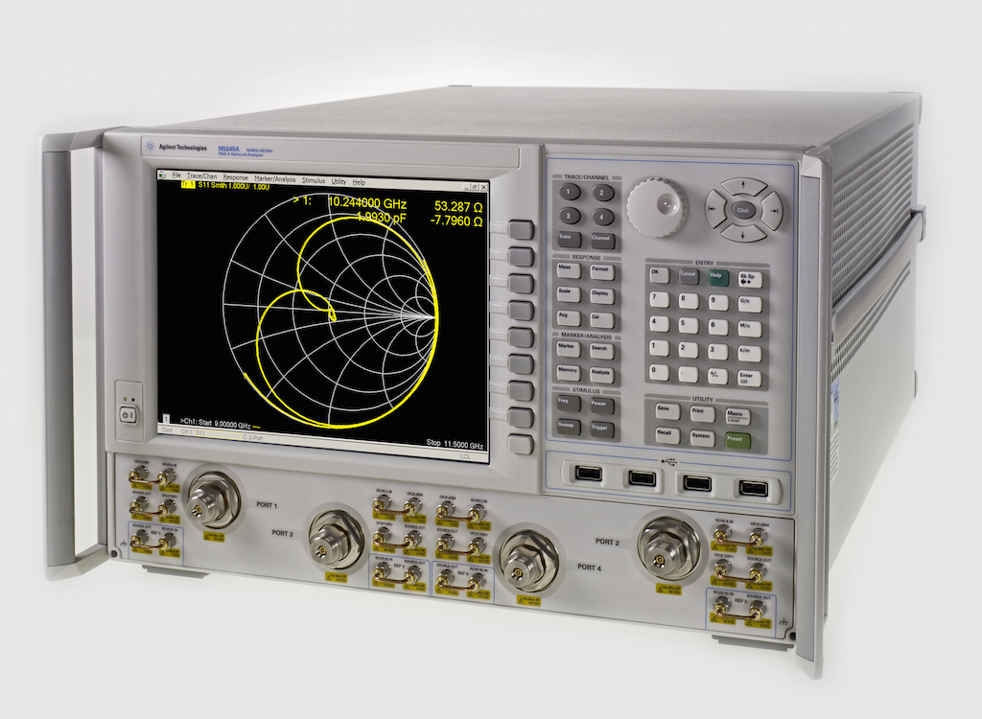Appraise a system using S-parameters
   1. **What is a VNA?**

A VNA (vector network analyzer) is the most important tool of the RF engineer. Seriously, they’re pretty awesome. The shortest definition: They measure the reflection coefficient. But they can do so much more! First let’s look at the VNA’s little cousin.

A **spectrum analyzer** is the scalar version of a VNA. A spectrum analyzer can analyze the signal on a single port and display the output. For instance, with a spectrum analyzer, we could look at each frequency between, say a few Hz and a GHz or two and record the power levels at each frequency bin. If we plot that, we would see the energy or power versus frequency. We could use this to scout for rogue sources such as 24-hour Rick Astley radio stations, or see what range of frequencies are present in our output (i.e., testing the bandwidth of our filter).

A spectrum analyzer has its uses and is a very important tool, but only gives us a magnitude versus frequency. We lose all phase information. That’s where the **VECTOR** network analyzer comes in. We can sweep frequency and take readings, but record both amplitude *and* phase. This forms our vector, and we can now plot this 2D data on the Smith chart.

A VNA typically has 2 ports. It can send power out of either of these ports and measure the return power on either port. For instance, we could send power out on port 1 and measure the received power on port 2. We could observe both the attenuation of our device as well as the phase shift as the signal passes through. Alternatively, we could send out a signal on port 1 and record the signal received back at port 1. This is the reflection coefficient that we have been working with.

* 1. **Working with a VNA**

When using a VNA, we need to carefully connect our device, and then specify a frequency range to measure. Most VNAs have an operating limit. The ones that we have access to can measure from dc to 3 GHz. In this example today, we are going to look at 915 MHz.

An important aspect of VNA usage is calibration and knowing where your calibration plane is. We will look at this next lecture, though. For not just understand that our VNA is set to record the data at the connector of our device.

* 1. **Plotting S1P files**

Most RF tools output the “touchstone SnP” format for the S-parameters. S-parameters are a fancy shorthand notation for what we’ve been talking about already. S stands for scattering, and these parameters can completely characterize a system. In fact, if you know the S-parameters, you don’t really need to know much else about the insides of the device.

The S-parameters are a set of measurements relating the ports of a network. If you have *N* ports, you will have a *N* by *N* matrix and N2 elements. They’re easy though! Just understand this.

*S21*

The first subscript number, in this case the 2, represents the receive port — or the port that we are measuring. The second subscript, in this case the 1, represents the transmit port — or the port that we are sending output on. So, **S21** would be a measurement of how much power is passing through a device and what the phase change is. **S11** would be the measurement of the reflection coefficient of a device connected to port 1. It would send a signal out on port 1, and measure the amplitude and phase coming back.

Whey this all works, is because the VNA knows exactly what signal it is sending and can compare the received signal to this known quantity.

So most tools and vendors will provide the S-parameters in the touchstone format. A lot of tools can work with these files, but its pretty easy to do in MATLAB.

Download the S1P file posted to Blackboard. Open this in Notepad++ and view it for now. The lines that begin with “!” are a comment and can be ignored (at least by the program). The # line is the option line that will define what type of file we have. We can look at this a bit more later. All the data fields then follow. The leftmost column is frequency. The other columns will vary depending on the file specifics. Notice that each field is separated by a space.

Let’s load this in MATLAB.

Use the MATLAB command **dlmread** to convert this file to a matrix. My command looked like this:

**% EXAMPLE OF READING IN S1P FILE FORMAT**

**dir = 'C:\Users\sthoma11\Desktop\;**

**fname = 'Testfile.s1p';**

**H = dlmread([dir, fname], ' ', 3, 0);**

**f = H(:, 1);**

**x = H(:, 2);**

**plot(f, x);**

Look at the command and understand what this is doing.

When you plot this file, you may notice it looks a little funny, like random data. That’s because this is not S-parameter data. Use the **char** command, **char(x)**, to display the ASCII-encoded data. You’re welcome.

With our VNA, we will have our data in .s1p formatted files. The measurement I’m going to take is a shunt 22 Ohm resistor. Where do we expect the reflection coefficient to be? Our VNA has a source impedance of 50 ohms and we are using a 50 ohm cable.

I am going to post this file to Blackboard, and I want you to plot the reflection coefficient on your smithchart. To do that, you will need a couple more pieces of information.

This VNA records the data as dB (decibel) and angle. First we need to convert the dB values to linear magnitude values.

$$mag={10}^{dB/20 }$$

Then we polar coordinates we need to convert to Cartesian. We know the angle and the magnitude. Draw the triangle, and you should hopefully remember your trig to be able to work this one out. Once you plot your file, it should match what we see on the screen from our VNA.

* 1. **Adding some impedance to the mix**

Now comes an interesting question. What happens when we add some impedance? I have a series inductor that I want to add. Where will it go?

Your task:

Play with adding in series L and C, and shunt L and C (i.e., series L,C and parallel L,C) and watch which direction increasing L moves and which direction increasing C moves. Draw a quick sketch to show which direction these move. This will be important.

Increasing series L moves:

Increasing series C moves:

Increasing shunt L moves:

Increasing shunt C moves:

At this point, it may make sense to introduce the admittance chart. The Smith chart we’ve been dealing with shows what happens for series impedances. However, if we just reverse this, we can draw the impedance Smith chart and admittance Smith chart on the same axes.

Typically these are drawn with slightly different colors to distinguish the lines. My **smithchart.m** function accepts 1 variable that I use to modify the color of all my plots. You may also find it necessary to modify your function with another input variable so it only draws the text labels once. Nonetheless, play with **AND MODIFY AS NEEDED** this code to create a Smith admittance and impedance chart. An example output (with no text) is shown to the right.

**% makes both impedance and admittance charts**

**figure(1);clf;**

**smithchart_work([.5 0 0 ], 0); % 0 for no text**

**set(gca, 'xdir', 'reverse');**

**hax = axes;**

**smithchart_work(.125 * [1 1 1], 5); % 1 for text**

I have highlighted the important lines. This is just a hack to flip the plot about on the y-axis. Looking at the admittance chart (the red one), what lines will adding in a parallel L or C follow?

See, this Smith chart can quickly tell you A LOT right away!

Where do you expect a 10 nH series inductor to move the impedance to (at 915 MHz)?

* 1. **You can transform any impedance!**

By just using L and C, you can move your load impedance and transform it to any other impedance! This may sound crazy, and it kind of us. You can rotate a 50 Ohm resistor to appear as a 100 Ohm resistor. Or anything else!

Your task:

1. Assume a 50-Ohm system. You have a load that is Zl = 50 – j200. Using a combination of L and C, transform this impedance to be 20 + j10. You can use as many elements as you need. I recommend tracing the circles on the Smith chart to get a guess of which way you need to move. Draw the network that performs this combination.
2. Assume a 50-Ohm system. You have a load that is Zl = 105 + j80. Using a combination of L and C, transform this impedance to be 5 + j10. Draw the network that performs this combination.