**Lesson #11: Propagation and Link Budgets**

**Lesson #11 Learning Objectives:** Upon successfully completing this lesson and the associated homework, students will be able to:

1. Calculate the received power and link margin for a wireless link.
2. Design a wireless link to meet the required link margin.
3. Calculate the received power using the Friis model.
4. Calculate and plot the effects of multipath interference on signal transmission
   1. **Free space path loss**

Below is a pretty fantastic picture from Wikipedia[1] that pretty much completely explains why signals fade, or drop in power as you move away from the transmitter. Go ahead, look at it and think about it.

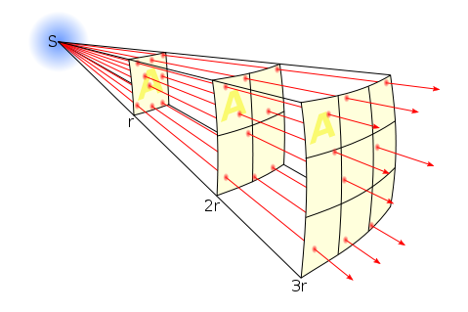

No seriously, think about it and try to explain to someone next to you what it’s trying to say.

The only problem with the picture (or at least one problem with the picture) is that it models a point source and shows charge density spreading as you move away. Point sources are typically uniform and isotropic (meaning, not affected by direction). Antennas, on the other hand, are usually directional. Keep in mind that antennas don’t actually boost the signal they are transmitting, they just concentrate the signal in a particular direction.

So the summary is that an antenna radiates a signal out into freespace. As this signal travels away from the antenna, it spreads out in a sphere. What is the area of the surface of a sphere?  [m2]. The total power that the antenna radiates is distributed over this spherical surface around the antenna (albeit with some peaks and valleys from the radiation pattern) that keeps expanding.

If we know the frequency we are using, for a given distance we can find how much of our power is lost due to the spherical expansion. The power is not lost, but for a given receiving area, only a portion of the power can be recovered. The rule-of-thumb is that the path loss is  for a distance in km and a frequency MHz. This is pretty confusing to look at. First of all, its in deciBels which is not a normal unit. Second, we need units in kilometers and Megahertz, two nonstandard units. Finally, there’s a constant of 32.45 thrown in there. Yikes!

We will develop a better method a little later. Let’s make some sense of the path loss.

* 1. **Using Path Loss in Calculations**

The basic idea for planning a wireless transmission, or link, is to sum all the gains or amplifications and subtract all the losses. If the result is higher than your required minimum power level, then you will have a successful transmission. Let’s assume we have the following system.

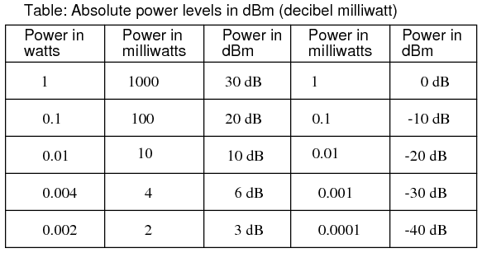For the rest of this we will be using dBm as our metric – deciBels referenced to 1 mW. The table shows typical conversions. Basically,   
0 dBm is 1 mW. |  
30 dBm is 1 W.   
-10 dBm is 0.1 mW.

Every 10 dB, we change an order of magnitude. Every 3 dB, we double power. For instance, how many Watts is +46 dBm of power?

Well, we can quickly see that +30 dBm is 1 Watt. So, we are 1 order of magnitude above 1 Watt. So we are at 10 Watts. Then we need to add 6 more dBm. To add 3 dBm means a doubling of power, so we are at +43 dBm = 20 Watts. Then we need to add 3 more dBm and we find that +46 dBm is 40 Watts. That’s the basics of the dB scale. You can quickly get an idea or make a conversion when needed.

Let’s assume we have an RF source that is connected through a +10 dB amplifier and cable of loss 2 dB to an antenna with a gain of 10 dBi. We are transmitting at 915 MHz to a receiver 1000 m away. The receiver antenna has a gain of 10 dBi. The receiver must receive at least -90 dBm of power, or else it will not work. What is the minimum transmit power do we need?

* 1. **The Friis Transmission Model**

While this mathematically works, it can be a bit confusing. The Friis transmission model is used to predict the performance of wireless links transmitted over line-of-sight. As we saw, the power per unit area (W/m2) will grow lower as we move away from the source due to spherical expansion. The same power is now being distributed over some surface of area 4 *pi * radius. Mathematically, this is power density [W/m2] is  where r is the distance away from our source. If we include the directional gain that comes from our antenna, we just need a small modification: .

A receiving antenna will have an effective aperture, or an effective area. When the spherical wavefront intersects this antenna, the power (watts / m2) that the receiving antenna absorbs will be related to the area, or slice of the sphere. Mathematically, this is  where lambda is the free-space wavelength and Gr is the receiving antenna gain. It is a measure of antenna effectiveness or efficiency.

Putting this all back together, for a given power being fed to a transmit antenna, we can predict the power received by an antenna at its end terminals. The Friis equation is .

If we run the same experiment from above, we will see the same answer. If we run the same experiment *backwards* (meaning change the direction of where we send the signal), we will also get the same result. This assumes we have antennas that are pointing towards each other optimally.

* 1. **Calculations with the Friis Transmission Model**

We have two antennas in a hallway. Each antenna has a gain of 6 dBi. A transmitter is transmitting 1 milliwatt (0 dBm). Plot the received power from 3 to 25 meters.

The antennas are placed 3 meters above the ground. Include the path and plot the results when two paths are modeled. (You must do phasor addition and calculate the phase of the received signal for the two paths at the receiver. It will either be constructive or destructive interference. Calculate the free-space path loss for each ray to calculate the new amplitude

Now assume that the antennas are also 5 m below the ceiling. Plot the three-path model. How does these compare to the line-of-sight model?

1. Edit it to your hearts’ content at https://en.wikipedia.org/wiki/File:Inverse_square_law.svg