ECE 490 – Wireless Computing Assignment #02 – Transforming Impedances

Due: Start of Wednesday’s Class Name: _______________________

Honor Code: Name: _______________________

______________________________________________________________________________

______________________________________________________________________________

_______________________ _______________________
Signature Signature

For the following 3 questions, form a matching network that will transform the load impedance (the circle) to appear as the specified impedance (the x). Use only L and C components. Use the contours and lines of the Smith chart to first guess your topology (i.e., series L followed by shunt C) that will move the impedance. Estimate the values for these, and validate with a computer tool. Assume a 50-Ohm characteristic impedance and measurement frequency of 915 MHz. Draw your network (you do not need to turn in plots).

- [4 pts] What network will transform Z_{L} = 10 – j25 to appear as Z_{new} = 10 + j100. 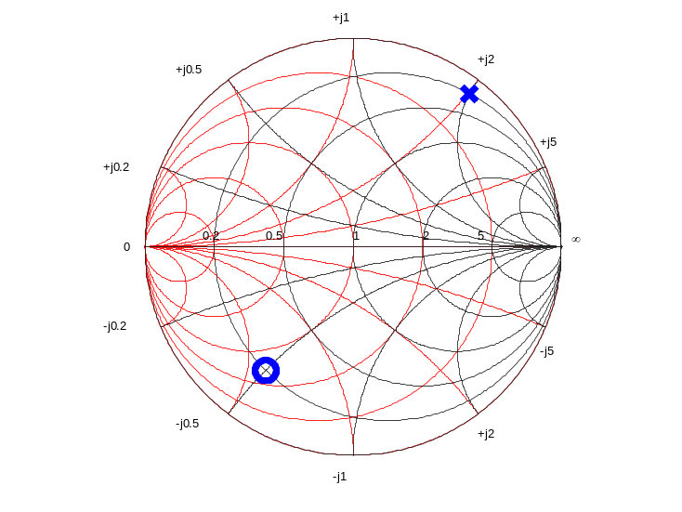
- [4 pts] What network will transform Z_{L} = 25 + j25 to appear as Z_{new} = 50 – j50. 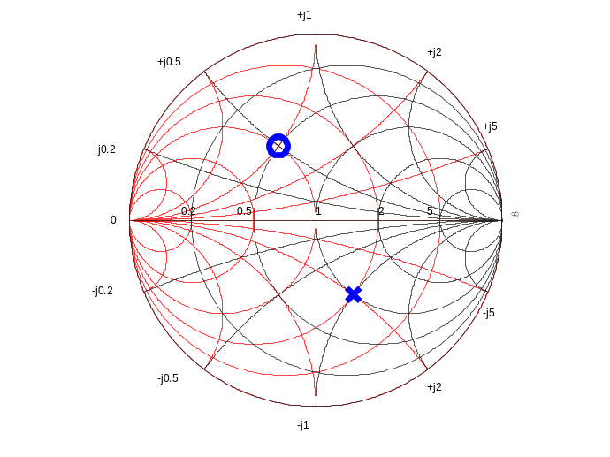

- [4 pts] What network will transform Z_{L} = 100 + j250 to appear as Z_{new} = 12.5 – j12.5. 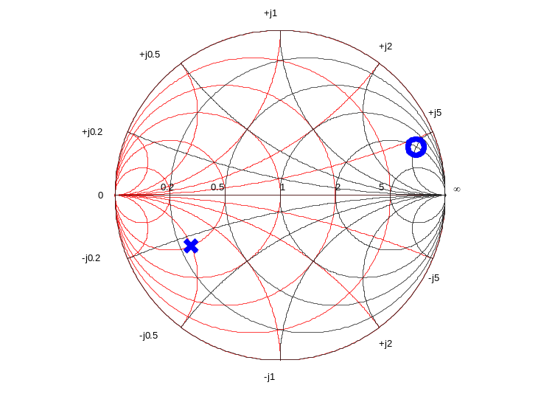

- [20 pts] MATLAB ASSIGNMENT. Download the S1P file from Blackboard. This is the measured reflection coefficient from the boards we will be using later this semester. To use them, we need to design a circuit that will transform their impedance from the measured values to appear as 50 Ohms. We will design around a single frequency of 915 MHz.

- (5 pts) From the file, determine what the measured load impedance is at (or near) 915 MHz in Ohms. Do not report gamma! Convert the data to a load impedance in Ohms (z = real + j*imaginary).

Zl = _______________ +j ______________ Ohms

- (5 pts) Using either 2 or 3 of the components listed below, design a transformation network that will bring the network to be as close as possible to 50 Ohms for 915 MHz. (Hint: there are only a few combinations possible with the 3 elements. Knowing which way these will move the impedance, estimate the network you think will work. You can first ignore Q and, later test Q in the next step.)

Draw your network:

- (10 pts) Now, apply the network to the downloaded S1p data set. For each frequency row in the file, calculate what the new impedance will be with the transformation network included. Hint: Find the impedance of your capacitors / inductors at each frequency, remembering to include the frequency-dependent Q value. Combine the L/C impedances with the measured load impedance from the data set being careful when to combine in series and parallel.

Then find the gamma value for each new, transformed impedance and plot on the Smith chart.

The reflection coefficient at 915 Mhz is: Г = __________________________

Components available:

All Capacitors have a Q of 200. All inductors have a Q of 20.

Capacitor:
10 pF

Inductors:
10 nH, 28 nH

