ECE 490 – Wireless Computing Assignment #04 – Path Loss and Multipath

Due: Start of Wednesday’s Class Name: _______________________

Name: _______________________ Name: _______________________

Honor Code:

______________________________________________________________________________

______________________________________________________________________________

_______________________ _______________________
Signature Signature
You may work with a partner on this assignment. However, you may share your data from the antenna experiment with other groups since you took this data together.

- (5 points) Decibel conversion. Fill in the following:

a)
+30 dBm = ________________ W

= ________________ mW

b)
–30 dBm = ________________ W

= ________________ mW

c)
+17 dBm = ________________ W

= ________________ mW

d)
A –3 dBm signal is passed through an amplifier with a gain of 20 dB. What is the output power in Watts?

e)
A 10 mW signal is passed through an amplifier with a gain of 20 dB. What is the output power in Watts?

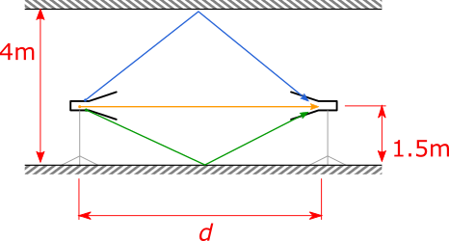
- (10 points total) There are two antennas in a hallway. Each antenna is 1.5 meters off of the ground and facing each other. The ceiling is 4 meters above the ground. The left antenna is transmitting at 915 MHz with a power of 27 dBm (0.5 Watts). Each antenna has a gain of 6 dBi. Plot the power level received at the other antenna as distance varies from 3 to 15 meters as outlined below. The y-axis for power level should be in dBm.

- (2 points) Use the Friis transmission model to plot the received power. HINT: It should vary from about -3 dBm down to -20.
- (3 points) The Friis transmission models direct line-of-sight without consdiering any extra interference. Plot the received power when the line-of-sight and a ground bounce is considered. The ground can be assumed to be perfectly reflective.
- (3 points) Plot the received power from line-of-sight, ground bounce, and ceiling bounce (which can also be assumed perfectly reflective).

(1 point) All three plots should be on the same axis. For part c, what is the distance with the lowest received power?
At ____________ m, Pr = ____________ dBm

(1 point) Using what we see in this graph you plotted, explain why I can be in my car at a stoplight and hear the radio perfectly fine. I move just a few inches forward, and my radio drops out.

- (5 points) Plot the data that you measured in class. The plot should be received power versus distance.

- (5 points) Plot the LOS (Friis) prediction for your measured data. Using this model, estimate what you believe to be your antenna’s gain. You will need to either describe how you came to this conclusion, or give some justification why you feel this is correct. (A plot will suffice).

