总体设计

需求规定
说明对本系统的主要的输入输出项目、 处理的功能性能要求， 详细的说明可参见 《需求
分析说明书》。

运行环境

数据库服务器
戴尔
PowerEdge R540
内存 8GB RDIMM, 2666MT/s, 单列 (x1)
硬盘 240GB SSD SATA 读取密集型 6Gbps 512 2.5英寸热插拔硬盘

应用服务器
戴尔
PowerEdge R540
内存 8GB RDIMM, 2666MT/s, 单列 (x1)
硬盘 240GB SSD SATA 读取密集型 6Gbps 512 2.5英寸热插拔硬盘

操作系统
Windows 7/vista/10

数据库管理系统
MySQL 8.0

开发工具
平台： Windows10、Linux
开发工具：IDEA
测试环境
Windows 7/vista/10

基本设计概念和处理流程
本系统共有五个角色对象，游客、管理员、医院/医疗组织、捐赠者、监管人员。游客是权限最低的目标人群，只可以在主页范围内查看本组织相关的专栏、新闻及公示数据等信息。管理员是权限最高的用户，可以管理所有的用户、管理捐赠和医院需求相关的各项数据，并可以发布专栏、新闻和公示数据等。医院/医疗组织是本系统最终受益用户群体，可提交口罩、防护服需求，并接收相应的医疗物资，医院/医疗组织有义务报备各项物资储备量和已使用的物资的详细使用情况。捐赠者则可以报备一次捐赠信息以及查看自己捐赠的物资的使用情况。监管人员原则上由监管部门官方人员组成，监管人员对捐赠的信息进行核实、对医院提出的需求和报备的使用情况进行审查核实、对公示数据信息进行审查。

数据模型
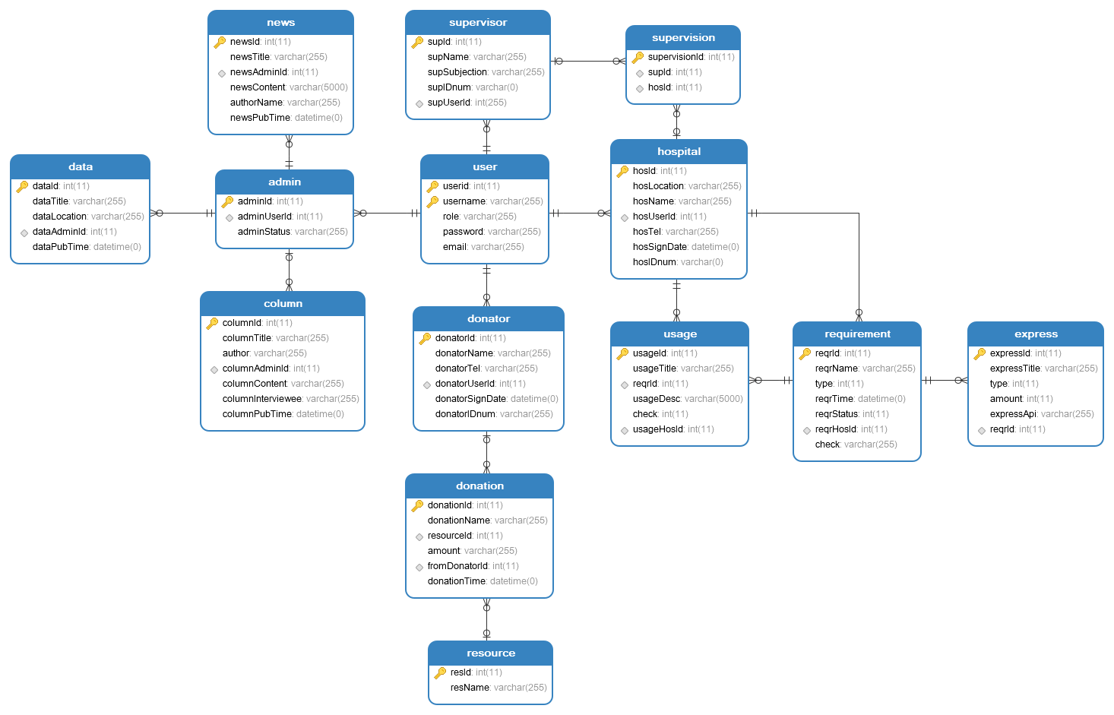
总体流程
（由于图片尺寸问题，详情见本文档附录“总体流程.pdf”）
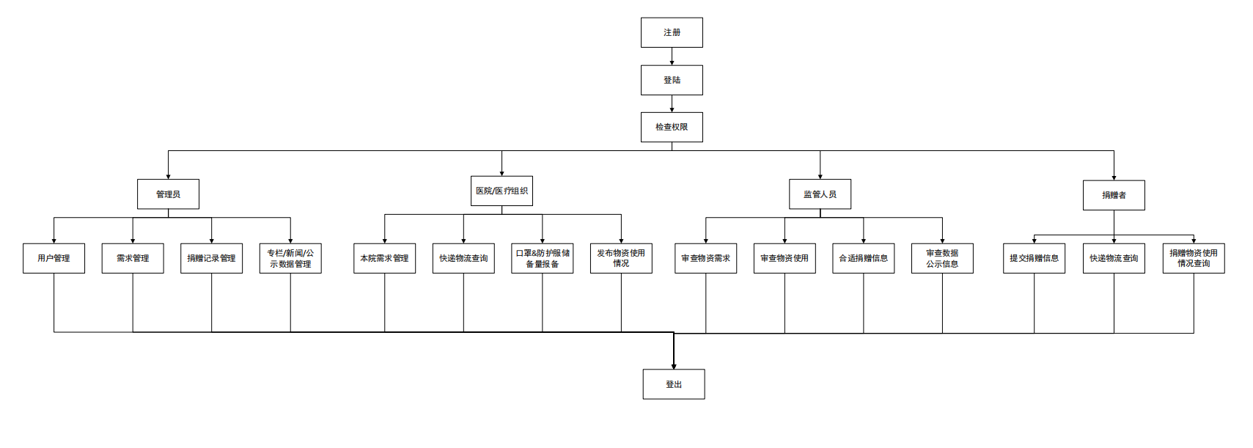

医院/医疗组织
- 医院在输入用户名和密码后，将传到系统后台，后台校验密码正确后，医院用户可以登陆系统。
登陆系统后：
- 医院可以在系统内提出需求，表单包含需求的详细信息内容（所需种类、所需数量等），表单提交到系统后台，监管人员对于各项需求进行审查，审查合理通过后反馈审查通过信息到系统后台，系统后台接收到监管人员的审查通过后，发送可满足需求的信息到医院用户账号。
- 在向医院运送相应的医疗物资时，医院用户账号可以在系统中提出查询物流信息请求，系统后台接收到请求后，向物流公司的接口发送查询请求并返回数据，再向医院组织账号前端返回相应的数据，医院账号前端接收到物流数据信息后，在前端展示。
- 在使用物资后，医院需向系统后台提供自己的物资使用情况，向后端提交详细信息表单数据，同时需要监管人员审核，监管人员进行实际审核后，反馈审核通过信息，后端存储使用情况信息并向医院账号反馈报备成功信息。
- 医院账号提交医疗物资储备量，提交表单到后台，后台存储储备信息并返回储备成功信息。
医院/医疗组织系统使用流程时序图
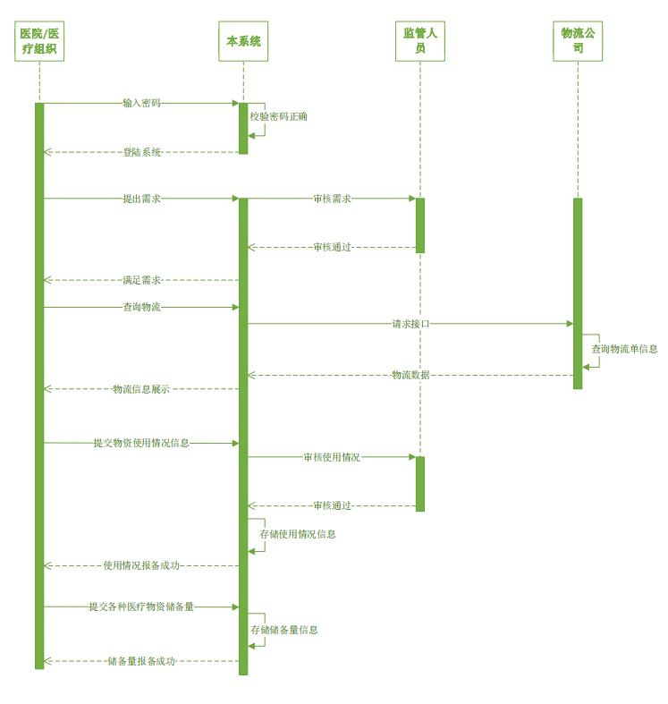
数据库详细设计
Admin表：管理员信息表
Column表：专栏数据存储表
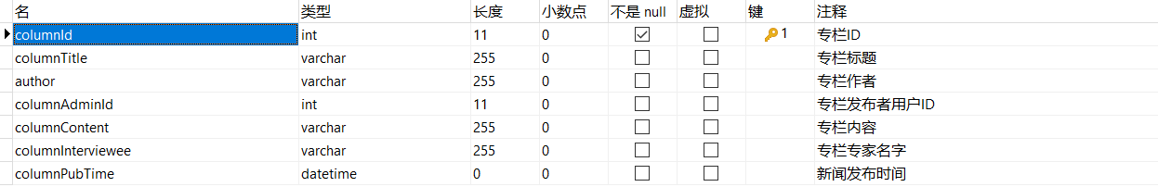
Data表：数据公示存储表
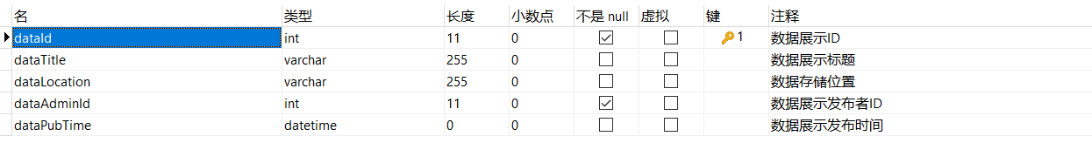
Donation表：捐赠信息数据存储表
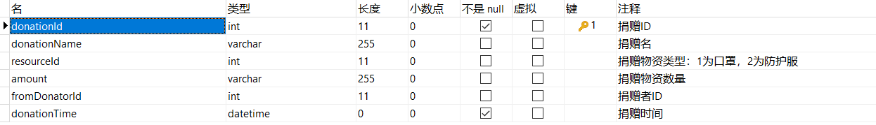
Donator表：捐赠者信息表
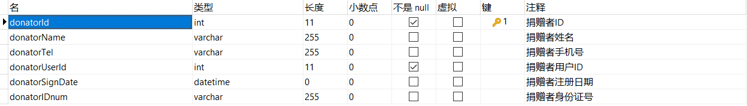
Express表：快递信息表
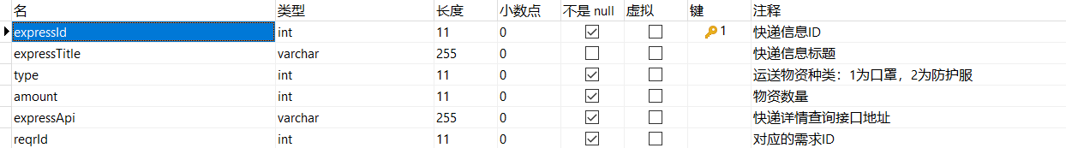
Hospital表：医院信息表
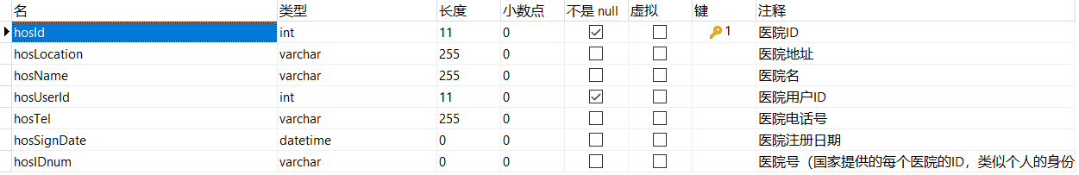
News表：新闻信息表
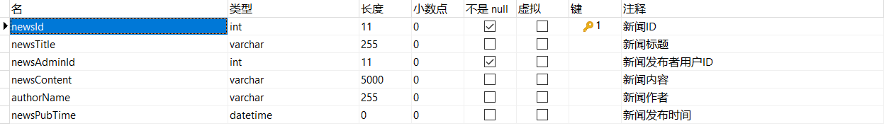
Requirement表：医院需求信息存储表
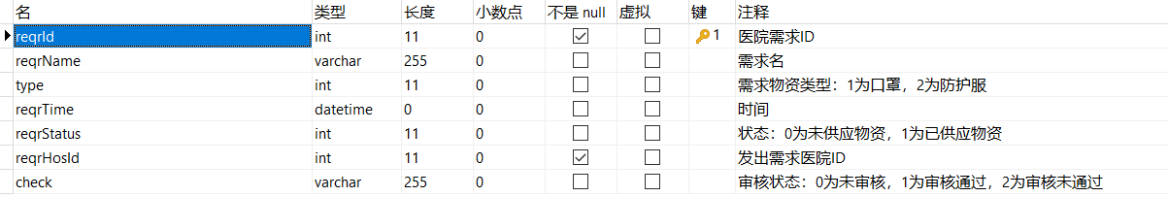
Resource表：资源种类表
Donsupervision表：捐赠信息核实表
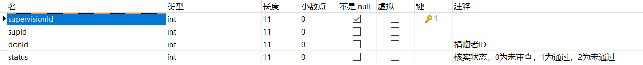
Hossupervision表：医院监督表
Supervisor表：监管人员信息表
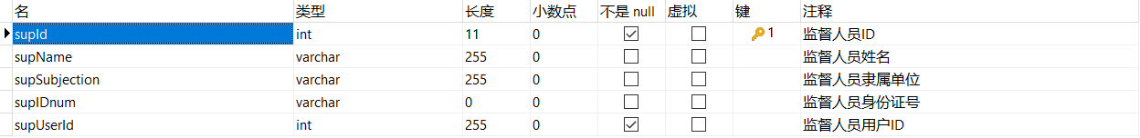
Usage表：使用情况信息表
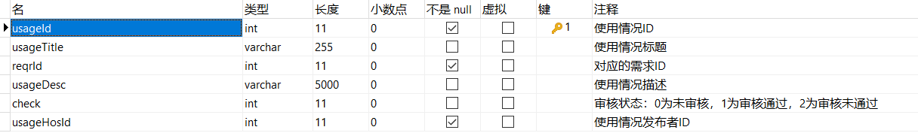
User表：用户信息表
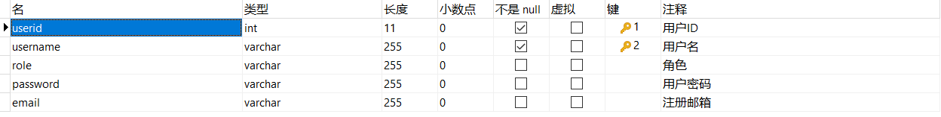
Storage表：存储量报备表
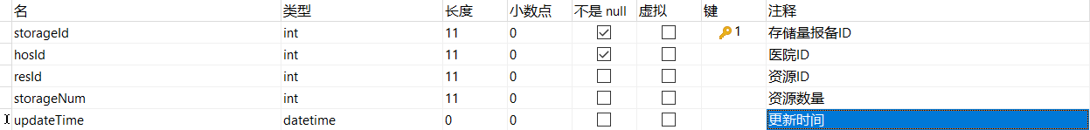
数据库SQL脚本
Admin
CREATE TABLE `admin` (
`adminId` int(11) NOT NULL COMMENT '管理员ID',
`adminUserId` int(11) NOT NULL COMMENT '管理员用户名',
`adminStatus` varchar(255) CHARACTER SET utf8 COLLATE utf8_general_ci NULL DEFAULT NULL COMMENT '管理员状态',
PRIMARY KEY (`adminId`) USING BTREE,
INDEX `16`(`adminUserId`) USING BTREE,
INDEX `adminId`(`adminId`) USING BTREE,
INDEX `adminId_2`(`adminId`) USING BTREE,
CONSTRAINT `16` FOREIGN KEY (`adminUserId`) REFERENCES `user` (`userid`) ON DELETE CASCADE ON UPDATE CASCADE
) ENGINE = InnoDB CHARACTER SET = utf8 COLLATE = utf8_general_ci ROW_FORMAT = Dynamic;

Column
CREATE TABLE `column` (
`columnId` int(11) NOT NULL COMMENT '专栏ID',
`columnTitle` varchar(255) CHARACTER SET utf8 COLLATE utf8_general_ci NULL DEFAULT NULL COMMENT '专栏标题',
`author` varchar(255) CHARACTER SET utf8 COLLATE utf8_general_ci NULL DEFAULT NULL COMMENT '专栏作者',
`columnAdminId` int(11) NULL DEFAULT NULL COMMENT '专栏发布者用户ID',
`columnContent` varchar(255) CHARACTER SET utf8 COLLATE utf8_general_ci NULL DEFAULT NULL COMMENT '专栏内容',
`columnInterviewee` varchar(255) CHARACTER SET utf8 COLLATE utf8_general_ci NULL DEFAULT NULL COMMENT '专栏专家名字',
`columnPubTime` datetime(0) NULL DEFAULT NULL COMMENT '新闻发布时间',
PRIMARY KEY (`columnId`) USING BTREE,
INDEX `5`(`columnAdminId`) USING BTREE,
CONSTRAINT `5` FOREIGN KEY (`columnAdminId`) REFERENCES `admin` (`adminid`) ON DELETE CASCADE ON UPDATE CASCADE
) ENGINE = InnoDB CHARACTER SET = utf8 COLLATE = utf8_general_ci ROW_FORMAT = Dynamic;

Data
CREATE TABLE `data` (
`dataId` int(11) NOT NULL COMMENT '数据展示ID',
`dataTitle` varchar(255) CHARACTER SET utf8 COLLATE utf8_general_ci NULL DEFAULT NULL COMMENT '数据展示标题',
`dataLocation` varchar(255) CHARACTER SET utf8 COLLATE utf8_general_ci NULL DEFAULT NULL COMMENT '数据存储位置',
`dataAdminId` int(11) NOT NULL COMMENT '数据展示发布者ID',
`dataPubTime` datetime(0) NULL DEFAULT NULL COMMENT '数据展示发布时间',
PRIMARY KEY (`dataId`) USING BTREE,
INDEX `6`(`dataAdminId`) USING BTREE,
CONSTRAINT `6` FOREIGN KEY (`dataAdminId`) REFERENCES `admin` (`adminid`) ON DELETE CASCADE ON UPDATE CASCADE
) ENGINE = InnoDB CHARACTER SET = utf8 COLLATE = utf8_general_ci ROW_FORMAT = Dynamic;

Donation
CREATE TABLE `donation` (
`donationId` int(11) NOT NULL COMMENT '捐赠ID',
`donationName` varchar(255) CHARACTER SET utf8 COLLATE utf8_general_ci NULL DEFAULT NULL COMMENT '捐赠名',
`resourceId` int(11) NULL DEFAULT NULL COMMENT '捐赠物资类型：1为口罩，2为防护服',
`amount` varchar(255) CHARACTER SET utf8 COLLATE utf8_general_ci NULL DEFAULT NULL COMMENT '捐赠物资数量',
`fromDonatorId` int(11) NULL DEFAULT NULL COMMENT '捐赠者ID',
`donationTime` datetime(0) NOT NULL COMMENT '捐赠时间',
PRIMARY KEY (`donationId`) USING BTREE,
INDEX `1`(`fromDonatorId`) USING BTREE,
INDEX `13`(`resourceId`) USING BTREE,
CONSTRAINT `1` FOREIGN KEY (`fromDonatorId`) REFERENCES `donator` (`donatorid`) ON DELETE CASCADE ON UPDATE CASCADE,
CONSTRAINT `13` FOREIGN KEY (`resourceId`) REFERENCES `resource` (`resid`) ON DELETE CASCADE ON UPDATE CASCADE
) ENGINE = InnoDB CHARACTER SET = utf8 COLLATE = utf8_general_ci ROW_FORMAT = Dynamic;

Donator
CREATE TABLE `donator` (
`donatorId` int(11) NOT NULL COMMENT '捐赠者ID',
`donatorName` varchar(255) CHARACTER SET utf8 COLLATE utf8_general_ci NULL DEFAULT NULL COMMENT '捐赠者姓名',
`donatorTel` varchar(255) CHARACTER SET utf8 COLLATE utf8_general_ci NULL DEFAULT NULL COMMENT '捐赠者手机号',
`donatorUserId` int(11) NOT NULL COMMENT '捐赠者用户ID',
`donatorSignDate` datetime(0) NULL DEFAULT NULL COMMENT '捐赠者注册日期',
`donatorIDnum` varchar(255) CHARACTER SET utf8 COLLATE utf8_general_ci NULL DEFAULT NULL COMMENT '捐赠者身份证号',
PRIMARY KEY (`donatorId`) USING BTREE,
INDEX `11`(`donatorUserId`) USING BTREE,
INDEX `donatorId`(`donatorId`) USING BTREE,
INDEX `donatorId_2`(`donatorId`) USING BTREE,
INDEX `donatorId_3`(`donatorId`) USING BTREE,
INDEX `donatorId_4`(`donatorId`) USING BTREE,
CONSTRAINT `11` FOREIGN KEY (`donatorUserId`) REFERENCES `user` (`userid`) ON DELETE CASCADE ON UPDATE CASCADE
) ENGINE = InnoDB CHARACTER SET = utf8 COLLATE = utf8_general_ci ROW_FORMAT = Dynamic;

Express
CREATE TABLE `express` (
`expressId` int(11) NOT NULL COMMENT '快递信息ID',
`expressTitle` varchar(255) CHARACTER SET utf8 COLLATE utf8_general_ci NULL DEFAULT NULL COMMENT '快递信息标题',
`type` int(11) NOT NULL COMMENT '运送物资种类：1为口罩，2为防护服',
`amount` int(11) NOT NULL COMMENT '物资数量',
`expressApi` varchar(255) CHARACTER SET utf8 COLLATE utf8_general_ci NOT NULL COMMENT '快递详情查询接口地址',
`reqrId` int(11) NOT NULL COMMENT '对应的需求ID',
PRIMARY KEY (`expressId`) USING BTREE,
INDEX `9`(`reqrId`) USING BTREE,
CONSTRAINT `9` FOREIGN KEY (`reqrId`) REFERENCES `requirement` (`reqrId`) ON DELETE CASCADE ON UPDATE CASCADE
) ENGINE = InnoDB CHARACTER SET = utf8 COLLATE = utf8_general_ci ROW_FORMAT = Dynamic;

Hospital
CREATE TABLE `hospital` (
`hosId` int(11) NOT NULL COMMENT '医院ID',
`hosLocation` varchar(255) CHARACTER SET utf8 COLLATE utf8_general_ci NULL DEFAULT NULL COMMENT '医院地址',
`hosName` varchar(255) CHARACTER SET utf8 COLLATE utf8_general_ci NULL DEFAULT NULL COMMENT '医院名',
`hosUserId` int(11) NOT NULL COMMENT '医院用户ID',
`hosTel` varchar(255) CHARACTER SET utf8 COLLATE utf8_general_ci NULL DEFAULT NULL COMMENT '医院电话号',
`hosSignDate` datetime(0) NULL DEFAULT NULL COMMENT '医院注册日期',
`hosIDnum` varchar(0) CHARACTER SET utf8 COLLATE utf8_general_ci NULL DEFAULT NULL COMMENT '医院号（国家提供的每个医院的ID，类似个人的身份证号）',
PRIMARY KEY (`hosId`) USING BTREE,
INDEX `10`(`hosUserId`) USING BTREE,
INDEX `hosId`(`hosId`) USING BTREE,
INDEX `hosId_2`(`hosId`) USING BTREE,
INDEX `hosId_3`(`hosId`) USING BTREE,
INDEX `hosId_4`(`hosId`) USING BTREE,
CONSTRAINT `10` FOREIGN KEY (`hosUserId`) REFERENCES `user` (`userid`) ON DELETE CASCADE ON UPDATE CASCADE
) ENGINE = InnoDB CHARACTER SET = utf8 COLLATE = utf8_general_ci ROW_FORMAT = Dynamic;

News
CREATE TABLE `news` (
`newsId` int(11) NOT NULL COMMENT '新闻ID',
`newsTitle` varchar(255) CHARACTER SET utf8 COLLATE utf8_general_ci NULL DEFAULT NULL COMMENT '新闻标题',
`newsAdminId` int(11) NOT NULL COMMENT '新闻发布者用户ID',
`newsContent` varchar(5000) CHARACTER SET utf8 COLLATE utf8_general_ci NULL DEFAULT NULL COMMENT '新闻内容',
`authorName` varchar(255) CHARACTER SET utf8 COLLATE utf8_general_ci NULL DEFAULT NULL COMMENT '新闻作者',
`newsPubTime` datetime(0) NULL DEFAULT NULL COMMENT '新闻发布时间',
PRIMARY KEY (`newsId`) USING BTREE,
INDEX `4`(`newsAdminId`) USING BTREE,
CONSTRAINT `4` FOREIGN KEY (`newsAdminId`) REFERENCES `admin` (`adminid`) ON DELETE CASCADE ON UPDATE CASCADE
) ENGINE = InnoDB CHARACTER SET = utf8 COLLATE = utf8_general_ci ROW_FORMAT = Dynamic;

Requirement
CREATE TABLE `requirement` (
`reqrId` int(11) NOT NULL COMMENT '医院需求ID',
`reqrName` varchar(255) CHARACTER SET utf8 COLLATE utf8_general_ci NULL DEFAULT NULL COMMENT '需求名',
`type` int(11) NULL DEFAULT NULL COMMENT '需求物资类型：1为口罩，2为防护服',
`reqrTime` datetime(0) NULL DEFAULT NULL COMMENT '时间',
`reqrStatus` int(11) NULL DEFAULT NULL COMMENT '状态：0为未供应物资，1为已供应物资',
`reqrHosId` int(11) NOT NULL COMMENT '发出需求医院ID',
`check` varchar(255) CHARACTER SET utf8 COLLATE utf8_general_ci NULL DEFAULT NULL COMMENT '审核状态：0为未审核，1为审核通过，2为审核未通过',
PRIMARY KEY (`reqrId`) USING BTREE,
INDEX `reqrId`(`reqrId`) USING BTREE,
INDEX `reqrId_2`(`reqrId`) USING BTREE,
INDEX `reqrId_3`(`reqrId`) USING BTREE,
INDEX `reqrId_4`(`reqrId`) USING BTREE,
INDEX `reqrId_5`(`reqrId`) USING BTREE,
INDEX `reqrId_6`(`reqrId`) USING BTREE,
INDEX `reqrId_7`(`reqrId`) USING BTREE,
INDEX `reqrId_8`(`reqrId`) USING BTREE,
INDEX `3`(`reqrHosId`) USING BTREE,
INDEX `reqrId_9`(`reqrId`) USING BTREE,
INDEX `reqrId_10`(`reqrId`) USING BTREE,
CONSTRAINT `3` FOREIGN KEY (`reqrHosId`) REFERENCES `hospital` (`hosid`) ON DELETE CASCADE ON UPDATE CASCADE
) ENGINE = InnoDB CHARACTER SET = utf8 COLLATE = utf8_general_ci ROW_FORMAT = Dynamic;

Resource
CREATE TABLE `resource` (
`resId` int(11) NOT NULL COMMENT '资源ID',
`resName` varchar(255) CHARACTER SET utf8 COLLATE utf8_general_ci NULL DEFAULT NULL COMMENT '资源名称',
PRIMARY KEY (`resId`) USING BTREE,
INDEX `resId`(`resId`) USING BTREE
) ENGINE = InnoDB CHARACTER SET = utf8 COLLATE = utf8_general_ci ROW_FORMAT = Dynamic;

-- ----------------------------
-- Records of resource
-- ----------------------------
INSERT INTO `resource` VALUES (1, '口罩');
INSERT INTO `resource` VALUES (2, '防护服');

Donsupervision
DROP TABLE IF EXISTS `donsupervision`;
CREATE TABLE `donsupervision` (
`supervisionId` int(11) NOT NULL,
`supId` int(11) NULL DEFAULT NULL,
`donId` int(11) NULL DEFAULT NULL COMMENT '捐赠信息ID',
`status` int(11) NULL DEFAULT NULL COMMENT '核实状态，0为未审查，1为通过，2为未通过',
PRIMARY KEY (`supervisionId`) USING BTREE,
INDEX `19`(`supId`) USING BTREE,
INDEX `20`(`donId`) USING BTREE,
CONSTRAINT `19` FOREIGN KEY (`supId`) REFERENCES `supervisor` (`supid`) ON DELETE CASCADE ON UPDATE CASCADE,
CONSTRAINT `20` FOREIGN KEY (`donId`) REFERENCES `donation` (`donationid`) ON DELETE CASCADE ON UPDATE CASCADE
) ENGINE = InnoDB CHARACTER SET = utf8 COLLATE = utf8_general_ci ROW_FORMAT = Dynamic;

Hossupervision
DROP TABLE IF EXISTS `hossupervision`;
CREATE TABLE `hossupervision` (
`supervisionId` int(11) NOT NULL COMMENT '监督ID',
`supId` int(11) NULL DEFAULT NULL COMMENT '监督者ID',
`hosId` int(11) NULL DEFAULT NULL COMMENT '医院ID',
PRIMARY KEY (`supervisionId`) USING BTREE,
INDEX `14`(`supId`) USING BTREE,
INDEX `15`(`hosId`) USING BTREE,
CONSTRAINT `14` FOREIGN KEY (`supId`) REFERENCES `supervisor` (`supid`) ON DELETE CASCADE ON UPDATE CASCADE,
CONSTRAINT `15` FOREIGN KEY (`hosId`) REFERENCES `hospital` (`hosid`) ON DELETE CASCADE ON UPDATE CASCADE
) ENGINE = InnoDB CHARACTER SET = utf8 COLLATE = utf8_general_ci ROW_FORMAT = Dynamic;

Supervisor
CREATE TABLE `supervisor` (
`supId` int(11) NOT NULL COMMENT '监督人员ID',
`supName` varchar(255) CHARACTER SET utf8 COLLATE utf8_general_ci NULL DEFAULT NULL COMMENT '监督人员姓名',
`supSubjection` varchar(255) CHARACTER SET utf8 COLLATE utf8_general_ci NULL DEFAULT NULL COMMENT '监督人员隶属单位',
`supIDnum` varchar(0) CHARACTER SET utf8 COLLATE utf8_general_ci NULL DEFAULT NULL COMMENT '监督人员身份证号',
`supUserId` int(255) NOT NULL COMMENT '监督人员用户ID',
PRIMARY KEY (`supId`) USING BTREE,
INDEX `12`(`supUserId`) USING BTREE,
INDEX `supId`(`supId`) USING BTREE,
INDEX `supId_2`(`supId`) USING BTREE,
CONSTRAINT `12` FOREIGN KEY (`supUserId`) REFERENCES `user` (`userid`) ON DELETE CASCADE ON UPDATE CASCADE
) ENGINE = InnoDB CHARACTER SET = utf8 COLLATE = utf8_general_ci ROW_FORMAT = Dynamic;

Usage
CREATE TABLE `usage` (
`usageId` int(11) NOT NULL COMMENT '使用情况ID',
`usageTitle` varchar(255) CHARACTER SET utf8 COLLATE utf8_general_ci NULL DEFAULT NULL COMMENT '使用情况标题',
`reqrId` int(11) NOT NULL COMMENT '对应的需求ID',
`usageDesc` varchar(5000) CHARACTER SET utf8 COLLATE utf8_general_ci NULL DEFAULT NULL COMMENT '使用情况描述',
`check` int(11) NULL DEFAULT NULL COMMENT '审核状态：0为未审核，1为审核通过，2为审核未通过',
`usageHosId` int(11) NOT NULL COMMENT '使用情况发布者ID',
PRIMARY KEY (`usageId`) USING BTREE,
INDEX `7`(`reqrId`) USING BTREE,
INDEX `8`(`usageHosId`) USING BTREE,
CONSTRAINT `7` FOREIGN KEY (`reqrId`) REFERENCES `requirement` (`reqrid`) ON DELETE CASCADE ON UPDATE CASCADE,
CONSTRAINT `8` FOREIGN KEY (`usageHosId`) REFERENCES `hospital` (`hosid`) ON DELETE CASCADE ON UPDATE CASCADE
) ENGINE = InnoDB CHARACTER SET = utf8 COLLATE = utf8_general_ci ROW_FORMAT = Dynamic;

User
CREATE TABLE `user` (
`userid` int(11) NOT NULL COMMENT '用户ID',
`username` varchar(255) CHARACTER SET utf8 COLLATE utf8_general_ci NOT NULL COMMENT '用户名',
`role` varchar(255) CHARACTER SET utf8 COLLATE utf8_general_ci NULL DEFAULT NULL COMMENT '角色',
`password` varchar(255) CHARACTER SET utf8 COLLATE utf8_general_ci NULL DEFAULT NULL COMMENT '用户密码',
`email` varchar(255) CHARACTER SET utf8 COLLATE utf8_general_ci NULL DEFAULT NULL COMMENT '注册邮箱',
PRIMARY KEY (`userid`, `username`) USING BTREE,
INDEX `userid`(`userid`) USING BTREE
) ENGINE = InnoDB CHARACTER SET = utf8 COLLATE = utf8_general_ci ROW_FORMAT = Dynamic;

SET FOREIGN_KEY_CHECKS = 1;

Storage
DROP TABLE IF EXISTS `storage`;
CREATE TABLE `storage` (
`storageId` int(11) NOT NULL,
`hosId` int(11) NOT NULL,
`resId` int(11) NULL DEFAULT NULL,
`storageNum` int(11) NULL DEFAULT NULL,
`updateTime` datetime(0) NULL DEFAULT NULL,
PRIMARY KEY (`storageId`) USING BTREE,
INDEX `17`(`hosId`) USING BTREE,
INDEX `18`(`resId`) USING BTREE,
CONSTRAINT `17` FOREIGN KEY (`hosId`) REFERENCES `hospital` (`hosid`) ON DELETE CASCADE ON UPDATE CASCADE,
CONSTRAINT `18` FOREIGN KEY (`resId`) REFERENCES `resource` (`resid`) ON DELETE CASCADE ON UPDATE CASCADE
) ENGINE = InnoDB CHARACTER SET = utf8 COLLATE = utf8_general_ci ROW_FORMAT = Dynamic;

