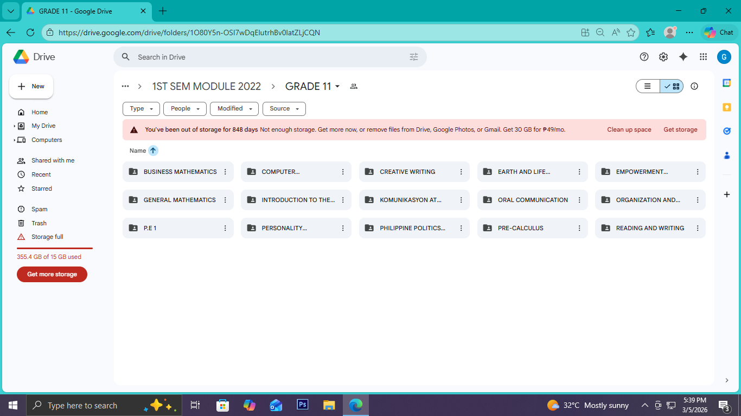
GRADE 11 : Sample Subject Module Compilation

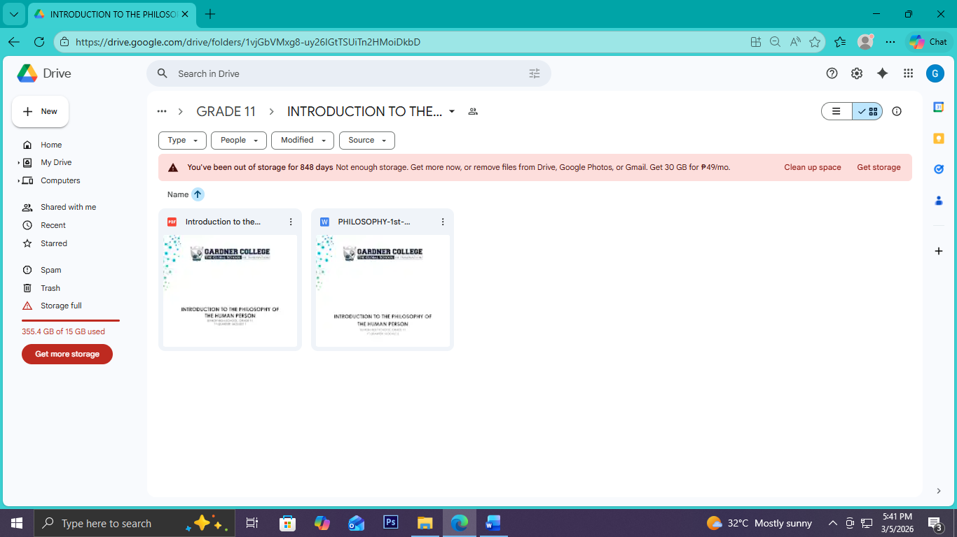

MODULE 1: 1ST AND 2ND QUARTER
MODULE 2: 3rd AND 4th QUARTER
SAMPLE LINK:
https://drive.google.com/drive/folders/1U6V9iwU4pyI8I-EK0YcJRsr9Z_8nXbJm?usp=sharing

GRADE 12 : Sample Subject Module Compilation
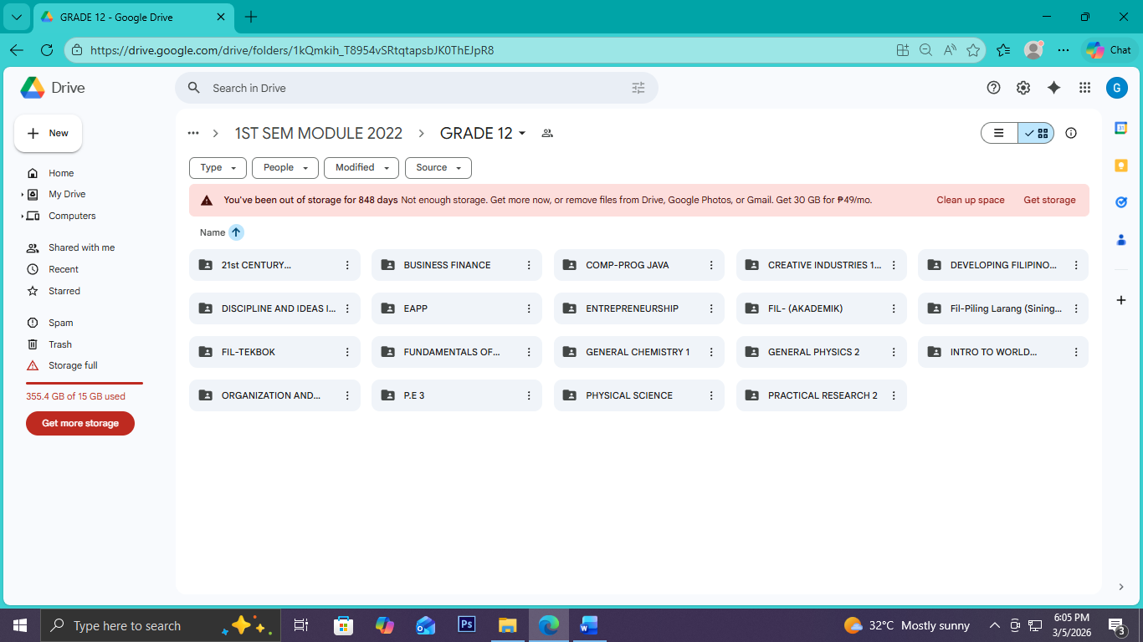

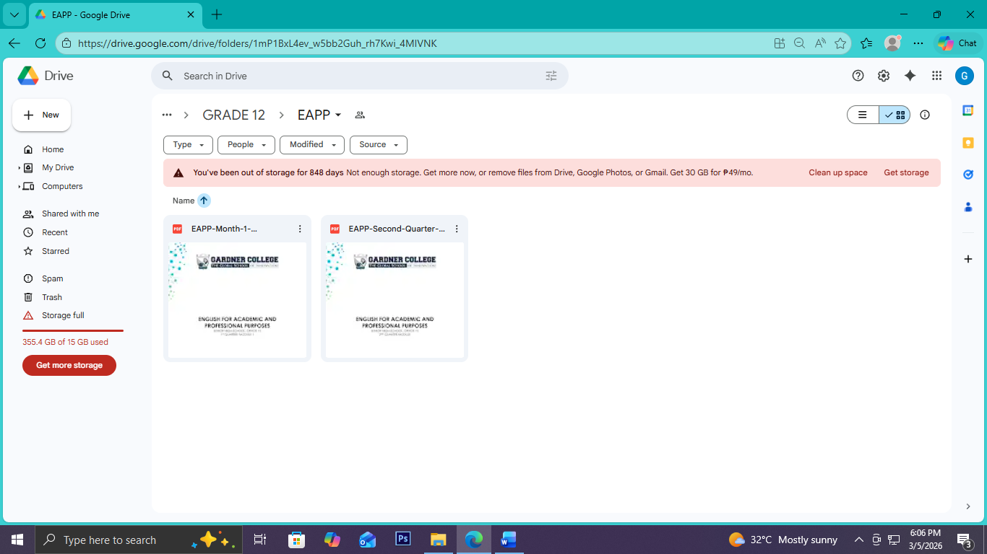

MODULE 1: 1ST AND 2ND QUARTER
MODULE 2: 3rd AND 4th QUARTER

SAMPLE LINK:

https://drive.google.com/drive/folders/1mP1BxL4ev_w5bb2Guh_rh7Kwi_4MIVNK?usp=sharing

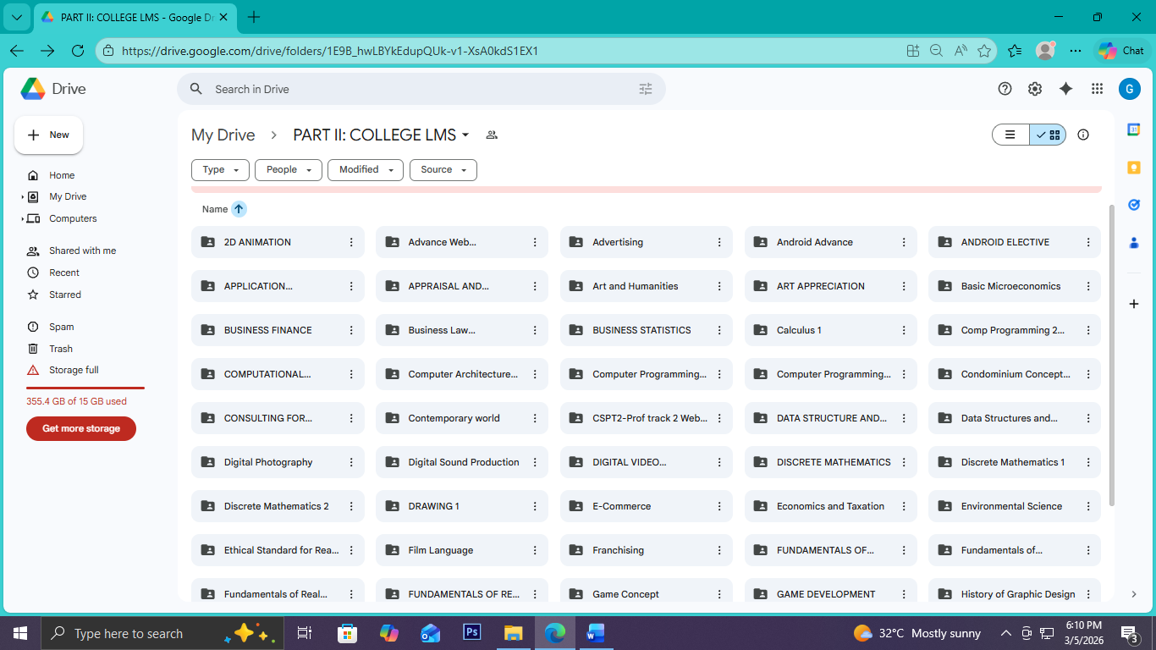
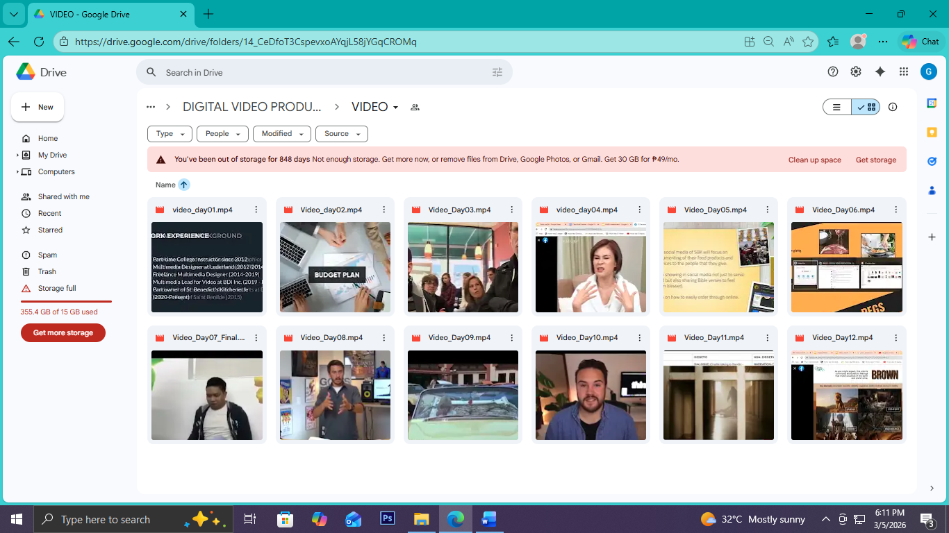

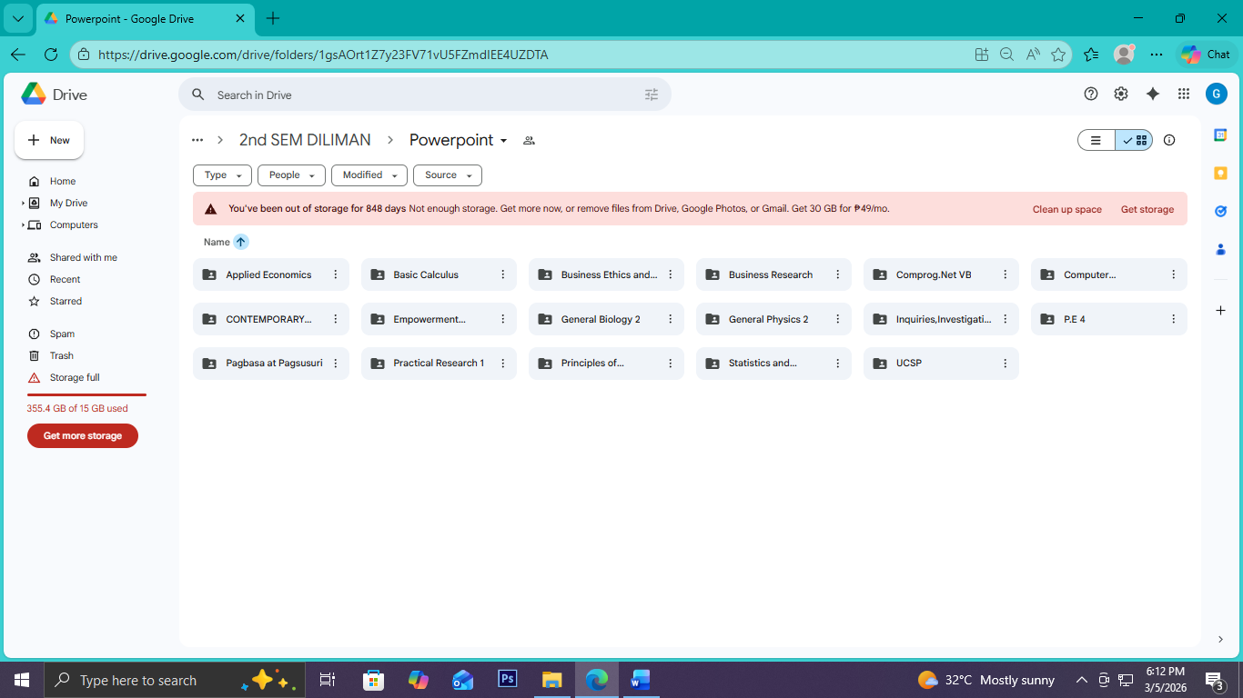

Sample Link:
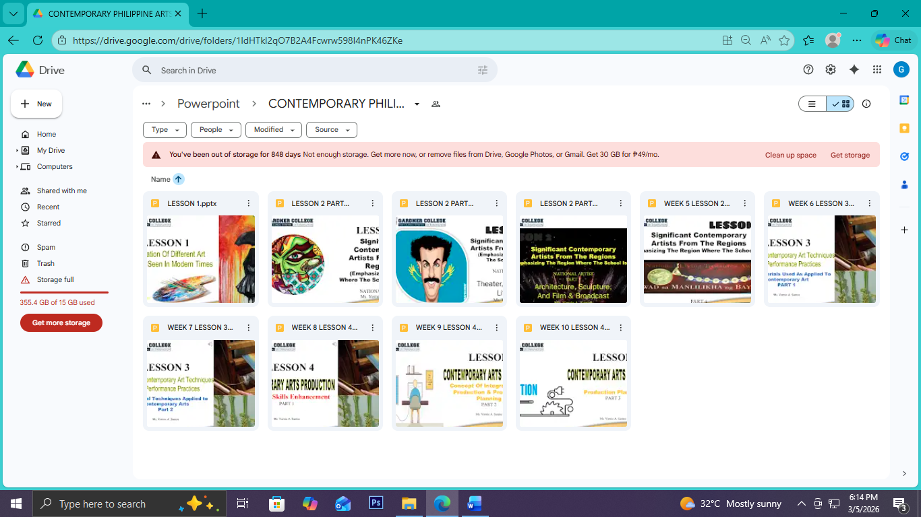
https://drive.google.com/drive/folders/1ldHTkl2qO7B2A4Fcwrw598I4nPK46ZKe?usp=sharing

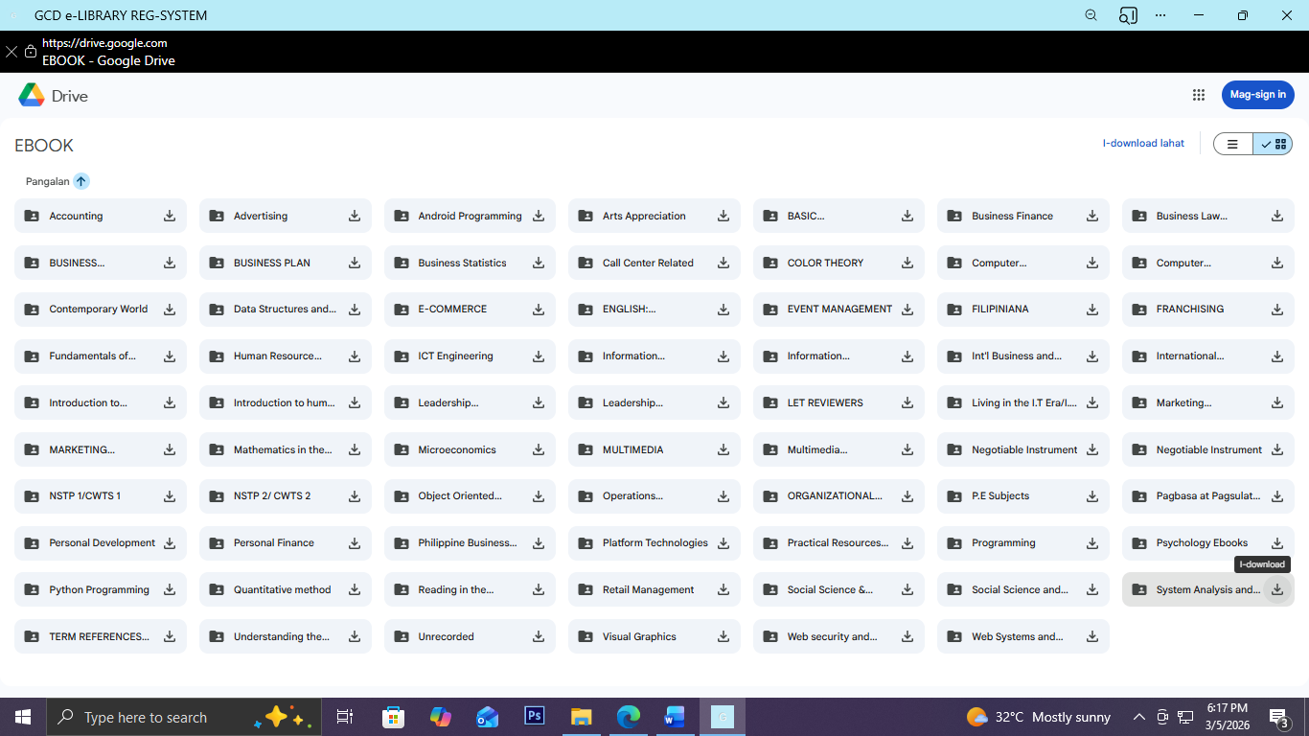

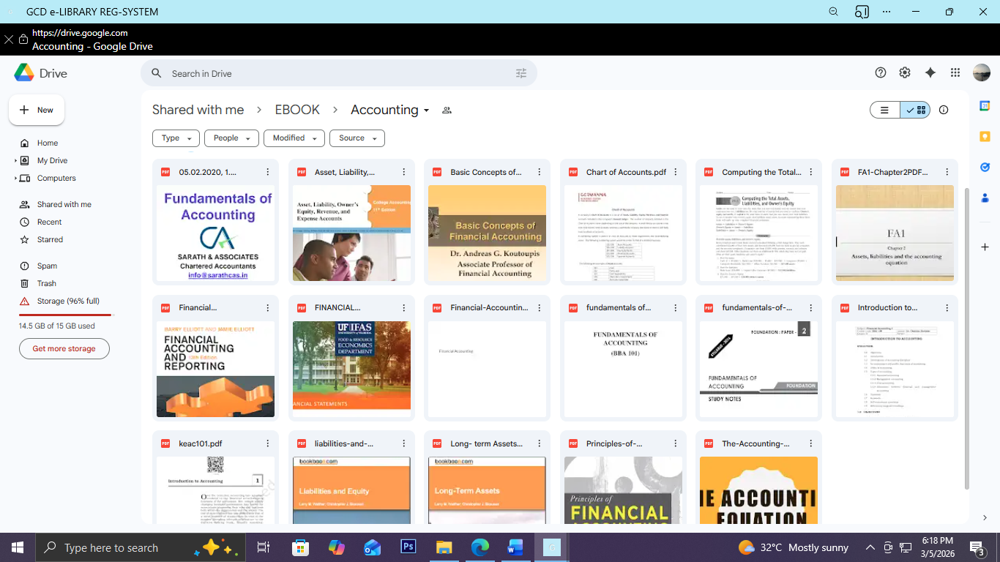
SAMPLE LINK: DIGITAL RESOURCES PART 1
GCD e-LIBRARY REG-SYSTEM - Welcome to GARDNER COLLEGELibrary

