FINAL PROJECT

Retail store sales analysis

*The main goal is to make a report of sales for our retail store, show how the business is doing and how profits are going up.  
The data source of our report will be the data warehouse which we build during DWH module.*

*The schema of our data is Star, so we have one fact tables and 5 dimensions. Here is the Star ERD`*

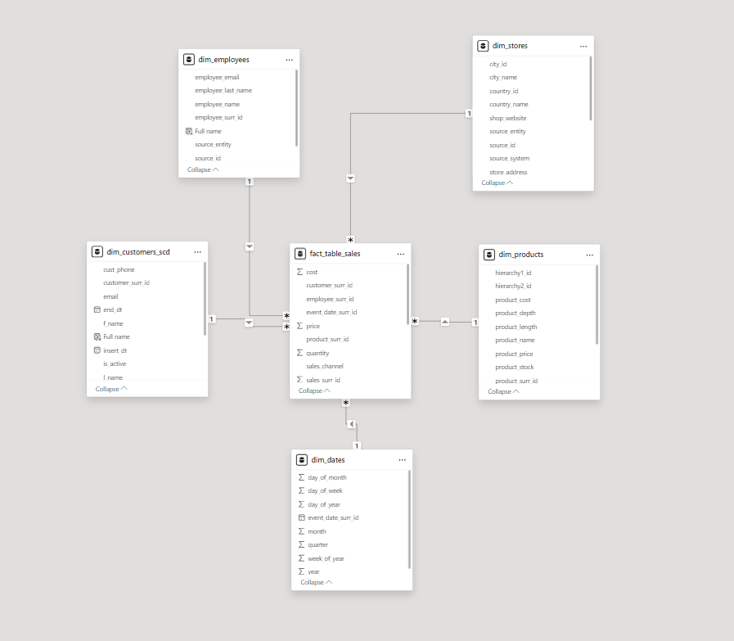

*Fact table contain all information about business process, including sale quantity, prices, costs, product, customer and employee information.*

*In each record will need to calculate the actual sale price amount and cost amount as well, so we need to multiply quantity and price for total amount sales and quantity and cost for total cost. For this I have created separate measures names Profit and Total Costs with DAX expressions, please see the screenshots `*

*Total Costs  
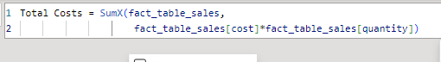*

*Profit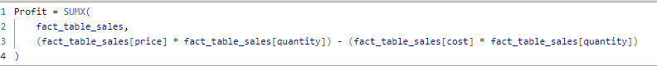*

Also I created Sales Count Per Product measure to count how many product has been sold (will use with separate product in other visuals)



Sales Count Per Product



Report plan:

In the report we have 2 unhidden pages, Revenue analysis and Trending analysis. In Revenue page I’m showing carts with total cost amount to allow business identify costs by date range, date range can be specified by using slicer. Other cart is showing the Total profit of the date range specified.

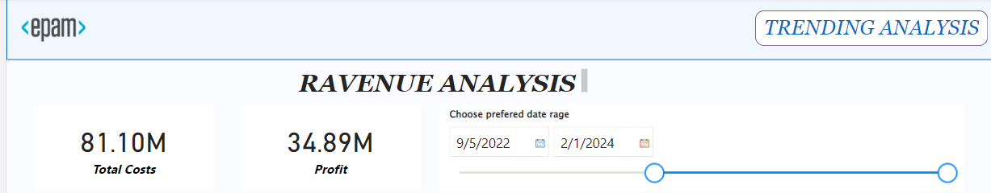

Profit by Month visual is showing sale amounts with ability to drill down by date and see sale amounts sales by year, month, quarter , day.  
Profit by store_name visual shows line chart about profits of each shop we have.

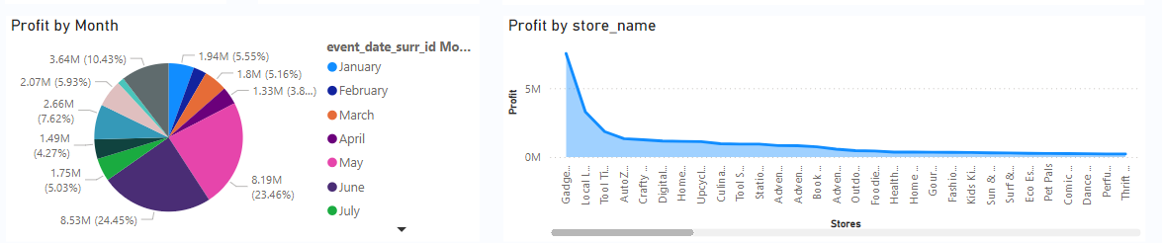

Map visual allow us to see sale states where we have a store and filter whole page by clicking on specific state, also when we hover on state it will show the top 10 maximum count of sale by customers.

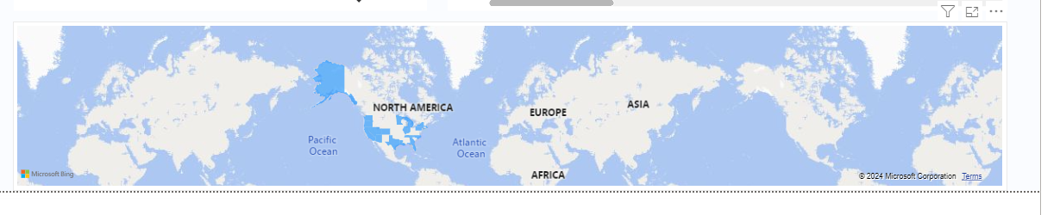

To switch between pages we have TRENDING ANALYSIS button in right top corner so ctrl+click on it.

In Trending page we identify trending products and most valuable customers for our shops.

In the first visual we can see product information with the count sold and total profit we got by selling these product.In top of the wisual we can change ordering buy most popular product by count sold and most profit generated product (THEY ARE NOT SAME ☺).  
In the map we show count of product sold inch each state with the tool tip which is showing customer based info in specific state.

Profit by Full name visual shows analysis of employees and profits.

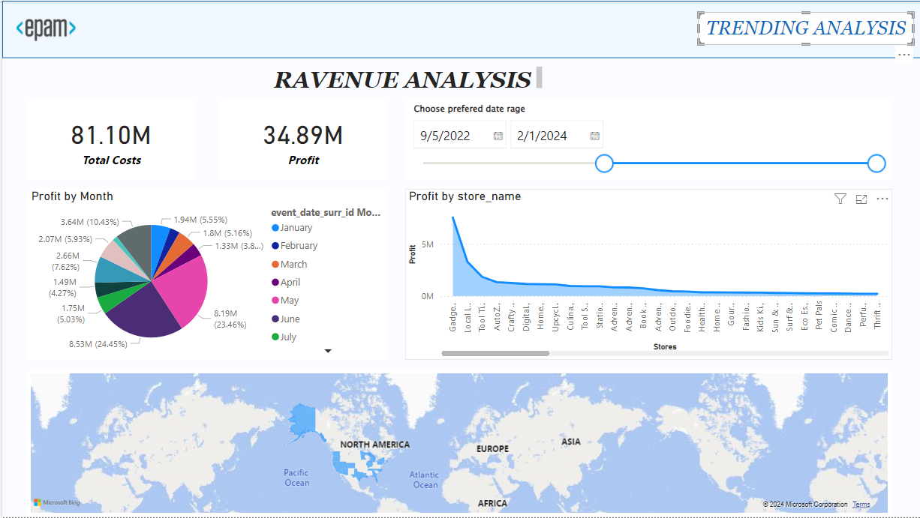

Report is published in Power BI service.  
