TASK 1 POWER BI

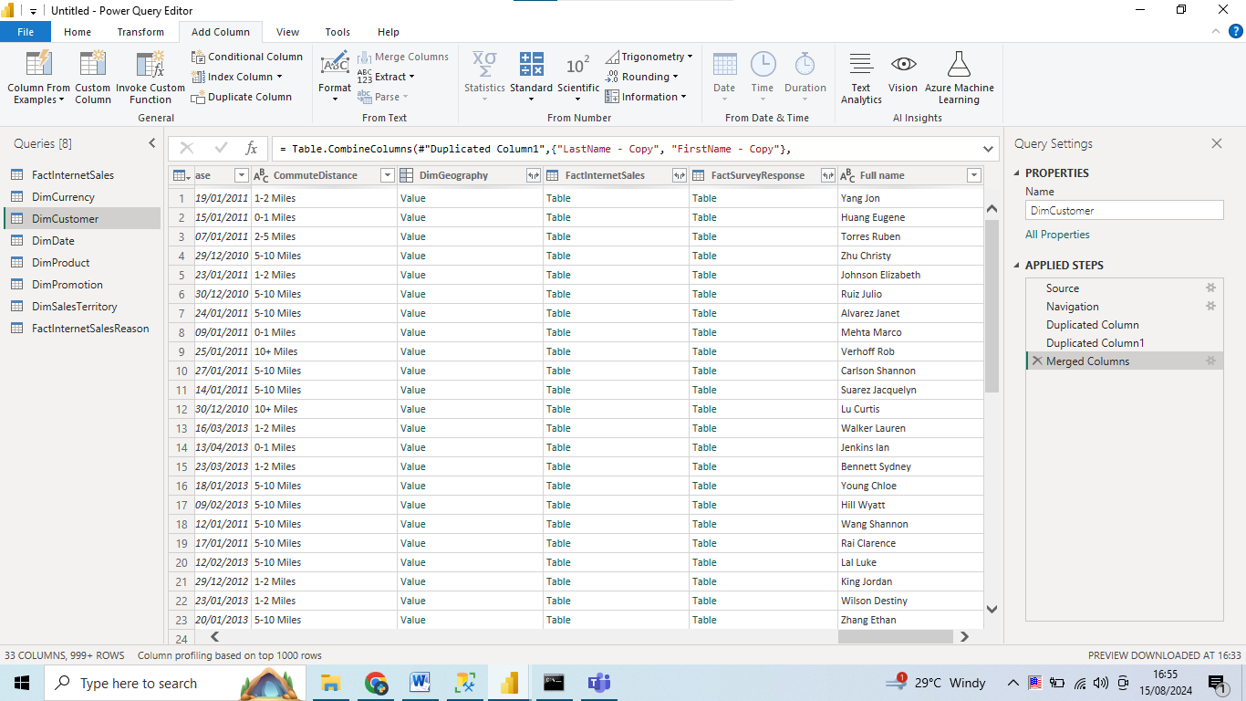

Full name column added.

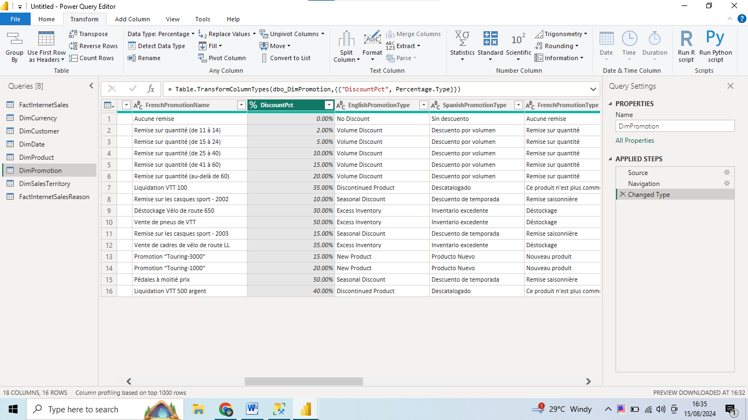

DiscountPct column datatype changed Percentage.

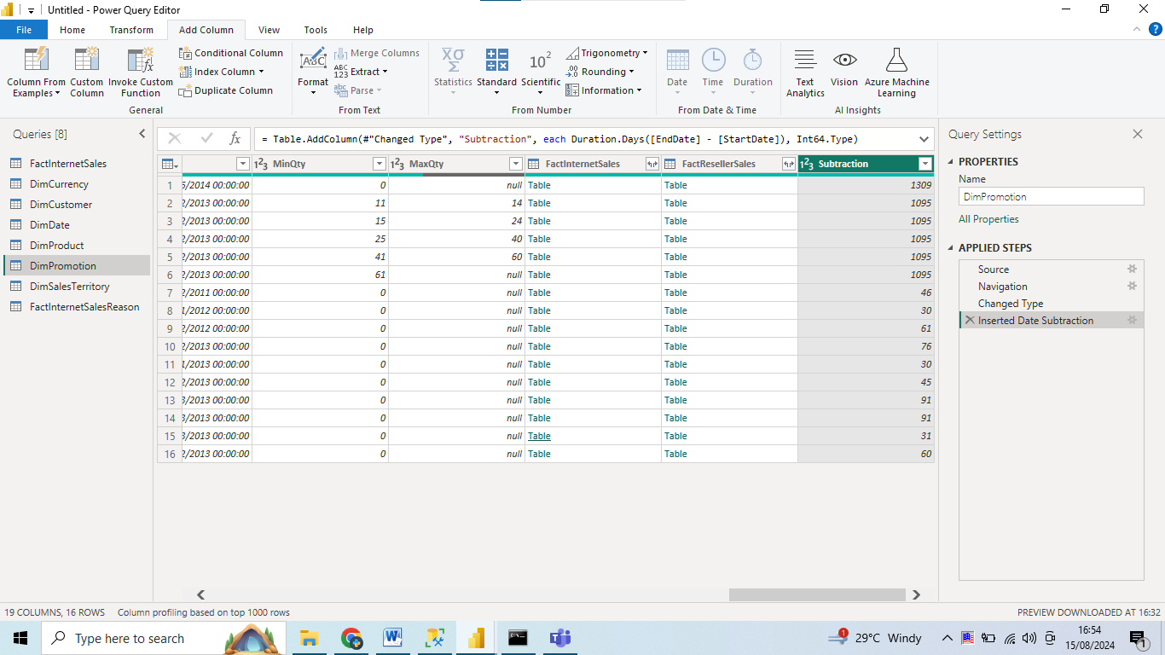

Date subtracted with two options.

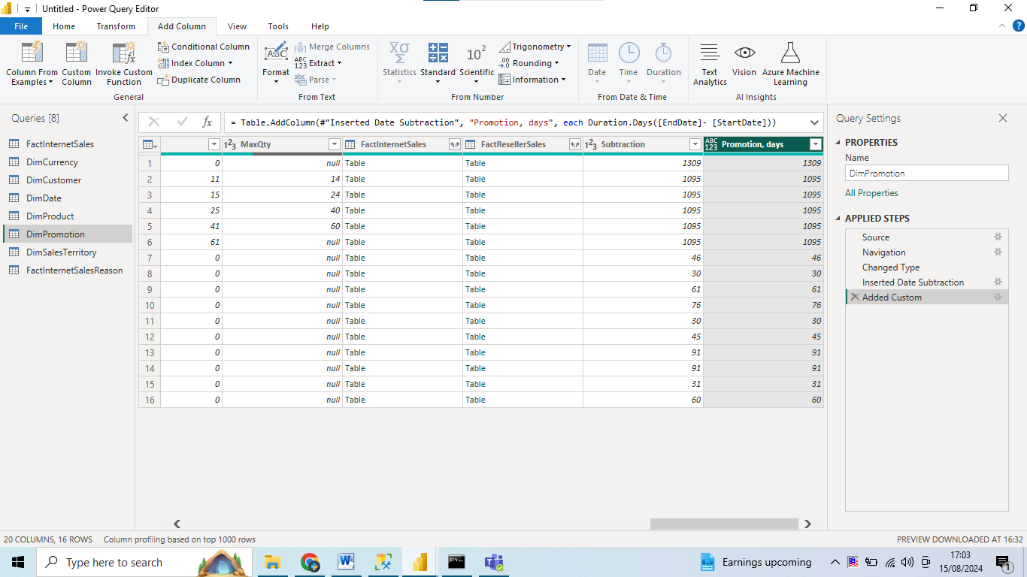

New referenced table from fact table .

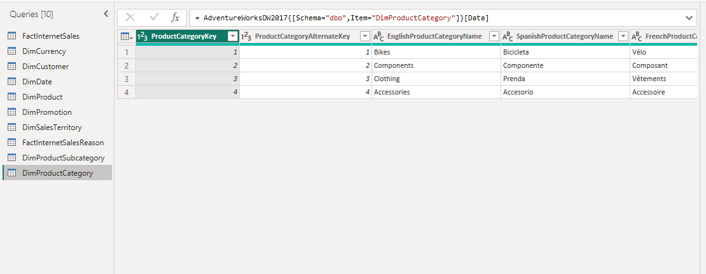

Views`

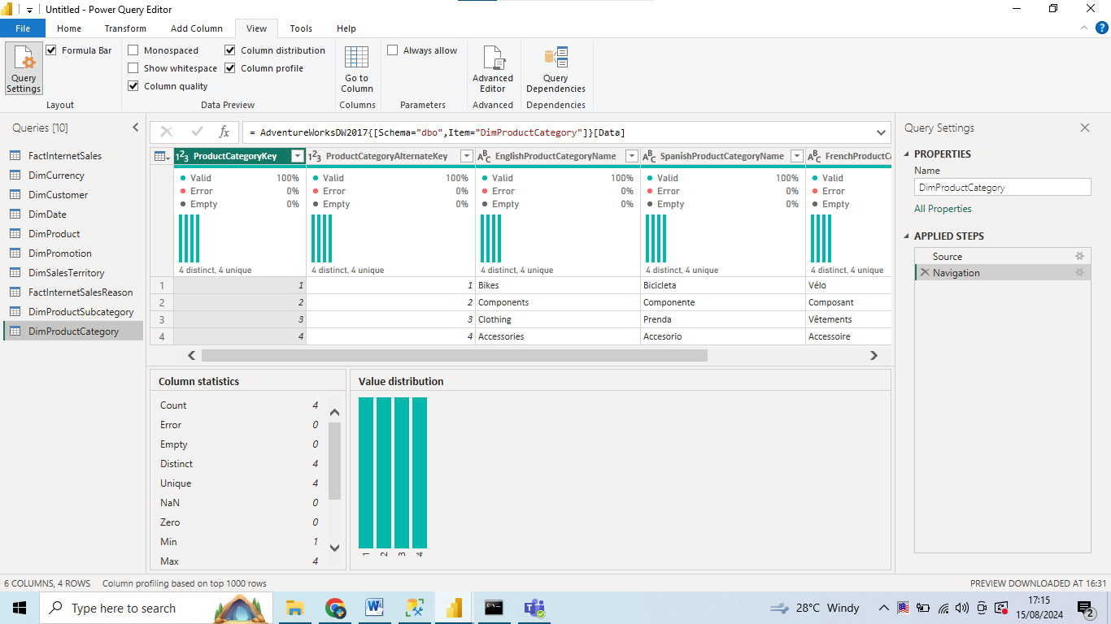

Order year column added

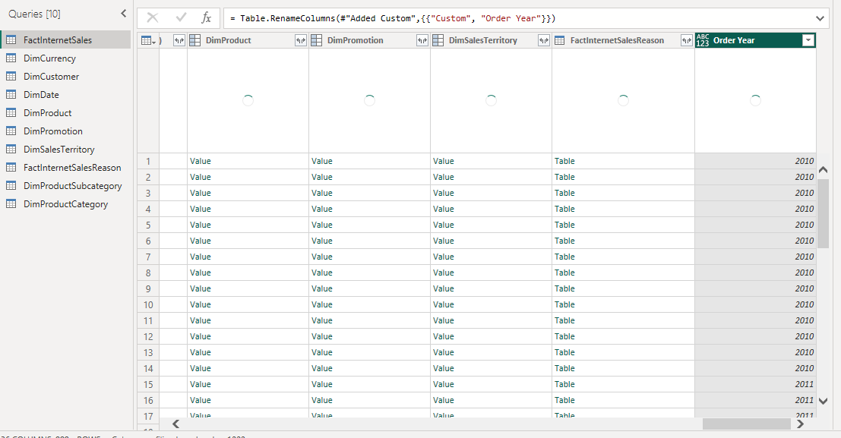

Pivot view`

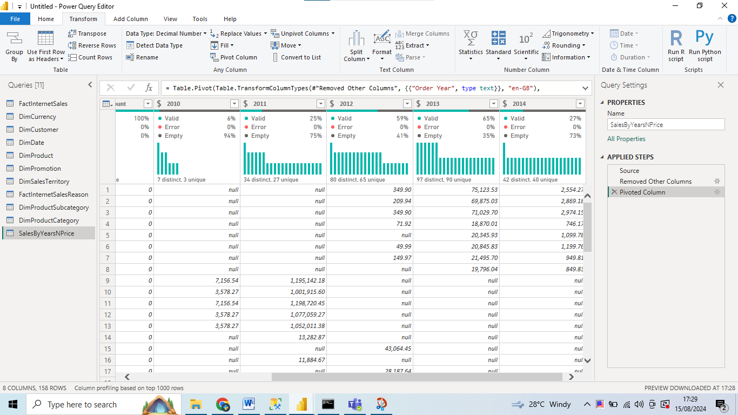

New table with cleaned columns`

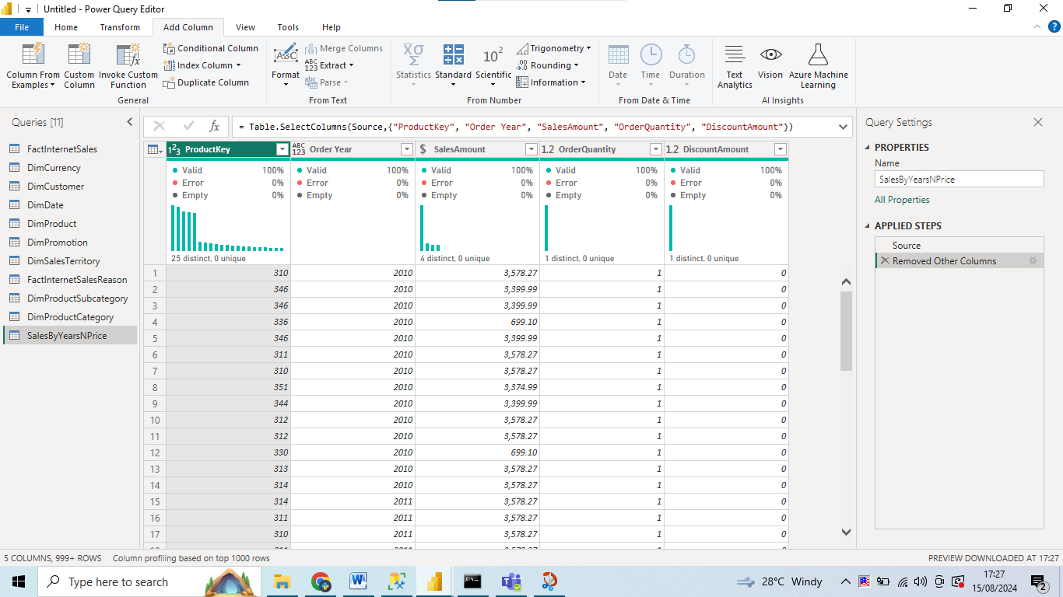

Merged tables with ProductCategory

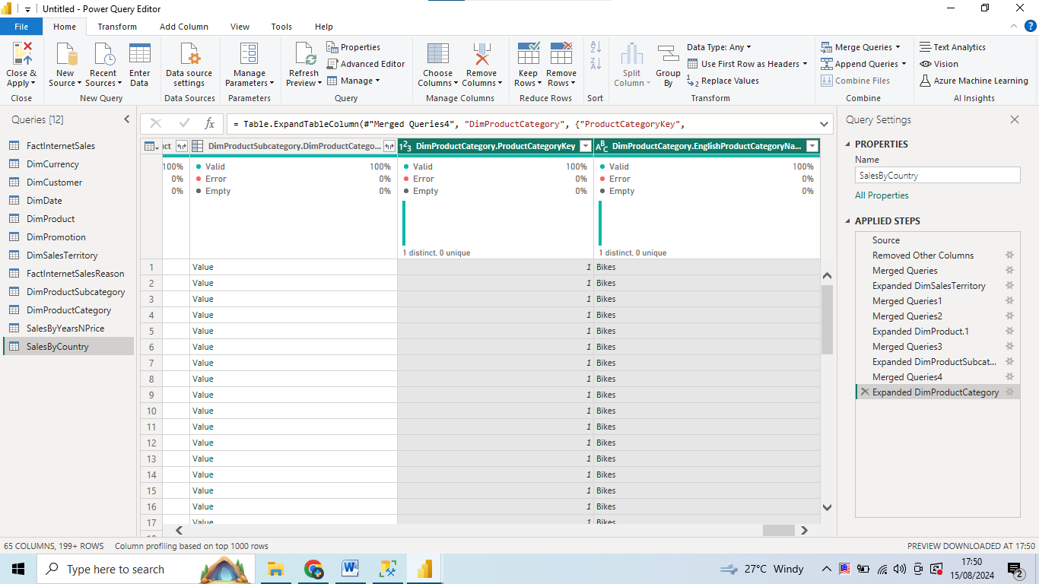

Sales grouped by 3 columns`

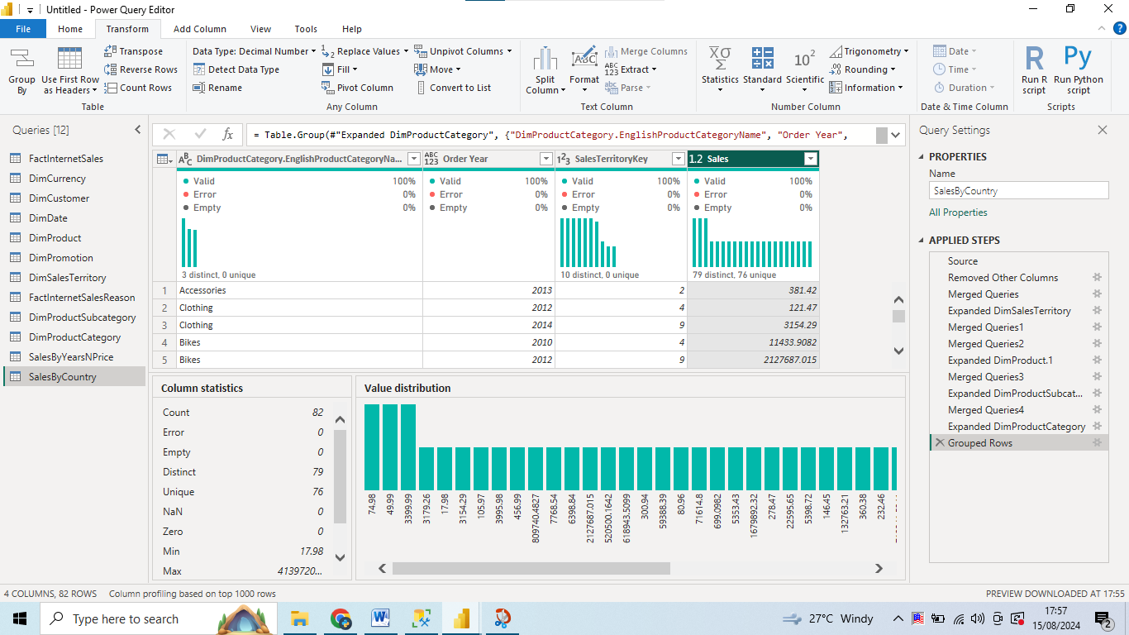

Relations deleted from fact table with DimDate`

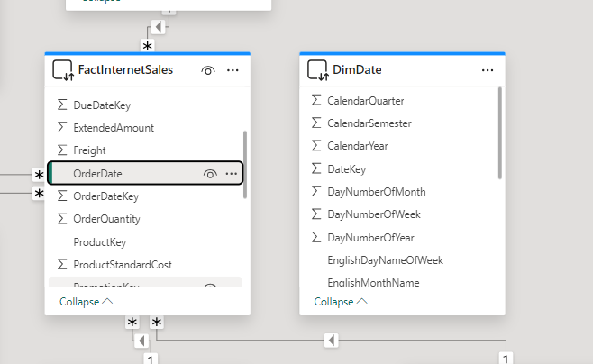

About connection methods DirectQuery and Import, the difference is that Import method copies data into memory of PC and it’s need to be updated in case of we need up to date Analysis. DirectQuery doesn’t copy it , instead its queries the original data , so its will be always up to date and no updates needed , but of course from point of performance it will be slower than Import. We have a limitation per dataset 1GB when importing data, DirectQuery don’t have limitations as it’s not loading data into application.

CHANGES

The percentage fixed.

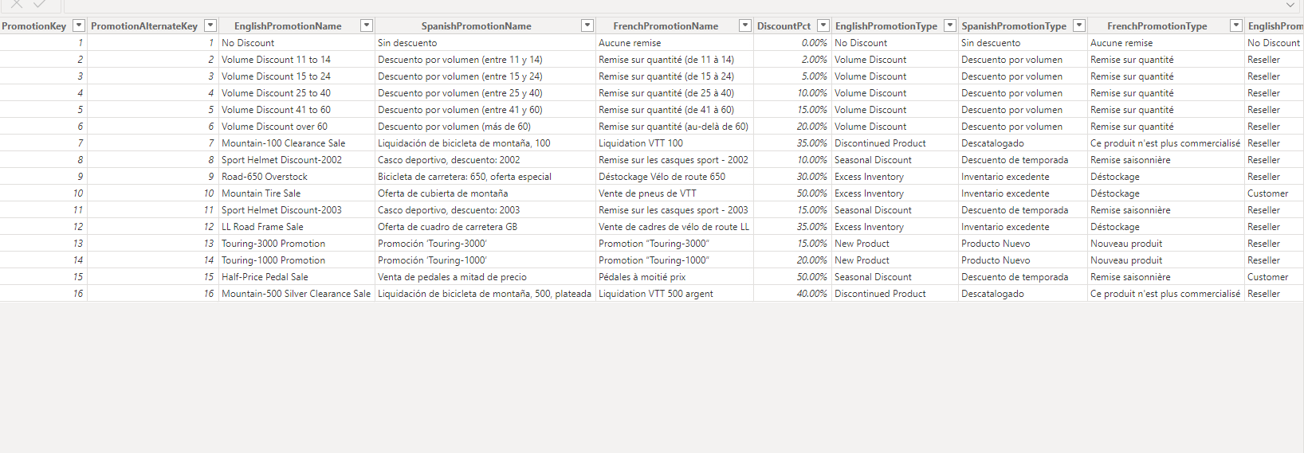  
  
  
Right columns are selected for SalesByYearsNPrice table, pivot view corrected.

