TASK 2

Creating Report and Publishing in Power BI service

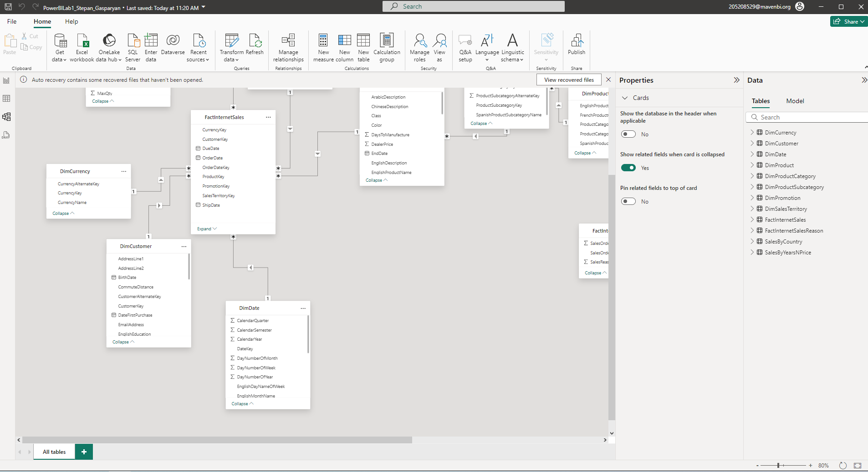

Relations deleted, only using DinDate (OrderDate) relation.

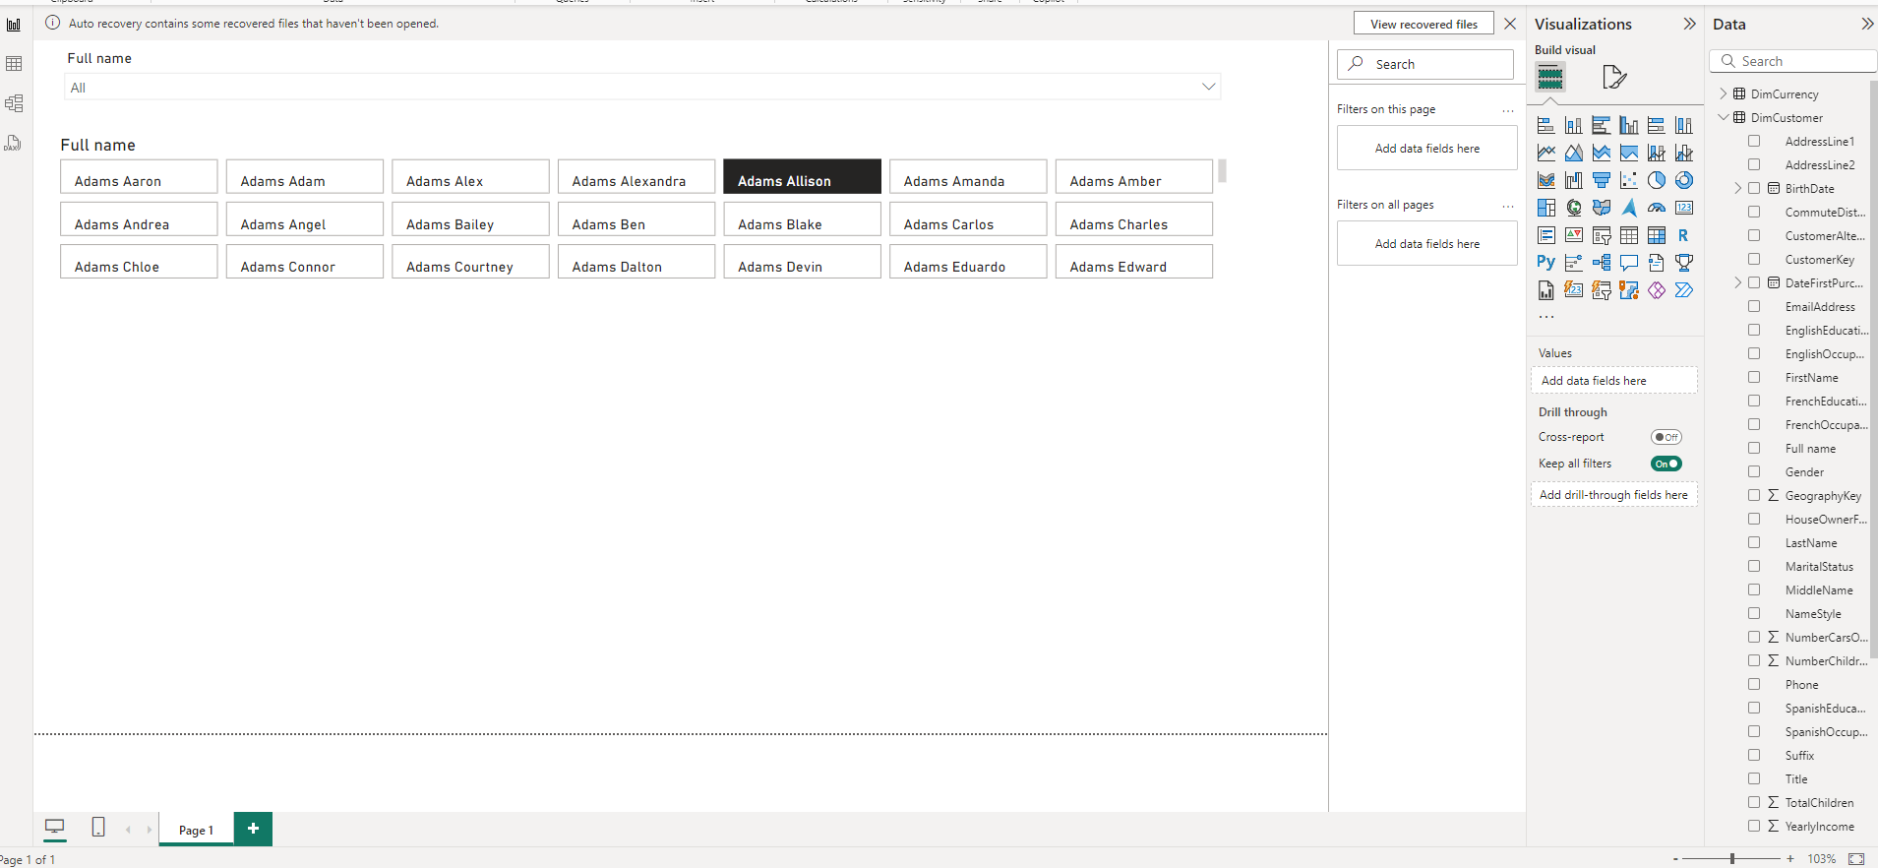

Slicers added , List and Dropdown.

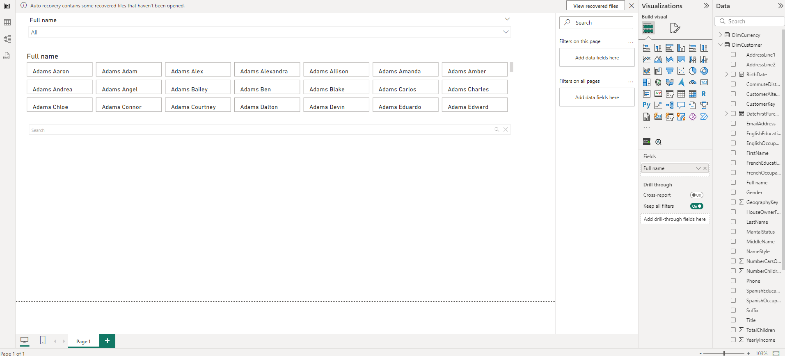

Search visual added by customer full name.

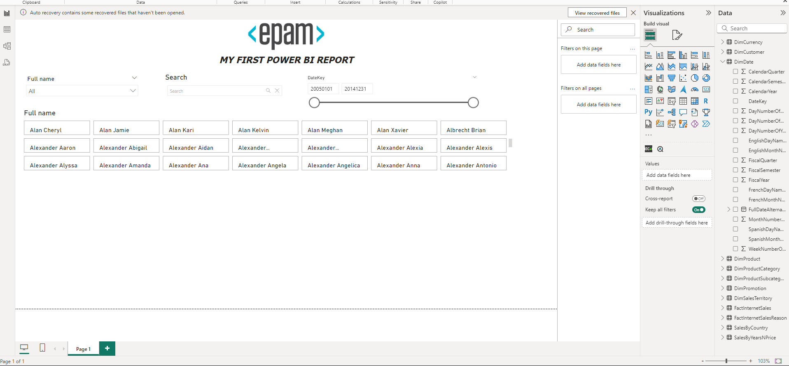

Added Epam’s logo and header for report name.

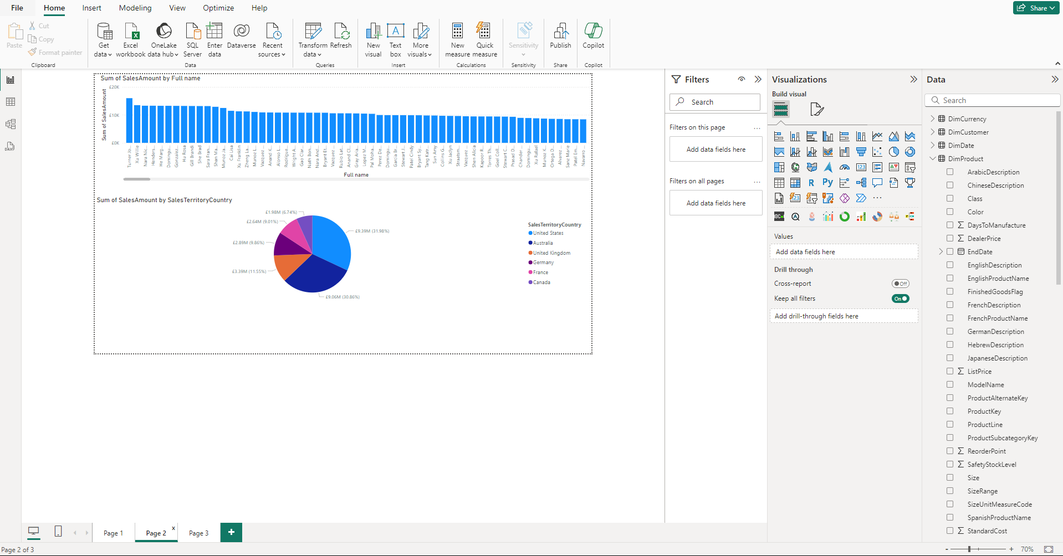

Few standards visuals added.

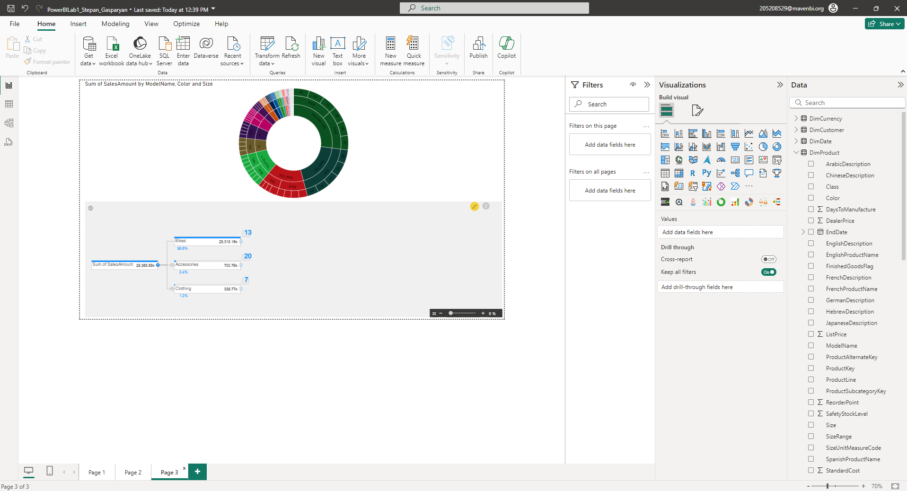

Also custom visuals are used in the report.

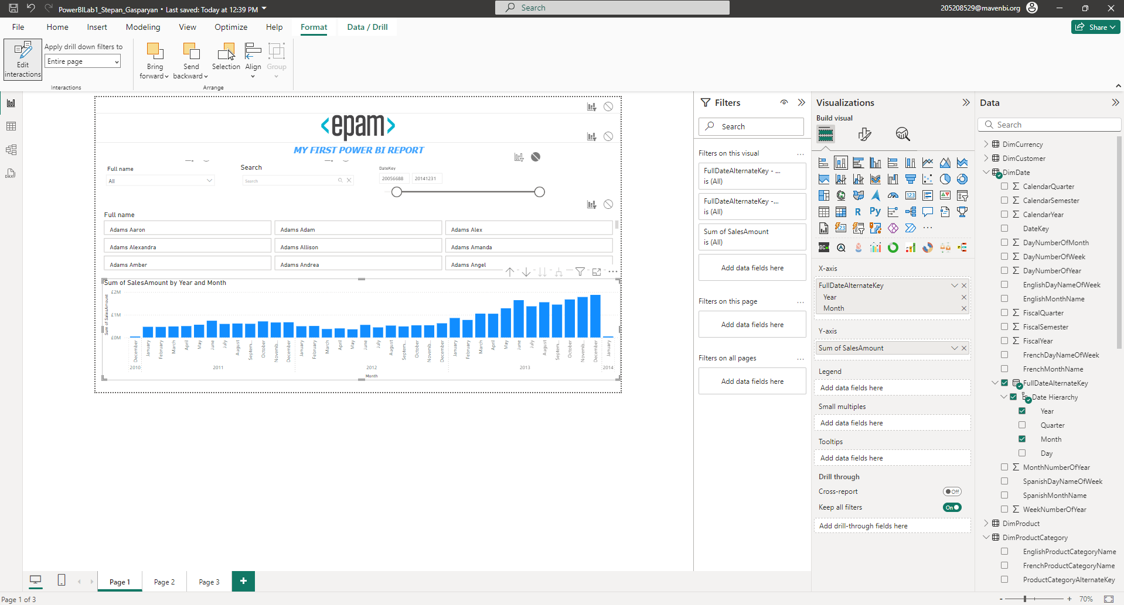

Interaction between date slicers and Sales amount chart is disabled.

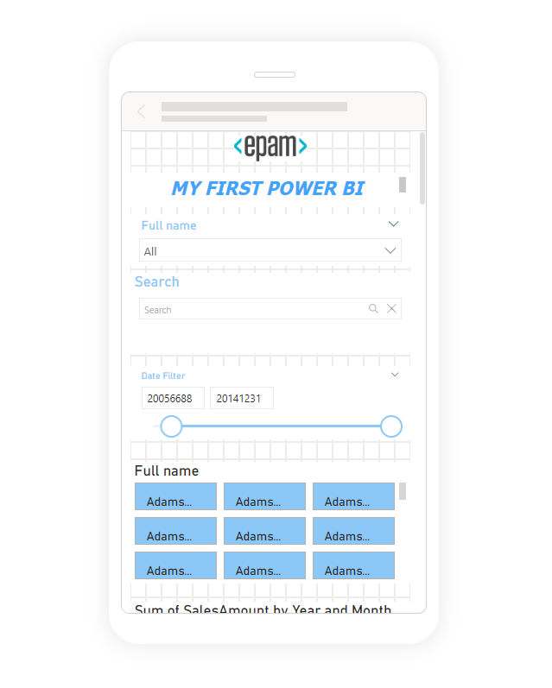

Mobile views are configured.

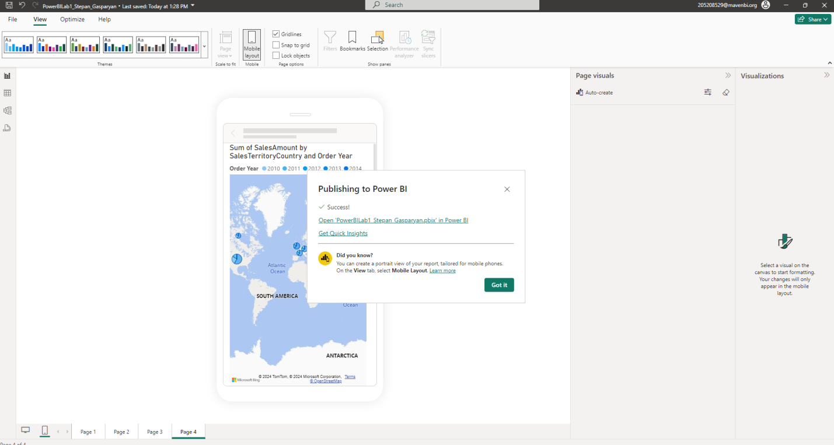

Report has been published in Power BI service.

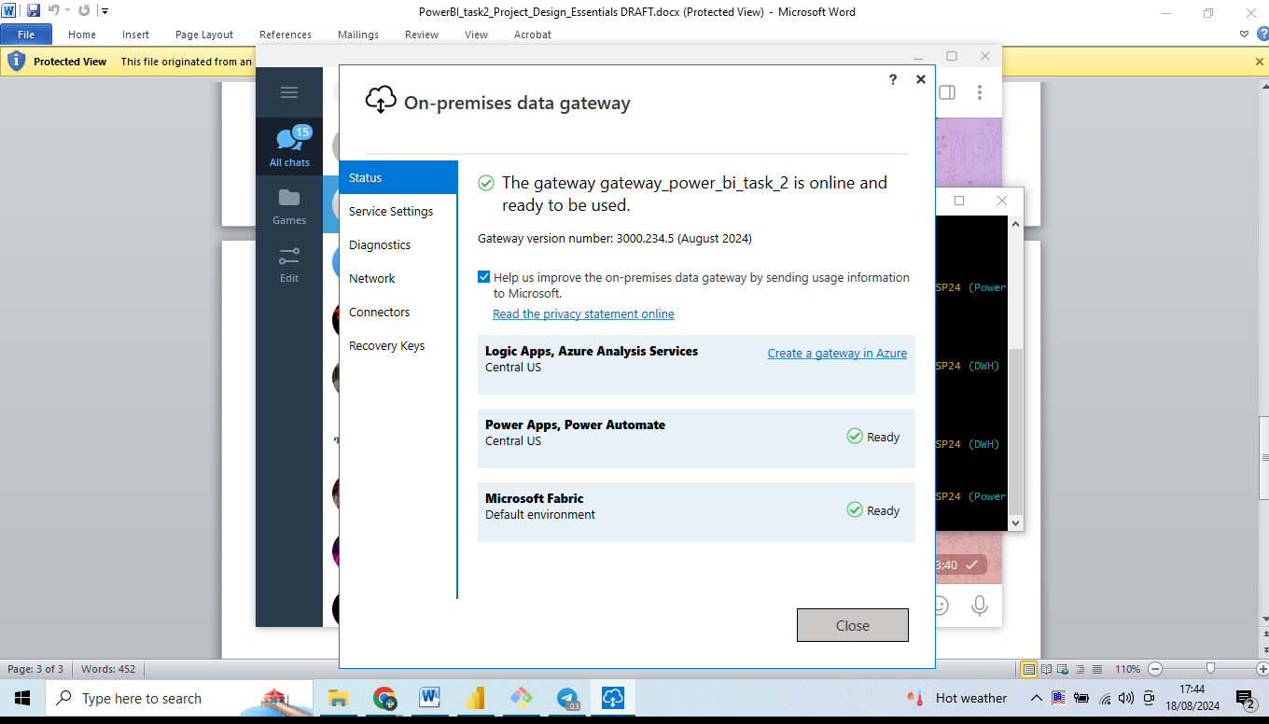

Personal Gateway installed and configured to serve new data once a day.

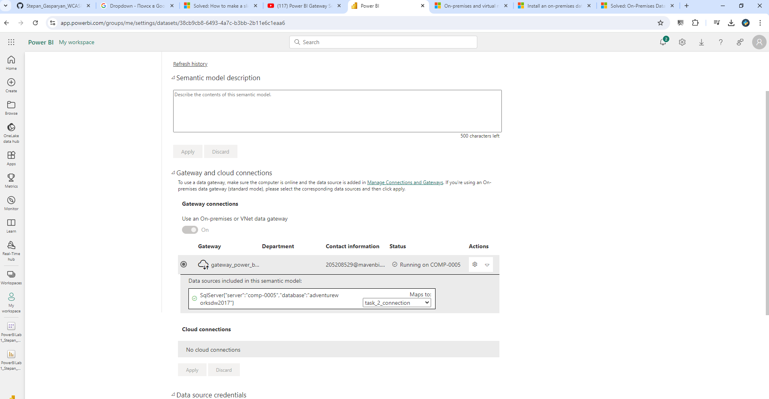

Here is the url for published report `

<https://app.powerbi.com/links/dNhIjD8F1p?ctid=25ce0261-bbd6-49cd-a1e2-54260886d159&pbi_source=linkShare>