TASK 2

Creating Report and Publishing in Power BI service

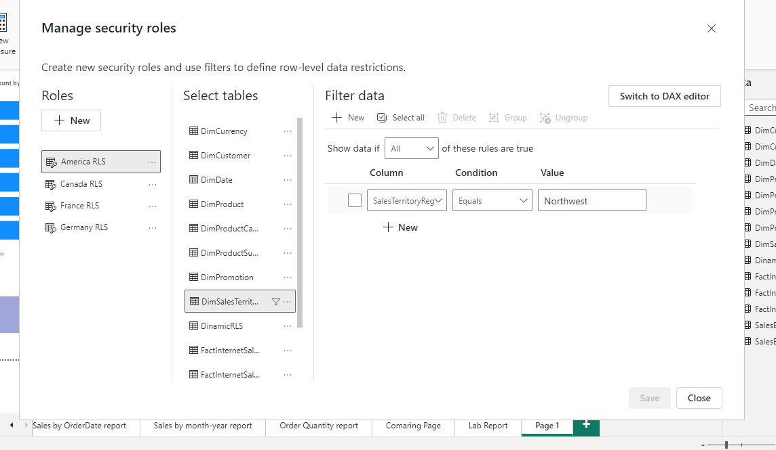

Row level security implemented by regions,

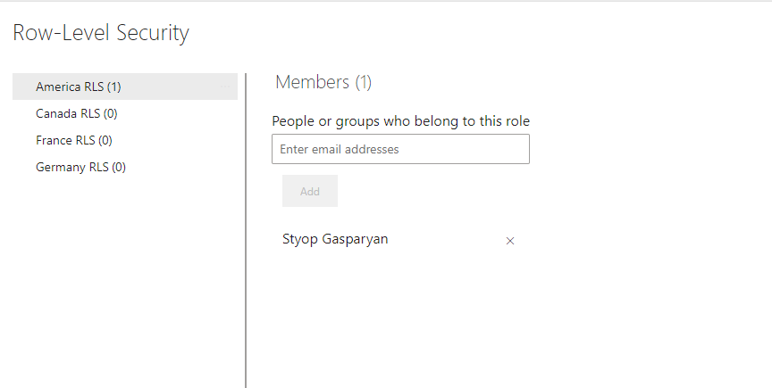

In Power BI service I added me in America RLS group.

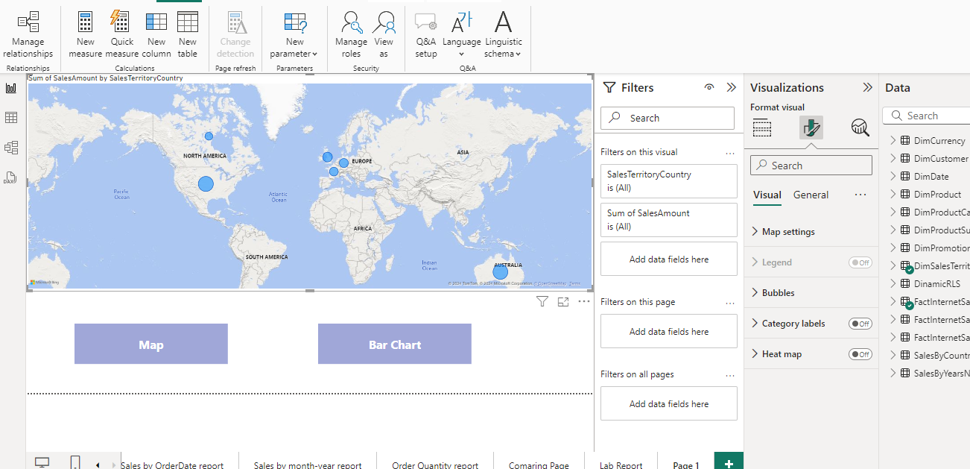

Map and bar charts created , and the buttons for switching between views.

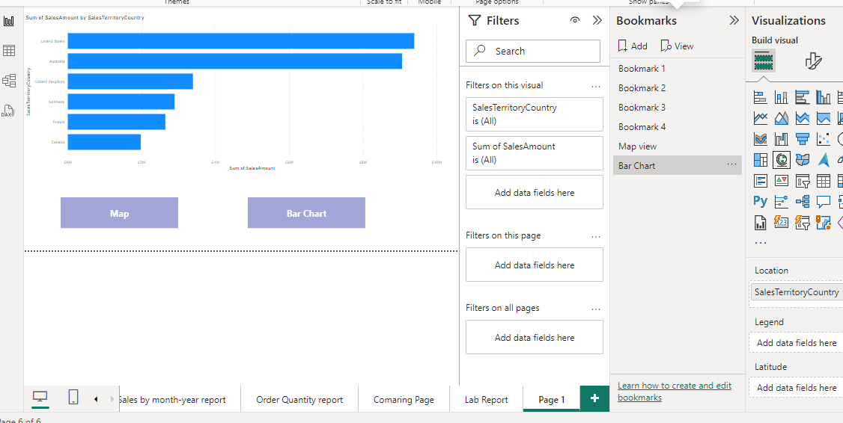

Bar Chart. Need to CTRL + click on buttons to swich.

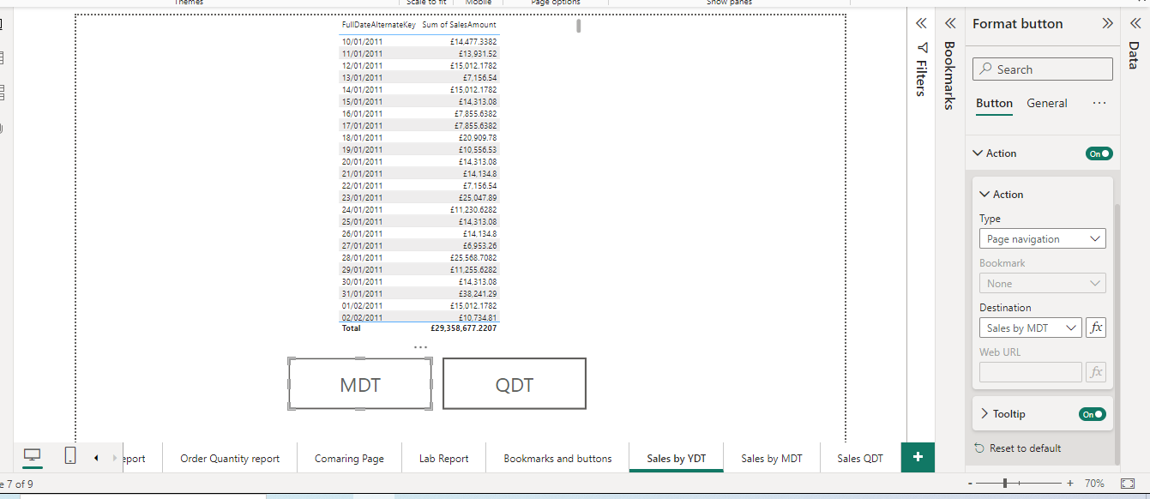

Sales YTD table , and two buttons for navigating to Sales MDT and Sales QDT , I decided to have separate pages with according analysis.

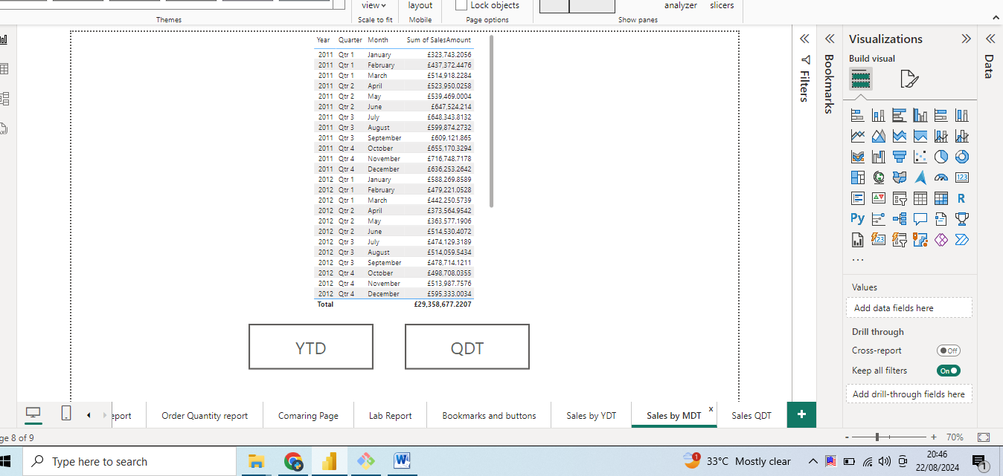

Sales MDT

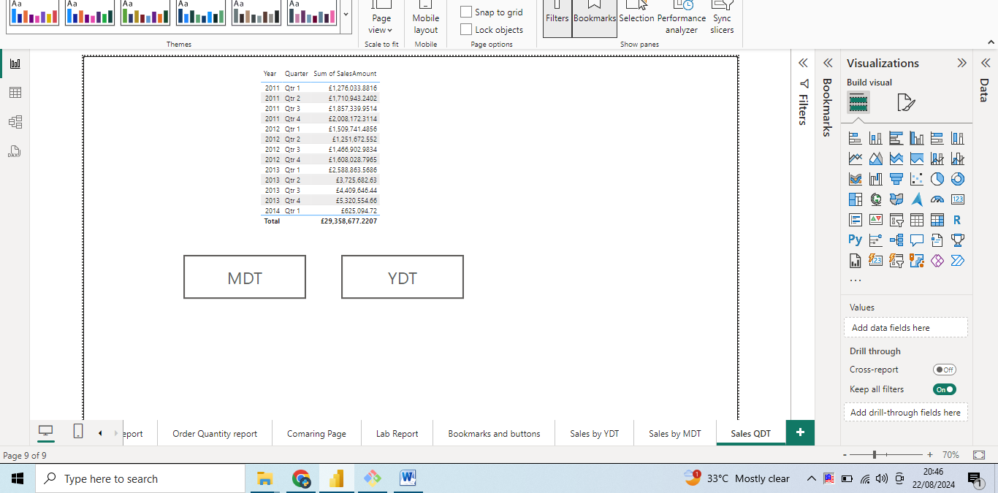

Sales QDT

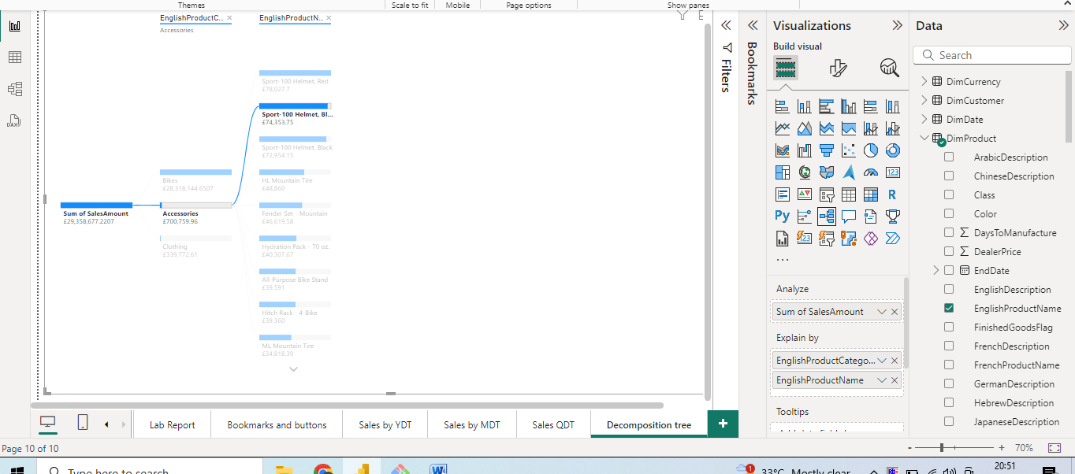

Decomposition tree visual with the information about sales by products category and product, also added tooltip for each product to show amount sales by region for that particular product.

