**伪代码：**

Main module

//声明变量

Declare EmployeeID As String

Declare HourlyRate As Float

Declare RegHours As Float

Declare GrossPay As Float

Declare Tax As Float

Declare OvertimeHours As Float

Declare NetPay As Float

Write "Payment Program"

Write "This program computes the GrossPay and NetPay"

Call Input Data module

Call Perform Calculations module

Call Output Results module

End Program

Input Data module

//输入数据模块

Write "What is the EmployeeID?"

Input EmployeeID

Write "What is the HourlyRate?"

Input HourlyRate

Write "What is the RegHours?"

Input RegHours

Write "What is the OvertimeHours?"

Input OvertimeHours

Perform Calculations module

//计算模块

Set GrossPay =RegHours*HourlyRate+OvertimeHours*(HourlyRate*1.5)

Set Tax =GrossPay * 0.3

Set NetPay=GrossPay-Tax-10

Output Results module

//输出模块

Write "The Employee is :"+ EmployeeID

Write "GrossPay is :$ “+GrossPay

Write "NetPay is :$ " +NetPay

**RAPTOR流程图：**

**Main:**

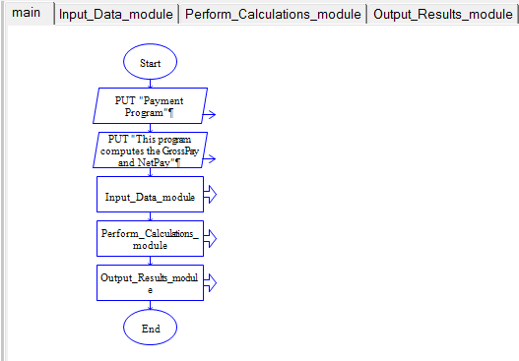

**Input_Data_module :**

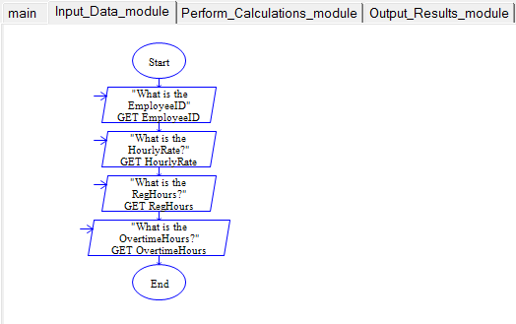

**Perform_Calculations_module:**

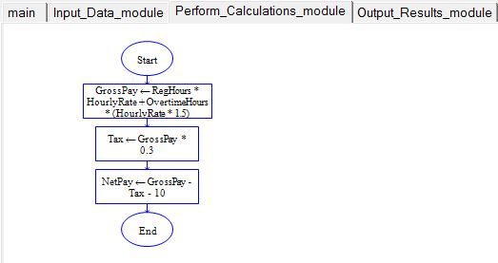

**Output_Results_module:**

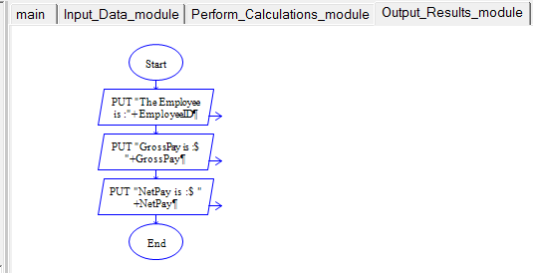

**运行结果：**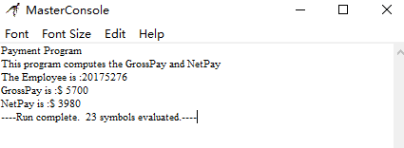

**Python 代码：**

def input_data_module():

EmployeeID=input("What is the EmployeeID? ")

HourlyRate=eval(input("What is the HourlyRate? "))

RegHours=eval(input("What is the RegHours? "))

OvertimeHours=eval(input("What is the OvertimeHours? "))

return EmployeeID,HourlyRate,RegHours,OvertimeHours

def Perform_Calculations_module():

EmployeeID,HourlyRate,RegHours,OvertimeHours=input_data_module()

GrossPay=RegHours*HourlyRate+OvertimeHours*(HourlyRate*1.5)

Tax=GrossPay * 0.3

NetPay=GrossPay-Tax-10

return EmployeeID,GrossPay,NetPay

def Output_Results_module():

EmployeeID,GrossPay,NetPay=Perform_Calculations_module()

print("The Employee is :",EmployeeID)

print("GrossPay is :$ ",GrossPay)

print("NetPay is :$ ",NetPay)

print ("Payment Program")

print("This program computes the GrossPay and NetPay")

Output_Results_module()

**代码运行结果：**

