WORKING DRAFT — NOT FOR SUBMISSION. Rebuilt 2026-09-02 on the re-run that followed the pre-index matching-variable fix. Prose and every number drawn from a re-run artifact are current. Every remaining v18.6 number is marked [STALE ...] inline: search this document for STALE. MarketScan was not re-run at all, so Table 1's MarketScan column, Figure 3's MarketScan series and eTable 10 are v18.6 throughout. Tables 1-3 and all eTables are v18.6 and are not marked cell by cell.
Survey-linked EHR measurement of social factors associated with COVID-19 hospitalization in the All of Us Research Program
Haining Wang, PhD¹; Yihan Zhang, BSc(c)^{1,2}; Chenxi Xiong, MS^{1,3}; Zhao Zhang, MD^{1,4}; Jiangqiong Li, PhD¹; Hengyi Fu, PhD⁵; Xiaojun Yuan, PhD⁶; Xiaochun Li, PhD¹; Jing Su, PhD¹*
¹ Department of Biostatistics and Health Data Science, Indiana University School of Medicine, Indianapolis, IN 46202, United States
² School of Interdisciplinary Science, McMaster University, Hamilton, ON L8S 4L8, Canada
³ Department of Computer and Information Technology, Purdue University, West Lafayette, IN 47907, United States
⁴ Department of Anesthesiology, Tianjin Chest Hospital, Tianjin, China
⁵ School of Information, San José State University, San José, CA 95192, United States
⁶ Department of Information Sciences and Technology, College of Emergency Preparedness, Homeland Security and Cybersecurity, University at Albany, State University of New York, Albany, NY 12226, United States
* Corresponding author: Jing Su, PhD, Associate Professor, Department of Biostatistics and Health Data Science, Indiana University School of Medicine, 410 W. 10th Street, HITS 3000, Indianapolis, IN 46202, United States. Telephone: +1 317-278-2950. Email: su1@iu.edu
Word count: [STALE — recount after the remaining extractions] (excluding title page, abstract, references, tables, and figure legends). Abstract: 250 words. Tables: 3. Figures: 5.
Keywords: Health Status Disparities; Social Determinants of Health; Electronic Health Records; COVID-19; Hospitalization.

ABSTRACT
Objective: To examine whether survey-derived social determinants of health (SDoH) are associated with COVID-19 hospitalization beyond demographic and clinical factors.
Materials and Methods: Propensity score-matched case-control study in All of Us (n = 25,160 COVID-positive). 3,997 cases hospitalized within 14 days of diagnosis were matched on encounter-density proxies. Conditional logistic models estimated adjusted odds ratios (AORs) for 19 Charlson comorbidities and six SDoH domains, separately, jointly, and with exposure-by-wave interactions.
Results: Jointly, unemployment (AOR 1.35, 95% CI 1.20-1.52), the two lowest income strata (both 1.21), Medicaid (1.19, 1.05-1.36), and renting (1.16, 1.05-1.28) remained associated; education below GED did not (1.06, 0.92-1.22). Their combined profile carried 1.67-fold odds (1.40-1.99). Six-domain adjustment moved the Black-race AOR from 2.39 (2.18-2.62) to 2.09 (1.89-2.31); income alone accounted for 11.7 of those 15.1 percentage points. Wave interaction was significant for insurance (P = 0.003), not race (P = 0.07) or income (P = 0.22); the pre-specified Black-race contrast, pre-Delta 2.30 against Omicron 1.78, was significant (P = 0.017).
Discussion: Four social domains remained associated after clinical adjustment, and employment rather than insurance carried the largest. The survey supplied social detail absent from structured EHR fields, which document 0-2% of encounters. Whether recording it would improve a screening decision is a question this design does not address.
Conclusion: Employment, income, insurance, and housing were independently associated with COVID-19 hospitalization after clinical adjustment. Measured socioeconomic position accounted for about a sixth of the Black-race association, almost all through income. Interpretation depends on survey timing and domain overlap.

INTRODUCTION
Respiratory viral pandemics will continue to emerge, and each will reproduce the health disparities observed during COVID-19 unless preparedness planning incorporates social risk factors alongside clinical ones.[1-3] COVID-19 provided a natural experiment: hospitalization fell disproportionately on Black, Hispanic, and lower-income populations throughout the pandemic,[4, 5] and meta-analytic evidence places the pooled standardised hospitalisation ratio for Black populations near 1.9 (1.87, 95% CI 1.69-2.04) against 0.74 for White populations.[6] What remains contested is how much of that excess reflects specific, measurable individual social conditions, and how much reflects structural factors that individual-level data cannot capture.

BACKGROUND AND SIGNIFICANCE
The exposure most often used to answer that question is an area-level deprivation index, and it is a poor proxy for the circumstances of an individual patient. County-level analyses have linked composite indices to higher incidence and mortality,[7] and the Social Deprivation Index predicted COVID-19 case rates but did not improve prediction of in-hospital outcome once demographics, comorbidities, and vitals were included.[8] In a national Medicare sample, area deprivation indices had low sensitivity for identifying patients with self-reported needs,[9] and in over 1.3 million community health center patients, none of the tested indices predicted individual social risk better than chance.[10]
The individual-level alternative, social risk coded in the electronic health record (EHR), is documented in fewer than 2% of encounters.[14-16] Two recent analyses worked around this. In All of Us, Choi et al. found an income gradient and no association with education, entering income, education, and an area-level index simultaneously in a single multivariable model.[11] Within the National COVID Cohort Collaborative (N3C), which has supported detailed characterization of clinical risk for COVID-19 severity,[12, 13] Vaidya et al. evaluated individual-level social determinants of health (SDoH) across three Healthy People 2030 domains and found all three associated with hospitalization, but drew exposures from those same sparsely coded EHR fields.[16] Neither study modelled multiple survey-derived domains jointly to assess mutual confounding, and neither matched on encounter density to address informative presence bias, the tendency for sicker and more socially complex patients to generate more EHR data and so to confound associations derived from those records.[17]
Two or three individual-level variables plus an area-level index cannot show which of the wider set of social domains carry independent signal, nor which share it. Here we evaluate six survey-derived social domains (insurance, income, education, employment, housing tenure and stability, and disability) in 25,160 COVID-positive All of Us participants, using a matched case-control design that balances encounter-density proxies rather than clinical severity.[18] We ask which domains remain associated with COVID-19 hospitalization after mutual adjustment and control for 19 Charlson comorbidities, vaccination, and pandemic wave; how much measured SDoH attenuate the Black-race hospitalization association; and how the social and racial associations differ from pre-Delta through Omicron, as vaccines became available. We compare clinical and demographic associations with MarketScan Commercial Claims (n = 4.4 million) as a cross-cohort check.

METHODS
We conducted a propensity score–matched case-control study using All of Us Research Program data.[19-21] Conditional logistic regression estimates associations between SDoH and COVID-19 hospitalization within strata balanced on encounter-density proxies. The design targets within-stratum associations rather than total causal effects of social position. Figure 1 shows the study flowchart.
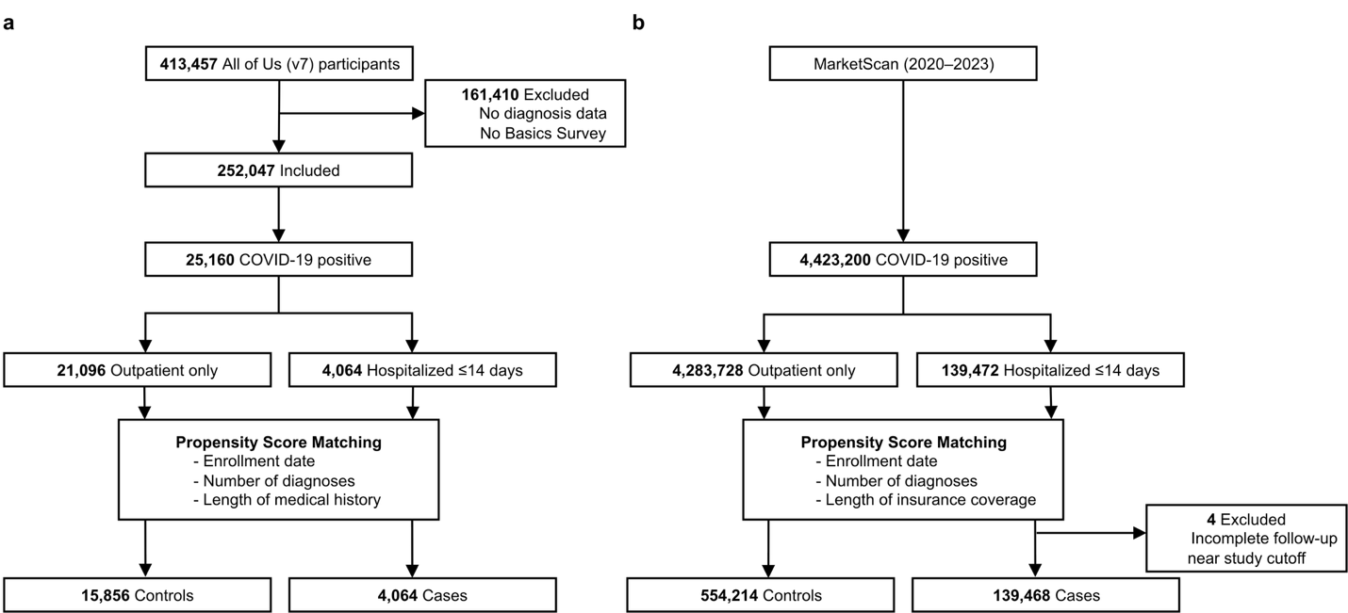

Study design and participants
We conducted a retrospective case-control study in All of Us Controlled Tier Data, Curated Data Repository version 7 C2022Q4R13, cutoff July 1, 2022. Conditions, drug exposures, visits, the Basics Survey, and vaccination records were extracted using the OMOP Common Data Model version 5.3.1. The COVID-19 index date was the earliest of a documented SARS-CoV-2 positive test or an ICD-10 U07.1 diagnosis. Participants with COVID-19 and both diagnosis and Basics Survey data were eligible. Cases were hospitalized within 14 days of the index date; controls were COVID-positive participants who were not. Control observations whose index date fell within 14 days of the CDR cutoff were excluded, because their follow-up cannot be verified.
Matching sought four controls per case on first Basics Survey date, number of diagnoses, and length of medical history as encounter-density proxies, implemented in MatchIt with nearest-neighbor matching with replacement on the logit propensity score and a caliper of 0.2 standard deviations of that score.[22, 23] We matched on encounter density rather than clinical characteristics because patients with more health-system contact accumulate more recorded diagnoses, creating informative presence bias, and adjusting for visit count alone does not correct it.[17, 24, 25] SDoH were excluded from the propensity score because they are the exposures of interest; residual imbalance was addressed through conditional regression. MarketScan matching used the same procedure with first enrollment date, number of distinct diagnoses, and coverage span.

Outcome
The primary outcome was COVID-19 hospitalization or extended emergency department care within 14 days of the index date, aligned with the CDC COVID-NET surveillance window.[26] COVID-19 was identified by ICD-10 U07.1 or a positive SARS-CoV-2 laboratory test from 65 measurement concepts (eTable 1). Hospitalization comprised inpatient visits, emergency-to-inpatient visits, and emergency visits with a recorded stay of one or more days; same-day emergency visits without admission were excluded from the strict outcome (eTable 2a; Figure 2). In MarketScan, hospitalization was any inpatient claim carrying U07.1 within 14 days.
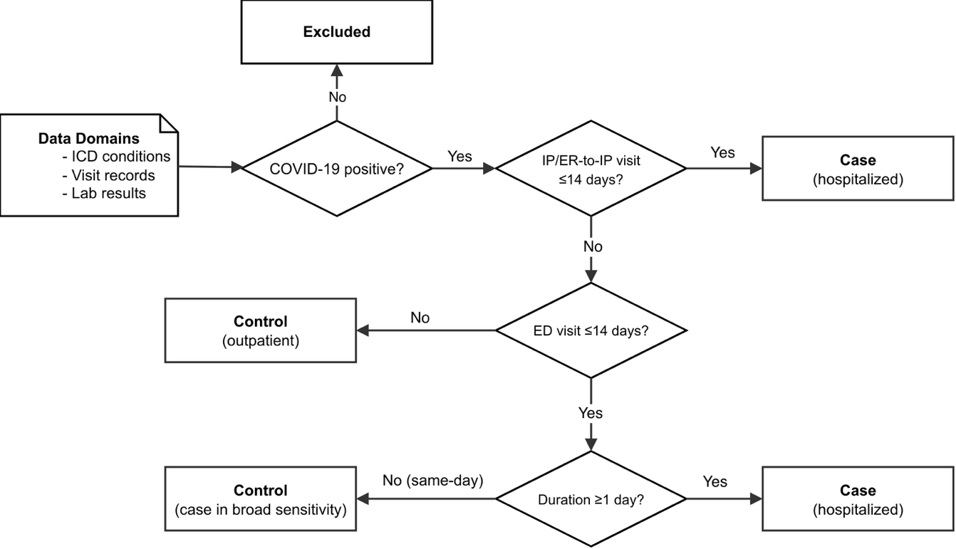

Exposure and covariates
We extracted demographic features, vaccination status (eTable 3), and Charlson comorbidities (eTable 4),[27] both ascertained only from records dated before the index date. Six SDoH domains (eTable 5) were derived from the Basics Survey, completed a median of 692 days (IQR 286-985) before the index date, with 86.4% preceding infection. Missingness arises by two different mechanisms and is not one quantity. Income, education, employment, and housing were asked of every participant, so a missing value is a Skip or Prefer-not-to-answer response. Disability and insurance were frequently not administered: the ACS-6 items were added to The Basics survey on November 10, 2020, and the insurance item after enrolment began, so many participants were never asked. Missing was retained as an explicit level in both cases (eMethod). A missing indicator avoids a complete-case analysis; it does not remove missing-data bias. Insurance used employer-provided coverage as the reference; participants reporting several coverage types were assigned to the category most indicative of access barriers, so a participant with both Medicaid and employer coverage was coded as Medicaid.

Statistical analysis
Matched data were analyzed by conditional logistic regression with standard errors clustered on person identifier to account for control reuse.[28] Under an alternative variance estimator the significance status of Asian race changed and no other variable did (eTable 11b); MarketScan used model-based standard errors. Pandemic wave (pre-Delta, before June 15, 2021; Delta, to December 14, 2021; Omicron, thereafter) entered as a covariate. The base model included sex, race, ethnicity, age, wave, vaccination, and 19 Charlson comorbidities. Domain-specific models added one SDoH domain to the base model,[18] and the joint model added all six. From the joint model we contrasted two profiles (employer-insured/$35,000-99,999/homeowner versus Medicaid/$10,000-24,999/renter) as the product of the three mutually adjusted odds ratios; conditional logistic regression conditions the stratum intercepts out of the likelihood, so absolute probabilities are not estimable. Wave-stratified models were fitted within strata whose index dates fell in that wave, using base-model covariates minus the wave indicator.[29, 30] For race we compared the base and joint models within each wave as the proportional reduction in the log adjusted odds ratio;[31] because the odds ratio is non-collapsible, part of any such change reflects the scale rather than confounding, so these percentages are indicative rather than exact explained fractions.
The MarketScan comparison used the same Charlson code sets and regression framework in Commercial Claims (2020-2023), with insurance plan type and geographic region as site-specific covariates (eTable 8).[32] It tests whether the clinical base model behaves comparably in a different population; it does not test whether the SDoH findings replicate, because MarketScan contains neither race nor individual-level SDoH.

RESULTS

Participant characteristics
Among 413,457 All of Us participants, 25,160 had confirmed COVID-19 with both EHR and Basics Survey data, of whom 4,064 (16.2%) met the hospitalization phenotype (Figures 1, 2). Complete matching variables were available for 24,809 participants, including 3,997 of the cases; participants with no diagnosis recorded before the index date have no measurable length of medical history and could not be matched. Most qualifying visits began on the index date itself (eFigure 2). Matching achieved 3.88 controls per case, giving 19,520 observations in 3,997 strata after 437 control observations were removed for unverifiable follow-up near the data cutoff; the 15,523 control observations came from [STALE: unique-individual count and maximum reuse await re-extraction] unique individuals (eTable 11). Pre-matching imbalance was largest for diagnosis count (SMD = 0.410), and all three matching variables fell below 0.03 after matching (eTables 6, 7; eFigure 1).
Because matching balanced encounter-density proxies rather than clinical or social characteristics, demographic differences persisted, as expected. Cases had higher proportions of males (39.0% vs 30.6%), Black participants (29.9% vs 17.9%), adults aged 65 or over (35.7% vs 30.5%), and Medicaid-insured participants (34.7% vs 26.2%). Characteristics are summarized in Tables 1 and 2.

Demographics, vaccination, pandemic wave, and comorbidities
In the base model, female sex (AOR 0.77, 95% CI 0.71-0.83) and recorded vaccination (0.43, 0.38-0.48) carried lower odds, age rose monotonically to 1.51 (1.35-1.68) at 65 or over, and Black race carried substantially elevated odds (2.39, 2.18-2.62; Table 1, Figure 3). [STALE: pandemic-wave and individual comorbidity estimates await re-extraction from base_model_coefficients.csv.] Chronic pulmonary disease (0.90, 0.84-0.98) and mild liver disease (0.83, 0.75-0.91) remained inverse. Both moved toward the null once the matching variables were restricted to records dated before the index date: chronic pulmonary from 0.85 and mild liver from 0.76, closing roughly a third of the distance to 1.0. Diagnosis codes accrued during the index admission had been entering the propensity model, so part of the earlier inverse association was an artifact of that leakage. The remainder is consistent with matching on encounter density rather than clinical severity, which pairs patients carrying these high-contact conditions with controls of comparably heavy utilization. Neither estimate should be read as protective.
Table 1. Demographic and clinical characteristics of the matched All of Us and MarketScan cohorts.
Data are n (%) unless otherwise specified. Cases were hospitalized within 14 days of the COVID-19 index date; controls were COVID-positive participants not hospitalized within that window, matched 1:4 on encounter-density proxies. Percentages are column percentages within each cohort. Abbreviations: AoU, All of Us Research Program; s.d., standard deviation.
 | All of Us |  | MarketScanᶜ
Characteristic | Cases | Controls | Cases | Controls
N | 4,064 | 15,856 | 139,468 | 554,214
Sex
Female | 2,441 (60.1) | 10,834 (68.3) | 67,914 (48.7) | 375,330 (67.7)
Male | 1,586 (39.0) | 4,854 (30.6) | 71,554 (51.3) | 178,884 (32.3)
Other | 37 (0.9) | 168 (1.1) | <20 | <20
Race
White | 1,726 (42.5) | 8,644 (54.5) | NA | NA
Black | 1,217 (29.9) | 2,833 (17.9) | NA | NA
Asian | 62 (1.5) | 260 (1.6) | NA | NA
Other | 1,059 (26.1) | 4,119 (26.0) | NA | NA
Ethnicity
Not Hispanic | 3,013 (74.1) | 11,727 (74.0) | NA | NA
Hispanic | 919 (22.6) | 3,670 (23.1) | NA | NA
Other | 132 (3.2) | 459 (2.9) | NA | NA
Age group, years
<45 | 920 (22.6) | 4,624 (29.2) | 53,369 (38.3) | 284,866 (51.4)
45–54 | 639 (15.7) | 2,901 (18.3) | 37,833 (27.1) | 130,590 (23.6)
55–64 | 1,055 (26.0) | 3,492 (22.0) | 47,908 (34.4) | 137,688 (24.8)
≥65 | 1,450 (35.7) | 4,839 (30.5) | 358 (0.3) | 1,070 (0.2)
Mean age (s.d.) | 57.4 (16.2) | 54.6 (16.2) | 45.6 (14.6) | 41.2 (15.9)
Vaccination
Recorded before index | 361 (8.9) | 2,700 (17.0) | 11,300 (8.1) | 108,286 (19.5)
No record | 3,703 (91.1) | 13,156 (83.0) | 128,168 (91.9) | 445,928 (80.5)
Charlson comorbidities
Myocardial infarction | 570 (14.0) | 1,842 (11.6) | 2,729 (2.0) | 7,733 (1.4)
Congestive heart failure | 1,034 (25.4) | 3,100 (19.6) | 6,614 (4.7) | 15,123 (2.7)
Peripheral vascular disease | 882 (21.7) | 3,042 (19.2) | 5,866 (4.2) | 20,464 (3.7)
Cerebrovascular disease | 786 (19.3) | 2,502 (15.8) | 4,215 (3.0) | 17,307 (3.1)
Dementia | 243 (6.0) | 763 (4.8) | 769 (0.6) | 2,202 (0.4)
Chronic pulmonary disease | 1,819 (44.8) | 7,744 (48.8) | 18,418 (13.2) | 92,037 (16.6)
Rheumatic disease | 437 (10.8) | 1,936 (12.2) | 3,604 (2.6) | 20,162 (3.6)
Peptic ulcer disease | 336 (8.3) | 1,299 (8.2) | 1,174 (0.8) | 6,366 (1.1)
Liver disease, mild | 854 (21.0) | 4,124 (26.0) | 7,881 (5.7) | 38,981 (7.0)
Liver disease, moderate/severe | 163 (4.0) | 391 (2.5) | 889 (0.6) | 1,984 (0.4)
Diabetes without complications | 551 (13.6) | 2,058 (13.0) | 19,085 (13.7) | 52,613 (9.5)
Diabetes with complications | 1,075 (26.5) | 3,542 (22.3) | 11,696 (8.4) | 26,591 (4.8)
Hemiplegia or paraplegia | 212 (5.2) | 794 (5.0) | 1,460 (1.0) | 3,423 (0.6)
Renal disease, mild/moderate | 630 (15.5) | 2,174 (13.7) | 6,199 (4.4) | 15,289 (2.8)
Renal disease, severe | 479 (11.8) | 1,236 (7.8) | 2,816 (2.0) | 3,855 (0.7)
HIV | 44 (1.1) | 135 (0.9) | 444 (0.3) | 1,610 (0.3)
Metastatic solid tumor | 191 (4.7) | 609 (3.8) | 2,295 (1.6) | 6,099 (1.1)
Malignancy | 700 (17.2) | 2,528 (15.9) | 4,951 (3.5) | 19,657 (3.5)
AIDS | 63 (1.6) | 264 (1.7) | 127 (0.1) | 393 (0.1)
Pandemic wave
Pre-Delta | 2,087 (51.4) | 7,656 (48.3) | NA | NA
Delta | 644 (15.8) | 2,338 (14.7) | NA | NA
Omicron | 1,333 (32.8) | 5,862 (37.0) | NA | NA
ᵃNA, not available. Race and ethnicity are not captured in MarketScan commercial claims. Pandemic wave was included as a covariate in the MarketScan base model (Figure 3, eTable 10) but is not tabulated here. Cell counts <20 are suppressed.
ᵇVaccination “No record” denotes no vaccination record identified before the index date using the concept set in eTable 3; it does not confirm the participant was unvaccinated.
ᶜMarketScan captures commercially insured individuals, so adults aged ≥65 years, who are predominantly covered by Medicare, are under-represented.

Table 2. Social determinants of health characteristics, matched All of Us cohort.
Data are n (%). Percentages are column percentages of the matched cohort (3,997 cases; 15,523 controls).
Variable | Cases | Controls
Income
<$10,000 | 675 (16.6) | 2,257 (14.2)
$10,000–24,999 | 650 (16.0) | 2,268 (14.3)
$25,000–34,999 | 318 (7.8) | 1,351 (8.5)
$35,000–99,999 (reference) | 793 (19.5) | 4,264 (26.9)
$100,000–149,999 | 277 (6.8) | 1,292 (8.1)
$150,000–199,999 | 122 (3.0) | 582 (3.7)
≥$200,000 | 143 (3.5) | 705 (4.4)
Missing | 1,086 (26.7) | 3,137 (19.8)
Employment
Employed (reference) | 1,099 (27.0) | 5,930 (37.4)
Student | 84 (2.1) | 318 (2.0)
Unemployed | 1,334 (32.8) | 4,407 (27.8)
Retired or other | 1,427 (35.1) | 4,819 (30.4)
Missing | 120 (3.0) | 382 (2.4)
Education
Never attended school | <20 | <20
Below high school or GED | 565 (13.9) | 1,643 (10.4)
High school, GED, or some college | 2,128 (52.4) | 8,164 (51.5)
College graduate or higher (reference) | 1,243 (30.6) | 5,758 (36.3)
Missing | 112 (2.8) | 273 (1.7)
Housing tenure
Own home (reference) | 1,519 (37.4) | 6,816 (43.0)
Rent | 2,030 (50.0) | 6,849 (43.2)
Other | 345 (8.5) | 1,615 (10.2)
Missing | 169 (4.2) | 571 (3.6)
Housing stability
Stable (reference) | 3,281 (80.7) | 12,967 (81.8)
Unstable | 710 (17.5) | 2,684 (16.9)
Missing | 73 (1.8) | 205 (1.3)
Disability (any)
Yes | 557 (13.7) | 2,174 (13.7)
No (reference) | 815 (20.1) | 3,349 (21.1)
Missing* | 2,692 (66.2) | 10,333 (65.2)
Insurance type
Employer (reference) | 788 (19.4) | 4,201 (26.5)
Medicare | 940 (23.1) | 3,496 (22.0)
Medicaid | 1,410 (34.7) | 4,159 (26.2)
Other or none | 368 (9.1) | 1,316 (8.3)
Missing* | 558 (13.7) | 2,684 (16.9)
“Missing” denotes a Skip or Prefer-not-to-answer response. Cell counts <20 are suppressed per All of Us data use policy.
*Disability and insurance missingness is mainly non-administration: the ACS-6 items were added to The Basics survey on November 10, 2020, and the insurance item after enrollment began.

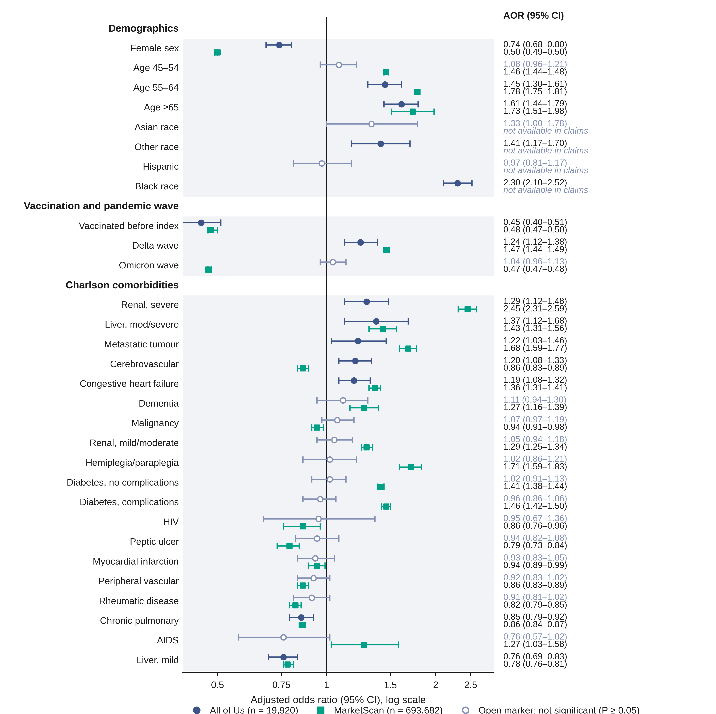

Social determinants of health
[STALE: domain-specific estimates await re-extraction; the joint-model values below are current.] Each domain was first entered alone into the base model (Table 3, Figure 4). Medicaid coverage carried the largest insurance estimate (AOR 1.59, 1.43-1.77) and other or no coverage was also elevated. The income pattern was not monotonic: the three lowest strata were elevated (<$10,000, 1.46, 1.29-1.65) but so was $100,000-149,999 (1.20, 1.03-1.41), which may reflect heterogeneity within the broad $35,000-99,999 reference or residual confounding from unmeasured factors such as occupational exposure. Education below GED (1.35, 1.18-1.53), unemployment (1.41, 1.28-1.56), student status (1.61, 1.24-2.09), non-employment (1.36, 1.22-1.51), and renting (1.28, 1.17-1.39) were all elevated. The "never attended school" estimate (3.35, 1.66-6.78) rests on fewer than 20 participants. Housing instability and disability were not significant.
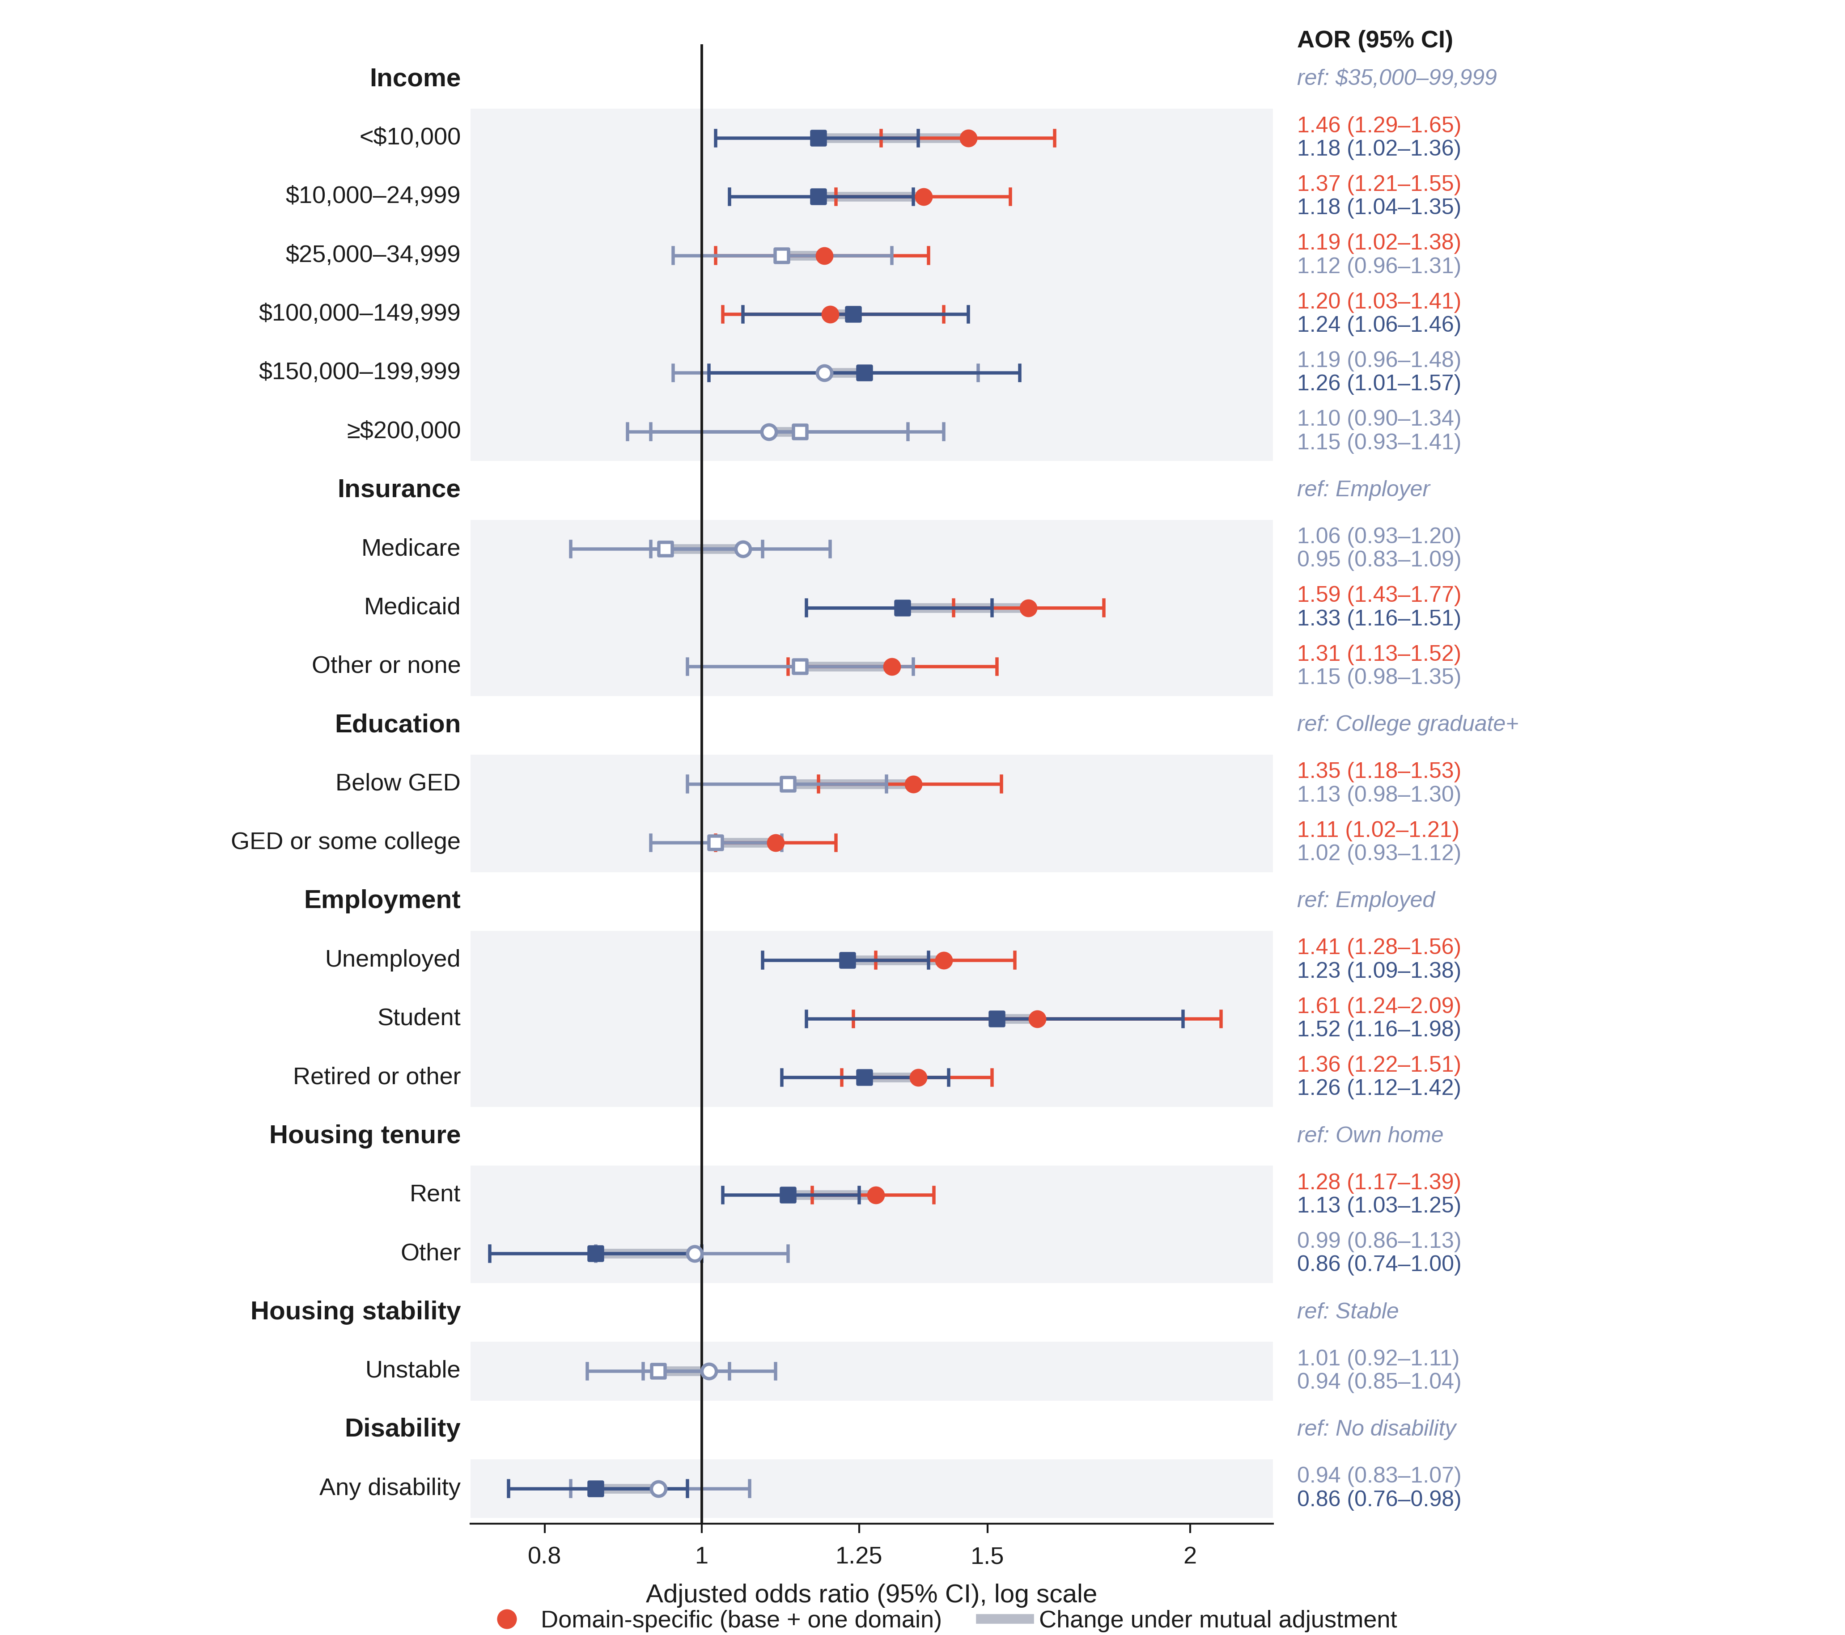
Table 3. Domain-specific and jointly adjusted associations of survey-derived SDoH with COVID-19 hospitalization.
Values are adjusted odds ratios (95% confidence intervals) from conditional logistic regression within matched strata. The domain-specific model adds one SDoH domain to the base model; the joint model adds all six domains simultaneously. Both adjust for sex, race, ethnicity, age, vaccination, pandemic wave, and 19 Charlson comorbidities.
Variable | Domain-specific AOR (95% CI) | Joint AOR (95% CI)
Income (reference: $35,000–99,999)
<$10,000 | 1.46*** (1.29–1.65) | 1.18* (1.02–1.36)
$10,000–24,999 | 1.37*** (1.21–1.55) | 1.18* (1.04–1.35)
$25,000–34,999 | 1.19* (1.02–1.38) | 1.12 (0.96–1.31)
$100,000–149,999 | 1.20* (1.03–1.41) | 1.24** (1.06–1.46)
$150,000–199,999 | 1.19 (0.96–1.48) | 1.26* (1.01–1.57)
≥$200,000 | 1.10 (0.90–1.34) | 1.15 (0.93–1.41)
Missing | 1.65*** (1.48–1.84) | 1.46*** (1.29–1.64)
Insurance (reference: Employer)
Medicare | 1.06 (0.93–1.20) | 0.95 (0.83–1.09)
Medicaid | 1.59*** (1.43–1.77) | 1.33*** (1.16–1.51)
Other or none | 1.31*** (1.13–1.52) | 1.15 (0.98–1.35)
Education (reference: College graduate or higher)
Never attended school | 3.35*** (1.66–6.78) | 2.85** (1.40–5.82)
Below GED | 1.35*** (1.18–1.53) | 1.13 (0.98–1.30)
GED or some college | 1.11* (1.02–1.21) | 1.02 (0.93–1.12)
Employment (reference: Employed)
Unemployed | 1.41*** (1.28–1.56) | 1.23*** (1.09–1.38)
Student | 1.61*** (1.24–2.09) | 1.52** (1.16–1.98)
Retired or other | 1.36*** (1.22–1.51) | 1.26*** (1.12–1.42)
Housing tenure (reference: Own home)
Rent | 1.28*** (1.17–1.39) | 1.13* (1.03–1.25)
Other | 0.99 (0.86–1.13) | 0.86* (0.74–1.00)
Housing stability (reference: Stable)
Unstable | 1.01 (0.92–1.11) | 0.94 (0.85–1.04)
Disability (reference: No)
Any disability | 0.94 (0.83–1.07) | 0.86* (0.76–0.98)
*P < 0.05; **P < 0.01; ***P < 0.001. Abbreviations: AOR, adjusted odds ratio; CI, confidence interval; GED, General Educational Development; SDoH, social determinants of health.

Mutually adjusted SDoH associations and Black-race coefficient attenuation
Under mutual adjustment (Table 3), unemployment carried the largest social association (1.35, 1.20-1.52), followed by the two lowest income strata (<$10,000, 1.21, 1.05-1.40; $10,000-24,999, 1.21, 1.05-1.38), Medicaid (1.19, 1.05-1.36), and renting (1.16, 1.05-1.28). Education below GED lost significance (1.06, 0.92-1.22, P = 0.42), indicating overlap with income and employment rather than a separate contribution. [STALE: student status, non-employment, the upper-middle income strata, disability and housing tenure recorded as other await re-extraction from joint_sdoh_coefficients.csv.] Insurance no longer carried the largest social estimate: restricting the matching variables to pre-index records moved Medicaid from 1.33 to 1.19 while moving unemployment from 1.23 to 1.35, so the ordering among domains is not robust to how the propensity model is specified, even though which domains remain associated is.
Including all six domains reduced the Black-race AOR from 2.39 (2.18-2.62) to 2.09 (1.89-2.31; eTable 12a), an attenuation of 15.1% on the log scale. Entering the domains one at a time shows where that reduction comes from: income accounts for 11.7 percentage points of it, housing tenure 8.7, insurance 6.2, education 4.8, and employment 3.8, while housing stability (0.1) and disability (0.0 across all seven codings) account for none. The association narrowed but did not resolve: even after adjustment for six domains, Black participants had roughly twice the odds of hospitalization compared with White participants. Individual-level socioeconomic factors, as measured by self-report and dominated by income, therefore capture only a fraction of the racial association, consistent with UK Biobank and integrated-care studies reporting similarly modest attenuation.[33, 34]
The combined profile of Medicaid coverage, household income of $10,000-24,999, and renting carried 1.67-fold higher odds (1.40-1.99) than employer-insured homeowners in the reference income stratum, the product of the three mutually adjusted odds ratios with a delta-method interval. [STALE: the equivalent product of the domain-specific AORs, 2.79 before the re-run, awaits re-extraction.] This is a within-stratum odds ratio; conditional logistic regression conditions the stratum intercepts out of the likelihood, so absolute probabilities are not identified.

Wave-stratified associations
[STALE: wave-specific income estimates await re-extraction. The income-by-wave interaction was not significant in the re-run (chi-square 17.77, 14 df, P = 0.22), which supports the word persisted: no difference across waves was detectable.] The lower-income association persisted across waves (Figure 5a; eTable 13). Income below $10,000 carried AOR 1.49 (1.21-1.82) pre-Delta, 2.11 (1.10-4.03) during Delta, and 1.64 (1.23-2.18) during Omicron, when vaccines were available. Confidence intervals overlap across waves, so the wave estimates are not distinguishable from one another, and the design cannot test treatment-access mechanisms directly. Period-based work has reported income-related disparities persisting across variant transitions.[29]
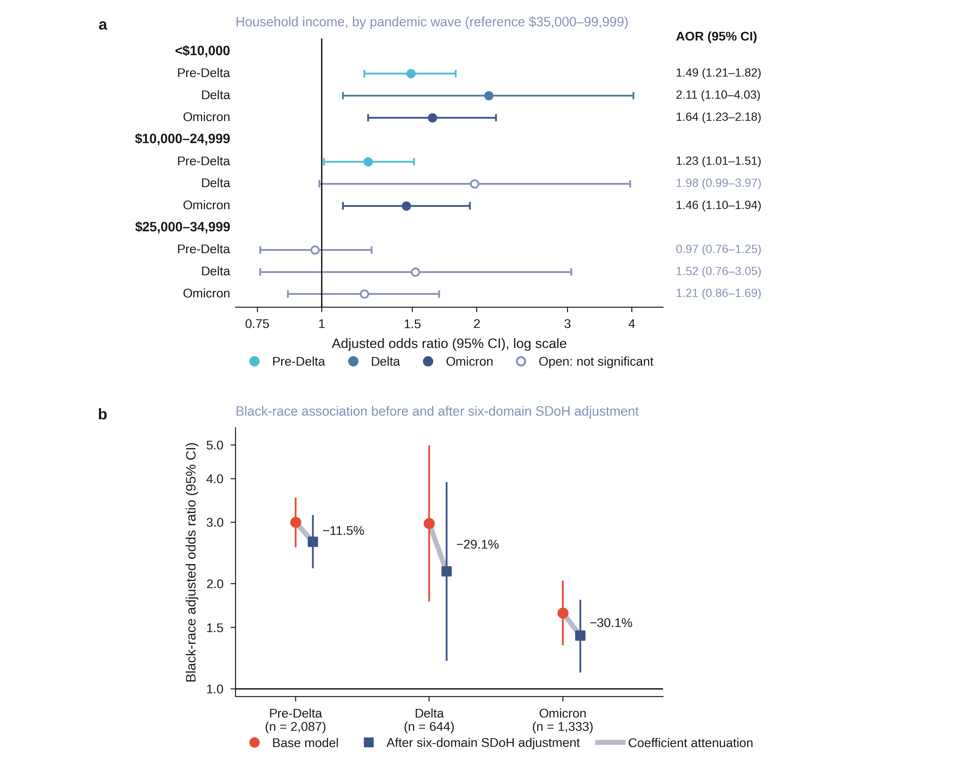

Wave-specific estimates come from a single model carrying exposure-by-wave interaction terms, which retains every matched stratum, rather than from three models fitted inside each wave, which discard any stratum whose case and controls straddle a boundary. The Black-race association was 2.30 (2.01-2.64) pre-Delta, 2.24 (1.77-2.83) during Delta, and 1.78 (1.52-2.09) during Omicron (Figure 5b), and remained significant in all three. The omnibus race-by-wave interaction, a joint test across all race categories, was not significant (chi-square 11.51, 6 df, P = 0.07); it is diluted by the Asian category, whose Delta estimate spans 0.14 to 1.65. The contrast the study set out to make was significant: pre-Delta against Omicron for Black race, P = 0.017, while pre-Delta against Delta was not (P = 0.83). The association was therefore flat through Delta and narrower by Omicron. Insurance was the one exposure whose omnibus wave interaction reached significance (chi-square 23.58, 8 df, P = 0.003). [STALE: within-wave attenuation percentages and Medicaid-by-wave estimates await re-extraction; eTables 12b and 12c still carry v18.6 values.]

Sensitivity analyses
[STALE: all five sensitivity analyses await re-extraction.] Five sensitivity analyses supported the stability of the joint estimates (eTable 15). Restricting to inpatient-only cases, excluding controls with acute-care utilization, removing vaccination, and collapsing income to three levels (<$35,000, 1.16, 1.04-1.30) preserved all key associations. Restricting to pre-infection surveys (86.4% of the cohort) preserved direction throughout, but the income and renter estimates lost significance; their intervals widened only slightly while the point estimates moved toward the null (1.18 to 1.13 and 1.13 to 1.09), so the change reflects attenuation rather than the smaller sample alone.

Cross-cohort clinical-model comparison
[STALE: MarketScan was not re-run. Every MarketScan figure in this paragraph, in Table 1 and in Figure 3 is a v18.6 value. 01_ms_etl.py carries an unexecuted fix restricting coverage_span_days to pre-index records, and it runs on Quartz, not the Workbench.] In MarketScan (693,682 matched observations; 139,468 cases; Table 1), female sex, recorded vaccination, and the age gradient were directionally concordant with All of Us, and comorbidity associations were generally larger (eTable 10). Five of 25 comparable estimates were directionally discordant: Omicron wave (All of Us 1.04, 0.96-1.13; MarketScan 0.47, 0.47-0.48), cerebrovascular disease, diabetes with complications, malignancy, and AIDS. The Omicron discordance is the largest and likely reflects the age and coverage differences between a commercially insured population and All of Us; the AIDS difference reflects the strict two-step All of Us phenotype (eTable 14). Concordance here means agreement in the direction of the point estimate irrespective of significance, which is a weak criterion.

DISCUSSION
Prior work in these data sources identified individual risk factors. Choi et al. found an income gradient in All of Us and no education association, and did not test employment or housing.[11] In N3C, Bennett et al. found Black race and obesity independently associated with clinical severity,[35] and Vaidya et al. found individual-level SDoH associations using EHR-coded fields.[16] We reproduce the low-income association and the residual Black-race association, and additionally identify independent employment, insurance, and housing associations that the few-variable and sparsely coded approaches did not surface.
Our joint model extends these findings in three ways. First, it distinguishes associations that composite indices and few-variable models cannot separate: Choi et al.'s three-variable design did not include employment or housing,[11] and Gupta et al.'s composite All of Us deprivation index collapses insurance, income, employment, and housing into one score.[36] Second, encounter-density matching mitigates informative presence bias.[17] Third, wave-stratified analyses show the income association persisting while the racial association narrowed. Our contribution is identifying which domains remain associated after mutual adjustment, and which lose significance once overlapping domains are included (Figure 4). The two models answer complementary questions: the one-domain estimate is the association a domain carries when it is the only social factor in the model, while the mutually adjusted estimate is what remains once the other measured social domains are included. Neither supersedes the other.

What persists and what attenuates
In the joint model, unemployment, the two lowest income strata, Medicaid coverage, and renting retained independent associations, and unemployment carried the largest of them. The Medicaid finding is consistent with cohort evidence that insurance type is associated with COVID-19 hospitalization beyond underlying health conditions,[38] and insurance likely functions as both a poverty marker and an access-barrier marker; separating those requires designs beyond what case-control data can provide.[39] The renter association is consistent with housing tenure tracking crowding, shared facilities, and reduced ability to isolate, and with the state-level increases in COVID-19 incidence observed after eviction moratoria expired.[40] Education below GED attenuated to 1.06 (0.92-1.22) once economic variables entered, matching Choi et al.'s null education finding.[11]

The Black-race association: what SDoH adjustment does and does not capture
After adjustment for six individual-level social domains, Black participants retained roughly twice the odds of hospitalization (AOR 2.09, 1.89-2.31), and the decomposition shows the adjustment is carried almost entirely by income. Interpreting a residual race coefficient requires care: the socioeconomic variables adjusted for are themselves shaped by structural disadvantage, and residual confounding from imperfectly measured socioeconomic position tends to bias such coefficients toward appearing independent.[41, 42] Because the odds ratio is non-collapsible, part of the observed change on adjustment may reflect scale properties rather than confounding or mediation, so the attenuation estimates indicate direction and approximate magnitude rather than precise explained fractions.[43]
This overall attenuation masks a temporal shift, and the interaction tests locate it precisely. The Black-race association was flat from pre-Delta to Delta (P = 0.83) and narrower by Omicron (P = 0.017), while the omnibus test across all race categories did not reach significance (P = 0.07). Early in the pandemic, structural factors beyond the reach of individual surveys, such as residential segregation, essential-worker exposure, and differential testing access, may have contributed more to the racial gap; as those exposures equalized, the residual association narrowed. Insurance was the only exposure with a significant omnibus wave interaction (P = 0.003), and income had none (P = 0.22), so the wave-varying element of this study is which insurance a patient held, not how poor they were.

Income persistence through Omicron and clinical implications
[STALE: the Omicron income estimate awaits re-extraction.] During Omicron, participants with household income below $10,000 still had 1.64-fold higher hospitalization odds despite available vaccines. In an 11.2-million-person Ontario cohort, income inequalities in COVID-19 death likewise persisted, and inequality in vaccination coverage accounted for 56.9% (95% CI 22.5-91.3) of the income inequality in later-wave deaths,[30] so countermeasure availability did not translate into equitable uptake. The Medicaid association, by contrast, was not significant in the joint model in either Delta or Omicron once income and housing entered, suggesting insurance type was less of an independent predictor than the economic conditions it tracks. Barriers to testing, prescriptions, paid sick leave, and isolation space may contribute to the residual income association, though the design cannot test access mechanisms directly.
Insurance and income are recorded in many intake workflows, so they are among the social factors most readily available to a health system.[3] Whether recording them would improve a screening decision is a prediction question this design does not address. Because the domains overlap, their combined association is smaller than the domain-specific estimates suggest: the combined profile carried 1.67-fold higher odds (1.40-1.99), and screening on any single social indicator would therefore overstate individual risk while missing how much the domains share.

The measurement case: why survey-linked EHR matters
The All of Us survey enabled analysis of socioeconomic risk at a level of detail unavailable in routine structured EHR data. Patient surveys detect socioeconomic risk in 8-41% of patients, against 0-2% in EHR-coded fields.[15] Across 2.7 billion US healthcare encounters, SDoH Z-code documentation ranged from 0.5% to 2.4%,[44] and only 24.4% of US hospitals screened for all five common social needs in 2017-2018.[45] Two results depend directly on that difference. Education below GED loses significance once income and employment enter the same model, and the decomposition of the Black-race association into its contributing domains requires all six measured in the same participants. Neither is recoverable from social risk documented in fewer than 2% of encounters.

Cross-cohort comparison
The MarketScan analysis is a descriptive cross-cohort comparison of clinical and demographic covariates, not external validation of the SDoH findings; formal transportability assumptions were not evaluated.[32] Sex and vaccination effects were directionally concordant, and renal and cardiac risk factors replicated in direction with larger effect sizes, likely reflecting cohort composition and the encounter-density matching strategy. Evaluating SDoH associations across populations requires individual-level social measures, which commercial claims do not provide.

Strengths
This study combines six survey-derived individual-level domains, a propensity-matched encounter-density design, and both domain-specific and joint models in a cohort enriched for underrepresented populations.[19, 20] Wave-stratified analyses show that income associations persisted while the racial association narrowed.

Limitations
All of Us is a volunteer cohort with higher health literacy and digital access than the general population,[46] and it oversampled populations underrepresented in biomedical research, which strengthens power for minority subgroup analyses but limits generalizability. The disability domain was least complete because the ACS-6 items were added to the survey on November 10, 2020, so earlier respondents have no response unless they later completed them. Vaccination capture was incomplete and many index dates preceded vaccine availability. SDoH were measured a median of 692 days before infection, so pandemic-era changes in income or employment are not captured. Matching required a diagnosis recorded before the index date, so 67 cases and 351 participants overall could not be matched; their exclusion is informative if having no pre-index record is itself related to social position. Matching on encounter density reduces but may not eliminate informative presence bias,[17] the inverse pulmonary and liver associations likely reflect residual confounding rather than protection, and the strict phenotype may not fully separate COVID-related admissions from admissions with incidental positivity. Because diagnosis count may lie on the SDoH-to-hospitalization causal pathway, our estimates are conservative within-stratum associations rather than total causal effects. [STALE: differential income missingness, the Omicron convergence warning, the comparison with Choi et al.'s hospitalization rate, and the effective control sample size await re-extraction.] Because matching used replacement, the effective control sample size is smaller than the 15,523 control observations, so nominal precision overstates the information available.

CONCLUSIONS
In this matched All of Us cohort, Medicaid coverage, unemployment, renting, and the two lowest income strata were independently associated with COVID-19 hospitalization after clinical adjustment; two upper-middle income strata were also elevated, so the income association was not monotonic. The Black-race association narrowed by the Omicron period while SDoH-associated coefficient attenuation rose between the pre-Delta and Delta waves, although the waves were not compared formally. Income associations persisted through Omicron despite available vaccines. Interpretation of these associations depends on survey timing and on overlap among the social domains.

ACKNOWLEDGMENTS
The All of Us Research Program was supported by the National Institutes of Health, Office of the Director: Regional Medical Centers: 1 OT2 OD026549; 1 OT2 OD026554; 1 OT2 OD026557; 1 OT2 OD026556; 1 OT2 OD026550; 1 OT2 OD026552; 1 OT2 OD026553; 1 OT2 OD026548; 1 OT2 OD026551; 1 OT2 OD026555; IAA #: AOD 16037; Federally Qualified Health Centers: HHSN 263201600085U; Data and Research Center: 5 U2C OD023196; Biobank: 1 U24 OD023121; The Participant Center: U24 OD023176; Participant Technology Systems Center: 1 U24 OD023163; Communications and Engagement: 3 OT2 OD023205; 3 OT2 OD023206; and Community Partners: 1 OT2 OD025277; 3 OT2 OD025315; 1 OT2 OD025337; 1 OT2 OD025276. The All of Us Research Program would not be possible without the partnership of its participants.

AUTHOR CONTRIBUTIONS
Haining Wang: conceptualization, methodology, formal analysis, investigation, data curation, software, validation, visualization, writing – original draft, writing – review and editing. Yihan Zhang: data curation, writing – review and editing. Chenxi Xiong: data curation, writing – review and editing. Zhao Zhang: writing – review and editing. Jiangqiong Li: writing – review and editing. Hengyi Fu: conceptualization, writing – review and editing. Xiaojun Yuan: conceptualization, writing – review and editing. Xiaochun Li: methodology, writing – review and editing. Jing Su: conceptualization, methodology, supervision, funding acquisition, validation, writing – review and editing.

FUNDING
This work was supported partially by the National Library of Medicine of the National Institutes of Health (R01LM013771). It was also supported by the Indiana University Precision Health Initiative and the Indiana University Melvin and Bren Simon Comprehensive Cancer Center Support Grant from the National Cancer Institute (P30CA082709). The content is solely the responsibility of the authors and does not necessarily represent the official views of the sponsors.

CONFLICTS OF INTEREST
The authors have no conflict of interest to disclose.

ETHICS AND DATA USE
The All of Us Research Program holds Institutional Review Board approval for its protocol, and all participants gave written informed consent for the collection and sharing of their data. This analysis used de-identified Controlled Tier data (Curated Data Repository version 7) inside the All of Us Researcher Workbench. Every author who accessed the data holds current Controlled Tier authorization and completed the required training, and the work was done in a registered workspace under the All of Us Data Use and Registration Agreement and the Data User Code of Conduct. MarketScan data were analyzed in de-identified form under licence from Merative.

DATA AVAILABILITY
All data and codes are available at All of Us Research Workbench for users authorized to access All of Us Controlled Tier Data v7. MarketScan data are available under license from Merative. Codes for reproducing the analysis are available at https://github.com/Su-informatics-lab/aou_covid.

REFERENCES
1. World Health Organization. Social determinants of health: progress of the World report on social determinants of health equity. Report by the Director-General. Document EB154/21. Geneva: World Health Organization, 2023.
2. Global Preparedness Monitoring Board. A Fragile State of Preparedness: 2023 Report on the State of the World's Preparedness. Geneva: World Health Organization, 2023.
3. Hoven H, Dragano N, Angerer P, et al. Striving for Health Equity: The Importance of Social Determinants of Health and Ethical Considerations in Pandemic Preparedness Planning. Int J Public Health 2022;67:1604542 doi: 10.3389/ijph.2022.1604542 [published Online First: 20220405].
4. Acosta AM, Garg S, Pham H, et al. Racial and Ethnic Disparities in Rates of COVID-19-Associated Hospitalization, Intensive Care Unit Admission, and In-Hospital Death in the United States From March 2020 to February 2021. JAMA Netw Open 2021;4(10):e2130479 doi: 10.1001/jamanetworkopen.2021.30479 [published Online First: 20211001].
5. Romano SD, Blackstock AJ, Taylor EV, et al. Trends in Racial and Ethnic Disparities in COVID-19 Hospitalizations, by Region - United States, March-December 2020. MMWR Morb Mortal Wkly Rep 2021;70(15):560–65 doi: 10.15585/mmwr.mm7015e2 [published Online First: 20210416].
6. Mude W, Oguoma VM, Nyanhanda T, et al. Racial disparities in COVID-19 pandemic cases, hospitalisations, and deaths: A systematic review and meta-analysis. J Glob Health 2021;11:05015 doi: 10.7189/jogh.11.05015 [published Online First: 20210626].
7. Karmakar M, Lantz PM, Tipirneni R. Association of Social and Demographic Factors With COVID-19 Incidence and Death Rates in the US. JAMA Netw Open 2021;4(1):e2036462 doi: 10.1001/jamanetworkopen.2020.36462 [published Online First: 20210104].
8. Goyal P, Schenck E, Wu Y, et al. Influence of social deprivation index on in-hospital outcomes of COVID-19. Sci Rep 2023;13(1):1746 doi: 10.1038/s41598-023-28362-0 [published Online First: 20230131].
9. Brown EM, Franklin SM, Ryan JL, et al. Assessing Area-Level Deprivation as a Proxy for Individual-Level Social Risks. Am J Prev Med 2023;65(6):1163–71 doi: 10.1016/j.amepre.2023.06.006 [published Online First: 20230610].
10. Bensken WP, McGrath BM, Gold R, et al. Area-level social determinants of health and individual-level social risks: Assessing predictive ability and biases in social risk screening. J Clin Transl Sci 2023;7(1):e257 doi: 10.1017/cts.2023.680 [published Online First: 20231110].
11. Choi A, Craver A, Luo J, et al. Socioeconomic status and risk of COVID-19 hospitalization in the All of Us Research Program. Front Public Health 2025;13:1690430 doi: 10.3389/fpubh.2025.1690430 [published Online First: 20251210].
12. Sharafeldin N, Bates B, Song Q, et al. Outcomes of COVID-19 in Patients With Cancer: Report From the National COVID Cohort Collaborative (N3C). J Clin Oncol 2021;39(20):2232–46 doi: 10.1200/jco.21.01074 [published Online First: 20210604].
13. Song Q, Bates B, Shao YR, et al. Risk and Outcome of Breakthrough COVID-19 Infections in Vaccinated Patients With Cancer: Real-World Evidence From the National COVID Cohort Collaborative. J Clin Oncol 2022;40(13):1414–27 doi: 10.1200/jco.21.02419 [published Online First: 20220314].
14. Aswani MS, Do LA, Shafer PR. Use Of Social Determinants Of Health Z Codes Was Sparse, 2016-22. Health Aff (Millwood) 2025;44(5):631–35 doi: 10.1377/hlthaff.2024.01033.
15. Iott BE, Rivas S, Gottlieb LM, et al. Structured and unstructured social risk factor documentation in the electronic health record underestimates patients' self-reported risks. J Am Med Inform Assoc 2024;31(3):714–19 doi: 10.1093/jamia/ocad261.
16. Vaidya D, Wilkins KJ, Hurwitz E, et al. Assessing associations between individual-level social determinants of health and COVID-19 hospitalizations: Investigating racial/ethnic disparities among people living with human immunodeficiency virus (HIV) in the U.S. National COVID Cohort Collaborative (N3C). J Clin Transl Sci 2024;8(1):e107 doi: 10.1017/cts.2024.550 [published Online First: 20240521].
17. McGee G, Haneuse S, Coull BA, et al. On the Nature of Informative Presence Bias in Analyses of Electronic Health Records. Epidemiology 2022;33(1):105–13 doi: 10.1097/ede.0000000000001432.
18. Gatz AE, Xiong C, Chen Y, et al. Health disparities in the risk of severe acidosis: real-world evidence from the All of Us cohort. J Am Med Inform Assoc 2024;31(12):2932–39 doi: 10.1093/jamia/ocae256.
19. Denny JC, Rutter JL, Goldstein DB, et al. The "All of Us" Research Program. N Engl J Med 2019;381(7):668–76 doi: 10.1056/NEJMsr1809937.
20. Mapes BM, Foster CS, Kusnoor SV, et al. Diversity and inclusion for the All of Us research program: A scoping review. PLoS One 2020;15(7):e0234962 doi: 10.1371/journal.pone.0234962 [published Online First: 20200701].
21. Tesfaye S, Cronin RM, Lopez-Class M, et al. Measuring social determinants of health in the All of Us Research Program. Sci Rep 2024;14(1):8815 doi: 10.1038/s41598-024-57410-6 [published Online First: 20240416].
22. Ho D, Imai K, King G, et al. MatchIt: Nonparametric Preprocessing for Parametric Causal Inference. Journal of Statistical Software 2011;42(8):1 – 28 doi: 10.18637/jss.v042.i08.
23. Austin PC. Optimal caliper widths for propensity-score matching when estimating differences in means and differences in proportions in observational studies. Pharm Stat 2011;10(2):150–61 doi: 10.1002/pst.433.
24. Goldstein BA, Bhavsar NA, Phelan M, et al. Controlling for Informed Presence Bias Due to the Number of Health Encounters in an Electronic Health Record. Am J Epidemiol 2016;184(11):847–55 doi: 10.1093/aje/kww112 [published Online First: 20161116].
25. Harton J, Mitra N, Hubbard RA. Informative presence bias in analyses of electronic health records-derived data: a cautionary note. J Am Med Inform Assoc 2022;29(7):1191–99 doi: 10.1093/jamia/ocac050.
26. Centers for Disease Control and Prevention. COVID-19-Associated Hospitalization Surveillance Network (COVID-NET). Atlanta, GA: CDC. https://www.cdc.gov/covid/php/covid-net/index.html (accessed 1 Sep 2026).
27. Glasheen WP, Cordier T, Gumpina R, et al. Charlson Comorbidity Index: ICD-9 Update and ICD-10 Translation. Am Health Drug Benefits 2019;12(4):188–97.
28. Austin PC, Cafri G. Variance estimation when using propensity-score matching with replacement with survival or time-to-event outcomes. Stat Med 2020;39(11):1623–40 doi: 10.1002/sim.8502 [published Online First: 20200228].
29. Harrigan SP, Fibke CD, Velásquez García HA, et al. The mediating role of SARS-CoV-2 variants between income and hospitalization due to COVID-19: a period-based mediation analysis. Am J Epidemiol 2025;194(5):1352–61 doi: 10.1093/aje/kwae266.
30. Wang L, Swayze S, Bodner K, et al. Social inequalities in COVID-19 death by area-level income in 11.2 million people in Ontario, Canada: patterns over time and the mediating role of vaccination. American Journal of Epidemiology 2026;195(2):379–90 doi: 10.1093/aje/kwaf051.
31. Maldonado G, Greenland S. Simulation study of confounder-selection strategies. Am J Epidemiol 1993;138(11):923–36 doi: 10.1093/oxfordjournals.aje.a116813.
32. Degtiar I, Rose S. A Review of Generalizability and Transportability. Annual Review of Statistics and Its Application 2023;10:501–24 doi: 10.1146/annurev-statistics-042522-103837.
33. Patel AP, Paranjpe MD, Kathiresan NP, et al. Race, socioeconomic deprivation, and hospitalization for COVID-19 in English participants of a national biobank. Int J Equity Health 2020;19(1):114 doi: 10.1186/s12939-020-01227-y [published Online First: 20200706].
34. Harding JL, Doucet N, Patel SA, et al. The Association Between Black vs. White Race and 30-Day Hospitalization Among People Diagnosed with COVID-19 Within an Integrated Care Setting: a Cohort Study. J Racial Ethn Health Disparities 2025;12(1):543–53 doi: 10.1007/s40615-023-01894-x [published Online First: 20231218].
35. Bennett TD, Moffitt RA, Hajagos JG, et al. Clinical Characterization and Prediction of Clinical Severity of SARS-CoV-2 Infection Among US Adults Using Data From the US National COVID Cohort Collaborative. JAMA Netw Open 2021;4(7):e2116901 doi: 10.1001/jamanetworkopen.2021.16901 [published Online First: 20210701].
36. Gupta S, Lam V, Jordan IK, et al. A composite socioeconomic deprivation index from All of Us survey data: associations with health outcomes and disparities. Preprint. medRxiv 2024 doi: 10.1101/2024.10.04.24314904.
37. Ardekani A, Fereidooni R, Heydari ST, et al. The association of patient-reported social determinants of health and hospitalization rate: A scoping review. Health Sci Rep 2023;6(2):e1124 doi: 10.1002/hsr2.1124 [published Online First: 20230222].
38. McConnell KH, Hajat A, Sack C, et al. Associations Between Insurance, Race and Ethnicity, and COVID-19 Hospitalization, Beyond Underlying Health Conditions: A Retrospective Cohort Study. AJPM Focus 2023;2(3):100120 doi: 10.1016/j.focus.2023.100120 [published Online First: 20230612].
39. Figueroa JF, Khorrami P, Bhanja A, et al. COVID-19-Related Insurance Coverage Changes and Disparities in Access to Care Among Low-Income US Adults in 4 Southern States. JAMA Health Forum 2021;2(8):e212007 doi: 10.1001/jamahealthforum.2021.2007 [published Online First: 20210813].
40. Leifheit KM, Linton SL, Raifman J, et al. Expiring Eviction Moratoriums and COVID-19 Incidence and Mortality. Am J Epidemiol 2021;190(12):2503–10 doi: 10.1093/aje/kwab196.
41. VanderWeele TJ, Robinson WR. On the causal interpretation of race in regressions adjusting for confounding and mediating variables. Epidemiology 2014;25(4):473–84 doi: 10.1097/ede.0000000000000105.
42. Kaufman JS, Cooper RS, McGee DL. Socioeconomic status and health in blacks and whites: the problem of residual confounding and the resiliency of race. Epidemiology 1997;8(6):621–8.
43. Pang M, Kaufman JS, Platt RW. Studying noncollapsibility of the odds ratio with marginal structural and logistic regression models. Stat Methods Med Res 2016;25(5):1925–37 doi: 10.1177/0962280213505804.
44. Hendricks-Sturrup RM, Yankah SE, Lu CY. Social determinants of health Z-code documentation practices in mental health settings: a scoping review. Health Aff Sch 2024;2(4):qxae046 doi: 10.1093/haschl/qxae046 [published Online First: 20240412].
45. Fraze TK, Brewster AL, Lewis VA, et al. Prevalence of Screening for Food Insecurity, Housing Instability, Utility Needs, Transportation Needs, and Interpersonal Violence by US Physician Practices and Hospitals. JAMA Netw Open 2019;2(9):e1911514 doi: 10.1001/jamanetworkopen.2019.11514 [published Online First: 20190904].
46. Kambara MS, Sharma S, Spouge JL, et al. Increasing Representativeness in the All of Us Cohort Using Inverse Probability Weighting. Preprint. medRxiv 2024 doi: 10.1101/2024.10.02.24314774 [revised 18 April 2025].

FIGURE LEGENDS
Figure 1. Study participant flowchart. (a) All of Us: 413,457 participants narrowing to 25,160 COVID-positive, then to 4,064 hospitalized cases and 21,096 outpatient controls; 3,997 cases carried complete matching variables and were matched up to four controls each (19,520 observations in 3,997 strata; 15,523 control observations, after 437 control observations were removed for unverifiable follow-up near the data cutoff). [STALE: panel (b), MarketScan, was not re-run.] (b) MarketScan: 4,423,200 COVID-positive narrowing to 139,472 hospitalized, matched 1:4 (693,682 observations in 139,468 strata; 554,214 control observations from 465,670 unique individuals).
Alt text: Two-panel CONSORT-style flowchart. Each panel reads top to bottom: the full cohort, then the COVID-positive subset, then a split into hospitalized cases and outpatient controls, then a propensity score matching box, then the matched analytic set. Panel (a) is All of Us; panel (b) is MarketScan. Every count is given in the legend above.
Figure 2. Hospitalization phenotype decision tree. The strict 14-day phenotype counts inpatient visits (OMOP concepts 9201, 32037), emergency-to-inpatient visits (262, 8717), and emergency visits with recorded stay duration ≥1 day (9203). Same-day emergency visits without subsequent admission are excluded from the strict outcome but included in the broad 30-day sensitivity outcome. Component counts are reported in eTable 2b.
Alt text: Decision tree for the hospitalization phenotype. Branches separate inpatient visits, emergency-to-inpatient visits, and emergency visits by recorded stay duration, and each branch ends in a strict 14-day or broad 30-day classification. Same-day emergency visits are excluded from the strict phenotype.
Figure 3. Base-model adjusted odds ratios for demographics, vaccination, pandemic wave, and comorbidities, compared between the two cohorts. Navy circles: All of Us (n = 19,520). Teal squares: MarketScan (n = 693,682; [STALE: not re-run]). Filled markers are statistically significant (P < 0.05); open markers are not. Error bars: 95% confidence intervals. Race and ethnicity are not captured in MarketScan. The panel shows Black race only; Asian and Other race estimates are given in the text and eTable 10. Seventeen of the 19 Charlson conditions are plotted; myocardial infarction and peripheral vascular disease are omitted for space and appear in eTable 10. Abbreviations: AOR, adjusted odds ratio; CI, confidence interval; DM, diabetes mellitus.
Alt text: Horizontal forest plot on a log scale with a reference line at an odds ratio of 1.0. Rows run down the left margin: demographics, vaccination, pandemic wave, and 17 Charlson comorbidities. Each row carries a navy circle for All of Us and a teal square for MarketScan, with horizontal error bars for the 95% confidence interval. Filled markers are statistically significant; open markers are not. The Black race row is marked not available for MarketScan.
Figure 4. Domain-specific versus joint associations of six survey-derived SDoH domains with COVID-19 hospitalization. For each level, the coral circle is the domain-specific estimate (base model plus that one domain) and the navy square is the joint estimate (base model plus all six domains simultaneously); the grey bar connecting them marks the change in the coefficient after mutual adjustment. Filled markers are statistically significant (P < 0.05); open markers are not. All models adjust for demographics, vaccination, pandemic wave, and 19 Charlson comorbidities. Domain-specific and joint models are complementary rather than ranked: the one-domain estimate is the association a domain carries when modelled alone, whereas the mutually adjusted estimate is what remains once the other measured social domains are included. Estimates and 95% CIs are listed at right and in Table 3; missing-indicator categories are modeled but omitted for clarity, and the “never attended school” education stratum (fewer than 20 participants; domain-specific 3.35, joint 2.85) falls outside the plotted range. Abbreviations: AOR, adjusted odds ratio; CI, confidence interval; SDoH, social determinants of health; GED, General Educational Development.
Alt text: Paired dumbbell forest plot on a log scale with a reference line at an odds ratio of 1.0, grouped into six social domains. Each level carries two markers joined by a grey bar: a coral circle for the domain-specific model and a navy square for the joint model. The length of the bar shows how far the estimate moves under mutual adjustment. Filled markers are statistically significant; open markers are not. Values are printed at the right of each row and in Table 3.
Figure 5. Wave-varying social and racial associations with COVID-19 hospitalization. Estimates come from single models carrying exposure-by-wave interaction terms, so every matched stratum contributes. (a) Income association within each pandemic wave, grouped by income stratum. Reference group: $35,000 to $99,999. The income-by-wave interaction was not significant (P = 0.22). [STALE: panel (a) values await re-extraction.] (b) Black-race adjusted odds ratio by wave, before (coral circles) and after (navy squares) adjustment for six survey-derived SDoH domains: 2.30 (2.01-2.64) pre-Delta, 2.24 (1.77-2.83) during Delta, and 1.78 (1.52-2.09) during Omicron. The pre-specified pre-Delta against Omicron contrast was significant (P = 0.017) and the pre-Delta against Delta contrast was not (P = 0.83), while the omnibus test across all race categories did not reach significance (P = 0.07). Filled markers are statistically significant (P < 0.05); open markers are not. Error bars and bracketed values are 95% confidence intervals.
Alt text: Two-panel figure. Panel (a) is a grouped forest plot on a log scale: three income strata, and within each stratum the three pandemic waves in time order, coded light to dark blue, with horizontal error bars. Panel (b) is a slope plot with one x-axis position per wave; at each position a coral circle for the unadjusted Black-race estimate sits above a navy square for the SDoH-adjusted estimate, joined by a grey bar whose length is the attenuation. Filled markers are statistically significant; open markers are not.

