Survey-derived social determinants of COVID-19 hospitalization: lessons for respiratory-pandemic preparedness from the All of Us Research Program
Haining Wang, PhD¹; Yihan Zhang^{1,2}; Chenxi Xiong, MS^{1,3}; Zhao Zhang, MD^{1,4}; Jiangqiong Li, PhD¹; Hengyi Fu, PhD⁵; Xiaojun Yuan, PhD⁶; Xiaochun Li, PhD¹; Jing Su, PhD¹*
¹ Department of Biostatistics and Health Data Science, Indiana University School of Medicine, Indianapolis, IN 46202, United States
² School of Interdisciplinary Science, McMaster University, Hamilton, ON L8S 4L8, Canada
³ Department of Computer and Information Technology, Purdue University, West Lafayette, IN 47907, United States
⁴ Department of Anesthesiology, Tianjin Chest Hospital, Tianjin, China
⁵ School of Information, San José State University, San José, CA 95192, United States
⁶ Department of Information Sciences and Technology, College of Emergency Preparedness, Homeland Security and Cybersecurity, University at Albany, State University of New York, Albany, NY 12226, United States
* Corresponding author: Jing Su, PhD (su1@iu.edu)
Keywords: health disparities; social determinants of health; electronic health records; COVID-19; All of Us.

ABSTRACT
Objective: To examine whether survey-derived social determinants of health (SDoH) are associated with COVID-19 hospitalization beyond demographic and clinical factors, using survey-linked OMOP-standardized EHR data.
Materials and Methods: We conducted a propensity score–matched case-control study in NIH All of Us (n = 25,160 COVID-positive). Cases (4,064 hospitalized within 14 days of COVID-19 diagnosis or positive test) were matched 1:4 to controls on encounter-density proxies. Conditional logistic models estimated adjusted odds ratios (AORs) with 95% CIs for 19 pre-existing Charlson comorbidities and six survey-derived SDoH domains, separately and jointly. Clinical and demographic associations were compared with an external MarketScan cohort (n = 4.4M).
Results: Medicaid (AOR 1.59; 1.33 jointly), income <$10,000 (1.46; 1.18), unemployment (1.41; 1.23), and renting vs. homeownership (1.28; 1.13) persisted in both domain-specific and joint models. Six-domain adjustment attenuated the Black-race AOR from 2.30 to 2.00 (1.81–2.20). Two upper-middle income strata were also elevated in the joint model ($100,000–149,999, 1.24; $150,000–199,999, 1.26), so the income pattern was not monotonic. The Black-race AOR was 3.00 (pre-Delta), 2.98 (Delta), and 1.65 (Omicron), with coefficient attenuation by SDoH of 11.5%, 29.1%, and 30.1%. The income association persisted through Omicron (AOR 1.64). Clinical and demographic associations were directionally similar in MarketScan for 20 of 25 comparable estimates.
Discussion: Four survey-derived social domains remained associated after demographic and clinical adjustment, identifying specific dimensions of social risk that health systems could screen for during respiratory surges. Survey-linked OMOP-standardized EHR data enabled domain-specific measurement unavailable from structured fields (0–2% capture) or area-level indices.
Conclusion: Insurance, income, employment, and housing were independently associated with COVID-19 hospitalization after clinical adjustment; the income association was not monotonic across strata. Survey-linked EHR cohorts provide the domain-specific measurement needed to identify social risk factors for respiratory-surge preparedness.

INTRODUCTION
Respiratory viral pandemics will continue to emerge, and each will reproduce health disparities observed during COVID-19 unless preparedness planning incorporates social risk factors alongside clinical ones.[1-3] COVID-19 provided a natural experiment: hospitalization fell disproportionately on Black, Hispanic, and lower-income populations throughout the pandemic,[4, 5] and meta-analytic evidence places the pooled standardised hospitalisation ratio for Black populations near 1.9 (1.87, 95% CI 1.69–2.04) against 0.74 for White populations.[6] This racial disparity is among the most consistently documented findings of the pandemic; what remains contested is how much of the excess reflects specific, measurable individual social conditions, and how much reflects structural factors that individual-level data cannot capture. Which social conditions account for this excess, and whether their relative contribution shifts as a pandemic evolves, remain unresolved.
County-level analyses have linked composite deprivation indices to higher incidence and mortality,[7] and the Social Deprivation Index predicted COVID-19 case rates but did not improve prediction of in-hospital outcome once demographics, comorbidities, and vitals were included.[8] These area-level measures, however, are poor proxies for individual social risk: in a national Medicare sample, area deprivation indices had low sensitivity for identifying patients with self-reported needs,[9] and in over 1.3 million community health center patients, none of the tested indices predicted individual social risk better than chance.[10] Whether the excess hospitalization among disadvantaged groups reflects specific, modifiable social conditions, or downstream consequences of structural disadvantage that conventional clinical risk factors cannot capture, has not been resolved with individual-level data.
Two recent analyses advanced this question with individual-level data. In All of Us, Choi et al. found an income gradient for COVID-19 hospitalization and no association with education, entering income, education, and an area-level deprivation index simultaneously in a single multivariable model.[11] Two individual-level domains plus an area-level index cannot show which of the wider set of social domains carry independent signal, nor which share it; we address both by modelling six survey-derived domains simultaneously and, in parallel, one domain at a time (Figure 4). The National COVID Cohort Collaborative (N3C) has supported detailed characterization of clinical risk for COVID-19 severity, including comorbidity burden, malignancy, and vaccine breakthrough.[12, 13] Within N3C, Vaidya et al. evaluated individual-level SDoH across three Healthy People 2030 domains and found all three associated with hospitalization, but drew exposures from sparsely coded EHR fields where social risk is documented in fewer than 2% of encounters.[14-16] Neither study jointly modelled multiple survey-derived domains to assess mutual confounding, nor matched on encounter density to address informative presence bias, the well-documented tendency for sicker, more socially complex patients to generate more EHR data, confounding associations derived from those records.[17]
Here we evaluate six survey-derived social domains (insurance, income, education, employment, housing tenure and stability, and disability) in 25,160 COVID-positive All of Us participants, using a matched case-control design that balances encounter-density proxies rather than clinical severity.[18] We ask three questions: which domains remain associated with COVID-19 hospitalization after mutual adjustment and control for 19 Charlson comorbidities, vaccination, and pandemic wave; how much measured SDoH attenuate the Black-race hospitalization association; and how social and racial associations evolved from pre-Delta through Omicron, as vaccines became available. We compare clinical and demographic associations with MarketScan Commercial Claims (n = 4.4 million) as a cross-cohort check.

METHODS
We conducted a propensity score–matched case-control study using All of Us Research Program data.[19-21] Conditional logistic regression estimates associations between SDoH and COVID-19 hospitalization within strata balanced on encounter-density proxies. The design targets within-stratum associations rather than total causal effects of social position. Figure 1 shows the study flowchart.
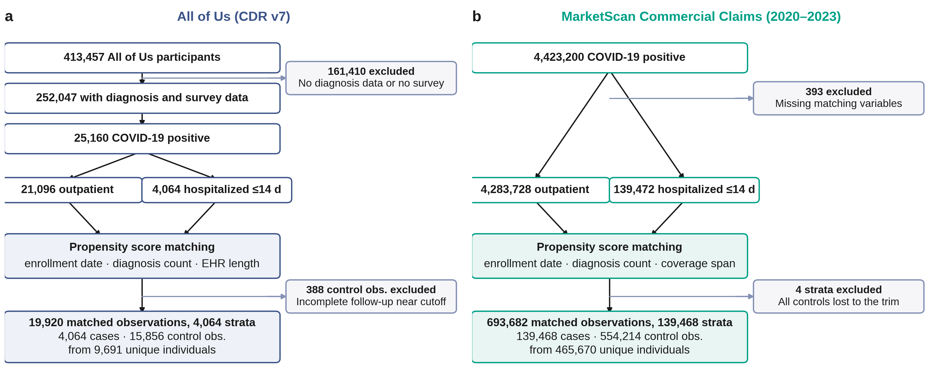

Study design and participants
We conducted a retrospective case-control study using All of Us Controlled Tier Data, Curated Data Repository version 7 C2022Q4R13, cutoff July 1, 2022. Conditions, drug exposures, and visits in the EHR domain, the Basics Survey, and vaccination records were extracted using the Observational Medical Outcomes Partnership (OMOP) Common Data Model version 5.3.1. The COVID-19 index date was defined as the earliest of a documented SARS-CoV-2 positive test or International Classification of Diseases, 10th Revision (ICD-10) U07.1 diagnosis. Participants who had COVID-19 and both diagnosis data and Basics Survey data were eligible. Cases were participants hospitalized within 14 days after the index date. Controls were COVID-positive participants not hospitalized within 14 days after their own index date. Control observations whose index date fell within 14 days of the CDR cutoff were excluded to ensure complete follow-up verification.
Case-control propensity matching at a 1:4 ratio used All of Us enrollment date, number of diagnoses, and length of medical history as encounter-density proxies, implemented using MatchIt with nearest-neighbor matching with replacement on the logit propensity score, using a caliper of 0.2 standard deviations of that score.[22, 23] We matched on encounter density rather than clinical characteristics because patients with more health-system contact accumulate more recorded diagnoses and comorbidity codes, creating informative presence bias that confounds associations derived from EHR.[17, 24] Adjusting for visit count alone does not fully correct this bias;[25] matching on data-availability proxies ensures that cases and controls have comparable EHR depth, so that observed SDoH–hospitalization associations are not artefacts of differential healthcare engagement. SDoH were excluded from the propensity score because they are the exposures of interest; residual SDoH imbalance was addressed through conditional regression. MarketScan matching used the same procedure with first enrollment date, number of distinct diagnoses, and coverage span as the encounter-density proxies. Because matching was with replacement, the effective control sample size is smaller than the number of control observations (All of Us 6,952; MarketScan 379,100).

Outcome
The primary outcome was COVID-19 hospitalization or extended emergency department care within 14 days of the index date, aligned with the Centers for Disease Control and Prevention (CDC) COVID-19-Associated Hospitalization Surveillance Network (COVID-NET) window.[26] COVID-19 was identified by ICD-10 code U07.1 or positive SARS-CoV-2 laboratory tests from 65 measurement concept identifiers (eTable 1). Hospitalization was defined as inpatient visits (9201, 32037), emergency-to-inpatient visits (262, 8717), or emergency visits with recorded stay duration of one or more days (9203). Same-day emergency visits without subsequent admission were excluded from the strict outcome (eTable 2a; Figure 2). In MarketScan, hospitalization was defined as any inpatient claim carrying U07.1 within 14 days of the index date.
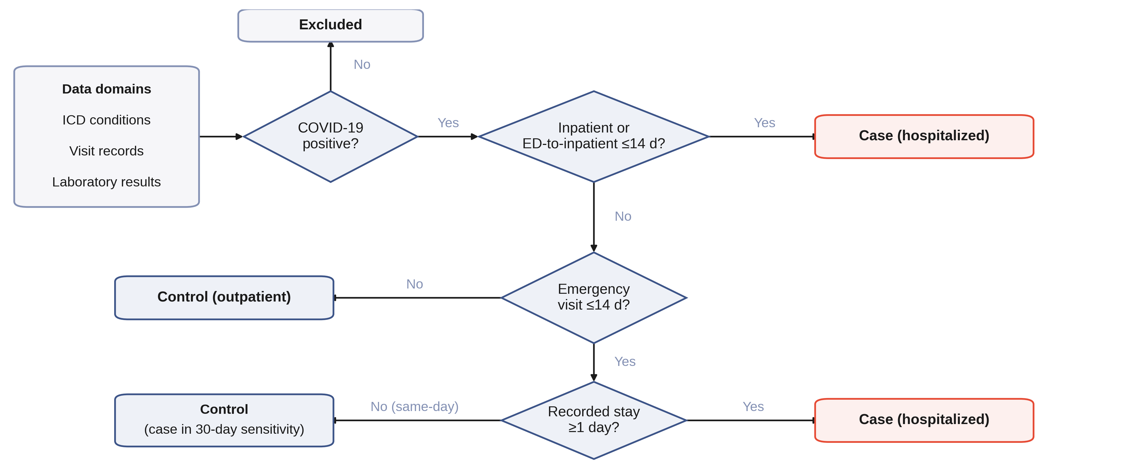

Exposure and covariates
We extracted demographic features (sex at birth, race, ethnicity, age), vaccination status (eTable 3), and Charlson comorbidities (eTable 4).[27] Charlson comorbidities were ascertained from all ICD-coded condition records before the COVID-19 index date; vaccination status was similarly restricted to doses recorded before the index date. Six SDoH domains (i.e., insurance, income, education, employment, housing tenure and stability, and disability; eTable 5) were derived from the Basics Survey, completed a median of 692 days (interquartile range [IQR] 286–985) before the COVID-19 index date; 86.4% of surveys preceded infection. Missing responses were present in all six SDoH domains and were retained as an explicit categorical level to avoid excluding participants with incomplete surveys and to evaluate whether missingness itself was informative (eMethod). Insurance was recoded as a categorical variable with employer-provided insurance as the reference; participants reporting multiple coverage types were assigned to the category most indicative of access barriers (e.g., a participant with both Medicaid and employer coverage was coded as Medicaid).

Statistical analysis
Case-control matched data were analyzed using conditional logistic regression. In AoU, standard errors were clustered on person identifier to account for control reuse from matching with replacement.[28] Under an alternative variance estimator, the significance status of one variable changed; all others were unaffected (eTable 11b). The MarketScan cross-cohort analysis used model-based standard errors. Pandemic wave (pre-Delta: before June 15, 2021; Delta: June 15–December 14, 2021; Omicron: December 15, 2021 onward) was included as a covariate to adjust for temporal variation in viral severity and vaccine availability. The base model included sex, race, ethnicity, age, pandemic wave, vaccination, and 19 Charlson comorbidities (eTable 4).
SDoH domain-specific analyses added each of the six SDoH domains to the base model separately, following Gatz et al.[18] The joint SDoH model added all six domains simultaneously to the base model to estimate mutually adjusted associations and construct a race-attenuation table. From the joint model, we contrasted two socioeconomic profiles (employer-insured/$35,000–99,999/homeowner versus Medicaid/$10,000–24,999/renter) as the product of the three mutually adjusted odds ratios. Because conditional logistic regression conditions the stratum intercepts out of the likelihood, absolute hospitalization probabilities are not estimable and only the odds ratio is reported. Analyses stratified by pandemic wave (pre-Delta, Delta, Omicron) evaluated whether lower-income, racial, and insurance associations persisted or evolved across pandemic phases, following period-stratified approaches used in prior COVID-19 disparity work;[29, 30] each wave-specific model was a separate conditional logistic regression within matched strata whose index dates fell within that wave, including the same base-model covariates minus the wave indicator. For race, we fitted both the base model and the joint SDoH model within each wave and compared the Black-race adjusted odds ratio between them. We summarized the degree to which the six social domains accounted for the Black-race association as the proportional reduction in its log adjusted odds ratio once those domains were added, following the standard change-in-estimate approach; because the odds ratio is non-collapsible, part of any such change reflects the scale rather than confounding, so these percentages are indicative rather than exact explained fractions.[31]
A cross-cohort clinical-model comparison was conducted in MarketScan Commercial Claims (2020–2023) using the same Charlson code sets and conditional logistic regression framework, with insurance plan type and geographic region as site-specific covariates (eTable 8; distributions in eTable 9).[32] This assessment tests whether the clinical base model behaves comparably in a different population; it does not test whether SDoH findings replicate, because MarketScan does not contain race/ethnicity or individual-level SDoH. Vaccination was identified from OMOP drug concept IDs (eTable 3) and coded as "Recorded vaccinated before index" versus "No vaccine record (unknown)." Unknown vaccination status indicates no record was identified using the concept set in eTable 3; it does not confirm absence of vaccination. The six SDoH domains correspond to the social items available in The Basics survey, and their exposures are correlated; we report domain-specific and jointly adjusted estimates for all six.

RESULTS

Participant characteristics
Our cohort comprised 4,064 hospitalized cases and 15,856 matched controls (Figure 1). Among 413,457 All of Us participants, 25,160 had confirmed COVID-19 with both EHR data and Basics Survey completion. Using the hospitalization phenotype (14-day window, ED visits requiring stay ≥1 day; Figure 2), 4,064 (16.2%) were classified as cases. Among cases, the majority of qualifying visits began on the index date itself (day 0); visits starting before the index date were excluded by the phenotype (eFigure 2). Matching sought four controls per case and achieved 3.90 on average; the matched cohort comprised 19,920 observations in 4,064 strata. Among 15,856 control observations, 9,691 were unique individuals (median reuse 1, IQR 1–2, maximum 13; eTable 11). Pre-matching imbalance was largest for diagnosis count (SMD = 0.489; eTable 6). Post-matching balance achieved standardized mean differences below 0.03 for all three matching variables (eTable 7); full-covariate balance is shown in eFigure 1.
Because matching balanced encounter-density proxies rather than clinical or social characteristics, demographic differences persisted between cases and controls, as expected. Cases had higher proportions of males (39.0% vs 30.6%), Black participants (29.9% vs 17.9%), older adults aged ≥65 (35.7% vs 30.5%), and Medicaid-insured participants (34.7% vs 26.2%) compared with the control group. Demographic and clinical characteristics are summarized in Table 1; SDoH characteristics in Table 2. The temporal distribution of index dates across pandemic waves is shown in Table 1; eFigure 3 shows the pre-matching distribution.

Demographics, vaccination, pandemic wave, and comorbidities
The base model showed significant associations between COVID-19 hospitalization and several demographic, clinical, and temporal factors (Table 1, Figure 3). Female sex was associated with lower odds (AOR 0.74, 95% CI 0.68–0.80), as was recorded vaccination before the index date (AOR 0.45, 0.40–0.51). Age showed a gradient with elevated odds at 55–64 (AOR 1.45, 1.30–1.61) and ≥65 (AOR 1.61, 1.44–1.79) relative to <45. Black race was associated with substantially elevated odds (AOR 2.30, 2.10–2.52), as was Other race (1.41, 1.17–1.70). Asian race was elevated but not statistically significant (1.33, 1.00–1.78).
Table 1. Demographic and clinical characteristics of the matched All of Us and MarketScan cohorts.
Data are n (%) unless otherwise specified. Cases were hospitalized within 14 days of the COVID-19 index date; controls were COVID-positive participants not hospitalized within that window, matched 1:4 on encounter-density proxies. Percentages are column percentages within each cohort. Abbreviations: AoU, All of Us Research Program; s.d., standard deviation.
 | All of Us |  | MarketScanᶜ
Characteristic | Cases | Controls | Cases | Controls
N | 4,064 | 15,856 | 139,468 | 554,214
Sex
Female | 2,441 (60.1) | 10,834 (68.3) | 67,914 (48.7) | 375,330 (67.7)
Male | 1,586 (39.0) | 4,854 (30.6) | 71,554 (51.3) | 178,884 (32.3)
Other | 37 (0.9) | 168 (1.1) | <20 | <20
Race
White | 1,726 (42.5) | 8,644 (54.5) | NA | NA
Black | 1,217 (29.9) | 2,833 (17.9) | NA | NA
Asian | 62 (1.5) | 260 (1.6) | NA | NA
Other | 1,059 (26.1) | 4,119 (26.0) | NA | NA
Ethnicity
Not Hispanic | 3,013 (74.1) | 11,727 (74.0) | NA | NA
Hispanic | 919 (22.6) | 3,670 (23.1) | NA | NA
Other | 132 (3.2) | 459 (2.9) | NA | NA
Age group, years
<45 | 920 (22.6) | 4,624 (29.2) | 53,369 (38.3) | 284,866 (51.4)
45–54 | 639 (15.7) | 2,901 (18.3) | 37,833 (27.1) | 130,590 (23.6)
55–64 | 1,055 (26.0) | 3,492 (22.0) | 47,908 (34.4) | 137,688 (24.8)
≥65 | 1,450 (35.7) | 4,839 (30.5) | 358 (0.3) | 1,070 (0.2)
Mean age (s.d.) | 57.4 (16.2) | 54.6 (16.2) | 45.6 (14.6) | 41.2 (15.9)
Vaccination
Recorded before index | 361 (8.9) | 2,700 (17.0) | 11,300 (8.1) | 108,286 (19.5)
No record | 3,703 (91.1) | 13,156 (83.0) | 128,168 (91.9) | 445,928 (80.5)
Charlson comorbidities
Myocardial infarction | 570 (14.0) | 1,842 (11.6) | 2,729 (2.0) | 7,733 (1.4)
Congestive heart failure | 1,034 (25.4) | 3,100 (19.6) | 6,614 (4.7) | 15,123 (2.7)
Peripheral vascular disease | 882 (21.7) | 3,042 (19.2) | 5,866 (4.2) | 20,464 (3.7)
Cerebrovascular disease | 786 (19.3) | 2,502 (15.8) | 4,215 (3.0) | 17,307 (3.1)
Dementia | 243 (6.0) | 763 (4.8) | 769 (0.6) | 2,202 (0.4)
Chronic pulmonary disease | 1,819 (44.8) | 7,744 (48.8) | 18,418 (13.2) | 92,037 (16.6)
Rheumatic disease | 437 (10.8) | 1,936 (12.2) | 3,604 (2.6) | 20,162 (3.6)
Peptic ulcer disease | 336 (8.3) | 1,299 (8.2) | 1,174 (0.8) | 6,366 (1.1)
Liver disease, mild | 854 (21.0) | 4,124 (26.0) | 7,881 (5.7) | 38,981 (7.0)
Liver disease, moderate/severe | 163 (4.0) | 391 (2.5) | 889 (0.6) | 1,984 (0.4)
Diabetes without complications | 551 (13.6) | 2,058 (13.0) | 19,085 (13.7) | 52,613 (9.5)
Diabetes with complications | 1,075 (26.5) | 3,542 (22.3) | 11,696 (8.4) | 26,591 (4.8)
Hemiplegia or paraplegia | 212 (5.2) | 794 (5.0) | 1,460 (1.0) | 3,423 (0.6)
Renal disease, mild/moderate | 630 (15.5) | 2,174 (13.7) | 6,199 (4.4) | 15,289 (2.8)
Renal disease, severe | 479 (11.8) | 1,236 (7.8) | 2,816 (2.0) | 3,855 (0.7)
HIV | 44 (1.1) | 135 (0.9) | 444 (0.3) | 1,610 (0.3)
Metastatic solid tumor | 191 (4.7) | 609 (3.8) | 2,295 (1.6) | 6,099 (1.1)
Malignancy | 700 (17.2) | 2,528 (15.9) | 4,951 (3.5) | 19,657 (3.5)
AIDS | 63 (1.6) | 264 (1.7) | 127 (0.1) | 393 (0.1)
Pandemic wave
Pre-Delta | 2,087 (51.4) | 7,656 (48.3) | NA | NA
Delta | 644 (15.8) | 2,338 (14.7) | NA | NA
Omicron | 1,333 (32.8) | 5,862 (37.0) | NA | NA
ᵃNA, not available. Race and ethnicity are not captured in MarketScan commercial claims. Pandemic wave was included as a covariate in the MarketScan base model (Figure 3, eTable 10) but is not tabulated here. Cell counts <20 are suppressed.
ᵇVaccination “No record” denotes no vaccination record identified before the index date using the concept set in eTable 3; it does not confirm the participant was unvaccinated.
ᶜMarketScan captures commercially insured individuals, so adults aged ≥65 years, who are predominantly covered by Medicare, are under-represented.

Table 2. Social determinants of health characteristics, matched All of Us cohort.
Data are n (%). Percentages are column percentages of the matched cohort (4,064 cases; 15,856 controls).
Variable | Cases | Controls
Income
<$10,000 | 675 (16.6) | 2,257 (14.2)
$10,000–24,999 | 650 (16.0) | 2,268 (14.3)
$25,000–34,999 | 318 (7.8) | 1,351 (8.5)
$35,000–99,999 (reference) | 793 (19.5) | 4,264 (26.9)
$100,000–149,999 | 277 (6.8) | 1,292 (8.1)
$150,000–199,999 | 122 (3.0) | 582 (3.7)
≥$200,000 | 143 (3.5) | 705 (4.4)
Missing | 1,086 (26.7) | 3,137 (19.8)
Employment
Employed (reference) | 1,099 (27.0) | 5,930 (37.4)
Student | 84 (2.1) | 318 (2.0)
Unemployed | 1,334 (32.8) | 4,407 (27.8)
Retired or other | 1,427 (35.1) | 4,819 (30.4)
Missing | 120 (3.0) | 382 (2.4)
Education
Never attended school | <20 | <20
Below high school or GED | 565 (13.9) | 1,643 (10.4)
High school, GED, or some college | 2,128 (52.4) | 8,164 (51.5)
College graduate or higher (reference) | 1,243 (30.6) | 5,758 (36.3)
Missing | 112 (2.8) | 273 (1.7)
Housing tenure
Own home (reference) | 1,519 (37.4) | 6,816 (43.0)
Rent | 2,030 (50.0) | 6,849 (43.2)
Other | 345 (8.5) | 1,615 (10.2)
Missing | 169 (4.2) | 571 (3.6)
Housing stability
Stable (reference) | 3,281 (80.7) | 12,967 (81.8)
Unstable | 710 (17.5) | 2,684 (16.9)
Missing | 73 (1.8) | 205 (1.3)
Disability (any)
Yes | 557 (13.7) | 2,174 (13.7)
No (reference) | 815 (20.1) | 3,349 (21.1)
Missing* | 2,692 (66.2) | 10,333 (65.2)
Insurance type
Employer (reference) | 788 (19.4) | 4,201 (26.5)
Medicare | 940 (23.1) | 3,496 (22.0)
Medicaid | 1,410 (34.7) | 4,159 (26.2)
Other or none | 368 (9.1) | 1,316 (8.3)
Missing* | 558 (13.7) | 2,684 (16.9)
“Missing” denotes a Skip or Prefer-not-to-answer response. Cell counts <20 are suppressed per All of Us data use policy.
*Disability and insurance missingness is mainly non-administration: the ACS-6 items were added to The Basics survey on November 10, 2020, and the insurance item after enrollment began.

Delta-wave infection carried elevated odds (AOR 1.24, 1.12–1.38) relative to pre-Delta, while Omicron did not differ significantly (1.04, 0.96–1.13). Among comorbidities, severe renal disease (AOR 1.29, 1.12–1.48), moderate/severe liver disease (1.37, 1.12–1.68), metastatic solid tumor (1.22, 1.03–1.46), cerebrovascular disease (1.20, 1.08–1.33), and congestive heart failure (1.19, 1.08–1.32) were significantly associated with hospitalization. Dementia was not significant after restricting comorbidities to pre-index records (1.11, 0.94–1.30). Chronic pulmonary disease (0.85, 0.79–0.92) and mild liver disease (0.76, 0.69–0.83) showed inverse associations in this cohort; because matching balanced encounter density rather than clinical severity, patients with these high-contact conditions were matched to controls with comparably heavy healthcare utilization and comorbidity burden, and these estimates should not be interpreted as clinically protective effects.
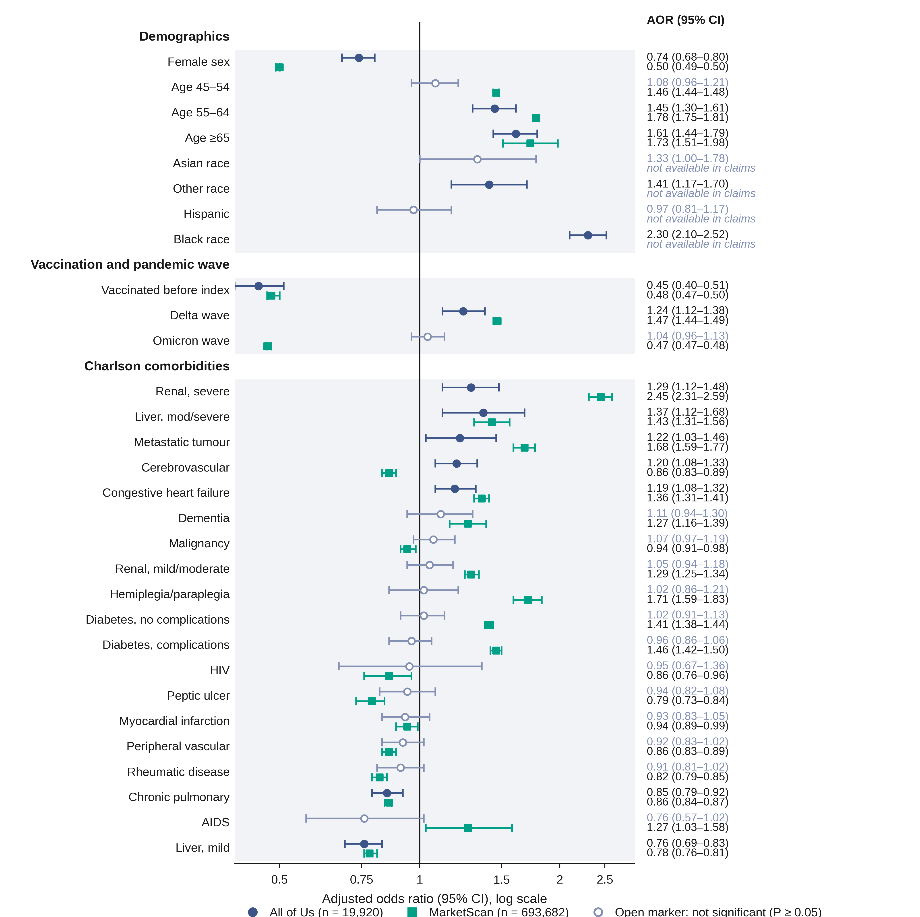

Social determinants of health
Each SDoH domain was first evaluated individually within the base model (Table 3). Compared with the $35,000–99,999 reference, lower-income strata were associated with elevated odds: <$10,000 AOR 1.46 (1.29–1.65), $10,000–24,999 1.37 (1.21–1.55), $25,000–34,999 1.19 (1.02–1.38). The pattern was non-monotonic: $100,000–149,999 (1.20, 1.03–1.41) was also elevated relative to the reference, while higher brackets were not significant. This non-monotonic pattern persisted in the joint model (Table 3) and may reflect heterogeneity within the broad $35,000–99,999 reference category or residual confounding from unmeasured factors such as occupational exposure. Medicaid-insured participants were at higher odds than those with employer-provided insurance (AOR 1.59, 1.43–1.77), and those with no insurance or other coverage types also showed elevated odds (1.31, 1.13–1.52). Education below GED was associated with increased odds (AOR 1.35, 1.18–1.53); the "never attended school" estimate (AOR 3.35, 1.66–6.78) is imprecise given the small subgroup (<20 participants; exact count suppressed per All of Us data use policy). Unemployment (1.41, 1.28–1.56), student status (1.61, 1.24–2.09), and non-employment (retired/other: 1.36, 1.22–1.51) were associated with higher odds of hospitalization. Education at GED or some college was also elevated (1.11, 1.02–1.21). Renters had elevated odds compared with homeowners (1.28, 1.17–1.39). Housing instability (1.01) and disability (0.94) were not significant.
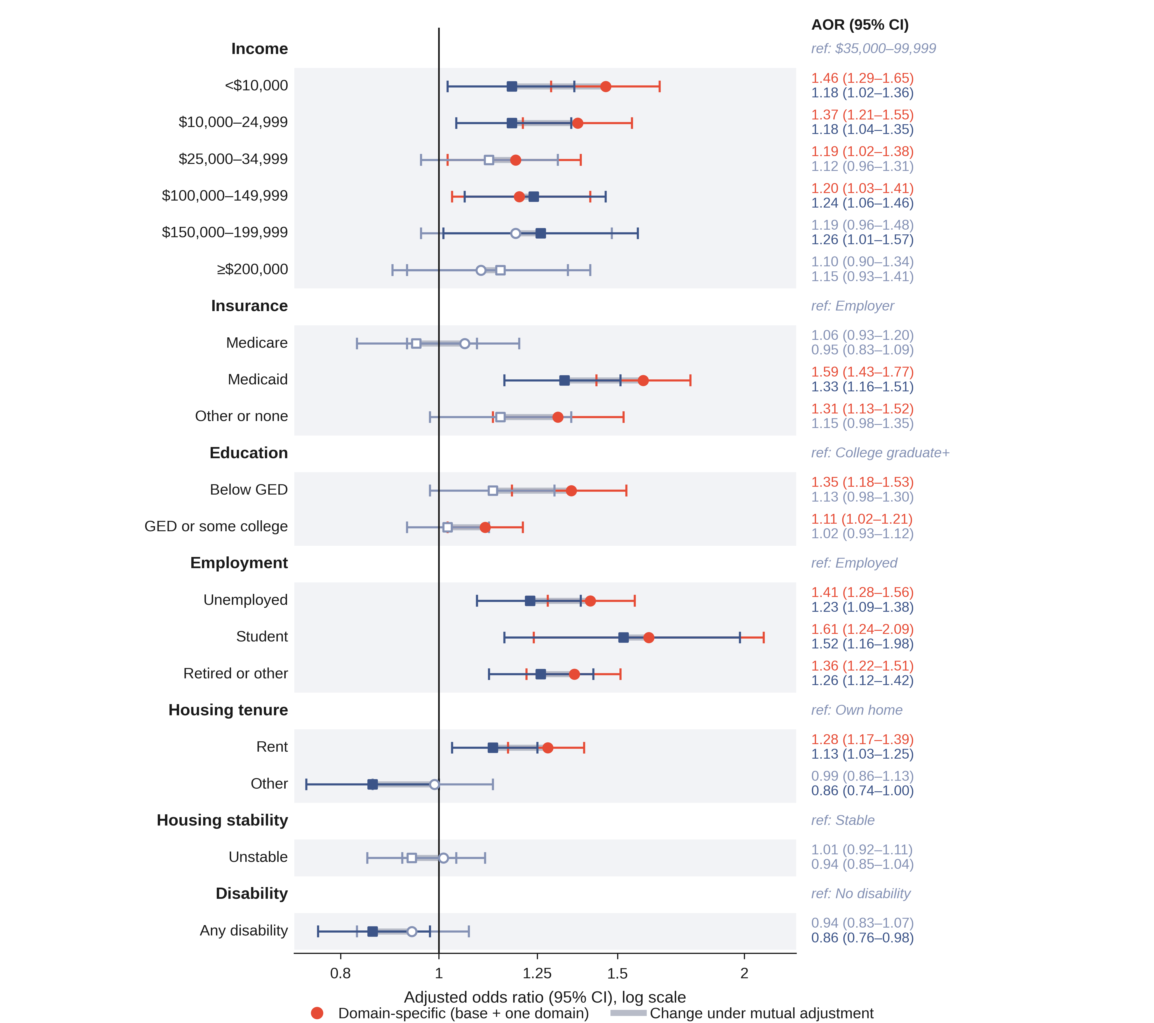
Table 3. Domain-specific and jointly adjusted associations of survey-derived SDoH with COVID-19 hospitalization.
Values are adjusted odds ratios (95% confidence intervals) from conditional logistic regression within matched strata. The domain-specific model adds one SDoH domain to the base model; the joint model adds all six domains simultaneously. Both adjust for sex, race, ethnicity, age, vaccination, pandemic wave, and 19 Charlson comorbidities.
Variable | Domain-specific AOR (95% CI) | Joint AOR (95% CI)
Income (reference: $35,000–99,999)
<$10,000 | 1.46*** (1.29–1.65) | 1.18* (1.02–1.36)
$10,000–24,999 | 1.37*** (1.21–1.55) | 1.18* (1.04–1.35)
$25,000–34,999 | 1.19* (1.02–1.38) | 1.12 (0.96–1.31)
$100,000–149,999 | 1.20* (1.03–1.41) | 1.24** (1.06–1.46)
$150,000–199,999 | 1.19 (0.96–1.48) | 1.26* (1.01–1.57)
≥$200,000 | 1.10 (0.90–1.34) | 1.15 (0.93–1.41)
Missing | 1.65*** (1.48–1.84) | 1.46*** (1.29–1.64)
Insurance (reference: Employer)
Medicare | 1.06 (0.93–1.20) | 0.95 (0.83–1.09)
Medicaid | 1.59*** (1.43–1.77) | 1.33*** (1.16–1.51)
Other or none | 1.31*** (1.13–1.52) | 1.15 (0.98–1.35)
Education (reference: College graduate or higher)
Never attended school | 3.35*** (1.66–6.78) | 2.85** (1.40–5.82)
Below GED | 1.35*** (1.18–1.53) | 1.13 (0.98–1.30)
GED or some college | 1.11* (1.02–1.21) | 1.02 (0.93–1.12)
Employment (reference: Employed)
Unemployed | 1.41*** (1.28–1.56) | 1.23*** (1.09–1.38)
Student | 1.61*** (1.24–2.09) | 1.52** (1.16–1.98)
Retired or other | 1.36*** (1.22–1.51) | 1.26*** (1.12–1.42)
Housing tenure (reference: Own home)
Rent | 1.28*** (1.17–1.39) | 1.13* (1.03–1.25)
Other | 0.99 (0.86–1.13) | 0.86* (0.74–1.00)
Housing stability (reference: Stable)
Unstable | 1.01 (0.92–1.11) | 0.94 (0.85–1.04)
Disability (reference: No)
Any disability | 0.94 (0.83–1.07) | 0.86* (0.76–0.98)
*P < 0.05; **P < 0.01; ***P < 0.001. Abbreviations: AOR, adjusted odds ratio; CI, confidence interval; GED, General Educational Development; SDoH, social determinants of health.

Mutually adjusted SDoH associations and Black-race coefficient attenuation
The domain-specific models treat each social factor as if the others do not exist. In practice, Medicaid coverage, low income, and unemployment overlap substantially (Table 2). To identify which domains carry independent signal, we fitted a joint model with all six domains entered simultaneously. Figure 4 contrasts the domain-specific and joint estimate for every level, showing which associations persist under mutual adjustment and which are shared across domains.
In the joint model, Medicaid insurance (AOR 1.33, 1.16–1.51), unemployment (1.23, 1.09–1.38), non-employment (1.26, 1.12–1.42), household income below $10,000 (1.18, 1.02–1.36), income $10,000–24,999 (1.18, 1.04–1.35), student status (1.52, 1.16–1.98), and renter status (1.13, 1.03–1.25) remained associated with hospitalization after mutual adjustment (Table 3). Education below GED lost significance (AOR 1.13, 0.98–1.30), suggesting its domain-specific association was shared with income and employment rather than reflecting an independent pathway. Other or no insurance coverage (1.15, 0.98–1.35) and income $25,000–34,999 (1.12, 0.96–1.31) likewise lost significance under mutual adjustment. Housing tenure recorded as “other” moved from null in the domain-specific model (0.99, 0.86–1.13) to a borderline inverse estimate under mutual adjustment (0.86, 0.74–1.00). Disability showed an inverse association (0.86, 0.76–0.98), which should be interpreted cautiously given 65.4% missingness and the collapse of heterogeneous functional limitations into one binary category.
Including all six social domains reduced the Black-race AOR from 2.30 (2.10–2.52) to 2.00 (1.81–2.20; eTable 12a). The association narrowed but did not resolve: even after adjustment for insurance, income, education, employment, housing, and disability, Black participants had twice the odds of hospitalization compared with White participants. The modest coefficient attenuation indicates that individual-level socioeconomic factors, as measured by self-report survey, capture only a fraction of the racial association. This is consistent with UK Biobank and integrated-care studies reporting similarly modest attenuation of the Black-race hospitalization coefficient when socioeconomic factors are included.[33, 34]
In the joint model, the combined profile of Medicaid coverage, household income of $10,000–24,999, and renter status carried 1.78-fold higher odds of hospitalization than employer-insured homeowners in the $35,000–99,999 reference stratum (the product of the three mutually adjusted AORs, 1.33 × 1.18 × 1.13). The equivalent product of the domain-specific AORs is 2.79, so mutual adjustment reduces the combined contrast by roughly a third. Both are within-stratum odds ratios; the matched case-control design does not identify absolute hospitalization probabilities.

Wave-stratified associations
The lower-income association persisted across pandemic waves (Figure 5a; eTable 13). In the pre-Delta period (N = 2,087 cases), income below $10,000 was associated with AOR 1.49 (1.21–1.82). During Omicron (N = 1,333 cases), when vaccines were available, income below $10,000 carried AOR 1.64 (1.23–2.18, P < 0.001). The Delta period (N = 644 cases) showed consistent direction (AOR 2.11, 1.10–4.03) but wide confidence intervals from the smaller stratum. Confidence intervals overlap across waves, so the wave estimates are not distinguishable from one another; the design cannot test treatment-access mechanisms directly. Period-based mediation work has reported income-related disparities persisting across variant transitions and treatment-landscape changes.[29]
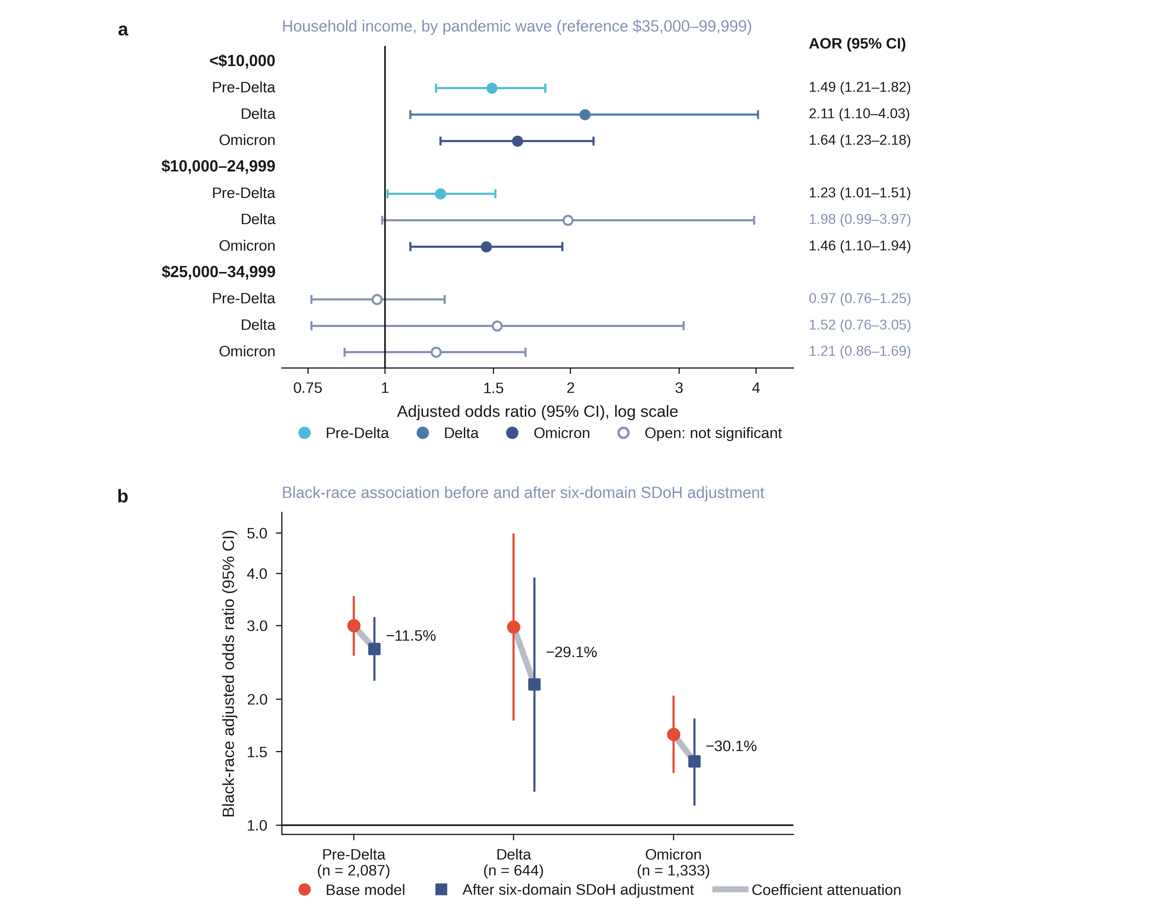

The Black-race association was large in the pre-Delta period (AOR 3.00, 2.56–3.51), essentially unchanged during Delta (2.98, 1.79–4.96), and narrowed to 1.65 (1.34–2.03) during Omicron (Figure 5b), consistent with the temporal convergence of racial hospitalization rates documented in national surveillance.[4, 5] The association remained statistically significant across all three waves. When all six SDoH domains were included in within-wave joint models, coefficient attenuation by individual socioeconomic factors was 11.5% during pre-Delta (AOR 3.00 to 2.64), 29.1% during Delta (2.98 to 2.17), and 30.1% during Omicron (1.65 to 1.42; Figure 5b, eTable 12b). Most of the change therefore occurred between pre-Delta and Delta rather than progressively across the three waves, and the wide Delta interval means the three attenuation values are not statistically distinguishable; no formal test compared them. Medicaid was significantly associated with hospitalization in all three waves in domain-specific models (pre-Delta AOR 1.71; Delta 2.24; Omicron 1.46), but its joint-model estimate was not significant in either Delta (AOR 1.64, 0.78–3.45; P = 0.196) or Omicron (1.13, 0.84–1.53; P = 0.420), consistent with overlap between the Medicaid, income, and housing signals in the later pandemic (eTable 12c). Within-wave models retain only strata whose control index dates also fall in that wave, so the three wave models rest on 1,913, 301, and 1,105 strata rather than 2,087, 644, and 1,333 cases. Delta-wave estimates therefore carry wide confidence intervals and should be interpreted cautiously.

Sensitivity analyses
Five sensitivity analyses supported the stability of the joint SDoH estimates (eTable 15). Restricting to inpatient-only cases (S1), excluding controls with acute-care utilization (S2), removing vaccination from the model (S4), and collapsing income to three levels (S5: <$35K AOR 1.16, 1.04–1.30) preserved all key associations. Restricting to pre-infection surveys (S3, 86.4% of the cohort) maintained direction for all domains; income and renter estimates lost significance. Their confidence intervals widened only slightly while the point estimates moved toward the null (income below $10,000, 1.18 to 1.13; renter, 1.13 to 1.09), so the change reflects attenuation rather than the smaller sample alone.

Cross-cohort clinical-model comparison
In the MarketScan cohort (N = 693,682 matched observations; 139,468 cases; Table 1), female sex, recorded vaccination, and age gradients were directionally concordant with AoU. Comorbidity associations were generally larger in MarketScan (eTable 10), likely reflecting cohort composition differences and the AoU encounter-density matching strategy. Chronic pulmonary disease and mild liver disease were concordantly inverse in both cohorts. Five of 25 comparable estimates were directionally discordant: Omicron wave (AoU 1.04, 0.96–1.13; MarketScan 0.47, 0.47–0.48), cerebrovascular disease, diabetes with complications, malignancy, and AIDS (eTable 10). The Omicron discordance is the largest and likely reflects the age and coverage differences between a commercially insured population and All of Us; the AIDS difference reflects the strict AoU two-step phenotype (eTable 14). Concordance here means agreement in the direction of the point estimate irrespective of significance, which is a weak criterion. On that criterion the clinical base model behaves similarly across data sources for most covariates; evaluating SDoH associations across populations requires individual-level social measures unavailable in commercial claims.

DISCUSSION
Prior work in these data sources identified individual risk factors. In All of Us, Choi et al. found an income gradient using income, education, and an area-level index, and detected no education association; they did not test employment or housing.[11] In N3C, Bennett et al. found Black race and obesity independently associated with clinical severity,[35] and Vaidya et al. found individual-level SDoH associations using EHR-coded fields documented in fewer than 2% of encounters.[16] We reproduce the low-income association and the residual Black-race association, and additionally identify independent employment, insurance, and housing associations that the separate-variable and sparsely-coded EHR approaches did not surface.
Our joint model extends these findings in three ways. First, it decomposes domain-specific signals that composite indices and separate-variable models cannot isolate: Choi et al.'s three-variable design11 did not include employment or housing, and Gupta et al.'s composite All of Us deprivation index[36] collapses insurance, income, employment, and housing into a single score that cannot show which domain carries independent signal. Second, the encounter-density matching design mitigates informative presence bias, a well-documented source of confounding in EHR-derived cohorts.[17] Third, wave-stratified analyses show that the income association persisted across pandemic phases while the racial association narrowed. Patient-reported SDoH have been consistently associated with hospitalization in prior scoping reviews;[37] our contribution is identifying which domains remain independently associated after mutual adjustment, and which lose significance once overlapping domains are included (Figure 4). Read together, the two models answer complementary questions rather than competing ones: the domain-specific estimate reflects the total association each domain carries, the quantity a single-item screen would capture, while the joint estimate isolates the association that remains after overlapping domains are removed. Neither supersedes the other.

What persists and what attenuates
In the joint model, Medicaid coverage, low income, unemployment, and renter status retained independent associations with hospitalization. The Medicaid finding (AOR 1.33) is consistent with cohort evidence that insurance type is associated with COVID-19 hospitalization beyond underlying health conditions.[38] Insurance likely functions as both a poverty marker and an access-barrier marker; separating these mechanisms requires designs beyond what case-control data can provide.[39] The renter-status association (AOR 1.13) is consistent with evidence that housing tenure tracks crowding, shared facilities, and reduced ability to isolate, mechanisms consistent with the state-level increases in COVID-19 incidence observed after eviction moratoria expired.[40]
Education below GED was significant in domain-specific analysis (AOR 1.35) but not after joint adjustment (1.13, 0.98–1.30), indicating its association was shared with income and employment. This pattern, education attenuating once economic variables are included, is consistent with Choi et al.'s null education finding in All of Us.[11] The disability domain showed an unexpected inverse association in the joint model (0.86, 0.76–0.98). Given 65.4% missingness and the collapse of heterogeneous functional limitations into a single binary variable, we interpret this estimate cautiously and do not draw substantive conclusions from it.

The Black-race association: what SDoH adjustment does and does not capture
After adjustment for six individual-level social domains, Black participants retained twice the odds of hospitalization compared with White participants (AOR 2.00, 1.81–2.20). Individual-level socioeconomic factors, as measured by self-report, attenuated only a small share of the overall racial association. This is consistent with UK Biobank evidence that socioeconomic deprivation and comorbidity adjustment attenuated only a modest portion of the excess COVID-19 hospitalization odds among Black participants, with a significant residual persisting after full adjustment[33], and with Kaiser Permanente Georgia findings that neighbourhood SDoH attenuated but did not eliminate the Black–White hospitalization difference.[34] Interpreting a residual race coefficient after socioeconomic adjustment requires care: the socioeconomic variables adjusted for are themselves shaped by structural disadvantage, and residual confounding from imperfectly measured socioeconomic position tends to bias such coefficients toward appearing independent.[41, 42] Because the odds ratio is non-collapsible, a portion of the observed coefficient change on adjustment may reflect scale properties rather than confounding or mediation; the attenuation estimates should be interpreted as indicative of the direction and approximate magnitude of confounding, not as precise explained fractions.[43]
This overall attenuation, however, masks a temporal shift. The Black-race AOR was unchanged from pre-Delta (3.00) to Delta (2.98) and then narrowed to 1.65 during Omicron (Figure 5b), consistent with the convergence of racial hospitalization rates in CDC surveillance.4, 5 Coefficient attenuation by individual SDoH was 11.5%, 29.1%, and 30.1% across the three waves, so it rose once, between pre-Delta and Delta, rather than progressively. Early in the pandemic, structural factors beyond the reach of individual surveys (residential segregation, essential-worker exposure, differential testing access) may have contributed more to the racial gap. As these exposures equalized, the residual association became more sensitive to socioeconomic adjustment. The wide Delta interval and the absence of a formal test across waves mean this pattern is a hypothesis rather than a demonstrated trend.

Income persistence through Omicron and clinical implications
During the Omicron period, participants with household income below $10,000 still had 1.64-fold higher hospitalization odds despite available vaccines. In an 11.2-million-person Ontario cohort, income inequalities in COVID-19 death likewise persisted across the pandemic period; inequality in vaccination coverage accounted for 56.9% (95% CI 22.5–91.3) of the income inequality in deaths during the later waves,29 indicating that countermeasure availability did not translate into equitable uptake. The Medicaid association, by contrast, was not significant in the joint model in either Delta or Omicron once income and housing were included, suggesting that insurance type was less of an independent predictor than the economic conditions it tracks in the later pandemic. Barriers to testing, prescriptions, paid sick leave, and isolation space may contribute to the residual income association, though the design cannot test access mechanisms directly.
These domains identify groups who could benefit from targeted outreach during surge periods. Insurance and income can be collected through screening or intake workflows, and the barriers they mark (access to testing, treatment, and isolation) apply to any respiratory pathogen capable of generating surge-level hospitalizations.[3] Because the social domains overlap, their combined association is smaller than the domain-specific estimates suggest: the combined profile of Medicaid, income $10,000–24,999, and renter status carried 1.78-fold higher odds, against 2.79 from the domain-specific AORs (Results).

The measurement case: why survey-linked EHR matters
The survey domain in the All of Us data enabled analysis of the roles of socioeconomic risk at a level of detail unavailable in routine structured EHR data. Patient surveys detect socioeconomic risk in 8–41% of patients, compared with 0–2% in EHR-coded fields.[15] Across 2.7 billion US healthcare encounters, SDoH Z-code documentation ranged from 0.5% to 2.4%,[44] and only 24.4% of US hospitals screened for all five common social needs (food, housing, utilities, transportation, and interpersonal violence) in 2017–2018.[45] Gupta et al.'s composite deprivation index, built from AoU survey items,[36] collapses related domains to a single score; our decomposition identifies which dimensions persist after mutual adjustment. Two results in this study depend directly on that measurement difference. First, the below-GED education association is not independent: it attenuates from 1.35 (1.18–1.53) to 1.13 (0.98–1.30) once income and employment enter the same model, a decomposition that requires all six domains measured in the same participants. Second, the growth in race-coefficient attenuation from 11.5% in the pre-Delta period to 30.1% during Omicron requires individual-level measures of all six domains within each wave. Neither result is recoverable from social risk documented in fewer than 2% of encounters.

Cross-cohort comparison
The MarketScan analysis is a descriptive cross-cohort comparison of clinical and demographic covariates, not external validation of the SDoH findings; formal transportability assumptions were not evaluated.31 Sex and recorded vaccination effects were directionally concordant; renal and congestive heart failure risk factors replicated in direction with larger effect sizes in MarketScan, likely reflecting cohort composition and the AoU encounter-density matching strategy. The AIDS directional discordance (AoU inverse, MarketScan risk) may reflect the strict two-step AoU phenotype and small sample (N = 205 unique participants). Evaluating SDoH associations across populations requires data sources with individual-level social measures, which commercial claims do not provide.

Strengths
This study extends prior AoU and N3C COVID-19 SDoH analyses by combining six survey-derived individual-level domains, a propensity-matched encounter-density design, conditional logistic regression, and both domain-specific and joint SDoH models in a cohort enriched for underrepresented populations.[19, 20] The matching design reduces confounding related to differential EHR data availability.[17, 24] Wave-stratified analyses show that income associations persisted while the racial association narrowed across pandemic phases.

Limitations
All of Us is a volunteer cohort with higher health literacy and digital access than the general population.[46] The program deliberately oversampled populations underrepresented in biomedical research (75% of participants met at least one UBR criterion), which strengthens statistical power for minority subgroup analyses but may limit generalizability to the broader US population. The disability domain was the least complete because the ACS-6 items were added to The Basics survey on November 10, 2020, so earlier respondents have no disability response and the domain-specific disability model rests on a reduced subset (Table 2). Vaccination capture was incomplete, and many index dates preceded vaccine availability (December 2020). SDoH were measured a median of 692 days (IQR 286–985) before infection; 86.4% preceded the index date; consequently, pandemic-era changes in income or employment are not captured. Income missingness was differential (26.7% cases vs 19.8% controls), and the missing-income category itself carried elevated odds (Table 3). With-replacement matching means individual controls may appear in multiple strata. The MarketScan comparison was limited to clinical variables; SDoH and race could not be evaluated. Our hospitalization rate (16.2%) exceeds the 2.6% reported by Choi et al. in the same data source; Choi et al. restricted to primary inpatient encounters in 2021–2023, so most of the difference reflects the outcome definition and study window rather than the cohort (eTable 2b). Matching on encounter density reduces but may not eliminate informative presence bias,[17] and the inverse pulmonary and liver disease associations likely reflect residual confounding rather than protection. The strict phenotype may still not fully separate COVID-related admissions from admissions with incidental SARS-CoV-2 positivity, particularly during Omicron. Because diagnosis count may lie on the SDoH-to-hospitalization causal pathway, our estimates are conservative within-stratum associations rather than total causal effects. The within-wave joint model for the Omicron period returned a convergence warning for one covariate; the Black-race coefficient was stable across restarts, but the wave-specific attenuation estimates should be read with that in mind (eTable 12b). Because matching used replacement, the effective control sample size (6,952) is smaller than the 15,856 control observations, so nominal precision overstates the information available.

CONCLUSIONS
In this matched All of Us cohort, Medicaid coverage, unemployment, renting, and the two lowest income strata were independently associated with COVID-19 hospitalization after clinical adjustment; two upper-middle income strata were also elevated, so the income association was not monotonic. The Black-race association narrowed by the Omicron period while SDoH-associated coefficient attenuation rose between the pre-Delta and Delta waves, consistent with growing sensitivity of the racial association to socioeconomic adjustment, although the waves were not compared formally. Income associations persisted through Omicron despite available vaccines. These findings identify screenable social risk dimensions for respiratory-surge preparedness and support the value of individual-level SDoH measurement for equity monitoring in future respiratory-pathogen surges.

ACKNOWLEDGMENTS
The All of Us Research Program was supported by the National Institutes of Health, Office of the Director: Regional Medical Centers: 1 OT2 OD026549; 1 OT2 OD026554; 1 OT2 OD026557; 1 OT2 OD026556; 1 OT2 OD026550; 1 OT2 OD026552; 1 OT2 OD026553; 1 OT2 OD026548; 1 OT2 OD026551; 1 OT2 OD026555; IAA #: AOD 16037; Federally Qualified Health Centers: HHSN 263201600085U; Data and Research Center: 5 U2C OD023196; Biobank: 1 U24 OD023121; The Participant Center: U24 OD023176; Participant Technology Systems Center: 1 U24 OD023163; Communications and Engagement: 3 OT2 OD023205; 3 OT2 OD023206; and Community Partners: 1 OT2 OD025277; 3 OT2 OD025315; 1 OT2 OD025337; 1 OT2 OD025276. The All of Us Research Program would not be possible without the partnership of its participants.

AUTHOR CONTRIBUTIONS
Haining Wang: conceptualization, methodology, formal analysis, investigation, data curation, software, validation, visualization, writing – original draft, writing – review and editing. Yihan Zhang: data curation, writing – review and editing. Chenxi Xiong: data curation, writing – review and editing. Zhao Zhang: writing – review and editing. Jiangqiong Li: writing – review and editing. Hengyi Fu: conceptualization, writing – review and editing. Xiaojun Yuan: conceptualization, writing – review and editing. Xiaochun Li: methodology, writing – review and editing. Jing Su: conceptualization, methodology, supervision, funding acquisition, validation, writing – review and editing.

FUNDING
This work was supported partially by the National Library of Medicine of the National Institutes of Health (R01LM013771). It was also supported by the Indiana University Precision Health Initiative and the Indiana University Melvin and Bren Simon Comprehensive Cancer Center Support Grant from the National Cancer Institute (P30CA082709). The content is solely the responsibility of the authors and does not necessarily represent the official views of the sponsors.

CONFLICTS OF INTEREST
The authors have no conflict of interest to disclose.

DATA AVAILABILITY
All data and codes are available at All of Us Research Workbench for users authorized to access All of Us Controlled Tier Data v7. MarketScan data are available under license from Merative. Codes for reproducing the analysis are available at https://github.com/Su-informatics-lab/aou_covid.

REFERENCES
1. World Health Organization. Social determinants of health: progress of the World report on social determinants of health equity. Report by the Director-General. Document EB154/21. Geneva: World Health Organization, 2023.
2. Global Preparedness Monitoring Board. A Fragile State of Preparedness: 2023 Report on the State of the World's Preparedness. Geneva: World Health Organization, 2023.
3. Hoven H, Dragano N, Angerer P, et al. Striving for Health Equity: The Importance of Social Determinants of Health and Ethical Considerations in Pandemic Preparedness Planning. Int J Public Health 2022;67:1604542 doi: 10.3389/ijph.2022.1604542 [published Online First: 20220405].
4. Acosta AM, Garg S, Pham H, et al. Racial and Ethnic Disparities in Rates of COVID-19-Associated Hospitalization, Intensive Care Unit Admission, and In-Hospital Death in the United States From March 2020 to February 2021. JAMA Netw Open 2021;4(10):e2130479 doi: 10.1001/jamanetworkopen.2021.30479 [published Online First: 20211001].
5. Romano SD, Blackstock AJ, Taylor EV, et al. Trends in Racial and Ethnic Disparities in COVID-19 Hospitalizations, by Region - United States, March-December 2020. MMWR Morb Mortal Wkly Rep 2021;70(15):560–65 doi: 10.15585/mmwr.mm7015e2 [published Online First: 20210416].
6. Mude W, Oguoma VM, Nyanhanda T, Mwanri L, Njue C. Racial disparities in COVID-19 pandemic cases, hospitalisations, and deaths: A systematic review and meta-analysis. J Glob Health 2021;11:05015 doi: 10.7189/jogh.11.05015 [published Online First: 20210626].
7. Karmakar M, Lantz PM, Tipirneni R. Association of Social and Demographic Factors With COVID-19 Incidence and Death Rates in the US. JAMA Netw Open 2021;4(1):e2036462 doi: 10.1001/jamanetworkopen.2020.36462 [published Online First: 20210104].
8. Goyal P, Schenck E, Wu Y, et al. Influence of social deprivation index on in-hospital outcomes of COVID-19. Sci Rep 2023;13(1):1746 doi: 10.1038/s41598-023-28362-0 [published Online First: 20230131].
9. Brown EM, Franklin SM, Ryan JL, et al. Assessing Area-Level Deprivation as a Proxy for Individual-Level Social Risks. Am J Prev Med 2023;65(6):1163–71 doi: 10.1016/j.amepre.2023.06.006 [published Online First: 20230610].
10. Bensken WP, McGrath BM, Gold R, Cottrell EK. Area-level social determinants of health and individual-level social risks: Assessing predictive ability and biases in social risk screening. J Clin Transl Sci 2023;7(1):e257 doi: 10.1017/cts.2023.680 [published Online First: 20231110].
11. Choi A, Craver A, Luo J, Yang Y, Aschebrook-Kilfoy B. Socioeconomic status and risk of COVID-19 hospitalization in the All of Us Research Program. Front Public Health 2025;13:1690430 doi: 10.3389/fpubh.2025.1690430 [published Online First: 20251210].
12. Sharafeldin N, Bates B, Song Q, et al. Outcomes of COVID-19 in Patients With Cancer: Report From the National COVID Cohort Collaborative (N3C). J Clin Oncol 2021;39(20):2232–46 doi: 10.1200/jco.21.01074 [published Online First: 20210604].
13. Song Q, Bates B, Shao YR, et al. Risk and Outcome of Breakthrough COVID-19 Infections in Vaccinated Patients With Cancer: Real-World Evidence From the National COVID Cohort Collaborative. J Clin Oncol 2022;40(13):1414–27 doi: 10.1200/jco.21.02419 [published Online First: 20220314].
14. Aswani MS, Do LA, Shafer PR. Use Of Social Determinants Of Health Z Codes Was Sparse, 2016-22. Health Aff (Millwood) 2025;44(5):631–35 doi: 10.1377/hlthaff.2024.01033.
15. Iott BE, Rivas S, Gottlieb LM, Adler-Milstein J, Pantell MS. Structured and unstructured social risk factor documentation in the electronic health record underestimates patients' self-reported risks. J Am Med Inform Assoc 2024;31(3):714–19 doi: 10.1093/jamia/ocad261.
16. Vaidya D, Wilkins KJ, Hurwitz E, et al. Assessing associations between individual-level social determinants of health and COVID-19 hospitalizations: Investigating racial/ethnic disparities among people living with human immunodeficiency virus (HIV) in the U.S. National COVID Cohort Collaborative (N3C). J Clin Transl Sci 2024;8(1):e107 doi: 10.1017/cts.2024.550 [published Online First: 20240521].
17. McGee G, Haneuse S, Coull BA, Weisskopf MG, Rotem RS. On the Nature of Informative Presence Bias in Analyses of Electronic Health Records. Epidemiology 2022;33(1):105–13 doi: 10.1097/ede.0000000000001432.
18. Gatz AE, Xiong C, Chen Y, et al. Health disparities in the risk of severe acidosis: real-world evidence from the All of Us cohort. J Am Med Inform Assoc 2024;31(12):2932–39 doi: 10.1093/jamia/ocae256.
19. Denny JC, Rutter JL, Goldstein DB, et al. The "All of Us" Research Program. N Engl J Med 2019;381(7):668–76 doi: 10.1056/NEJMsr1809937.
20. Mapes BM, Foster CS, Kusnoor SV, et al. Diversity and inclusion for the All of Us research program: A scoping review. PLoS One 2020;15(7):e0234962 doi: 10.1371/journal.pone.0234962 [published Online First: 20200701].
21. Tesfaye S, Cronin RM, Lopez-Class M, et al. Measuring social determinants of health in the All of Us Research Program. Sci Rep 2024;14(1):8815 doi: 10.1038/s41598-024-57410-6 [published Online First: 20240416].
22. Ho D, Imai K, King G, Stuart EA. MatchIt: Nonparametric Preprocessing for Parametric Causal Inference. Journal of Statistical Software 2011;42(8):1 – 28 doi: 10.18637/jss.v042.i08.
23. Austin PC. Optimal caliper widths for propensity-score matching when estimating differences in means and differences in proportions in observational studies. Pharm Stat 2011;10(2):150–61 doi: 10.1002/pst.433.
24. Goldstein BA, Bhavsar NA, Phelan M, Pencina MJ. Controlling for Informed Presence Bias Due to the Number of Health Encounters in an Electronic Health Record. Am J Epidemiol 2016;184(11):847–55 doi: 10.1093/aje/kww112 [published Online First: 20161116].
25. Harton J, Mitra N, Hubbard RA. Informative presence bias in analyses of electronic health records-derived data: a cautionary note. J Am Med Inform Assoc 2022;29(7):1191–99 doi: 10.1093/jamia/ocac050.
26. Centers for Disease Control and Prevention. COVID-19-Associated Hospitalization Surveillance Network (COVID-NET). Atlanta, GA: CDC. https://www.cdc.gov/covid/php/covid-net/index.html (accessed 1 Sep 2026).
27. Glasheen WP, Cordier T, Gumpina R, Haugh G, Davis J, Renda A. Charlson Comorbidity Index: ICD-9 Update and ICD-10 Translation. Am Health Drug Benefits 2019;12(4):188–97.
28. Austin PC, Cafri G. Variance estimation when using propensity-score matching with replacement with survival or time-to-event outcomes. Stat Med 2020;39(11):1623–40 doi: 10.1002/sim.8502 [published Online First: 20200228].
29. Harrigan SP, Fibke CD, Velásquez García HA, et al. The mediating role of SARS-CoV-2 variants between income and hospitalization due to COVID-19: a period-based mediation analysis. Am J Epidemiol 2025;194(5):1352–61 doi: 10.1093/aje/kwae266.
30. Wang L, Swayze S, Bodner K, et al. Social inequalities in COVID-19 death by area-level income in 11.2 million people in Ontario, Canada: patterns over time and the mediating role of vaccination. American Journal of Epidemiology 2026;195(2):379–90 doi: 10.1093/aje/kwaf051.
31. Maldonado G, Greenland S. Simulation study of confounder-selection strategies. Am J Epidemiol 1993;138(11):923–36 doi: 10.1093/oxfordjournals.aje.a116813.
32. Degtiar I, Rose S. A Review of Generalizability and Transportability. Annual Review of Statistics and Its Application 2023;10:501–24 doi: 10.1146/annurev-statistics-042522-103837.
33. Patel AP, Paranjpe MD, Kathiresan NP, Rivas MA, Khera AV. Race, socioeconomic deprivation, and hospitalization for COVID-19 in English participants of a national biobank. Int J Equity Health 2020;19(1):114 doi: 10.1186/s12939-020-01227-y [published Online First: 20200706].
34. Harding JL, Doucet N, Patel SA, et al. The Association Between Black vs. White Race and 30-Day Hospitalization Among People Diagnosed with COVID-19 Within an Integrated Care Setting: a Cohort Study. J Racial Ethn Health Disparities 2025;12(1):543–53 doi: 10.1007/s40615-023-01894-x [published Online First: 20231218].
35. Bennett TD, Moffitt RA, Hajagos JG, et al. Clinical Characterization and Prediction of Clinical Severity of SARS-CoV-2 Infection Among US Adults Using Data From the US National COVID Cohort Collaborative. JAMA Netw Open 2021;4(7):e2116901 doi: 10.1001/jamanetworkopen.2021.16901 [published Online First: 20210701].
36. Gupta S, Lam V, Jordan IK, Mariño-Ramírez L. A composite socioeconomic deprivation index from All of Us survey data: associations with health outcomes and disparities. medRxiv 2024 doi: 10.1101/2024.10.04.24314904.
37. Ardekani A, Fereidooni R, Heydari ST, Ghahramani S, Shahabi S, Bagheri Lankarani K. The association of patient-reported social determinants of health and hospitalization rate: A scoping review. Health Sci Rep 2023;6(2):e1124 doi: 10.1002/hsr2.1124 [published Online First: 20230222].
38. McConnell KH, Hajat A, Sack C, Mooney SJ, Khosropour CM. Associations Between Insurance, Race and Ethnicity, and COVID-19 Hospitalization, Beyond Underlying Health Conditions: A Retrospective Cohort Study. AJPM Focus 2023;2(3):100120 doi: 10.1016/j.focus.2023.100120 [published Online First: 20230612].
39. Figueroa JF, Khorrami P, Bhanja A, Orav EJ, Epstein AM, Sommers BD. COVID-19-Related Insurance Coverage Changes and Disparities in Access to Care Among Low-Income US Adults in 4 Southern States. JAMA Health Forum 2021;2(8):e212007 doi: 10.1001/jamahealthforum.2021.2007 [published Online First: 20210813].
40. Leifheit KM, Linton SL, Raifman J, et al. Expiring Eviction Moratoriums and COVID-19 Incidence and Mortality. Am J Epidemiol 2021;190(12):2503–10 doi: 10.1093/aje/kwab196.
41. VanderWeele TJ, Robinson WR. On the causal interpretation of race in regressions adjusting for confounding and mediating variables. Epidemiology 2014;25(4):473–84 doi: 10.1097/ede.0000000000000105.
42. Kaufman JS, Cooper RS, McGee DL. Socioeconomic status and health in blacks and whites: the problem of residual confounding and the resiliency of race. Epidemiology 1997;8(6):621–8.
43. Pang M, Kaufman JS, Platt RW. Studying noncollapsibility of the odds ratio with marginal structural and logistic regression models. Stat Methods Med Res 2016;25(5):1925–37 doi: 10.1177/0962280213505804.
44. Hendricks-Sturrup RM, Yankah SE, Lu CY. Social determinants of health Z-code documentation practices in mental health settings: a scoping review. Health Aff Sch 2024;2(4):qxae046 doi: 10.1093/haschl/qxae046 [published Online First: 20240412].
45. Fraze TK, Brewster AL, Lewis VA, Beidler LB, Murray GF, Colla CH. Prevalence of Screening for Food Insecurity, Housing Instability, Utility Needs, Transportation Needs, and Interpersonal Violence by US Physician Practices and Hospitals. JAMA Netw Open 2019;2(9):e1911514 doi: 10.1001/jamanetworkopen.2019.11514 [published Online First: 20190904].
46. Kambara MS, Sharma S, Spouge JL, Graubard BI, Jordan IK, Mariño-Ramírez L. Increasing Representativeness in the All of Us Cohort Using Inverse Probability Weighting. medRxiv 2025 doi: 10.1101/2024.10.02.24314774 [published Online First: 20250418].

FIGURE LEGENDS
Figure 1. Study participant flowchart. (a) All of Us: 413,457 participants narrowing to 25,160 COVID-positive, then to 4,064 hospitalized cases and 21,096 outpatient controls, matched up to 1:4 (19,920 observations in 4,064 strata; 15,856 control observations from 9,691 unique individuals, after 388 control observations were removed for incomplete follow-up near the data cutoff). (b) MarketScan: 4,423,200 COVID-positive narrowing to 139,472 hospitalized, matched 1:4 (693,682 observations in 139,468 strata; 554,214 control observations from 465,670 unique individuals).
Alt text: Two-panel CONSORT-style flowchart. Panel (a) shows All of Us: 413,457 participants narrowing to 25,160 COVID-positive, then splitting into 4,064 hospitalized cases and 21,096 outpatient controls, converging into propensity score matching producing 19,920 matched observations in 4,064 strata with 15,856 control observations from 9,691 unique individuals. Panel (b) shows MarketScan: 4,423,200 COVID-positive narrowing to 139,472 hospitalized cases and 4,283,728 outpatient controls, matched to 693,682 observations in 139,468 strata after four strata lost all their controls to the follow-up trim.
Figure 2. Hospitalization phenotype decision tree. The strict 14-day phenotype counts inpatient visits (OMOP concepts 9201, 32037), emergency-to-inpatient visits (262, 8717), and emergency visits with recorded stay duration ≥1 day (9203). Same-day emergency visits without subsequent admission are excluded from the strict outcome but included in the broad 30-day sensitivity outcome. Component counts are reported in eTable 2b.
Alt text: Decision tree diagram for the hospitalization phenotype. Branches show visit types (inpatient, ED-to-inpatient, ED with stay duration) and classification rules for strict 14-day and broad 30-day outcomes. Same-day ED visits are excluded from the strict phenotype.
Figure 3. Base-model adjusted odds ratios for demographics, vaccination, pandemic wave, and comorbidities, compared between the two cohorts. Navy circles: All of Us (n = 19,920). Teal squares: MarketScan (n = 693,682). Filled markers are statistically significant (P < 0.05); open markers are not. Error bars: 95% confidence intervals. Race and ethnicity are not captured in MarketScan. The panel shows Black race only; Asian and Other race estimates are given in the text and eTable 10. Seventeen of the 19 Charlson conditions are plotted; myocardial infarction and peripheral vascular disease are omitted for space and appear in eTable 10. Abbreviations: AOR, adjusted odds ratio; CI, confidence interval; DM, diabetes mellitus.
Alt text: Horizontal forest plot comparing base-model adjusted odds ratios between two cohorts, on a log scale with a reference line at AOR equals 1.0. Each row shows a navy circle for All of Us and a teal square for MarketScan; filled markers are statistically significant, open markers are not. Rows cover demographics, vaccination, pandemic wave, and 17 of the 19 Charlson comorbidities. In All of Us, Black race is highest (2.30), followed by age 65 plus (1.61), moderate/severe liver disease (1.37), severe renal disease (1.29), metastatic tumor (1.22), cerebrovascular disease (1.20), and congestive heart failure (1.19); female sex (0.74), recorded vaccination (0.45), chronic pulmonary disease (0.85), and mild liver disease (0.76) are below 1.0. MarketScan values track All of Us in direction for most rows but diverge for the Omicron wave (0.47 against 1.04), cerebrovascular disease, diabetes with complications, malignancy, and AIDS. Black race is marked not available in claims.
Figure 4. Domain-specific versus joint associations of six survey-derived SDoH domains with COVID-19 hospitalization. For each level, the coral circle is the domain-specific estimate (base model plus that one domain) and the navy square is the joint estimate (base model plus all six domains simultaneously); the grey bar connecting them marks the change in the coefficient after mutual adjustment. Filled markers are statistically significant (P < 0.05); open markers are not. All models adjust for demographics, vaccination, pandemic wave, and 19 Charlson comorbidities. Domain-specific and joint models are complementary rather than ranked: the domain-specific estimate reflects the total association each domain carries and is the quantity relevant to single-item screening, whereas the joint estimate reflects the association that remains independent after overlapping domains are removed. Estimates and 95% CIs are listed at right and in Table 3; missing-indicator categories are modeled but omitted for clarity, and the “never attended school” education stratum (fewer than 20 participants; domain-specific 3.35, joint 2.85) falls outside the plotted range. Abbreviations: AOR, adjusted odds ratio; CI, confidence interval; SDoH, social determinants of health; GED, General Educational Development.
Alt text: Paired dumbbell forest plot comparing domain-specific and joint adjusted odds ratios for six survey-derived SDoH domains, grouped by domain on a log scale with a reference line at AOR equals 1.0. Each level shows two markers connected by a grey bar: a coral circle for the domain-specific model (base plus one domain) and a navy square for the joint model (base plus all six domains). Filled markers are statistically significant, open markers are not. Medicaid, income below $25,000, unemployment, student status, retired status, and renting remain elevated and significant in both models. Below-GED education, Other/None insurance, and income $25,000 to $34,999 are significant in the domain-specific model but lose significance in the joint model, indicating signal shared with other domains. The $100,000 to $149,999 and $150,000 to $199,999 brackets shift higher under joint adjustment and become statistically significant, so the income pattern is not monotonic. The "never attended school" education stratum (fewer than 20 participants) is off the plotted scale; its values appear at right and in Table 3.
Figure 5. Temporal shifts in social determinant contributions to COVID-19 hospitalization across pandemic waves. (a) Income association with hospitalization within each pandemic wave, grouped by income stratum so that the three waves for a given stratum appear together. The panel shows the three lowest income strata only; the remaining four strata, including the missing-income category, are in eTable 13. The two lowest strata were elevated in every wave, and significantly so in every wave except the $10,000–24,999 stratum during Delta. Reference group: $35,000 to $99,999. Filled markers are statistically significant (P < 0.05); open markers are not. Error bars and bracketed values are 95% confidence intervals. (b) Black-race adjusted odds ratio before (coral circles) and after (navy squares) adjustment for six survey-derived SDoH domains. In panel (a) the three waves are coded light to dark blue. The overall Black-race association was unchanged from pre-Delta to Delta and narrowed by Omicron, while coefficient attenuation by SDoH was 11.5%, 29.1%, and 30.1% across the three waves (grey bars: attenuation gap).
Alt text: Two-panel figure showing temporal shifts in social determinant contributions. Panel (a) is a grouped forest plot organized by income stratum; within each of the three strata (less than $10,000; $10,000 to $24,999; $25,000 to $34,999) the three pandemic waves are plotted in sequence. The lower-income association persists through Omicron, with less than $10,000 showing AOR 1.64 (significant). The $10,000 to $24,999 stratum is not significant during Delta. Delta estimates have wide confidence intervals due to smaller sample size. Only the three lowest strata are plotted.Panel (b) is a slope plot with three x-axis positions (Pre-Delta, Delta, Omicron). For each wave, two points connected by a grey bar show the Black-race AOR before SDoH adjustment (coral, higher) and after SDoH adjustment (navy, lower). The coral points are level from pre-Delta (3.00) to Delta (2.98) and then fall to 1.65 at Omicron. The navy points sit below them and descend less steeply. Annotations show attenuation of 11.5%, 29.1%, and 30.1%.

