**Academic Year: 2022-23 Name of Student:**

**Semester: VI Student ID:**

**Class / Branch/ Div: TE- IT A/ B Roll No.**

**Subject: IP Lab Date of Submission:**

**Name of Instructor: Yaminee Patil**

**Experiment No.:11**

**Aim:** Write a program to implement Event Loop using Node JS.

**Software Used:** Visual Studio code

**Prerequisites:** JavaScript

**Code & Output:**

1. **Sync.js**

const listItems = function(items) {

items.forEach(function(item) {

console.log(item)

})

}

const items = ["Buy milk", "Buy coffee"]

listItems(items)

**Output:**

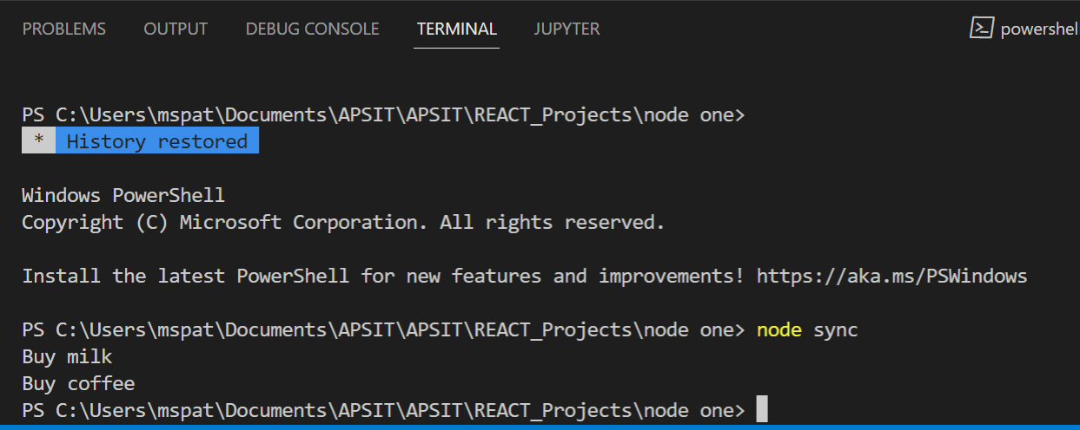

1. **Asyn.js**

console.log(" Start: This is the first statement");

setTimeout(function(){

console.log("This is the second statement: Zero Second Timeout");

}, 0);

setTimeout(function(){

console.log("This is the Third statement: Two Second Timeout");

}, 2000);

console.log(" End: This is the Last statement");

**Output:**

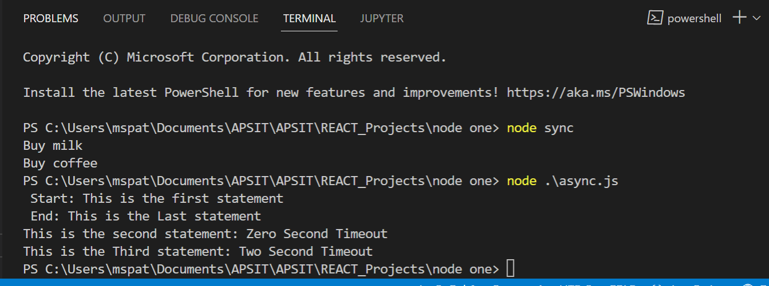

**Conclusion:** In this experiment we have studied and implemented Node js application with event loop concept.