**Academic Year: 2022-23 Name of Student:**

**Semester: VI Student ID:**

**Class / Branch/ Div: TE- IT A/ B Roll No.**

**Subject: IP Lab Date of Submission:**

**Name of Instructor: Yaminee Patil**

**Experiment No.:12**

**Aim:** Write a program to implement routing in Express JS.

**Software Used:** Visual Studio code

**Prerequisites:** JavaScript, Node JS

**Code & Output:**

1. **Index.js**

var express = require('express');

var app = express();

app.get('/', function (req, res) {

console.log("Got a GET request for the homepage");

res.send('Welcome to IP Session!');

})

app.post('/', function (req, res) {

console.log("Got a POST request for the homepage");

res.send('I am Impossible! ');

})

app.delete('/del_student', function (req, res) {

console.log("Got a DELETE request for /del_student");

res.send('I am Deleted!');

})

app.get('/enrolled_student', function (req, res) {

console.log("Got a GET request for /enrolled_student");

res.send('I am an enrolled student.');

})

// This responds a GET request for abcd, abxcd, ab123cd, and so on

app.get('/ab*cd', function(req, res) {

console.log("Got a GET request for /ab*cd");

res.send('Pattern Matched.');

})

var server = app.listen(5000, function () {

var host = server.address().address

var port = server.address().port

console.log("Example app listening at http://%s:%s", host, port)

})

Now, you can see the result generated by server on the local host <http://127.0.0.1:5000>

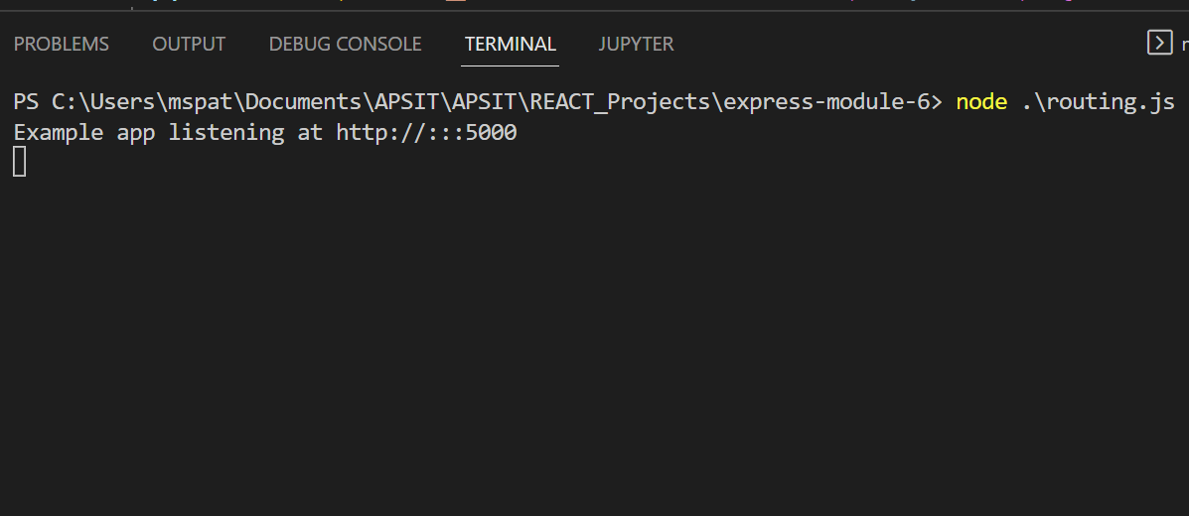

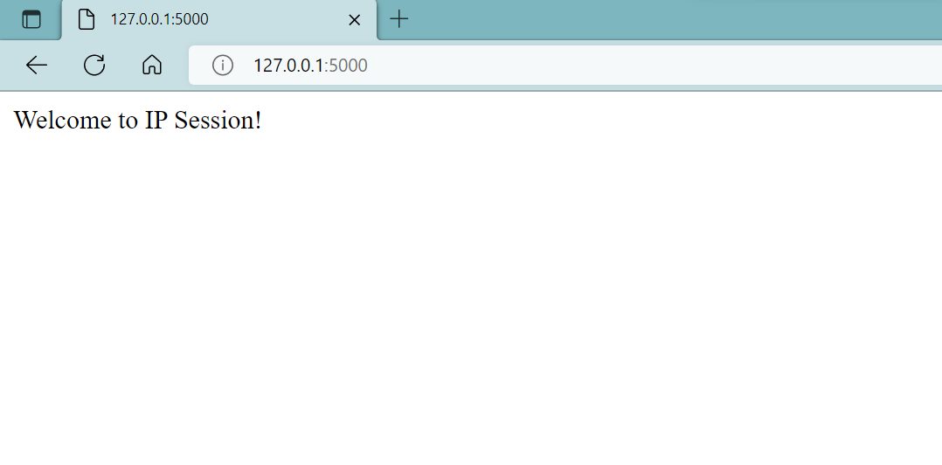

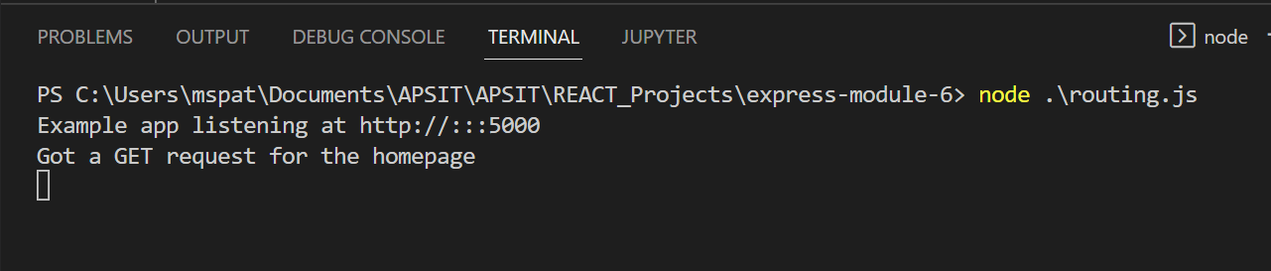

You can see the different pages by changing routes. <http://127.0.0.1:5000/enrolled_student>

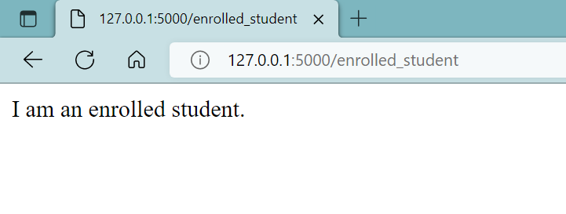

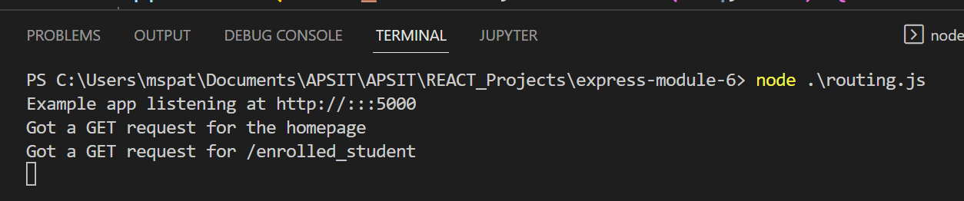

This can read the pattern like abcd, abxcd, ab123cd, and so on.

Next route <http://127.0.0.1:5000/abcd>

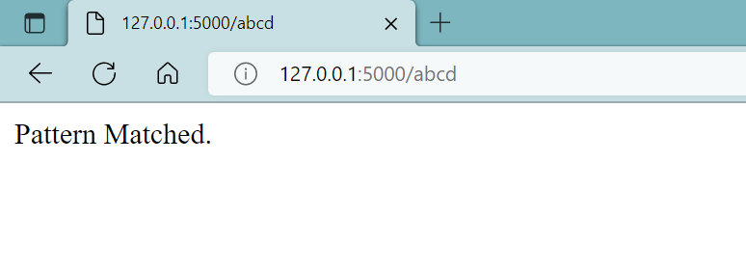

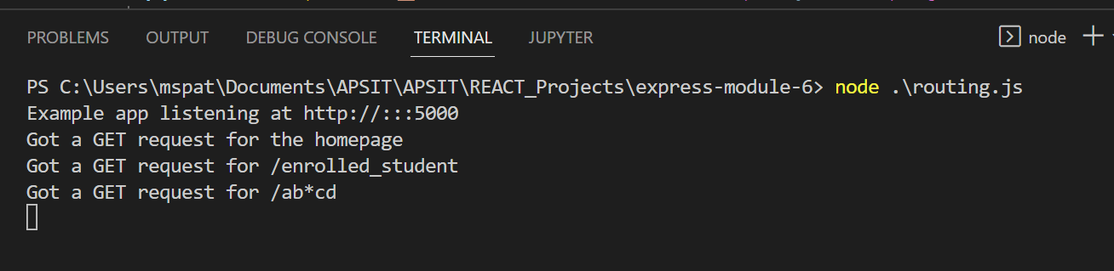

**Conclusion:** In this experiment we have studied and implemented routing in Express js.