**Academic Year: 2022-23 Name of Student:**

**Semester: VI Student ID:**

**Class / Branch/ Div: TE- IT A/ B Roll No.**

**Subject: MAD & PWA Lab Date of Submission:**

**Name of Instructor: Yaminee Patil**

**Experiment No.:3**

**Aim:** Write a program to apply different CSS selectors to webpage.

**Software Used:** Visual Studio code

**Prerequisites:** HTML, CSS

**Code & Output:**

1. **Index.html**

<!DOCTYPE html>

<html lang="en">

<head>

<title>Student Portfolio</title>

<meta charset="utf-8">

<meta name="viewport" content="width=device-width, initial-scale=1">

<link rel="stylesheet" type="text/css" href="css\index_css.css">

<style>

p {

padding: 5px;

font-size:large;

font-weight: 500;

}

</style>

</head>

<body>

<h1 style="text-align: center; color: darkslateblue;">Hey, I'm Sharlene</h1>

<p>I am Front-end Developer in Mumbai. I am bringing the creativity and precision in designing websites.</p>

<p>Web designing is my forte and I like to work in UI/UX Design.</p>

<nav>

<ul>

<li><a href="C:\Users\mspat\Documents\APSIT\KC_MISC\Workshop\New folder\about.html">About Me</a></li>

<li><a href="C:\Users\mspat\Documents\APSIT\KC_MISC\Workshop\New folder\qual.html">Qualification</a></li>

<li><a href="C:\Users\mspat\Documents\APSIT\KC_MISC\Workshop\New folder\skill.html">Skills</a></li>

</ul>

</nav>

<section>

<article>

<h1>Why Work With Me???</h1>

<ul class="cls_i" type="square">

<li>Analytical</li>

<li>Results Driven</li>

<li>Strong Interpersonal Skills</li>

<li>Deadline Concious</li>

<li>Clear Communicator</li>

</ul>

</article>

</section>

<footer>

<img id="foo_i" src="images\new.png">

</footer>

</body>

</html>

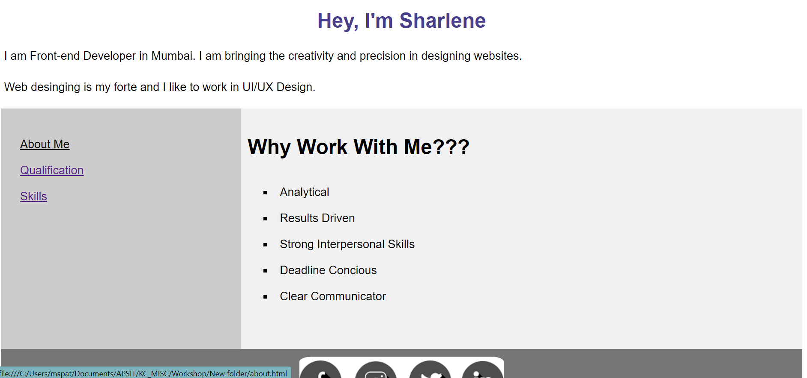

1. **About Me**

<!DOCTYPE html>

<html lang="en">

<head>

<title>Personal Info</title>

<meta charset="utf-8">

<meta name="viewport" content="width=device-width, initial-scale=1">

<link rel="stylesheet" type="text/css" href="css\index_css.css">

</head>

<body>

<h2>“About Me”</h2>

<section>

<nav>

<ul>

<li><a href="C:\Users\mspat\Documents\APSIT\KC_MISC\Workshop\New folder\index.html">Home</a>

</li>

<li><a href="C:\Users\mspat\Documents\APSIT\KC_MISC\Workshop\New folder\qual.html">Qualification</a></li>

<li><a href="C:\Users\mspat\Documents\APSIT\KC_MISC\Workshop\New folder\skill.html">Skills</a></li>

</ul>

</nav>

<article>

<h1>Personal Info</h1>

<p style="text-align:justify;" ><b>Beyond conventional interaction patterns</b><br>

I’m Sharlene, an energetic designer who combines rapid prototyping, interaction, motion, and visual design to transform thorny problems into elegant solutions.

I specialize in consumer products that distill complex data into simple and beautiful visualizations.

With my extensive experience working in tandem with engineers, executives, and marketing teams, I know how to ensure user needs are aligned with business goals.</p>

<p style="text-align:justify;"><b>How volleyball made me a better designer</b><br>

Playing volleyball twice a day for 8 years taught me how to make intentional decisions in complicated situations.

I had to work as a team, regularly iterate through practice and understand the psychology of fellow players under intense, competitive conditions.

These valuable lessons I learned on the volleyball court have carried over to the digital design work I do today.

<p style="text-align:justify;"><b>Things that put a smile on my face</b><br>

Volleyball, skateboarding, architectural photography, strawberry ice cream and fried chicken! :)</p>

</article>

</section>

<footer>

<p><img src="images\download (1).png"></p>

</footer>

</body>

</html>

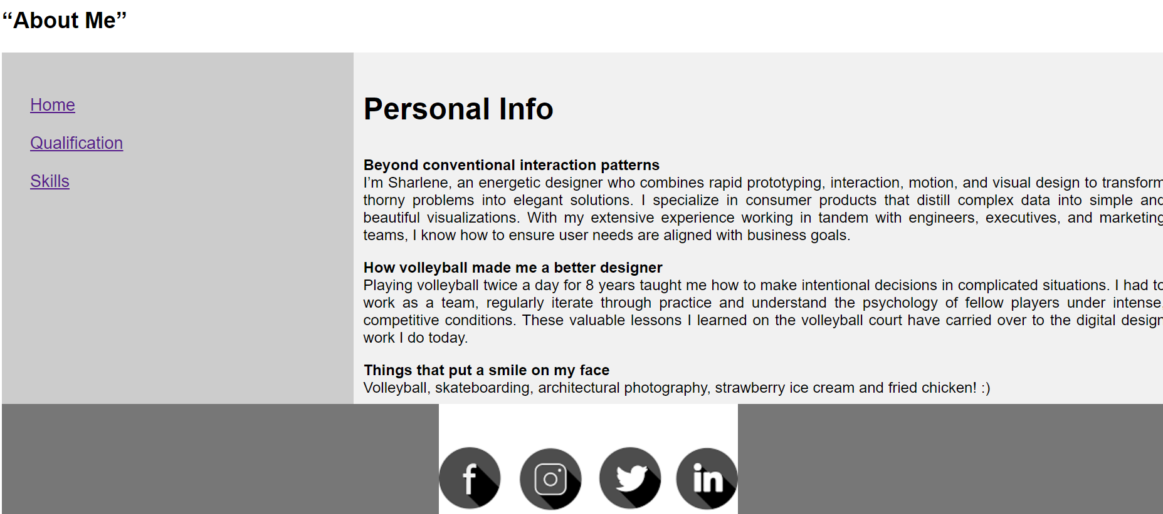

1. **Qualification:**

<!DOCTYPE html>

<html lang="en">

<head>

<title>Student Portfolio</title>

<meta charset="utf-8">

<meta name="viewport" content="width=device-width, initial-scale=1">

<link rel="stylesheet" type="text/css" href="css\index_css.css">

<style>

table {

border-collapse: collapse;

width: 100%;

}

th, td {

padding: 8px;

text-align: left;

border-bottom: 1px solid #DDD;

}

tr:hover {background-color: #D6EEEE;}

</style>

</head>

<body>

<h2>“Education is what they equip you with; just in case your dream doesn't workout.”</h2>

<nav>

<ul>

<li><a href="C:\Users\mspat\Documents\APSIT\KC_MISC\Workshop\New folder\index.html">Home</a></li>

<li><a href="C:\Users\mspat\Documents\APSIT\KC_MISC\Workshop\New folder\about.html">About Me</a></li>

<li><a href="C:\Users\mspat\Documents\APSIT\KC_MISC\Workshop\New folder\skill.html">Skills</a></li>

</ul>

</nav>

<section>

<article>

<p style="font-size: large; font-weight: 300;">Educational Details:</p>

<table>

<tr>

<th>Degree</th>

<th>Grades</th>

<th>University</th>

<th>Year</th>

</tr>

<tr>

<td>Masters of CS</td>

<td>First Class</td>

<td>University of Mumbai</td>

<td>2021</td>

</tr>

<tr>

<td>Bachelors of CS</td>

<td>First Class</td>

<td>University of Mumbai</td>

<td>2019</td>

</tr>

<tr>

<td>H.S.C</td>

<td>Distinction</td>

<td>University of Mumbai</td>

<td>2015</td>

</tr>

<tr>

<td>S.S.C</td>

<td>First Class</td>

<td>University of Mumbai</td>

<td>2013</td>

</tr>

</table>

</article>

</section>

<footer>

<img id="foo_i" src="images\download (1).png">

</footer>

</body>

</html>

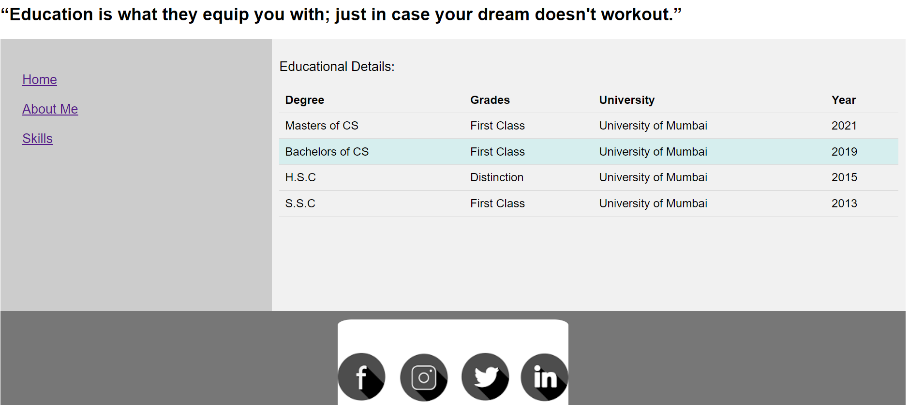

1. **Skill**

<!DOCTYPE html>

<html lang="en">

<head>

<title>Student Portfolio</title>

<meta charset="utf-8">

<meta name="viewport" content="width=device-width, initial-scale=1">

<link rel="stylesheet" type="text/css" href="css\index_css.css">

</head>

<body>

<h2>I transform thorny problems into elegant solutions using visual design, rapid prototyping, and interaction skills</h2>

<nav>

<ul>

<li><a href="C:\Users\mspat\Documents\APSIT\KC_MISC\Workshop\New folder\index.html">Home</a>

</li>

<li><a href="C:\Users\mspat\Documents\APSIT\KC_MISC\Workshop\New folder\about.html">About Me</a></li>

<li><a href="C:\Users\mspat\Documents\APSIT\KC_MISC\Workshop\New folder\qual.html">Qualification</a></li>

</ul>

</nav>

<section>

<article>

<h1>Skills</h1>

<ul>

<li>Wireframing and prototyping skills.</li>

<li>UX writing skills.</li>

<li> Visual communication skills.</li>

<li>Interaction design skills.</li>

</ul>

</article>

</section>

<footer>

<p><img src="images\download (1).png"></p>

</footer>

</body>

</html>

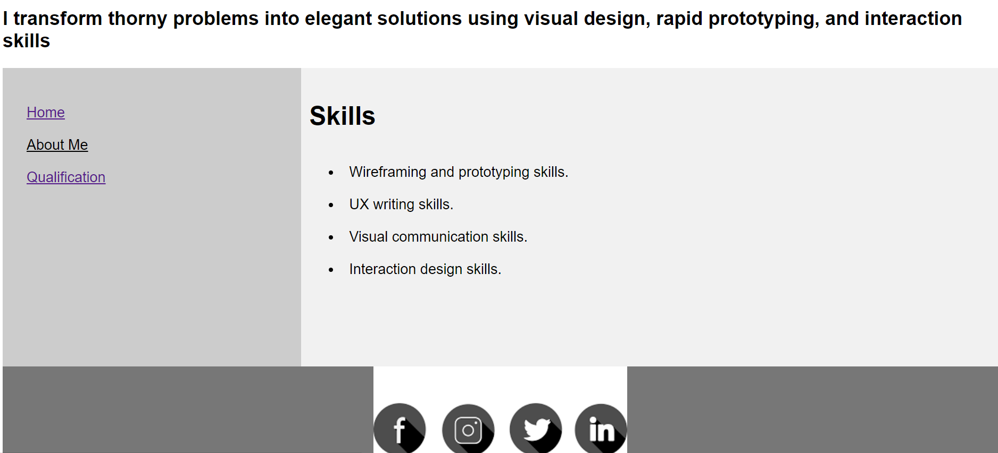

**index_css.css**

* {

box-sizing: border-box;

}

body {

font-family: Arial, Helvetica, sans-serif;

}

h1 {

font-size: xx-large;

}

/* Style the header */

header {

background-color: #666;

text-align: center;

font-size: 30px;

color: white;

}

nav {

float: left;

width: 30%;

height: 375px;

background: #ccc;

padding: 20px;

}

/* Style the list inside the menu */

nav ul {

list-style-type: none;

padding: 0;

}

nav ul li {

font-size: large;

padding: 10px;

}

a:hover{

color: black;

}

article {

float: left;

padding: 10px;

width: 70%;

background-color: #f1f1f1;

height: 375px;

}

li {

padding: 10px;

font-size: large;

}

/* Style the footer */

footer {

background-color: #777;

padding: 10px;

text-align: center;

color: white;

}

#foo_i {

padding-top: 12px;

border-radius: 20px;

}

**Conclusion:** In this experiment we have studied and implemented CSS Selectors to style webpages.